COP26 at Fram November 2021

Analysis of the survey responses

Ben Anderson ([dataknut@icloud.com](mailto:dataknut@icloud.com))

Last run at: 2022-03-11 14:39:58

Table of Contents

# two sources, questions asked slightly differently :-(  
onlineDT_wide <- data.table::fread(paste0(dataPath, "COP26@FRAMLINGHAM SURVEY.csv"))  
  
onlineDT <- data.table::melt(onlineDT_wide[`Do you have any comments or further ideas we can consider?` != "answers from Ben - for test purposes!"], # remove  
 id.vars = "Timestamp")  
  
onlineDT[, question := ifelse(variable %like% "improve energy efficiency",  
 "1",  
 NA)]  
onlineDT[, question := ifelse(variable %like% "electric vehicle",  
 "2",  
 question)]  
onlineDT[, question := ifelse(variable %like% "renewable electricity",  
 "3",  
 question)]  
onlineDT[, question := ifelse(variable %like% "Reducing car journeys",  
 "4",  
 question)]  
onlineDT[, question := ifelse(variable %like% "solar panel",  
 "5",  
 question)]  
onlineDT[, question := ifelse(variable %like% "thermal imaging camera",  
 "6",  
 question)]  
onlineDT[, question := ifelse(variable %like% "make space for nature",  
 "7",  
 question)]  
onlineDT[, question := ifelse(variable %like% "wildlife corridors",  
 "8",  
 question)]  
onlineDT[, question := ifelse(variable %like% "green space management",  
 "9",  
 question)]  
onlineDT[, question := ifelse(variable %like% "native planting",  
 "10",  
 question)]  
onlineDT[, question := ifelse(variable %like% "bigger recycling centre",  
 "11",  
 question)]  
onlineDT[, question := ifelse(variable %like% "swap and mend",  
 "12",  
 question)]  
onlineDT[, question := ifelse(variable %like% "single use plastic",  
 "13",  
 question)]  
onlineDT[, question := ifelse(variable %like% "compostable bags",  
 "14",  
 question)]  
onlineDT[, question := ifelse(variable %like% "rainwater",  
 "15",  
 question)]  
onlineDT[, question := ifelse(variable %like% "flood plains",  
 "16",  
 question)]  
onlineDT[, question := ifelse(variable %like% "summer shading",  
 "17",  
 question)]  
onlineDT[, question := ifelse(variable %like% "overheating",  
 "18",  
 question)]  
onlineDT[, question := ifelse(variable %like% "comments",  
 "comments",  
 question)]  
onlineDT[, response_str := value]  
onlineDT[, source := "On-line"]  
  
paperDF <- readxl::read_xlsx(paste0(dataPath, "COP26@FramMarket-Survey-Data.xlsx"), sheet = "paper")  
   
paperDT <- data.table::as.data.table(paperDF)  
  
# code paper response for easier comparison  
paperDT[, response_str := ifelse(response >= 1,  
 "Yes (1+ ticks)",  
 response)]  
paperDT[, response_str := ifelse(is.na(response_str),  
 "No (empty)",  
 response_str)]  
paperDT[, response_str := ifelse(response_str == -1,  
 "No (cross)",  
 response_str)]  
paperDT[, response_str := ifelse(response_str == -99,  
 "Don't know (stated)",  
 response_str)]  
# now code the final comments box  
paperDT[, response_str := ifelse(question == "comments",  
 comment,  
 response_str)]  
paperDT[, source := "Paper"]  
# select the variables that match and rbind them into one data file  
  
dataDT <- rbind(paperDT[, .(survey_id, question, response_str, source)],  
 onlineDT[, .(survey_id = Timestamp, question, response_str, source)])  
  
  
# add question text (from online survey data)  
questionText <- unique(onlineDT[, .(question = as.numeric(question), qtext = variable)])  
questionText[, theme := ifelse(question < 7, "Emissions reduction", NA)]  
questionText[, theme := ifelse(question > 6 & question < 11, "Biodiversity enhancement",  
 theme)]  
questionText[, theme := ifelse(question > 10 & question < 15, "Least trace living",  
 theme)]  
questionText[, theme := ifelse(question > 14 , "Resilience",  
 theme)]  
dataDT[, question := as.numeric(question)]  
setkey(dataDT, question)  
setkey(questionText, question)  
dataDT <- dataDT[questionText]  
  
popPc <- uniqueN(dataDT[, .(survey_id)])/4016

# 1 Introduction

The [Sustainability Framlingham](https://github.com/SusFram) group ran a survey in November 2021 intended to collect Framlingham residents’ views on a range of potential sustainability actions or initiatives.

The survey organised its questions into four themes:

* Emissions reduction - reducing our ‘carbon’ footprint
* Biodiversity enhancement - making space for nature
* Least trace living - reducing waste and increasing re-use
* Resilience - reducing the risks of climate change

Each theme asked between 4 and 6 questions.

The survey was distributed in two ways:

* online (available during the whole of November 2021)
* on [paper](COP26@Fram-Questions-V8-FINAL.pdf) at a market stall on the 6th November, timed to coincide with COP26

The online survey was communicated via various social media and the Town Council’s website/newsletter.

The market survey was available to all visitors to the stall on the 6th November and was also taken round to market visitors on that morning by students from [Framlingham College](https://www.framlinghamcollege.co.uk/). The market stall also offered information in the form of:

* [posters](marketStallPosters.pdf) summarising evidence on climate change as well as national and local district/parish emissions footprints;
* a leaflet on the Framlingham [sustainability themes](SUSTAINABLE%20FRAM%20Themes-V2-FINAL.pdf)

The survey responses therefore represent the views of those who chose to respond online or who agreed to respond at the market. In both cases respondents are likely to be those who are *already* more engaged with sustainability issues and so should not be considered as representative of the views of all Framlingham residents. It is also likely that at least some responses came from non-Framlingham residents.

# 2 Data

There were 118 survey responses. Of these:

* 58 were on-line responses between 2021-10-19 and 2021-11-17;
* 60 were paper-based responses collected at the market on 2021-11-06.

118 survey responses represent about 3 % of the estimated Framlingham population of ~ [4,000](https://en.wikipedia.org/wiki/Framlingham).

Table 2.1 shows the survey questions. These were worded identically in the online and paper-based surveys.

t <- unique(dataDT[, .(Theme = theme, Question = qtext)])  
makeFlexTable(t, cap = "Survey questions")

**Table 2.1:** Survey questions

| Theme | Question |
| --- | --- |
|  | Do you have any comments or further ideas we can consider? |
| Emissions reduction | 1 DO YOU SUPPORT: Initiatives to improve energy efficiency (e.g. insulation, double glazing) including listed buildings? |
| Emissions reduction | 2 DO YOU SUPPORT: Installing publicly accessible electric vehicle charging points? |
| Emissions reduction | 3 DO YOU SUPPORT: Encouraging homes and businesses to switch to renewable electricity suppliers? |
| Emissions reduction | 4 DO YOU SUPPORT: Reducing car journeys - encourage local shopping, walk to school and car sharing schemes? |
| Emissions reduction | 5 DO YOU SUPPORT: Promoting community solar panel and heat pump purchase schemes? |
| Emissions reduction | 6 DO YOU SUPPORT: Providing a thermal imaging camera free for residents to borrow to identify heat loss from homes? |
| Biodiversity enhancement | 7 DO YOU SUPPORT: Calling for new buildings to ‘make space for nature’ by designing for natural plant and wildlife habitats? |
| Biodiversity enhancement | 8 DO YOU SUPPORT: Working to create linked green wildlife corridors through and around the town? |
| Biodiversity enhancement | 9 DO YOU SUPPORT: Ensuring that green space management boosts local wildlife and encourage local land owners to do the same? |
| Biodiversity enhancement | 10 DO YOU SUPPORT: Allocating land to native planting, wildlife habitats and 're-wilding' via the Neighbourhood Plan |
| Least trace living | 11 DO YOU SUPPORT: Having a bigger recycling centre on the edge of Framlingham for a wider range of materials? |
| Least trace living | 12 DO YOU SUPPORT: Encouraging swap and mend initiatives? |
| Least trace living | 13 DO YOU SUPPORT: Aiming to get rid of all single use plastic (starting with bags & take away packaging)? |
| Least trace living | 14 DO YOU SUPPORT: Aiming to supply compostable bags at cost price, or free at point of use? |
| Resilience | 15 DO YOU SUPPORT: Calling for new buildings and renovations to be designed to reduce or store rainwater run-off? |
| Resilience | 16 DO YOU SUPPORT: Working to prevent unsustainable development on local flood plains? |
| Resilience | 17 DO YOU SUPPORT: Encouraging native tree planting to provide summer shading throughout the town? |
| Resilience | 18 DO YOU SUPPORT: Exploring options for reducing the risk of overheating in buildings? |

However the potential responses for the paper-based and online surveys differed:

* online: options were yes, no, maybe and there was only the opportunity to add comments at the end in a specific ‘further ideas or comments’ question;
* paper: respondents were asked to tick boxes next to the options they would support - we have therefore coded empty tick boxes as ‘no’ but also coded boxes which were marked with an X as a more intentional ‘No.’ A number of paper respondents added comments beside their responses to each question. These are reported below each plot as a table - where the table is empty there were no specific comments.

In order to avoid confusion and maintain transparency the responses from the two forms of the survey are presented separately (but on the same plots) below.

# 3 Results

## 3.1 Emissions reduction

### 3.1.1 Q1: Initiatives to improve energy efficiency (e.g. insulation, double glazing) including listed buildings?

q <- "1"  
  
makeBarPlot(dataDT, q)

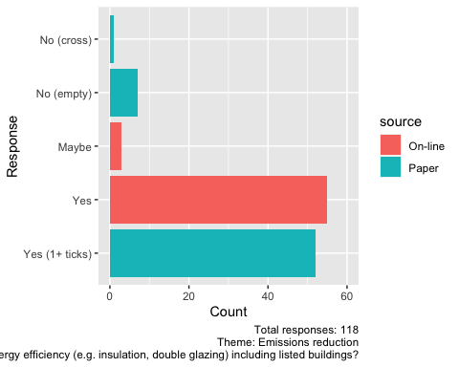

t <- paperDT[question == q & !is.na(comment), .(comment)]  
  
makeFlexTable(t, cap = "Specific comments for this question (paper survey only)")

**Table 3.1:** Specific comments for this question (paper survey only)

| comment |
| --- |
| assisting in applications for grants for insulation & effective home heating for elderly & vulnerable |
| Obliging all developers to build new buildings with sustainable materials & properly insulated with carbon neutral heating systems, Developers comply with requirements of the council & not alter the plans after consent is granted |

### 3.1.2 Q2: Installing publicly accessible electric vehicle charging points

q <- "2"  
  
makeBarPlot(dataDT, q)

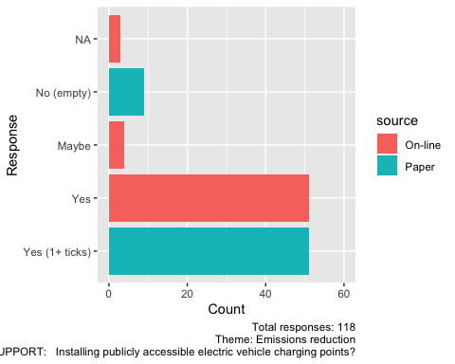

t <- paperDT[question == q & !is.na(comment), .(comment)]  
  
makeFlexTable(t, cap = "Specific comments for this question (paper survey only)")

**Table 3.2:** Specific comments for this question (paper survey only)

| comment |
| --- |

### 3.1.3 Q3: Encouraging homes and businesses to switch to renewable electricity suppliers

q <- "3"  
  
makeBarPlot(dataDT, q)

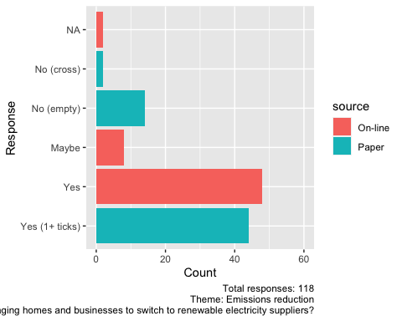

t <- paperDT[question == q & !is.na(comment), .(comment)]  
  
makeFlexTable(t, cap = "Specific comments for this question (paper survey only)")

**Table 3.3:** Specific comments for this question (paper survey only)

| comment |
| --- |

### 3.1.4 Q4: Reducing car journeys - encourage local shopping, walk to school and car sharing schemes

q <- "4"  
  
makeBarPlot(dataDT, q)

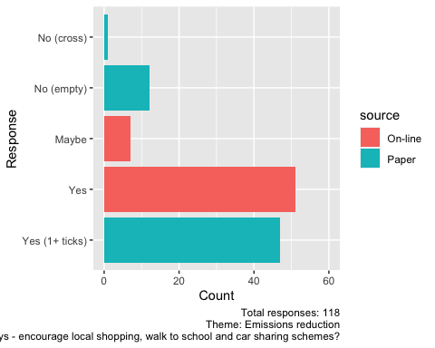

t <- paperDT[question == q & !is.na(comment), .(comment)]  
  
makeFlexTable(t, cap = "Specific comments for this question (paper survey only)")

**Table 3.4:** Specific comments for this question (paper survey only)

| comment |
| --- |
| Bring back bus to rural villages |
| Minimise car travel, provide pedestrian/cycle use, Zebra crossing near Fram DIY to promotoe walking, |
| Close off Fram market to cars to encourage walking; introduce e-scooter schemes to reduce car use into town |
| Better & more bike racks - especially for cargo bikes + longer tandems / pulling trailers |
| car sharing schemes? |
| More public services leaving & returning to Framlingham |
| This! |

### 3.1.5 Q5: Promoting community solar panel and heat pump purchase schemes

q <- "5"  
  
makeBarPlot(dataDT, q)

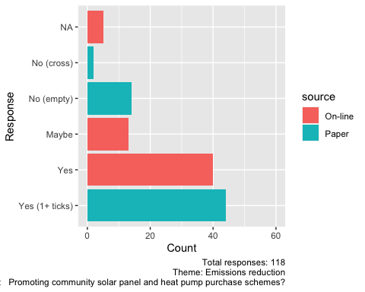

t <- paperDT[question == q & !is.na(comment), .(comment)]  
  
makeFlexTable(t, cap = "Specific comments for this question (paper survey only)")

**Table 3.5:** Specific comments for this question (paper survey only)

| comment |
| --- |
| cost? |
| Subsidy or grants |

### 3.1.6 Q6: Providing a thermal imaging camera free for residents to borrow to identify heat loss from homes

q <- "6"  
  
makeBarPlot(dataDT, q)

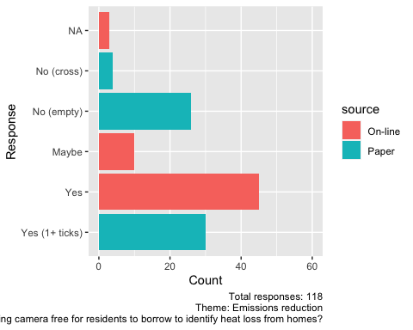

t <- paperDT[question == q & !is.na(comment), .(comment)]  
  
makeFlexTable(t, cap = "Specific comments for this question (paper survey only)")

**Table 3.6:** Specific comments for this question (paper survey only)

| comment |
| --- |
| Good but costly |

## 3.2 Biodiversity enhacement

### 3.2.1 Q7: Calling for new buildings to ‘make space for nature’ by designing for natural plant and wildlife habitats

q <- "7"  
  
makeBarPlot(dataDT, q)

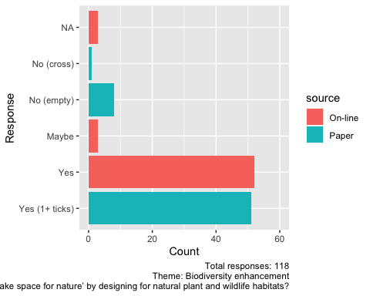

t <- paperDT[question == q & !is.na(comment), .(comment)]  
  
makeFlexTable(t, cap = "Specific comments for this question (paper survey only)")

**Table 3.7:** Specific comments for this question (paper survey only)

| comment |
| --- |
| As long as housing doesn’t sprawl |

### 3.2.2 Q8: Working to create linked green wildlife corridors through and around the town

q <- "8"  
  
makeBarPlot(dataDT, q)

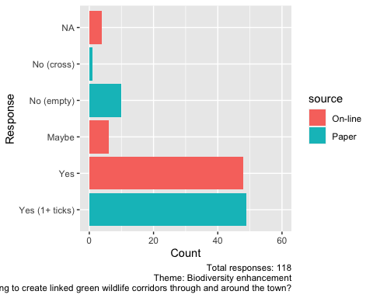

t <- paperDT[question == q & !is.na(comment), .(comment)]  
  
makeFlexTable(t, cap = "Specific comments for this question (paper survey only)")

**Table 3.8:** Specific comments for this question (paper survey only)

| comment |
| --- |
| encourage locals to adopt lanes & verges to prevent spring cutting |

### 3.2.3 Q9: Ensuring that green space management boosts local wildlife and encourage local land owners to do the same

q <- "9"  
  
makeBarPlot(dataDT, q)

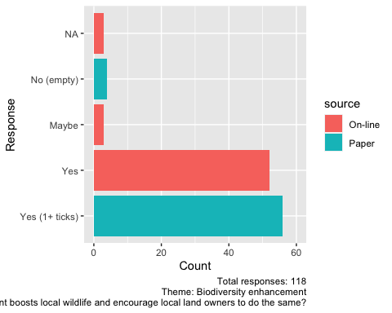

t <- paperDT[question == q & !is.na(comment), .(comment)]  
  
makeFlexTable(t, cap = "Specific comments for this question (paper survey only)")

**Table 3.9:** Specific comments for this question (paper survey only)

| comment |
| --- |
| Already done? |
| Encourage re-wilding pledges to home & business premises |

### 3.2.4 Q10: Allocating land to native planting, wildlife habitats and ‘re-wilding’ via the Neighbourhood Plan

q <- "10"  
  
makeBarPlot(dataDT, q)

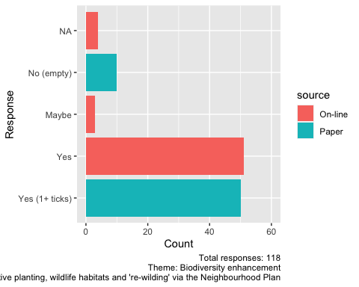

t <- paperDT[question == q & !is.na(comment), .(comment)]  
  
makeFlexTable(t, cap = "Specific comments for this question (paper survey only)")

**Table 3.10:** Specific comments for this question (paper survey only)

| comment |
| --- |
| As long as managed cost? |
| rewilding gardening practices |

## 3.3 Least Trace Living

### 3.3.1 Q11: Having a bigger recycling centre on the edge of Framlingham for a wider range of materials

q <- "11"  
  
makeBarPlot(dataDT, q)

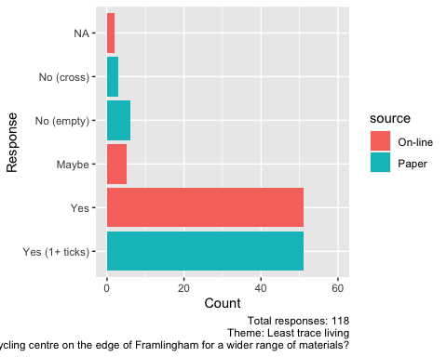

t <- paperDT[question == q & !is.na(comment), .(comment)]  
  
makeFlexTable(t, cap = "Specific comments for this question (paper survey only)")

**Table 3.11:** Specific comments for this question (paper survey only)

| comment |
| --- |
| No |
| We need easier ways to recycle items locally |
| Parking problem, who has priority? |

### 3.3.2 Q12: Encouraging swap and mend initiatives

q <- "12"  
  
makeBarPlot(dataDT, q)

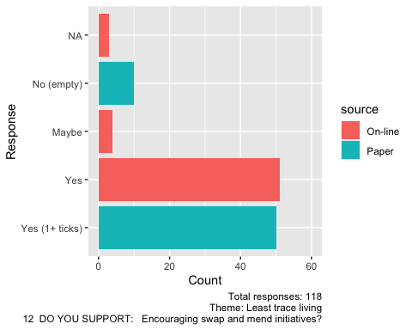

t <- paperDT[question == q & !is.na(comment), .(comment)]  
  
makeFlexTable(t, cap = "Specific comments for this question (paper survey only)")

**Table 3.12:** Specific comments for this question (paper survey only)

| comment |
| --- |
| At variety of times so access to all |
| Educating on mending, charity shop fashion show |
| Thru social network (Fram fb) or pick-up point |
| including exchange of unwanted/2nd hand clothes - maybe a stand in the market? |

### 3.3.3 Q13: Aiming to get rid of all single use plastic (starting with bags & take away packaging)

q <- "13"  
  
makeBarPlot(dataDT, q)

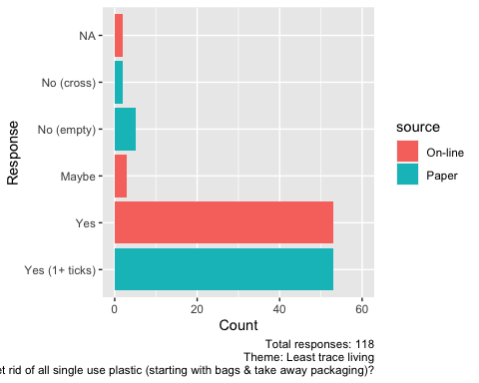

t <- paperDT[question == q & !is.na(comment), .(comment)]  
  
makeFlexTable(t, cap = "Specific comments for this question (paper survey only)")

**Table 3.13:** Specific comments for this question (paper survey only)

| comment |
| --- |
| Bigger bin at co-op |
| 100% ban, supermarkets, small businesses; lobby supermarket to stop all supply of plastic bags & reduce plastic packaging |

### 3.3.4 Q14: Aiming to supply compostable bags at cost price, or free at point of use

q <- "14"  
  
makeBarPlot(dataDT, q)

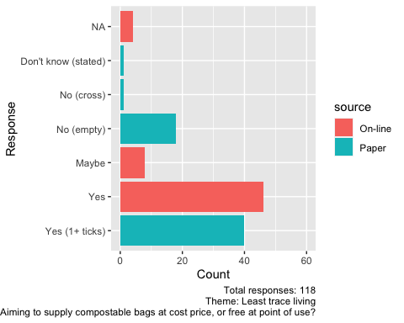

t <- paperDT[question == q & !is.na(comment), .(comment)]  
  
makeFlexTable(t, cap = "Specific comments for this question (paper survey only)")

**Table 3.14:** Specific comments for this question (paper survey only)

| comment |
| --- |
| Just ban plastic bags 100% |
| ? |

## 3.4 Resilience

### 3.4.1 Q15: Calling for new buildings and renovations to be designed to reduce or store rainwater run-off

q <- "15"  
  
makeBarPlot(dataDT, q)

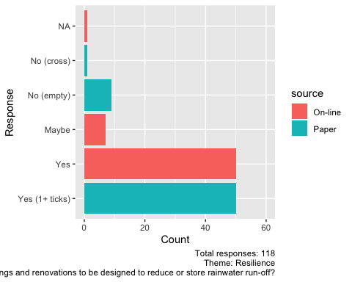

t <- paperDT[question == q & !is.na(comment), .(comment)]  
  
makeFlexTable(t, cap = "Specific comments for this question (paper survey only)")

**Table 3.15:** Specific comments for this question (paper survey only)

| comment |
| --- |
| Increase brown water use |
| All to have car charge points and renewable energy built in |

### 3.4.2 Q16: Working to prevent unsustainable development on local flood plains

q <- "16"  
  
makeBarPlot(dataDT, q)

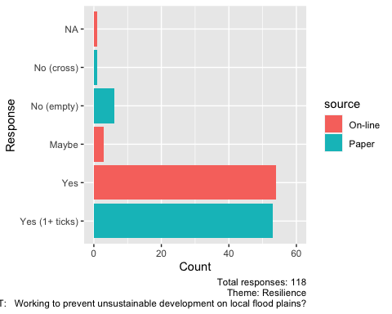

t <- paperDT[question == q & !is.na(comment), .(comment)]  
  
makeFlexTable(t, cap = "Specific comments for this question (paper survey only)")

**Table 3.16:** Specific comments for this question (paper survey only)

| comment |
| --- |
| Again good idea, but costly |

### 3.4.3 Q17: Encouraging native tree planting to provide summer shading throughout the town

q <- "17"  
  
makeBarPlot(dataDT, q)

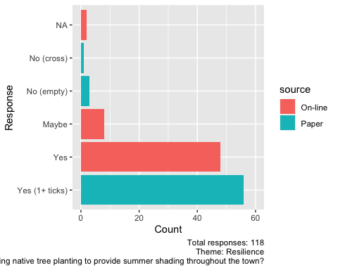

t <- paperDT[question == q & !is.na(comment), .(comment)]  
  
makeFlexTable(t, cap = "Specific comments for this question (paper survey only)")

**Table 3.17:** Specific comments for this question (paper survey only)

| comment |
| --- |

### 3.4.4 Q18: Exploring options for reducing the risk of overheating in buildings

q <- "18"  
  
makeBarPlot(dataDT, q)

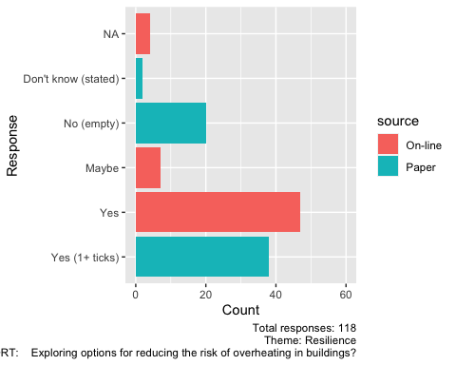

t <- paperDT[question == q & !is.na(comment), .(comment)]  
  
makeFlexTable(t, cap = "Specific comments for this question (paper survey only)")

**Table 3.18:** Specific comments for this question (paper survey only)

| comment |
| --- |
| dk ? |
| ? |

## 3.5 General comments

The table below shows all general comments made at the end of the survey. No attempt has yet been made to cluster these by theme.

Please flag any that you consider disclosive (i.e. could identify the respondent) and these will be redacted in some way!

q <- "comments"  
  
t <- dataDT[question == q & !is.na(response_str) &  
 response_str != "", .(Comment = response_str, source)]  
  
# remove anything that looks like an email address  
pattern <- "[a-z]*@[a-z]*[.][a-z]*"  
t[, Comment := stringr::str_replace(Comment, pattern, " <XX email redacted XX> ")]  
  
makeFlexTable(t, cap = "General comments for this question (both surveys)")

**Table 3.19:** General comments for this question (both surveys)

| Comment | source |
| --- | --- |

## 3.6 Additional comments

In addition to the above the following general comments were also made.

* investigate a tree & woodland strategy - c.f. Stonehouse Town Council’s [Arboretum](https://treecare.org.uk/2243/stonehouse-community-arboretum-management-plan-launched/) - strategy prepared by Barcham (local contact)
* investigate Debenham Repairs shed - Friday afternoons
* electric car chargers - could make 2 types available (fast & standard) but consider implications of each for how long vehicle would ‘need’ to be plugged in
* old oil tank comment?
* investigate Enterprise @ Badingham

# 4 Summary

Overall the respondents to the survey were generally supportive of all actions proposed.

dataDT[, yes_response := ifelse(response_str %like% "Yes",  
 "Yes", "Other")]  
dataDT[, no_response := ifelse(response_str %like% "No",  
 "No", "Other")]  
  
yesDT <- dataDT[question != "comments", .(count = .N), keyby = .(question, theme, qtext, yes_response)]  
noDT <- dataDT[question != "comments", .(count = .N), keyby = .(question, theme, qtext,no_response)]  
  
nResponses <- uniqueN(dataDT$survey_id)  
  
# questionText <- data.table::as.data.table(table(onlineDT$variable))  
# questionText$question <- as.character(1:nrow(questionText))  
  
yesDT[, pc_yes := 100*count/nResponses]  
yes_t <- yesDT[question != 19 # avoid comments question  
 ]  
  
noDT[, pc_no := 100*count/nResponses]  
no_t <- noDT[question != 19]

Actions that were most strongly supported (> 80% of responses were ‘yes’) are shown in Table 4.1.

t <- yes_t[yes_response == "Yes" & pc_yes > 80][order(-pc_yes)]  
  
makeFlexTable(t[, .(Theme = theme, Question = qtext, `% yes` = pc_yes)], cap = "Most strongly supported (> 80% of responses were 'yes')")

**Table 4.1:** Most strongly supported (> 80% of responses were ‘yes’)

| Theme | Question | % yes |
| --- | --- | --- |
| Biodiversity enhancement | 9 DO YOU SUPPORT: Ensuring that green space management boosts local wildlife and encourage local land owners to do the same? | 91.5 |
| Emissions reduction | 1 DO YOU SUPPORT: Initiatives to improve energy efficiency (e.g. insulation, double glazing) including listed buildings? | 90.7 |
| Resilience | 16 DO YOU SUPPORT: Working to prevent unsustainable development on local flood plains? | 90.7 |
| Least trace living | 13 DO YOU SUPPORT: Aiming to get rid of all single use plastic (starting with bags & take away packaging)? | 89.8 |
| Resilience | 17 DO YOU SUPPORT: Encouraging native tree planting to provide summer shading throughout the town? | 88.1 |
| Biodiversity enhancement | 7 DO YOU SUPPORT: Calling for new buildings to ‘make space for nature’ by designing for natural plant and wildlife habitats? | 87.3 |
| Emissions reduction | 2 DO YOU SUPPORT: Installing publicly accessible electric vehicle charging points? | 86.4 |
| Least trace living | 11 DO YOU SUPPORT: Having a bigger recycling centre on the edge of Framlingham for a wider range of materials? | 86.4 |
| Biodiversity enhancement | 10 DO YOU SUPPORT: Allocating land to native planting, wildlife habitats and 're-wilding' via the Neighbourhood Plan | 85.6 |
| Least trace living | 12 DO YOU SUPPORT: Encouraging swap and mend initiatives? | 85.6 |
| Resilience | 15 DO YOU SUPPORT: Calling for new buildings and renovations to be designed to reduce or store rainwater run-off? | 84.7 |
| Emissions reduction | 4 DO YOU SUPPORT: Reducing car journeys - encourage local shopping, walk to school and car sharing schemes? | 83.1 |
| Biodiversity enhancement | 8 DO YOU SUPPORT: Working to create linked green wildlife corridors through and around the town? | 82.2 |

Actions that were least strongly supported (> 10% of responses were ‘no’) are shown in Table 4.2.

t <- no_t[no_response == "No" & pc_no > 10][order(-pc_no)]  
  
makeFlexTable(t[, .(Theme = theme, Question = qtext, `% no` = pc_no)], cap = "Least strongly supported (> 10% of responses were 'no')")

**Table 4.2:** Least strongly supported (> 10% of responses were ‘no’)

| Theme | Question | % no |
| --- | --- | --- |
| Emissions reduction | 6 DO YOU SUPPORT: Providing a thermal imaging camera free for residents to borrow to identify heat loss from homes? | 27.1 |
| Least trace living | 14 DO YOU SUPPORT: Aiming to supply compostable bags at cost price, or free at point of use? | 18.6 |
| Resilience | 18 DO YOU SUPPORT: Exploring options for reducing the risk of overheating in buildings? | 18.6 |
| Emissions reduction | 5 DO YOU SUPPORT: Promoting community solar panel and heat pump purchase schemes? | 17.8 |
| Emissions reduction | 3 DO YOU SUPPORT: Encouraging homes and businesses to switch to renewable electricity suppliers? | 14.4 |
| Biodiversity enhancement | 8 DO YOU SUPPORT: Working to create linked green wildlife corridors through and around the town? | 11.9 |
| Emissions reduction | 4 DO YOU SUPPORT: Reducing car journeys - encourage local shopping, walk to school and car sharing schemes? | 11.0 |
| Biodiversity enhancement | 10 DO YOU SUPPORT: Allocating land to native planting, wildlife habitats and 're-wilding' via the Neighbourhood Plan | 11.0 |
| Emissions reduction | 2 DO YOU SUPPORT: Installing publicly accessible electric vehicle charging points? | 10.2 |
| Least trace living | 12 DO YOU SUPPORT: Encouraging swap and mend initiatives? | 10.2 |

# 5 Annex

## 5.1 Full results table (% Yes)

t <- yes_t[yes_response == "Yes"][order(-pc_yes)]  
  
makeFlexTable(t[, .(Theme = theme, Question = qtext, `% yes` = pc_yes)], cap = "% Yes")

**Table 5.1:** % Yes

| Theme | Question | % yes |
| --- | --- | --- |
| Biodiversity enhancement | 9 DO YOU SUPPORT: Ensuring that green space management boosts local wildlife and encourage local land owners to do the same? | 91.5 |
| Emissions reduction | 1 DO YOU SUPPORT: Initiatives to improve energy efficiency (e.g. insulation, double glazing) including listed buildings? | 90.7 |
| Resilience | 16 DO YOU SUPPORT: Working to prevent unsustainable development on local flood plains? | 90.7 |
| Least trace living | 13 DO YOU SUPPORT: Aiming to get rid of all single use plastic (starting with bags & take away packaging)? | 89.8 |
| Resilience | 17 DO YOU SUPPORT: Encouraging native tree planting to provide summer shading throughout the town? | 88.1 |
| Biodiversity enhancement | 7 DO YOU SUPPORT: Calling for new buildings to ‘make space for nature’ by designing for natural plant and wildlife habitats? | 87.3 |
| Emissions reduction | 2 DO YOU SUPPORT: Installing publicly accessible electric vehicle charging points? | 86.4 |
| Least trace living | 11 DO YOU SUPPORT: Having a bigger recycling centre on the edge of Framlingham for a wider range of materials? | 86.4 |
| Biodiversity enhancement | 10 DO YOU SUPPORT: Allocating land to native planting, wildlife habitats and 're-wilding' via the Neighbourhood Plan | 85.6 |
| Least trace living | 12 DO YOU SUPPORT: Encouraging swap and mend initiatives? | 85.6 |
| Resilience | 15 DO YOU SUPPORT: Calling for new buildings and renovations to be designed to reduce or store rainwater run-off? | 84.7 |
| Emissions reduction | 4 DO YOU SUPPORT: Reducing car journeys - encourage local shopping, walk to school and car sharing schemes? | 83.1 |
| Biodiversity enhancement | 8 DO YOU SUPPORT: Working to create linked green wildlife corridors through and around the town? | 82.2 |
| Emissions reduction | 3 DO YOU SUPPORT: Encouraging homes and businesses to switch to renewable electricity suppliers? | 78.0 |
| Least trace living | 14 DO YOU SUPPORT: Aiming to supply compostable bags at cost price, or free at point of use? | 72.9 |
| Resilience | 18 DO YOU SUPPORT: Exploring options for reducing the risk of overheating in buildings? | 72.0 |
| Emissions reduction | 5 DO YOU SUPPORT: Promoting community solar panel and heat pump purchase schemes? | 71.2 |
| Emissions reduction | 6 DO YOU SUPPORT: Providing a thermal imaging camera free for residents to borrow to identify heat loss from homes? | 63.6 |

## 5.2 Full results table (% No)

t <- no_t[no_response == "No"][order(-pc_no)]  
  
makeFlexTable(t[, .(Theme = theme, Question = qtext, `% no` = pc_no)], cap = "Least strongly supported")

**Table 5.2:** Least strongly supported

| Theme | Question | % no |
| --- | --- | --- |
| Emissions reduction | 6 DO YOU SUPPORT: Providing a thermal imaging camera free for residents to borrow to identify heat loss from homes? | 27.1 |
| Least trace living | 14 DO YOU SUPPORT: Aiming to supply compostable bags at cost price, or free at point of use? | 18.6 |
| Resilience | 18 DO YOU SUPPORT: Exploring options for reducing the risk of overheating in buildings? | 18.6 |
| Emissions reduction | 5 DO YOU SUPPORT: Promoting community solar panel and heat pump purchase schemes? | 17.8 |
| Emissions reduction | 3 DO YOU SUPPORT: Encouraging homes and businesses to switch to renewable electricity suppliers? | 14.4 |
| Biodiversity enhancement | 8 DO YOU SUPPORT: Working to create linked green wildlife corridors through and around the town? | 11.9 |
| Emissions reduction | 4 DO YOU SUPPORT: Reducing car journeys - encourage local shopping, walk to school and car sharing schemes? | 11.0 |
| Biodiversity enhancement | 10 DO YOU SUPPORT: Allocating land to native planting, wildlife habitats and 're-wilding' via the Neighbourhood Plan | 11.0 |
| Emissions reduction | 2 DO YOU SUPPORT: Installing publicly accessible electric vehicle charging points? | 10.2 |
| Least trace living | 12 DO YOU SUPPORT: Encouraging swap and mend initiatives? | 10.2 |
| Biodiversity enhancement | 7 DO YOU SUPPORT: Calling for new buildings to ‘make space for nature’ by designing for natural plant and wildlife habitats? | 8.5 |
| Least trace living | 11 DO YOU SUPPORT: Having a bigger recycling centre on the edge of Framlingham for a wider range of materials? | 8.5 |
| Resilience | 15 DO YOU SUPPORT: Calling for new buildings and renovations to be designed to reduce or store rainwater run-off? | 8.5 |
| Emissions reduction | 1 DO YOU SUPPORT: Initiatives to improve energy efficiency (e.g. insulation, double glazing) including listed buildings? | 6.8 |
| Least trace living | 13 DO YOU SUPPORT: Aiming to get rid of all single use plastic (starting with bags & take away packaging)? | 6.8 |
| Resilience | 16 DO YOU SUPPORT: Working to prevent unsustainable development on local flood plains? | 5.9 |
| Biodiversity enhancement | 9 DO YOU SUPPORT: Ensuring that green space management boosts local wildlife and encourage local land owners to do the same? | 4.2 |
| Resilience | 17 DO YOU SUPPORT: Encouraging native tree planting to provide summer shading throughout the town? | 3.4 |

## 5.3 Data processing

This analysis was created using [R](https://cran.r-project.org/) embedded in [Rmarkdown](https://rmarkdown.rstudio.com/) in [RStudio](https://www.rstudio.com/).

## 5.4 R packages used

* base R (R Core Team 2016)
* bookdown (Xie 2016a)
* data.table (Dowle et al. 2015)
* ggplot2 (Wickham 2009)
* flextable (Gohel 2021)
* knitr (Xie 2016b)
* rmarkdown (Allaire et al. 2018)

# References

Allaire, JJ, Yihui Xie, Jonathan McPherson, Javier Luraschi, Kevin Ushey, Aron Atkins, Hadley Wickham, Joe Cheng, and Winston Chang. 2018. *Rmarkdown: Dynamic Documents for r*. <https://CRAN.R-project.org/package=rmarkdown>.

Dowle, M, A Srinivasan, T Short, S Lianoglou with contributions from R Saporta, and E Antonyan. 2015. *Data.table: Extension of Data.frame*. <https://CRAN.R-project.org/package=data.table>.

Gohel, David. 2021. *Flextable: Functions for Tabular Reporting*. <https://CRAN.R-project.org/package=flextable>.

R Core Team. 2016. *R: A Language and Environment for Statistical Computing*. Vienna, Austria: R Foundation for Statistical Computing. <https://www.R-project.org/>.

Wickham, Hadley. 2009. *Ggplot2: Elegant Graphics for Data Analysis*. Springer-Verlag New York. <http://ggplot2.org>.

Xie, Yihui. 2016a. *Bookdown: Authoring Books and Technical Documents with R Markdown*. Boca Raton, Florida: Chapman; Hall/CRC. <https://github.com/rstudio/bookdown>.

———. 2016b. *Knitr: A General-Purpose Package for Dynamic Report Generation in r*. <https://CRAN.R-project.org/package=knitr>.