***Figure 5-2 E-R Diagram for Purchase Order Application***

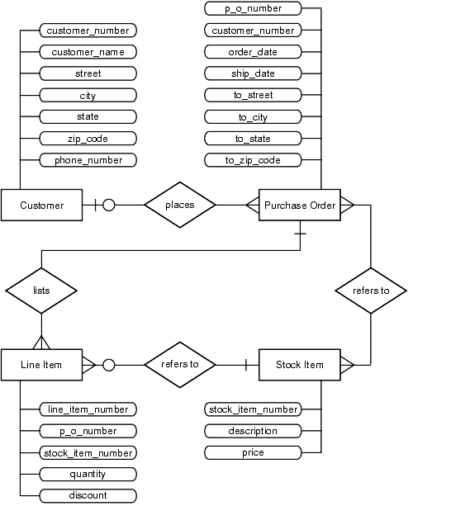

#### Figure 5-1 Rules for Drawing an E-R Diagram

