INNOVATION AND DESIGN THINKING / COMMUNITY PROJECT / MINI PROJECT
Project Synopsis

Project Batch No. | : | B.E/CSE/Sem-1 / Batch No:
Academic Year | : | 2026-27 (Odd Semester)
Branch / Semester & Section | : | CSE / I Semester / Section: C
Course Name & Code | : | Innovation Design Thinking (B25IDL108)
Title of the Project work | : | EduVault: A Smart Academic Platform
Name of the Project Guide | : | Prof. Sandhya H, Physics Cycle
Name of the Project Coordinator | :
Name of the HoD | : | Dr. K. S. Krishna Kumar
Field/Domain/Area of project | : | Educational Technology (EdTech), Web Development, Artificial Intelligence, and Academic Resource Management

 | 
Name: Susambhram R  USN: 1RF26CS177-T  E-MAIL:  rajeshsusambhram@gmail.com | Name: Saurav Gautham  USN: 1RF26CS046-T  E-MAIL:  sauravgautam0009@gmail.com

Abstract:
EduVault is a proposed centralized academic platform designed to organize notes, previous question papers, model papers, laboratory programs, assignments, and announcements. It will arrange resources by branch, year, semester, and subject so that students can locate relevant materials more easily. The platform aims to reduce the time students spend searching across messaging groups, websites, personal devices, and informal networks. Authorized users will be able to upload, search, view, and download academic materials through a structured repository. An AI assistant is proposed to answer academic questions using approved syllabus documents and verified learning resources as its reference. The platform will also aim to generate practice questions and mock tests to support self-assessment.
Assessment tracking will record test scores and provide initial topic-wise insights into areas that may require more study. Based on these insights, the system may recommend relevant materials for further practice. A teacher dashboard will support the management of resources, assignments, and academic announcements. Role-based access will help separate student and faculty actions within the platform. The prototype will be tested for functionality, usability, and the relevance of AI-generated responses. Feedback from students and faculty will guide further improvements. Students will be able to access these materials in one place instead of relying on scattered links and files. The initial implementation will focus on a usable prototype that can be refined based on student and faculty feedback. The project aims to provide a college-level academic support platform that brings resource access and learning activities together in one place.

Introduction
Students and faculty commonly rely on multiple channels to share and locate academic materials. This can make resources difficult to discover, keep organized, and verify. Conventional file repositories may help store documents but may not connect them with practice assessments, performance insights, or context-based academic assistance. EduVault proposes a unified system that combines structured resource access with learning support, while keeping AI responses tied to approved academic sources.

Drawbacks of the existing project
• Resources may be scattered across messaging groups, websites, personal devices, and separate platforms.
• Students may need to ask classmates or seniors for older papers, notes, or laboratory materials.
• Announcements and assignment details shared in different places can be overlooked.
• Finding materials for a specific subject, semester, or module may take unnecessary time.
• Basic repositories may provide limited integration between resources, practice tests, learning-gap analysis, and recommendations.
• The reliability of shared files may vary unless materials are reviewed or approved.
Problem Statement
Students and faculty lack a single, consistently organized place to access academic resources, assignments, and announcements. This fragmentation makes relevant material harder to locate and offers limited support for connecting study resources with practice and performance feedback. EduVault proposes a centralized academic platform that organizes approved resources and integrates assessment, AI-assisted learning, and resource recommendations to support more efficient academic preparation.
Objectives:
• Centralize academic resources in one platform.
• Organize materials by branch, year, semester, and subject.
• Support notes, previous papers, model papers, laboratory programs, assignments, and announcements.
• Provide AI-assisted answers grounded in approved academic resources.
• Offer practice questions, mock tests, score tracking, and topic-wise insights.
• Recommend resources for concepts needing improvement.
• Give teachers tools to manage resources, assignments, and announcements.
• Evaluate the prototype using student and faculty feedback.

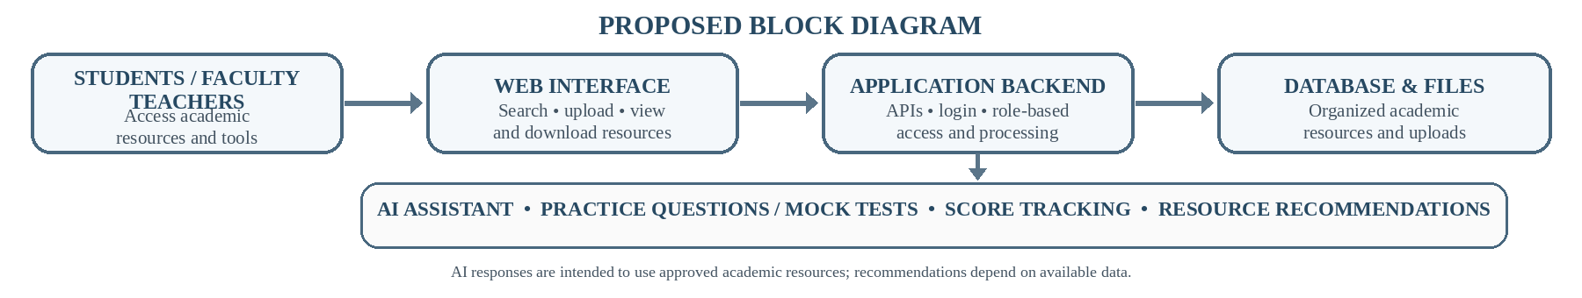
Fig. Proposed Block diagram
Proposed Methodology
• Analyze student and faculty needs and select initial subjects and resources.
• Design the interface, database, user roles, and system architecture.
• Implement secure login and role-based access.
• Build resource upload, search, viewing, and download features.
• Integrate an AI service grounded in approved syllabus and verified materials.
• Add practice tests, score tracking, topic-wise analysis, and recommendations.
• Build teacher tools for resources, assignments, and announcements.
• Test functionality, usability, access control, and AI responses; deploy a prototype and collect feedback.
Hardware Requirement:
• Minimum: computer/laptop with a dual- or quad-core processor, 8 GB RAM, approximately 10 GB of free storage, and reliable internet access.
• Recommended: Intel Core i5 or equivalent AMD processor, 16 GB RAM, SSD storage with at least 20 GB free, and a current web browser.
• A smartphone or second computer is useful for responsive testing.
• A dedicated GPU is not required when using a cloud-based AI API.
Software Requirement:
• Frontend: HTML5, CSS3, JavaScript, and React.js.
• Backend/API: Python and Django REST Framework.
• Database and file storage: MySQL or PostgreSQL with suitable academic-resource storage.
• AI: a suitable large-language-model API with document retrieval or retrieval-augmented generation (RAG).
• Development tools: Visual Studio Code, Git, GitHub, and Postman.
• Deployment: an appropriate web-hosting or cloud platform.

Expected Outcome:
• A working prototype for centralized academic resources.
• Subject-wise access to notes, question papers, laboratory programs, assignments, and announcements.
• An AI academic assistant grounded in approved materials, subject to available AI services.
• Practice tests with score recording and initial topic-wise performance insights.
• Recommendations for relevant resources and a teacher dashboard for academic uploads.
Project Guide Project Coordinator HOD

