Marvel & DC Analysis

Susan Lin

5/1/2022

read.csv("db.csv")

## X Original.Title Company Rate Metascore Minutes  
## 1 1 Iron Man Marvel 7.9 79 126  
## 2 2 The Incredible Hulk Marvel 6.7 61 112  
## 3 3 Iron Man 2 Marvel 7.0 57 124  
## 4 4 Thor Marvel 7.0 57 115  
## 5 5 Captain America: The First Avenger Marvel 6.9 66 124  
## 6 6 The Avengers Marvel 8.0 69 143  
## 7 7 Iron Man Three Marvel 7.2 62 130  
## 8 8 Thor: The Dark World Marvel 6.9 54 112  
## 9 9 Captain America: The Winter Soldier Marvel 7.7 70 136  
## 10 10 Guardians of the Galaxy Marvel 8.0 76 121  
## 11 11 Avengers: Age of Ultron  Marvel 7.3 66 141  
## 12 12 Ant-Man Marvel 7.3 64 117  
## 13 13 Captain America: Civil War Marvel 7.8 75 147  
## 14 14 Doctor Strange Marvel 7.5 72 115  
## 15 15 Guardians of the Galaxy Vol. 2 Marvel 7.6 67 136  
## 16 16 Spider-Man: Homecoming Marvel 7.4 73 133  
## 17 17 Thor:Ragnarok Marvel 7.9 74 130  
## 18 18 Black Panther Marvel 7.3 88 134  
## 19 19 Avengers: Infinity War Marvel 8.5 68 149  
## 20 20 Ant-Man and the Wasp Marvel 7.1 70 118  
## 21 21 Captain Marve Marvel 6.9 64 123  
## 22 22 Avengers: Endgame Marvel 8.5 78 181  
## 23 23 Spider-Man: Far from Home Marvel 7.6 69 129  
## 24 24 Catwoman DC 3.3 27 104  
## 25 25 Batman Begins DC 8.2 70 140  
## 26 26 Superman Returns DC 6.0 72 154  
## 27 27 The Dark Knight DC 9.0 84 152  
## 28 28 Watchmen DC 7.6 56 162  
## 29 29 Jonah Hex  DC 4.7 33 81  
## 30 30 Green Lantern DC 5.5 39 114  
## 31 31 The Dark Knight Rises DC 8.4 78 164  
## 32 32 Man of Steel DC 7.1 55 143  
## 33 33 Batman v Superman: Dawn of Justice DC 6.5 44 151  
## 34 34 Suicide Squad  DC 6.0 40 123  
## 35 35 Wonder Woman DC 7.4 76 141  
## 36 36 Justice League DC 6.4 45 120  
## 37 37 Aquaman DC 7.0 55 143  
## 38 38 Shazam! DC 7.1 71 132  
## 39 39 Joker DC 8.7 59 122  
## Release Budget Opening.Weekend.USA Gross.USA Gross.Worldwide  
## 1 2008 1.40e+08 98618668 318604126 585366247  
## 2 2008 1.50e+08 55414050 134806913 263427551  
## 3 2010 2.00e+08 128122480 312433331 623933331  
## 4 2011 1.50e+08 65723338 181030624 449326618  
## 5 2011 1.40e+08 65058524 176654505 370569774  
## 6 2012 2.20e+08 207438708 623357910 1518812988  
## 7 2013 2.00e+08 174144585 409013994 1214811252  
## 8 2013 1.70e+08 85737841 206362140 644783140  
## 9 2014 1.70e+08 95023721 259766572 714421503  
## 10 2014 1.70e+08 94320883 333176600 772776600  
## 11 2015 2.50e+08 191271109 459005868 1402805868  
## 12 2015 1.30e+08 57225526 180202163 519311965  
## 13 2016 2.50e+08 179139142 408084349 1153296293  
## 14 2016 1.65e+08 85058311 232641920 677718395  
## 15 2017 2.00e+08 146510104 389813101 863756051  
## 16 2017 1.75e+08 117027503 334201140 880166924  
## 17 2017 1.80e+08 122744989 315058289 853977126  
## 18 2018 2.00e+08 202003951 700059566 1346913161  
## 19 2018 3.21e+08 257698183 678815482 2048359754  
## 20 2018 1.62e+08 75812205 216648740 622674139  
## 21 2019 1.75e+08 153433423 426829839 1128274794  
## 22 2019 3.56e+08 357115007 858373000 2797800564  
## 23 2019 1.60e+08 92579212 390532085 1131927996  
## 24 2004 1.00e+08 16728411 40202379 82102379  
## 25 2005 1.50e+08 48745440 206852432 373413297  
## 26 2006 2.70e+08 52535096 200081192 391081192  
## 27 2008 1.85e+08 158411483 535234033 1004934033  
## 28 2009 1.30e+08 55214334 107509799 185258983  
## 29 2010 4.70e+07 5379365 10547117 10903312  
## 30 2011 2.00e+08 53174303 116601172 219851172  
## 31 2012 2.50e+08 160887295 448139099 1081041287  
## 32 2013 2.25e+08 116619362 291045518 668045518  
## 33 2016 2.50e+08 166007347 330360194 873634919  
## 34 2016 1.75e+08 133682248 325100054 746846894  
## 35 2017 1.49e+08 103251471 412563408 821847012  
## 36 2017 3.00e+08 93842239 229024295 657924295  
## 37 2018 1.60e+08 67873522 335061807 1148161807  
## 38 2019 1.00e+08 53505326 140371656 364571656  
## 39 2019 5.50e+07 96202337 333204580 1060504580

db <- read.csv("db.csv")  
names(db)

## [1] "X" "Original.Title" "Company"   
## [4] "Rate" "Metascore" "Minutes"   
## [7] "Release" "Budget" "Opening.Weekend.USA"  
## [10] "Gross.USA" "Gross.Worldwide"

keepcols <- c("Original.Title", "Company", "Rate", "Budget", "Opening.Weekend.USA","Gross.USA", "Gross.Worldwide")  
db <- db[, keepcols]  
names(db)

## [1] "Original.Title" "Company" "Rate"   
## [4] "Budget" "Opening.Weekend.USA" "Gross.USA"   
## [7] "Gross.Worldwide"

db.sorted <- db[order(db$Rate,decreasing=TRUE),]  
head(db.sorted, 10)

## Original.Title Company Rate Budget Opening.Weekend.USA Gross.USA  
## 27 The Dark Knight DC 9.0 1.85e+08 158411483 535234033  
## 39 Joker DC 8.7 5.50e+07 96202337 333204580  
## 19 Avengers: Infinity War Marvel 8.5 3.21e+08 257698183 678815482  
## 22 Avengers: Endgame Marvel 8.5 3.56e+08 357115007 858373000  
## 31 The Dark Knight Rises DC 8.4 2.50e+08 160887295 448139099  
## 25 Batman Begins DC 8.2 1.50e+08 48745440 206852432  
## 6 The Avengers Marvel 8.0 2.20e+08 207438708 623357910  
## 10 Guardians of the Galaxy Marvel 8.0 1.70e+08 94320883 333176600  
## 1 Iron Man Marvel 7.9 1.40e+08 98618668 318604126  
## 17 Thor:Ragnarok Marvel 7.9 1.80e+08 122744989 315058289  
## Gross.Worldwide  
## 27 1004934033  
## 39 1060504580  
## 19 2048359754  
## 22 2797800564  
## 31 1081041287  
## 25 373413297  
## 6 1518812988  
## 10 772776600  
## 1 585366247  
## 17 853977126

db.sorted <- db[order(db$Gross.Worldwide,decreasing=TRUE),]  
head(db.sorted, 10)

## Original.Title Company Rate Budget Opening.Weekend.USA  
## 22 Avengers: Endgame Marvel 8.5 3.56e+08 357115007  
## 19 Avengers: Infinity War Marvel 8.5 3.21e+08 257698183  
## 6 The Avengers Marvel 8.0 2.20e+08 207438708  
## 11 Avengers: Age of Ultron  Marvel 7.3 2.50e+08 191271109  
## 18 Black Panther Marvel 7.3 2.00e+08 202003951  
## 7 Iron Man Three Marvel 7.2 2.00e+08 174144585  
## 13 Captain America: Civil War Marvel 7.8 2.50e+08 179139142  
## 37 Aquaman DC 7.0 1.60e+08 67873522  
## 23 Spider-Man: Far from Home Marvel 7.6 1.60e+08 92579212  
## 21 Captain Marve Marvel 6.9 1.75e+08 153433423  
## Gross.USA Gross.Worldwide  
## 22 858373000 2797800564  
## 19 678815482 2048359754  
## 6 623357910 1518812988  
## 11 459005868 1402805868  
## 18 700059566 1346913161  
## 7 409013994 1214811252  
## 13 408084349 1153296293  
## 37 335061807 1148161807  
## 23 390532085 1131927996  
## 21 426829839 1128274794

db.sorted <- db[order(db$Opening.Weekend.USA,decreasing=TRUE),]  
head(db.sorted, 10)

## Original.Title Company Rate Budget Opening.Weekend.USA  
## 22 Avengers: Endgame Marvel 8.5 3.56e+08 357115007  
## 19 Avengers: Infinity War Marvel 8.5 3.21e+08 257698183  
## 6 The Avengers Marvel 8.0 2.20e+08 207438708  
## 18 Black Panther Marvel 7.3 2.00e+08 202003951  
## 11 Avengers: Age of Ultron  Marvel 7.3 2.50e+08 191271109  
## 13 Captain America: Civil War Marvel 7.8 2.50e+08 179139142  
## 7 Iron Man Three Marvel 7.2 2.00e+08 174144585  
## 33 Batman v Superman: Dawn of Justice DC 6.5 2.50e+08 166007347  
## 31 The Dark Knight Rises DC 8.4 2.50e+08 160887295  
## 27 The Dark Knight DC 9.0 1.85e+08 158411483  
## Gross.USA Gross.Worldwide  
## 22 858373000 2797800564  
## 19 678815482 2048359754  
## 6 623357910 1518812988  
## 18 700059566 1346913161  
## 11 459005868 1402805868  
## 13 408084349 1153296293  
## 7 409013994 1214811252  
## 33 330360194 873634919  
## 31 448139099 1081041287  
## 27 535234033 1004934033

db.sorted <- db[order(db$Gross.USA,decreasing=TRUE),]  
head(db.sorted, 10)

## Original.Title Company Rate Budget Opening.Weekend.USA Gross.USA  
## 22 Avengers: Endgame Marvel 8.5 3.56e+08 357115007 858373000  
## 18 Black Panther Marvel 7.3 2.00e+08 202003951 700059566  
## 19 Avengers: Infinity War Marvel 8.5 3.21e+08 257698183 678815482  
## 6 The Avengers Marvel 8.0 2.20e+08 207438708 623357910  
## 27 The Dark Knight DC 9.0 1.85e+08 158411483 535234033  
## 11 Avengers: Age of Ultron  Marvel 7.3 2.50e+08 191271109 459005868  
## 31 The Dark Knight Rises DC 8.4 2.50e+08 160887295 448139099  
## 21 Captain Marve Marvel 6.9 1.75e+08 153433423 426829839  
## 35 Wonder Woman DC 7.4 1.49e+08 103251471 412563408  
## 7 Iron Man Three Marvel 7.2 2.00e+08 174144585 409013994  
## Gross.Worldwide  
## 22 2797800564  
## 18 1346913161  
## 19 2048359754  
## 6 1518812988  
## 27 1004934033  
## 11 1402805868  
## 31 1081041287  
## 21 1128274794  
## 35 821847012  
## 7 1214811252

db.sorted <- db[order(db$Budget,decreasing=TRUE),]  
head(db.sorted, 10)

## Original.Title Company Rate Budget Opening.Weekend.USA  
## 22 Avengers: Endgame Marvel 8.5 3.56e+08 357115007  
## 19 Avengers: Infinity War Marvel 8.5 3.21e+08 257698183  
## 36 Justice League DC 6.4 3.00e+08 93842239  
## 26 Superman Returns DC 6.0 2.70e+08 52535096  
## 11 Avengers: Age of Ultron  Marvel 7.3 2.50e+08 191271109  
## 13 Captain America: Civil War Marvel 7.8 2.50e+08 179139142  
## 31 The Dark Knight Rises DC 8.4 2.50e+08 160887295  
## 33 Batman v Superman: Dawn of Justice DC 6.5 2.50e+08 166007347  
## 32 Man of Steel DC 7.1 2.25e+08 116619362  
## 6 The Avengers Marvel 8.0 2.20e+08 207438708  
## Gross.USA Gross.Worldwide  
## 22 858373000 2797800564  
## 19 678815482 2048359754  
## 36 229024295 657924295  
## 26 200081192 391081192  
## 11 459005868 1402805868  
## 13 408084349 1153296293  
## 31 448139099 1081041287  
## 33 330360194 873634919  
## 32 291045518 668045518  
## 6 623357910 1518812988

head(db, 23)

## Original.Title Company Rate Budget  
## 1 Iron Man Marvel 7.9 1.40e+08  
## 2 The Incredible Hulk Marvel 6.7 1.50e+08  
## 3 Iron Man 2 Marvel 7.0 2.00e+08  
## 4 Thor Marvel 7.0 1.50e+08  
## 5 Captain America: The First Avenger Marvel 6.9 1.40e+08  
## 6 The Avengers Marvel 8.0 2.20e+08  
## 7 Iron Man Three Marvel 7.2 2.00e+08  
## 8 Thor: The Dark World Marvel 6.9 1.70e+08  
## 9 Captain America: The Winter Soldier Marvel 7.7 1.70e+08  
## 10 Guardians of the Galaxy Marvel 8.0 1.70e+08  
## 11 Avengers: Age of Ultron  Marvel 7.3 2.50e+08  
## 12 Ant-Man Marvel 7.3 1.30e+08  
## 13 Captain America: Civil War Marvel 7.8 2.50e+08  
## 14 Doctor Strange Marvel 7.5 1.65e+08  
## 15 Guardians of the Galaxy Vol. 2 Marvel 7.6 2.00e+08  
## 16 Spider-Man: Homecoming Marvel 7.4 1.75e+08  
## 17 Thor:Ragnarok Marvel 7.9 1.80e+08  
## 18 Black Panther Marvel 7.3 2.00e+08  
## 19 Avengers: Infinity War Marvel 8.5 3.21e+08  
## 20 Ant-Man and the Wasp Marvel 7.1 1.62e+08  
## 21 Captain Marve Marvel 6.9 1.75e+08  
## 22 Avengers: Endgame Marvel 8.5 3.56e+08  
## 23 Spider-Man: Far from Home Marvel 7.6 1.60e+08  
## Opening.Weekend.USA Gross.USA Gross.Worldwide  
## 1 98618668 318604126 585366247  
## 2 55414050 134806913 263427551  
## 3 128122480 312433331 623933331  
## 4 65723338 181030624 449326618  
## 5 65058524 176654505 370569774  
## 6 207438708 623357910 1518812988  
## 7 174144585 409013994 1214811252  
## 8 85737841 206362140 644783140  
## 9 95023721 259766572 714421503  
## 10 94320883 333176600 772776600  
## 11 191271109 459005868 1402805868  
## 12 57225526 180202163 519311965  
## 13 179139142 408084349 1153296293  
## 14 85058311 232641920 677718395  
## 15 146510104 389813101 863756051  
## 16 117027503 334201140 880166924  
## 17 122744989 315058289 853977126  
## 18 202003951 700059566 1346913161  
## 19 257698183 678815482 2048359754  
## 20 75812205 216648740 622674139  
## 21 153433423 426829839 1128274794  
## 22 357115007 858373000 2797800564  
## 23 92579212 390532085 1131927996

Marvel <- head(db, 23)  
  
tail(db, 16)

## Original.Title Company Rate Budget Opening.Weekend.USA  
## 24 Catwoman DC 3.3 1.00e+08 16728411  
## 25 Batman Begins DC 8.2 1.50e+08 48745440  
## 26 Superman Returns DC 6.0 2.70e+08 52535096  
## 27 The Dark Knight DC 9.0 1.85e+08 158411483  
## 28 Watchmen DC 7.6 1.30e+08 55214334  
## 29 Jonah Hex  DC 4.7 4.70e+07 5379365  
## 30 Green Lantern DC 5.5 2.00e+08 53174303  
## 31 The Dark Knight Rises DC 8.4 2.50e+08 160887295  
## 32 Man of Steel DC 7.1 2.25e+08 116619362  
## 33 Batman v Superman: Dawn of Justice DC 6.5 2.50e+08 166007347  
## 34 Suicide Squad  DC 6.0 1.75e+08 133682248  
## 35 Wonder Woman DC 7.4 1.49e+08 103251471  
## 36 Justice League DC 6.4 3.00e+08 93842239  
## 37 Aquaman DC 7.0 1.60e+08 67873522  
## 38 Shazam! DC 7.1 1.00e+08 53505326  
## 39 Joker DC 8.7 5.50e+07 96202337  
## Gross.USA Gross.Worldwide  
## 24 40202379 82102379  
## 25 206852432 373413297  
## 26 200081192 391081192  
## 27 535234033 1004934033  
## 28 107509799 185258983  
## 29 10547117 10903312  
## 30 116601172 219851172  
## 31 448139099 1081041287  
## 32 291045518 668045518  
## 33 330360194 873634919  
## 34 325100054 746846894  
## 35 412563408 821847012  
## 36 229024295 657924295  
## 37 335061807 1148161807  
## 38 140371656 364571656  
## 39 333204580 1060504580

DC <- tail(db, 16)  
  
summary(db)

## Original.Title Company Rate Budget   
## Length:39 Length:39 Min. :3.300 Min. : 47000000   
## Class :character Class :character 1st Qu.:6.900 1st Qu.:150000000   
## Mode :character Mode :character Median :7.300 Median :175000000   
## Mean :7.203 Mean :184102564   
## 3rd Qu.:7.850 3rd Qu.:210000000   
## Max. :9.000 Max. :356000000   
## Opening.Weekend.USA Gross.USA Gross.Worldwide   
## Min. : 5379365 Min. : 10547117 Min. :1.090e+07   
## 1st Qu.: 65390931 1st Qu.:203221666 1st Qu.:4.843e+08   
## Median : 96202337 Median :318604126 Median :7.468e+08   
## Mean :115109770 Mean :323265923 Mean :8.276e+08   
## 3rd Qu.:155922453 3rd Qu.:408549172 3rd Qu.:1.105e+09   
## Max. :357115007 Max. :858373000 Max. :2.798e+09

summary(Marvel)

## Original.Title Company Rate Budget   
## Length:23 Length:23 Min. :6.700 Min. :130000000   
## Class :character Class :character 1st Qu.:7.050 1st Qu.:161000000   
## Mode :character Mode :character Median :7.400 Median :175000000   
## Mean :7.478 Mean :192782609   
## 3rd Qu.:7.850 3rd Qu.:200000000   
## Max. :8.500 Max. :356000000   
## Opening.Weekend.USA Gross.USA Gross.Worldwide   
## Min. : 55414050 Min. :134806913 Min. :2.634e+08   
## 1st Qu.: 85398076 1st Qu.:224645330 1st Qu.:6.233e+08   
## Median :117027503 Median :333176600 Median :8.540e+08   
## Mean :135096585 Mean :371542272 Mean :9.820e+08   
## 3rd Qu.:176641864 3rd Qu.:417921916 3rd Qu.:1.184e+09   
## Max. :357115007 Max. :858373000 Max. :2.798e+09

summary(DC)

## Original.Title Company Rate Budget   
## Length:16 Length:16 Min. :3.300 Min. : 47000000   
## Class :character Class :character 1st Qu.:6.000 1st Qu.:122500000   
## Mode :character Mode :character Median :7.050 Median :167500000   
## Mean :6.806 Mean :171625000   
## 3rd Qu.:7.750 3rd Qu.:231250000   
## Max. :9.000 Max. :300000000   
## Opening.Weekend.USA Gross.USA Gross.Worldwide   
## Min. : 5379365 Min. : 10547117 Min. :1.090e+07   
## 1st Qu.: 53014501 1st Qu.:134429035 1st Qu.:3.284e+08   
## Median : 80857880 Median :260034906 Median :6.630e+08   
## Mean : 86378724 Mean :253868671 Mean :6.056e+08   
## 3rd Qu.:120885084 3rd Qu.:333668887 3rd Qu.:9.065e+08   
## Max. :166007347 Max. :535234033 Max. :1.148e+09

library(ggplot2)

## Warning: package 'ggplot2' was built under R version 4.1.3

ggplot(db, aes(x= Budget, y= Rate, color= Company, pch= Company)) +  
 geom_point(size=2) +  
 geom_smooth(method="lm", aes(fill=Company))

## `geom_smooth()` using formula 'y ~ x'

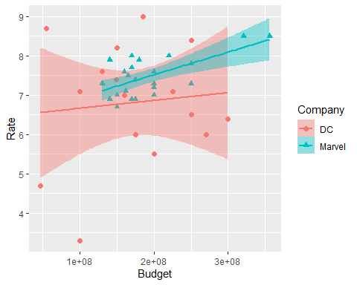

ggplot(db, aes(x= Budget, y= Gross.Worldwide, color= Company, pch= Company)) +  
 geom_point(size=2) +   
 geom_smooth(method="lm", aes(fill=Company))

## `geom_smooth()` using formula 'y ~ x'

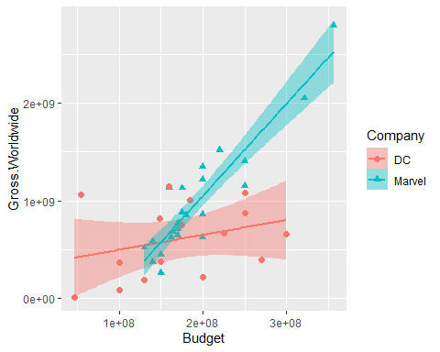

library(regclass)

## Loading required package: bestglm

## Loading required package: leaps

## Loading required package: VGAM

## Loading required package: stats4

## Loading required package: splines

## Loading required package: rpart

## Loading required package: randomForest

## randomForest 4.7-1

## Type rfNews() to see new features/changes/bug fixes.

##   
## Attaching package: 'randomForest'

## The following object is masked from 'package:ggplot2':  
##   
## margin

## Important regclass change from 1.3:  
## All functions that had a . in the name now have an _  
## all.correlations -> all_correlations, cor.demo -> cor_demo, etc.

associate(Rate~Budget, data= db)

## Association between Budget (numerical) and Rate (numerical)  
## using 39 complete cases

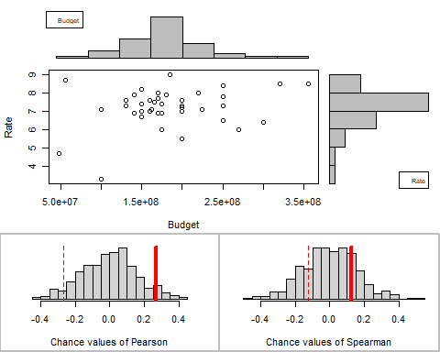

## Permutation procedure:  
## Value Estimated p-value  
## Pearson's r 0.2656554 0.098  
## Spearman's rank correlation 0.1238763 0.416  
## With 500 permutations, we are 95% confident that:  
## the p-value of Pearson's correlation (r) is between 0.073 and 0.127   
## the p-value of Spearman's rank correlation is between 0.372 and 0.461   
## Note: If 0.05 is in this range, increase the permutations= argument.  
##   
##   
##   
## Advice: If stream of points is well described by an ellipse, use Pearson's r.  
## Otherwise, as long as stream is monotonic, use Spearman's rank correlation  
## or try logs, e.g. associate( log10(y)~log10(x) )

associate(Gross.Worldwide~Budget, data= db)

## Association between Budget (numerical) and Gross.Worldwide (numerical)  
## using 39 complete cases

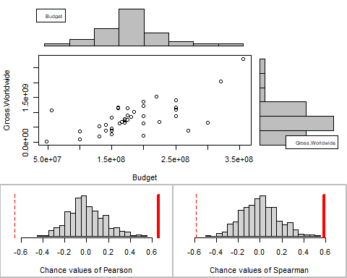

## Permutation procedure:  
## Value Estimated p-value  
## Pearson's r 0.6563322 0  
## Spearman's rank correlation 0.5858797 0  
## With 500 permutations, we are 95% confident that:  
## the p-value of Pearson's correlation (r) is between 0 and 0.007   
## the p-value of Spearman's rank correlation is between 0 and 0.007   
## Note: If 0.05 is in this range, increase the permutations= argument.  
##   
##   
##   
## Advice: If stream of points is well described by an ellipse, use Pearson's r.  
## Otherwise, as long as stream is monotonic, use Spearman's rank correlation  
## or try logs, e.g. associate( log10(y)~log10(x) )

associate(Opening.Weekend.USA~Budget, data= db)

## Association between Budget (numerical) and Opening.Weekend.USA (numerical)  
## using 39 complete cases

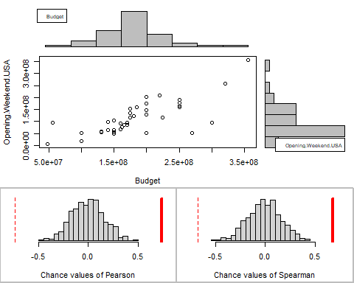

## Permutation procedure:  
## Value Estimated p-value  
## Pearson's r 0.7410089 0  
## Spearman's rank correlation 0.6850988 0  
## With 500 permutations, we are 95% confident that:  
## the p-value of Pearson's correlation (r) is between 0 and 0.007   
## the p-value of Spearman's rank correlation is between 0 and 0.007   
## Note: If 0.05 is in this range, increase the permutations= argument.  
##   
##   
##   
## Advice: If stream of points is well described by an ellipse, use Pearson's r.  
## Otherwise, as long as stream is monotonic, use Spearman's rank correlation  
## or try logs, e.g. associate( log10(y)~log10(x) )

associate(Gross.USA~Budget, data= db)

## Association between Budget (numerical) and Gross.USA (numerical)  
## using 39 complete cases

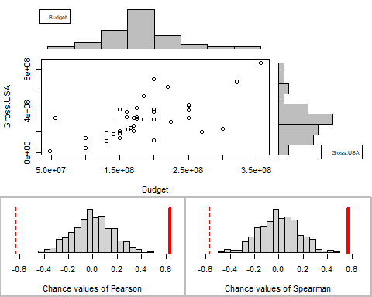

## Permutation procedure:  
## Value Estimated p-value  
## Pearson's r 0.6319721 0  
## Spearman's rank correlation 0.5697489 0  
## With 500 permutations, we are 95% confident that:  
## the p-value of Pearson's correlation (r) is between 0 and 0.007   
## the p-value of Spearman's rank correlation is between 0 and 0.007   
## Note: If 0.05 is in this range, increase the permutations= argument.  
##   
##   
##   
## Advice: If stream of points is well described by an ellipse, use Pearson's r.  
## Otherwise, as long as stream is monotonic, use Spearman's rank correlation  
## or try logs, e.g. associate( log10(y)~log10(x) )

lm(Rate~Budget, data= db)

##   
## Call:  
## lm(formula = Rate ~ Budget, data = db)  
##   
## Coefficients:  
## (Intercept) Budget   
## 6.387e+00 4.433e-09

M <- lm(Rate~Budget, data= db)  
possible_regressions(M)

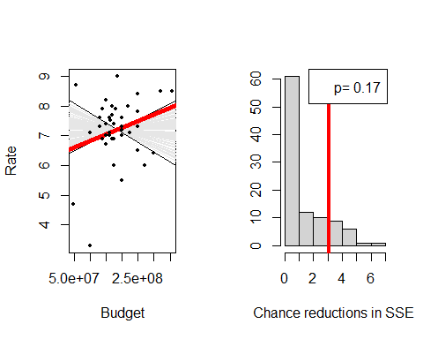

summary(M)

##   
## Call:  
## lm(formula = Rate ~ Budget, data = db)  
##   
## Residuals:  
## Min 1Q Median 3Q Max   
## -3.5298 -0.2676 0.2378 0.5986 2.0697   
##   
## Coefficients:  
## Estimate Std. Error t value Pr(>|t|)   
## (Intercept) 6.387e+00 5.151e-01 12.399 9.61e-15 ***  
## Budget 4.433e-09 2.644e-09 1.676 0.102   
## ---  
## Signif. codes: 0 '***' 0.001 '**' 0.01 '*' 0.05 '.' 0.1 ' ' 1  
##   
## Residual standard error: 1.05 on 37 degrees of freedom  
## Multiple R-squared: 0.07057, Adjusted R-squared: 0.04545   
## F-statistic: 2.809 on 1 and 37 DF, p-value: 0.1021

confint(M,level=0.95)

## 2.5 % 97.5 %  
## (Intercept) 5.342885e+00 7.430155e+00  
## Budget -9.256954e-10 9.790796e-09

lm(Gross.Worldwide~Budget, data= db)

##   
## Call:  
## lm(formula = Gross.Worldwide ~ Budget, data = db)  
##   
## Coefficients:  
## (Intercept) Budget   
## -1.728e+08 5.434e+00

B <- lm(Gross.Worldwide~Budget, data= db)  
possible_regressions(B)

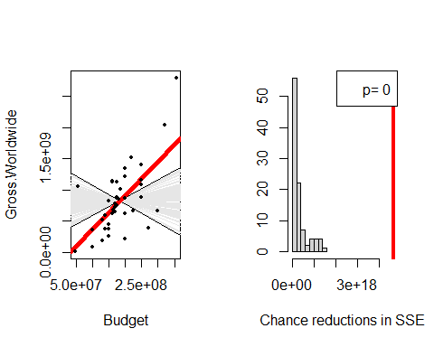

summary(B)

##   
## Call:  
## lm(formula = Gross.Worldwide ~ Budget, data = db)  
##   
## Residuals:  
## Min 1Q Median 3Q Max   
## -903221102 -243114673 -32334628 201090738 1036211362   
##   
## Coefficients:  
## Estimate Std. Error t value Pr(>|t|)   
## (Intercept) -1.728e+08 2.000e+08 -0.864 0.393   
## Budget 5.434e+00 1.027e+00 5.292 5.71e-06 ***  
## ---  
## Signif. codes: 0 '***' 0.001 '**' 0.01 '*' 0.05 '.' 0.1 ' ' 1  
##   
## Residual standard error: 407700000 on 37 degrees of freedom  
## Multiple R-squared: 0.4308, Adjusted R-squared: 0.4154   
## F-statistic: 28 on 1 and 37 DF, p-value: 5.713e-06

confint(B,level=0.95)

## 2.5 % 97.5 %  
## (Intercept) -5.779995e+08 2.324770e+08  
## Budget 3.352989e+00 7.514148e+00

lm(Opening.Weekend.USA~Budget, data= db)

##   
## Call:  
## lm(formula = Opening.Weekend.USA ~ Budget, data = db)  
##   
## Coefficients:  
## (Intercept) Budget   
## -3.033e+07 7.900e-01

C <- lm(Opening.Weekend.USA~Budget, data= db)  
possible_regressions(C)

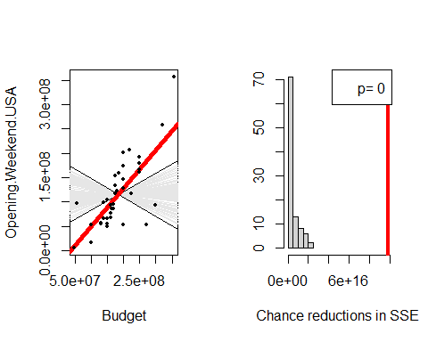

summary(C)

##   
## Call:  
## lm(formula = Opening.Weekend.USA ~ Budget, data = db)  
##   
## Residuals:  
## Min 1Q Median 3Q Max   
## -130432125 -20034043 -1421811 21472587 106209311   
##   
## Coefficients:  
## Estimate Std. Error t value Pr(>|t|)   
## (Intercept) -3.033e+07 2.292e+07 -1.323 0.194   
## Budget 7.900e-01 1.177e-01 6.712 6.87e-08 ***  
## ---  
## Signif. codes: 0 '***' 0.001 '**' 0.01 '*' 0.05 '.' 0.1 ' ' 1  
##   
## Residual standard error: 46730000 on 37 degrees of freedom  
## Multiple R-squared: 0.5491, Adjusted R-squared: 0.5369   
## F-statistic: 45.06 on 1 and 37 DF, p-value: 6.87e-08

confint(C,level=0.95)

## 2.5 % 97.5 %  
## (Intercept) -7.677340e+07 1.611742e+07  
## Budget 5.515216e-01 1.028443e+00

lm(Gross.USA~Budget, data= db)

##   
## Call:  
## lm(formula = Gross.USA ~ Budget, data = db)  
##   
## Coefficients:  
## (Intercept) Budget   
## -3.158e+06 1.773e+00

D <- lm(Gross.USA~Budget, data= db)  
possible_regressions(D)

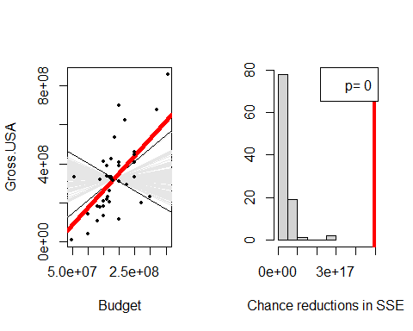

summary(D)

##   
## Call:  
## lm(formula = Gross.USA ~ Budget, data = db)  
##   
## Residuals:  
## Min 1Q Median 3Q Max   
## -299734064 -75699066 -32021300 65547748 348606628   
##   
## Coefficients:  
## Estimate Std. Error t value Pr(>|t|)   
## (Intercept) -3.158e+06 6.962e+07 -0.045 0.964   
## Budget 1.773e+00 3.575e-01 4.960 1.59e-05 ***  
## ---  
## Signif. codes: 0 '***' 0.001 '**' 0.01 '*' 0.05 '.' 0.1 ' ' 1  
##   
## Residual standard error: 141900000 on 37 degrees of freedom  
## Multiple R-squared: 0.3994, Adjusted R-squared: 0.3832   
## F-statistic: 24.6 on 1 and 37 DF, p-value: 1.595e-05

confint(D,level=0.95)

## 2.5 % 97.5 %  
## (Intercept) -1.442253e+08 1.379095e+08  
## Budget 1.048784e+00 2.497325e+00

all_correlations(db, interest= "Budget", sorted= "magnitude")

## var1 var2 correlation pval  
## 1 Budget Opening.Weekend.USA 0.7410089 6.869768e-08  
## 2 Budget Gross.Worldwide 0.6563322 5.713323e-06  
## 3 Budget Gross.USA 0.6319721 1.594958e-05  
## 4 Rate Budget 0.2656554 1.021411e-01