Lab Report 2 Date:2081/04/32

Title: Family Tree Problem in Prolog.

1. Objective: The objective of the lab is to model a family tree using Prolog, define relationships such as parent-child, siblings, and ancestors, and demonstrate the process of querying this family tree to retrieve specific information.
2. Theory:

The family tree problem is a classic example of representing relationships between individual using logic programming languages, particularly prolog. Prolog is well-suited for tasks involving logical inference and relations, making it an excellent choice for solving problems related to family trees.The problem typically involves determining various family relationships such as parent-child, grandparent-grandchild, siblings, and other familal ties.

2.1 Key concepts:

**Facts**: A fact is a basic assertion about some knowledge. It is written as a predicate with a list of parameters. The predicate represents a relation, and the parameters represent the objects involved. Example: parent(john, mary). Meaning that John is the parent of Mary.

**Rules**: A rule is a logical implication that defines relationship between facts. It follows the structure **Head :- Body,** where the head is what we want to prove, and the body consists that must hold true for the head to be true. Example: grandparent(X, Y) :- parent(X, Z), parent(Z, Y). States that

X is a grandparent of Y if X is a parent of Z and Z is a parent of Y.

**Queries**: A query is used to ask Prolog questions about the facts and rules. It is written as a goal to be satisfied, and Prolog tries to find the solutions based on the provided facts and rules. Example: ?- parent(john, mary). asks whether John is the parent of Mary.

**Variables:** In prolog, variables are used to represent unknown or unspecified values in logical expressions. They are placeholders that can stand for any term, and they are essential for pattern matching, querying, and reasoning within the language.Example: X in parent (X, mary) is a variable.

1. Code Implementation:

Defining the family tree:

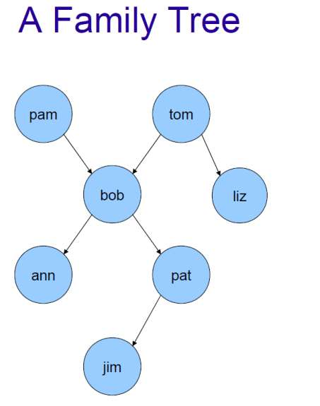

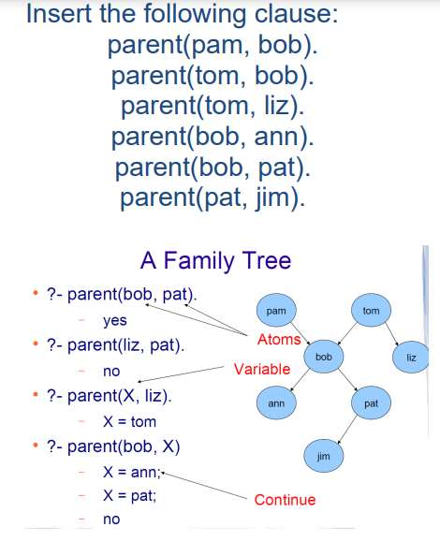

1. Conclusion:

This lab report explored the family tree problem in Prolog, focusing on modeling familial relationships like parent-child, siblings, grandparents, and ancestors. By using Prolog’s logical rules and facts, we can efficiently query and infer various family relationships. Prolog's strengths lie in its declarative syntax and ability to handle complex, recursive relationships, making it a valuable tool for solving problems of this nature..