**Chapter One: Introduction**

* 1. **Introduction**

This project is based on developing an Library management system designed to automate the processes of managing a library. The system tracks books, members, loans, and returns, providing better service to library patrons and enhancing the efficiency of library staff.This project aims to develop a Library Management System that automates the operations of a library, allowing staff to track books, manage member records, and oversee book loans.

In this project users can search for,borrow, and reserve materials, while librarians can monitor inventory, handle fines, and generate reports. The system automatically updates the status of books, tracks due dates, and sends notifications for overdue items.

In this project there are two panel that are admin and user panel. When the user login to the system the admin overviews system activity, including statistics on books, users and overdue items. This system will be very helpful for the librarians manage inventory, plan acquisitions, and optimize library resources.

* 1. **Objectives of the Study**

The objective of the study is to develop a streamlined and automated system that enhance the efficiency of library operations.

* 1. **Methodology:**

The methodology outlines the approach taken to develop, implement, and evaluate the system. This section is critical in demonstrating how the project was executed and the steps followed to achieve its objective.

**Chapter Two: Tasks and Activities performed**

2.1 Requirement Analysis

The first step in the methodology is to gather all necessary information to understand the requirement of the library system. This phase involves **Interviews** with library staff and administrators to identify their needs,**Surveys** or questionnaire for users(Students, members) to understand their requirements, **Research** on existing library management system to identify common features.

The requirements can be functional and non-functional. Functional requirements are the services that system is supposed to provide whereas the non-functional requirements are the additional functionality of the system such as usability, performance, security and scalability, etc.

1. **Functional Requirement**

Some of the functional requirements of the library Management system are:

* User should be able to register themselves by providing necessary details.
* User must be log into the access system using their unique credentials(username and passwords).
* Different user roles such as student, member, and librarian have varying level of access.
* The system should record the date of book check-out, check in, status, renewal, calculate the due date and fines and notify the user once the book becomes available.
* The system should have a separate admin panel to manage overall library operation such as manage memberships, including activating or deactivating user accounts, adding or removing services, issuing or revoking library cards, and tracking user fines and fees.

**Use Case Diagram**

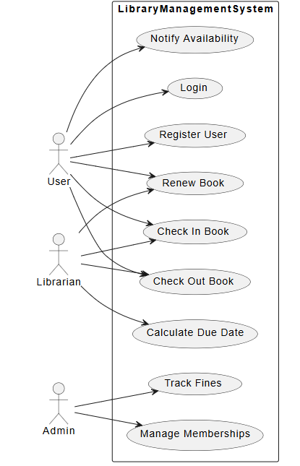

1. **Non functional requirement**

Non-functional requirement (NFR) is requirement that defines systems quality attributes, such as performance, security, usability, and reliability. Below is a detailed explanation of some common non-functional requirements of the Library management system:

* Security: The system ensures login mechanisms for users and admins using multi-factor authentication. All sensitive data (such as credentials, borrowing history, and personal history should be encrypted both in transit and at rest using industry-standard encryption protocols.
* Usability: The system have an intuitive and user-friendly interface, so that library users with no technical background can easily search for books, check availability, and borrow books. Clear documentation and online help shall be available for both end-users and admin.
* Availability :The system availability depends on the operational time of the organization itself. Other than from the operational time of the organization the service is unavailable.
* Compliance:The system complies with relevant standards and regulations (example: Local library regulations, copyright laws, data privacy laws).

2.2 Feasibility study

It is essential to determine whether developing and implementing library management is practical and beneficial. This study evaluates various aspects, including technical, economic, operational, and legal factors. Here is a detailed breakdown of a feasibility study for Library management system:

1. Technical Feasibility

It focuses on evaluating whether the technology required for the system is available and compatible with existing infrastructure. The technology that can be used for this project are:

* HTML, CSS and Javascript for frontend.
* PHP, python and Java for backend.
* MySQL or cloud databases for databases.
* Local area Network or cloud-based systems for scalability.

1. Economic feasibility

Economic feasibility involves determining the financial resources required for the Library management system and whether the project will be cost effective.

* Initial Costs: Cost of hiring developers or licensing an existing LMS solution, Hardware costs, Training library staff.
* Ongoing Costs: Maintenance, Data Backup, Licensing Fees.
* Expected Benefits: Reduced time spent by staff in performing routine tasks,improved user satisfaction leading to increased library patronage.

1. Legal Feasibility

It focuses on compliance with regulations and laws regarding data privacy, intellectual property, and copyright issues.

* Data privacy: LMS complies with data protection laws like(GDPR) for user data and implements secure authentication and data encryption methods.
* Licensing: If the LMS uses third-party software or APIs, check that all license are complaint with usage rights and copyright laws.
* Copyright Complaiance: The systems respects copyright laws, especially when dealing with digital content such as e-books or digital articles.

1. Operational Feasibility

This assessment involves undertaking a study to analyze and determine whether and how well the organizations need can be met by completing the project. Operational feasibility studies how a project plan satisfies the requirements identified in the requirements analysis phase of system development.

1. Schedule Feasibility

This evaluates timeline for the development, implementation, and deployment of the Library Management system.This phases can be easily described by the following table and gantt chart:

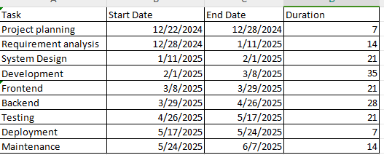

**Gantt Chart on the basis of the above schedule:**

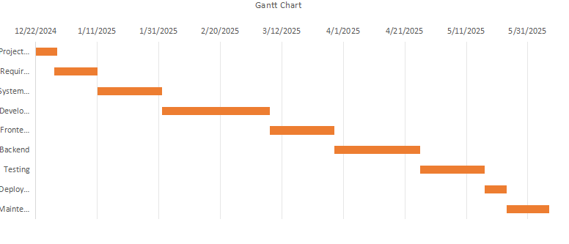

**2.3 Solution Design**

System Designing is the process of defining elements of a system like modules, architecture, components and their interfaces and data for a system based on the specified requirements. It is the process of defining and developing and designing the systems which satisfies the needs and requirements of a business or organization.

**2.3.1 DFD level 0 diagram**

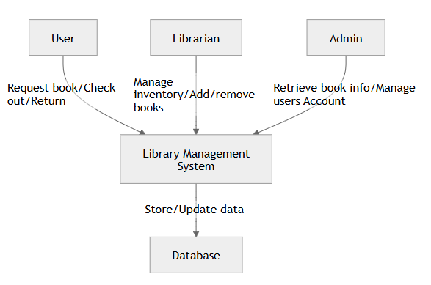

**2.3.2 DFD level 1 Diagram**

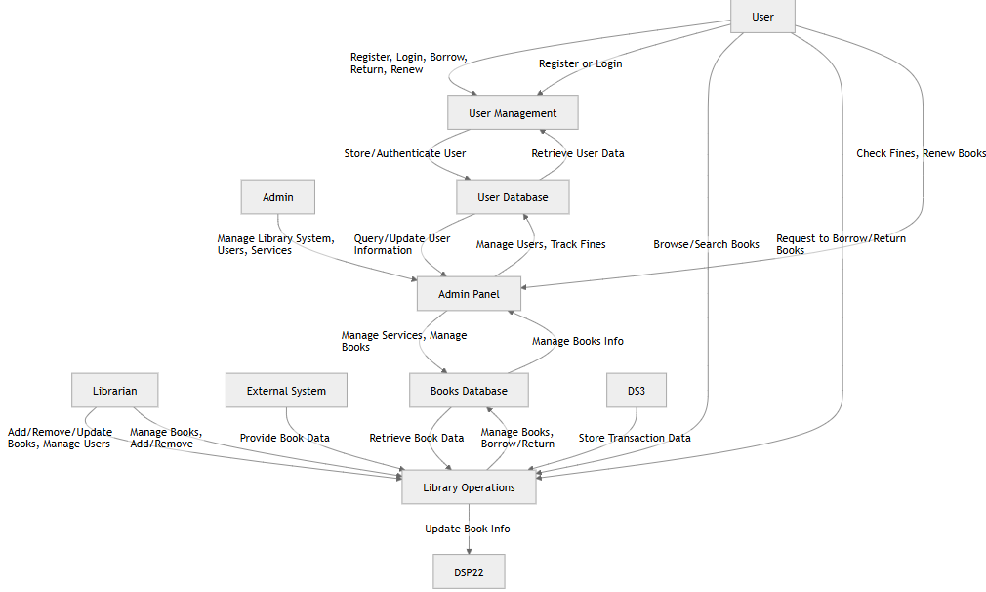

**2.3.2 Class Diagram**

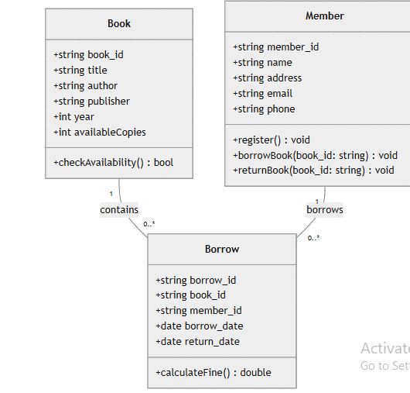

**2.3.3 ER-diagram**

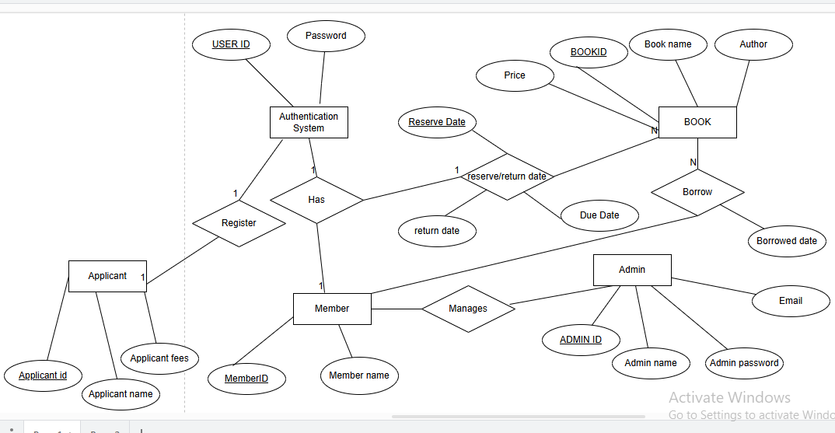

**2.4 System Development**

In this stage executable software is developed using different web development tools. The different tools are listed below:

2.4.1 Tools Used

The tools used for the development of the system are listed below:

1. Front end tools

Front end tools refer to those tools which are used to develop front end or interface of a system. Some of the tools used for library management system are:

* HTML: HTML(Hyper text markup language) is the standard language used to create and design web pages. It provides the structure for web content and is the foundational technology for building websites.
* CSS: CSS(Cascading Style Sheet) is a stylesheet language used to describe the presentation or look and feel of a document written in HTML. While HTML provides the structure of a web page, CSS controls how the structure appears .
* JavaScript: JavaScript is a high-level, interpreted programming language that is primarily used to create dynamic and interactive effects within web browsers. It is a core technology of the World Web Wide, alongside HTML and CSS.
* Bootstrap:Bootstrap is an open-source front-end framework that helps developers design and develop responsive, mobile-first web pages quickly and easily. Originally created by Twitter engineers Mark Otto and Jacob Thornton in 2011, Bootstrap has since become one of the most widely used frameworks for web development. It provides a collection of pre-designed components, layout styles, and utilities that streamline the process of building user interfaces.

1. Back End Tool:

Back end tools refer to a tool to design a back-end or database of any particular system. Some back-end tools used for the library management system:

* Python: Python is a high-level, interpreted programming language known for its simplicity and readability. It was created by Guido van Rossum and released in 1991. Python supports multiple programming paradigms, including procedural, object-oriented, and functional programming.
* Django: Django is a high-level, open-source web framework for building web applications in python.It is widely used in web development for creating everything from simple websites to complex, data-driven applications. Its features are Automatic Admin interface, Security, Scalability, URL Routing.

1. Database:

* MySQL: MySQL is an open-source relational database management system (RDBMS) that uses Structured Query Language (SQL) for managing and manipulating databases. Originally developed by MySQL AB, it is now owned by Oracle Corporation. MySQL is widely used for web applications, data warehousing, and online transaction processing.
* MongoDB: A NoSQL database that can be used if the application requires high flexibility and scalability, particularly with unstructured data.

1. IDE(Integrated Development Environment)

* Visual Studio Code: A popular code editor with extensions for Python, JavaScript, HTML, CSS, and more.
* PyCharm: A dedicated IDE for Python development, ideal for Django and Flask projects.

1. Version Control:

* Git: A version control system to track changes in the codebase and manage collaborative development.
* GitHub/GitLab/Bitbucket: Platforms to host the code repository, collaborate with team members, and deploy code.

2.4.2 Modules Descreption

The different modules that are used in the library management are:

* User Management Module: This module handles the registration, authentication, and management of users (both staff and members).Key Features: User registration and login, Profile management (name, contact information, membership details), Role-based access control (librarians, members, administrators), Password reset and user status management (active/inactive).
* Admin Module: Allows administrators to manage system settings and user roles.Manage user roles (admin, librarian, member), Configure library settings (library hours, membership types, fine policies), Backup and restore system data, System logs and audit trails for security purposes.
* Service Module: Responsible for managing the library's collection of books and other materials.Key Features:Add, edit, and remove books (title, author, publisher, ISBN, genre), Categorize books (by genre, subject, etc.), Track book availability (checked in or out), Search and filter books (by title, author, genre, etc.), Barcode/RFID scanning for easy tracking

**Chapter Three: Discussion and Conclusion**

3.1 Discussion

A Library Management System (LMS) is a software application designed to manage a library's operations such as cataloging books, managing user accounts, tracking book loans and returns, and generating reports. The development of an LMS is crucial for modern libraries to streamline their operations, reduce human error, and provide a better experience for both users and library staff.

3.2 Conclusion

The Library Management System project provides a comprehensive solution for managing library resources, improving efficiency, and enhancing the user experience. The development of an LMS involves addressing several core functionalities like user management, book management, borrowing, and reservation systems, as well as ensuring proper security, scalability, and usability.

This project significantly reduces manual work and human error, automating tasks such as tracking borrowed books, calculating overdue fines, and generating reports. By improving the overall efficiency of library operations, the LMS enables librarians to focus more on user engagement and less on administrative tasks. Furthermore, users benefit from a more streamlined, accessible, and transparent system for managing library resources.