Lab Report 2 Date:2081/02/11

Experiment 1: Control Statements.

Title: Programming to learn about control statements.

Objective:The objective of control statement in programming is to manage the flow of execution in the program.

Theory: Control statements in Python are used to control the flow of program execution. They allow you to make decisions, repeat actions, and change the flow based on specific conditions.

1. Create a python program to reverse a String.

*a=input("Enter a string")*

*b=a[::-1]*

*print(b)*

Output:

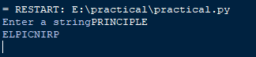

1. Write a program to count vowels and consonants in a string.

*a=input("enter the String")*

*ccount=0*

*vcount=0*

*b=a.lower()*

*for char in b:*

*if char=='a' or char=='e' or char=='i' or char=='u':*

*vcount+=1*

*else:*

*ccount+=1*

*print("The number of vowels is ",vcount)*

*print("The number of consonants is ",ccount)*

Output:

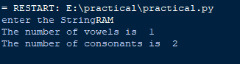

1. Find the GCD of two numbers.

*a=270*

*b=192*

*def gcd(a,b):*

*if b==0:*

*return a*

*else:*

*return gcd(b,a%b)*

*print("The gcd of two numbers is ",gcd(a,b))*

Output:



1. WAP to sort a list of numbers in ascending order.

*a=[5,1,4,6,7,8]*

*a.sort()*

*print("The numbers are in ascending order are:")*

*print(a)*

Output:



1. Implement a Python program to find the second largest number in a list.

*a=[5,1,4,6,7,8]*

*a.sort(reverse=True)*

*print("The second largest number are:")*

*print(a[1])*

Output:



1. Create the python program to count the frequency of each word.

*txt="Hello world Hello"*

*def frequency(txt):*

*words=txt.lower().split()*

*wcount={}*

*for word in words:*

*if word in wcount:*

*wcount[word]+=1*

*else:*

*wcount[word]=1*

*for word,count in wcount.items():*

*print(f"'{word}',{count}")*

*print("the number of times the words are repeated are")*

*frequency(txt)*

Output:

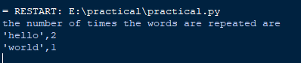

1. WAP to check if a number is amstrong or not.

*n=int(input("enter the number"))*

*power=0*

*arm=0*

*m=n*

*c=n*

*while n>0:*

*power+=1*

*n=n//10*

*while m>0:*

*r=m%10*

*arm+=pow(r,power)*

*m=m//10*

*print(arm)*

*if c==arm:*

*print("it is armstrong")*

*else:*

*print("It is not armstrong")*

Output:



1. Implement a python program to convert decimal into binary.

*def convert(decimal):*

*if decimal=='0':*

*return '0'*

*binary=''*

*while decimal>0:*

*binary=str(decimal%2)+binary*

*decimal=decimal//2*

*return binary*

*decimal=int(input("Enter a decimal number: "))*

*print("The binary form of ",decimal,"is ",convert(decimal))*

Output:

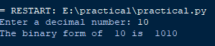

1. Create a program to merge two dictionaries.

*d1={'x':1,'y':2}*

*d2={'w':3,'z':4}*

*d1.update(d2)*

*print(d1)*

Output:



1. Write a python program to print all prime numbers within a given range.

*def is_prime(num):*

*if num<=1:*

*return False*

*for i in range(2,int(num**0.5)+1):*

*if num%i==0:*

*return False*

*return True*

*def print_primes(n):*

*for num in range(1,n+1):*

*if is_prime(num):*

*print(num)*

*n=int(input("enter the value of n:"))*

*print("The numbers from 1to n:")*

*print_primes(n)*

Output:

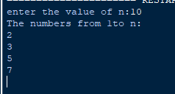

Conclusion: In the above page we have done the python programming using control statements with its output .