Lab Report 3 Date:2081/02/18

Experiment 1: File Handling.

Title: Programming to learn about File handling.

Objective:The objective of this Lab-Work is to allow a program to interact with data stored in files on a storage device that enables programs to read from, write to, update, or delete data persistently.

Theory: File handling in programming refers to the process of reading from and writing to files. It is essential when you need to store data persistently beyond the programs runtime. Some of the operation of file handling are: Opening, Reading, writing and closing a file.

1. Write a program to read and count the number of lines and words in it.

*lcount=0*

*wcount=0*

*with open("example1.txt","r") as file:*

*for line in file:*

*lcount+=1*

*words=line.split()*

*wcount=wcount+len(words)*

*print("Number of lines is : ",lcount)*

*print("Number of words is : ",wcount)*

Output:

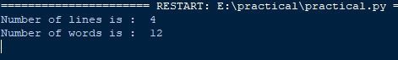

1. Create a python program to copy the content of one to another.

*with open("example.txt","r") as file:*

*content=file.read()*

*print(content)*

*with open("example2.txt","w") as file1:*

*file1.write(content)*

*print("file has been copied")*

Output:



1. Write a python to check if a file exists.

*import os*

*if os.pth.exists("example.txt"):*

*print("the file exists")*

Output:



1. Append user input to a file and display the numbers.

*with open("example.txt","a")as file:*

*line=input("enter a line :")*

*content=file.write(line)*

*with open("example.txt","r") as file:*

*content=file.read()*

*print(content)*

Output:



1. Implement a Python program to delete specific line from a file.

*num=int(input("enter the line number you need to delete"))*

*with open("example1.txt","r") as file:*

*lines=file.readlines()*

*print(lines)*

*print("After deletion")*

*if 0<num<=len(lines):*

*del lines[num-1]*

*with open('example1.txt','w') as file:*

*print(lines)*

*file.writelines(lines)*

Output:

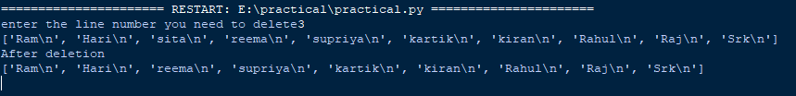

Conclusion: In the above page we have done the python programming using file handling with its output .