Lab Report 7 Date:2081/04/11

Experiment 1: NumPy, Pandas and Matplotlib

Title: Programming to learn about python numpy, pandas and matplotlib.

Objective:The objective of this lab-work is to learn more about NumPy, Pandas and Matplotlib.

Theory

* NumPy: NumPy is a fundamental package for scientific computing in python. It provides support for arrays, matrices, and high-level mathematical functions to operate on these data structures.
* Pandas: Pandas is a library used for data manipulation and analysis. It provides two primary data structures: Series(1D) and DataFrame (2D). Its great for handling structured data (like CSV files, SQL databases).
* Matplotlib: Matplotlib is a plotting library used to create static, animated, and interactive visualiztions in python. It is often used alongside NumPy and Pandas for visualizing data.

1. Create two NumPy arrays, A and B, each of size(3,3) with random integers between 1 and 50. Perform matrix addition, subtraction, and multiplication(both element wise and dot product).

*import numpy as np*

*a=np.random.randint(50,size=(3,3))*

*b=np.random.randint(50,size=(3,3))*

*print("Addition is:")*

*print(a+b)*

*print("Substraction is:")*

*print(a-b)*

*print("Element wise :")*

*print(a*b)*

*print("Dot wise :")*

*print(np.dot(a,b))*

Output:

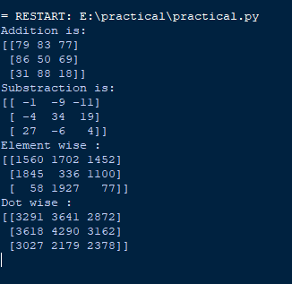

1. Generate a 1D NumPy array with 50 random numbers between 10 and 100. Compute and display the mean median standard deviation and variance of an array.

*import numpy as np*

*array=np.random.randint(10,101,size=50)*

*mean=np.mean(array)*

*median=np.median(array)*

*std_deviation=np.std(array)*

*variance=np.var(array)*

*print("Array:",array)*

*print("Mean:",mean)*

*print("Standard Deviation:",std_deviation)*

*print("Variance:",variance)*

Output:

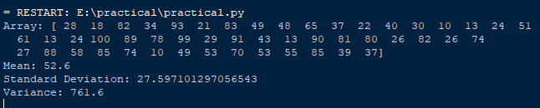

1. Create a (4,5) NumPy array filled with random integers. Extract:

* All rows and the second column.
* Elements greater than 20.
* The sub-matrix consisting of rows 2 to 3 columns 1 to 3

.

*import numpy as np*

*array=np.random.randint(10,101,size=(4,5))*

*print("Array is: ")*

*print(array)*

*print("All rows")*

*row=array[:]*

*second_col=array[:,1]*

*print(row)*

*print("Second column")*

*print(second_col)*

*print("elements greater than 20")*

*elem=array[array>20]*

*print(elem)*

*sub_2x3=array[:2,:3]*

*sub_1x3=array[:1,:3]*

*print("sub matrix 2x3 is ",sub_2x3)*

*print("sub matrix 1x3 is ",sub_1x3)*

Output:

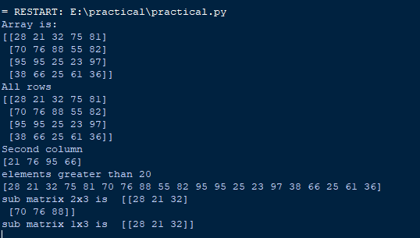

1. Create two arrays:

* A 1D array arr1 with 5 elements.
* A 2D array arr2 of size[3,5].

Perform element-wise addition and multiplication using broadcasting.

*import numpy as np*

*array_1d = np.array([1, 2, 3, 4, 5])*

*array_2d = np.array([[6, 7, 8, 9, 10],*

*[11, 12, 13, 14, 15],*

*[16, 17, 18, 19, 20]])*

*add = array_2d + array_1d*

*mul = array_2d * array_1d*

*print("Element-wise Addition Result:")*

*print(add)*

*print("\nElement-wise Multiplication Result:")*

*print(mul)*

Output:

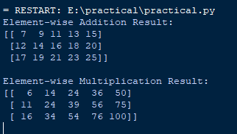

1. Solve the system of linear equations using NumPy;

2x+y+z=1, x+2y+3z=7, 3x+y+2z=4

*import numpy as np*

*A=np.array([[2,1,1],[1,2,3],[3,1,2]])*

*B=np.array([1,7,4])*

*solution=np.linalg.solve(A,B)*

*print("The value of x ,y and z are",solution,"respectively.")*

Output:



1. Plot y=sin(x) for xxx ranging from 0 to 2n. Add labels for the axes, a title, and a legend.

*import numpy as np*

*import matplotlib.pyplot as plt*

*x = np.linspace(0, 2 * np.pi, 100)*

*y = np.sin(x)*

*plt.plot(x, y, label='y = sin(x)')*

*plt.title('Plot of y = sin(x)')*

*plt.xlabel('x')*

*plt.ylabel('y')*

*plt.legend()*

*plt.show()*

Output:

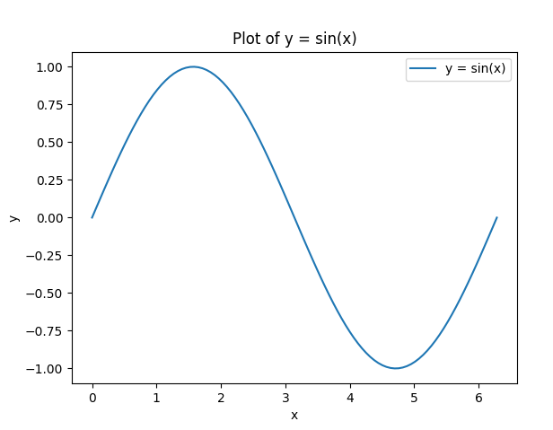

1. Generate 100 random points for x and y using NumPy. Plot them using Matplotlib and customize the markers,and color and title.

*import numpy as np*

*import matplotlib.pyplot as plt*

*x=np.random.rand(100)*

*y=np.random.rand(100)*

*plt.scatter(x,y,color='blue',marker='o',edgecolors='black')*

*plt.title("Scatter plot of random points")*

*plt.xlabel('X values')*

*plt.ylabel('Y values')*

*plt.show()*

Output:

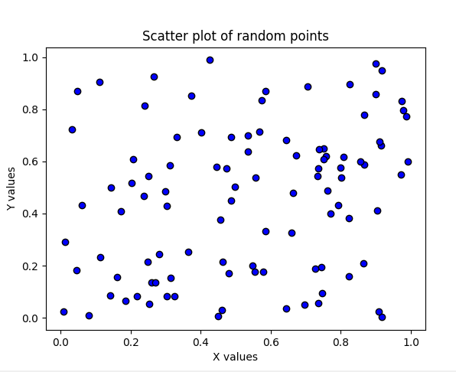

1. Plot two functions y1=x2 and y2=x3 on the same graph for xxx ranging from -10 to 10. Use different line styles and add a legend.

*import numpy as np*

*import matplotlib.pyplot as plt*

*x=np.linspace(-10,10,400)*

*y1=x**2*

*y2=x**3*

*plt.plot(x,y1,label='y=x^2',linestyle='-',color='blue')*

*plt.plot(x,y2,label='y=x^3',linestyle='--',color='red')*

*plt.legend()*

*plt.xlabel('x')*

*plt.ylabel('y')*

*plt.title("plot of y=x2 and y=x3")*

*plt.grid(True)*

*plt.show()*

Output:

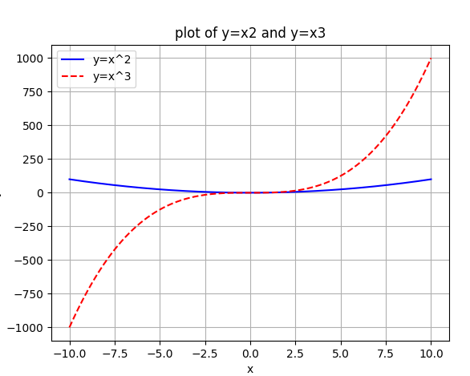

1. Create a Pandas Data Frame with data on students name, marks in 3 subjects, and their total marks Perform the following.

* Calculate the average marks for each subject.
* Add a column with grades based on total marks.
* Filter rows where the grade is “A”.

*import pandas as pd*

*data={'Name':['Ram','Hari','shyam'],'Math':[76, 95, 91],'Science':[98, 82,96],'Computer':[99, 64, 32]}*

*df=pd.DataFrame(data)*

*print(df)*

*print("The average of all three subjects are:")*

*print(df['Math'].mean()," for Math")*

*print(df['Science'].mean()," for science")*

*print(df['Computer'].mean()," for computer")*

*print("After a grade column was added:")*

*df['Total marks']=df['Math']+df['Science']+df['Computer']*

*def grade(marks):*

*if marks>=270:*

*return 'A'*

*elif marks>=240:*

*return 'B'*

*else:*

*return 'C'*

*df['Grade']=df['Total marks'].apply(grade)*

*print(" DataFrame with grades")*

*print(df)*

*A=df[df['Grade'] =='A']*

*print("The Filtered dataframe where grade is A ")*

*print(A)*

Output:

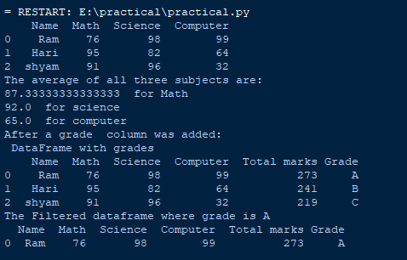

1. Write a program to:

* Read a CSV file containing employee data (name, department, salary)
* Display the top 5 highest paid employees.
* Group the data by department and compute the average salary for each department.

*import pandas as pd*

*df = pd.read_csv('employees.csv')*

*top= df.nlargest(5, 'SALARY')*

*print("Top 5 Highest Paid Employees:")*

*print(top)*

*average_salary_by_department = df.groupby('DEPARTMENT_ID')['SALARY'].mean()*

*print("\nAverage Salary by Department:")*

*print(average_salary_by_department)*

Output:

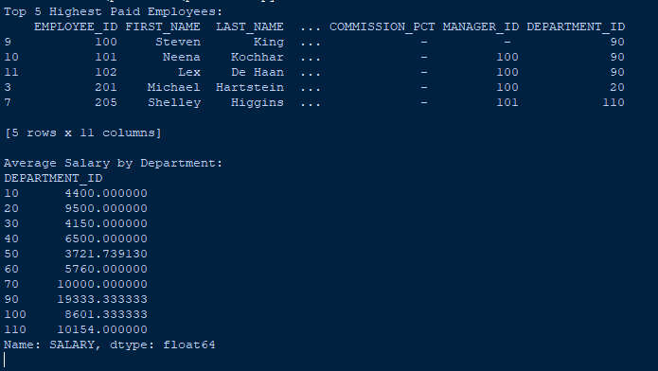

Conclusion: In the above page we have done the basic NumPy, Matplotlib and pandas with its output .