**Cyber Security**

**Assignment Day 4**

**Question 1:**

Find out the mail servers of the following domain:

* Ibm.com
* Wipro.com

Ans: 1)Open **PenTester** VMware workstation

2)Open **Command Prompt**

3)Type:

ipconfig

nslookup

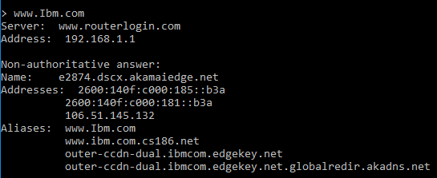

www.Ibm.com

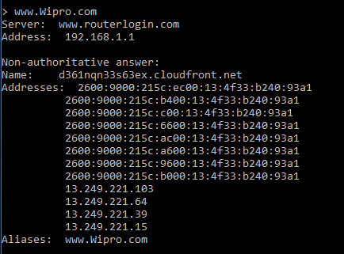

[www.Wipro.com](http://www.Wipro.com)

**Question 2:**

Find the locations, where these Email servers are hosted.

Continuation of Question 1

Ans: Type:

set type=mx

Ibm.com

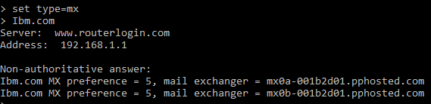

**Open google chrome**

Open IP Location Finder

Copy paste the url and find the location

**Address 1:**

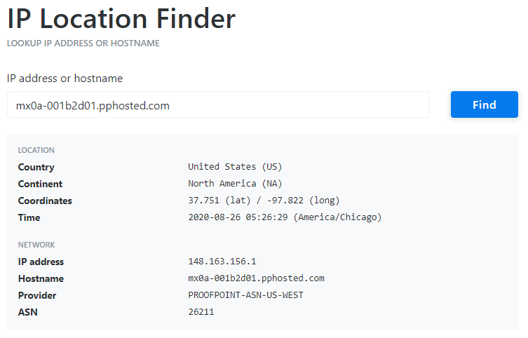

**Address 2:**

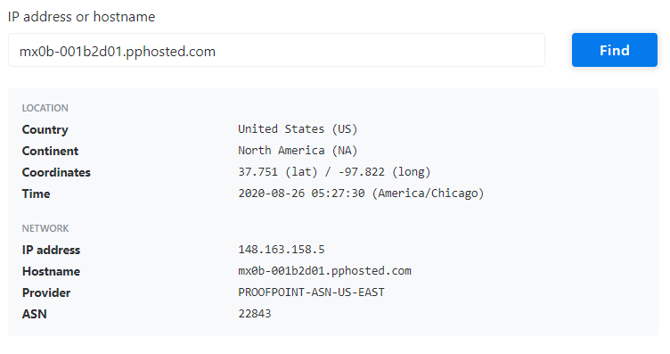

Wipro.com

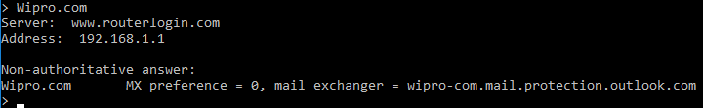

Open **Google Chrome**

Open **IP Location Finder**

Copy paste the URL and find the location

**Address:**

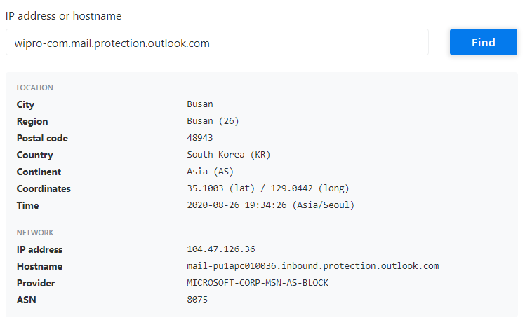

**Question 3:**

Scan and find out port numbers open **203.163.246.23**

Open **Kali-pc**

Right click on the screen and **Open Terminal**

Type:

sudo su –

Enter password

Enter – nmap –Pn –sS 203.163.246.23

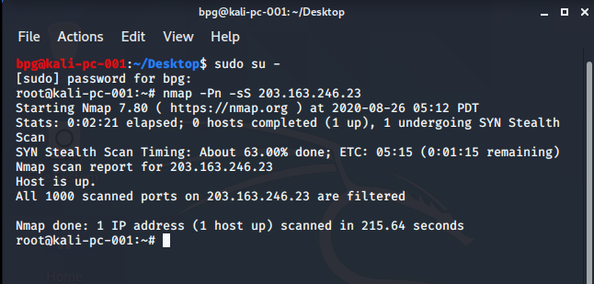

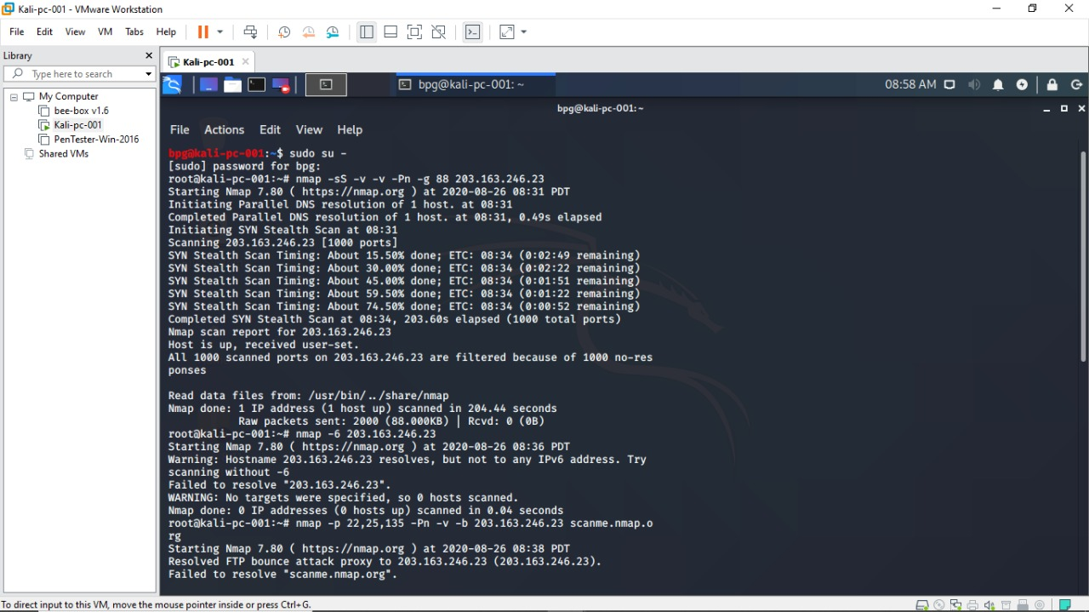

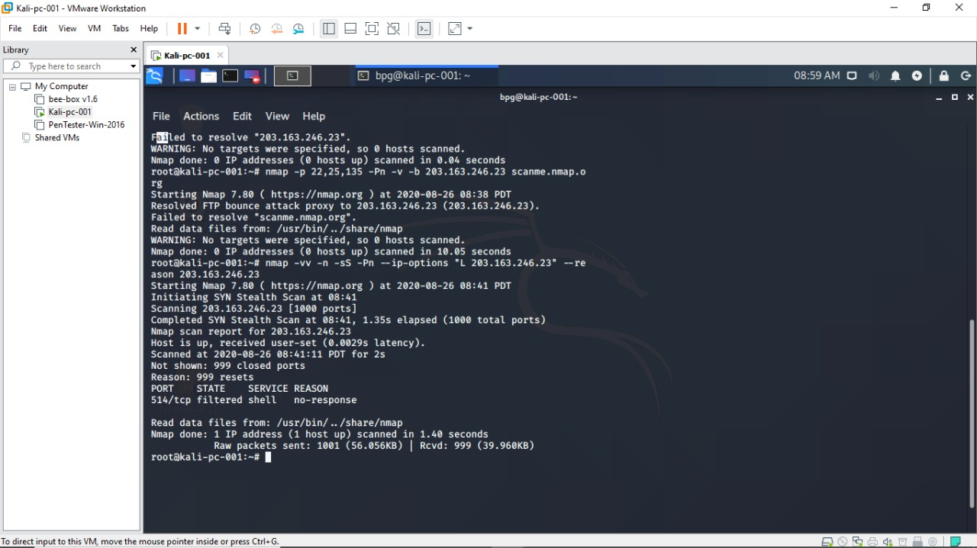

**Question 4:**

Install nessus in a VM and scan your laptop/desktop for CVE

Open PenTester VMware workstation

Install Google Chrome

Install Nessus

Click on All scansCreate a new scanAdvance settingsWindows Fill the required blanks in credentials as well Launch

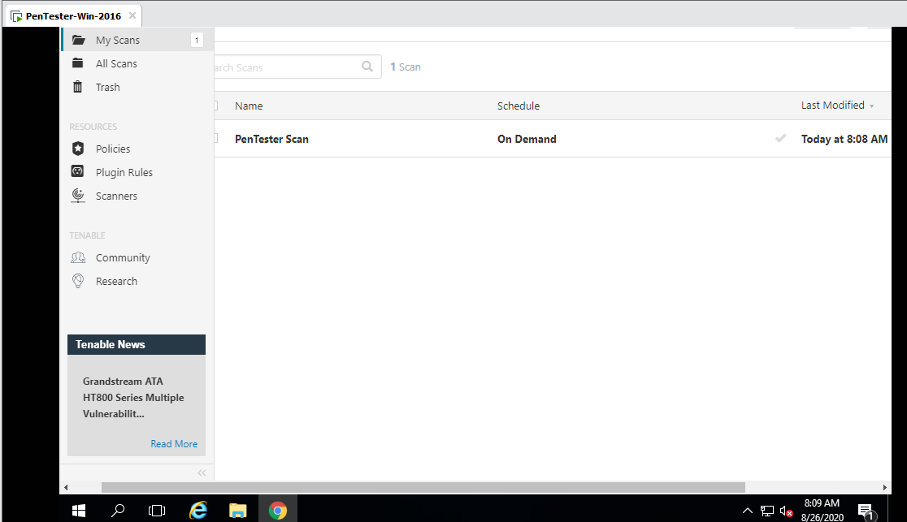

Report:

