Program 1:

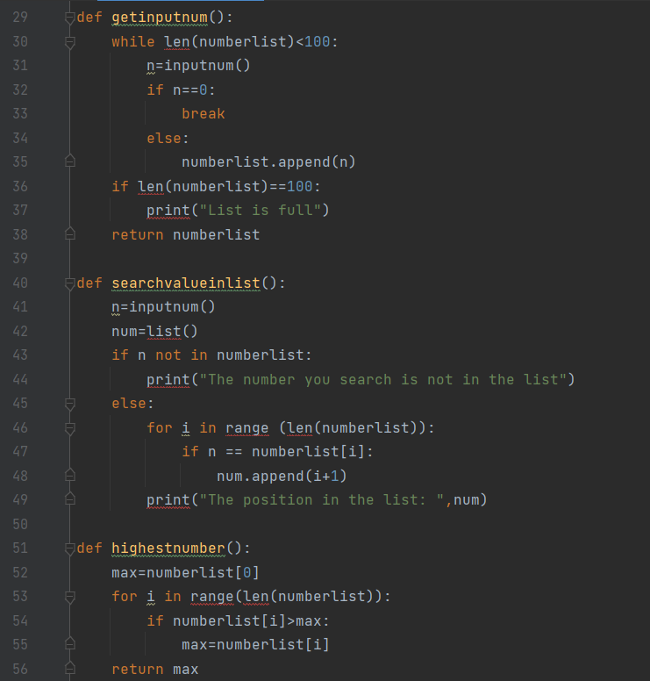

Result:

Program 2:

Code:

Result:

