Program 1:

Code:

Result:

Program 2:

Code:

Result:



Program 3:

Code:

Result:

Program 4:

Code:

Result:

Program 5:

Code:

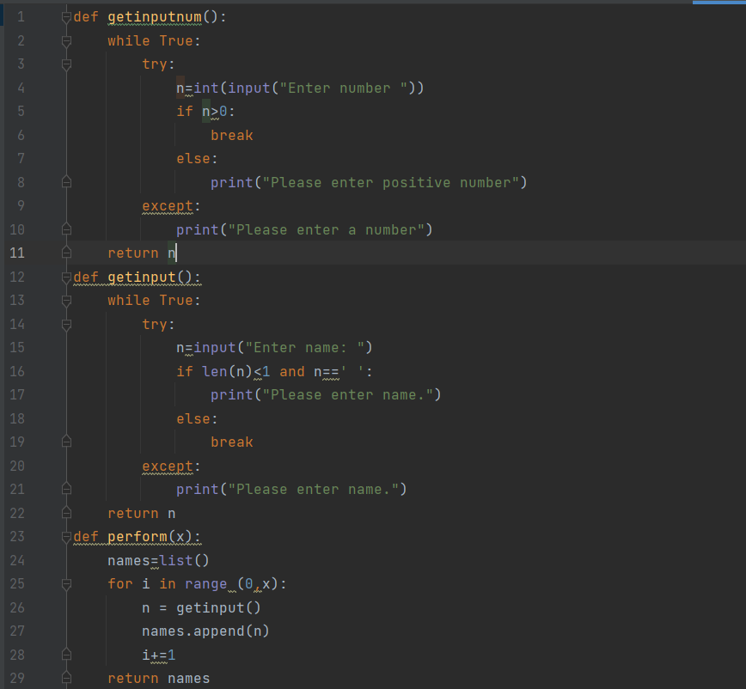

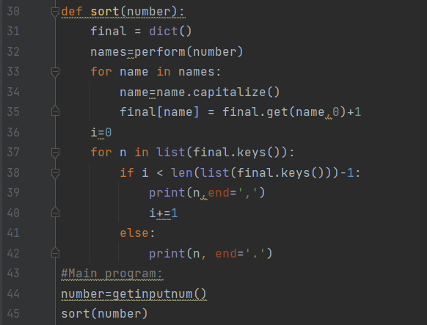

Result:

