**Name: Susan Sebastian**

**Roll No: 45**

**Batch: B**

**Date: 25-03-2022**

**ADVANCED DBMS LAB**

**Experiment No.: 1**

**AIM**

To study various DDL commands – CREATE, INSERT

**QUESTION**

Create the following Tables and Insert values.

**Table 1: DEPOSIT**

ACTNO VARCHAR (5) PRIMARY KEY, FIRST LETTER MUST START WITH ‘D’

CNAME VARCHAR (20) FOREIGN KEY REFERENCES CUSTOMER

BNAME VARCHAR (20) FOREGIGN KEY REFERENCES BRANCH

AMOUNT NUMBER (8,2) NOT NULL, CANNOT BE 0

ADATE DATE

**Table 2: BRANCH**

BNAME VARCHAR2(20) PRIMARY KEY

CITY VARCHAR2(30) NOT NULL , any one of NAGPUR, DELHI, BANGALORE, BOMBAY

**Table 3: CUSTOMER**

CNAME VARCHAR (15) PRIMARY KEY

CITY VARCHAR (20) NOT NULL

**Table 4: BORROW**

LOANNO VARCHAR (28) PRIMARY KEY / FIRST LETTER MUST START WITH ‘L’

CNAME VARCHAR (15) FOREIGN KEY REFERENCES CUSTOMER

BNAME VARCHAR2(20) FOREIGN KEY REFERENCES BRANCH

AMOUNT NUMBER(8,2) NOT NULL, CANNOT BE 0

**PROCEDURE**

1. **Create Database**

CREATE DATABASE database1;

USE database1;

1. **Customer table (Create and Insert)**

CREATE TABLE CUSTOMER (c_name VARCHAR(15) PRIMARY KEY ,city VARCHAR(20) NOT NULL );

1. **Branch (Create and Insert)**

CREATE TABLE BRANCH (b_name VARCHAR(20) PRIMARY KEY,city VARCHAR(30) CHECK (city IN ('NAGPUR','DELHI','BANGALORE','BOMBAY')) NOT NULL);

1. **Borrow (Create and Insert)**

CREATE TABLE BORROW (loan_no VARCHAR(8) CHECK (loan_no LIKE 'L%') PRIMARY KEY, c_name VARCHAR(15) REFERENCES CUSTOMER(c_name),b_name VARCHAR(20) REFERENCES

BRANCH(b_name),amount FLOAT(8) CHECK (amount>0) NOT NULL);

1. **Deposit (Create and Insert)**

CREATE TABLE DEPOSIT (act_no VARCHAR(5) CHECK (act_no LIKE 'D%') PRIMARY KEY ,c_name VARCHAR(15) REFERENCES CUSTOMER(c_name),b_name VARCHAR(20) REFERENCES

BRANCH(b_name),amount FLOAT(8) CHECK (AMOUNT>0) NOT NULL, a_date DATE);

**INSERT VALUES**

INSERT INTO CUSTOMER VALUES('ANIL','CALCUTTA');

INSERT INTO CUSTOMER VALUES('SUNIL','DELHI');

INSERT INTO CUSTOMER VALUES('MEHUL','BARODA');

INSERT INTO CUSTOMER VALUES('MANDAR','PATNA');

INSERT INTO CUSTOMER VALUES('MADHURI','NAGPUR');

INSERT INTO CUSTOMER VALUES('PRAMOD', 'NAGPUR');

INSERT INTO CUSTOMER VALUES('SANDIP','SURAT');

INSERT INTO CUSTOMER VALUES('SHIVANI','BOMBAY');

INSERT INTO CUSTOMER VALUES('KRANTI','BOMBAY');

INSERT INTO CUSTOMER VALUES('NAREN','BOMBAY');

INSERT INTO BRANCH VALUES('VRCE','NAGPUR');

INSERT INTO BRANCH VALUES('AJNI','NAGPUR');

INSERT INTO BRANCH VALUES('KAROLBAGH','DELHI');

INSERT INTO BRANCH VALUES('CHANDNI','DELHI');

INSERT INTO BRANCH VALUES('DHARAMPETH','NAGPUR');

INSERT INTO BRANCH VALUES('MG ROAD','BANGLORE');

INSERT INTO BRANCH VALUES('ANDHERI','BOMBAY');

INSERT INTO BRANCH VALUES('NEHRU PALACE','DELHI');

INSERT INTO BRANCH VALUES('POWAI','BOMBAY');

INSERT INTO DEPOSIT VALUES('D100','ANIL','VRCE',1000.00,'1995-03-01');

INSERT INTO DEPOSIT VALUES('D101','SUNIL','ANJNI',500.00,'1996-04-01');

INSERT INTO DEPOSIT VALUES('D102','MEHUL','KAROLBAGH',3500.00,'1995-11-17');

INSERT INTO DEPOSIT VALUES('D104','MADHURI','CHANDNI',1200.00,'1995-12-17');

INSERT INTO DEPOSIT VALUES('D105','PRAMOD','MG ROAD',3000.00,'1996-03-27');

INSERT INTO DEPOSIT VALUES('D106','SANDIP','ANDHERI',2000.00,'1996-03-31');

INSERT INTO DEPOSIT VALUES('D107','SHIVANI','VIRAR',1000.00,'1995-10-05');

INSERT INTO DEPOSIT VALUES('D108','KRANTI','NEHRU PLACE',5000.00,'1995-07-02');

INSERT INTO DEPOSIT VALUES('D109','MINU','POWAI',7000.00,'1995-08-10');

INSERT INTO BORROW VALUES('L201','ANIL','VRCE',1000.00);

INSERT INTO BORROW VALUES('L206','MEHUL','AJNI',5000.00);

INSERT INTO BORROW VALUES('L311','SUNIL','DHARAMPETH',3000.00);

INSERT INTO BORROW VALUES('L321','MADHURI','ANDHERI',2000.00);

INSERT INTO BORROW VALUES('L371','PRAMOD','VIRAR',8000.00);

INSERT INTO BORROW VALUES('L481','KRANTI','NEHRU PLACE',3000.00);

select * from CUSTOMER;

select * from branch;

select * from borrow;

select * from deposit;

**OUTPUT SCREENSHOT**

1. **Customer Table**

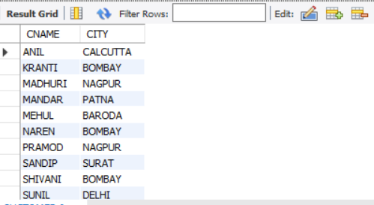

1. **Branch Table**

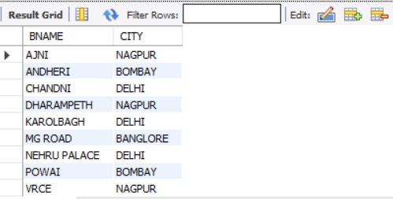

**3. BORROW TABLE**

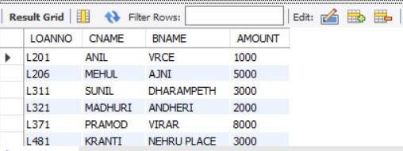

1. **DEPOSIT TABLE**

