|  |
| --- |
| **Name: Susan Sebastian**  **Roll No: 45**  **Batch: B**  **Date: 01-04-2022** |

**ADVANCED DBMS LAB**

**EXPERIMENT NO.: 2**

**AIM**

To familiarize with selecting data from single table.

**QUESTION**

1. **List all data from table deposit.**

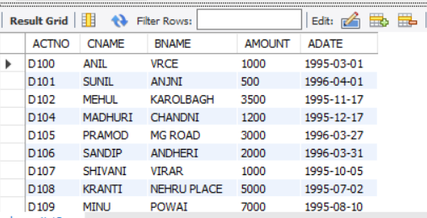

1. **List all data from borrow.**

SELECT * FROM borrow;

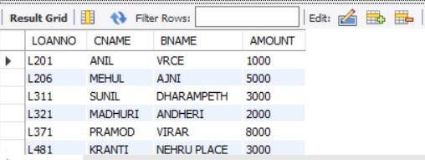

1. **List all data from customer.**

SELECT * FROM customer**;**

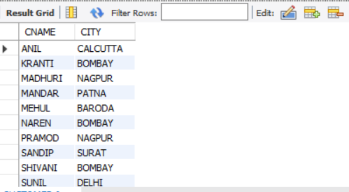

1. **List all data from branch.**

SELECT * FROM branch;

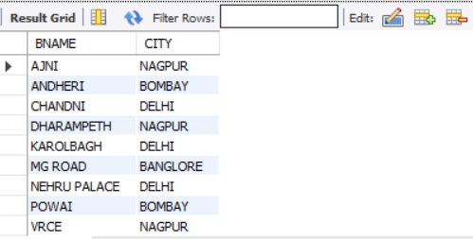

1. **Give account no and amount of deposit.**

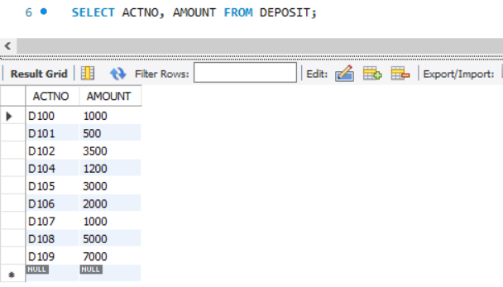

1. **Give customer name and account no of depositors.**

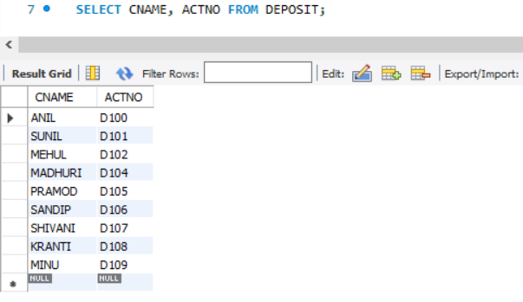

1. **Give name of customers.**

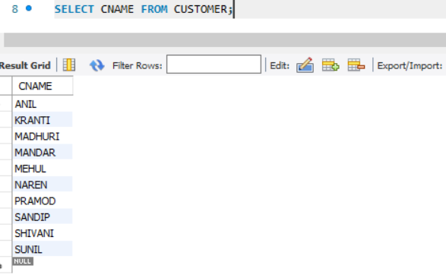

1. **Give name of branches.**

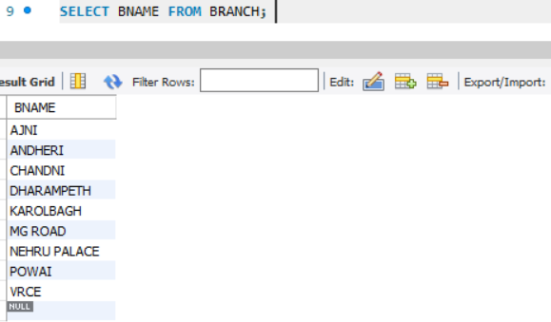

1. **Give name of borrows.**

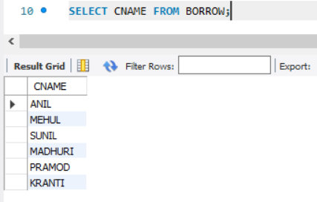

1. **Give names of customer living in city Nagpur.**

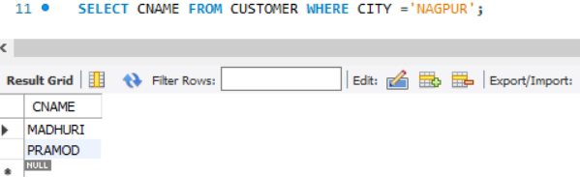

1. **Give names of depositors having amount greater than 4000.**

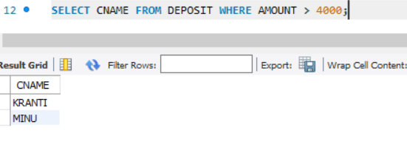

1. **Give account date of Anil.**

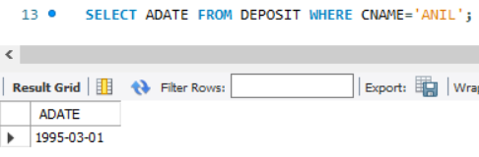

1. **Give name of all branches located in Bombay.**

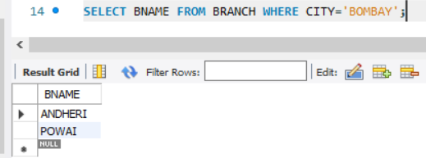

1. **Give name of borrower having loan number L206.**

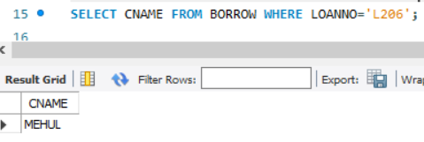

1. **Give names of depositors having account at VRCE.**

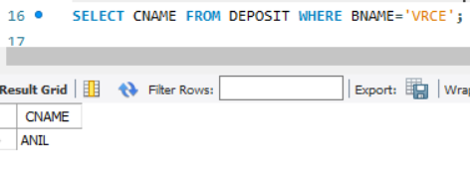

1. **Give names of all branched located in city Delhi.**

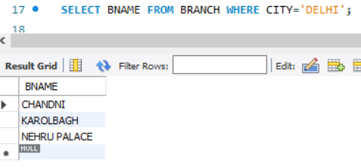

1. **Give name of the customers who opened account date ‘1-04-96’.**

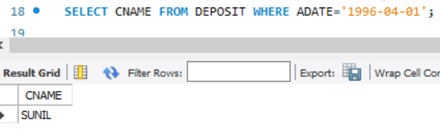

1. **Give account no and deposit amount of customers having account opened between dates ‘1-12-96’ and ‘1-5-96’.**

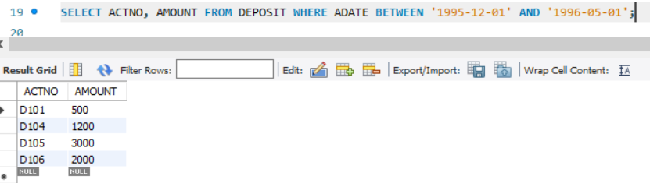

1. **Give name of the city where branch KAROLBAGH is located.**

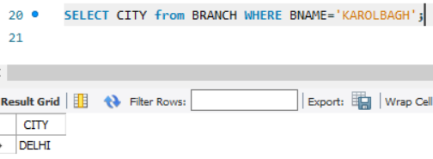

1. **Give details of customer ANIL.**

