|  |
| --- |
| **Name :** Susan Sebastian  **Roll No** : 45  **Batch :** B  **Date:** 01-04-2022 |

**ADVANCED DBMS LAB**

**Experiment No.: 3**

**Aim**

To familiarize DDL Commands- ALTER,DROP,TRUNCATE,RENAME

**Commands**

**1. Create a table emp with attributes empno number(4)as primary key, ename char(10),hiredate, salary, commission and insert values.**

CREATE TABLE EMP (EMPNO INT (4) PRIMARY KEY, ENAME CHAR (10), HIREDATE DATE, SALARY INT (5), COMMISION INT (5));

INSERT INTO EMP (EMPNO, ENAME, HIREDATE, SALARY, COMMISION)

VALUES(101,'RAMESH','1980-01-17',5000,500), (102,'AJAY','1985-07-05',5000,500),

(103,'RAVI','1981-08-12',1500,150), (104,'Nikesh','1983-03-03',3000,300),

(105,'Ravi','1985-07-05',3000,300);

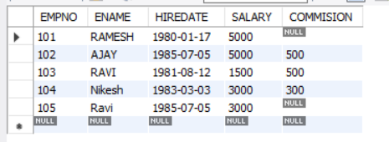

# Modifying the structure of tables a) Add new columns: sal number

ALTER TABLE EMP ADD SAL INT;

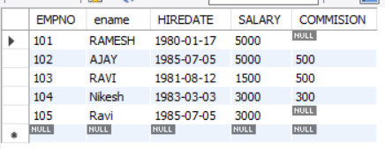

# b) Dropping a column from a table: sal

ALTER TABLE EMP DROP COLUMN SAL;

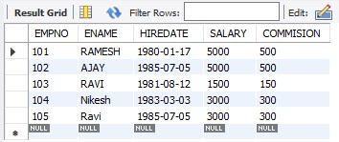

1. **Modifying existing column :ename varchar2(15)**

ALTER TABLE EMP MODIFY ename VARCHAR(15);

1. **Renaming the tables: emp to emp1**

RENAME TABLE EMP to EMP1;

# e) Truncating the tables:emp1

TRUNCATE TABLE EMP1;

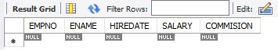

**f) Destroying tables:emp**

DROP TABLE EMP1;

# Create a table stud with sname varchar2(20) primary key , rollno number(10) not null,dob date not null

CREATE TABLE STUD(SNAME VARCHAR(20) PRIMARY KEY, ROLLNO INT NOT NULL, DOB DATE NOT NULL);

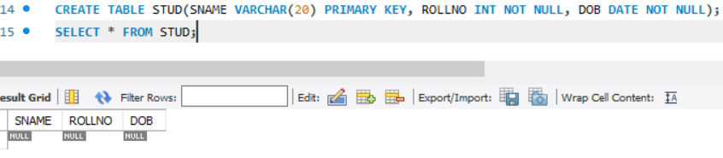

# Create a table student as regno number (6), mark number (3) check constraint (mark >=0 and mark <=100));

CREATE TABLE STUDENT (REGNO INT, MARK INT(3) CONSTRAINT B CHECK (MARK >=0 AND MARK <=100));

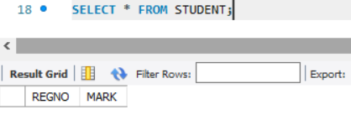

# In table student add check constraint(length(regno<=4))

ALTER TABLE STUDENT ADD CONSTRAINT B2 CHECK

(length(REGNO<=4));

DESC student;

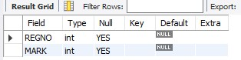

# Create a table cust with(custid number(6) constraint unique, name char(10)

CREATE TABLE CUST(CUSTID INT(6) NOT NULL UNIQUE, NAME CHAR(10));