|  |
| --- |
| **Name :** Susan Sebastian  **Roll No** : 45  **Batch :** B  **Date:** 19-04-2022 |

**ADVANCED DBMS LAB**

**Experiment No.: 4**

**Aim**

To familiarize with aggregate functions

**Commands**

1. **List total loan.**

SELECT SUM(amount) FROM borrow;

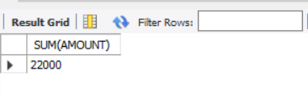

1. **List total deposit.**

SELECT SUM(amount) FROM deposit;

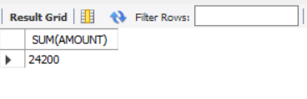

1. **List total loan taken from KAROLBAGH branch.**

SELECT MAX(amount) FROM borrow WHERE b_name ='KAROLBAGH';

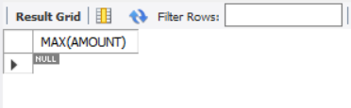

1. **List total deposit of customers having account date later than 1-Jan-96.**  SELECT SUM(amount) FROM deposit WHERE a_date>'1995-03-01';

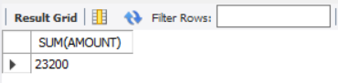

1. **List total deposit of customers living in city NAGPUR.**

SELECT SUM(D1.amount) FROM deposit D1 , customer C1 WHERE C1.CITY = 'NAGPUR' AND C1.c_name = D1.c_name;

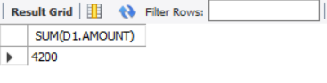

1. **List maximum deposit of customer living in Bombay.**

SELECT MAX(D1.amount) FROM deposit D1 , customer C1 WHERE C1.CITY = 'Bombay' AND C1.c_name = D1.c_name;

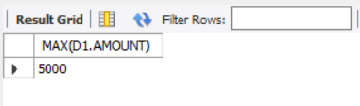

1. **List total deposit of customer having branch in BOMBAY.**

SELECT SUM(amount) FROM deposit, branch where city='BOMBAY';

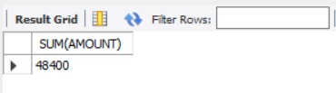

1. **Count total number of branch cities.**

SELECT COUNT(DISTINCT(CITY)) FROM branch ;

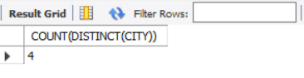

1. **Count total number of customers cities.**

SELECT count(city) FROM customer;

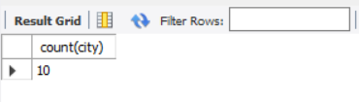

1. **Give branch names and branch wise deposit.**

SELECT b_name, SUM(amount) FROM DEPOSIT GROUP BY b_name;

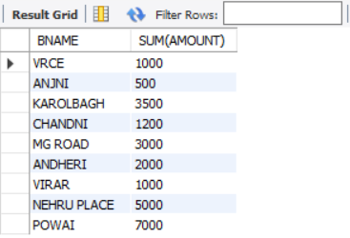

1. **Give city wise name and branch wise deposit.**

SELECT C1.CITY, SUM(D1.amount) FROM customer C1, DEPOSIT D1

WHERE D1.c_name = C1.c_name GROUP BY C1.city;

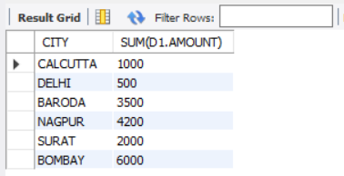

1. **Give the branch wise loan of customer living in NAGPUR.**

SELECT b_name, SUM(amount) FROM borrow,customer WHERE city

='NAGPUR' GROUP BY b_name;

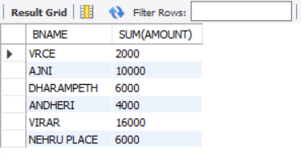

1. **Count total number of customers.**

SELECT count(c_name) FROM customer;

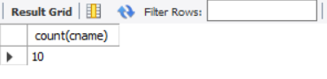

1. **Count total number of depositors branch wise.**

SELECT b_name, count(*) FROM deposit, customer WHERE deposit.c_name = customer.c_name GROUP BY b_name;

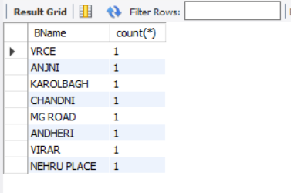

1. **Give maximum loan from branch VRCE.**

SELECT MAX(amount) FROM borrow WHERE b_name ='VRCE';

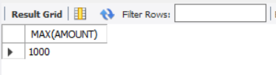

1. **Give the number of customers who are depositors as well as borrowers.**

SELECT count(DISTINCT (c_name)) FROM customer WHERE c_name in ((SELECT c_name deposite)IN (SELECT c_name FROM borrow));

