Which is **interpreted** as…

To examine…

*Second derivative* can be calculated by applying the first derivative calculation **twice in succession**.

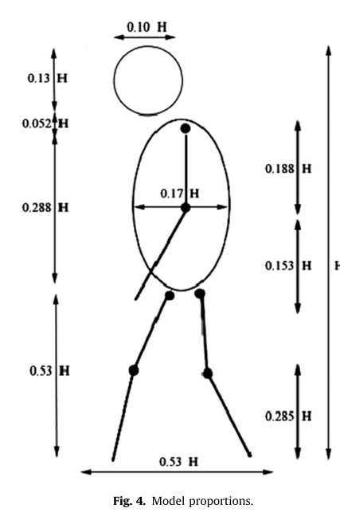

We can estimate the model by dividing the bounding box of the temporal accumulation measured through the subject’s velocity, based on the mean anatomical proportions

… to enhance the objects of interest while diminishing the contribution of irrelevant image detail.

Edge detection in particular has been a **staple** of segmentation algorithm for many years.

Intuitively