[Resources to help use this Word template to create your thesis can be found at:

[Training in using Word to create a thesis](https://www.southampton.ac.uk/doctoral-college/professional-development-programme/about-the-programme/knowledge-and-techniques-for-research/using-it-software/text-word.page)

Web pages

<http://go.soton.ac.uk/thesispc>

or

<http://go.soton.ac.uk/thesismac>]

**UNIVERSITY OF SOUTHAMPTON**

FACULTY OF [YOUR\_FACULTY (in capitals)]

[Academic\_Unit (underlined)]

Volume [X] of [Y]

[Thesis\_Title (bold)]

by

**[Your\_Name (bold)]**

Thesis for the degree of [name of degree]

[Month\_Year]

**UNIVERSITY OF SOUTHAMPTON**

**ABSTRACT**

FACULTY OF [YOUR\_FACULTY (in capitals)]

[Discipline (underlined)]

Thesis for the degree of [Doctor of Philosophy\_or\_something]

**[THESIS\_TITLE (bold and in capitals)]**

[Your\_Full\_Name e.g. Arthur Francis Jones]

Table of Contents

[Table of Contents i](#_Toc498004668)

[Table of Tables i](#_Toc498004669)

[Table of Figures i](#_Toc498004670)

[List of Accompanying Materials i](#_Toc498004671)

[Academic Thesis: Declaration Of Authorship i](#_Toc498004672)

[Acknowledgements i](#_Toc498004673)

[Definitions and Abbreviations i](#_Toc498004674)

[Chapter 1 Use the style Heading 1 for chapter titles. There is numbering attached so only use it for chapter titles 1](#_Toc498004675)

[1.1 Use the style Heading 2 for subheadings. This style has numbering attached 1](#_Toc498004676)

[1.1.1 Use the style Heading 3 for the next level of headings. This style has numbering attached. 1](#_Toc498004677)

[1.2 Images 1](#_Toc498004678)

[1.3 Tables 1](#_Toc498004679)

[Chapter 2 Working efficiently 1](#_Toc498004680)

[2.1 Learn useful ways to work with your file 1](#_Toc498004681)

[Chapter 3 A new chapter 1](#_Toc498004682)

[3.1 Adding new sections 1](#_Toc498004683)

[3.2 Cross-referencing 1](#_Toc498004684)

[Chapter 4 Reviewing tools 1](#_Toc498004685)

[4.1 Track changes 1](#_Toc498004686)

[4.2 Spell checker and auto-correct 1](#_Toc498004687)

[Chapter 5 Chapter 5 awaits content 1](#_Toc498004688)

[5.1 Chapter 5 subheading 1](#_Toc498004689)

[Chapter 6 Finishing 1](#_Toc498004690)

[6.1 Printing and PDFs 1](#_Toc498004691)

[Appendix A Your first appendix 1](#_Toc498004692)

[Appendix B Your second appendix 1](#_Toc498004693)

[Glossary of Terms 1](#_Toc498004694)

[List of References 1](#_Toc498004695)

[Bibliography 1](#_Toc498004696)

Table of Tables

**No table of figures entries found.**

Table of Figures

[Figure 1 The Clipboard group in Word 2010 1](#_Toc498004497)

List of Accompanying Materials

Academic Thesis: Declaration Of Authorship

I, [please print name]

declare that this thesis and the work presented in it are my own and has been generated by me as the result of my own original research.

[title of thesis]

I confirm that:

1. This work was done wholly or mainly while in candidature for a research degree at this University;
2. Where any part of this thesis has previously been submitted for a degree or any other qualification at this University or any other institution, this has been clearly stated;
3. Where I have consulted the published work of others, this is always clearly attributed;
4. Where I have quoted from the work of others, the source is always given. With the exception of such quotations, this thesis is entirely my own work;
5. I have acknowledged all main sources of help;
6. Where the thesis is based on work done by myself jointly with others, I have made clear exactly what was done by others and what I have contributed myself;
7. [Delete as appropriate] None of this work has been published before submission [or] Parts of this work have been published as: [please list references below]:

Signed:

Date:

Acknowledgements

Definitions and Abbreviations

# Use the style Heading 1 for chapter titles. There is numbering attached so only use it for chapter titles

## Use the style Heading 2 for subheadings. This style has numbering attached

### Use the style Heading 3 for the next level of headings. This style has numbering attached.

Learn about [using Styles](https://guides.soton.ac.uk/uni/isolutions/lg-office-2013/start/default.htm?7BD2F0D5-EEDA-4431-9C2F-9EF58724B150) to create a well formatted document and get a Table of Contents created by Word based on the Headings you include.

Use the style Normal for your standard paragraphs.

Use the style Quotation for large quotes. This style has indents on the left and right hand side and a slightly larger spacing before them to make them stand out.

Use the style Quotation\_Attribution to show the source of the quote

If you wish to change the default font used throughout the file see [Change the default font](https://guides.soton.ac.uk/uni/isolutions/lg-office-2013/start/default.htm?19F15C7B-1CC4-4F98-96BF-D6EA1DAF8A09)

## Images

[Insert images](https://guides.soton.ac.uk/uni/isolutions/lg-office-2013/start/default.htm?866F12E1-A2EC-4177-AD89-D19949D12186) in their own paragraph of Normal formatted text and ‘In line with text’. Images should have a [Caption](https://guides.soton.ac.uk/uni/isolutions/lg-office-2013/start/default.htm?8B3C0228-F863-4A37-9F68-1CEB3D86375E) inserted



Figure 1 The Clipboard group in Word 2010

## Tables

[Tables](https://guides.soton.ac.uk/uni/isolutions/lg-office-2013/start/default.htm?A9CFD92F-2CD9-4526-8B18-3EE00583BA35) should have a caption and long tables can be made to repeat their title row on multiple pages

# Working efficiently

## Learn useful ways to work with your file

There are lots of time saving ways to speed up working with your file:

[The Navigation Pane](https://guides.soton.ac.uk/uni/isolutions/lg-office-2013/start/default.htm?922E5D68-7B22-45D7-B58E-7F0BB82EF6BB)

[Browsing and selecting](https://guides.soton.ac.uk/uni/isolutions/lg-office-2013/start/default.htm?F333358B-B64A-4468-8A94-D662612DC58F)

[Keyboard shortcuts](https://guides.soton.ac.uk/uni/isolutions/lg-office-2013/start/default.htm?D790044D-A346-4664-8CB7-705C0257124A)

# A new chapter

## Adding new sections

The template has 6 chapters and 2 appendices. Find out how to use [Page Layout](https://guides.soton.ac.uk/uni/isolutions/lg-office-2013/start/default.htm?A3C076D6-ADAA-44C5-AC9F-C8CFF551A08F) features to add

* New chapters
* New appendices
* Landscaped sections

## Cross-referencing

If you use the heading styles then [cross-referencing](https://guides.soton.ac.uk/uni/isolutions/lg-office-2013/start/default.htm?257D2144-3CC1-47D0-BE3B-BE1A0888BFBB) to a heading elsewhere is made very easy

# Reviewing tools

## Track changes

Word has useful tools that will allow you to [track changes](https://guides.soton.ac.uk/uni/isolutions/lg-office-2013/start/default.htm?2167815B-C3D2-4C5A-8BC1-8020A1520D7A) that you might want to make to the file.

## Spell checker and auto-correct

Word has features that will help [check your spelling](https://guides.soton.ac.uk/uni/isolutions/lg-office-2013/start/default.htm?8DF05004-D415-4320-92B4-24FB460DA31C) – find out how to add words to its dictionary so it can recognise technical terminology that you use.

# Detecting Acceleration for Gait and Crime Scene Analysis

Gait analysis is the systematic study of human walking. It has been mainly applied in two fields: human identification [1] and medical consultation for diseases which affect walking [2]. Current gait analysis techniques can be classified as three types based on the sensor modality that is used to make measurements: physical-sensor based, depth image based and standard image based.

Clinical analysis often uses physical-sensor based techniques to measure physical data from different parts of the walking subject’s body to determine gait events. The main approach is to sense the force level of gait through force sensitive sensors [3], [4]. A popular alternative is kinematic information. One of the most common quantities is the acceleration of the body in two or three dimensions [5], [6]. Rueterbories and *et al.* [7] also use gyroscopes to capture the angular displacement, which is the Coriolis force in nature, to discriminate gait events.

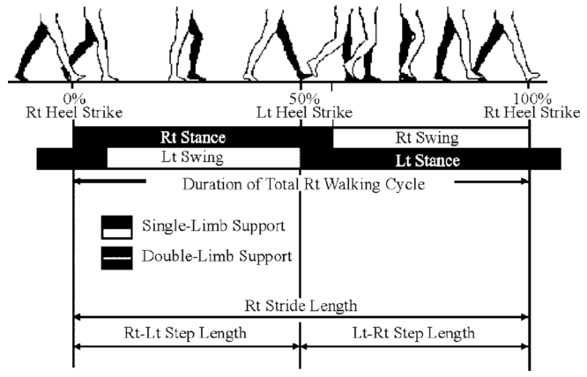

**Fig. 1** The temporal components contained in a gait cycle and step and stride length during the cycle [27].

Depth, or RGBD image, based gait analysis techniques have expanded since the introduction and wide availability of PrimeSense and Kinect sensors. These measurements use the distance between the body parts and the sensor in depth images to analyse gait [8], [9]. Lu et al. [10] have built a gait database named ADSC-AWD based on Kinect data.

Standard image based gait recognition has been extensively studied. Most approaches are targeted at recognition of individual humans, using gait as a biometric signature. The general framework consists of background subtraction, feature extraction and classification [11]. Model-based approaches have an intimate relationship with the human body and its motion, [12] presents an analytical gait model which extract the angle of thigh and lower leg rotation without parameter selection and [13] uses the statistical shape of the body for recognition. Model-free based approaches concentrate on the body shape or the motion of the entire gait process and thus could be used for the analysis of other moving shapes or mammals. Bobick and Davis [14] employ the motion-energy image and motion-history images of silhouette, Han and Bhanu [15] use the gait-energy image for recognition. Model-based methods are view-invariant and scale-invariant but the computation cost is relatively high and the approaches can be very sensitive to image quality. Model-free approaches, an alternative to model-based approaches, are less sensitive to the image quality with lower computation cost though they are not intrinsically robust to variation in viewpoint and scale [11].

These gait analysis methods all rely on accurate gait events detection. The components of one gait cycle are shown in *Fig.* *1*: a *gait cycle* is defined as the interval between two consecutive heel strikes of the same foot. A *heel strike* refers to the moment the heel first strikes the floor. Suppose one gait cycle starts from the heel strike of right foot, the right foot rotates on the heel to touch the floor (‘*stance phase*’) to support the body while the left foot is swinging forward (‘*swing phase*’) until the left heel touches the floor. Then the roles of the two feet switch, the left foot remains flat on the floor whilst the right foot is swinging forward. When the right heel strikes the floor again, then a gait cycle is complete. Hence the accurate and efficient detection of heel strikes is essential because it partitions a walking sequence into cycles composed of stance and swing phases [16]. In addition, the stride and step length can be derived from the stationary position of the heel at the moment of strike.

In this paper, we introduce a novel image-based technique to determine the time and position of heel strikes by using our new approach: *acceleration flow*. Accelerationhas been commonly used in physics-based approaches to indicate gait events: [7] and [17] use accelerometers; [18] and [19] use gyroscopes to measure the acceleration (the transition of force in nature) on the subject to determine the gait phases. In our contribution, we note that changes of acceleration can also be determined by analysis of optical flow in image sequences. Standard optical flow algorithms focus on the displacement of brightness values, and do not consider high order motions or classification of different motion types. To address this, we propose an algorithm to classify motion types with in image sequences and subsequently use the extracted acceleration information to detect heel strikes.

Previous standard image based heel strike detection methods accumulate all silhouettes of the subject and find the areas where candidate points are most dense. They use corner detection [20] and the motion of the head [21] as clues to the heel strikes. Compared with these approaches, our new method only requires three consecutive frames for processing and it also allows near real-time detection with only a single frame of delay.

The technique presented in this paper is based on the idea of differentiating motion types. Heel strikes incorporate radial acceleration on the foot while walking as they can be detected by changes in angular velocity measured with gyroscopes [7]. In our approach, we first disambiguate acceleration and velocity from optical flow and then decompose the acceleration into tangential and radial components. Experimentation on multiple databases shows that our method reaches state of art accuracy on predicting the timing of heel strikes, as well as demonstrating improved reliability on predicting the positioning of each heel strike within the frame in which it occurs. An earlier version of this analysis showed how acceleration could be used to detect heel strikes [22] by applying a physical quantity to detect gait events based on a computer vision technique. There we classified acceleration and velocity from optical flow and decomposed acceleration along radial and tangential directions. We now extend the evaluation and explore ramifications of the new analysis. This paper makes the following contributions:

* We evaluate the sensitivity of our approach to different imaging conditions via a wider range of datasets;

*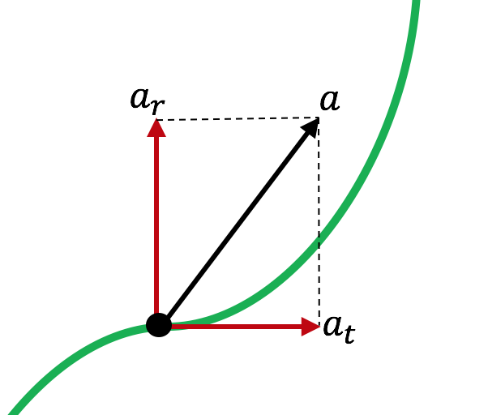*

**Fig. 2** The relationship between result, tangential and radial acceleration.

* We now evaluate different types of distortion: visual angle, lighting condition, Gaussian noise, occlusion and low resolution; and
* We compare the performance of our new operator with that of a previous technique and show performance improvement and capabilities.

The paper is organised as follows: Section 2 explains the details of acceleration flow and decomposition algorithms. Section 3 describes the methodology of applying acceleration flow to detect heel strikes. The experiments and analysis are presented in Section 4. Section 5 discusses the current heel strike detection techniques and the advantages and limitation of our algorithm. Finally, Section 6 concludes our work and explores potential future directions

## Gait and Heel Strike

Identifying criminals from surveillance videos is often difficult for police because the quality of images is severely affected by illumination and insufficient image resolution. Criminals also cover their faces to avoid recognition which compounds the investigation difficulties. In this case, gait is the optimal biometric technique to recognize criminals.

Gait is a behavioural biometric obtained at a distance from the camera, which is hard to hide or disguise. Since it is not affected by the low quality of images, gait is the most reliable biometric in the criminal investigation when other biometrics are not available. It has been demonstrated previously that gait can be used in criminal investigations either as body measurements [1] or gait measurements [2]. Figure 1 is a CCTV footage of an Australian jewellery shop murder: the target covered his face during the crime and he was recognised by his gait after it was found in the surveillance video that he had come to the jewellery shop earlier that day.

In gait analysis, heel strikes are an important and preliminary cue for gait analysis because gait period, step and stride length can be derived accurately by the moment and position of heel strike. It refers to the heel first makes contact with the ground during the stance phase of the walking cycle [3].

We introduce a new method of using acceleration to detect the time when a heel strikes the floor and likely crime events. When the foot is approaching heel strike, its motion status changes from moving forward to making circular motion centred at the heel. The amount of acceleration on the leading foot will dramatically increase when the heel hits the floor. According to this clue, we can determine the key frame and position of the heel strike precisely. Previous approaches of heel strike detection have used more of the image sequence and have determined the frame which has the most corners [4] and by detection based on the sinusoidal movement of the head and a silhouette accumulator map [5]. In contrast, the new approach uses only three consecutive frames to detect acceleration and thence heel strikes, and further can be generalised to detect crime events which invariably involve acceleration rather than smooth movement.

Figure 1: Murderer who was recognised by his gait.[[1]](#footnote-1)

|  |
| --- |
|  |
|  |

This paper is the first to use acceleration to analyse gait and crime scenes, and we show that this new basis provides a robust and accurate method to automatically describe these basic events. The paper is arranged as follows: Section 2 presents the new algorithm for disambiguating acceleration from optical flow. Section 3 describes each stage of our heel strike detection approach. Experimental results and the robustness of our algorithm are illustrated in Sections 4 and 5, followed by the suggestion for future avenues of research.

## Detecting Heel Strike for Gait Analysis by Acceleration

When the heel is approaching to strike, it changes from swinging forward to hit the ground and simultaneously the foot is in a circular motion which is centred at the heel. During this process, a large amount of radial acceleration flow is generated around the foot. The key frame and location of heel strike can be estimated within an image sequence by using the radial acceleration caused by heel strikes as the cue. The framework of our heel strike detection system is illustrated in *Fig. 3.*

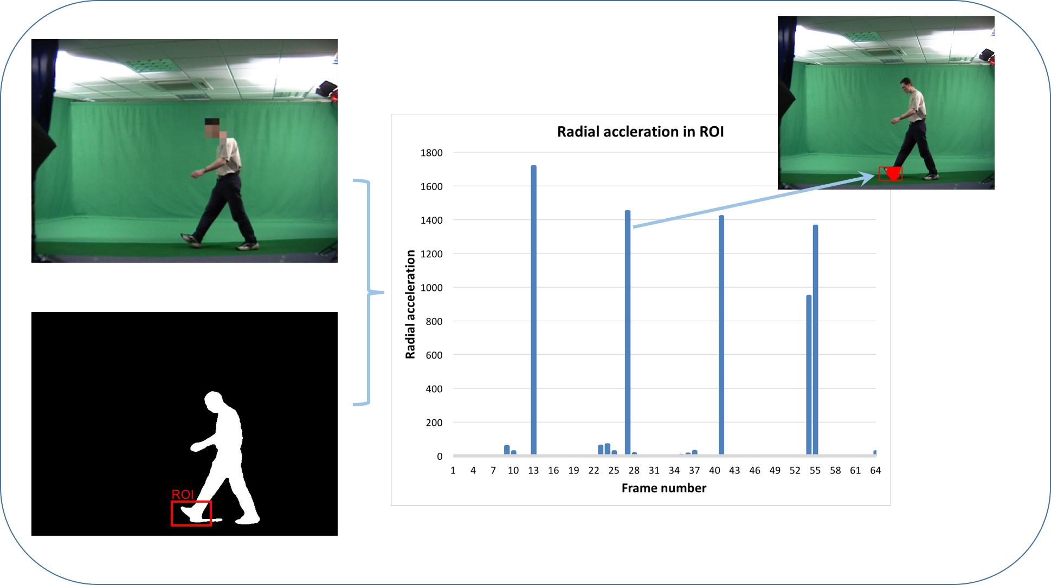

***Fig. 3*** *An overview of key frame detection.*

### Locating the Frame of Heel Strike

At the instant of heel strike, the foot hits the ground which forces its velocity to cease in a short time. Therefore, the acceleration of the front foot increases dramatically, due to the disappearance of velocity (rapid deceleration). Also, the striking foot sole’s motion is approximately circular during the period between the heel striking on the ground to fully touching the ground, centred at the heel. Hence, most acceleration caused by heel strikes is radial in nature. The video frames where the heel strikes then can be located by the quantity of radial acceleration. When people are walking, the motion of the body is similar to several joined penduli [27].

Therefore, the radial acceleration caused by a heel strike might be confused with that caused by other limbs since the motion of a pendulum incorporates radial acceleration. To reduce interference, we extract the region of interest (ROI) which is located on the leading foot according to a walking body model. The size of the ROI is where represents the height, shown in *Fig.* *4*.

At heel strike the acceleration on the front foot increases dramatically, due to the disappearance of velocity (deceleration). Also, the striking foot's motion is approximately circular, centred at the heel for a small period of time. Hence, most acceleration on the front foot is radial in nature. Heel strikes can be detected by determining when the number of radial acceleration of the front foot is the maximum. The position of the heel strike is the (circle) centre of radial acceleration.

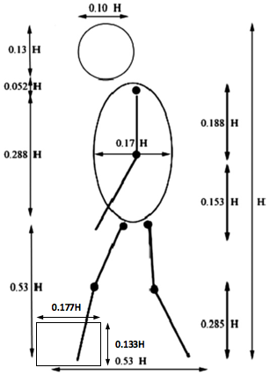

Figure 3: Gait proportions [13]

In implementation, we only consider the radial acceleration in the area we are interested in (the leading foot). The detection area is extracted according to a model of a walking human [13]. Regarding experiments, the area of detection **D** is defined as a rough area around the leading foot and the size of the area is 0.133H0.177H as illustrated in Figure 3. Only the radial acceleration in this area and points to the heel (below and posterior to the acceleration starting point) will be considered as valid data in our experiments.

When the heel strikes, the front foot is performing circular motion centred at the heel. We assume all the radial acceleration in the detection region is caused by a heel strike, then their centres of acceleration should all located at the same position: the heel (ie. the heel strike position).

The radial acceleration estimation algorithm is repeated for all points in the detection region to derive a set of all possible heel strike positions. In order to reduce the effect of noise, the location of the heel strike in frame *t* is estimated by a weighted sum of radial acceleration circle centres in the detection area:

(8)

where **O** is the set of all detected radial acceleration centres in detection area **D**. The weighting factor is determined by:

(9)

*n* is the number of radial acceleration centres that are located at the *k*th position, and *s* is the number of total detected radial acceleration in the detection region **D**.

Figure 4 shows a key frame at the detected moment of heel strike. The green square in the silhouette image is the detection region. Figure 5 is the histogram of radial acceleration within a walking sequence. A threshold has been applied to reduce the effect of noise. In the sequence, the radial acceleration appears regularly and noticeably during the sequence, showing the periodicity of gait. However, in frame 105, some radial acceleration also appears in the frames before heel strike. This is caused by the low frame rate. At this moments, the real heel strike occurs between the two consecutive frames.

|  |  |
| --- | --- |
| ICPRS16/77_meitu_1.png | sil-77.png |
| Figure 4: Detecting the region of interest. | |

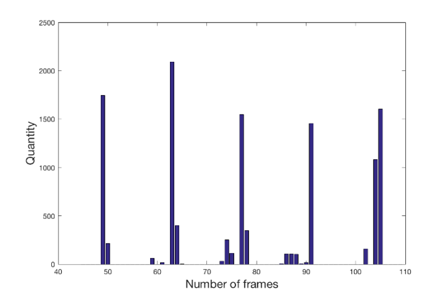

Figure 5: Detected radial acceleration of the leading feet.

### Positioning and Verification

The area of interest derived by gait proportions does not locate the leading foot precisely because the shape of the human body changes during the gait cycle. Also, a part of the calf can sometimes be included in the detection region. Moreover, there is also radial acceleration on other areas of the body because the limbs’ motion is that of several joined pendulums [3]. The erroneous radial acceleration vectors might also form some invalid heel strike candidates. To obtain accurate heel strike position which estimated by Equation 6, we use detected key frames to verify the heel strike candidates. In other words, the position of the heel strike is only considered to be in the frames in which the radial acceleration on the front foot peaks. If a heel strike occurs between frames, the position is obtained by the weighted coordinates sum according to the amount of radial acceleration in each frame (Equation 8 and 9). Figure 6(a) shows detected candidates of heel strike positions and (b) is the result after being filtered by key frames. The periodicity of gait is evident in the result.

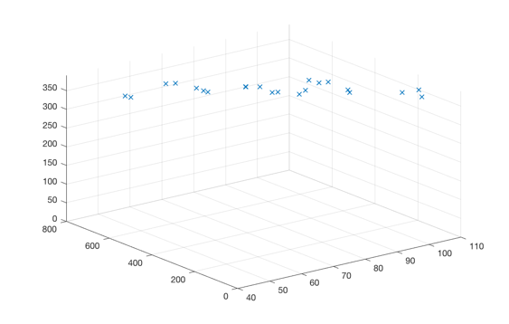

(a) Candidates for heel strikes

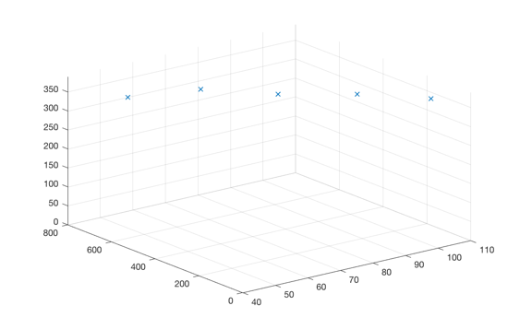

(b) Detected heel strikes (after filtering)

Figure 6: Heel strike verification process.

|  |  |
| --- | --- |
| Database | Detection rate |
| SOTON | 95.2% (254/267) |
| OU-ISIR | 94.8% (369/391) |

Table 1: Heel strike detection rates on different databases.

The images in Figure 7 illustrate the detection results on two different databases. These are the indoor SOTON [14] and OU-ISIR [15] gait datasets. Our heel strike detection system performs very well in both of them even if the lighting condition, the angles of view and walking direction are all different. Table 1 shows the outline detection rates of 50 sequences chosen at random from each database compared with the manually labelled ground truth. A distance of horizontal coordinates within ±5 pixels is considered as successfully detected. We successfully detected 254 out of 267 heel strikes in the SOTON and 369 out of 391 in OU-ISIR dataset. Compared with the results of a previous study of detecting heel strikes (95.6% on the SOTON gait database) [5], the detection rate is similar and our approach only requires three consecutive frames. The results in Figure 7(a) also show capability to detect heel strikes in outdoor imagery where the lighting is uncontrolled.

|  |  |
| --- | --- |
| ../Desktop/radial-43_meitu_2.jpg | ../Desktop/radial-30_meitu_1.jpg |
| (a) SOTON outdoor images | |
| ../Desktop/radial-58_meitu_3.jpg | ../Desktop/radial-72_meitu_4.jpg |
| (b) OU-ISIR indoor images | |
| ../Desktop/radial-77_meitu_5.jpg | ../Desktop/radial-63_meitu_6.jpg |
| (c) SOTON indoor images | |
| Figure 7: The heel strike detection results of different databases. | |

### Key Frames Positioning Performance on Different Databases

Since the performance of a system under interference is an important issue, we evaluate the robustness of our heel strike detection technique in this section. Three different types of noise that might deteriorate the detection results are added to the original gait sequences: Gaussian zero-mean white noise, occlusion in the detection area and insufficient resolution of the object. These noise reflect some of the anticipated difficulties when applying this new technique to real surveillance videos. Figure 9 illustrates the detection results of the noise at different levels. The results are evaluated by F-score:

(9)

First Gaussian distributed zero-mean white noise was added to each frame in the sequences. The accuracy of heel strike detection result drops dramatically when the variance increased to 12 and beyond as shown in Figure 9(a). Figure 8(a) shows that the image is quite adversely affected by this level of noise and it is not inconsistent with poor quality surveillance video.

|  |  |
| --- | --- |
| ../Documents/MATLAB/0.043-77.png | ../Desktop0.4-77.png |
| (a) Zero-mean Gaussian white noise (12) | (b) Occlusion  (40%) |
| Figure 8: Different types of noise are incorporated to the original sequence.  ../Documents/MATLAB/gaussian.png(a) Testing immunity to Gaussian white noise | |

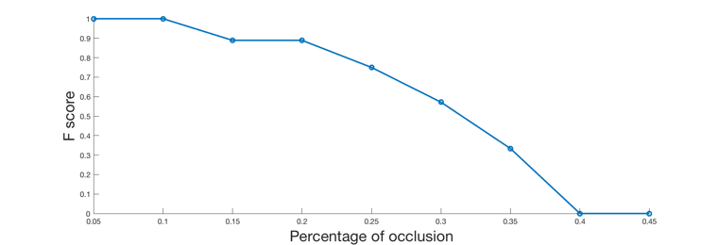

(b) Testing immunity to occlusion

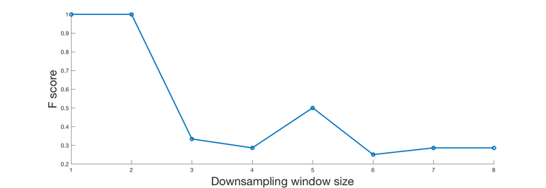

(c) Testing immunity to low resolution

Figure 9: Performance analysis of heel strikes.

Adding occlusion concerns whether the gait information in the real-world image sequences is complete or not. In the experiment of testing the immunity of heel strike detecting system to occlusion, we add addition of a random texture to cover the area of interest from toe to heel. The performance on occlusion decreases steadily and our approach totally failed when the detection area are covered over 40%. It is because the pixels on toe travelled the longest when heel strikes but most large radial acceleration located in the toe area are occluded.

Reducing resolution concerns whether resolution of the object might be insufficient in surveillance footage. The original images are down sampled by different window sizes. The F-score with insufficient resolution decreases below 0.3 when the down sampling window’s size increases up to 4×4 patches then the detection results fluctuate at similar level subsequently. The height of the subject is reduced from 350 pixels to 87 approximately when the window size is 4×4. The most critical issue for evaluating the performance on low resolution images is setting the threshold for the magnitude of radial acceleration. In the experiments, the thresholds are set at the same rate with down sampling window’s size but the system still misses most heel strikes. It is the main reason that causes the low F-score while the window size bigger than 2×2.

Overall, acceleration algorithm shows good robustness in the experiments although there is certain level fluctuation. One of the most important reasons of fluctuation is that the number of heel strike in one gait sequence is low (5 in one sequence). A wrong prediction can make a significant influence on the results. As such the technique appears to be able to tolerate noise, occlusion and resolution effects that are often found in surveillance imagery.

### Error Analysis

## Conclusion

# Finishing

## Printing and PDFs

There’s even advice on ways to improve you [printing](https://guides.soton.ac.uk/uni/isolutions/lg-office-2013/start/default.htm?B3BA6016-BA29-4074-8750-ED984008519A) experience and the [PDF](https://guides.soton.ac.uk/uni/isolutions/lg-office-2013/start/default.htm?DE05446D-6E1B-4D7B-9574-4CFF1053550B) version of your file.

1. Your first appendix
2. Your second appendix

Glossary of Terms

List of References

Bibliography

1. Image is taken from: <https://www.youtube.com/watch?v=F1b_apXjjV0&feature=youtu.be> [↑](#footnote-ref-1)