**RFID(LINUX)**

**RFID PROJECT REPORT**

Prepared By:

**Van Tze Shan**

User Guide

10 January 2020

### IMPORTANT NOTICE

### ALL RIGHTS RESERVED

Software and documentation are the confidential property and contain the trade secrets of

Prestige Atlantic Asia Sdn Bhd

1-2, Jalan 5/125D, Taman Desa Petaling

57100 Kuala Lumpur

Malaysia

Tel: 603-90573428 Fax: 603-90575088

e-mail: [support@prestigeatlantic.com.my](mailto:support@prestigeatlantic.com.my)

website: [www.prestigeatlantic.com.my](http://www.prestigeatlantic.com.my)

Any copying, use, disclosure, modification, transfer or otherwise must have written consent from

Prestige Atlantic Asia Sdn Bhd

# Contents

## Chapter 1

## Introduction

Project introduction 1

## Chapter 2

## /RD/p01/ Folder

/RD/p01/ folder and files 2

## Chapter 3

## Program Flow

LOGIN page 4

p01menu 4

Create ID (CRID) 5

Setup Project (FMPJ) 5

Setup ID (FMID) 6

View ID (VWID) 7

Print ID (PTID) 8

Output of printing records 9

Mobile Scanner (SCHHID) 10

Fixed Reader – Single Read (SCFRID) 10

Fixed Reader – Multiple Read (SCFRID2) 10

## Chapter 4

## Configuration

/RD/p01/RFID/prg/etc/iscobol.properties 11

/RD/p01/RFID/prg/iscobol.properties 11

Other-db-compiler.properties 12

## Chapter 5

## Compilation and Run

How to Compile? 13

How to Run? 13

## Chapter 1 – Introduction

**Project Introduction**

This project is to use RFID Fixed Reader in isCOBOL with MariaDB using CentOS 7.

**OPERATING ENVIRONMENT**

|  |  |
| --- | --- |
| OPERATING SYSTEM | CENTOS 7 |
| DATABASE | MARIA DB |
| COBOL COMPILER | ISCOBOL COMPILER |
| COBOL DATA BRIDGE | ISCOBOL DATA BRIDGE |
| RFID PROGRAMMING | JAVA |
| FILE SYSTEM | /RD |
| FOLDER | /RD/p01 |
| RFID PRINTER | RFID PRINTER + RFID TAG |
| RFID READER | FIXED READER + ANTENNA WITH LAN |
| RFID MOBILE READER | MOBILE READER WITH WIFI |

**CENTOS 7**

* A stable, predictable, manageable and reproducible platform derived from the sources of Red Hat Enterprise Linux (RHEL).
* Freely provided
* Approximately every 6-12 months for minor point releases and several years for major version bumps.
* This version of CentOS support until 30 June 2024.

**MARIADB**

* A popular open source relational database.
* It's made by the original developers of MySQL and guaranteed to stay open source.
* It is part of most cloud offerings and the default in most Linux distributions.
* It is built upon the values of performance, stability, and openness, and MariaDB Foundation ensures contributions will be accepted on technical merit.
* Recent new functionality includes advanced clustering with Galera Cluster 4, compatibility features with Oracle Database and Temporal Data Tables, allowing one to query the data as it stood at any point in the past.

**RFID(LINUX)**

* A system that can read/insert/delete RFID tag records from MariaDB.
* Connection of MariaDB and the system through isCOBOL EasyDB data bridge.
* RFID hand-held reader or Fixed Reader is used to read the tags then insert the records to MariaDB.
* The file description for project (FDPJ) and ID tag(FDID) are as below

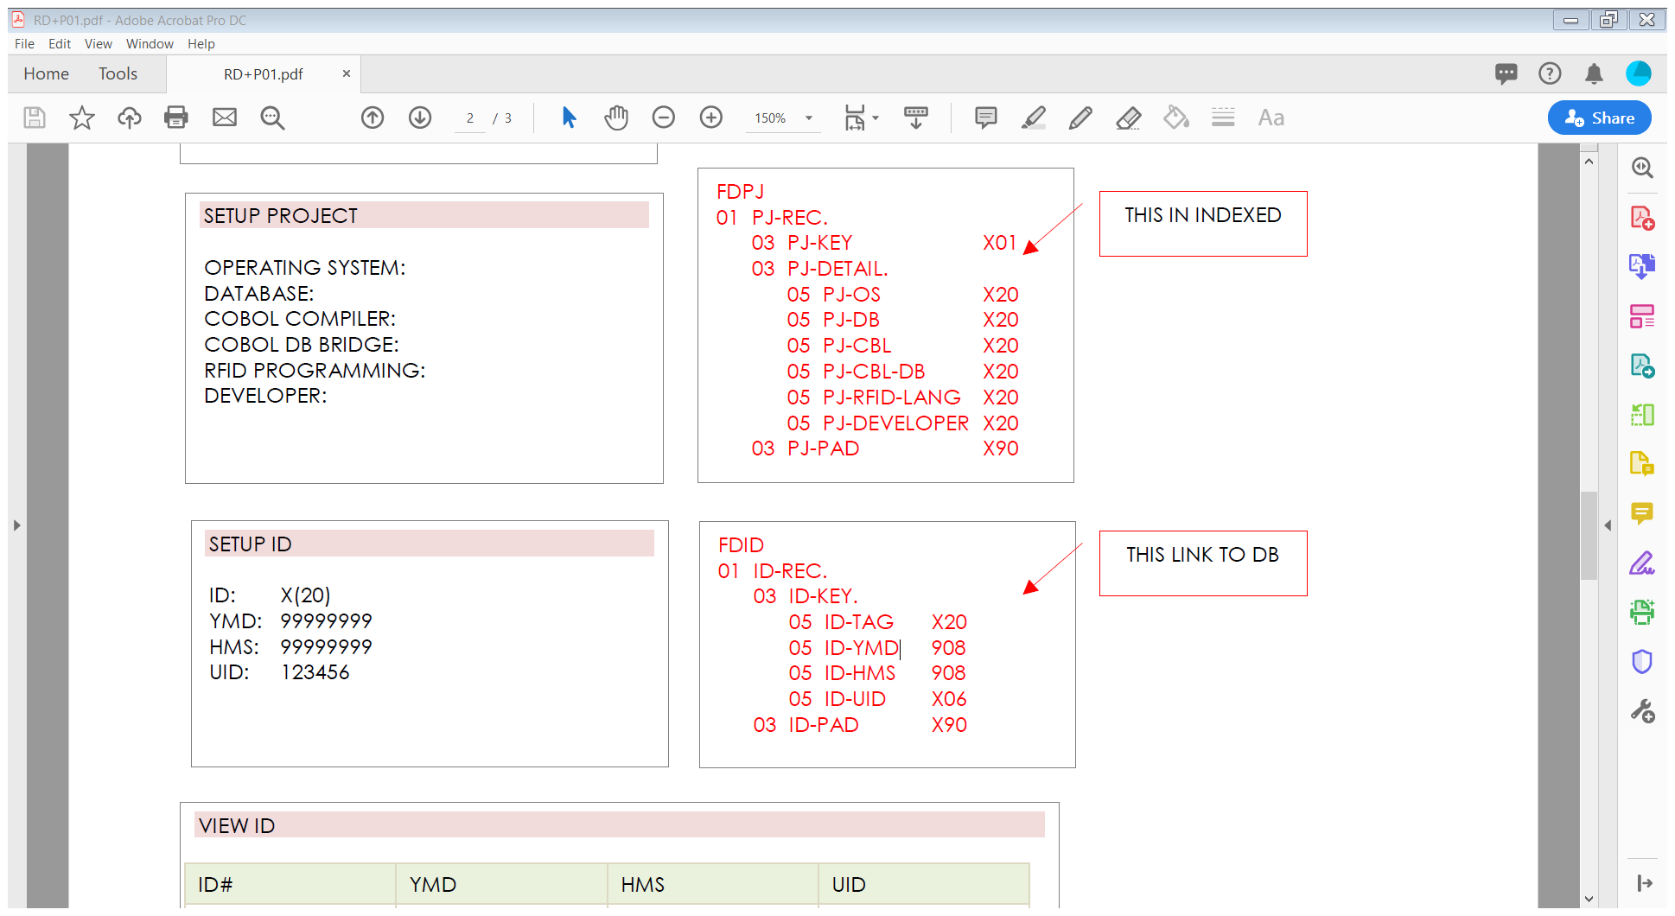

## Chapter 2 – /RD/p01/ Folder

**/RD/p01/ folder and files**

|  |  |
| --- | --- |
| **Folder** | **Description** |
| Cprt,db, hotkey,lib,library,mgr,p,r,sam | Takes from company library, 128.0.0.247.  Use as library for screen, printing, errors message, function key |
| RFID | RFID program is inside this folder. Contain login, main menu, project creation, ID creation, ID File Maintenance, View ID, Print ID, Scanning Hand-Held ID, Scanning Fixed-Reader ID (Single read), Scanning Fixed-reader ID (Multiple read)* |

* Not functioning as the device is not available

## Chapter 3 – Program Flow

**LOGIN page**

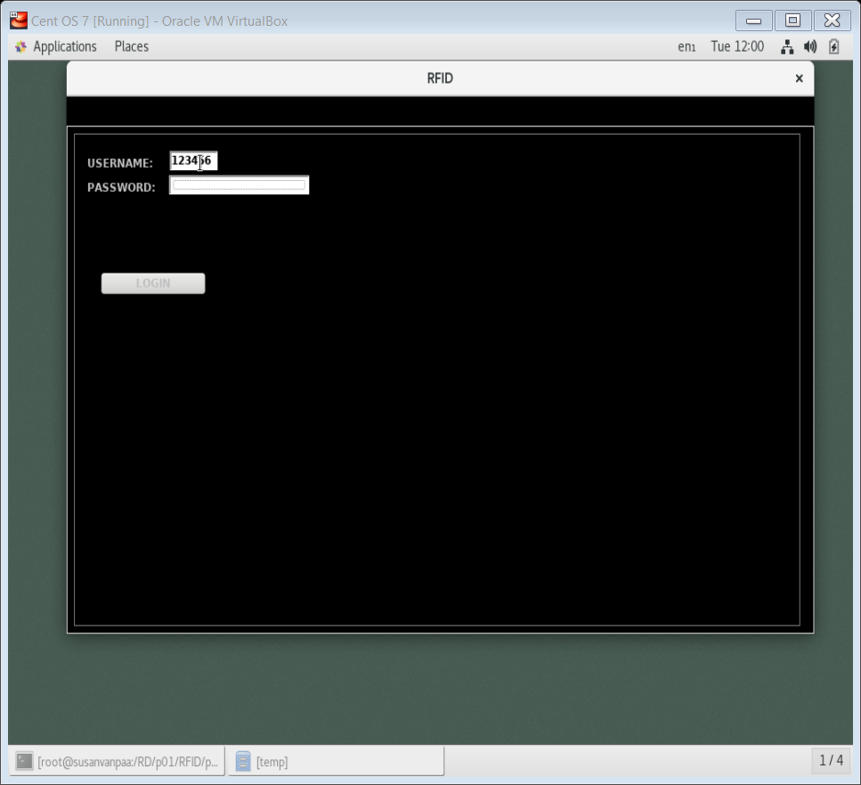

|  |  |
| --- | --- |
| **Function** | **Description** |
| Login | Login using any userID (up to 6 characters). Passowrd function is not available yet. The userID will then pass for future use, eg: FMID. |

**P01menu**

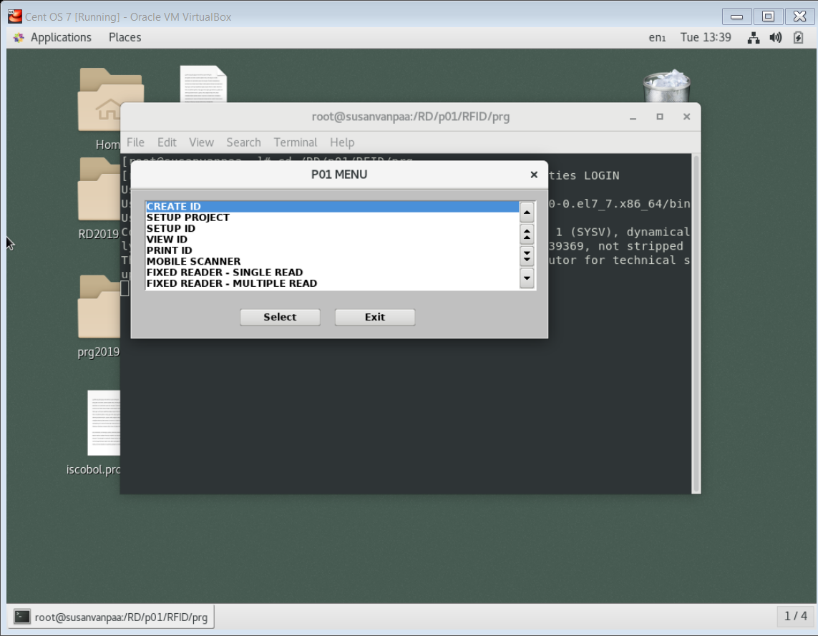

|  |  |
| --- | --- |
| **Function** | **Description** |
| CREATE ID | ID database creation |
| SETUP PROJECT | Project information manipulation |
| SETUP ID | ID information manipulation:  Insert new scanning record  Review the pass records  Delete the pass recards |
| VIEW ID | View records in a list form |
| PRINT ID | Print the selected range of records (export to text file in /RD/p01/r/[userID].txt |
| MOBILE SCANNER | Scanning records using Hand-held reader |
| FIXED READER – SINGLE READ | Scanning records using RFID fixed-reader with single card reading mode |
| FIXED READER – MULTIPLE READ | Scanning records using RFID fixed-reader with multiple cards reading mode |

**Create ID (CRID)**

|  |  |
| --- | --- |
| **Function** | **Description** |
| CREATE ID | ID database creation  ID database as in MariaDB, ‘ID’ table |

**Setup Project (FMPJ)**

|  |  |
| --- | --- |
| **Function** | **Description** |
| PROJECT SETUP | Project setup requirements** button |

**Setup ID (FMID)**

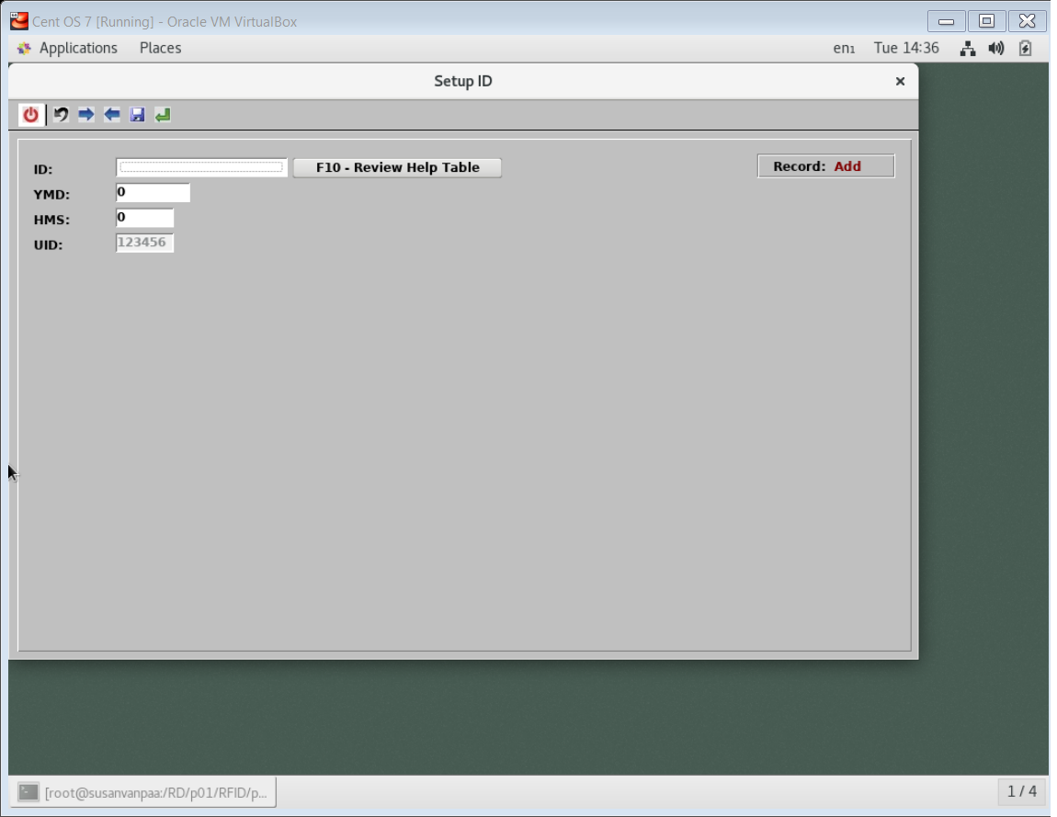 **Add mode**

**ID Help Table**

**Review mode**

|  |  |
| --- | --- |
| **Function** | **Description** |
| Add mode | ID records manipulation  Add mode:   * Insert a new record by inserting the details of records and save it * UID is not changeable as that is according to Login page UID * To enter review mode, press ‘Review Help Table’ |
| Help Table | Help table is the only way to enter review mode.  It is a list of records.  By selecting the record, it will pass the information to review mode. |
| Review Mode | Review mode:   * Cannot change the information of the record * But can delete the record * Back to Add mode when click the ‘Back’ button |

**View ID (VWID)**

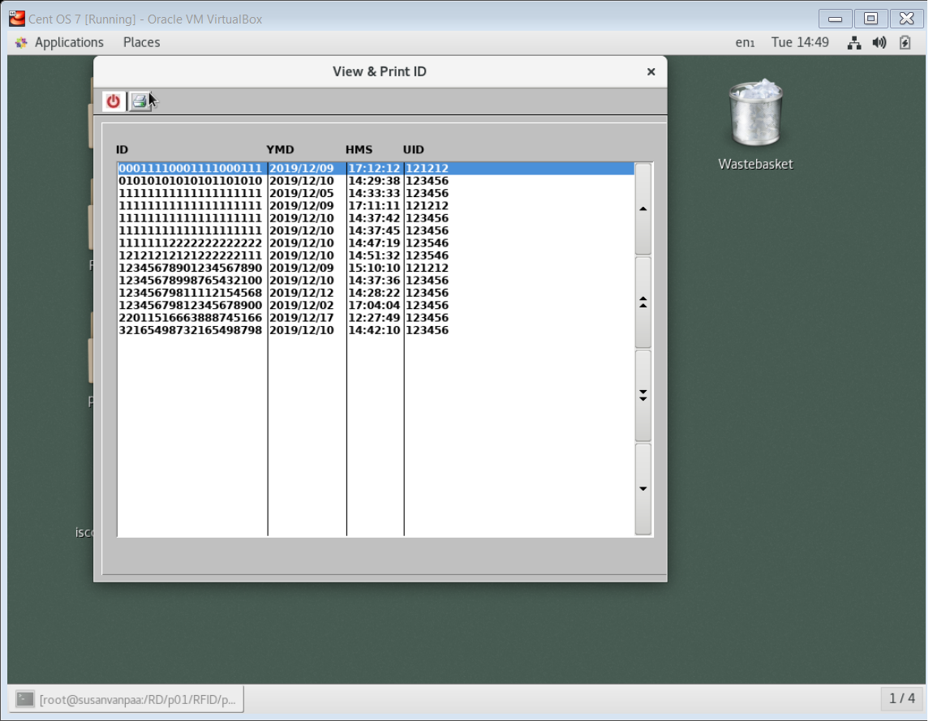

|  |  |
| --- | --- |
| **Function** | **Description** |
| VWID | View the records in a list form  Sort by ID tag |

**Print ID (PTID)**

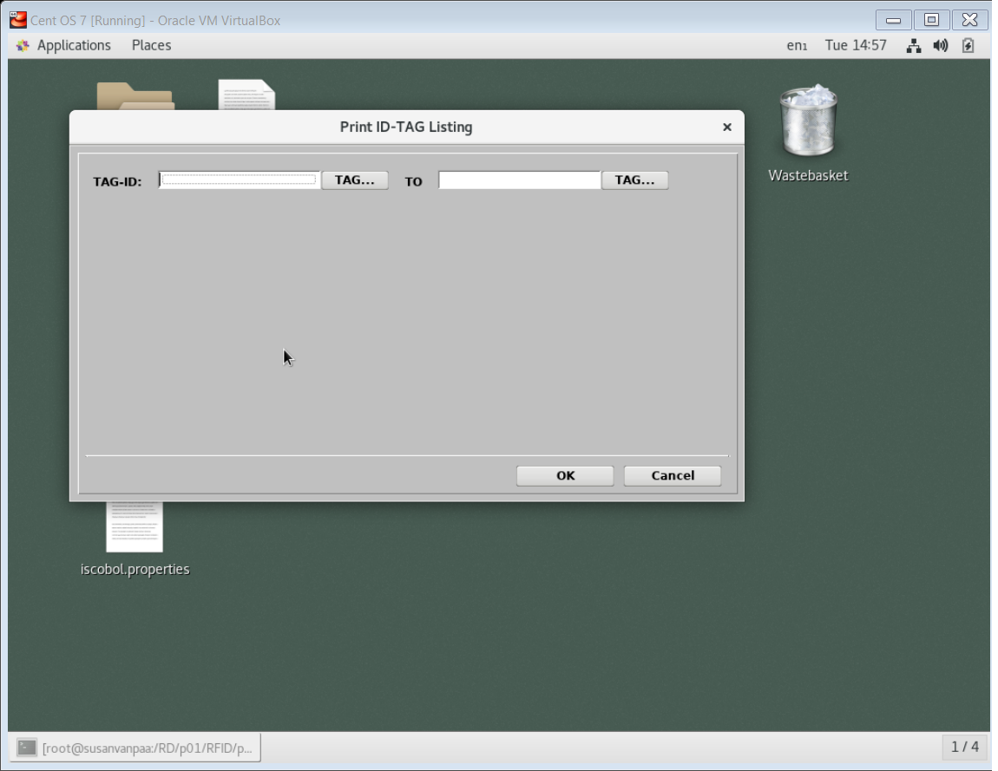 **Print ID**

**Printer Selection**

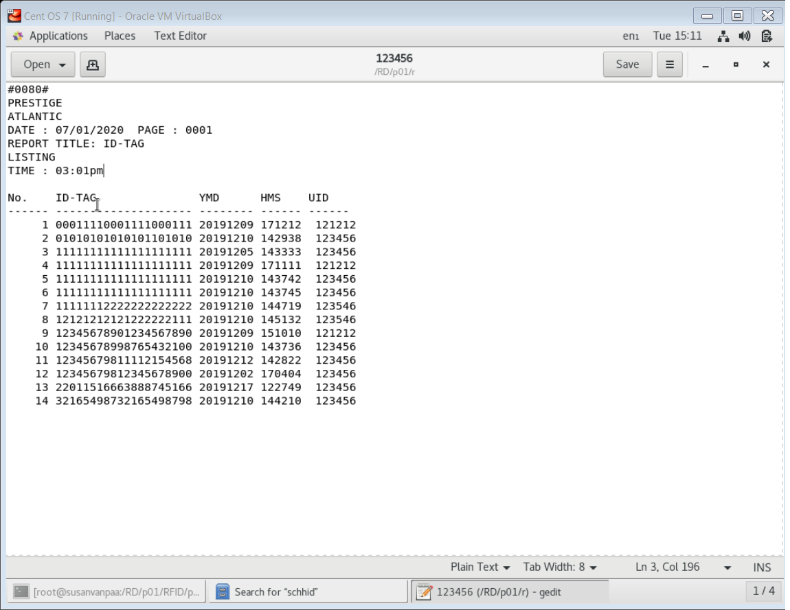

**Output of printing records**

|  |  |
| --- | --- |
| **Function** | **Description** |
| PRINT ID | Print the selected recordd range  Due to different COBOL application, the Viewer is not available as AcuViewer is Acucorp’s product  Due to different OS problem, the library for printer driver is not compatible to CentOS, originally is Windows  The selected records thus will export in form text file and save it in the /RD/p01/r/ folder, name is userID |
| Help Table | To help user to select ID tag |
| Printer Selection | To select to print to AcuViewer or printers or export to Excel or export to PDF file |

**Mobile Scanner (SCHHID)**

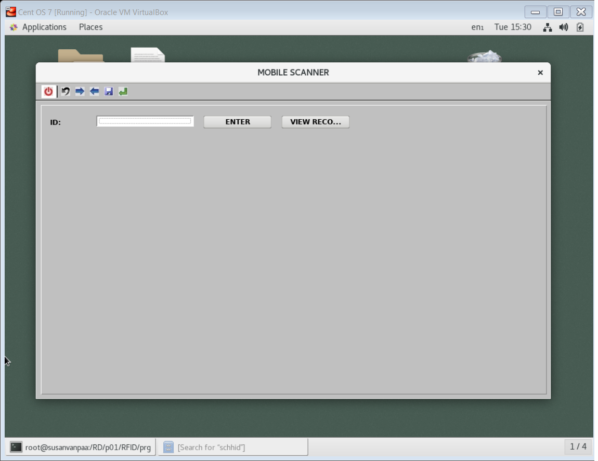

|  |  |
| --- | --- |
| **Function** | **Description** |
| SCHHID | This is using RFID Hand-held reader to scan the tag and insert record automatically  Proceed to Review Mode by clicking the view record button  Review mode is same as FMID review mode |

**Fixed Reader – Single Read (SCFRID)**

|  |  |
| --- | --- |
| **Function** | **Description** |
| SCFRID | This is using RFID Fixed Reader to scan the tag and insert record  In this mode, it only can read one tag at one time. |

* Not done due to device not available

**Fixed Reader – Multiple Read (SCFRID2)**

|  |  |
| --- | --- |
| **Function** | **Description** |
| SCFRID2 | This is using RFID Fixed Reader to scan multiple tag and insert the records at once  In this mode, it support scanning multiple tag reading |

* Not done due to device not available

## Chapter 4 – Configuration

**/RD/p01/RFID/prg/etc/iscobol.properties**

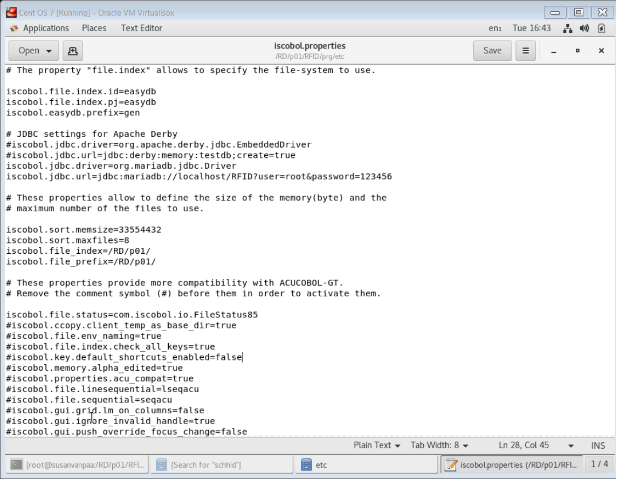

|  |  |
| --- | --- |
| **Function** | **Description** |
| iscobol.file.index.id=easydb  iscobol.file.index.pj=easydb | The default file index for iscobol is JISAM.  As the ID and PJ is from MariaDB, therefore, to gain the data or to modify the data in MariaDB, we need to create EasyDB data bridge. |
| iscobol.jdbc.driver=org.mariadb.jdbc.Driver  iscobol.jdbc.url=jdbc:mariadb://localhost/RFID  ?user=root&password=123456 | JDBC is Java Database Bridge Connector, for MariaDB JDBC, it is available in the MariaDB website. The code is to let EasyDB to login to our MariaDB using ‘root’ as user and ‘123456’ as password. |
| iscobol.easydb.prefix=gen | To differentiate the program generated from easyDB, we declare ‘gen’ as its prefix. |
| Iscobol.file.status=com.iscobol.io.FileStatus85 | This is to make iscobol more compatibility with program that generated from ACUCOBOL-GT. |

**/RD/p01/RFID/prg/iscobol.properties**

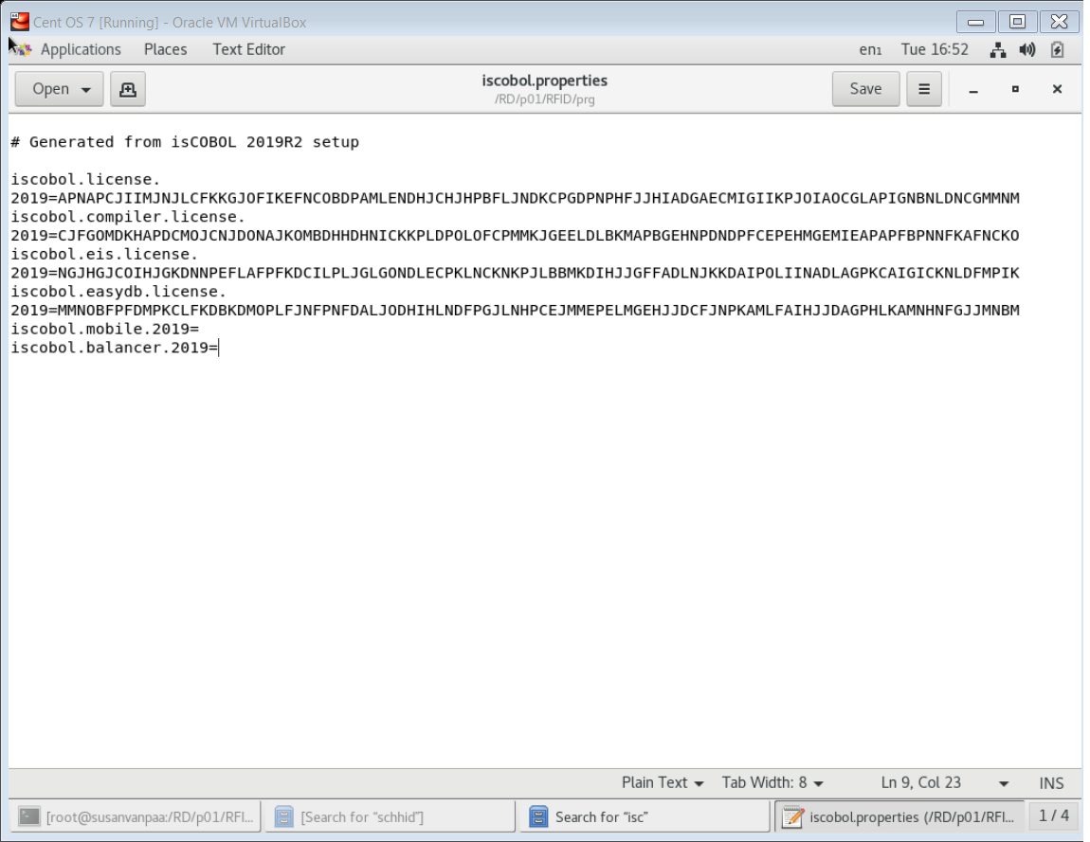

|  |  |
| --- | --- |
| **Function** | **Description** |
| iscobol.license | License key for iscobol IDE |
| iscobol.compiler.license | License key for iscobol compiler |
| iscobol.eis.license | License key for iscobol EIS |
| iscobol.easydb.license | License key for iscobol EasyDB |

**other-db-compiler.properties**

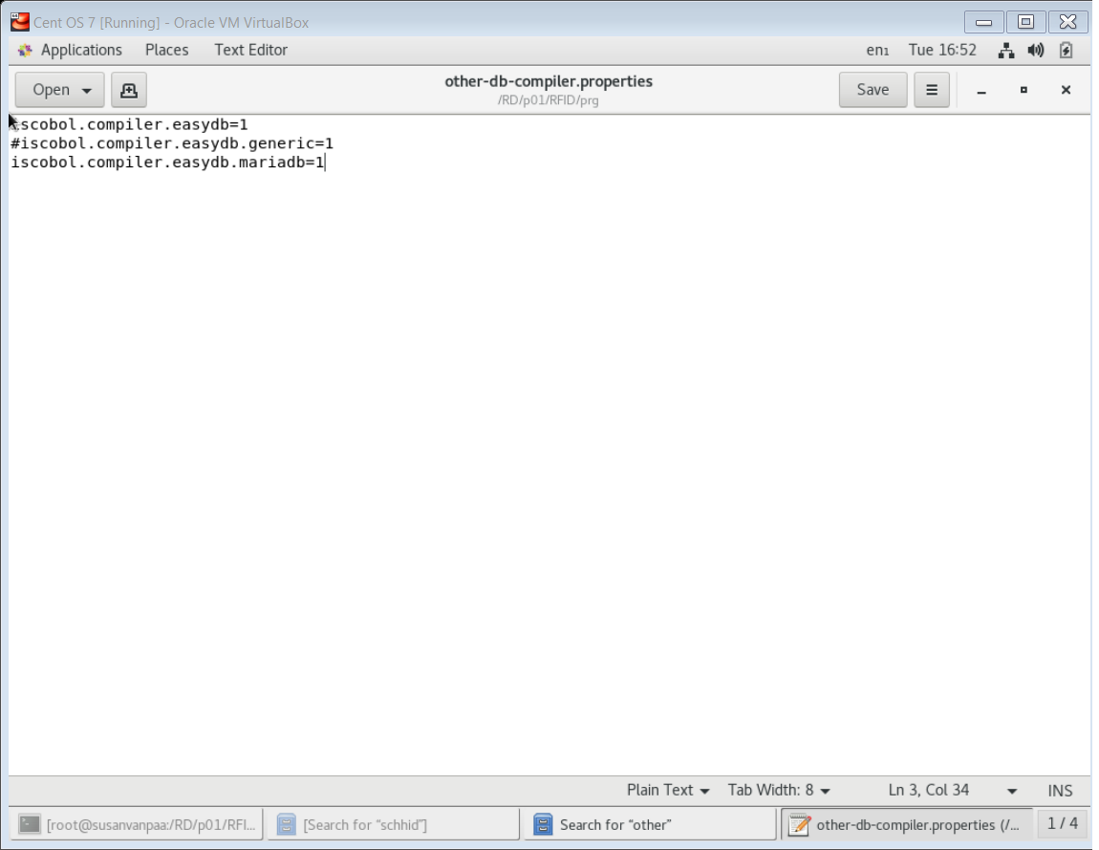

This properties is saved in the /RD/p01/RFID/prg/ folder.

|  |  |
| --- | --- |
| **Function** | **Description** |
| iscobol.compiler.easydb=1 | To compile the program with EasyDB |
| iscobol.compiler.easydb.mariadb=1 | To compiler the program with MariaBD through EasyDB |

## Chapter 5 – Compilation and Run

**How to Compile?**

The programs were written in text writter and save in.cbl format.

After saving it, compile it with command. Eg:

*./bin/iscc file.cbl*

Compile with debugger mode just need to add ‘-d’ in front of the filename. Eg:

./bin/iscc -d file.cbl

If the program need to connect the database in MariaDB server, it needs to compile with the other-db-compiler.properties. Eg:

*./bin/iscc -c=other-db-compiler.properties -sp=isdef fmpj*

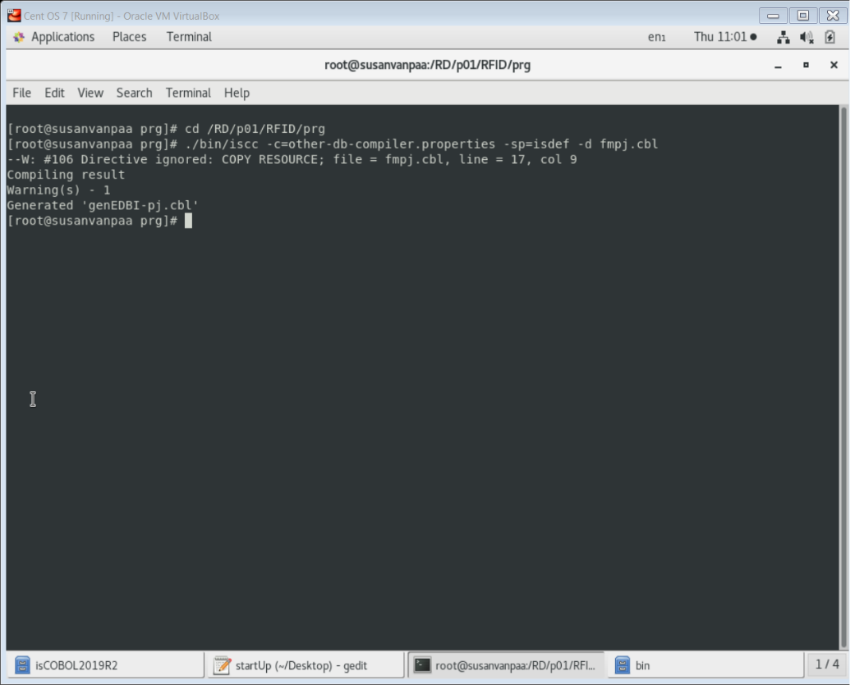

**How to Run?**

To run the program, the filename must be in capital letters and without extension. Eg:

*./bin.iscrun -c ./etc/iscobol.properties FILENAME*

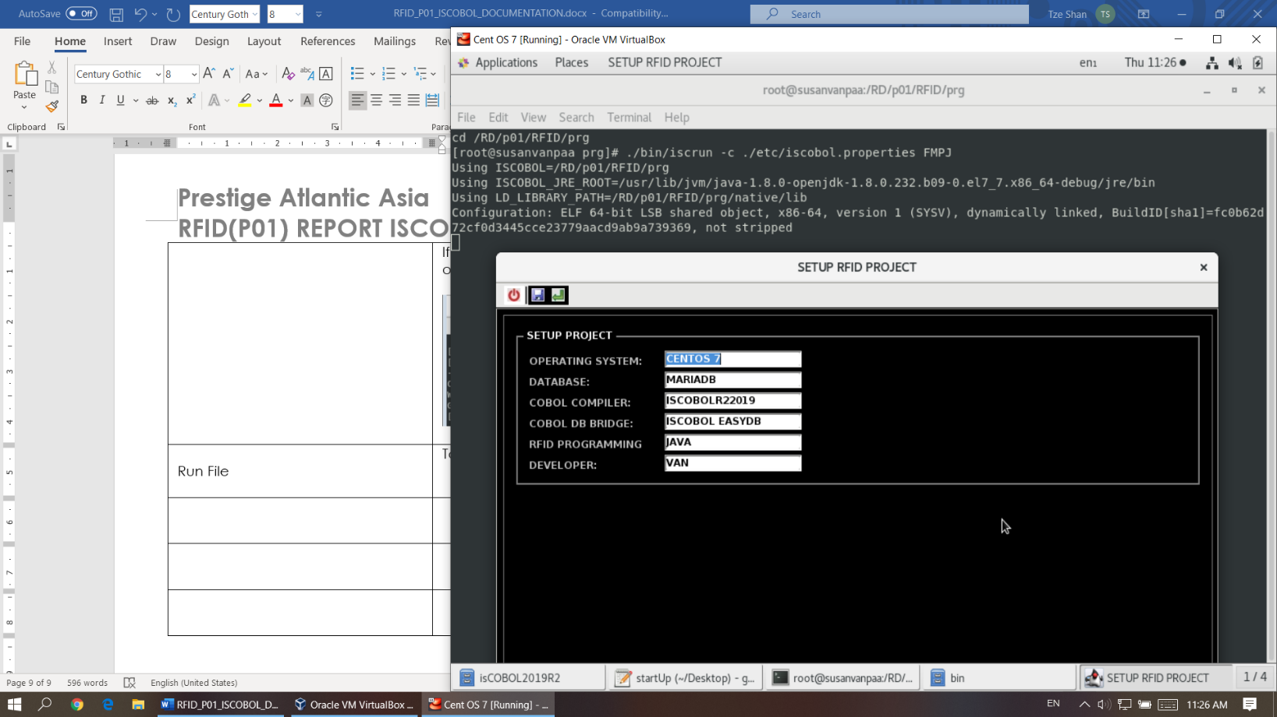

To enter to debugger mode, just add ‘-d’ in front of the filename.