

**Data Technician**

|  |
| --- |
|  |

|  |
| --- |
| Name: |
| Course Date: |
|  |

**Table of contents**

Day 1: Task 1 3

Day 1: Task 2 3

Day 1: Task 3 4

Day 2: Task 1 5

Day 3: Task 1 9

Day 3: Task 2 10

Day 3: Task 3 11

Day 4: Task 1 12

Day 4: Task 2 13

1. Scenario Background 13

2. Data Laws and Regulations 14

3. Azure Service Recommendations 14

4. Data Types and Data Modelling 14

5. Data Storage Formats and Structures in Azure 14

6. Additional Considerations 15

Submission Guidelines: 15

Course Notes 17

Additional Information 17

# Day 1: Task 1

Please research and complete the below questions relating to key concepts of cloud.

Be prepared to discuss the below in the group following this task.

|  |  |
| --- | --- |
| What can cloud computing do for us in the real-world? | It allows us to:  Remote work and collaboration tools (Teams, Microsoft), Streaming services,  online banking,  virtual classrooms,  NHS access to patient data |
| How can it benefit a business? | Reduce costs in data storage, can be use scaling up or down based on demand, back up in a case of losing data, collaborations in real time, customers everywhere |
| What’s the alternative to cloud computing? | On premises infrastructure. Renting space for hardware in a data centre (third part) |
| What cloud providers can we use, what are their features and functions? | AWS (databases, extensive services), Azure (Microsoft product), Google Cloud. |

# Day 1: Task 2

Please research the below cloud offerings, explain what they are and examples of use cases.

|  |  |  |
| --- | --- | --- |
| Cloud Offerings | Explain what it is | When / how might you use this service in the real-world? |
| IaaS (Infrastructure as a service) | You rent virtual machines, storage, network without owning the physical servers, operating systems from a cloud provider | Scalable infrastructure.  A startup to launch an e commerce, manage databases |
| PaaS (Platform as a service) | Gives a platform, ready to use for testing, manage applications....not worrying about the server or infrastructure | To build a website, or mobile app focusing on the CODE.  To build a customer portal. |
| SaaS (Software as a service) | Manages your data without installing anything.  Gives you access to certain needed software | Storage in Dropbox, google drive...  Access for a company to software (Microsoft email, collaboration on teams, all Microsoft components) |

# Day 1: Task 3

Please research the below terms and explain what they are, when they would be appropriate and a real-world example of where it could be implemented (i.e. what type of organisation).

|  |  |
| --- | --- |
| Public Cloud | It is owned and operated by a third-party provider (like AWS, Azure, or Google Cloud) and delivers services like storage, servers, and applications over the internet. Resources are shared among multiple users.  Appropriate When cost savings and scalability are important, for development environments  Real sample: Online retailers, small businesses/startups |
| Private Cloud | It is a cloud environment dedicated to one organization. Run on the premises or by a third party, but the infrastructure is not shared  Appropriate when you need high security, custom infrastructure, industries with sensible data (banks, healthcare)  Real Sample: Any hospital and any bank |
| Hybrid Cloud | It combines both public and private cloud environments, allowing data and applications to move between them.  Appropriate, the organization needs flexibility of public cloud and control/security of the private cloud  Also, on gradual cloud migration  Real Sample: Government agency with public face service and private cloud for internal systems |
| Community Cloud | is shared by several organizations with similar requirements or interests (e.g., compliance, security). It can be managed internally or by a third party.  Appropriate: Organisations with common goals. On surveys?  Research institutions, healthcare alliances, public sector groups  Real Sample: Multiple hospitals sharing a community cloud to manage regional data.  Local government collaborating in public service apps in a shared environment. |

# Day 2: Task 1

Describe, with examples, the **three** major areas that the Computer Misuse Act deals with.

|  |  |  |
| --- | --- | --- |
| Area | Description | Example |
| Unauthorised access to computer material | Accessing computer systems or data without permission | Hacking somebody’s email account without consent |
| Unauthorised access with intention to commit further offences | Gaining unauthorised access  With the intention of committing further crimes | Accessing a company’s database to steal data from customers |
| Unauthorised access with intention to impair operations | Actions to impair the operation of computers or programs | Introducing malware to disrupt a company’s network operations. |

The computer misuse act 1990 is an act where an individual can be criminalised because of computer related offense. Describe three extra powers that the Police and Justice Act 2006 (Computer Misuse) has added.

|  |
| --- |
| Description |
| Increased penalties for offences, The Act raised the maximum penalties for certain offences. |
| Criminalisation of denial of service attacks. The Act makes an offence to intentionally perform DoS attack to disrupt services. |
| Offence of making , obtaining articles for use in offences. It becomes illegal to create, distribute or obtain software with the intention to commit offences |

Look at the below website to answer the questions:

<https://www.gov.uk/personal-data-my-employer-can-keep-about-me>

|  |
| --- |
| Write down three items of data which a company can store about an employee. |
| Emergency contact details |
| Employment terms and conditions |
| Disciplinary action |

|  |
| --- |
| Give three more examples of data that an employer can only store if they first get the employee’s permission. |
| Political opinions |
| Health or medical information |
| Trade union membership |

Conduct further research to answer the below questions.

|  |  |
| --- | --- |
| Question | Answer |
| Provide one example of: Copyright infringement | Use music from a band in a political campaign without consent form the band’ |
| Provide one example of: Plagiarism | Copying an article and publish it as yours.  Or,  lyrics music/sounds copying in a new song |
| What are two consequences of copyright infringement and software piracy? | Legal penalties, up to £250k and imprisonment  Civil Liability, paying damages |
| Give three possible consequences for individuals when using pirated software | Legal action, facing lawsuits, fines, potential imprisonment.  Security risks, increased vulnerability to any cybersecurity threats.  Lack of support and updates. |

Listed below are some laws which we have covered today:

1. Computer Misuse Act 1990

2. Police and Justice Act 2006 (Computer Misuse)

3. Copyright, Designs and Patents Act 1988

4. Copyright (Computer Programs) Regulations 1992

5. The Health and Safety (Display Screen Equipment) Regulations 1992

6. Data Protection Act 2018

7. Consumer Rights Act 2015

* Insert a number in the first column of each row to match each of the statements with one of the above Acts.
* One of statements is incorrect and not illegal. For this statement, write ‘Not illegal’.

|  |  |
| --- | --- |
| **Act number** | **Clause** |
| 4 | With some exceptions, it is illegal to use unlicensed software |
| 7 | Any product, digital or otherwise, must be fit for the purpose it is supplied for |
| 1 | Unauthorised modification of computer material is illegal |
| Not illegal | It is illegal to create or use a hacking tool for penetration testing |
| 6 | Personal data may only be used for specified, explicit purposes |
| 5 | Employers must provide their computer users with adequate health and safety training for any workstation they work at |
| 2 | It is illegal to distribute hacking tools for criminal purposes |
| 3 | It is illegal to distribute an illicit recording |
| 6 | Personal data may not be kept longer than necessary |
| 1 | Gaining unauthorised access to a computer system is illegal |
| 5 | Employers must ensure that employees take regular and adequate breaks from looking at their screens |
| 2 | It is illegal to prevent or hinder access (e.g. by a denial-of-service attack) to any program or data held in any computer |
| 6 | Personal data must be accurate and where necessary kept up to date |

# Day 3: Task 1

Please complete the below lab (3) *‘Explore relational data in Azure’* and paste evidence of the completed lab in the box provided.

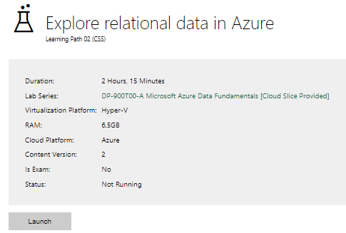

|  |  |
| --- | --- |
| Completed lab |  |

Complete the exercises below if finished early. [Azure Lab 1 Exercises](https://forms.office.com/e/kz2sCX75fc)

# Day 3: Task 2

Please complete the below lab (4) *‘Explore non-relational data in Azure’* and paste evidence of the completed lab in the box provided.

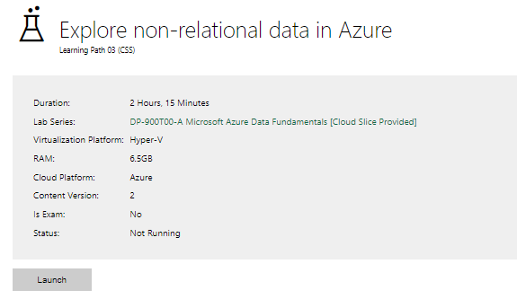

|  |  |
| --- | --- |
| Completed lab |  |

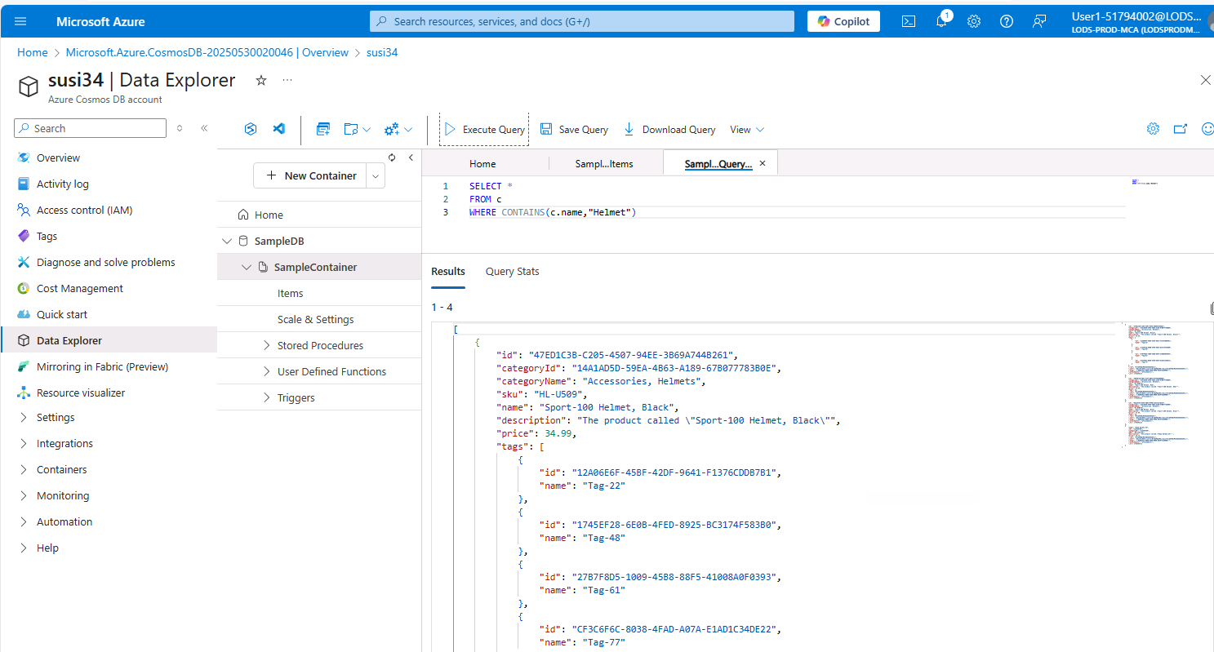

I have documented each step I've completed, in case I need to restart the process, like in the previous lab, so you could see where I ended each time.

# Day 3: Task 3

Please complete the below lab (5) ‘Explore data analytics in Azure’ and paste evidence of the completed lab in the box provided.

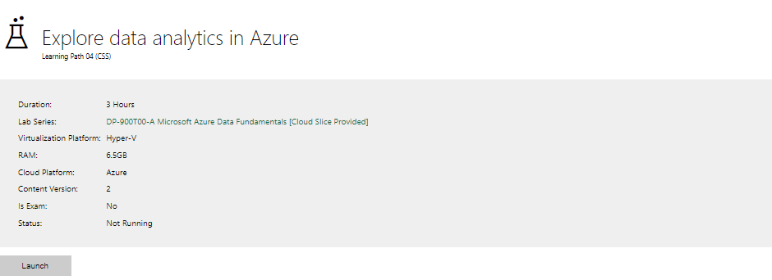

|  |  |
| --- | --- |
| Completed lab |  |

# Day 4: Task 1

In your teams, complete the Azure DP-900 practice exam and paste your result below – this is open book and please research and discuss your answers as a team.

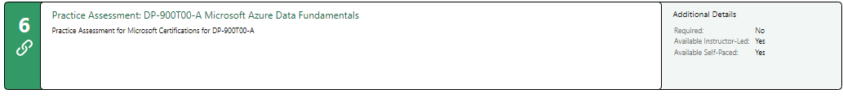

|  |  |
| --- | --- |
| Result |  |

# Day 4: Task 2 (Optional)

#### **1. Scenario Background**

"Paws & Whiskers" is a growing pet shop that aims to improve its business by analysing sales, customer information, and inventory data. Currently, the data is collected manually or stored in spreadsheets. Management is interested in transitioning to Microsoft Azure to streamline data storage, analysis, and reporting, enabling them to make data-driven decisions.

#### **2. Data Laws and Regulations**

Identify and explain the data laws and regulations relevant to handling customer data within the proposal. Ensure you cover the following points:

* **GDPR Compliance**: Highlight the importance of adhering to the General Data Protection Regulation (GDPR), particularly as it relates to storing and processing customer information.
* **Data Protection Act (DPA) 2018**: Outline how the DPA 2018 may affect the way "Paws & Whiskers" collects and stores data, ensuring compliance with UK laws on data privacy.
* **Other Industry Standards**: Research any additional data protection standards or regulations that may apply to pet shop data, particularly if they involve sensitive or payment information.

#### **3. Azure Service Recommendations**

Recommend Microsoft Azure services that would suit the company’s data analysis needs and explain why these services are suitable. Your recommendations should include:

* **Data Storage**: Identify suitable storage options, such as **Azure Blob Storage** or **Azure SQL Database**, and discuss the benefits of each for storing large datasets, including inventory, sales transactions, and customer details.
* **Data Analysis Tools**: Recommend tools such as **Azure Machine Learning** for customer behaviour analysis or **Azure Synapse Analytics** for analysing sales trends.
* **Data Integration and Automation**: Explain how services like **Azure Data Factory** could automate data collection and integration processes, improving efficiency.

#### **4. Data Types and Data Modelling**

Define the types of data "Paws & Whiskers" will need to work with and describe your approach to data modelling:

* **Data Categories**: Identify key data types, such as customer demographics, transaction history, pet inventory, and product categories.
* **Data Modelling Approach**: Outline how you would structure this data using a relational model or a data warehouse approach, considering factors like tables, entities, relationships, and primary keys.

#### **5. Data Storage Formats and Structures in Azure**

Discuss how you would store data within Azure and the formats you would recommend:

* **Data Formats**: Specify recommended formats (e.g., CSV for raw data imports, JSON for structured data, Parquet for analytics) and explain why these formats are suitable for specific data types.
* **Data Security and Encryption**: Include recommendations for securing data using Azure’s built-in encryption features and access controls to ensure compliance with data privacy regulations.

#### **6. Additional Considerations**

Provide any other considerations that might enhance data handling and efficiency in Azure, such as:

* **Backup and Disaster Recovery**: Outline a backup plan using **Azure Backup** or **Azure Site Recovery** to safeguard against data loss.
* **Data Visualisation**: Discuss potential use of **Power BI** within Azure for creating dashboards that provide management with real-time insights into sales and customer trends.
* **Future Scalability**: Comment on how Azure services can scale as the business grows, accommodating larger datasets and more complex analyses.

### **Submission Guidelines:**

1. **Structure**: Ensure your report is well-organised, with sections for each task (e.g., Data Laws, Azure Services, Data Types, etc.).
2. **Formatting**: Include headings, bullet points where appropriate, and any visuals or diagrams that support your explanations.
3. **References**: Cite any resources or regulations referenced in the report.
4. **Length**: Aim for 1500-2000 words.

|  |
| --- |
|  |

|  |
| --- |
| **Course Notes** |

It is recommended to take notes from the course, use the space below to do so, or use the revision guide shared with the class:

|  |
| --- |
| **Additional Information** |

We have included a range of additional links to further resources and information that you may find useful, these can be found within your revision guide.

**END OF WORKBOOK**

**Please check through your work thoroughly before submitting and update the table of contents if required.**

**Please send your completed work booklet to your trainer.**