Nombre: Balvy Susana Gonzalez Castillo

Carnet: 2011-003513

Actividad: App Recycle View Vo Telefono

MOKUP

https://github.com/Susana268/AppAndroid/blob/main/Tareas/RecycleVoTelefono.epgz

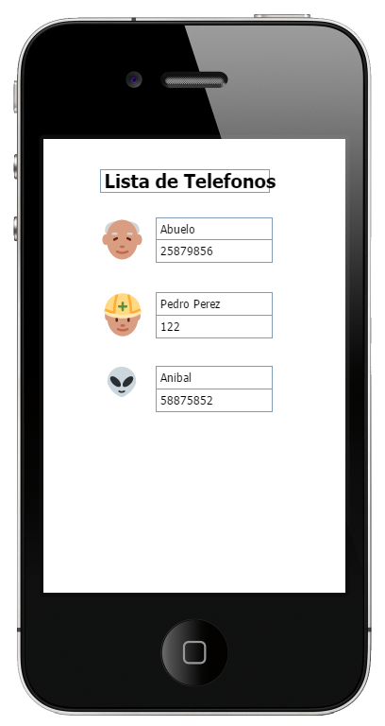

PROGRAMA

<https://github.com/Susana268/AppAndroid/tree/main/MyAppRecycleTelefonos>

VIDEO

<https://github.com/Susana268/AppAndroid/blob/main/Tareas/Video_Recycle_Telefono.mp4>

