CaMKII-NMDAR interactions in Learning and Memory: A Case Study in Ethical and Reproducible Modelling Approaches
Susana Román García
September 8, 2025
Table of contents

Declaration
I declare:
- That the thesis has been composed by myself, and
- that the work is my own, and that if I have been a member of a research group, that I have made a substantial contribution to the work, such contribution is clearly indicated, and
- that the work has not been submitted for any other degree or professional qualification except as specified, and
- that any included publications are my own work, except where indicated throughout the thesis and summarised and clearly identified on the declarations page of the thesis.

Abstract
This PhD project integrates biological inquiry with ethical considerations. On the one hand, this PhD investigates the molecular interactions between N-methyl-D-aspartate receptors (NMDARs) and calcium/calmodulin-dependent protein kinase II (CaMKII) in the postsynaptic dendrite during Long-Term Potentiation (LTP), a key process believed to underlie memory formation in animals. Understanding these molecular interactions can provide valuable insights into cognitive function and neurological disorders. Beyond the biological scope, this research also examines how computational models can be employed to study these mechanisms in a way that is both reproducible and ethically responsible.
A key contribution of this research is the development of a novel computational model that simulates CaMKII as a dodecamer interacting dynamically with NMDARs in both time and space within a neuronal dendrite environment. By doing so, it offers new predictions regarding the role of these molecules in synaptic strengthening and memory-related processes.
Additionally, this project addresses the ethical considerations of such models. Emphasising principles of research integrity, reproducibility, and transparency, this work aligns with FAIR (Findable, Accessible, Interoperable, Reusable) data principles. The model developed in this thesis serves as a case study of how to create a PhD project designed to be open and accessible, ensuring that it can be replicated and extended by future researchers, thereby reducing waste and increasing scientific reliability. In keeping with this approach, this project uses a Data Hazards framework to critically assess potential risks associated with computational modelling, such as environmental impact of the project, how it will be used in the future and what biases it might be perpetuating, implementing strategies to mitigate these risks. By demonstrating how to use this tool, this PhD thesis offers a framework for reducing waste and enhancing scientific reliability across future associated research projects.
Ultimately, this PhD goes beyond the creation of a biological model; it serves as a case study for responsible scientific practice. By integrating molecular neuroscience with ethical research methodologies, this work highlights the importance of both advancing knowledge and conducting science with integrity, ensuring that computational approaches contribute meaningfully to the broader scientific community.

Lay Summary
This PhD project weaves together multiple threads, including biological questions as well as ethical ones. The foundational thread of this PhD is rooted in a biological question: looking at specific molecular mechanisms underlying learning and memory in animals. Interwoven with this, is the exploration of how these mechanisms can be studied through computer models in a manner that is both reproducible and ethically responsible.
Understanding how learning and memory work at the molecular level can reveal important insights into brain function and potentially help develop treatments for memory-related illnesses. While research in this field often focuses on finding cures, I argue that the true value of this PhD lies not in directly discovering a new mechanism or potential drug, but in providing a project that shows how to create a PhD that upholds research integrity, ensures reproducibility, minimizes waste, and thoughtfully considers broader ethical implications. By prioritizing transparent methodologies, well-documented modelling approaches, and open data practices, this work aims to be easily reused in the future, allowing other researchers to build upon it.
Firstly, to address the biological aspect of this PhD, I begin by explaining why I focus on memory, learning, and the specific molecules involved in these processes. During learning and memory, neural circuits are altered in our brains. These circuits are composed of neurons (nerve cells) that communicate with one another through special junctions called synapses. These synapses contain a pre-synaptic neuron that sends a signal to the post-synaptic neuron. When the travelling signal reaches the end of the presynaptic neuron, it triggers the release of chemical messengers known as neurotransmitters. These chemical messengers cross the synaptic gap and bind to receptors on the postsynaptic neuron, which triggers a cascade of molecular events. This can lead to changes in the strength of synaptic connections. A persistent strengthening of synaptic connections is known as Long Term Potentiation (LTP), which is considered a potential mechanism for explaining learning and memory at the cellular level, where neuronal connections become stronger with repeated activation.
In this cascade of events, I investigate the temporal and spatial dynamics of two molecules in the postsynaptic neuron: N-methyl-D-aspartate receptor (NMDAR) and calcium/calmodulin-dependent protein kinase II (CaMKII). CaMKII and NMDARs are key components of a complex network within neurons that work together to strengthen neuronal connections.
CaMKII is a complex molecule formed of 12 subunits (dodecamer). Its unique structure allows it to stay active for a long time after an initial signal has passed. CaMKII’s capacity to remain active is crucial for strengthening synapses during LTP. Importantly, recent research has shown that the direct interaction between CaMKII and NMDARs might be a minimal requirement for LTP. This means that by focusing on these essential molecular interactions —those between CaMKII and NMDARs— we may be able to isolate some of the essential steps that are eventually leading to memory formation without the added complexity of larger molecular networks.
Moreover, growing evidence suggests that the interaction between NMDARs and CaMKII plays a crucial role at the molecular level in processes related to memory and learning. For example, studies ab-using rodents have shown that impairing these molecules interacting, or abolishing their functions leads to memory impairment. Additionally, changes in the function of these molecules have been implicated in a range of diseases and conditions, including age-related cognitive decline in human and non-human animals and neurodegenerative diseases. Likewise, these changes have also been shown to be implicated in epilepsy, schizophrenia, addiction, autism spectrum, and multiple neurodevelopmental disorders.
I use computational models to simulate molecular interactions and investigate these molecular processes. A key innovation in my research is the development of a reproducible computer model that, to the best of my knowledge, is the first to simulate CaMKII as a dodecamer directly interacting with NMDARs in both time and space within a realistic neuronal environment. While previous studies have modelled CaMKII as a dodecamer in a 3D space and over time, they did not explore its direct interactions with NMDARs. This research is valuable because it allows us to make predictions about how CaMKII may interact with NMDARs as essential components for memory mechanisms.
Given the complexity and multiscale nature of the biological system studied, computational models like the one used in this project play a crucial role in integrating experimental data and theoretical hypotheses. In general, models aim to make clear the current state of knowledge regarding a particular system, by attempting to be precise about the elements involved and the interactions between them. Doing this can be an effective way to highlight gaps in our understanding and guide future research directions. Moreover, these models then serve to synthesize knowledge from different published research, and make biological predictions which can then serve as hypotheses to be tested empirically by experimentalists. Additionally, computer-simulated experiments can streamline the wet-lab process by narrowing the experimental search space, making research more cost-effective, time-efficient, and environmentally friendly. This approach also promotes ethical research practices by reducing the need for animal testing, thereby minimizing animal suffering.
A major emphasis in this PhD is placed on ensuring these models and the techniques used adhere to the principles of reproducibility and FAIR (Findable, Accessible, Interoperable, Reusable) guidelines. This commitment to open, transparent, and ethically responsible research is one of the core strengths of the project. While the PhD centres on creating a biological model of NMDARs and CaMKII, its true value lies in how the model is developed, documented, and made accessible, allowing others to easily build upon it. The model presented in this thesis is reproducible and serves as a case study for how biological models can be developed with careful attention to both scientific integrity and ethical considerations.
Furthermore, I use something known as Data Hazards labels, a framework that highlights the potential risks associated with the research at hand, including topics such as environmental impacts, biases, and misuse of the work at hand. By using Data Hazards, I identify and address key ethical concerns, assigning hazard-like labels (similar to chemical warning labels) to specific risks such as “danger of misuse” or “high environmental impact”. This proactive approach allows me to implement and suggest precautions to mitigate potential risks throughout the research process —from design to execution.
Therefore, this project goes beyond simply creating a model to understand a biological mechanism; this project addresses the pressing issue of how models can be shared and refined in an open, accountable manner, ensuring the research community can rely on them. Ignoring these principles often leads to wasted resources, lost progress, and flawed conclusions—something we cannot afford, especially when working on models that may have real-world implications for areas like memory and neurobiology.

Acknowledgements
“I want to thank me for believing in me, I want to thank me for doing all this hard work.” — Snoop Dogg.
Inspired by that quote, I’d like to first and foremost thank myself for persevering throughout these four years and a bit, and for being patient with myself and this PhD. It feels a bit unusual to thank myself but the personal growth I’ve experienced feels significant enough to be recognized here for future reference. I am proud of myself. I can see the differences in my confidence when it comes to coding and my knowledge of what I want and how I want things done. This journey has been one of love, patience, and consistent effort.
I’d like to thank my friend Ceilidh, who has been a refreshing, kind, loving, and solid friendship that I did not expect would happen midway through my PhD. You have been a major support buddy and inspiration to get through this PhD.
I’d like to thank my family and particularly my siblings, Felipe y Clara, who remind me constantly to take care of myself first, fill up my cup, and, in doing so, show up to anything else with revitalized energy, including this PhD. Gracias, hermanos amados, os quiero. My gratitude is extended to James, Florence and Clementine who have put up with a lot of my breakdowns and been there for me all throughout this journey.
I am very grateful for the opportunity to have been an enrichment student at The Alan Turing Institute during the 2022–2023 cohort. It was a catalytic moment for me and for this PhD. My time here really propelled my PhD into what I wanted it to be. The people I met during this time have made a huge impact on my academic and personal life, and I am forever grateful. This experience was also an opening door to the Turing Way Community, whom I would also like to thank as a whole, but particularly some of the people with whom I have had meaningful conversations that have steered the direction of my PhD: Anne Le Steele, Claudia Fischer, Malvika Sharan, and Kirstie Whittaker.
The Data Hazards team has also been an amazing group to have been able to work with, and I’d like to especially thank Natalie Zelenka and Nina Di Cara for their help and support in my Data Hazard endeavours, from co-organising workshops, and attending conferences to presenting this topic at conferences. In a similar vein, I would also like to thank the team at the Open Seeds Project, as well as the Cohort 6 participants (of which I was a part), for providing the opportunity to deepen my understanding of open science practices.
This PhD would have not been possible without the amazing support of my supervisors: Melanie Stefan, David Sterratt and Nicola Romano. I am very lucky that I have had such understanding, caring, supportive and intelligent people as my supervisors; I know I am extremely privileged to have carried out my PhD under your supervision. Not only have you helped me with the content of this thesis, but I feel like you have truly impacted my life in how I want to do research. Your passion and knowledge for doing research with integrity is contagious. Thank you, truly.

Publications and Author Contributions
Chapter 5 includes a published article titled “Data Hazards as an Ethical Toolkit for Neuroscience”, co-authored with Susana Román García, Ceilidh Welsh, Nina H. Di Cara, David C. Sterratt, Nicola Romanò, and Melanie I. Stefan. The article was published in the Journal of Neuroethics on 19 February 2025.
Co-author contributions are detailed in the chapter using Contributor Roles Taxonomy (CRediT) (https://credit.niso.org/).

Introduction
This PhD project combines biological research with ethical considerations. It investigates how N-methyl-D-aspartate receptors (NMDARs) and calcium/calmodulin-dependent protein kinase II (CaMKII) interact in the postsynaptic dendrite during Long-Term Potentiation (LTP), a key process thought to underlie memory formation in animals (M. A. Lynch 2004; Dringenberg 2020; Vorhees and Williams 2024; K. Park, Park, and Chung 2024). Understanding these molecular interactions could offer important insights into cognitive function and neurological disorders (A. Ghosh and Giese 2015; Liang, Kulasiri, and Samarasinghe 2017; Schmidt et al. 2020; Yang et al. 2023). Addressing these questions is challenging due to the complexity of the molecular environment and the limitations of experimental techniques to resolve highly dynamic protein interactions at fine spatiotemporal scales. Computational modelling offers a powerful tool alongside experimental work by enabling researchers to systematically explore and test models about molecular mechanisms of interest.
Alongside the biological focus, this project also looks at how computational models can be used to study these mechanisms in a way that is reproducible and ethically responsible. Therefore, this thesis integrates molecular neuroscience, computational modelling, and research ethics into an interdisciplinary PhD project. As such, the structure of this thesis reflects its multifaceted aims: to deepen understanding of the molecular basis of learning and memory, to advance how such systems can be computationally modelled, and to question the ethical responsibilities of this work. Building on an interdisciplinary foundation, this PhD project has the following aims. These aims reflect the biological, computational, and ethical dimensions of the work, and together they define the scope and direction of the research.

Research objectives of this PhD
The overarching objective of this PhD research is to investigate how CaMKII and NMDARs interact in a postsynaptic dendrite following calcium entry, using reproducible computational models. To achieve this, the research is structured around the following specific aims:
Aim 1. Develop a computational model of CaMKII/NMDAR interactions based on published models and known findings on CaMKII regulation. This way, the model itself functions as a testable hypothesis that synthesises literature knowledge about CaMKII/NMDAR interactions.
Aim 2. Throughout the model development process, ensure that the computational models follow FAIR (Findable, Accessible, Interoperable, and Reproducible) principles, promoting transparency and reproducibility.
Aim 3. Determine in detail how functional states of CaMKII contribute to stabilizing the CaMKII/NMDAR complex, defined as achieving long-lasting binding that reaches equilibrium. This includes investigating how conformational states of CaMKII and phosphorylation events influence the stability of the complex.
Aim 4. Investigate how CaMKII/NMDAR binding influences CaMKII activity and function by examining an in silico mutation model where CaMKII-NMDAR interaction is disrupted.
Aim 5. Investigate how CaMKII phosphorylation influences CaMKII/NMDAR binding by examining an in silico mutation model where CaMKII cannot be phosphorylated at key functional residues.
Aim 6. Evaluate the ethical considerations of this research using the Data Hazards framework, a community-driven interdisciplinary vocabulary for assessing ethical risks in computational and biological research.

Chapters Outline
Having outlined the aims of this PhD, the remainder of the thesis is organised to address these objectives through a combination of theoretical background, methodological development, results, and ethical reflection. What follows is an overview of the structure and focus of each chapter.

Chapter 1
In this chapter, I introduce the biological foundations of this project. I outline the mechanisms of Long-Term Potentiation (LTP), focusing on how CaMKII and NMDARs are involved, and why and how they are important. I also explore the detailed molecular interactions between these two key molecules in the context of LTP, covering what is currently known and what remains unknown. This chapter sets the scene for the biological mechanisms that will be studied throughout the thesis.

Chapter 2
In this chapter, I explain why I use computational modelling to investigate the biological questions described in Chapter 1. I introduce the modelling techniques used in this PhD and provide an overview of the software workflow.

Chapter 3
This chapter introduces the importance of open and ethical research practices. I discuss why these considerations matter in scientific research and provide a personal account of the steps I have taken to make this project more reproducible and ethically responsible.

Chapter 4
This chapter presents a detailed case study on ethical reflection within this project, using the Data Hazards framework. I present a published paper were the co-authors and I explore how this framework can be used to identify and address ethical risks associated with computational modelling, and use my PhD as a case study to apply Data Hazard labels. I reflect on the application of Data Hazards to this research and the practical steps taken to mitigate potential risks.

Chapter 5
This chapter describes the computational model developed for this PhD, focusing on CaMKII, NMDARs, and their associated signalling molecules. I begin with a review of relevant prior work, followed by a detailed description of the model. This includes the molecular concentrations, spatial considerations, reaction rules, and kinetic parameters. Special attention is given to modelling CaMKII as a dodecamer and simulating its interactions with NMDARs, as well as processes such as calcium binding, conformational states, and phosphorylation dynamics. Furthermore, I discuss the validation of the computational model. The chapter covers how biological plausibility is assessed, how the model was incrementally built and validated at each step, and how uncertainty in parameters was explored.

Chapter 6
This chapter presents and discusses the results generated from the computational models. I first introduce findings from the wild-type model, including calcium signalling, CaMKII activation, phosphorylation patterns, and interactions with NMDARs. I then explore mutant models, specifically those affecting T286 phosphorylation and CaMKII/NMDAR binding. Findings are discussed in the context of existing literature, with particular attention to unexpected results and their possible implications. Limitations of the models are acknowledged, and potential directions for refining model complexity and experimental validation are proposed.

Chapter 7
This chapter provides the overall conclusions of the thesis. It summarises key findings, reflects on the research questions, and outlines broader implications for the field.

Chapter 8
This final chapter lists the publications and presentations that have resulted from this PhD project.

1. Biological Research Background
This introductory chapter outlines the biological research questions explored in this PhD. It begins by defining key concepts, including learning and synaptic plasticity, and highlights the relevance of long-term potentiation (LTP) as a model for studying these processes at the cellular level.
The chapter then delves into the roles of the primary molecules of interest —N-methyl-D-aspartate receptors (NMDARs) and calcium/calmodulin-dependent protein kinase II (CaMKII) — and their critical involvement in the mechanisms underlying LTP.
Importantly, CaMKII/NMDAR binding is known to be a key molecular interaction for synaptic plasticity during learning and memory (Sanhueza and Lisman 2013; “Biochemical Principles Underlying the Stable Maintenance of LTP by the CaMKII/NMDAR Complex” 2015; Karl Ulrich Bayer and Giese 2024), and the disruption of their binding has been shown to contribute to neurodegeneration, spineopathies and memory impairment in diseases such as Alzheimer’s or Huntington’s disease (A. Ghosh and Giese 2015; Liang, Kulasiri, and Samarasinghe 2017; Schmidt et al. 2020; Yang et al. 2023). Understanding the involvement of these proteins in neuronal structures could be especially important when investigating spineopathies that affect both the biochemistry and the overall shape of dendritic spines (Fink and Meyer 2002; Halpain, Spencer, and Graber 2005; Lai and Ip 2013; Yasuda 2017).

1.1 Learning, memory and synaptic plasticity
Learning and memory, whether declarative (referring to the conscious recollection of events) or non-declarative (which underpins changes in skilled behaviour and its improvement through practice) has been a topic of interest and intrigue for centuries. The question of how the brain learns and stores information remains central to our understanding of cognition. It is widely recognised that information is encoded in patterns of synaptic connections within neuronal networks, and that activity-dependent changes in these connections, known as synaptic plasticity, are fundamental to learning and memory. Current understanding suggests that the cellular changes underlying different forms of memory involve modifications in the strength of neuronal connections (Shapiro and Eichenbaum 1999; Lamprecht and LeDoux 2004a; Takeuchi, Duszkiewicz, and Morris 2014; Wickliffe C. Abraham, Jones, and Glanzman 2019).
Over a century ago, Ramon y Cajal (Ramón y Cajal 1909) proposed that the nervous system is composed of microscopic, independent neurons that form intricate networks of connections. The notion that synaptic strength changes during learning and memory was refined into a concrete model by Hebb (1949). Hebb (Hebb 1949) proposed that if two neurons are active at the same time, the synapses between them are strengthened. The first mechanism supporting synaptic strengthening, long-term potentiation (LTP), was then discovered in the late 1960s using rabbits’ hippocampus in vitro (Lomo 1971) (Figure 1.1). This discovery of LTP showed that short, high frequency stimulation (tetanus) of hippocampal excitatory synapses produced a rapid and long-lasting increase in the strength of these synapses that could persist for several hours; and later experiments showed persistence of up to 3 days (T. V. P. Bliss and Gardner-Medwin 1973).
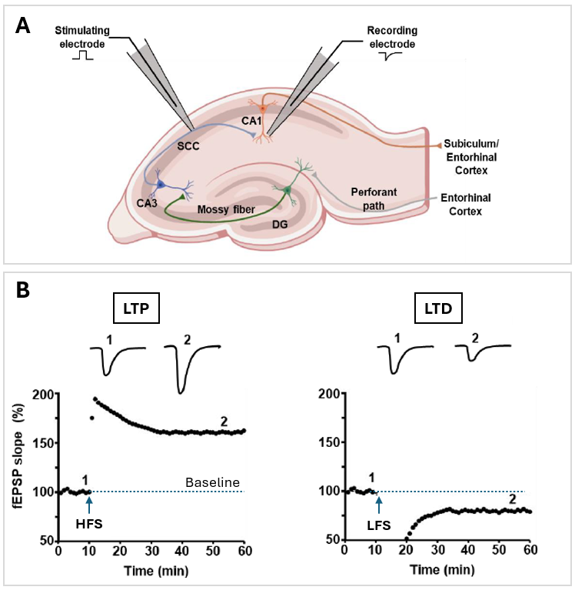
Figure 1.1: (A) Bliss and Lomo’s experiment (T. V. P. Bliss and Lømo 1973) demonstrated LTP in the hippocampus by stimulating the perforant pathway in an anaesthetized rabbit. The experimental setup involved placing a stimulating electrode in the axons of the perforant pathway at the hippocampal entry, while a recording electrode was positioned in the CA1 region. Axonal projections from the entorhinal cortex innervate granule cells in the dentate gyrus (DG) via the perforant pathway. These granule cells, in turn, send their axonal projections to pyramidal neurons in the CA3 region. The CA3 neurons then excite pyramidal neurons in the CA1 region through the Schaffer collateral-commissural pathway (SCC), forming a critical neural circuit for hippocampal information processing. (B) The results showed that the high-frequency stimulation (HFS) of SCCs led to a lasting increase in field excitatory postsynaptic potentials (fEPSP) amplitude, further supporting the concept of LTP as a measurable and significant phenomenon (left). The results revealed that high-frequency stimulation (HFS) of the SCC led to a persistent increase in the amplitude of fEPSPs, providing further evidence for LTP as a measurable and significant phenomenon (left panel). The right panel shows LTD induced by low-frequency stimulation (LFS). Synaptic strength is quantified as the initial slope of the fEPSP (normalised to baseline), and this is plotted over time. Figure adapted from Curtis (2024).
In 1986, Morris et al. provided some of the first evidence that LTP was indeed required for the formation of memories in vivo using rats (Morris et al. 1986). These rats were trained in the Morris water maze, a spatial memory task in which the rodents swam in a pool of murky water until they located a platform hidden beneath the surface. During this exercise, the rats had no other choice but to learn the location of the hidden platform through salient cues placed at specific positions around the maze’s circumference. After the rats had memorised where the cues and platforms were, one group was subjected to having their hippocampi bathed in a N-methyl-D-aspartate (NMDA) receptor blocker, while another group to whom nothing was done, served as the control. Rats in the control group were able to locate the platform and escape from the pool. However, the rats that had been subjected to the blocker treatment had significantly impaired memory. Moreover, when both groups were killed and slices of their hippocampal slices were analyzed, LTP was readily induced in the control group, while it could not be induced in the brains of the rats subjected to the NMDAR blocker. This experiment using rats provided early evidence that the NMDA receptor (and LTP) was important for at least some types of learning and memory. In the years since, there have been many more experiments conducted on rodents, often using fear conditioning or subjecting them to brain injuries, that provide further evidence supporting the role of LTP in different types of memory and learning (M. A. Lynch 2004; Dringenberg 2020; Vorhees and Williams 2024; K. Park, Park, and Chung 2024).

1.2 Studying synaptic plasticity at the hippocampus
The hippocampus has long been considered a key model for studying synaptic plasticity due to its central role in learning and memory (T. V. P. Bliss and Collingridge 1993; Morris 2006). Much of this knowledge has come from research done using rodents, often involving experiment that induce stress or fear conditioning, and/or introduce genetic mutations designed to impair the rodents behaviour (see the following some non-exhaustive examples: (Foy et al. 1987; J. J. Kim and Diamond 2002; Zemla and Basu 2017; Knierim 2015; P. Park et al. 2018)). This brain region is particularly important in processes such as spatial memory, episodic memory, and the consolidation of information from short-term to long-term memory (Moscovitch et al. 2016; Postle 2016). Its structure, which includes well-defined neural circuits and easily identifiable synapses, makes it an ideal system for investigating how synaptic connections change. In particular, the CA1-CA3 regions have been extensively studied due to their involvement in these memory processes (John E. Lisman 1999; T. V. P. Bliss and Collingridge 1993; Hunsaker, Lee, and Kesner 2008; Cutsuridis, Cobb, and Graham 2010; Rebola, Carta, and Mulle 2017).
In addition to LTP, the hippocampus also exhibits long-term depression (LTD), a complementary mechanism in which synaptic strength is reduced (Figure 1.1) (Malenka and Bear 2004; W. C. Abraham et al. 2024). LTD is typically induced by low-frequency stimulation of afferent inputs, leading to a decrease in synaptic efficacy. This weakening of synapses is essential for synaptic homeostasis, preventing excessive strengthening of connections and allowing for the encoding of new information (Lüscher and Malenka 2012a; Nabavi et al. 2014). Together, LTP and LTD are thought to form the basis of bidirectional synaptic plasticity, enabling the hippocampus to modulate and refine its neural circuits to optimise memory storage and retrieval. The focus of this thesis is on LTP to further understand learning and memory at the cellular and molecular level.
It is important to note here that LTP does not equal memory, though they are linked. LTP refers to long-lasting enhancement in synaptic strength and signal transmission between neurons. As we have just seen, it is considered a cellular mechanism underlying learning and memory, primarily observed in brain regions like the hippocampus, where synaptic activity is persistently amplified in response to high-frequency stimulation (Burgess, Maguire, and O’Keefe 2002). Memory, on the other hand, is a higher level process by which information is encoded, stored, and retrieved in the brain. Memory underpins cognitive functions and allows for the recall of past events, facts, and procedures (Wickliffe C. Abraham, Jones, and Glanzman 2019); nevertheless, as we will discuss next, synaptic strengthening and weakening provide compelling characteristics that make LTP a prime candidate to study molecular mechanisms underpinning memory formation.

1.3 LTP as an attractive model to explain memory and learning
To this day, LTP remains a compelling model for explaining memory at the cellular and molecular level. There are several experimental strategies that are widely used to explore the relationship between LTP and learning and memory. One widely used approach involves behavioural pharmacological studies, in which the effects of drugs that inhibit LTP induction are assessed in parallel with their impact on learning and memory performance (Dringenberg 2020; Najenson 2024). These studies often reveal that pharmacological blockade of key molecular pathways necessary for LTP, such as NMDAR activity or kinase signalling, is associated with deficits in learning tasks. A well-known example is the pharmacological inhibition of NMDARs in rats using the Morris Water Maze (see example description in Section 1.1), where NMDAR antagonists reduce LTP and impair the acquisition of spatial information, correlating NMDARs and LTP impairment with deficits in spatial memory.
Another strategy involves the use of genetic manipulations, particularly gene deletion (knockout) or transgenic mice. For example, knockout mice lacking $α$-CaMKII, the predominant isoform in the hippocampus, exhibit a complete loss of LTP at Schaffer collateral synapses (Stevens, Tonegawa, and Wang 1994; Incontro et al. 2018). These mice also show severe deficits in spatial learning. These examples illustrate that when LTP is impaired, memory performance is also often disrupted, supporting a correlation between the two. They also highlight the ethical implications of such invasive experiments, which would not be morally unacceptable if conducted in humans in our current day and age, yet we talk about these experiments as if they were normal routine to explain molecular mechanisms of learning and memory.
The proposal of LTP as a leading model to explain learning and memory, however, has not been one without significant challenges. Interestingly, different studies have shown that when rats undergo nonspatial pretraining (a technique designed to teach the rats the behavioural strategies necessary for successfully completing the maze, without having the rat learn a specific spatial location of the platform) before application of an NMDAR blocker, they exhibit intact spatial learning despite complete LTP blockade (Bannerman et al. 1995; Saucier and Cain 1995). Suggesting that hippocampal LTP is not strictly necessary for spatial memory acquisition, and that there are other mechanisms apart from LTP through which learning and memory can proceed (Moser and Moser 2000).
These examples highlight the complexity of these processes and start to shed light as to why their exact molecular mechanisms remain elusive. In fact, it is worth noting that LTP is not the sole mechanism contributing to memory storage. Alternative mechanisms, including long-term depression (LTD), neurogenesis, changes in neuronal excitability, and specialized neuronal assemblies (for example engram cells), likely interact with or compensate for LTP during learning and memory (Lüscher and Malenka 2012b; Cameron and Glover 2015; John Lisman 2017; Luis and Ryan 2022). Nonetheless, whilst LTP is not the only mechanism underlying learning and memory, it still provides a valuable model for understanding the cellular and molecular processes involved.
Adding further complexity to the relationship between LTP and memory, since its discovery, different forms of LTP have been observed across various regions of the brain in both humans and non-human animals (W. R. Chen et al. 1996; Beck et al. 2000; Nicoll 2017; Spriggs et al. 2019). Moreover, the different forms of LTP further depend on a number of factors such as developmental stage, pre- or post-synaptic stimulation as well as stimulation protocols. Two main types of LTP have been described as being either NMDA receptor-dependent or NMDA receptor-independent (Collingridge, Kehl, and McLennan 1983; E. W. Harris, Ganong, and Cotman 1984; Morris et al. 1986; Grover and Teyler 1990, 1992; Zi et al. 1993; Bortolotto and Collingridge 1993; Bortolotto, Fitzjohn, and Collingridge 1999; Cavus and Teyler 1996; Grover 1998; Nicoll and Schmitz 2005a; Aou et al. 2003; Rebola et al. 2008; Erondu and Kennedy 1985; Kumar 2011). This project will focus on studying the NMDA receptor-dependent form of LTP at synapses in the CA1 region of the hippocampus. To avoid ambiguities, this is the type of LTP discussed unless otherwise stated.

1.3.1 Dividing LTP into phases
LTP is typically divided into distinct phases: induction, expression, and maintenance. These phases describe the progression from the initial trigger of synaptic potentiation to the long-lasting changes in synaptic strength (Sweatt 2010). To provide a clearer understanding of the molecular mechanisms underlying LTP, key molecular interactions associated with these phases are described next.
Induction refers to the transient events that initiate the formation of LTP. This phase involves high-frequency (tetanic) stimulation of presynaptic fibres, which leads to the release of glutamate. Glutamate binds to both $α$-amino-3-hydroxy-5-methyl-4-isoxazolepropionic acid receptors (AMPARs) and NMDARs on the postsynaptic membrane (Scheefhals and MacGillavry 2018). Importantly, although glutamate binds to NMDARs, this alone is typically insufficient to open the channel and let ions through due to the $Mg^{2+}$ voltage block. In contrast, AMPARs’ fast kinetics and voltage independence rapidly mediate membrane depolarisation by allowing Na⁺ influx into the postsynaptic cell (Otmakhova, Otmakhov, and Lisman 2002; Fuenzalida et al. 2010). If this depolarisation is strong enough to remove the $Mg^{2+}$ block from the NMDAR channel,$Ca^{2+}$ influx through this channel is increased, initiating downstream signalling and setting the stage for LTP. NMDA receptors function as molecular coincidence detectors, permitting ion flux only when both agonist binding such as glutamate and membrane depolarisation coincide to activate the receptors. This mechanism ensures tight regulation of calcium entry, with elevated or reduced Ca²⁺ influx triggering LTP or LTD, respectively. This coincidence detection permits NMDARs to facilitate spike-timing dependent plasticity, where the precise timing between presynaptic and postsynaptic activity dictates whether plasticity results in potentiation or depression (Morrison, Diesmann, and Gerstner 2008; Fuenzalida et al. 2010; Stefanescu and Shore 2015; Martínez-Gallego, Rodríguez-Moreno, and Andrade-Talavera 2022).
Expression and maintenance refer to the phases in which the molecular and cellular changes triggered during the induction phase are translated into long-lasting alterations in synaptic strength. These changes typically involve an increase in the number of receptors and their sensitivity (Reymann and Frey 2007; Wickliffe C. Abraham and Williams 2008). For instance, phosphorylation of AMPA receptors by proteins within the PSD enhances their ion conductance, thereby amplifying the postsynaptic response to glutamate (Sacktor 2008; Purkey and Dell’Acqua 2020). In addition, synaptic structure is often modified, with dendritic spines enlarging or new synaptic connections forming, further strengthening their connection (Sala and Segal 2014; Chidambaram et al. 2019; Meldolesi 2022). Long-lasting alterations in intracellular signalling pathways, such as enhanced activation of protein kinases also contribute to the sustained strengthening of synaptic transmission (Mayford 2007). Structural modifications, such as the enlargement of dendritic spines and cytoskeletal rearrangement mediated by actin polymerisation, support the long-term persistence of LTP. Protein synthesis, regulated by transcription factors like CREB (cAMP response element-binding protein), also facilitates the production of proteins necessary for synaptic stabilisation (Lamprecht and LeDoux 2004b). Additionally, scaffolding proteins, such as PSD-95, $α$-actinin-2 and more, anchor AMPA receptors at the postsynaptic density (de Bartolomeis and Fiore 2004; Ivie and Thain 2018), ensuring their sustained incorporation into the synaptic membrane. These changes collectively enable the persistence of LTP, making it a robust mechanism for memory storage at the cellular level.
Additionally, LTP is often further categorised into early-phase LTP (E-LTP) and late-phase LTP (L-LTP), although a short term potentiation and an intermediate phase of LTP have also been suggested (Huang 1998; Winder et al. 1998; J. E. Lisman et al. 2005; Kumar 2011). E-LTP occurs shortly after high-frequency stimulation of a synapse, and is typically characterized by a rapid increase in synaptic strength that lasts for a few minutes to hours. It relies primarily on the activation of NMDARs and the influx of calcium ions (Malenka, Lancaster, and Zucker 1992; Frey and Morris 1997; T. V. P. Bliss et al. 2003; Tim V. P. Bliss et al. 2018). L-LTP, on the other hand, is the prolonged phase of synaptic enhancement that can last for days or even weeks (P. S. Jackson, Suppes, and Harris 1993; K. M. Harris and Teyler 1984; Muller, Oliver, and Lynch 1989; Bekenstein and Lothman 1991; Figurov et al. 1996; Mohns and Blumberg 2008). L-LTP is dependent on new protein synthesis and gene expression. This phase is critical for the consolidation of memory and is associated with structural changes in the synapse, including the growth of dendritic spines and the synthesis of new receptors (Tim V. P. Bliss et al. 2018; Baltaci, Mogulkoc, and Baltaci 2019).
The categorisation of LTP into distinct phases is not rigidly defined as strictly sequential; rather, the phases serve as distinct categories to help us talk about the different stages of LTP. Induction, expression, and maintenance can apply to both E-LTP and L-LTP; with E-LTP and L-LTP phases being induced and expressed in diverse ways (for example, through protein synthesis) (Pfeiffer and Huber 2006; Wickliffe C. Abraham and Williams 2008) and maintained for differing durations (for seconds, hours or longer) (Wickliffe C. Abraham and Williams 2003). Additionally, E-LTP and L-LTP are not mutually exclusive. In fact, depending on the specific LTP induction protocol applied, E-LTP can happen concurrently with the development of L-LTP, with one gradually replacing the other over time (Roberson, English, and Sweatt 1996; T. V. P. Bliss and Collingridge 1993; Kandel 2001; Nicoll 2003; Malenka and Bear 2004; Lüscher and Malenka 2012a). This PhD research investigates the specific molecular interactions between CaMKII and NMDARs, primarily focusing on their roles in E-LTP induction and maintenance.

1.3.2 Key features of NMDAR-dependent LTP
To better understand NMDAR-dependent LTP, we first examine the structure and function of these receptors and their role in the process. NMDARs are non-selective cationic, glutamate receptors primarily located at dendritic spines where they links to intracellular proteins within the postsynaptic density (PSD) through subunit-specific interactions.(Volianskis et al. 2015). NMDARs are heterotetramers commonly composed of two GluN1 and two GluN2 subunits (Figure 1.2). There are different subunit subtypes, for example GluN2 can be found as GluN2A, GluN2B, GluN2C or GluN2D, and we know there are GluN3A and 3B isoforms too (Ciabarra et al. 1995; Kvist et al. 2013).
The specific subunit composition of NMDARs influences their properties and functions. For example, a “GluN2B-GluN2A developmental switch” has been observed in rodents (Piggott et al. 1992; Matta et al. 2011; McKay et al. 2018) (and humans (Piggott et al. 1992)) where GluN2B is predominantly present in the early postnatal brain, but switches to GluN2A during early development. Eventually, GluN2A subunits become more numerous than GluN2B. These subtypes have different kinetics, where NMDAR with more GluN2B subunits remain open for longer compared to those with GluN2A subunits (Liu, Murray, and Jones 2004). In the postnatal brain, a higher abundance of GluN2B-containing NMDARs enables greater calcium influx and enhances synaptic plasticity. This has been suggested to support faster learning and stronger memory formation in early development, partly accounting for greater memory abilities in the immediate postnatal period compared to later in life (Bar-Shira, Maor, and Chechik 2015).
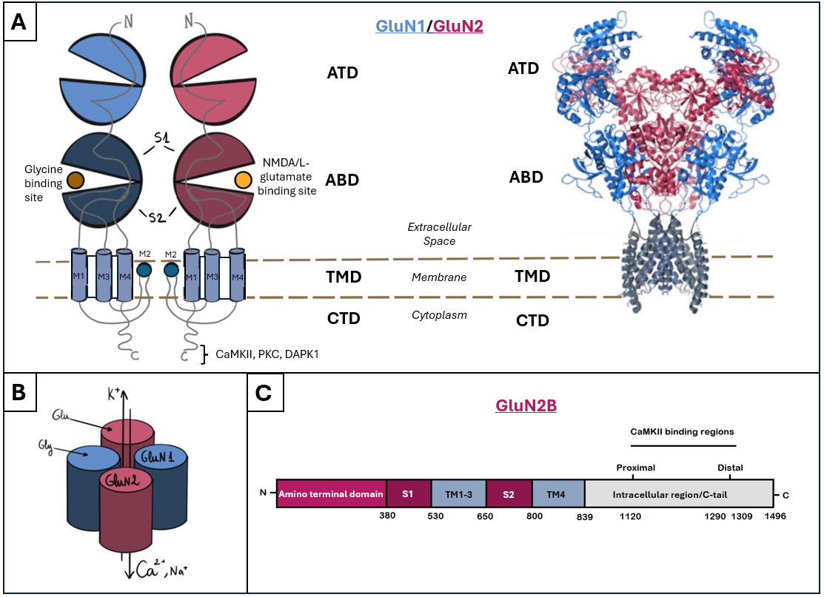
Figure 1.2: NMDARs are heterotetramers composed of four subunits, typically two GluN1 and two GluN2 subunits. A cross-sectional schematic of two subunits is shown in (A), alongside a structural model, and a simplified pictogram of the full tetrameric assembly is shown in (B). Each subunit has four major structural domains: the amino-terminal domain: ATD, the agonist-binding domain: ABD, the transmembrane domain: TMD, and the C-terminal domain: CTD. The ATD is located extracellularly and is primarily responsible for subunit assembly and allosteric modulation. Ligands bind to the ABD site, glutamate binds to GluN2 subunits, while glycine binds to GluN1 subunits. Ligand binding at the ABD, together with membrane depolarization to relieve the voltage-dependent magnesium block, is necessary to open the ion channel. The TMD spans the cell membrane and forms the ion channel pore. It consists of three membrane-spanning helices: M1, M3, and M4, which collectively shape the channel’s permeability to calcium ($Ca^{2+}$), sodium ($Na^{+}$), and potassium ($K^{+}$) ions. And a re-entrant loop, M2, which dips into the membrane from the cytoplasmic side. The CTD is located intracellularly and serves as a platform for binding to various intracellular proteins, including scaffolding proteins and kinases. CaMKII binds with high affinity to the CTD of the GluN2B subunit. Panel (C) illustrates the domain structure of a GluN2B subunit, highlighting the location of the proximal and distal CaMKII binding regions within the intracellular CTD region (in grey). Numbers on the x axis represent amino acid numbers in the GluN2B subunit. Adapted from Valdivielso et al. (2020).
NMDARs are primarily permeable to calcium ions and require both glutamate and glycine as ligands, with glutamate being the more common ligand and glycine serving as a co-agonist (Traynelis et al. 2010; Henneberger et al. 2013; Hansen et al. 2018). The binding of these ligands typically does not open the channel due to a voltage-dependent magnesium block, which is removed only once the neuron is sufficiently depolarized (Ruppersberg, Kitzing, and Schoepfer 1994). This feature confers to NMDARs the role of a “coincidence detector” (Seeburg et al. 1995), as discussed in Section 1.3.1.
The binding of CaMKII to the GluN2B subunit of NMDARs is considered a critical step in triggering structural changes in dendritic spines following LTP induction. Compared to other subunits, CaMKII binds more readily to GluN2B (Strack and Colbran 1998; Leonard et al. 2002; Barria and Malinow 2005), and this interaction appears to be a primary site involved in LTP mechanisms (K.-Ulrich Bayer et al. 2001a; Barria and Malinow 2005). Specifically, the interaction between CaMKII and the intracellular region of the GluN2B subunit’s cytoplasmic tail (C-tail) plays a pivotal role in this process, as further discussed in Section 1.4.3.
LTP is a process in which the strength of synaptic connections is enhanced, and it relies heavily on the activity of NMDARs as well as another important glutamate receptor, namely: AMPARs. Both of these receptors are located on the PSD (Hunt and Castillo 2012; Chater and Goda 2014). Although both are glutamate receptors, they have importantly different kinetics and channel properties.
AMPARs mediate rapid excitatory synaptic transmission, with a peak response time of approximately 200 $μ\text{s}$ and decay constants of around 2-3 ms (Jonas 2000; Nielsen, DiGregorio, and Silver 2004; Choquet 2010). These receptors are primarily permeable to Na+ ions and are voltage-independent, enabling the swift influx of sodium into the postsynaptic neuron upon synaptic transmission. In contrast, NMDARs have a slower peak response time of approximately 10 ms and a decay constant of around 100 ms (Perouansky and Yaari 1993; Kampa et al. 2004; Tovar and Westbrook 2017). Their ion flow is regulated by their voltage-dependent magnesium block, which prevents ion entry at resting membrane potentials and requires sufficient depolarization for activation. Together, AMPARs and NMDARs work in concert to regulate synaptic plasticity. AMPARs mediate the initial rapid response to glutamate, while NMDARs are crucial for the longer-term changes in synaptic strength that underlie LTP (and LTD) Figure 1.3 (Turrigiano and Nelson 2000; J. C. Brown, Higgins, and George 2022).
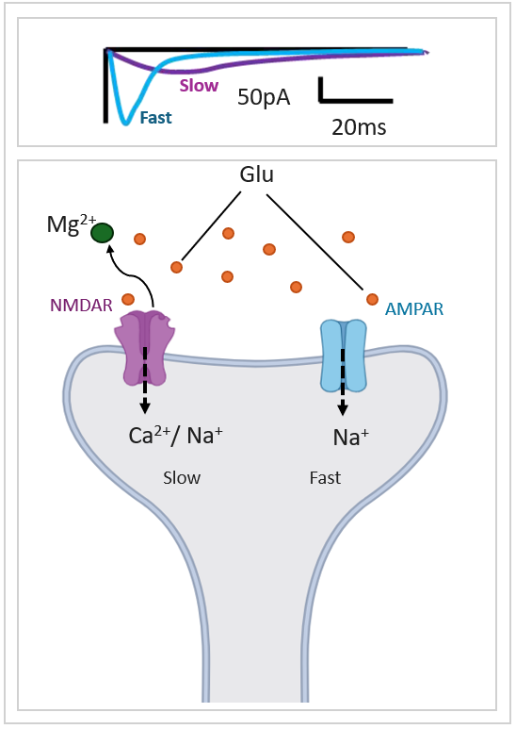
Figure 1.3: (Top) synaptic current traces are shown in response to glutamate receptor activation, with two distinct kinetic components. The fast component -the blue trace- corresponds to AMPAR-mediated currents, which activate and deactivate rapidly. The slow component -in purple- corresponds to NMDAR-mediated currents, which have a slower activation and deactivation profile. The y-axis represents current amplitude in picoamperes (pA), while the x-axis represents time in milliseconds (ms). (Bottom) schematic diagram of synaptic transmission, highlighting the roles of AMPARs and NMDARs in excitatory synaptic signalling. Glutamate (Glu) can bind to both receptor types. AMPARs, mediate fast synaptic currents by allowing sodium ions ($Na^{+}$) to enter the postsynaptic neuron. NMDARs mediate slow synaptic currents, allowing both calcium ($Ca^{2+}$) and sodium ($Na^{+}$) ions inside the cell. NMDAR activation requires the removal of a magnesium ($Mg^{2+}$) block.

Molecular Signalling in LTP: Role of Calcium, CaMKII and Phosphatases
A key second messenger in NMDAR-dependent LTP is calcium. This ion drives signalling cascades through the activation of the intermediary $Ca^{2+}$ sensitive protein calmodulin (CaM). During LTP, elevated $Ca^{2+}$ influx activates CaM, which subsequently triggers several kinases, such as Protein Kinase C (PKC) and $Ca^{2+}$-calmodulin-dependent protein kinase II (CaMKII) (Gnegy 2000; Xia and Storm 2005; Mohanan et al. 2022). CaMKII has been shown to have several important effects during LTP. Namely, CaMKII is one of the main kinases that phopshorylates AMPARs, thereby elevating these receptor’s channels conductance. CaMKII has also been shown to be important for the recruitment of AMPA receptors to the PSD following synaptic stimulation during LTP (Hayashi et al. 2000; Herring and Nicoll 2016). More recently, CaMKII binding to NMDARs has been proposed to be key for LTP induction and maintenance at synapses in the brain (Karl Ulrich Bayer and Giese 2024).
In contrast to LTP, low levels of Ca2+ during LTD activates a cascade of competing signalling pathways. For instance, during LTD, CaM binds to and activates a well known phosphatase: calcineurin, also known as Protein Phosphatase 2B (PP2B) (Shibasaki, Hallin, and Uchino 2002). Calcineurin can dephosphorylate the GluA1 subunit of AMPARs, reversing the phosphorylation that would normally enhance receptor activity and membrane insertion, thereby reducing synaptic strength (S. Kim and Ziff 2014; Zhou et al. 2024). Other phosphatases, such as Protein Phosphatase 1 (PP1) and PP2A play central roles in the regulation of synaptic plasticity during both LTP and LTD. Their actions not only depend on the relative levels of kinase and phosphatase activity, but also help determine the direction and extent of synaptic change. Their precise regulation ensures the appropriate strengthening or weakening of synapses during learning and memory processes (Munton, Vizi, and Mansuy 2004; Roger J. Colbran 2004; Belmeguenai and Hansel 2005).
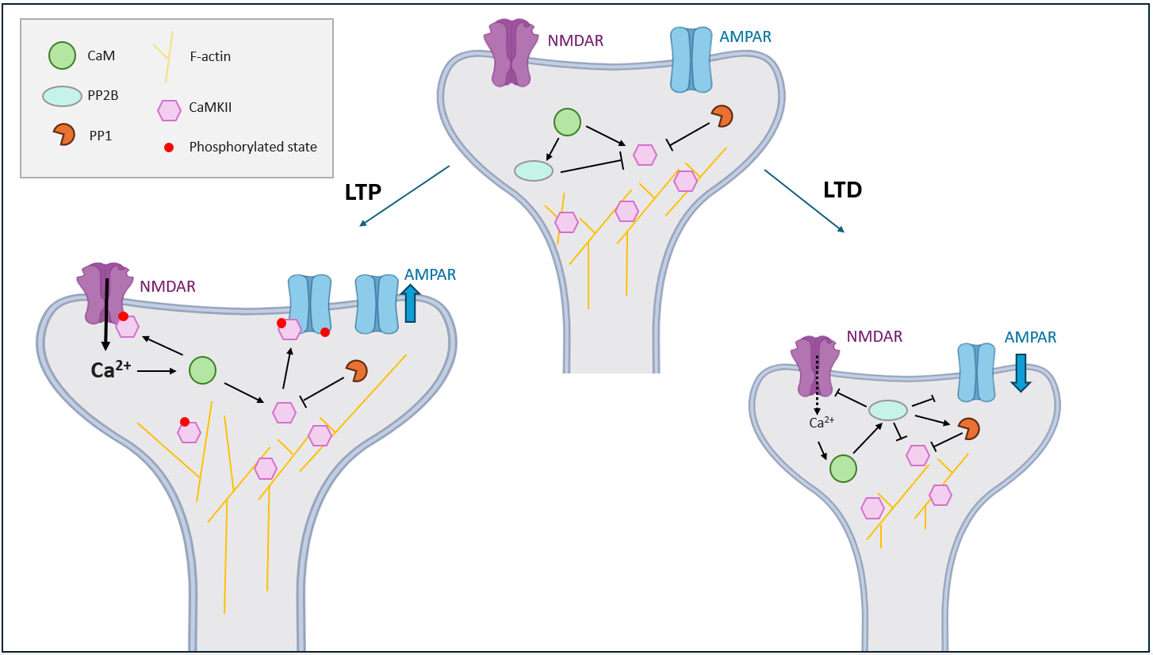
Figure 1.4: Molecular Signalling in Synaptic Plasticity: CaMKII in LTP and LTD Pathways. High frequency stimulation leads to LTP (left), characterised by a large and sustained Ca²⁺ influx through NMDARs. This activates CaM, which in turn stimulates CaMKII and PKC, promoting AMPAR phosphorylation and insertion into the PSD, strengthening synaptic transmission. During LTP, CaMKII isoforms associated to F-actin filaments separate from it and allow the dendritic spine to grow. Low-frequency stimulation induces LTD (right), where a smaller Ca²⁺ influx preferentially activates PP2B over CaMKII, leading to PP1 activation and AMPAR dephosphorylation. The downregulation of AMPARs from the synaptic membrane weakens synaptic transmission. Additionally, reduced CaMKII dissociation from actin filaments contributes to synaptic depression.
The spatial and temporal dynamics of calcium influx, which vary depending on the frequency and pattern of neuronal activity are detected by proteins in the PSD and this triggers differing signalling cascades. These calcium signals can lead to opposing outcomes in NMDAR-dependent plasticity, contributing to either long-term potentiation (LTP) or long-term depression (LTD). The precise localisation of key proteins involved in these processes near NMDARs is thought to enable the receptors to detect subtle spatio-temporal variations in calcium levels and modulate downstream signalling accordingly (Gladding and Raymond 2011; Brini et al. 2013). Hence, highlighting how this PhD research is well positioned to investigate LTP mechanisms, particularly by focusing on the spatio-temporal dynamics of NMDARs and CaMKII. But why specifically focus on the interactions between these two proteins?
To answer this question, we can call back on the importance of how NMDA receptors’ ability to act as a coincidence detector underpins hallmark features of LTP. NMDARs are essential mediators for the induction of NMDAR-dependent LTP. Indeed, inhibition of these receptors in various regions of the hippocampus has been shown to prevent LTP induction, as well as lead to impairments in learning and memory in rodents (Collingridge, Kehl, and McLennan 1983; Morris et al. 1986). Likewise, both pharmacological inhibition and genetic knockout of NMDARs subunits have been shown to block LTP induction in rodent hippocampal circuits (Lüscher and Malenka 2012a; Hunt and Castillo 2012; Alkadhi 2021). Moreover, over the past few decades, CaMKII has emerged as a critical molecule in the study of synaptic plasticity, with substantial evidence supporting its role as a key mediator of LTP (John Lisman, Yasuda, and Raghavachari 2012b; Sanhueza and Lisman 2013; Chang et al. 2017; Nicoll and Schulman 2023a; Xiumin Chen et al. 2024). In particular, its structural interaction with NMDARs seems to be a critical and minimal requirement for the induction of LTP, as we will see in the following Section 1.4.

1.4 Biophysical properties of CaMKII
CaMKII is expressed ubiquitously in animals, with four known isoforms $α$, $β$, $γ$ and $λ$ (Zalcman, Federman, and Romano 2018; Tullis and Bayer 2023). This study focuses on the brain specific $α$ isoform, which constitutes up to 2% of total brain protein (Kennedy, Bennett, and Erondu 1983; Xiaobing Chen et al. 2005; John Lisman, Yasuda, and Raghavachari 2012b). $α$-CaMKII is one of the main proteins in the PSD, and has extensively been shown to be important for LTP and memory formation (Hell 2014; Yasuda, Hayashi, and Hell 2022a). Unless otherwise stated, references to CaMKII throughout this project will specifically pertain to $α$-CaMKII. This kinase is a large holoenzyme consisting of 10 to 12 (and sometimes 14) subunits (Rosenberg et al. 2005; Chao et al. 2011a; Myers et al. 2017; Buonarati et al. 2021). CaMKII holoenzymes are made up of two hexameric rings stacked together, where the association domain (or hub) holds the subunits together in a double-ring formation (Figure 1.5 (B)).
Each of the subunits has a N-terminal catalytic/kinase domain (dark blue section Figure 1.5), followed by a regulatory domain that contains a self-inhibitory region and a binding site for the Ca2+/calmodulin complex (green and pink in Figure 1.5), the variable linker domain (grey section in Figure 1.5) and the C-terminal hub domain (light blue Figure 1.5). The kinase domain is the region that binds substrates and contains the ATP-binding site necessary for phosphorylation (Pellicena and Schulman 2014). There is also a model proposed where CaMKII subunits have an S-site and T-site within the kinase domain where the GluN2B subunit of NMDARs binds to (Strack, McNeill, and Colbran 2000; K.-Ulrich Bayer et al. 2001b), although this has recently been contested (Özden et al. 2022a), as discussed in Section 1.4.3.
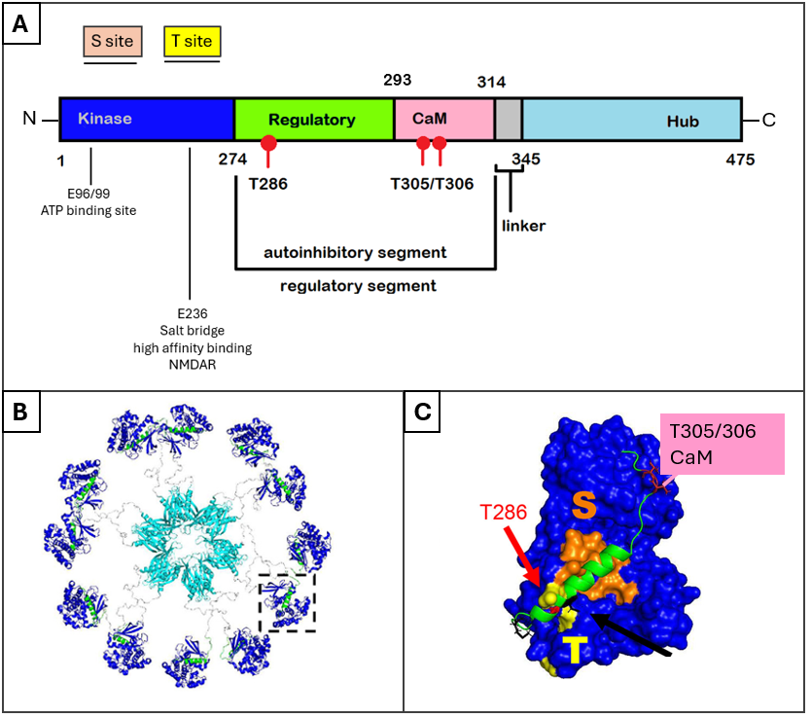
Figure 1.5: (A) Schematic representation of CaMKII, highlighting key domains, phosphorylation sites (T286, T305/306), and regulatory regions. (B) Holoenzyme structure crystallography showing dodecameric assembly, view from above, rigs are stacked on top of each other (Myers et al. 2017). The structure is based on the crystal structure available at the Protein Data Bank (PDB: 5U6Y). (C) A single subunit, with a close up of the kinase domain with phosphorylation sites (T286, T305/306) and proposed substrate-binding sites S-site (orange) and T-site (yellow). ($α$-CaMKII amino acids 7–274, PDB: 6vzk, and regulatory ribbon amino acids 281–309, PDB: 5u6y). Figure adapted from C. N. Brown and Bayer (2024).
CaMKII subunits can be found docked (also known as “compact state”), or undocked (or extended); and open, or closed (L. Hoffman et al. 2011; Bhattacharyya, Karandur, and Kuriyan 2020). The docked/undocked states describe the compact or extended structure configurations of the CaMKII holoenzyme subunits, where the kinase domains are packed close to the central hub or not. The closed/open states refer to the conformational changes in the kinase and regulatory domains; these domains can adopt an “open” state, allowing kinase activity, or a “closed” state, in which the kinase and regulatory domain are bound together, reducing CaMKII’s kinase activity (Nguyen et al. 2015; Pandini, Schulman, and Khan 2019; Bhattacharyya et al. 2020; Özden et al. 2022b) (Figure 1.6)(Figure 1.5) (Figure 1.7).
In the docked state, CaMKII subunits adopt a more compact configuration, where the regulatory domain is closely associated with the hub domain (Figure 1.5). When CaMKII subunits are found in the docked state, they cannot autophosphorylate their neighbouring subunits, even if the subunits are open. This is because the compact shape does not allow the kinase domain of one subunit to structurally reach its neighbour (Rosenberg et al. 2005). Therefore, it is thought that for CaMKII to have autphosphorylation activity, subunits need to be in an “open” and undocked conformation. Subunits in a docked, open state lack the structural capacity for autophosphorylation activity (Chao et al. 2011a; Myers et al. 2017). In the undocked state, the regulatory domain is extended and separated from the hub domain. This conformation makes the subunits less compact and more “loose” which can facilitate interactions within subunits, and with other substrates. When undocked, CaMKII subunits can phosphorylate neighbours so long as they are in an open state as the kinase domain is structurally available to perform such function. If a subunit is undocked but closed, it lacks catalytic activity because its regulatory domain is bound to its catalytic site, preventing the kinase domain from being accessed or accessing targets (Chao et al. 2011b; Nguyen et al. 2015).
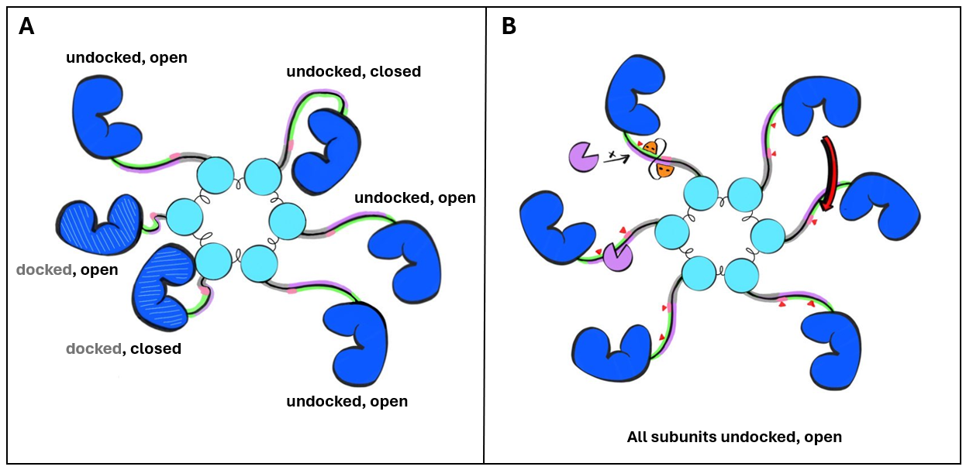
Figure 1.6: (A) CaMKII subunits can exist in docked (compact) or undocked (extended) positions, and in open or closed conformations. The docked/undocked distinction refers to the spatial arrangement of the kinase domains (dark blue) relative to the central hub (light cyan blue), either closely packed or extended outward. In contrast, the open/closed states describe the structural relationship between the kinase domain (dark blue) and regulatory (green, purple, grey) domain. In the open state, these domains are separated, enabling kinase activity; in the closed state, they are bound together, limiting activity. We illustrates two docked subunits, one in an open and one in a closed conformation, positioned near the hub. The remaining subunits are undocked, with one shown in the closed state. (B) All subunits are shown in the undocked and open state, with various possible interactions highlighted. When two neighbouring subunits are both open, one can phosphorylate the other at T286 (red arrow). A phosphatase (purple molecule) can access and dephosphorylate T286 and/or T306 sites if the subunit is undocked and open. However, when calmodulin (orange double-headed molecule) is bound, the phosphorylation sites are inaccessible to the phosphatase. CaM can bind to a subunit that is open and not phosphorylated at T306.

1.4.1 CaM binding and T286 phosphorylation
When CaMKII is in its closed conformation, structural constraints prevent CaM from interacting with the kinase (Sheela I. Singla et al. 2001; L. Hoffman et al. 2011; Gaertner et al. 2004). In contrast, when CaMKII subunits are the open state, the calmodulin binding site of the regulatory segment becomes available for interaction (Gaertner et al. 2004; Chao et al. 2011b; Nguyen et al. 2015; Rellos, Pike, Niesen, Salah, Lee, Delft, et al. 2010; Asciutto, Pantano, and General 2021a). In the open conformation, CaMKII subunits can also autophosphorylate each other at threonine 286 (T286) found in the regulatory segment, which prevents the segment from closing, and uncovers the binding sites in the kinase domain for CaMKIIs substrates and anchoring proteins. In other words, when subunits are in their open conformation, two main events can stabilise this conformation: CaM binding to the regulatory domain (because it prevents closing) and phosphorylation at T286 (which is close to the hinge connecting the active domain and regulatory domain).
Calmodulin binding is thought to stabilise CaMKII’s subunits in their open conformation, facilitating further autophosphorylation among neighbouring subunits. What is more, binding of Ca2+/CaM has been shown to significantly increase the kinase’s affinity for $Ca^{2+}$/CaM itself (Meyer et al. 1992; Putkey and Waxham 1996), creating a feedforward loop. This means that as more CaM binds, it makes it easier for additional CaM to bind, which promotes further autophosphorylation and stabilisation of the kinase in its open conformation (Chao et al. 2011b; Nguyen et al. 2015). This phenomenon, known as CaM trapping, refers to the increased retention of calcium bound CaM by CaMKII following T286 autophosphorylation, which effectively locks CaM in place even after intracellular calcium levels drop (Meyer et al. 1992; S. I. Singla et al. 2001).
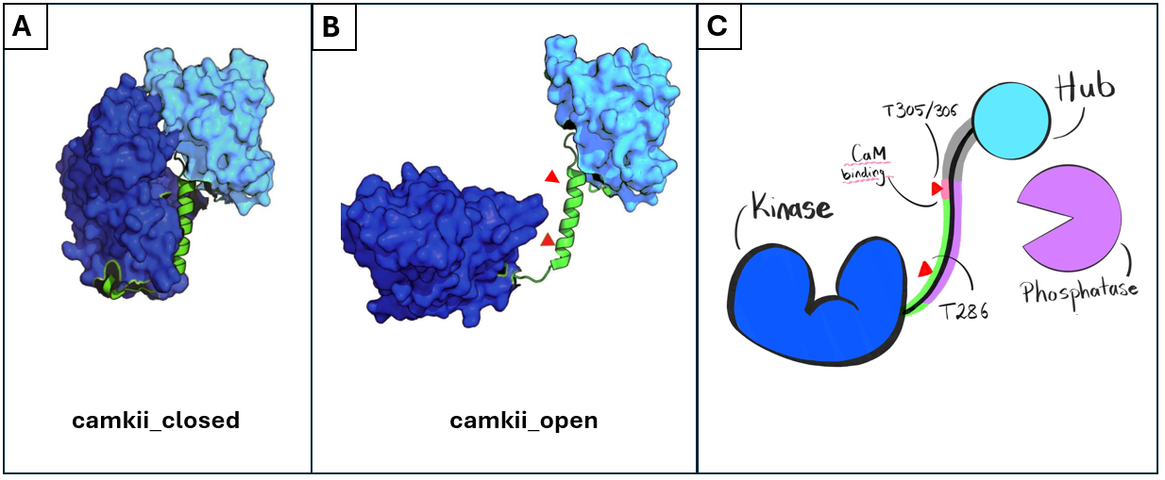
Figure 1.7: (A-B) Conformational states of CaMKII: closed and open with exposed phosphorylation sites. (C) Different binding and phosphorylation sites highlighted, CaMKII subunit in open conformation. CaM binding region and T305/306 sites overlap; T305/306 phosphorylation prevents CaM binding. Phosphatase can dephosphorylate both phosphorylation sites. Figure modified from (Pharris et al. 2019)
Furthermore, as autophosphorylation at T286 prevents the regulatory domain from re-associating with the catalytic domain, even in the absence of CaM, it enables CaMKII activity that is independent of calcium. Therefore, CaMKII’s increased autophosphorylation capability allows it to retain an autonomous activity, indepedent of calcium/calmodulin binding, even after the initial calcium signal has faded (Braun and Schulman 1995; S. G. Miller and Kennedy 1986; Coultrap et al. 2010; Buard et al. 2010; Chang et al. 2017). This autonomous activation is thought to be important for memory formation and synaptic modification, as it allows CaMKII to sustain long-term changes in cellular activity, ensuring that modifications are maintained over time. T286 autophosphorylation and CaM trapping play a crucial role in conferring frequency-dependent activation of CaMKII (Figure 1.8). Experimental studies with purified CaMKII have shown that the enzyme responds differently to varying frequencies and durations of Ca²⁺ spikes (De Koninck and Schulman 1998; K. Ulrich Bayer, Koninck, and Schulman 2002; Chang et al. 2017). This frequency dependence is thought to correlate with the requirements for LTP induction, which is promoted by HFS and relies on CaMKII autonomy.
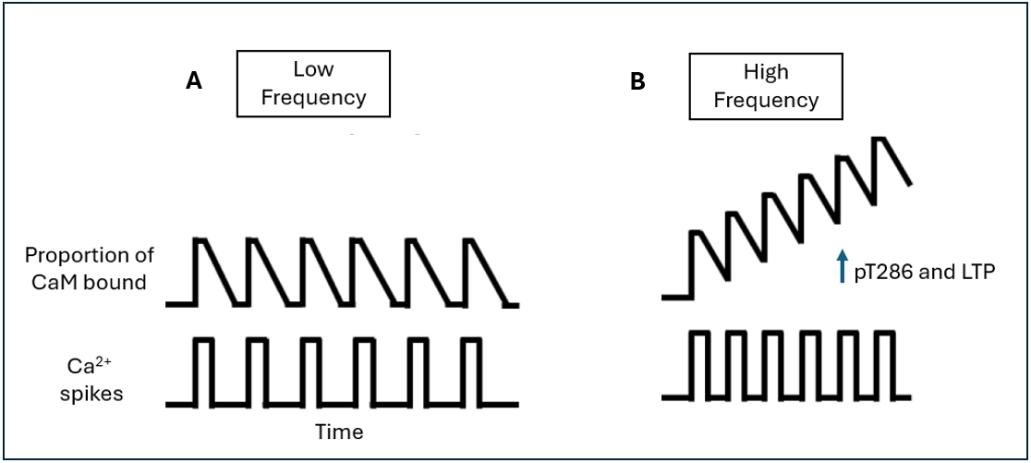
Figure 1.8: The dual role of CaM and T286 phosphorylation enables frequency detection of threshold to induce autonomous activity. (A) At low frequency calcium spikes, Ca2+/CaM can bind to CaMKII and dissociate between intervals. (B) At higher stimulation frequencies, when the interval between calcium spikes is shorter than the Ca2+/CaM dissociation time, new Ca2+/CaM molecules can bind to neighboring CaMKII subunits before the previously bound Ca2+/CaM fully dissociates. Adapted from Coultrap and Bayer (2012).
In the literature, the term ‘CaMKII activity’ can sometimes be used intercheably when referring to CaMKII subunits being in their open state (Nicoll and Schmitz 2005b; Pharris et al. 2019), being bound to CaM (Nicoll and Schmitz 2005b; Rellos, Pike, Niesen, Salah, Lee, Delft, et al. 2010), and/or being phosphorylated, typically at the T286 site (Nicoll and Schmitz 2005b; Rellos, Pike, Niesen, Salah, Lee, Delft, et al. 2010; John Lisman, Yasuda, and Raghavachari 2012b). However, these states are distinct and we therefore clarify that we define different types of activity. CaMKII can have enzymatic activity, which refers to the protein’s ability to catalyse the phosphorylation of downstream substrates. We use the term autonomous activity, where CaMKII remains open even after CaM dissociates. While autonomous activity still entails enzymatic function, this distinction helps clarify whether CaMKII is active in the presence or absence of CaM.
Furthermore, CaM binding is commonly considered to induce activation (L. Hoffman et al. 2011; Yasuda, Hayashi, and Hell 2022a), further obtusing the meaning behind CaM binding and CaMKII activation. However, studies have demonstrated that CaMKII can exhibit enzymatic activity even in the absence of CaM-induced activation, albeit at a reduced level (Erickson et al. 2008; Rellos, Pike, Niesen, Salah, Lee, Delft, et al. 2010; Bhattacharyya et al. 2020), which challenges the notion that CaM binding is synonymous with CaMKII activation.
This leads to the discussion of an ‘induced fit’ model versus a ‘conformational selection’ model. In the former, an activator binds to the enzyme and induces a conformational change. For instance, CaM binding facilitates the opening of the CaMKII subunit. In contrast, a ‘conformational selection’ model suggests that the enzyme can exist in both active and inactive conformations independently, with the activator selectively binding to and stabilizing the active conformation, without inducing a conformational change. Moreover, within cells, signaling cascades and events do not occur in a sequential, orderly fashion; rather, they happen simultaneously, with random events occurring at various locations and times. Therefore, in this dissertation, the conformational selection approach is considered more appropriate to describe the interaction leading to CaMKII activation.

1.4.2 CaMKII T305/306 phosphorylation
Two additional phosphorylation sites, T305 and T306, are thought to provide CaMKII with important autoregulatory functions, although their exact functions and mechanisms are not fully understood. It has been shown that following T286 phosphorylation, this site can become phosphorylated shortly after either by an adjacent subunit within the holoenzyme (same as for T286, as shown in Figure 1.6), or if the subunit has not been phosphorylated at T286 (which binds at the hinge and keeps the kinase domain “locked” in an open conformation), the kinase domain can bend around via the flexible linker and access its own regulatory segment, where T305 and T306 are located (Hanson and Schulman 1992; Pi et al. 2010; Bhattacharyya et al. 2020).
Located within the CaM binding segment, phosphorylation of the T305/306 site prevents CaM from binding to the enzyme. Similarly, if CaM is bound, these sites cannot undergo phosphorylation (Hanson and Schulman 1992; R. J. Colbran 1993). Unlike T286 phosphorylation, phosphorylation at T305/306 does not prevent CaMKII subunits from closing (S. G. Cook et al. 2021). This, together with the fact that it prevents CaM from binding, increases the likelihood that T305/306 phosphorylated subunits adopt the closed state (as it reduces likelihood of CaM trapping described above). In the closed state, the kinase’s catalytic activity is reduced, as the kinase domain is inaccessible. Therefore, T305/306 phosphorylation is often described as reducing CaMKII’s catalytic activity, or being an “inhibitory phosphorylation” (Chang et al. 2019a; Yasuda, Hayashi, and Hell 2022b). Phosphorylation at T305/306 has been proposed to act as a form of kinetic proofreading, ensuring CaMKII remains inactive or less active unless sustained or repetitive calcium signals are present. This mechanism would prevent premature or excessive kinase activation, enhancing the specificity and fidelity of CaMKII-mediated signalling in response to synaptic activity (Ordyan et al. 2020a; S. G. Cook et al. 2021; Karl Ulrich Bayer and Giese 2024).

1.4.3 CaMKII association with NMDARs: enzymatic vs structural roles in LTP
One of the most popular theories for memory in molecular neuroscience has been that LTP induction (and potentially maintenance) requires enzymatic activity of CaMKII (Buard et al. 2010; John Lisman, Yasuda, and Raghavachari 2012b; Coultrap et al. 2014; Chang et al. 2017; S. G. Cook et al. 2021). The enzymatic action of CaMKII has two types of targets. First, itself, as T286 autophosphorylation maintains the enzyme in the open and autonomous, conformation. Secondly, CaMKIIs enzymatic action also targets the phosphorylation of various downstream target proteins, such as the GluA1 subunit of AMPARs, or the GluN2B subunit of NMDARs, among others (Nicoll and Schulman 2023b). Although not the focus of this study, it is worth noting that CaMKII can enhance synaptic strength by phosphorylating AMPAR subunits such as GluA1, increasing their conductance and contributing to larger excitatory postsynaptic currents (EPSCs). This activity also facilitates further calcium entry via NMDARs, supporting LTP induction. In addition, it is also proposed that $α$ and $β$ CaMKII isoforms activation and their postsynaptic translocation induces the synaptic trapping of AMPARs diffusing in the membrane, although the exact mechanisms remain unclear (Díaz-Alonso et al. n.d.; Opazo et al. 2010; Patriarchi, Buonarati, and Hell 2018; Hell 2014).
The role of T286 phosphorylation in CaMKII activity and LTP has long been debated. Historically, T286 autophosphorylation was thought to be essential for LTP induction, as early studies showed that T286A mutant mice, unable to phosphorylate at this site, showed impaired LTP (Giese et al. 1998; Ohno, Frankland, and Silva 2002; Vigil and Giese 2016). However, these conclusions were based on correlation rather than causation. The mutation’s effects could stem from CaMKII failing to activate through alternative mechanisms, rather than proving an absolute requirement for phosphorylation. For example, T286A CaMKII mutants have also been shown to have reduced GluN2B binding, which is likely to be accounting for CaMKII’s disrupted function (Giese et al. 1998; Gustin et al. 2011). A T286A mutation alone does not isolate the effects of T286 phosphorylation from confounding factors, such as disrupted binding or altered localisation of CaMKII.
Recent work by Rumian et al. (2024) have shed light into this using hippocampal slices from T286A mutant mice. Since T286A CaMKII cannot phosphorylate at T286, any LTP observed in these mutants must occur via a mechanism independent of T286 phosphorylation. Remarkably, high-frequency stimulation still induced LTP in T286A slices when the ATP-competitive CaMKII inhibitor AS283 was applied. This finding shows that T286 phosphorylation is indeed not necessary for LTP induction. Furthermore, since AS283 inhibits CaMKII enzymatic activity, this study also shows that enzymatic activity is not required for LTP induction. What is more, using AS283 could reverse LTP if applied shortly after induction, whereas applying the same inhibitor 15 minutes later had no effects on LTP. Suggesting that CaMKII’s enzymatic activity is important during the early post-induction phase but not for later maintenance of LTP (Rumian et al. 2024; Karl Ulrich Bayer and Giese 2024). It is important to note that AS283 is an experimental tool not present under physiological conditions. While these findings demonstrate that LTP can occur without T286 phosphorylation or enzymatic activity when AS283 is used, the relevance of this mechanism to in vivo systems remains uncertain. The results clearly point to a non-enzymatic role for CaMKII in LTP, but the precise nature of that role requires further investigation.
The relative significance of CaMKIIs T286 autophosphorylation, phosphorylation and binding of downstream target proteins, continues to be a subjet of intense debate (Buard et al. 2010; Sanhueza et al. 2011; Chang et al. 2017; Sarah G. Cook, Rumian, and Bayer 2022). Much of the uncertainty in interpreting studies that inhibit CaMKII enzymatic activity and its exact role in LTP arises from the fact that some CaMKII enzymatic inhibitors also affect CaMKII’s structural functions, particularly its binding to the GluN2B subunit of NMDA receptors.
In this context, at the turn of the century, research by K.-Ulrich Bayer et al. (2001a) demonstrated that the binding of GluN2B and CaMKII could induce autonomous CaMKII activity. The proposed mechanism for CaMKII and NMDAR binding was that the CTD of the NMDAR, which has homology to CaMKIIs regulatory segment, binds to the kinase domain in its place Figure 1.9. This idea presents a paradox: as binding of the regulatory domain to the kinase domain is typically known to inhibit the kinase, rendering it inactive/closed. Thus, with this explanation, it would be expected that the GluN2B CTD would inhibit the kinase rather than keep it persistently active. A long-standing proposed mechanism to explain how the CTD peptide can keep CaMKII in its constitutive active state, is that one end of the GluN2B CTD may act as a wedge at the T site of the CaMKII subunit, preventing the autoinhibitory segment from reassociating, while the other end remains loosely bound to the active S site, allowing substrates to interact with the kinase domain (K.-Ulrich Bayer et al. 2001b; K. Ulrich Bayer et al. 2006; Nicoll and Schulman 2023b).
However, recent crystal structure studies of CaMKII subunits challenge this two-site-binding model, and show that CaMKII substrates, including GluN2B among other activator petptides, bind to a single continuous site across the kinase domain (Özden et al. 2022b). This finding highlights a salt bridge interaction, located far from the active S site, that enhances the binding affinity of CaMKII for activator peptides such as GluN2B. These high-affinity interactions are believed to sustain CaMKII’s enzymatic activity by keeping the subunits in an open, active conformation. But how, as we face the same paradox as before? Özden et al. (2022b) propose that that GluN2B binding is able to maintain CaMKII subunits in their open conformation by displacing the regulatory segment, triggering a conformational change that causes the $α$-D helix, a structural feature within the kinase domain, to rotate outward. This outward shift stabilises the kinase in its active form, preventing the regulatory segment from reassociating and allowing CaMKII to remain catalytically active.
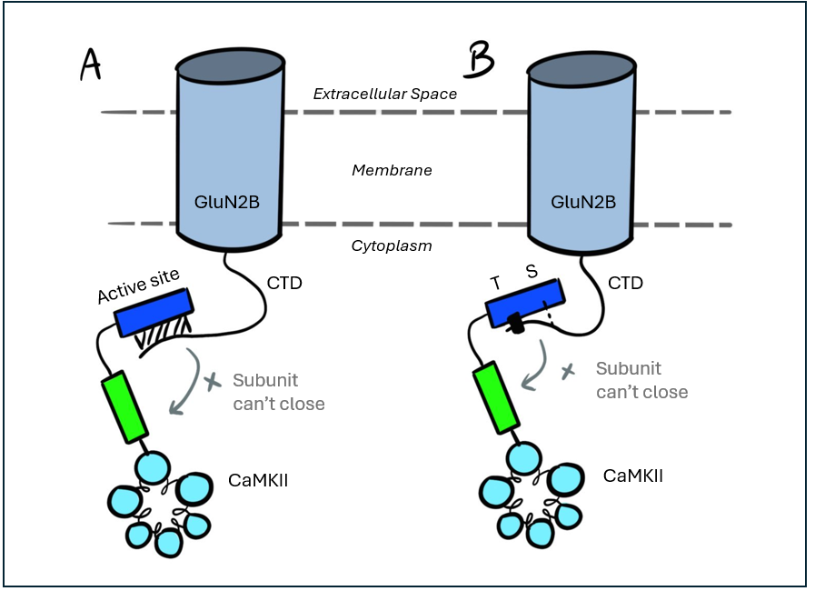
Figure 1.9: Schematic of two proposed models of CaMKII binding to the GluN2B subunit of NMDARs. Both models propose that CaMKII regulatory segment binds to the C-terminal domain (CTD) of GluN2B, stabilizing CaMKII subunits in an open, active conformation. Model A proposes that GluN2B binds to a single continuous site across the CaMKII kinase domain (blue). This interaction prevents autoinhibitory segment (green) from reassociating. This model proposes that kinase activity is preserved via a conformational change in the $α$-D helix of the kinase domain (not shown), causing it to rotate outward and accommodate binding of other substrates (pink circle). Model B suggests that the CaMKII kinase domain binds more strongly at a defined T site and more weakly at a secondary S site. This configuration may prevent the autoinhibitory segment from reassociating, while still allowing substrate access at the active site.
Although the exact mechanism by which CaMKII and NMDAR bind to form a complex is not yet fully understood, existing evidence consistently indicates that CaMKII subunits interact with the CTD of NMDARs, and that this structural complex plays a crucial role in LTP (Engelhardt et al. 2008; Akashi et al. 2009; Foster et al. 2010; Incontro et al. 2018). In fact, there is increasing evidence supporting a structural model in which LTP is maintained through the binding of CaMKII to the GluN2B subunit, independent of CaMKII’s enzymatic activity (Sanhueza et al. 2011). Halt et al. (2012) showed that disrupting CaMKII-GluN2B binding using peptides that block this interaction such as CN21, prevented LTP even when CaMKII kinase activity was intact. More recently, there have been some key studies (Özden et al. 2022a; Tullis et al. 2023) that focused on finding the minimal requirements for the ability of CaMKII to enhance synaptic transmission and its role in LTP maintenance. Although these studies were conducted independently, they both arrived at a similar conclusion: the role of T286 phosphorylation in CaMKII during LTP may not be primarily enzymatic.
Instead, it may serve to enable and stabilize the CaMKII-GluN2B complex that is essential for regulating synaptic CaMKII accumulation and supporting the associated structural functions of CaMKII required for LTP. In other words, T286 phosphorylation modulates (not mediates) the initial signal processing that triggers LTP induction, enabling a downstream response via CaMKII’s structural functions without requiring enzymatic activity. It is these structural functions of CaMKII that are, therefore, more likely to meet the essential and minimum molecular requirements for LTP induction and maintenance (K. Kim et al. 2016; Özden et al. 2022a), though the precise mechanisms remain unclear. The CaMKII/NMDAR complex may enable activity-dependent CaMKII incorporation into postsynaptic sites, potentially acting as a structural seed to recruit postsynaptic density proteins, contributing to synapse restructuring and plasticity.
In addition to forming a complex with GluN2B, CaMKII can phosphorylate the S1303 site at the GluN2B CTD. However, while the CaMKII/NMDAR binding complex is likely essential for synaptic function during LTP, S1303 phosphorylation does not appear to be necessary (John Lisman, Yasuda, and Raghavachari 2012a; Goodell et al. 2017, 2017; Tullis et al. 2021). Recent mutagenesis studies detected increased S1303 phosphorylation after induced chemical LTD, but not after LTP, suggesting that S1303 phosphorylation may be more relevant to synaptic weakening rather than strengthening (Tullis et al. 2021; Tullis and Bayer 2023). It is known that CaMKII and death-associated protein kinase 1 (DAPK1), another kinase of the CaMK family, competes for binding to the GluN2B subunit of NMDARs (Goodell et al. 2017, 2017). Recently, it has been posited that S1303 may act as a point of convergence for these kinases to modulate GluN2B-containing NMDARs. S1303 phosphorylation may play a more critical role in LTD, as DAPK1, which inhibits CaMKII binding, targets this site and initiates the molecular cascade leading to LTD. In summary, the precise mechanism of CaMKII binding to the NMDAR CTD remains unclear. And while it is known that CaMKII can phosphorylate S1303 in the NMDAR, this phosphorylation function remains enigmatic; the primary function of CaMKII binding to the receptor seems to be mainly structural during LTP (Tullis et al. 2021).
Phosphorylation at T305/306, unlike T286, has been more readily observed during LTD (Pi et al. 2010; Coultrap et al. 2014); what is more, phosphorylation at T305/306 is suggested to direct the signalling cascade toward LTD (Karl Ulrich Bayer and Giese 2024), although the exact mechanisms remain unclear. Specifically, phosphorylation at these sites seems to be important when CaMKII binds to GluN2B of NMDARs. Some studies suggest that phosphorylation at these sites inhibits binding to GluN2B (Elgersma et al. 2002; Sarah G. Cook et al. 2021), while others propose that binding to GluN2B suppresses T305/306 phosphorylation (K.-Ulrich Bayer et al. 2001b). Interestingly, Barcomb et al. (2014) demonstrated that a phosphomimic T305/306D CaMKII mutant retained its ability to bind GluN2B without significant reduction. This finding suggests that T305/306 phosphorylated CaMKII can still bind to GluN2B, challenging the idea that T305/306 phosphorylation directly inhibits binding, and that indeed CaMKII can bind to GluN2B and phosphorylate at T305/306 at the same time.
If phosphorylation at T305/306 makes CaMKII more likely to be in a “closed” state (see Section 1.4.2), this would reduce its likelihood of binding to GluN2B. In other words, it is not the phosphorylation itself that directly inhibits binding, but rather that the kinase, when phosphorylated at T305/306, is more likely to be in a closed state, which in turn reduces its chances of binding with NMDARs. This explanation, however, does not fully account for the observed reduction in T305/306 phosphorylation once CaMKII is bound to the GluN2B subunit (Elgersma et al. 2002; Sarah G. Cook et al. 2021). It remains unclear whether binding to GluN2B is reduced indirectly through T305/306 phosphorylation, if the GluN2b-CaMKII directly suppresses T305/306 phosphorylation, or if another mechanism is at play.
Ultimately, any structural LTP mechanism must regulate the filamentous (F)-actin cytoskeleton in dendritic spines. Changes in spine shape and size are closely linked to actin remodelling, which affects the strength of excitatory synaptic connections. During LTP induction, the balance between F-actin polymerization and degradation is transiently altered. Dendritic spine morphogenesis involves many actin-binding proteins and signalling pathways, and our protein of interest, CaMKII, is situated upstream of the signalling pathway that regulates F-actin modification (Shen et al. 1998; Ahmed et al. 2006; K.-I. Okamoto et al. 2007; Wang et al. 2019). Notably, the $β$-CaMKII isoform has been shown to have direct structural roles in binding and bundling F-actin filaments (Shen et al. 1998; O’Leary, Lasda, and Bayer 2006; K.-I. Okamoto et al. 2007). In its inactive, closed conformation, the $β$-CaMKII isoform is bound to and crosslinked with F-actin filaments via the variable linker between the regulatory and association domains. This binding limits access of actin-regulating proteins to F-actin and stabilizes spine structure.
Upon calcium influx after postsynaptic stimulation, calcium-bound CaM and T287 autophosphorylation of $β$-CaMKII releases these subunits from F-actin (Brocke et al. 1999), enabling actin remodelling (K.-I. Okamoto et al. 2007). Actin filaments subsequent reassociation stabilises the restructured F-actin (K.-I. Okamoto et al. 2004, 2007). Thus, the activity-dependent dissociation of $β$-CaMKII from F-actin may be of importace for actin dynamics remodelling that may allow dendritic spine plasticity and synaptic reorganization during LTP (K. Okamoto, Bosch, and Hayashi 2009; Borovac, Bosch, and Okamoto 2018). It has been demonstrated that both $α$ and $β$ isoforms of CaMKII can directly interact with the GluN2B subunit of NMDARs. However, it is the $α$ isoform, rather than the $β$, that is proposed to facilitate the activity-dependent incorporation of the CaMKII/NMDAR complex into postsynaptic sites (Fink et al. 2003). This process may act as a structural scaffold, recruiting postsynaptic density proteins and contributing to synaptic restructuring and plasticity. Consequently, these two primary neuronal isoforms appear to have distinct roles in neuronal plasticity, with $α$-CaMKII regulating synaptic strength and $β$-CaMKII influencing dendritic morphology.

What we don’t know
Alltogether, there is strong evidence showing CaMKII and NMDAR interactions play a critical role during LTP (Engelhardt et al. 2008; Akashi et al. 2009; Foster et al. 2010; Incontro et al. 2018), however, many questions remain unanswered. For example, what role does the binding of CaMKII and NMDAR have in the different phases of LTP? While it is well-established that the CaMKII/NMDAR complex helps maintain CaMKII in an enzymatically active state, this enzymatic activity has not been proven to be an essential requirement for the induction or maintenance of LTP (Incontro et al. 2018). Rather, the evidence seems to suggest it is necessary for the expression phase of LTP (Karl Ulrich Bayer and Giese 2024; Rumian et al. 2024).
What is more, the precise mechanism of how CaMKII and NMDAR interactions form a complex is also hotly debated. As discussed above, longstanding model posited that CaMKII binds to two distinct sites on the NMDAR C-terminal (K.-Ulrich Bayer et al. 2001b). However, recent crystal structure studies challenge this by suggesting that CaMKII substrates and activators interact at a single continuous site on the kinase domain (Özden et al. 2022a). A more recent review offers a refined perspective, suggesting that CaMKII binds continuously through its S and T sites on the kinase domain, with these sites acting in concert to mediate binding to the GluN2B subunit of NMDARs. Furthermore, although docking of CaMKII to GluN2B subunits is emerging as a key candidate for mediating the structural changes associated with LTP, the connection between this interaction and subsequent changes that affect the cytoskeleton’s structure remains unclear.
Another unresolved question is the exact role of T305/306 phosphorylation in regulating CaMKII activity. Evidence suggests that this phosphorylation acts as a regulatory mechanism, influencing signalling pathways associated with both LTP and LTD, with increased T305/306 phosphorylation seemingly promoting LTD (S. G. Cook et al. 2021). As previously discussed, T305/306 phosphorylation has been proposed to function as a form of kinetic proofreading, ensuring that CaMKII remains inactive or less active unless sustained or repetitive calcium signals are detected. This mechanism would serve to prevent premature or excessive activation of the kinase, thereby enhancing the specificity and fidelity of CaMKII-mediated signalling in response to synaptic activity. However, there is ongoing debate within the experimental literature regarding whether T305/306 phosphorylation alone inhibits LTP and facilitates LTD, or if its effects are mediated in concert with the activation of competing kinases, such as DAPK1, in regulating the bidirectional processes of LTP and LTD (Goodell et al. 2017, 2017).
These questions underscore the importance of further research into the dynamics of CaMKII/NMDAR interactions. Gaining a clearer understanding of these interactions may shed light on the biochemical processes that stabilise memories and provide crucial insights into LTP and memory formation. Therefore, this PhD research of relevance and is well positioned to allow us to test the minimal requirements of CaMKII/NMDAR interactions while considering the spatial and temporal dynamics of CaMKII activity using computer models of these interactions.
This PhD investigates how distinct functional states of CaMKII—including its conformational changes and phosphorylation at key regulatory residues such as T286 and T306, contribute to the formation and stabilisation of the CaMKII/NMDAR complex. Specifically, I explore how different functional modifications of CaMKII affect its ability to bind to NMDARs, and how, in turn, NMDAR binding alters CaMKII’s kinase activity. To examine these mechanisms, I developed three main in silico models: a wild-type control model, a mutant in which CaMKII/NMDAR interactions are abolished, and a mutant in which phosphorylation at the T286 residue is prevented. Together, these models enable a systematic investigation of how disrupted binding or phosphorylation influences both the stability of the CaMKII/NMDAR complex and downstream CaMKII signalling dynamics.
To this end, this PhD research aims to investigate how CaMKII and NMDARs interact in a postsynaptic dendrite following calcium entry, using reproducible computational models. The overarching objective is to develop and refine these models to enhance our understanding of synaptic plasticity and memory formation. In order to understand how these biological phenomena are modelled computationally, the following chapter provides an introduction to the software and applications used in this research.

2. Computational Modelling Background
Computational modelling offers a powerful means of investigating complex biological systems by simulating molecular interactions. These models aim to describe the elements of a system, their states, and their interactions with sufficient precision to replicate real-world dynamics. Biological systems, such as cells, operate through multiscale processes in which molecular interactions give rise to larger-scale cellular behaviors (Rothschild 2006; Suki, Bates, and Frey 2011). For example, in neurons, molecular interactions like neurotransmitter release, receptor activation, and intracellular signalling regulate synaptic plasticity. These interactions give rise to emergent behaviours, where molecular and cellular changes scale up to influence higher-order functions. Changes in synaptic strength, such as Long-Term Potentiation (LTP) and Long-Term Depression (LTD) (see Section 1.3), drive larger-scale processes like dendritic spine remodelling and receptor trafficking, ultimately influencing neural circuit activity —key mechanisms underlying learning and memory.
To study intricate cellular processes such as signal transduction and neuronal plasticity we require appropriate mathematical tools and models capable of simulating dynamic, nonlinear interactions at multiple scales. A computational model incorporates numerous variables representing the system under study, with simulations performed by adjusting these variables, either independently or in combination, and observing the outcomes (Hassan et al. 2023). Computational models allow for the exploration of the system’s emergent behaviors, where system-level properties arise from simple interactions among individual components but are not explicitly encoded at the molecular level (Xiao, Zhang, and Huang 2015).
This PhD employs computational modelling to explore biological systems, focusing on biochemical modelling of dynamic, complex reaction networks that underpin biological processes. Specifically, we look at the interactions between CaMKII and NMDAR in the postsynaptic dendrite of neurons that are thought to be relevant for learning and memory (see Chapter 1). The rationale for selecting specific modelling approaches to study the interactions between these molecules are introduced and discussed next. These approaches include rule-based modelling, agent-based modelling and stochastic simulation algorithms. This chapter also discusses the computational tools used to implement these models, including Monte Carlo Cell (MCell) (Stiles et al. 1996; “Monte Carlo Methods for Simulating Realistic Synaptic Microphysiology Using MCell” 2000; Kerr et al. 2008; Husar et al. 2022) for stochastic spatial simulations and Biological Network Generator (BioNetGen) (L. A. Harris et al. 2016) for rule-based modelling. Together, these tools provide a robust framework for simulating complex molecular interactions and cellular behaviours, enabling the study of dynamic processes that can often be difficult to investigate experimentally.

2.1 Why use computational modelling to study biological systems?
Computational models are becoming increasingly popular in Neuroscience (and in the sciences in general) (Noble 2002; Kaur and Gaba 2021; Levenstein et al. 2023), as they provide useful advances to enhance our understanding of systems that want to be studied. When modelling biological systems, we aim to describe the system’s elements, states, and interactions to accurately simulate its behaviour. In the context of this PhD study, we examine postsynaptic neuronal dendrites, where complex biochemical processes span multiple compartments and scales.
Given the vast complexity of reactions and molecular networks within a dendrite, mathematical tools used in computational modelling can help simplify the analysis of these systems. This way, models allow questions to be investigated that are difficult to approach experimentally. By focusing on specific parts of biological multiscale dynamics, these tools allow researchers to isolate particular aspects of interest. This approach helps minimize the influence of unrelated variables and reduces the complexity of the full biological system. Computer simulations allow adjustments to almost any state variable at any given time point, and they enable data to be analysed with virtually any level of precision, both in terms of time and space (Levenstein et al. 2023).
It is important to note that when modelling, just like with wet-lab, care must be taken when interpreting simulation results, as they are subject to finite accuracy. Errors can arise from a variety of reasons, such as the properties used in simulations, the mathematical models, their numerical algorithms, and more (this is further discussed in Chapter 4). Moreover, biological systems are inherently stochastic and exhibit natural variability (Teschendorff and Feinberg 2021; Demopoulos 2025). For computational results to be meaningful, they must account for the full range of expected variability in the physical systems they aim to represent. That is why simulations are carefully validated by comparing their behaviour to experimental data; and inconsistencies can suggest incomplete assumptions or misinterpretations. However, it is also important to recognize that even if a model successfully recapitulates experimental results, this does not necessarily mean it is correct. Biological systems can often exist in multiple states that produce the same observable outcome, meaning that different underlying mechanisms could lead to similar results.
Models that survive this initial validation can be used to predict new outcomes and explore scenarios that are challenging to investigate experimentally, offering insights into the workings and principles of biological systems. This way, modelling aims to clarify the current state of knowledge about a system by precisely defining its elements and interactions, which can reveal gaps in understanding (Székely and Burrage 2014). Whilst it is true that models may omit certain details of a biological system, the purpose of computational models is not to replicate every detail of a biological system, but rather to offer a specific representation that captures the essential dynamics relevant to a specific research question. By focusing on key components and interactions, models offer the capability of testing minimal requirements of very complex systems by just considering the molecules immediately influencing the phenomenon that is being studied.
Furthermore, models can be refined iteratively as new data becomes available or as understanding of the system deepens, facilitating continuous improvement and development of the system at hand. Even if a model does not encompass every element of the system, it remains a powerful tool for identifying critical relationships, predict system behaviour, guiding experimental design, generating hypotheses and offering structured frameworks for exploring complex biological phenomena (Székely and Burrage 2014; Brodland 2015).
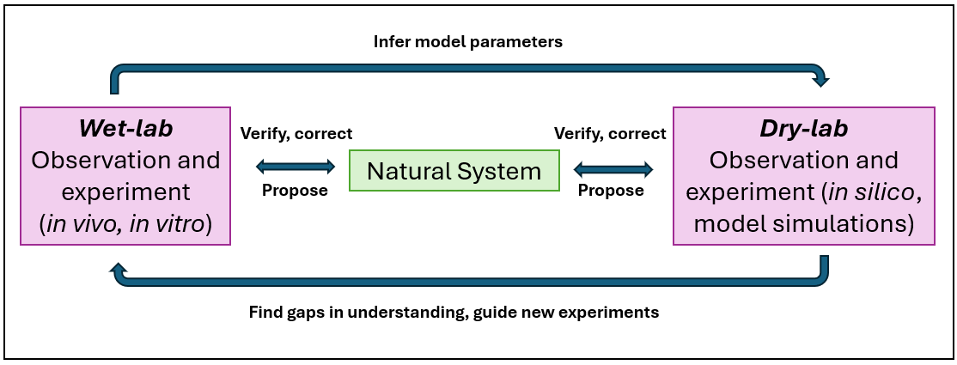
Figure 2.1: Computational models can guide and refine biological experiments and vice versa, creating an iterative cycle that improves both approaches. Adapted from Székely and Burrage (2014).
Moreover, using computational methods for studying biological mechanisms can be time and cost-efficient. Modelling is well positioned for integration into the experimental cycle of biology. Although in vitro and in vivo experiments are still needed to advance our understanding of biological processes, conducting in silico, or computer-simulated experiments can help guide the wet-lab process by narrowing the experimental search space (Robinson et al. 2004). Importantly, this creates an iterative cycle, where computational models inform experimental design, and experimental findings, in turn, refine and improve the models. This continuous process strengthens both approaches, leading to a deeper and more accurate understanding of biological systems (Figure 2.1).
In addition to the reasons discussed, my preference for computational modelling over wet-lab experiments is also shaped by personal considerations. Among these personal reasons, is my desire to move away from animal experimentation, as the speciesist assumption that testing on animals is both acceptable and necessary does not align with my values. A detailed and nuanced discussion of this perspective is provided in Chapter 4. Following the principles of the “3Rs alternatives” framework: replacement, reduction, and refinement of animal use in research; I am particularly committed to the goals of replacement and reduction. I don’t believe in the speciesist beliefs that place one species above another, justifying the harm of those deemed inferior for research (LaFOLLETTE and Shanks 1995; Dhont et al. 2019; Jaquet 2021).
In my opinion, computational modelling research such as the one undertaken in this PhD, however, cannot be fully separated from animal research because experimental data is often derived from studies that have involved using animals to a certain degree (Domínguez-Oliva et al. 2023; Mukherjee et al. 2022). Moreover, models must usually be validated against experimental results to confirm their biological relevance, and in many cases, such validation still depends on data from in vivo or in vitro studies (Madden et al. 2020). Nevertheless, I advocate for a shift toward computational research that not only minimizes reliance on animal studies but also emphasizes reproducibility. Ensuring that research is reproducible helps avoid redundant experimentation by allowing scientists to verify and build upon existing findings rather than repeating studies due to unclear methodologies or irreproducible results (Pound et al. 2004). When computational models are rigorously validated and openly shared, they can serve as reliable references, reducing the need for additional animal-based experiments to confirm previous findings. Reproducibility and opennnes of computational models is further discussed in Chapter 3.

2.2 How do we model biochemical systems networks?
When constructing a computational model for biochemical system networks, one of the first steps researchers must undertake is identifying the key components of the system and the critical interactions between them. There is no single applicable method for this, as the approaches and questions will vary depending on the specific study being conducted, just like in wet-lab experiments. For instance, is it necessary to represent the behaviour of the system in three dimensions, or would a two-dimensional approximation be sufficient, or is spatial information necessary at all? Similarly, should individual cells and molecules be explicitly modelled, or can their behaviour be adequately captured using appropriate constitutive equations? Other factors to consider include determining which interactions between components are essential for the model and assessing the role of stochastic influences on these interactions. These examples are not exhaustive, as the questions and decisions depend on the system studied, the hypotheses being tested, the study approach, and more. A detailed description of factors chosen for the model in this project are given in Chapter 5. Although each assumption made at this stage may introduce differences between the model and the biological system it seeks to emulate, well-considered assumptions -chosen based on biological knowledge, empirical evidence, and modelling best practices- can improve the model’s clarity, providing a solid foundation for effective representation of the biological system.
Deciding which simplifications and choices to make during the creation of a model requires a deep understanding of the system combined with mathematical and computational skills. Modelling biochemical systems networks is usually a combined effort between modellers and biologists (although these roles are not exclusive). This interdisciplinarity is a key strength of the process, as it means modelling combines diverse expertise, encouraging are more holistic understanding of diverse perspectives.
Once the key factors to be modelled have been identified, conceptual elements of the model can be translated into a mathematical framework. This process involves defining aspects such as state variables, as well as representing components of the system using appropriate data types to model the system. Each interaction within the system may then be characterised by appropriate mathematical relationships too. For instance, biochemical reactions can be expressed through differential equations that describe the rate of change in the concentrations of reactants and products. The implementation of suitable algorithms to accurately realise the various components of the model is critical in ensuring its functionality and efficiency.
For example, is deterministic modelling or stochastic modelling more suitable for studying a particular system of interest? See deterministic modelling and stochastic modelling below. Additionally, there is an expanding array of tools and modelling approaches available that researchers can choose from (S. Ghosh et al. 2011; Olivier, Swat, and Moné 2016; Bartocci and Lió 2016; Kohl 2011); translating biological processes into mathematical models on a computer requires not only the appropriate algorithms but also a suitable programming language. There is a wide range of programming languages to choose from —such as Python, MATLAB, and C to name a few- each with its own advantages and limitations. In the following sections, we will explore the modelling approaches and programming languages that are relevant to this PhD.

Reaction-based modelling:
When translating biological and chemical systems (such as CaMKII and NMDARs interactions in the postsynaptic neuron) into algorithms, one way of describing these systems can be through networks of chemical reactions (M. Cook et al. 2009). This approach is known as reaction-based modelling, where mathematical models are used to represent the dynamics of biological systems in a computer (Besozzi 2016). Reaction-based models are formalized as sets of reactions that describe the given system in terms of mechanistic interactions between the species of interest. This is, biochemical networks are a set of chemical species that can be converted into each other through chemical reactions.
The focus of biochemical network models is usually on the levels of the chemical species and this usually requires explicit mathematical expressions for the velocity at which the reactions proceed (kinetic reaction rates). Once kinetics have been specified, these systems can be used directly to construct full dynamic simulations of the system behaviour (M. Cook et al. 2009).
Biochemical network models allow us to gather insight by simulating chemical interactions over time; we can observe changes in species levels, visualise stable states within the system, and look for potential direct or indirect causal relationships between the species being studied. Importantly, the modellers can modify any of these parameters to test how such changes impact the model’s results. Computational models allow us to modify parameters in ways that would be extremely difficult or even impossible to test experimentally, such as precisely controlling molecular concentrations of molecules in particular states, eliminating specific interactions, or simulating conditions that cannot be easily replicated in a laboratory setting. Using a reaction-based approach is particularly useful for modelling the interactions of molecules of interest in this PhD, where we can simulate various chemical components such as NMDARs and CaMKII among others and their interactions in an efficient manner, as seen in Chapter 5.
Biological systems can be simulated in different ways using different algorithms depending on the assumptions made about the underlying kinetics [Resat, Petzold, and Pettigrew (2009);], as discussed below; and different formalisms are usually applied to describe the dynamics of these biochemical systems (Marchetti, Priami, and Thanh 2017). The kinetics of chemical reactions vary based on the timing of molecular interactions, with reactions unfolding over a timescale determined by the microscopic mechanics involved. Molecular collisions occur randomly inside cells, and are influenced by factors like thermal motion and diffusion. This randomness means that the number of molecules of a particular species fluctuates as a random variable (Mazo 2008; Earnest, Cole, and Luthey-Schulten 2018).
However, when we observe large-scale, or macroscopic, quantities —such as the concentration of a substance over time— the outcomes tend to be consistent and predictable. This predictable trend enables us to develop rate laws, mathematical expressions that describe how the concentration of molecules changes over time. Rate laws are foundational to deterministic modelling, as they assume that, given a specific starting point (initial conditions), the progression of a chemical process is fixed or “predestined.” Deterministic models thus allow scientists to predict the time evolution of chemical concentrations with high accuracy, even if the underlying molecular interactions remain random on a microscopic scale. Deterministic models work well where molecular species exists in vast quantities. However, as systems decrease in scale, such as in the confined environment of a cell’s cytosol, random fluctuations in molecular populations become significant, making experimental results less reproducible and measurements more variable. Unlike deterministic models, which assume smooth, predictable changes, stochastic models accommodate the random fluctuations in molecule numbers that can significantly impact reaction outcomes in confined environments. Lets briefly examine the reasons why each of these approaches may be employed for distinct purposes:

Deterministic modelling:
Deterministic approaches to chemical kinetics are often used to characterize time evolutions of chemical reactions in large systems (Marin, Yablonsky, and Constales 2019). A popular representation for these models is to use ordinary differential equations (ODEs) to describe the change in the concentrations of chemical species (Hoops et al. 2016). Running the same set of parameters using deterministic simulations will produce the same results each time by solving these ODEs. Such descriptions are appropriate when the number of particles involved in the biochemical network is large enough to be able to consider continuous concentrations and when spatial effects are negligible, i.e. well-mixed environment is assumed and space has no effect on reactions. In ODE-based models, each chemical species in the network is represented by an ODE that describes the rate of change of that species along time. Therefore, ODE models of biochemical processes are useful and accurate in the high-concentration limit, but often fail to capture stochastic cellular dynamics accurately because the deterministic continuous formulation assumes spatial homogeneity and continuous molecular concentrations (M. E. Johnson et al. 2021; Smith and Grima 2019).
These ODE models can be used to simulate the dynamics of the concentrations of the chemical species along time given their initial values. This is achieved by numerical integration of the system of ODE which can be carried out with well-established algorithms (Postawa, Szczygieł, and Kułażyński 2020). They are also useful to find, for example, steady states of the system, which are conditions when the concentrations of the chemical species do not change (Maly 2009).

Stochastic modelling:
As a general rule, stochastic simulations are preferred where the numbers of particles of a chemical species is small (Gillespie 2007; Székely and Burrage 2014); the ODE approach is required when the number of particles is large because the stochastic approach might be computationally intractable. However, when the assumption of continuous concentration fails due to small-scale cellular environment with limited reactant populations ODE representation also fails. It is here when stochastic simulations are useful. Unlike ODE models, which assume continuous concentrations, stochastic simulations track individual reaction events using probability distribution functions. Stochastic Simulation Algorithms (SSAs) (Gillespie 2007; Székely and Burrage 2014), determine the timing and sequence of reactions based on these probabilities.
It is important to stress that one simulation run according to stochastic approaches is only one realization of a probabilistic representation, and thus provides limited amount of information on its own. When running stochastic simulations, it is important that they are repeated for a sufficient number of times in order to reveal the entire range of behaviour presented by such a system to estimate a probability distribution for each chemical species and its dynamic evolution. The number of required runs depends on the system’s complexity and the degree of variability in its dynamics, with guidelines available in the literature (Ritter et al. 2011; Byrne 2013) for determining sufficient sampling (for example based on statistical confidence intervals).
Ultimately, both SSAs and ODEs offer valuable modelling insights, and the selection of the appropriate method depends on the specific dynamics and the level of detail required for simulating the biochemical network under investigation.
As we have seen, computational modelling has its benefits for studying biological systems. However, the complexity of these systems presents unique challenges. Biological systems consist of numerous interacting components and emergent behaviours, requiring careful consideration of both individual components and their dynamic interactions. The next section delves deeper into the concept of complexity in biological systems, examining the challenges of modelling such networks, and how these challenges are directly linked to the biological questions of this PhD. I will also discuss the modelling approaches I employ to handle the complexity of these systems.

2.3 Complexity in Systems Biology: Modelling approaches and challenges
This PhD thesis is grounded in Complexity Science, which studies how interactions between components of a system give rise to emergent behaviors. Examples of application of Complexity Science can be predator-prey models, epidemiological modelling of pandemics, protein-protein interaction networks, models of neurons, and more. When applied to biology, complexity science often falls under the banner of Systems Biology. Systems biology refers to the quantitative analysis of dynamic interactions between multiple components within a biological system, with the goal of understanding the system’s behaviour as a whole. Systems biology entails the study of complex biological systems by combining mathematical modelling, computational simulation, and biological experimentation.
Complexity is a critical aspect of the systems studied in this project, that is, the spatiotemporal dynamics of molecules such as CaMKII and NMDARs in the PSD; making it essential to understand our choices in how and why we model these elements. Specifically, this project looks at catalytic interactions that drive post-translational modifications such as enzyme-driven phosphorylation of CaMKII and NMDARs, as well as interactions between these proteins that promote the assembly of molecular complexes (Sanhueza and Lisman 2013; “Biochemical Principles Underlying the Stable Maintenance of LTP by the CaMKII/NMDAR Complex” 2015). These types of interactions are hallmark drivers of something known as combinatorial complexity in cellular systems and biochemical networks (Klamt and Stelling 2002).
When proteins interact, they create unique states that alter the protein’s function, structure, or binding capabilities. Meaning that each protein can undergo multiple types of modifications or engage in various site binding interactions, which leads to a multitude of distinct protein configurations. Systems of interacting proteins are inherently complex as the interactions between its constituent proteins usually have the potential to create a vast array of distinct chemical species. This number can far exceed the actual count of proteins or protein interactions within the system itself, creating a combinatorial explosion where every modification or binding event adds another layer of potential molecular arrangements. This high number in potential molecular arrangements is referred to as combinatorial complexity, a defining feature of cellular systems and biochemical networks (M. I. Stefan et al. 2014).
Moreover, these distinct molecular species states do not exist in isolation. They are interconnected through an extensive network of reactions, further amplifying the system’s complexity. Intricate network of protein–protein interactions is in fact a prominent feature of any signal-transduction system (Gomperts, Tatham, and Kramer 2009; Hunter 2000). These interactions can occur at multiple levels, including feedback loops, cross-talk between pathways, and spatial-temporal variations. Each reaction acts as a link within a larger network, creating pathways that connect different species. Modelling these networks is therefore particularly complex due to the difficulty in capturing all possible interactions and the uncertainty in the exact nature of these interactions; i.e. not all possible states of a molecular species may be relevant for its functions (Changeux and Edelstein 2005; Pharris et al. 2019).
The magnitude of combinatorial complexity can be exemplified well with the CaMKII holoenzyme studied in this PhD. CaMKII is a multi-subunit protein that can exist in a vast number of possible functional states, depending on the modifications and interactions at each subunit. Each of the individual subunits of CaMKII can have multiple possible states, influenced by factors such as phosphorylation, binding to calmodulin, and interactions with other proteins like NMDARs, and more (Nicoll and Schulman 2023a). It has been proposed that a CaMKII dodecamer could potentially exist in as many as ${10}^{20}$ possible states (see calculations in methods section and appendix S1 in Pharris et al. (2019)). Moreover, the fact that the potential states of CaMKII vastly outnumber the actual CaMKII molecules in a dendritic spine (Pharris et al. 2019), suggests that not all states occur with the same frequency and therefore not all mathematically calculated states are of equal biological relevance, which highlights the challenges of modelling systems that involve combinatorial complexity.
Combinatorial complexity of signalling systems involving multi-state proteins impacts both the process of writing the model, known as the specification problem, and the computational demands of running it, particularly in terms of time and resources, known as the computation problem (M. I. Stefan et al. 2014). The specification problem encompasses challenges such as representing all possible states of a molecule like CaMKII, the various complexes it can form, the transformations those complexes can undergo, and the parameters and conditions that govern these processes, all in a robust and efficient manner. When faced with the computation problem, where it may become computationally infeasible to enumerate or simulate all state and network possibilities, the model may become intractable, requiring excessive time and resources to compute, store and/or analyse.
As explored next, rule based modelling provides a powerful solution to the specification problem: rather than accounting for every possible state explicitly, it enables a focus on biologically significant states while allowing emergent behaviours to arise through rule-based interactions. As for the computation problem, we will see later on how particle-based rule evaluations can help with it.

2.4 Rule based modelling
The challenges posed by the specification problem of combinatorial complexity motivate the adoption of a rule based modelling (RBM) approach for simulating cell signalling systems in this PhD. RBM can help by using a set of logical rules to describe how molecules interact with each other. With this type of modelling, the system is modelled by specifying the reactions (or rules) that describe how molecules interact and change (L. A. Harris, Hogg, and Faeder 2009; Lily A. Chylek et al. 2014; Lily A. Chylek et al. 2015). Instead of listing every individual interaction or molecular species explicitly, rules are used to represent how molecules bind, modify, and transform. These rules, which are primarily based on experimental observations, are applied to sets of molecules that can be in different states or configurations, and the overall dynamics of the system emerge from the repeated application of these rules. This method allows for more efficient specification of models, and can scale to handle complex systems like the ones studied in this PhD; this way, avoiding the impossible enumeration of the ${10}^{20}$ calculated states of CaMKII alone.

BioNetGen: A tool for rule based modelling
BioNetGen (Biological Network Generator) (L. A. Harris et al. 2016) is a useful tool for performing RBM of biochemical networks, particularly in the context of signalling systems and protein–protein interactions. BioNetGen uses a language called BNGL (BioNetGen Language) to define molecular species and the rules that govern their interactions. A key feature of BNGL is that it allows researchers to describe the interactions between proteins and other molecules in a high-level, abstract form, without the need to manually enumerate every possible molecular species or state. Instead, BNGL allows users to define generalized rules using an RBM approach, specifying how molecular entities can interact -such as binding, phosphorylation, or degradation — along with the conditions under which these interactions occur.
Different approaches to RBM are used depending on one’s objectives and modelling focus (Schaff et al. 2016; Faeder, Blinov, and Hlavacek 2009; Lopez et al. 2013; Boutillier et al. 2018). In our approach, we employ BioNetGen and its associated language BNGL, as it provides some key advantages for the research at hand. Firstly, BNGL provides a language that is tailored towards modelling biochemical networks with domain-specific requirements, allowing for the detailed specification of molecules and their binding domains, which is particularly useful for studying protein post-translational modifications, for example autophosphorylation of CaMKII. Moreover, BNGL helps resolve nomenclature challenges by allowing explicit naming of molecules, binding sites, and modification states in a structured and consistent manner (see Figure 5.2 for an in depth example of CaMKII nomenclature using BNGL). The ability to model site-specific details of protein-protein interactions allows these dynamics to be captured systematically.
Guided by the “don’t care, don’t write” principle at the heart of RBM modeling (Lily A. Chylek et al. 2014), BNGL allows us to specify only the relevant states for a given reaction. This approach eliminates the need to define every possible state explicitly. That is, the rules determine when an implicitly defined reaction can happen and then, for any given iteration, only the states that matter for the execution of a particular reaction (or rule) are explicitly declared. States that do not matter to a particular rule can be omitted. For instance, lets consider a reaction rule where a CaMKII subunit binds to a CaM molecule (Figure 2.2).
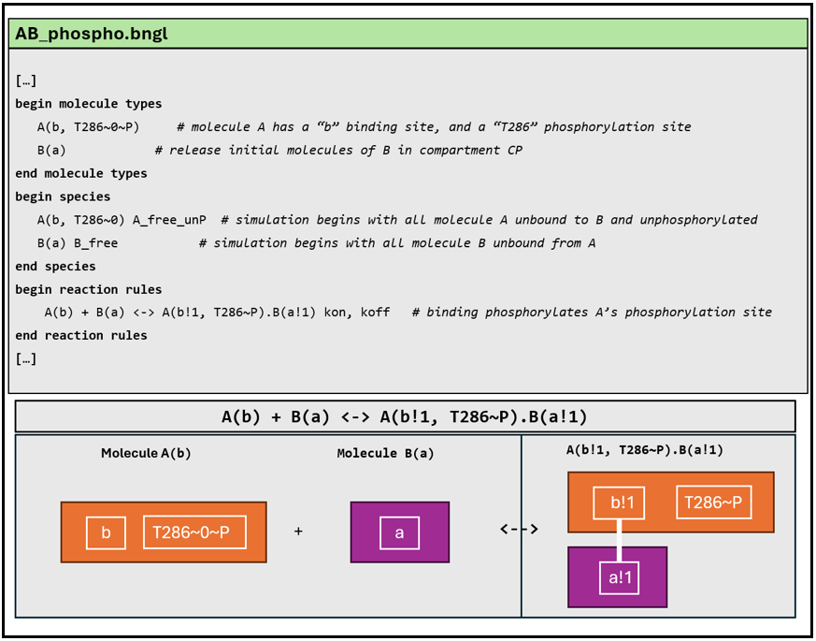
Figure 2.2: A and B molecule binding causes phosphorylation; an example of don’t care, don’t write in BNGL. The possible states of molecules A and B are defined under the molecule types block. Molecule A has a binding site (b) and a phosphorylation site (T286), which can exist in a phosphorylated (~P) or unphosphorylated (~0) state. Molecule B is defined simply with a single binding site (a). The initial states of these molecules are defined in the species block, which specifies how the molecules are introduced at the start of the simulation. Molecule A is released with its binding site (b) free (unbound to B) and its phosphorylation site in the unphosphorylated state (T286~0). Molecule B is released in a free state, unbound to molecule A. The reaction rules block defines how the molecules interact. In this example, the rule specifies that phosphorylation occurs when molecules A and B bind (indicated by the “!1” link notation). Importantly, the state of A’s phosphorylation site does not need to be explicitly stated in the rule. What is required for the reaction to occur is the binding of A and B, after which phosphorylation can take place. While this is a simple example with limited complexity, as more possible states are introduced, the value of this method becomes clearer. Note this example does not represent a complete BNGL model, as indicated by the “[…]”, which denote additional model definitions that would typically appear before and after these lines.
In the example shown in Figure 2.2, we don’t specify the state of T286 in the reaction rule of A and B leading to phosphorylation of the former. Instead, we only specify the states that are relevant for a specified reaction (in this case, that molecule A has a free binding site to bind with B, and vice versa) and the rest is left unspecified. In more complex models such as the one used in this thesis, this dramatically reduces the number of reactions that need to be written (R. M. Karp 1975; Richard M. Karp 1972; Błażewicz, Formanowicz, and Kasprzak 2005; Suárez and Jaramillo 2009). Details of how this is done in our model are described in Chapter 5.
Additionally, BNGL supports the inclusion of cellular compartments through its compartmental extension (cBNGL), enabling explicit modelling of the compartmental organization of the cell and its effects on system dynamics (L. A. Harris, Hogg, and Faeder 2009). This way, we can introduce localization attributes for molecular species, as well as appropriate volumetric scaling of reaction rates. BioNetGen and its associated language BNGL have been integrated with MCell via pyBNGL, a Python library (Husar et al. 2022). As we will see next, this provides further advantages when it comes to the computation problem of combinatorial complexity.

MCell: A tool for dynamic protein visualisation and modelling
MCell (Monte Carlo Cell) is an agent-based (also known as particle-based) reaction-diffusion software platform designed to simulate complex biochemical processes with a focus on spatial and stochastic dynamics (Stiles et al. 1996; “Monte Carlo Methods for Simulating Realistic Synaptic Microphysiology Using MCell” 2000; Kerr et al. 2008; Husar et al. 2022). Agent-based modelling simulates the interactions of autonomous agents -such as molecules- to understand how a system behaves and to capture emergent behaviours; for example, the formation of molecular complexes, signal transduction pathways, or spatial patterning within a cell. MCell is particularly valuable for modelling biological systems where the precise location and movement of molecules are crucial, such as synaptic signalling or interactions at the cellular level studied in this PhD. To facilitate the visualisation of these complex geometries, MCell integrates with CellBlender. CellBlender is an addon for Blender, a widely used open-source 3D modelling and animation software (Gupta et al. 2018).
Reaction-based models typically rely on networks to represent chemical interactions (as discussed in Section 2.3), but they can become computationally expensive as system complexity grows, especially when handling large numbers of reactions or species. MCell, however, bypasses this limitation by tracking individual molecules and their interactions in real-time, only focusing on the relevant species and states. Its particle-based rule evaluation eliminates the need to construct full or partial reaction networks, both at the start and during the simulation, by concentrating solely on the molecules present, their current states, and the reactions they can participate in at any given moment. This approach, known as network-free simulation, not only reduces computational demands but also allows researchers to explore more complex and realistic biological scenarios without the constraints of predefined reaction networks.
As a spatial particle-based simulator, MCell models molecules as point particles within a 3D space. Each time step of an MCell simulation, particles can move, interact with other particles or surfaces, and undergo bimolecular and/or unimolecular reactions. Briefly, MCell operates as follows: as a volume molecule diffuses, all molecules within a given radius along its trajectory, or at the point of collision on a surface, are considered for a reaction. For surface molecules (in membranes), the molecule first diffuses, and then its neighbours are evaluated for reaction Figure 2.3. Moreover, MCell allows defining arbitrary geometry, and complex models such as a 180μm3 3DEM reconstruction of hippocampal neuropil have been used to construct a geometrically-precise simulation of 100s of neuronal synapses at once (Bartol et al. 2015). A detailed description of mathematical foundations of MCell’s algorithms can be found here (Bartol and Stiles 2000; Kerr et al. 2008)
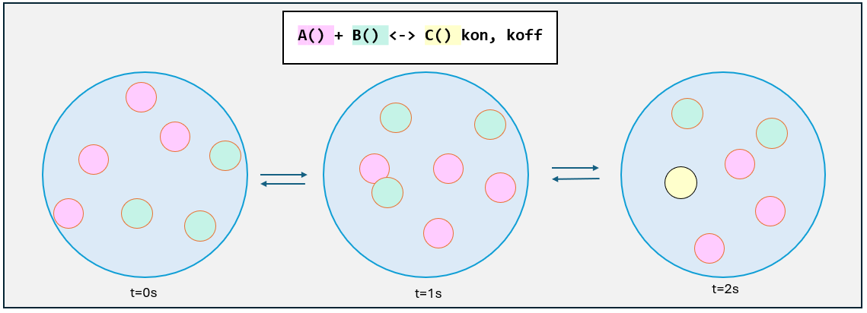
Figure 2.3: MCell simplified schematic to understand how particle collision works. At time zero, molecules are released into a 3D space (represented by a blue circle), and they begin to diffuse according to specified diffusion coefficients (not shown). Over time, if molecules A and B collide, they are considered for a reaction, in this case, where A and B combine to form molecule C, with kinetic rates kon and koff.
MCell software employs stochastic Monte Carlo algorithms, which rely on random sampling to simulate the behaviour of molecules. This stochastic approach makes MCell particularly effective for capturing the inherent randomness found in biological systems, previously discussed in Section 2.2. MCell can model the diffusion of molecules within cellular compartments and the probabilistic interactions between proteins, making it a powerful tool for studying phenomena where small fluctuations can have significant impacts, such as in the postsynaptic signalling pathways studied in this thesis.
MCell4 (version 4, the one used here) also provides a versatile Python interface. This recently implemented Python interface allows for greater ease in scripting and model construction, making it more user-friendly and adaptable for researchers (Husar et al. 2022). Additionally, the newly created BioNetGen Library for python (pyBNG) allows direct loading and parsing of a BNG model into MCell. This allows for the creation of models that capture multimeric structures, site-specific binding properties, and the dynamic interactions of proteins over time and space (Husar et al. 2022). Next, we provide a more detailed discussion emphasizing how this approach supports the goals of this PhD project.

MCell and BioNetGen integration
The main components of MCell4 (henceforth MCell), which enable interaction between various libraries and engines, include: a PyMCell library which offers a Python interface and contains classes to manage the model representation. The MCell4 engine, responsible for executing simulation algorithms, and a pyBNG library, which provides methods for resolving BioNetGen reactions Figure 2.4.
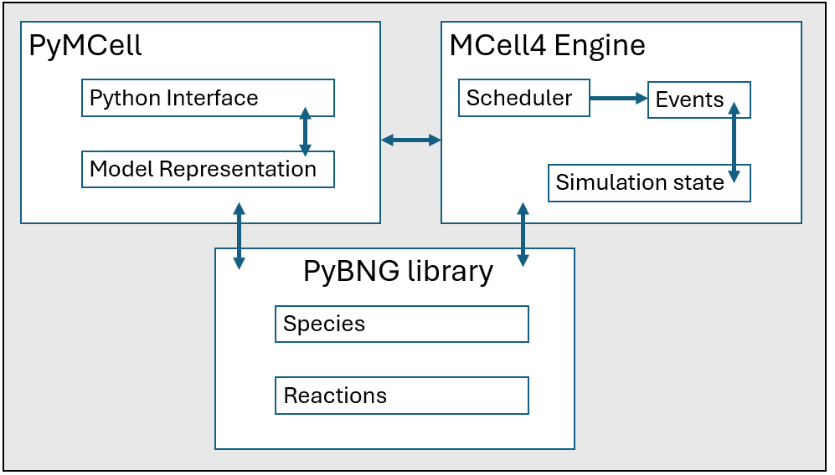
Figure 2.4: The MCell4 (version used in this PhD) components that allow for integration between different libraries and engines. PyMCell Library allows for python interface for model representation. The MCell4 engine implements simulation algorithms through a scheduler that keeps track of events to be run in each iteration. The pyBNG library provides methods to resolve BioNetGen reactions using python scripts. Figure modified from Husar et al. (2022).
A model can be defined using BNGL, where molecular interactions are specified through detailed rules and reactions. This model can then be parsed using the pyBNG library, allowing Python scripts to handle the BNGL files and initiate simulations with MCell. Python scripts play a crucial role in this workflow. They are not only responsible for parsing BNGL files but also for defining the cellular geometry and setting parameters required for MCell simulations. Once the simulation is executed in MCell, the output is generated in the form of data files, containing time-series data on molecular concentrations and dynamics as dictated by the initial reactions see 2.6 (a).
To illustrate the integration between MCell and BioNetGen using python scripts, see Figure 2.6 (a), where a BNGL file defines species, reaction rules, molecule released and compartments. These elements are then imported into MCell, as shown in Figure 2.6 (b), through a python script that “calls” the BNGL file to run it through MCell, using the mechanisms described in Figure 2.4.
Standard BNGL files, such as the one shown in Figure 2.6 (a), are compatible with tools like BioNetGen itself, which enables rapid validation of a reaction network using BioNetGen’s ODE or SSA solver or other analysis tools (L. A. Harris et al. 2016). This method allows the model to be directly compared with spatial simulation results in MCell4, eliminating the need of creating multiple versions of the same model. This integration of tools not only provides a more accurate depiction of cellular dynamics but also enhances reproducibility, as the Python scripting enables the simulations to be replicated and adjusted easily. While this overview provides a general understanding of the model’s inputs and outputs, specific methodological details will be elaborated in Chapter 5.
For a simpler but more comprehensive model that incorporates detailed compartments and cell geometry, you can access, download and execute the code here TEST_ABC. This repository includes a set of models where spatial features are taken into consideration, and a thorough README is provided with step-by-step instructions that are beyond the scope of this introduction chapter.
Altogether, the integration of MCell and BioNetGen provides a robust framework for addressing key challenges in this PhD project. BioNetGen’s rule-based modelling approach effectively addresses the specification problem arising from the combinatorial complexity of the biochemical systems under study. By enabling the concise representation of CaMKII as a multimeric molecule and its interactions with other multimeric proteins, BioNetGen simplifies the modelling process. MCell complements this by allowing these molecular interactions to be modelled within spatially defined geometries. Additionally, the data output from simulations can be further analysed and interpreted to explore key behavioural patterns, quantify interaction dynamics, and assess model accuracy, providing a deeper understanding of the system’s behaviour. The particle-based, network-free simulation capabilities of MCell are critically helpful for addressing the computational challenges associated with the combinatorial complexity of CaMKII. Moreover, MCell enables the stochastic modelling of molecules within defined environments, such as dendritic spines, providing advantages that are key for studying the stochastic dynamics relevant to this research.
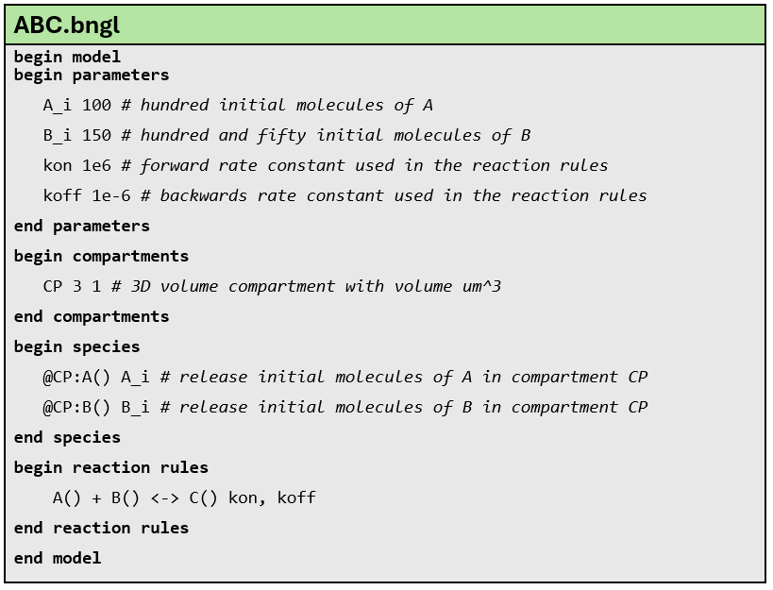
(a) An example BNGL model file titled “ABC.bngl” includes initial parameters, defined compartments, and species within those compartments. It also contains a simple reaction rule, where A + B produces C, and the reverse reaction is also possible.

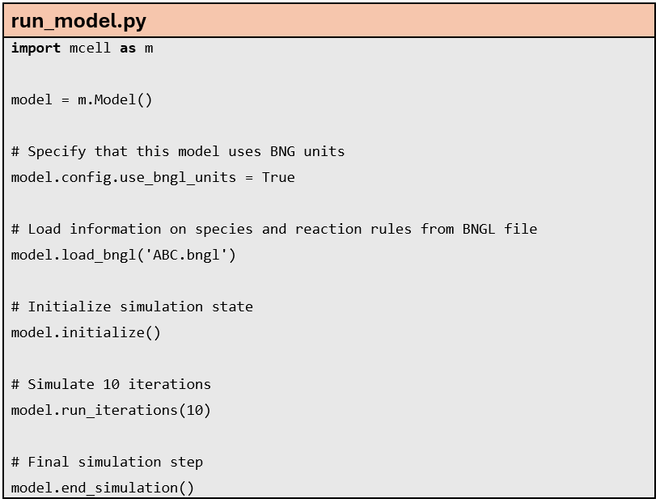
(b) The Python file run_model.py imports mcell as a module via the PyMCell library. This script loads the BNGL file shown in (a), where the entire BNGL file is read, the model is initialised and run for 10 iterations. Specific parts of the BNGL file, such as reaction rules or compartment and molecule release information, can be loaded. BNGL compartments can be replaced with actual 3D geometry.

Figure 2.5: BNGL and PyMCell workflow.

Birds eye view of model inputs and outputs
To provide an overview of the implementation of model files (Figure 2.6) and to clarify the overall process of what goes into a model and what is generated, see a simplified illustration in (Figure 2.6 (a)). The inputs to the model are the model files, which are written in the chosen modelling language, such as Python or BioNetGen. These input files include the reaction rules, the definitions of molecular species, and other parameters that define the model. The molecular interactions defined in these models are executed and simulated within a 3D environment, and an output is produced, typically displaying changes in molecular concentrations over time.
In the context of this PhD, this involves constructing a model that defines CaMKII and NMDAR interactions, along with other relevant molecules (detailed in Chapter 5). These interactions are simulated within a postsynaptic dendritic volume, and the resulting data captures the variations in molecular concentrations over time. Capturing the variations in molecular concentrations over time allows for a detailed analysis of the kinetics of these interactions, providing insights into the rates and mechanisms of biochemical reactions at a level of precision that is challenging to achieve experimentally. This information can then reveal how specific molecular dynamics contribute to larger-scale cellular behaviours like LTP for understanding how learning and memory work. Additionally, understanding the chemical properties of the reactions involved, including binding affinities, reaction rates, and diffusion characteristics, can aid in predicting how changes at the molecular level may impact the overall function of the synapse.
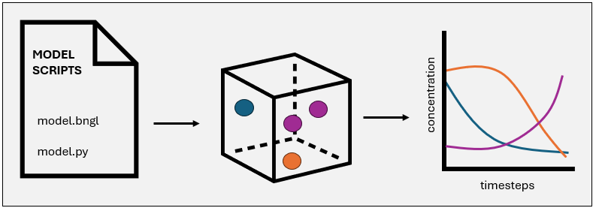
(a) What goes in and what comes out when modelling. An overview of input and output workflow of models in this project. Input files define the model, which is run to simulate diffusion of molecules in a 3D space, to give an output of molecular concentrations across time.

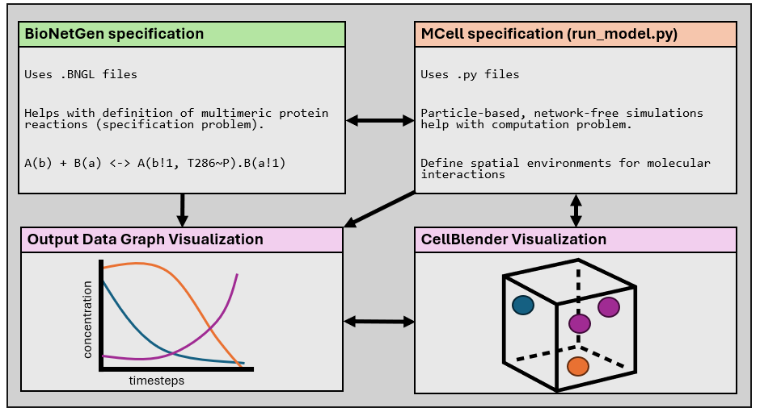
(b) There are alternative workflows for modelling and visualisation. BioNetGen uses .BNGL files to define biochemical reactions. MCell uses .py files. Outputs from either path can be visualised as graphs of molecular concentration over time or as 3D spatial distributions in CellBlender. The arrows emphasise the flexible flow between tools, showing how BioNetGen and MCell outputs can be independently or jointly visualised to provide both temporal and spatial insights into molecular dynamics.

Figure 2.6: Modelling workflow.
Not only can BioNetGen and MCell can be integrated and used together via the Python API, but the models created here can, in theory, be further integrated with software that supports Systems Biology Markup Language (SBML), a widely recognised standard for representing biological models. SBML enables the translation and integration of models written in different formats, allowing them to be executed across a range of software platforms (Hucka et al. 2003; Keating et al. 2020). As a well-established standard, SBML is frequently used to describe chemical reaction networks, such as those involved in metabolic processes or cell signalling pathways. Critically, BioNetGen can export models written in BNGL to the SBML format. This export capability allows for the conversion of rule-based BNGL models into a format that is compatible with SBML-supporting tools, increasing the flexibility of what future researchers can do with models like this one.
The ability to export BioNetGen models to SBML not only enhances interoperability but also aligns with key principles of reproducible and open science. This is particularly relevant to the FAIR (Findable, Accessible, Interoperable, and Reusable) principles for research, which are central to fostering transparency and collaboration in computational biology. The following chapter builds on these concepts, discussing how this project embeds openness, reproducibility, and responsible research practices.

3. Open, Reproducible and Ethics-focused PhD
In recent decades, scientific research has accelerated significantly, with a “publish or perish” culture becoming deeply ingrained in the academic community’s consciousness (ANGELL 1986; Rawat and Meena 2014). Frequent publication is widely regarded as a powerful tool for scholars to showcase their expertise and gain recognition among their peers. Likewise, there is a generalised view that this keeps academics constantly engaged with relevant knowledge works in their fields of expertise. In theory, it also serves to benefit the wider public by making scholarly insights available. Successfully published research not only enhances an individual’s reputation but also raises the profile of their institution, often attracting greater funding opportunities. Moreover, academic institutions and universities commonly use the number of publications credited to a researcher as a key indicator of their competence and career progression (York, Gibson, and Rankin 2015; Aksnes, Langfeldt, and Wouters 2019; Elbanna and Child 2023). In this view, a strong publication record can be beneficial, opening up opportunities for researchers and their institutions.
However, this mindset exerts significant pressure on researchers to continuously publish in order to secure funding and advance their careers (A. N. Miller, Taylor, and Bedeian 2011; Hangel and Schmidt-Pfister 2017-09-18Z). Alongside this, there are persistent biases in academic publishing, where work affiliated with prestigious institutions is often (wrongly) perceived as higher quality than that from less well-known or under-resourced institutions, regardless of the actual merit of the research (Morley and Aynsley 2007; Paradeise and Thoenig 2013; Campbell, Jimenez, and Arrozal 2019). On top of this, the Eurocentric bias where academic knowledge produced in wealthier countries is often regarded as superior, marginalises and even dismisses the realities and contributions of the Global South (Jazeel and McFarlane 2010; Jyothis 2016; Castro Torres and Alburez-Gutierrez 2022; Amutuhaire 2022). Similarly, the expectation for a high volume of publications impacts disproportionately low-paid academics in resource-constrained countries, who can face a variety of structural barriers, including limited grant funding (Castro Torres and Alburez-Gutierrez 2022) and inaccessible academic journal costs (Chan et al. 2014; Collyer 2018) among many other reasons (Hopkins et al. 2013; Willis, Bridges, and Jozkowski 2021).
In the culture of continuously publishing and publishing fast, those who are already at a disadvantage due to systemic bias and oppression are the ones who continue to lose the most. For example, research has shown that minoritised communities —whether this be due to race, gender, sexual orientation, or other factors— are underrepresented in prestigious journals, partly due to implicit biases and the dominance of Western academic frameworks (Hopkins et al. 2013; Willis, Bridges, and Jozkowski 2021; Boda, and and Kulkarni 2022). Consequently, the “publish or perish” culture overwhelmingly benefits scholars in wealthier countries while deepening global inequalities in knowledge production.
Moreover, a pressure to publish in high impact journals is closely tied to what is known as publication bias. In published academic research, publication bias occurs when the outcome of an experiment or research study biases the decision to publish or otherwise distribute it. This typically results in a preference for publishing significant or positive results, disrupting the balance of findings and favouring those that are deemed novel or noteworthy. Whilst negative or inconclusive results are rarely published or considered less worthy of publication (Thornton and Lee 2000; Matthew J. Page et al. 2021).
Examining this bias towards positive results reveals substantial evidence of a troubling trend: an overrepresentation of false-positive findings in the scientific literature (Sinha and and Montori 2006; Esarey and Wu 2016; Hartgerink, Wicherts, and van Assen 2017; Stahl and Pickles 2018; Schneck 2023). This bias towards positive results has several concerning and wasteful consequences, including, but not restricted to a significant number of valid negative results remaining unpublished, which excludes critical findings from the scientific record. This means that other research teams, unaware of these unpublished negative results, may continue to unknowingly test the same hypotheses (which may actually be false) until, by chance or artifact, a positive result is obtained. These chance positive results are then published, as they align with the preference for significant findings, even when substantial and more definitive contradictory evidence may exist in contrast to it (Carlson and Herdman 2012). What is more, this underreporting of negative results introduces bias into meta-analysis, which consequently misinforms researchers, doctors, policymakers and the public in general (Afonso et al. 2024). Additionally, more resources are wasted on already disputed research that remains unpublished and therefore unavailable to the scientific community (Kicinski 2013, 2014; Aert, Wicherts, and Assen 2019; Matthew J. Page, Higgins, and Sterne 2019).
This cycle sustains an error-prone body of scientific literature, undermining the reliability of published research. Hand in hand with this publication bias, comes something now known as a Reproducibility Crisis, where it is becoming increasingly apparent that making “fast-science”, while not the sole cause, is associated with a lack of being able to reproduce research (Stengers 2016; Leite and Diele-Viegas 2021). The reproducibility crisis has been in the rise for the past few decades as we uncover the fact that much of the research that is published fails to be reproduced by others. To give some examples, a survey of 1576 scientists published in Nature (Baker 2016) reported that over 70% of the participants failed to reproduce others’ experiments and over 50% failed to reproduce their own results. Similarly, Tiwari et al. (2021a) assessed the reproducibility of 455 mathematical models in systems biology and found that about 50% of published models were not reproducible either due to incorrect or missing information in the manuscript.
Much of the criticism surrounding the reproducibility crisis centres on statistical methods and research practices (Ioannidis 2005; Friese and Frankenbach 2020; A. M. Stefan and Schönbrodt 2023). Problematic scientific behaviours, such as HARKing (Hypothesising After the Results are Known), p-hacking (manipulating data analysis to achieve statistical significance), and selectively reporting only positive outcomes, as discussed above, have been identified as major contributors to irreproducibility (Wagenmakers 2007; Nuzzo 2014; Lew 2020). Indeed, this reliance on p-values, provided they meet the conventional threshold of statistical significance (typically p < 0.05), can sometimes lead to studies being treated as definitive evidence, even when their findings are not robust or reproducible (Lew 2020).
The list of factors contributing to irreproducibility is extensive and is not restricted to statistical methods. A lack of access to raw data or, in some cases, outright data fabrication also plays a role (Flier 2017; Bausell 2021). Ambiguities in experimental procedures and data analysis steps further undermine research reliability. On a broader, more systemic level, there’s an important discussion regarding how current academic systems often prioritize novelty and statistically significant findings, as research funding is more likely to be secured and promoted when the outcomes are more profitable (Bhandari et al. 2004; J. R. Lynch et al. 2007; Ebadi and Schiffauerova 2016). Although these behaviours fall under scientific misconduct (Science 2023) and are not considered acceptable scientific practice, they continue to occur as the mindset of publish or perish continues to embed itself in how scientists work.
Interestingly, a large-scale survey of nearly 6,000 academic psychologists (with 2,155 responses) assessed self-reported engagement in some of these questionable research practices (for example ambiguities in experimental procedures, p-harking, etc) known to introduce bias into research findings (John, Loewenstein, and Prelec 2012). Notably, respondents often justified their own use of these practices while simultaneously viewing them as unacceptable when used by others (p. 530). This is just one example, and it is worth noting that scientific standards and methodologies continuously evolve, meaning that questionable research practices are not static. Methods once tolerated, or even considered standard, may now be recognised as problematic, reflecting our ability to reassess and refine ethical and methodological frameworks. Encouragingly, awareness of the reproducibility crisis is growing, and there is a gradual shift towards promoting open and reproducible research practices Nature (2018).
Together, the issues outlined above, from the reproducibility crisis and publication bias to the prevalence of questionable research practices, reveal not isolated failings, but a systemic entanglement that compromises the integrity, efficiency, and ethical foundation of scientific research. In this context, the need for a fundamental shift becomes clear: one that centres reproducibility and accessibility not as optional enhancements, but as essential to producing ethical and meaningful research.
While I cannot solve these systemic issues alone, this PhD is an opportunity to actively engage with them. I am approaching my research with a conscious commitment to reproducibility, transparency, and accessibility, while also taking seriously the ethical responsibilities that come with producing and sharing knowledge. By embedding these values into the way I design, conduct, and communicate my work, I hope to contribute to a broader shift towards more inclusive, accountable, and responsible research practices.

3.1 Reproducibility Definition Used in this PhD
There is a long history of the terms reproducibility and replicability being used interchangeably, or their meanings being swapped depending on the field of study (Claerbout and Karrenbach 1992; Ivie and Thain 2018; Plesser 2018). For example, a review on the usage of reproducible/replicable meanings (Barba 2018) showed that most papers and disciplines use the terminology as defined by Claerbout and Karrenbach (Claerbout and Karrenbach 1992), whereas microbiology, immunology and computer science tend to follow the Associtation for Computing Machinery use of reproducibility and replication given by (Ivie and Thain 2018). In political science and economics literature, both terms are used interchangeably.
In this PhD, we use the definition used by (Turing Way Community et al. 2019), where reproducible research is understood as “work that can be independently recreated from the same data and the same code that the original team used”. Reproducible, replicable, robust and generalisable have different meanings as described in the table below.
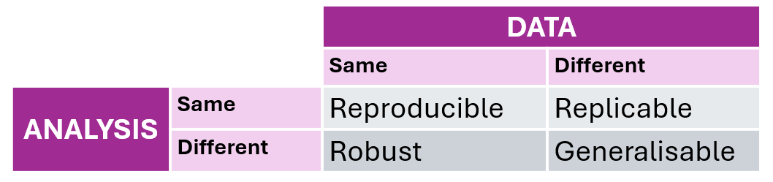
Figure 3.1: How The Turing Way defines reproducible research. Adapted from Turing Way Community et al. (2019).
- Reproducible research: is obtained when same analysis is performed on the same data, to produce the same results.
- Replicable research: refers to conducting the same analysis on different datasets, resulting in qualitatively similar outcomes.
- Robust research: entails subjecting the same dataset to different analysis workflows to address the same research question, such as employing distinct pipelines in R and Python. Robustness demonstrates that findings can remain consistent regardless of different methods used for analysis, indicating validity and resilience to various factors like changes in conditions or methods (such as different programming languages).
- Generalisable research: refers to findings or conclusions that can be applied beyond the specific context in which they were derived. It indicates that the results are not limited to a particular dataset, methodology, or experimental setup, but instead can be extended to broader populations, situations, or conditions. By combining replicable and robust research, we can obtain more generalisable results.

3.2 Open Science
Open Science is an approach to the scientific process that promotes cooperative work and new ways of diffusing knowledge accessible to everyone, without barriers such as paywalls or restrictions on the use of research outputs. By making research more accessible and transparent, open science seeks to enable more efficient scientific progress, enhance reproducibility, and increase the societal impact of research findings. A definition provided by Vicente-Saez and Martinez-Fuentes (2018) gives an overall good idea of what open science is referring to: “Open Science is transparent and accessible knowledge that is shared and developed through collaborative networks, [it] helps the scientific community, the business world, political actors, and citizens […] and stimulates an open debate about the social, economic, and human added value of this phenomenon.” Additionally, the United Nations Educational, Scientific and Cultural Organization (UNESCO) promote the following message in their Recommendation on Open Science: “By promoting science that is more accessible, inclusive and transparent, open science furthers the right of everyone to share in scientific advancement and its benefits as stated in Article 27.1 of the Universal Declaration of Human Rights”.
Open Science includes related concepts such as Open Data (n.d.a), Open Source (“The Open Definition - Open Definition - Defining Open in Open Data, Open Content and Open Knowledge” n.d.) and Open Access (Suber 2012) among others (n.d.c, n.d.c; Parsons et al. 2022; Turing Way Community et al. 2019). Open Data refers to the openness and accessibility of data. It involves thinking (and acting) about data sharing, privacy, and protection, as well as considerations like consent and the nuances of handling sensitive data. In the context of computational projects like this PhD, Open Source applies to both software (e.g., programs and applications used) and hardware (e.g., types of machines involved) that are released under Open Licensing, making them publicly accessible for anyone to view, modify, use, and distribute. (n.d.b; Open Content - a Practical Guide to Using Creative Commons Licences 2014). Open Access refers to how freely available research content is. There are different ways to achieve this; some times, open access might involve paying an Article Processing Charge to a journal, which then publishes the final version of the article under an open license (Borrego 2023), making it permanently free to access online (this is known as Gold Open Access). Sometimes, it may involve self-archiving a version of the research, often alongside preprints, allowing public access without direct journal fees (this is known as Green Open Access) (Björk et al. 2014).
In order to achieve Open Science, the research process should:
- Be publicly available: It’s hard to benefit from knowledge hidden behind barriers like passwords and paywalls.
- Be reusable: Research outputs should be licensed adequately, informing potential users of any restrictions on reuse.
- Be transparent: With appropriate metadata to provide clear statements of how research output was produced and what it contains.
Additionally, Open Science and its various elements are directly related with the broader concept of Open Scholarship (Scanlon 2014; Tennant et al. 2019). Open Scholarship promotes transparency and accessibility in teaching, learning, research, and academia (Emery n.d.). More importantly, Open Scholarship emphasizes equity, diversity, and inclusion, ensuring that knowledge is openly available to everyone, regardless of ethnicity, gender, sexual orientation, or other protected characteristics.
It is worth noting that Open Science does not mean “sharing absolutely everything”. Many fields of science involve working with sensitive personal data, with medical research being the most obvious example, where data is not to be widely shared. Likewise, privacy and data protection, as well as consent, and national and commercially sensitive data can be some of the most common examples of when data cannot always be open (Regulation 2016). If access to data needs to be restricted due to security reasons, however, the justification for this should be made clear. Free access to and subsequent use of data is of significant value to society and the economy. The concept of Open Science views that data should, therefore, be open by default and only as closed as necessary.

3.3 FAIR Principles for Open and Reproducible Science
Weaved in with the topics already discussed, are the FAIR principles for scientific data management. These principles were created as a guideline to develop and collectively support a clear and measurable set of principles that allow for Findability, Accessibility, Interoperability and Reusability of digital assets, to ultimately support more reproducible research (Wilkinson et al. 2016). FAIR principles, therefore, serve as a valuable framework for conducting research with integrity.
The advantages of applying FAIR principles become apparent when we understand each principle (Cole et al. 2017-03-20Z; Kremen and Necasky 2018; I. Kim 2024). Specifically linked to computational projects such as this PhD, FAIR practices can lead to more efficient code, minimising time spent on things like model retraining/rewriting, and reducing redundant data generation and storage (Hasselbring et al. 2019; Borrego 2023). Likewise, the interoperability aspect of FAIR principles enables researchers to integrate datasets from various sources, fostering new insights and innovative problem-solving approaches. For example, application of FAIR principles can result in lowering carbon footprint of computer simulations as less time and resources are wasted trying to run models that lacks useful information on how to run it (Lannelongue et al. 2023).
It is not uncommon for scientific code and workflows to originate within small, specialised research groups, often resulting in ad-hoc code that functions as a ‘black box’ to external researchers and developers. As this process unfolds and mixes with the fast-paced mindset mentioned above, if a workflow and materials are not clear from the beginning, future researchers may prioritise immediate functionality over long-term code quality, often due to constraints such as tight deadlines, limited resources, or evolving project requirements, causing something known as technical debt where the long term costs of workflow opacity costs human effort, money and time. One of the goals of this thesis project is to provide a workflow that enables reusability at initial creation and at the time of reuse, so that technical debt is decreased and the barriers for driving community interactions and innovations are lowered as a result.

3.4 Important steps taken to apply FAIR principles, Open Science by Design and Reproducibility
While extensive literature and tutorials exist on best practices for reproducibility, the following provides a personal account of the tools and methods I have employed, along with their practical benefits in creating a computational model that others can reproduce. This section not only demonstrates the practical implementation of these practices but also showcases this PhD as an example of working towards a reproducible, open, and ethics-focused PhD in Computational Neuroscience. I reflect on how I have engaged with these principles, adopted the most relevant practices for this project, and integrated them into my research.
I begin by outlining the steps taken to align with each of the FAIR principles, before exploring additional strategies that, while extending beyond the FAIR principles, still support FAIR research overarching goals.

3.4.1 Findable:
Data is well-described with rich metadata, making it easier to locate by both humans and machines (Jacobsen et al. 2020).
- The dataset will be available with a Digital Object Identifier (DOI) upon finalization.
- Presentations, workshops, and papers are available with persistent identifiers where applicable (for example, see (Garcia, Sterratt, and Stefan 2022; Roman Garcia [2023] 2023)).
- Metadata used in the model follows human-readable naming conventions while still being domain-specific within neuroscience. Although some terminology is niche, notations and explanations are provided.

3.4.2 Accessible
Data is stored in a way that ensures users can retrieve it with clear licensing and open protocols (Jacobsen et al. 2020).
- The models created during this PhD project are open and accessible through GitHub, with documentation explaining their use and specifications.
- Related to the point above, README files provide clear guidance on protocols and explain how each repository works and what they contain, including licensing where appropriate.
- As well as models, workshops and presentations associated with my research are also available in public repositories such as Zenodo (and GitHub). These platforms are invaluable in making the tools and materials I have developed publicly accessible, while also offering mechanisms for proper citation through DOIs and appropriate licensing, where applicable.
- Data will be stored in a database, , ensuring long-term accessibility
- There are plans for the model to be made available in a platform such as BioModels, which is a freely accessible online repository of mathematical models representing biological and biomedical systems.
- Research resulting from this PhD has been made publicly accessible through preprints (Garcia et al. 2024) (Green Open Access, allows access without the need for direct journal fees (Björk et al. 2014)), and Open Access publication when publishing in journals (García et al. 2025), making it permanently free to access online (this is known as Gold Open Access (Borrego 2023)).

3.4.3 Interoperable
Data is formatted using standardised vocabularies and structures, enabling seamless integration across different applications or workflows (Jacobsen et al. 2020).
- Interoperability is particularly relevant to this project, as the model needs to interface with multiple software tools (e.g., BioNetGen, MCell, Python) (see Section 2.2). By structuring the data and code to be compatible across these platforms, I ensure that the model can be integrated with future datasets and incorporated into diverse workflows for analysis, storage, and processing.
- The scripts written in Python utilize libraries that facilitate cross-software integration, making the model adaptable.
- The nomenclature in this project follows similar vocabulary/naming of molecules, albeit with slight variances in naming as the model, molecules functions and behaviours are not the same as other models. However, using BioNetGen Language and Python allows for a formal, accessible, shared and broadly applicable language.

3.4.4 Reusable
Data is well-documented, with detailed provenance and clear usage rights, supporting reproducibility and future research (Jacobsen et al. 2020).
- I have provided a detailed description of the model and its components, ensuring that (meta)data are richly annotated with relevant descriptors and attributes. Specifically, I outline the specifications for usage of data, including kinetic rates, molecule reaction rule names, and their sources or calculation methods.
- Where appropriate (for example when using GitHub repositories), I have explicitly licensed the data and stated usage rights, making it clear how others can build upon this work.
- The model includes comprehensive provenance details (in Chapter 5), documenting data origins, derivation methods, and any transformations applied.

3.4.5 Good Computational Research Practices
In addition to the steps outlined above in alignment with the FAIR principles, this section elaborates on the broader computational practices adopted throughout this PhD to further support the goals of reproducibility and open science. These practices include maintaining comprehensive documentation of code and methods, managing computational environments to ensure consistency, carefully tracking and addressing errors, and using version control to log changes and facilitate collaboration. These practices form the foundation of reproducible research and have been central to building a workflow that is transparent and accessible to others.

Comprehensive Documentation
Ensuring that my code is clear, well-documented, and reusable has proven essential for both my own future reference and for others who may build upon this work. Indeed, code that is human readable with useful comments (see The Turing Way for guidelines on good code comment practices (Turing Way Community et al. 2019)) not only enhances reproducibility but also facilitates collaboration by making it easier to understand, modify, and extend. One of the key strategies I have implemented to achieve clarity and reusability is incorporating detailed and clear comments throughout the code to explain its purpose, logic, and key functions has been essential to help anyone (including my future self) quickly grasp what each section does without having to decipher it from scratch. Comments also help to clarify why certain decisions were made, which is crucial for long-term sustainability of the project.
Beyond inline comments, comprehensive documentation has also been key. I have documented the broader aspects of my computational work, including the software, hardware specifications, and version numbers used (see Chapter 4). This ensures that the research can be replicated under similar conditions, minimising inconsistencies caused by version mismatches or dependency issues. Likewise, each repository includes a README file (GitHub n.d.) that provides an overview of the project, instructions for installation, dependencies, and usage guidelines. This serves as an entry point for users, making it easier to navigate the codebase and understand how to run and interpret the scripts.

Computational Environments
I run the model on my local machine, as well as on the university’s high-performance computing (HPC) cluster. Additionally, if my supervisors or collaborators wish to run the model on their own machines, their computer environments will be different again. So the model is bound to be run in different environments depending on who’s running it and where. Every computer operates within a unique computational environment, encompassing its operating system, installed software, specific versions of packages, libraries, and system configurations.
Since the model depends on these components, ensuring compatibility across different setups is essential for seamless execution. Even minor variations in library versions can cause unexpected errors or inconsistencies in results, or worse, prevent the code from running entirely (Spinellis 2003). To address these challenges, as well as the comprehensive code and documentation, I have created computational environments using package management systems (see definition (Turing Way Community et al. 2019)) that collaborators can use in their own machines when running the model. Computational environments act as, as per their name, “containers/environments” where all required software, libraries, and packages are pre-defined, allowing the model to run under controlled conditions (Grüning et al. 2018; Maji, Gorenstein, and Lentner 2020). In this project, I use Conda (https://conda.io) as my preferred package management system for creating environments, as I find it the most intuitive and flexible. However, other environment managers can be used depending on user preference. These environments allow specific versions of software and libraries to be installed without affecting the global system setup. This ensures that the model runs identically on any machine with the same environment, providing a robust solution for running the same model on different machines.
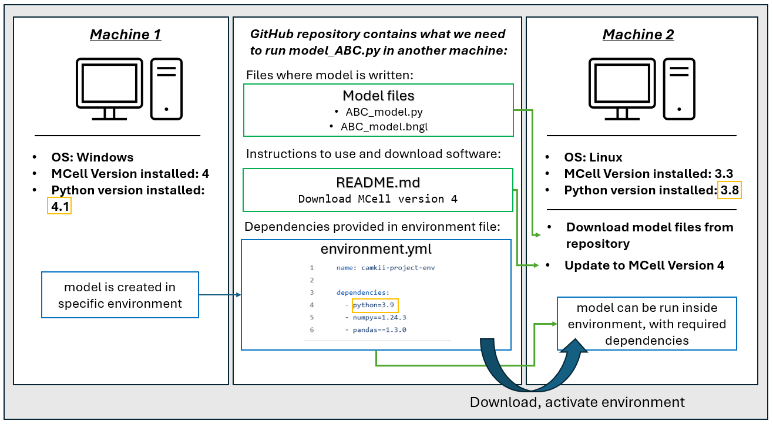
Figure 3.2: As an example of how environments work, the model is initially created on Machine 1, which runs the Windows operating system, has MCell version 4 installed, and uses Python version 4.1. To ensure that the model can be successfully executed on a different system, a dedicated computational environment is set up, capturing all the necessary dependencies. The environment setup and the model files are uploaded to a GitHub repository. This repository can contain the environment.yml file listing the required dependencies, including Python 3.9, NumPy, and pandas, as well as the model files (ABC_model.py and ABC_model.bngl), and a README.md file with instructions (such as downloading MCell version 4). On Machine 2, which runs Linux, has MCell version 3.3, and Python version 3.8, the user can, according to README instructions, update MCell to version 4 and use the specified environment by activating the environment.yml file. The model can be run within this contained environment.

Prepare for Errors
Regularly testing code is, unsurprisingly, helpful for ensuring reliable and reproducible research. Throughout my PhD, I have incorporated various testing strategies to improve the reliability of my code. One key practice has been anticipating and preparing for errors, which has helped me catch potential issues before they become major problems. This is nothing ground-breaking but rather following good-practice coding, such as readable, commented code, as explained above, having print statements to know what the code is doing where and when, error handling and creating validation steps throughout. For me, creating validation steps involved carefully adding reactions one by one, running the code, and confirming that the molecules were reacting as expected —or at least within a reasonable range— since the model is stochastic (see Section 2.2) and may exhibit emergent behaviours that were not predicted. I have also learned to validate my code step by step through debugging (McCauley et al. 2008), the process of identifying, analyzing, and fixing errors or bugs in a program, to break down how the code is working and pinpoint where things go wrong. Additionally, I have used mock or dummy test models, such as the (ABC_model: https://github.com/Susana465/test_ABC), to simplify testing when the main model is too complex to easily trace errors.

Version Control
Version control is a pillar of most, if not all, guides for reproducible research (Sandve et al. 2013; Stodden, Leisch, and Peng 2014; Sullivan, DeHaven, and Mellor 2019; Turing Way Community et al. 2019; Peikert, van Lissa, and Brandmaier 2021; Hamra et al. 2025). Version control is a method for tracking and managing changes to files or projects over time. It allows you and your collaborators to monitor modifications, review past edits, and restore previous versions if needed. Using version control helps maintain a relatively organized and traceable record of updates across different stages of development. This is extremely helpful for times when I needed to check back on when and where I did a specific change to my work, or when working collaboratively to know who wrote what and when. In terms of reproducibility, this means that version control helps with having clear provenance of information (Hamra et al. 2025). As a result of using version control, I have made my life easier (and potentially others in the future too) as I could track what version of the code and data produced specific outputs, for example. As datasets grow larger and more complex, by having a solid version control workflow you are doing your future self (and collaborators) a huge favour.
There are various ways to implement version control (Atkins et al. 2002; Pilato, Collins-Sussman, and Fitzpatrick 2008; Milentijevic, Ciric, and Vojinovic 2008; Hethey 2013), but I primarily use Git and GitHub (Loeliger and McCullough 2012) —partly because they are widely adopted and partly because they were the tools introduced in the version control courses I attended. With Git, each version update (or “commit”) can include a message describing the changes made, such as “changed value x=1 to x=2.” This has made it much easier to track modifications over time and follow the evolution of this project. Version control is therefore, especially useful when sharing analyses, as it ensures transparency, reproducibility, and auditability -key aspects of good scientific practice.

Gradual Development and Validation
The way I built the model for this project involved gradually developing the code; for example, starting with CaMKII as a monomer, then a hexamer, and finally a dodecamer. This step-by-step approach ensured proof of concept and allowed me to develop the model incrementally, building on solid, validated foundations before moving to the next stage. Git’s branching feature made this process much smoother, as it let me work on different aspects of the model in separate lines of development without affecting the main project. This meant I could experiment, test, and refine changes in parallel workspaces, keeping the main codebase stable until updates were ready to be merged. Further details on model validation can be found in Section 5.3.

Data Management
With this gradual development, the datasets evolved, variable names changed, and file hierarchies were adjusted throughout. As a result, managing large data outputs eventually became a challenge (see Challenges in Version Controlling Data described by Turing Way Community et al. (2019)). For example, GitHub imposes a limit of 100MB per file, preventing the storage of large files directly within the repository. Whilst Git can be used for data versioning by installing tools like git-annex, Git LFS, or git submodules, this means integration of more complex tools, which can introduce accessibility issues for newcomers. For example, with a data version control add-on tool like DataLad (which builds upon git and git-annex (https://git-annex.branchable.com/)), users may be able to see the files in the repository, but they won’t be able to access or download it directly, instead they would have to clone the entire repository, which may be far from ideal. This added complexity can be a barrier for those who are not familiar with the tools, potentially hindering the ease of use for collaborative projects.
To address data versioning, I implemented various strategies. Firstly, timestamping output files: I saved output files with timestamps rather than overwriting them. This practice ensures that each file’s creation time is preserved, although it does not allow for version control of those files. While this means any modifications to the files won’t be tracked automatically, the documentation clearly specifies that any updates to the files should be reflected in the file names, maintaining clarity and transparency. Secondly, I developed a simplified version of the model, called the ABC_model, which mirrors the workflow of the main CaMKII_dodecamer_model. This model tracks fewer molecules (e.g., a + b -> c) and produces less complex, smaller output files. Although this doesn’t address the version control of the primary model’s data, it is an effective tool for monitoring how outputs are generated and understanding their structure during testing phases. Additionally, I uploaded final outputs to a database: once the final, validated outputs were produced, I uploaded them to a database for proper storage and sharing. This step ensures that the final, reproducible data is securely stored and accessible. Likewise, packing data output files into smaller sized files (for example, zipping them), allows for data to be tracked, albeit, sometimes this is not a viable solution because data may still be too big.

Quarto for Version-Controlled Documents
In addition to maintaining version control of the model(s), I also used Quarto (Allaire et al. 2024), an open-source publishing system designed for scientific and technical writing. Quarto enables the dynamic generation of various file formats, including Markdown, LaTeX, HTML, PDF, and Word, all of which can be version controlled. This functionality has been invaluable in creating a structured, traceable workflow within a single, integrated system. By leveraging Quarto’s flexibility, I have been able to write my thesis in Markdown, a highly intuitive and lightweight markup language, while keeping individual .qmd (Quarto Markdown) files under version control. Quarto then renders these files into my preferred output format, including PDF, Word, LaTeX, among other formats. This approach has been significantly more efficient than the previous ad-hoc method of manually tracking document versions (e.g., final, final_forreal, final_forreal2), which lacked transparency and made it difficult to trace specific changes. With Quarto, I can use version control of the files and precisely track modifications, review previous iterations, and revert to earlier versions when necessary, greatly improving both the organisation and reliability of my work.

Automation for Efficacy and Sustainability
Beyond ensuring clarity, documentation, and reproducibility, automation plays a key role in making code more sustainable. By automating repetitive tasks, I reduce the likelihood of human error, save time, and ensure consistency across different runs of the model. This is particularly important when working with complex simulations, large datasets, or high-performance computing (HPC) environments, where manually setting up and executing processes can be inefficient and error-prone.
One example of automation in this project is the use of scripts for setting up environments and running simulations. Instead of manually installing dependencies and configuring settings each time the model is used, I have created scripts that automatically execute the necessary commands to run the model, as well as provide computational environment files that can be used to run the model in different machines. This eliminates the risk of missing dependencies, ensures the correct software versions are used, and reduces the setup burden for new users. Additionally, I have automated data processing workflows to streamline the handling of simulation outputs. Large-scale simulations generate significant amounts of data, and manually processing these results would be time-consuming and inconsistent. By writing reusable scripts for tasks such as data cleaning, aggregation, and visualization, I ensure that results are processed systematically and efficiently. This not only saves time but also makes it easier to compare outputs across different runs, improving the reproducibility of results.

3.5 Reflections and Future Steps
As with most research projects, there are always opportunities for refinement and further exploration. While I am pleased with the level of effort and attention put into reproducibility throughout this work, there are several directions in which this could be extended and strengthened.
Although the model was successfully run on different machines, showcasing practical reproducibility, due to time constraints, I was unable to include the figures to back up this demonstration within this chapter. However, the tools, code, and documentation are fully available in the accompanying GitHub repository, enabling others to explore and replicate these reproducibility tests for themselves.
Looking ahead, I am keen to extend this work through a formal publication that includes a more comprehensive evaluation of how the project aligns with FAIR and open science principles. A structured FAIR assessment, such as the one proposed by Balaur et al. (Balaur et al. 2025), could provide a detailed appraisal of the reusability and transparency of the models developed. In support of these reflections, I refer to the reproducibility framework developed by Tiwari et al. (2021). Based on the rubric provided (see Figure 3.3), I have scored this project at 6.5 out of 8. As described throughout this chapter, considerable effort has gone into meeting the majority of the quick criteria proposed by Tiwari et al. (2021b).

Figure 3.3: Reproducibility Scorecard suggested by Tiwari et al. (2021b), adapted.
One area still under development is the conversion of the model code into standardised formats such as SBML, with the intention of submitting it to a public repository for mathematical models of biological and biomedical systems, such as BioModels (Le Novère et al. 2006; Malik-Sheriff et al. 2020). BioModels requires submissions to follow specific guidelines, which include the provision of SED-ML (Simulation Experiment Description Markup Languag) files —a format used to describe the simulation experiments performed on computational models, including details of the algorithms, tasks, and outputs. Experimental data, simulation results, and associated metadata can also be submitted in a COMBINE archive, a single container file that brings together all relevant documents required to fully describe, reproduce, and share a computational modelling project (Bergmann et al. 2014).
With respect to the seventh criterion in the Tiwari et al. (2021) framework, I awarded a partial point. The model is well annotated, with inline comments and supporting tables that describe variables and their meanings, thus aiding interpretability. However, molecule and reaction naming conventions, while consistent within the project, could benefit from further simplification. This is a known challenge in computational biology, where names must often strike a balance between being human-readable and programmatically functional (see, for example, discussions on standardised biological ontologies) (Bodenreider and Stevens 2006; Brochhausen et al. 2018; Fitzpatrick and Stefan 2022).
Overall, the limitations identified here present valuable opportunities for growth and refinement, typical of any ongoing research effort. Future steps represent an exciting part of the process that will enhance the transparency, accessibility, and usefulness of the model for the broader research community. By ensuring that models follow FAIR, open principles we not only strengthen the scientific rigour of this PhD, but also uphold the ethical responsibility of researchers to share their work in a way that benefits the wider community. This is precisely what is discussed next.

3.6 Defining Ethical Science
Open, reproducible and FAIR ideas are fundamentally linked to ethics, as these practices ultimately promote more ethical and responsible research by fostering transparency, integrity, and accountability (Farrow 2016; Kushwaha et al. 2024). No matter how efficient or reproducible a study may be, its value is questionable if it causes harm to a group of individuals. Likewise, recognizing biases and risks in our research without providing the necessary resources for replication may undermine the advancement of truly ethical and reliable research.
Here, we refer to “scientific ethics” as the principles and guidelines that govern the behaviour of scientists in their work, and their impact in wider society (Rollin 2006; Edel 2018; Menapace 2019). More broadly, ethics can be seen as a system of moral values and principles that a particular society or community upholds (Gensler 2017). Ethics can be understood as a core aspect of moral philosophy -an area of study that, among other things, seeks to differentiate between right and wrong. Viewing ethics as the study of what constitutes appropriate or inappropriate behaviour emphasizes its connection to action. Therefore, we can see how ethics is relevant when considering the impact of actions and behaviours of scientists throughout the research process. Recognizing this also highlights the fundamental role of moral philosophy and ethics in shaping how research impacts society.
Ethical standards and beliefs evolve over time, and as a result, so do the ethical guidelines that govern scientific research (Joyner and Payne 2002; Y. Kim and Choi 2003; Macklin 2008). Practices that were once considered acceptable may no longer align with contemporary ethical norms, just as certain current methodologies may be deemed unethical in the future. Either way, throughout history, including current times, there are numerous examples of scientific research leading to significant ethical concerns and harmful consequences (J. P. Jackson, Weidman, and Rubin 2005–2006; Seth 2009; Birhane and Guest 2020; Garcia, Sterratt, and Stefan 2022), as discussed more in detail in the article included in Chapter 4. I believe it is important to recognise the heavy weight that science carries, of not only unethical but also oppressive research that has undermined and hurt minoritised groups and individuals throughout time. Unless we recognise where scientific research stands and where it comes from, we cannot stop repeating the same oppressive behaviours that may go unspoken or unrecognised otherwise.
In a presentation I delivered in 2022, I provided several examples of historical social biases that persist in scientific research, with a focus on Medicine, Neuroscience and Computer Science, including examples of racism, sexism, ableism, and speciesism (Garcia, Sterratt, and Stefan 2022). I define social bias as a systematic and often unconscious prejudice or favouritism toward certain groups over others, based on characteristics such as race, gender, species, or other socially constructed categories. A good example of embedded biases in science is given by Branch et al. (2022) as they eloquently articulate how a desire to quantify and establish hierarchies among organisms was not purely for scientific interest, but that there is extensive evidence in the fact that the roots of evolutionary biology, which serves as a baseline for many other disciplines like neuroscience, are steeped in histories of white-supremacism, eugenics, and scientific racism. They discuss the definition of the “Not-So-Fit”, and how this limits the diverse thought and investigative potential in biology. This is important to recognise for this thesis, as I use hierarchies and models of biology that are based on a historical context of how science has reached its current status of knowledge.

3.7 Why is this important?
Reflecting on the ethical history and potential future implications of research helps to uphold accountability and minimise harm, as further discussed in the Data Hazards Chapter 4. It is the synergy of combining opennes, reproducibility and ethics that create research that shows integrity and enhances credibility (Medicine et al. 2017; Zhaksylyk et al. 2023). Thinking about reproducibility can, in turn, help to think how you will share your data, as well as where your own data has come from. Hence, reaching an increased awareness of how data was sourced and its ethics and potential biases. Working with ethics, philosophy, reproducibility and an openness to discuss the wider context of where our research rests, may add time to the research timeline, but can very much enrich a fuller and more complex understanding of the shortcomings of our research and how to do better moving forward. This is why I believe that continuous reflection on ethical standards is essential, and why I have made a big emphasis on reiterative reflection throughout this PhD.
As we have seen, creating research that takes into account opennes, reproducibility and ethical considerations offers benefits not only for researchers but for society as a whole. Researchers can directly benefit through increased visibility and citation rates, greater opportunities for collaboration, and reduced waste of time and resources. Additionally, fostering open scientific practices helps build a stronger sense of community, in contrast to the traditionally competitive nature of research. Embedding these considerations into research workflows can enhance the credibility and reliability of scientific findings. Furthermore, reflecting on the broader impact of research promotes accountability and encourages proactive measures to mitigate potential harm.
Beyond academic advantages, open, ethical, and reproducible research contributes to more equitable knowledge dissemination. When data, methods, and findings are openly shared, barriers to access are reduced, enabling a wider range of researchers, institutions, and communities to engage with and build upon existing work. This can drive innovation, improve public trust in science, and ensure that research benefits can be reaped by as many individuals as possible.

3.7.1 A personal account: Where it started
Before turning to the technical discussion of Data Hazards in the following chapter, I offer a brief personal account of how I came to engage with these issues, alongside a poster I developed to capture the key questions and reflections that have shaped my thinking throughout this PhD.
A common experience in my academic career has been the limited focus on the social dimensions of ethics in the research I conduct. As I became aware that much of the research I conduct is based on biased views of how the world works (Tjeltveit 2015; Mayson 2018–2019; Ross 2020), I developed a keen interest in examining the biases within my own work.
My position as a woman, an immigrant in the UK, and someone from a working-class background has deeply shaped my experience in academia. It has influenced how I am perceived, the hurdles I’ve had to overcome, and the opportunities available to me. Over time, these experiences have led me to care deeply about the inequalities I kept encountering. At the same time, I also acknowledge the privileges I hold, being perceived as white, European, and a student at a prestigious university. These intersecting experiences of marginalisation and privilege have shaped and motivated my commitment to critically examine implicit biases within society and strive for a more equitable and accessible research process.
My focus on addressing biases in my research made me realise the need for greater reproducibility and accessibility to ensure open, meaningful dialogues, and progress. The initial bias I encountered was the assumption that “there is no need to account for social bias in my research”, because one might think my research topic is neutral at first glance: computer simulations of proteins does not scream a need for ethical considerations, mainly because we are not directly using animals, human or non-human.
In an effort to challenge the initial notion that my project does not require ethical considerations, I began exploring how others were thinking about bias and reproducibility. This led to the creation of a detailed (though wordy) poster, which framed my PhD journey as a series of milestones. I presented this poster at the COMBINE and ICSB 2022 conferences (Roman Garcia et al. [2022] 2022), where I shared how I address bias and reproducibility in my own work, and encouraged researchers at various stages of their careers to reflect on these aspects in theirs. A common concern raised during these discussions was the additional time and effort required to make research fully reproducible. While it is true that ensuring reproducibility can increase an individual’s workload and extend the research timeline, it ultimately proves more efficient in the long run. By making research accessible, well-documented, and easy to build upon, future researchers are better equipped to continue and expand on existing work, reducing redundancy and advancing scientific progress more effectively.
At each milestone proposed in the poster, I present potential biases that could influence the work, along with tools to either mitigate or highlight them. At the same time, I recognised that for my PhD to be truly ethical, it needed to prioritise both reproducibility and accessibility. To reflect this, I organised the questions I had been grappling with into different sections of the research process. All of this is documented in a publicly available GitHub repository (Roman Garcia et al. [2022] 2022).
For instance, during the design of the computational model I use, I consider questions such as: Who is my data including or excluding? What assumptions am I making? To what extent am I simplifying? In my research, I work mostly with data from non-human animals. A common assumption in the field is that findings from experiments on mice can be extrapolated to humans. However, it is essential to acknowledge that this remains an assumption, not a certainty. Similarly, my work often involves explaining memory and learning in highly simplified terms, typically focusing on specific molecular mechanisms. Yet, these processes are inherently complex, and we do not fully understand all their nuances. Recognising these limitations is crucial for maintaining scientific integrity and ensuring that findings are interpreted within their appropriate context (see Figure 3.4 for resources I used).
These questions around data provenance and the ethical dimensions of my research are explored in greater depth in the next section, where I introduce and explore the Data Hazards framework (see chapter Chapter 4). This framework encourages researchers to critically assess not only the potential risks and limitations of their work, but also how it might be used in future, and what biases it could be perpetuating. Reflecting on these concerns shaped the design of my computational model and prompted a broader engagement with the ethics and reproducibility of research in neuroscience. This line of thinking ultimately led to the development and publication of the paper included in the following chapter “Data Hazards as an Ethical Toolkit for Neuroscience” (García et al. 2025).
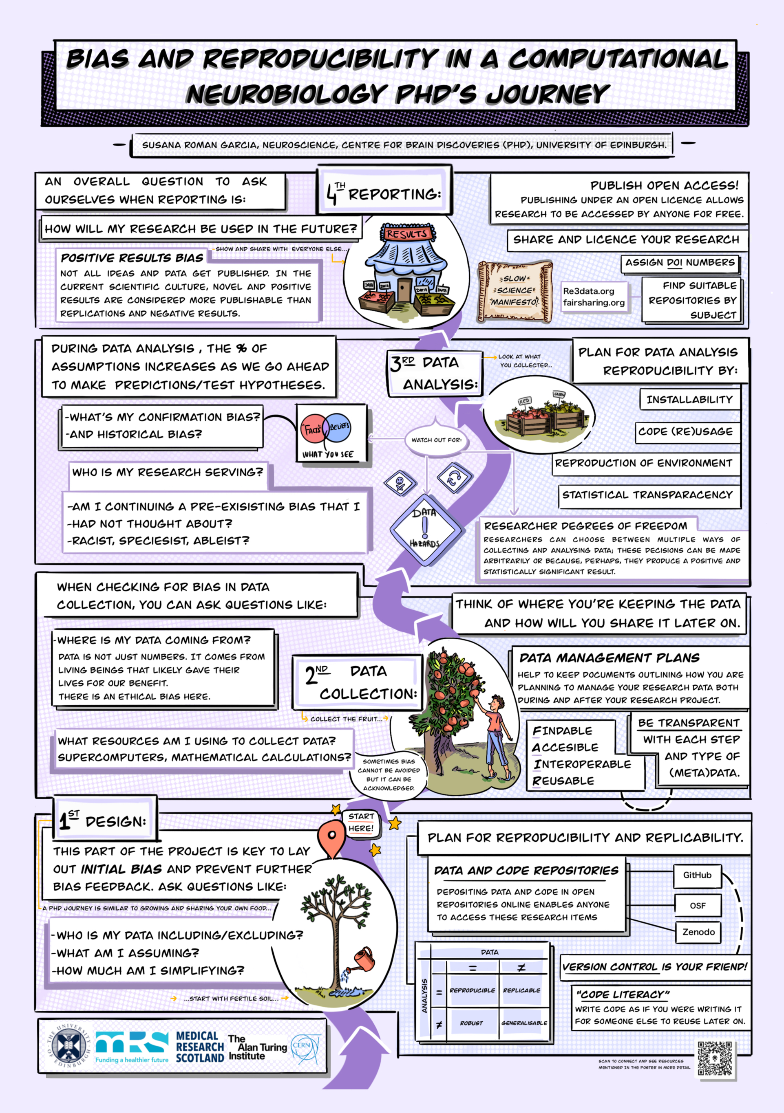
Figure 3.4: Poster about bias and reproducibility, showing research cycle as a journey which starts with design, then data collection, data analysis and final reporting, and compares this through images to growing an apple tree, collecting the apples and then selling them.

4. A Case Study in Ethical Reflection: Data Hazards in this PhD
As discussed in more detail below, the Data Hazards initiative was developed as a community-driven, shared vocabulary to identify and address risks and potential harms in data science (Zelenka et al. 2023). This project aims to mitigate risks by helping researchers recognize potential ethical challenges that may not have been initially considered and explore strategies for addressing them. While data scientists are typically trained to solve technical problems, ethical considerations are often overlooked. The Data Hazards project seeks to foster a cultural shift in research by encouraging a wider adoption of ethical considerations within the science community, promoting a more responsible and socially aware approach to scientific work.
As part of my ongoing effort to assess the broader implications of my research, I encountered the Data Hazards Project in 2021. Since then, I have progressively applied the Data Hazards framework to my PhD research. In addition to incorporating Data Hazards into my own research, I have facilitated several workshops on the topic (Roman-Garcia et al. [2022] 2022). In 2023, I co-organised and co-hosted a one-day symposium focused on Data Hazards, ethics, and reproducibility. Furthermore, I co-authored a chapter on Data Hazards to The Turing Way handbook (Turing Way Community et al. 2019).
The work that ultimately led to the development of the paper “Data Hazards as an Ethical Toolkit for Neuroscience” was preceded by an earlier collaboration with the Data Hazards team. As part of this, I designed a poster for AI UK 2023 that followed the methodology outlined in Method 1 of the (Roman Garcia [2023] 2023). This poster served as an interactive tool, enabling reflective discussions with conference attendees who were invited to engage by selecting Data Hazard labels they felt were applicable to my PhD project.
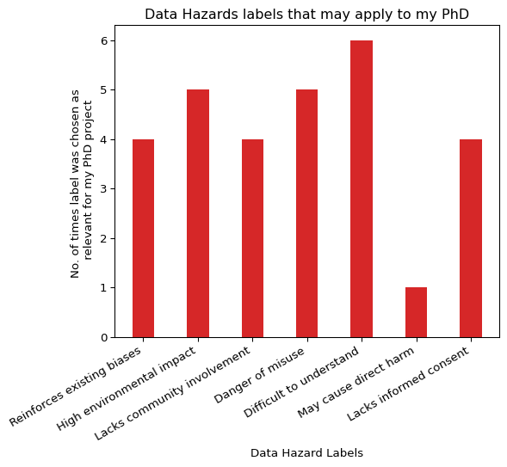
Figure 4.1: Data Hazards labels that may apply to my PhD.
Interestingly, not all labels were chosen as applicable to my project (Figure 4.1). Only 6 of the 11 current labels were chosen as relevant, with “difficult to understand” being the most prevalent one, chosen by 6 people. High environmental impact and danger of misuse follow in closely with 5 people having chosen these ones. Of course these numbers are small and hold, more than anything, illustrative value as to how and why people may think certain labels apply to a project. Difficult to understand” label was chosen the most, followed by “high environmental impact” and “danger of misuse”. Throughout the discussions, each person — myself included — brought their own assumptions about which issues mattered more or less and why. Disagreements around the application of the Data Hazard labels continued during the follow up, in-depth collaborative work for the paper presented below. While consensus wasn’t always reached, these discussions gave rise to meaningful conversations about the ethical dimensions of the project.
I include these results not as definitive data, but to show the kind of reflective, participatory work that led up to the paper. This approach embodies the core aim of the Data Hazards project: to create space for collaborative dialogue, invite critique, and support researchers in actively thinking through the ethical implications of their work.
All of this work culminates with this PhD and the paper I present below, where we extend the application of the Data Hazards framework to the field of Neuroscience, exploring how these hazard labels can highlight ethical challenges in computational modelling, specifically focusing on my PhD as a case study. The following paper demonstrates how I have identified risks of my work as well as the efforts taken to mitigate them.
The development of this chapter and its associated publication was a collaborative effort, and I would like to acknowledge the contributions of each co-author using the Contributor Roles Taxonomy (CRediT) (https://credit.niso.org/):
- Nicola Romanò contributed to the conceptualization of the work, provided supervision, and was involved in both the original drafting and reviewing and editing of the manuscript.
- David C. Sterratt supported the conceptualization and provided supervision, as well as contributing to the review and editing of the manuscript.
- Melanie I. Stefan was involved in the conceptualization, secured funding, provided supervision, and contributed to both the original drafting and reviewing and editing of the manuscript.
- Nina Di Cara contributed to conceptualization, methodology development, and participated in reviewing and editing the manuscript.
- Ceilidh Welsh was involved in the original drafting, reviewing and editing, and also contributed to conceptualization, funding acquisition, and visualisation (including the graphical abstract).
- I, Susana Román García, contributed to the original drafting, reviewing and editing, conceptualization, funding acquisition, and visualisation (graphical abstract). I also played a key role in project administration, overseeing the execution and coordination of the paper.
I am deeply grateful to all co-authors for their collaborative spirit, critical insights, and valuable contributions to both the paper and the thinking that shaped this chapter.

Conclusion
This chapter has detailed my journey with the Data Hazards framework, from initial engagement and community-driven activities to the co-authorship of a publication applying the framework within Neuroscience. Through workshops, symposiums, and collaborative writing, I’ve sought to embed ethical reflection into the core of my research practice. The culmination of these efforts is the paper “Data Hazards as an Ethical Toolkit for Neuroscience”, which not only applies the framework to my PhD research but also proposes Data Hazards to better suit the nuances of ethical discussions and risks in Neuroscience. This work demonstrates how a PhD project such as this one can create space for critical reflection on the potential consequences of scientific research, and contribute to improving research integrity more broadly.

5. In Silico Model of CaMKII, NMDARs, and Associated Signalling Molecules
Numerous computational models of CaMKII dynamics have been developed over the past decade to look at different interactions of CaMKII and its substrates or binding partners at varying levels of detail (Holmes 2000; John E. Lisman and Zhabotinsky 2001; J. Lisman, Schulman, and Cline 2002; Zhabotinsky 2000; Lučić, Greif, and Kennedy 2008; M. I. Stefan, Edelstein, and Le Novère 2008; M. Stefan et al. 2011; T. Johnson et al. 2015; Pharris et al. 2019; Ordyan et al. 2020b; Bartol et al. 2024). Many of these models center on the binding of calcium to calmodulin (CaM) and the subsequent formation of the CaM-CaMKII complex. While these studies provide a good foundation for understanding CaMKII dynamics, the models either focus solely on temporal dynamics without considering geometry, or explore both spatial and temporal dynamics but do not model CaMKII as a multimeric molecule. Some models do account for CaMKII as a multimeric dodecamer (Pharris et al. 2019; Ordyan et al. 2020b; Bartol et al. 2024) but do not focus on its interactions with NMDARs. To my knowledge, this research is novel in the field, as it incorporates all these aspects: modeling CaMKII as a dodecamer, examining spatiotemporal dynamics, and focusing specifically on the CaMKII/NMDAR complex.
The research carried out in this PhD project follows recent studies (Pharris et al. 2019; Ordyan et al. 2020b; Bartol et al. 2024) that have looked at CaMKII as a dodecamer to study its autophosphorylation and spatiotemporal regulation in postsynaptic dendrites using BioNetGen and MCell. Incorporating spatial, temporal, and multimeric aspects is crucial because these dimensions fundamentally shape the behaviour of molecular complexes like the CaMKII/NMDAR interaction. Spatial dynamics can reveal how the molecules interact within different cellular regions; CaMKII phosphorylation levels, as well as its functions have been shown to differ depending on its subcellular localization (Davies et al. 2007). Temporal dynamics are important to understand how CaMKII/NMDAR interactions evolve over time. The duration and timing of CaMKII activation influence whether synaptic changes are transient or long-lasting, affecting the induction and maintenance of LTP and LTD.

5.1 Previous work
Several multi-state models of CaMKII have been proposed, each differing in focus and scope from the present one (Holmes 2000; John E. Lisman and Zhabotinsky 2001; J. Lisman, Schulman, and Cline 2002; Zhabotinsky 2000; Lučić, Greif, and Kennedy 2008; M. I. Stefan, Edelstein, and Le Novère 2008; M. Stefan et al. 2011; T. Johnson et al. 2015; Pharris et al. 2019; Ordyan et al. 2020b; Bartol et al. 2024). Notably, there are multiple models by Stefan et al. (M. I. Stefan, Edelstein, and Le Novère 2008; M. Stefan et al. 2011) on CaMKII which explore the dynamics between CaMKII and CaM using Stochsim simulator (Le Novère and Shimizu 2001) which does not does not account for spatial effects, unlike MCell. These computational models provide insights into the mechanisms of calcium binding to CaM and the subsequent interaction with CaMKII, influencing the kinase’s activation, phosphorylation, and opening and closing dynamics. Notably, Pharris et al. (2019) published a model that specifically examines the dynamics of CaMKII in relation to CaM using MCell. However, this study was conducted using MCell 3.3, which did not support the diffusion of multi-state molecules. In this model, CaMKII was represented as a dodecamer, though not using BNGL, and the holoenzymes themselves were non-diffusing. Instead, the authors implemented a model in which CaM could diffuse and interact with a non-diffusing multi-state representation of CaMKII.
Ordyan et al. (2020b) employed a BioNetGen rule-based modelling approach using Monte Carlo methods, similar to the present study, to investigate how $Ca^{2+}$ signals influence CaMKII phosphorylation dynamics within the PSD. Their work primarily focuses on the interactions between CaM and the scaffolding molecule Neurogranin (Ng) in regulating CaMKII dynamics. However, their study does not investigate the crucial interaction between CaMKII and NMDARs.
More recently, Bartol et al. (2024) have published a study using the same version of MCell 4 as the model used in this PhD. They use particle-based stochastic simulations in MCell4 to model the activation of CaMKII by $Ca^{2+}$ flowing through NMDARs within a postsynaptic spine. Their spatiotemporal model simulates CaMKII as a dodecamer with calcium influx through NMDARs, yet they do not directly examine interactions between NMDARs and CaMKII.
Each of these models represents a step towards the development of the present study, which advances the field by explicitly modelling CaMKII as a dodecamer that directly interacts with NMDARs on the surface of the postsynaptic dendrite.

5.2 Model Description
In this model, CaMKII is represented as a dodecamer using BioNetGen Section 5.2.3. The model simulates its diffusion over time and space within a postsynaptic density (PSD) volume. Other molecules involved in the system include calcium, CaM, and protein phosphatase 1 (PP1), and NMDARs. The following sections provide a detailed breakdown of how these reactions are modelled, highlighting their biological relevance.

5.2.1 Molecule concentrations, localization and cell volume
All molecules (except NMDARs which are surface molecules) are released from inside the cell to interact with each other. Molecules are released as discrete molecule numbers. Concentrations can be calculated as shown below in Equation 5.1, where we begin with the number of molecules $N$ and convert it to moles using Avogadro’s number $N_{A}$. Next, we account for the volume in cubic micrometers, represented as $V \left(μ{\text{m}}^{3}\right)$. This equation gives us concentration in Molar.
$$N \text{molecules}×\frac{1 \text{mol}}{N_{A} \text{molecules}}×\frac{1}{V\left(μ{\text{m}}^{3}\right)}×\frac{V \left(μ{\text{m}}^{3}\right)}{V \left(\text{L}\right)}=C_{1} \left(\text{M}\right) \left(5.1\right)$$
The example calculation below considers an initial release of 10000 molecules and a dendritic volume of 0.5 µm³ (Equation 5.2).
$$1*{10}^{4}\text{molecules}×\frac{1mol}{6.023*{10}^{23}\text{molecules}}×\frac{1}{0.5 μ{\text{m}}^{3}}×\frac{1 μ{\text{m}}^{3}}{{10}^{−15}\text{L}}=3.32*{10}^{−6}\text{M} \left(5.2\right)$$
CaMKII is modelled as a dodecameric molecule, which is biologically accurate. The model contains four protein species: CaM, PP1, CaMKII and NMDARS (see table of molecules included in the model). Initial molecules released inside the cell are: $Ca^{2+}$ ions, CaM, CaMKII and PP1, inside the cytosol, and NMDARs as cell surface molecules. Interactions between different molecules are modelled as rules in BNGL, where each molecule reacts according to specified conditions and kinetic rates (Figure 5.5).
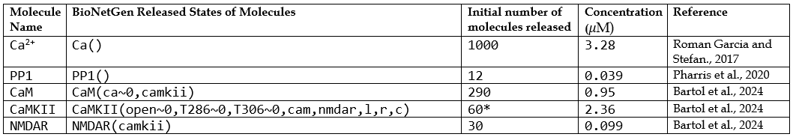
Figure 5.1: Molecules released into the model, including their defined possible states specified in BioNetGen. Concentrations were calculated using Equation Equation 5.1, based on a simulation volume of 0.50588 $μ{\text{m}}^{3}$. *Note: 60 CaMKII holoenzymes, each comprising 12 subunits, correspond to a total of 720 subunits (60 × 12).

5.2.2 Biological Plausibility
While care was taken to compare model outputs with known biological processes described in the literature and supported by experimental data, this type of comparison is inherently complex. Different models capture different aspects of biological systems, and even subtle variations in assumptions or parameter choices can lead to divergent behaviours. As such, the evaluation of biological plausibility should be interpreted with caution; it provides useful insight, but not definitive validation. The process of matching simulated outputs—such as concentration profiles and reaction kinetics—to literature values is valuable, yet inherently limited by the variability and uncertainty present in both modelling and experimental data.
In the model presented here, reactions of cytoplasmatic molecules specified in BNGL, were placed into the geometry of a postysnaptic dendritic spine with a volume of 0.50588 $μ{\text{m}}^{3}$, which matches the volume chosen by Ordyan et al. (2020b) in their model of CaMKII in the PSD and is within ranges of spine volume of 0.004 to 0.6 μm3 in hippocampal CA1 neurons (Harris et al., 1989). Moreover, Tonnesen et al. (Tønnesen, Inavalli, and Nägerl 2018) report a median spine volume of 0.1 $μ{\text{m}}^{3}$, with some spines reaching up to 0.5~$μ{\text{m}}^{3}$. As such, a volume of 0.5 $μ{\text{m}}^{3}$ is within physiologically observed bounds, albeit on the higher end of the range.
The molecular concentrations used are also within biologically plausible ranges. For example, the initial release of 1000 $Ca^{2+}$ ions corresponds to a concentration of 3.28 $μ\text{M}$. Fluorescent $Ca^{2+}$ indicator studies show resting intracellular $Ca^{2+}$ concentrations between 0.05–0.1 $μ\text{M}$, with increases up to 100-fold during stimulation (Brette and Destexhe 2012; Zheng, Jensen, and Rusakov 2018). Therefore, the calcium concentrations used are within ranges of stimulated neuronal activation. I discuss this further in the discussion section and future steps of the model.
With respect to CaMKII, concentrations of CaMKIIα subunits have been reported to range between 5 and 100 $μ\text{M}$ in neuronal dendrites (Lee et al. 2009; Feng, Raghavachari, and Lisman 2011; Otmakhov and Lisman 2012). NMDARs are typically found at approximately 10 to 100 receptors per synapse (Petralia 2012). In the present model, the concentrations of CaMKII and NMDARs are positioned at the lower end of these reported ranges, primarily due to the relatively large spine volume modelled. Specifically, we include 290 CaMKII subunits (equivalent to 2.36 $μ\text{M}$) and 30 NMDARs (0.099 $μ\text{M}$). Although the concentration of CaMKII in this model is on the lower end of reported values, this choice remains valid given the larger spine volume incorporated in the model, which dilutes the concentration of CaMKII while maintaining a reasonable estimate for its overall abundance [REFERENCE]. Furthermore, the number of NMDARs in the model is within the reported range, reinforcing the biological relevance of the simulation. The limitations of these parameter choices and potential future directions for refining this model are further discussed in the Future Directions section.
PP1 concentrations in neurons are typically reported between 1 $μ\text{M}$ and 10 $μ\text{M}$ (Cohen 2002), with CaMKII concentrations around 5 $μ\text{M}$, yielding a literature-based ratio of approximately 5:1. In the model, PP1 is present at 0.039 $μ\text{M}$, and CaMKII at 2.36 $μ\text{M}$, resulting in a model ratio of about 60:1. While this higher CaMKII:PP1 ratio may exaggerate the kinase dominance. Higher PP1 concentrations should be considered in future iterations for a more accurate representation of the CaMKII:PP1 ratio, though the model remains useful for exploring activation dynamics and regulation under varying conditions.
These values are on the lower end of the reported ranges but remain within an order of magnitude of typical experimental data. This margin is reasonable, particularly given the experimental variability (Eastwood et al. 2006). Additionally, the relative abundance of these molecules is often more important than their absolute concentrations, as it governs the signalling dynamics. The values used in this model were taken from other computational models that have been validated against experimental biological data, ensuring that the concentrations are within the expected range based on observed physiological conditions.
These values are consistent with those found in the literature and previous models that accurately represent the biological system at hand. Albeit, because the model uses a cell volume that is on the larger side for dendritic spines, the molecular concentrations are slightly lower than what others report (Pharris et al. 2019; Yasuda, Hayashi, and Hell 2022c; Bartol et al. 2024). In the future, running the model with a slightly smaller cell volume would naturally increase the total observed molecular concentrations. However, the actual behaviour of the molecules is not expected to change significantly, as the relative ratios of the molecules would remain the same. Thus, the signalling dynamics are expected to be largely unaffected by such changes in concentration.

5.2.3 Modelling CaMKII as a dodecamer
In the model at hand, the individual subunits are specified in BNGL as seen in Figure 5.2. The components l, r, and c represent binding sites within the holoenzyme: l is a binding site on the left of the subunit, r on the right, and c is the central site interacting with an opposing subunit in the six-membered ring (Figure 5.2). In BNGL syntax, interactions between components are represented by a period, with a “!” (bang) followed by a number to denote specific binding. For example, a bond between the right side of one subunit and the left side of another is written as shown in Figure 5.2 (B). The “!” is followed by any number, provided the two binding components share the same number.
Modelling CaMKII as a dodecamer using BNGL enables the representation of the molecule as multimeric, with each subunit able to adopt the following possible states:
- A CaM binding site, CaM can be bound or unbound,
- A NMDAR binding site, CaMKII can be bound or unbound to NMDARs,
- A T286 phosphorylation site, which can be unphosphorylated (T286~0) or phosphorylated (T286~P),
- A T306 phosphorylation site, which can be unphosphorylated (T306~0) or phosphorylated (T306~P),
- A status of being open (open~1) or closed (open~0).
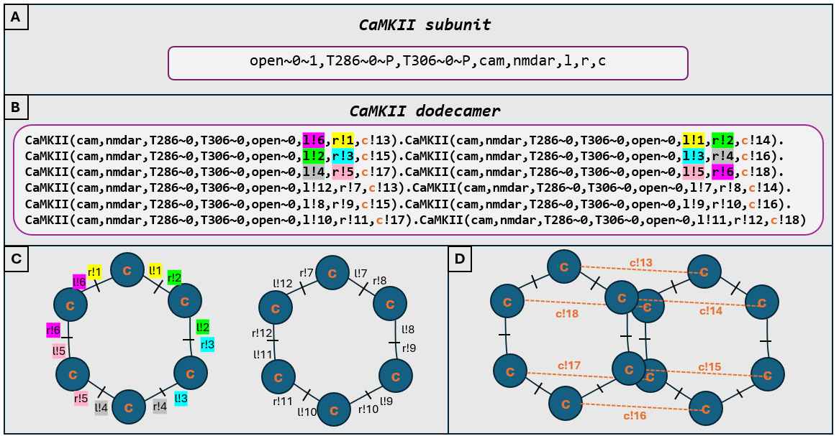
Figure 5.2: (A) The open flag determines whether the subunit is in a closed (0) or open (1) state. The T286 and T306 flags represent the phosphorylation states, where a value of 0 indicates the subunit is unphosphorylated, and “P” indicates phosphorylation. The cam flag refers to a binding site for CaM, which can either be bound or unbound. Similarly, the nmdar flag represents another binding site for the NMDA receptor, which can also be in a bound or unbound state. The cam and nmdar flags represent binding events that can occur or not, depending on whether CaM or NMDA receptors are bound to the subunit. (B) The left (l), right (r), and centre (c) binding sites facilitate the assembly of subunits into two hexameric rings. These rings are stabilised via interactions at the centre binding site. Subunits participating in the left and right rings are highlighted in matching colours to distinguish the respective assemblies. (C) A more visual depiction of the two separated hexameric rings. (D) The centre binding interactions are specifically highlighted to show the dodecameric representation of CaMKII in the model.
The model includes autonomous activation of CaMKII subunits, allowing them to flicker between open and closed states when unbound to CaM and unphosphorylated at T286 (see reaction rule #5 in Figure 5.5). The binding of CaM or phosphorylation at T286 stabilises the open state by preventing reversion to a closed conformation. Additionally, CaM binding can only occur if the subunit is in an open state due to the structural requirements for high-affinity binding. Electron microscopy of rat $α$-CaMKII in Sf9 cells (Myers et al. 2017) suggests that fewer than 3% of CaMKII subunits adopt a compact, docked-like conformation (K. Ulrich Bayer and Schulman 2019). The model therefore assumes all CaMKII to be in an undocked confirmation, in order to streamline the focus on the fundamental functional states of CaMKII.
Each CaMKII holoenzyme diffuses through the cell volume with a specified diffusion constant of $1×{10}^{−6}{\text{cm}}^{2}/\text{s}$, which is within biological limits (Sanabria et al. 2008). In the model, CaMKII subunits can interact with NMDA receptors located on the cell surface. When they interact, CaMKII can bind reversibly to the NMDA receptor, forming a complex in which the CaMKII subunit that has been bound remains open (see reaction rule #12 in Figure 5.5). As CaMKII remains open when bound to NMDARs, further reactions can happen such as phosphorylation at T286 and T305, as well as binding to CaM molecules Figure 5.3.

5.2.4 CaMKII and NMDAR binding
In this model, NMDARs are represented as single-site molecules, rather than as tetramers, due to the fact that the primary interaction between CaMKII and NMDARs occurs predominantly through the GluN2B subunit. While it is important to acknowledge that the GluN2B subunit is distinct from the entire NMDAR heteromer, we refer to the model as NMDAR for simplicity and clarity. This nomenclature is used as a practical approximation, since the interactions we are modelling are specifically associated with the GluN2B subunit, which is often studied in isolation in experimental settings. In many in vitro experiments, the focus is on the GluN2B subunit, and the behaviour of the whole NMDAR complex is inferred based on these more controlled interactions (Akashi et al. 2009; Goodell et al. 2014; Barcomb et al. 2016; Rumian et al. 2024). Therefore, for the purposes of this model, referring to the system as NMDAR aligns with the established experimental approach, even though the underlying interactions are predominantly occurring via the GluN2B subunit. Further developments of this model to account for a more complex NMDAR molecule are possible, as I propose in Section 6.3.
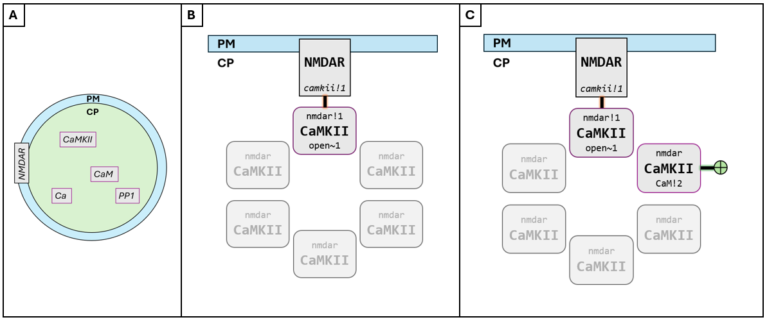
Figure 5.3: Simplified schematic of CaMKII binding to NMDARs in Compartmental BioNetGen. (A) A cell is defined with plasma membrane (PM) and cytoplasm (CP) volumes. Molecules are released as surface molecules (NMDARs) or volume molecules (rest). (B) NMDARs embedded in the PM can bind to CaMKII subunits diffusing within the cytoplasm. (C) Different subunits within the CaMKII dodecamer (simplified here as a hexamer) can independently interact with other molecules such as NMDAR or CaM. These interactions can occur simultaneously or asynchronously, allowing CaMKII to integrate multiple signals through subunit-specific states.
Furthermore, as previously discussed in Section 1.4.3, the precise molecular mechanism by which CaMKII binds to NMDARs is not yet fully understood. Nonetheless, the literature seems to agree that CaMKII interaction with the C-terminal domain (CTD) of NMDARs plays a key role in stabilising CaMKII in its open, catalytically active conformation (K.-Ulrich Bayer et al. 2001b; K. Ulrich Bayer et al. 2006; Özden et al. 2022b; Nicoll and Schulman 2023b). In our model, CaMKII may bind to an NMDAR provided that it is in the open conformation and that the receptor possesses an available CaMKII-binding site (see reaction rule 12 in TABLE-REFERENCE). Upon binding, a stable CaMKII/NMDAR complex is formed, in which the kinase remains in its active state due to the stabilisation of its open structure.

5.2.5 Binding of calcium to calmodulin
CaM has four EF hands divided into N and C lobes capable of binding two calcium ions per lobe, consequently CaM is modelled as being able to bind four calcium ions in our model. The N lobe binds calcium faster with lower affinity and the C lobe binds slower with higher affinity (Kawasaki and Kretsinger 2017). Numerous models have been developed to investigate the dynamics of calcium ions binding to CaM (M. I. Stefan, Edelstein, and Le Novère 2008; Pepke et al. 2010; González-Andrade et al. 2016). Linkevicius et al. (2025) examined and compared various of these models, providing a useful summary of the typical categories for modeling CaM binding to $Ca^{2+}$. The model used here falls under their proposed “scheme 3” (Figure 5.4), where calcium binds and unbinds to four separate calcium binding sites in CaM. Unlike other models that distinguish between CaM’s N-terminal and C-terminal binding lobes, this project does not, as the specifics of calcium binding to CaM are beyond its scope and following “scheme 3” approach to calcium binding produces biologically relevant results while avoiding complexity, allowing us to focus on further CaMKII and NMDARs interactions.
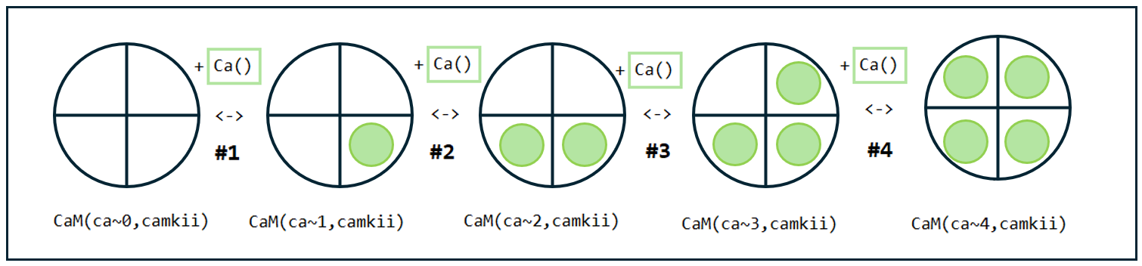
Figure 5.4: We model calcium binding to CaM following “scheme 3” proposed by Linkevicius et al., 2024. It is a sequential CaM scheme where each binding site is represented individually.

5.2.6 CaMKII subunits flicker between open and closed states
It is well established that CaMKII subunits can exist in both open and closed conformations (Pullara, Asciutto, and General 2017; Zhang et al. 2017), even in the absence of CaM (Asciutto, Pantano, and General 2021b). While the notion that CaM induces a conformational change in CaMKII is the common view, the assumption that this binding event directly triggers subunit activation is largely based on the induced-fit model, as discussed in Section 1.4.1. These observations may be due to the fact that binding of $Ca^{2+}$/CaM to CaMKII is more likely when the CaMKII kinase subunits are in the open conformation.
CaMKII subunits inherently fluctuate between different conformational states (open and closed), and an alternative perspective is that CaM does not directly induce the opening of the subunit but rather stabilises the open conformation upon binding (Asciutto, Pantano, and General 2021b). This suggests that the enzyme does not strictly require CaM to transition into an open state; rather, CaM serves to stabilise and prolong this conformation, thereby sustaining enzymatic activity. From a dynamic standpoint, it is plausible that, in the absence of CaM, there exists a low probability of the subunit adopting an open conformation due to intrinsic structural fluctuations. Upon CaM binding, this equilibrium may shift, favouring the stabilisation of the open state and ultimately leading to the full activation observed in vitro (Asciutto, Pantano, and General 2021b). Accordingly, in this model, CaMKII subunits are considered to undergo spontaneous transitions between open and closed conformations (see #a in Figure 5.6 for schematic depiction), and the impact of CaM binding is assessed in terms of its stabilising effects on these states.
CaM binding is not the only mechanism that can render CaMKII subunits in their open conformation. In the model used in this PhD, as per the known literature, CaMKII subunits can remain in an open conformation due to one or more of the following events:
- CaM binding: CaM binding has been shown to structurally stabilise the open conformation of the CaMKII kinase subunit, preventing the kinase domain from re-engaging with its own regulatory region, thereby maintaining the open state (Sheela I. Singla et al. 2001; L. Hoffman et al. 2011; Gaertner et al. 2004).
- T286 phosphorylation: Phosphorylation at this site occurs at the hinge region of CaMKII and prevents subunits from closing (Braun and Schulman 1995; S. G. Miller and Kennedy 1986; Coultrap et al. 2010; Buard et al. 2010; Chang et al. 2017). This modification thus sustains the subunit in an open conformation, contributing to the prolonged activation of the kinase.
- NMDAR binding: Once a CaMKII subunit binds to the NMDA receptor, the interaction can stabilise the open state of the kinase. This CaMKII/NMDAR association has been shown to maintain the kinase in an active, open conformation, as discussed in Section 1.4.3.

5.2.7 Binding of CaM to CaMKII
CaM bound to different amounts of calcium has been shown to bind to CaMKII with different affinities, with CaM bound to four calcium having the highest affinity (Linkevicius et al. 2025; Ordyan et al. 2020b; Khan et al. 2024). While CaM binding to the low-affinity site is compatible with CaMKII remaining in a closed state, binding to the high-affinity site is thought to structurally prevent CaMKII from closing (Sheela I. Singla et al. 2001; L. Hoffman et al. 2011; Gaertner et al. 2004). The literature suggests that CaM binding in itself is not sufficient for CaMKII activation, although high-affinity binding of CaM is (Evans and Shea 2009; M. I. Stefan, Marshall, and Novère 2012; Bossuyt and Bers 2013). This is likely due to the stabilising effect of high affinity binding of CaM to CaMKII structurally keeping the kinase in its active state.
In this model, for simplicity, we therefore assume that only fully saturated CaM with four calcium ions (CaM_Ca4) binds to open CaMKII subunits. Additionally, CaM binds to a CaMKII subunit only if T306 is dephosphorylated. The T305/T306 site lies within the CaM binding region. It has been shown that autophosphorylation at T305/T306 (T306 hereforth) impedes CaM binding, and similarly CaM binding prevents T306 phosphorylation (Rellos, Pike, Niesen, Salah, Lee, von Delft, et al. 2010). In the model here, CaM is able to bind to CaMKII with the following rules:
- CaM must be fully saturated (bound to four calcium ions), i.e. only CaM_Ca4 binds to CaMKII. We assume only one high affinity binding site for CaM in each CaMKII subunit.
- CaMKII subunit must be in its open/active state.
- T306 must be unphosphorylated.
As described above in Section 5.2.6 when a CaMKII subunit spontaneously flickers into its active/open state CaM binding is likely to stabilize the subunit once it is already active, but does not initiate activation. Similarly, while it is commonly suggested that simultaneous binding of CaM to two neighbouring subunits triggers T286 autophosphorylation, we propose that CaM’s role might be more nuanced. Instead of being essential for T286 phosphorylation, CaM may stabilize the open state of CaMKII, thereby increasing the likelihood of phosphorylation. Therefore, in this model, we do not make it a requirement for CaM to be bound to neighbouring subunits for phosphorylation to happen. We consider CaM binding is not strictly necessary for autophosphorylation but rather enhances the probability of phosphorylation by maintaining subunits in their active/open state.

5.2.8 CaMKII phosphorylation and dephosphorylation
The most studied phosphorylation sites on CaMKII are T286 and T305/T306. These sites are key for regulating CaMKII activity and subcellular localization at the PSD during LTP, which is of relevance for synaptic plasticity as well as learning and memory see 1.4.1. Likewise, in this study, we focus on these two sites. While other phosphorylation sites on CaMKII have been identified (Migues et al. 2006; Gangopadhyay et al. 2008), their functions are not yet fully understood and are not within the scope of this study.

5.2.9 T286 phosphorylation
I have modelled phosphorylation of T286 to occur with the condition that two adjascent CaMKII subunits are in their open states. Research shows that CaMKII subunits need to be open to expose the ATP binding site in the regulatory domain, allowing the gamma-phosphate of ATP to transfer to the threonine residue at T286 (Lou, Lloyd, and Schulman 1986; L. R. Hoffman 2011). The open (kinase domain available) and undocked (subunits can reach their neighbours) states of two neighbouring subunits is crucial for the catalytic site of one subunit to reach and phosphorylate its neighbouring subunit. In our model, we assume ATP molecule levels are sufficient to ensure the reaction proceeds at its maximal rate (saturating), so we do not model ATP as a reactant but rather focus on the phosphorylation process under these conditions.
As discussed earlier, CaM bound to two neighbouring subunits is often referred to in the literature as being required for autophosphorylation and subsequent CaMKII activation (Nicoll and Schmitz 2005b; Rellos, Pike, Niesen, Salah, Lee, Delft, et al. 2010). CaM has been shown to keep CaMKII subunits in their open state, and therefore it may indirectly enhance probability of T286 phosphorylation.
In the model I use here I don’t make CaM a requirement for T286 phosphorylation, but rather once CaMKII is bound to CaM_Ca4, this binding keeps CaMKII subunits in their open state and further enables phosphorylation. The only requirement for CaMKII T286 phosphorylation is, therefore, that two adjacent subunits are in their open state to enable inter subunit phosphorylation at this site (as per Figure 1.6 previously described in Chapter 1 and below in Figure 5.6).

5.2.10 T306 phosphorylation
In contrast to T286 phosphorylation, T306 phosphorylation prevents binding of CaM, as the phosphate group added to the threonine creates electrostatic and steric interference, occupying the position where CaM normally interacts. In the model used here, CaM can therefore only bind to CaMKII if the T306 site is not phosphorylated, and conversely, phosphorylation at T306 cannot occur while CaM is bound (previously discussed in Section 5.2.3). Similar to the conditions for T286, the model requires that a subunit must be in the open state for phosphorylation at T306 to take place. Since T286 phosphorylation maintains subunits in their open state, phosphorylation at T306 is more likely to occur if a neighbouring subunit is phosphorylated at T286.
An aspect of phosphorylation at this site is that it does not prevent CaMKII subunits from closing, unlike T286 phosphorylation (S. G. Cook et al. 2021). This, together with the fact that it prevents CaM from binding, makes it more likely that subunits that are phosphorylated at T306 are found in the closed state too. When the subunit is closed, catalytic activity of the kinase is reduced, as the kinase domain is not accessible to perform catalytic activity. Therefore, this phosphorylation is often referred to as reducing catalytic activity of CaMKII. T306 phosphorylation may act as a form of kinetic proofreading, by ensuring that CaMKII remains inactive, or less active, unless sustained or repetitive calcium signals are present. Phosphorylation at T306 likely prevents premature or excessive kinase activity, thereby enhancing the specificity and fidelity of CaMKII-mediated signalling in response to synaptic activity.

5.2.11 Dephosphorylation of CaMKII subunits
There are multiple known phosphatases which act to dephosphorylate CaMKII in the PSD (Cohen 1997; Roger J. Colbran 2004). Different phosphatase proteins will carry out their function depending on their localization and what protein assemblies they are bound to or are available for them. The Ser/Thr phosphatase Protein Phosphatase-1 (PP1) is a key regulator of CaMKII signalling (Shioda and Fukunaga 2017); and it can dephosphorylate both T286 and T306 sites of the kinase.
The colocalization with PSD-associated PP1 or sequestration away from other protein phosphatases, such as protein phosphatase 2A or protein phosphatase 2B (PP2A, PP2B), results in differential modulation of CaMKII’s T286 dephosphorylation. PP1 can form a complex with over 50 regulatory or scaffolding proteins that dictate substrate specificity and subcellular localization. There are four known PP1 subunit isoforms of the catalytic subunit ($α$, $β$, $γ$-1, and $γ$-2), each interacting with over 40 known regulatory and target subunits. PP1-$α$ has been shown to account for the majority of phosphatase activity with CaMKII in the PSD (Roger J. Colbran 2004). Therefore, we focus on PP1-$α$ in this study, and refer to it simply as PP1.
In the model used here, PP1 catalyzes the dephosphorylation of CaMKII without forming a stable enzyme-substrate complex. Instead, the reaction proceeds in a manner where PP1 transiently interacts, without binding, with a CaMKII subunit under specific conditions, facilitating the dephosphorylation process. PP1 can only dephosphorylate CaMKII subunits when they are unbound from CaM, as CaM structurally obstructs access to the T286 phosphorylation site. Additionally, the CaMKII subunit must be in its open conformation to expose both the T286 and T306 sites for PP1-mediated dephosphorylation.

5.2.12 Reaction rules and kinetic rates
In BNGL, reaction rules are specified as discrete transformations. For example, the rule “CaM(ca~0,camkii) + Ca() <-> CaM(ca~1,camkii)” represents the binding of a single calcium ion to CaM that is not bound to CaMKII (see reaction #1 in Figure 5.5). The assigned rate constants for each rule are used to calculate the probability of the reaction occurring when the two involved molecules collide, or at each time step for unimolecular transformations.
As molecules diffuse within the simulation volume, all molecules within a specified radius along a given trajectory or at the point of collision on a surface are considered for potential reactions. For example, when a calcium ion molecule encounters a free CaM molecule at the point of collision, they react according to the specified rule in the model, resulting in the formation of the molecule CaM_Ca1. CaM_Ca1 can continue to diffuse based on the parameters defined in the simulation and can interact with other molecules as well (see back for diagram example explanation in Figure 2.3).
The reaction rules defined below follow the “don’t care, don’t write” principle of rule-based modelling: if a molecular feature is irrelevant to a particular reaction, it is simply omitted from the reaction definition. For example, in reaction #5, which describes the flickering of CaMKII subunits between open and closed states, the conditions specified are that the subunit’s CaM-binding site must be free, the subunit must be unphosphorylated at T286, and the subunit must be open. However, the phosphorylation state at T306 is irrelevant to this reaction, and therefore is not specified.
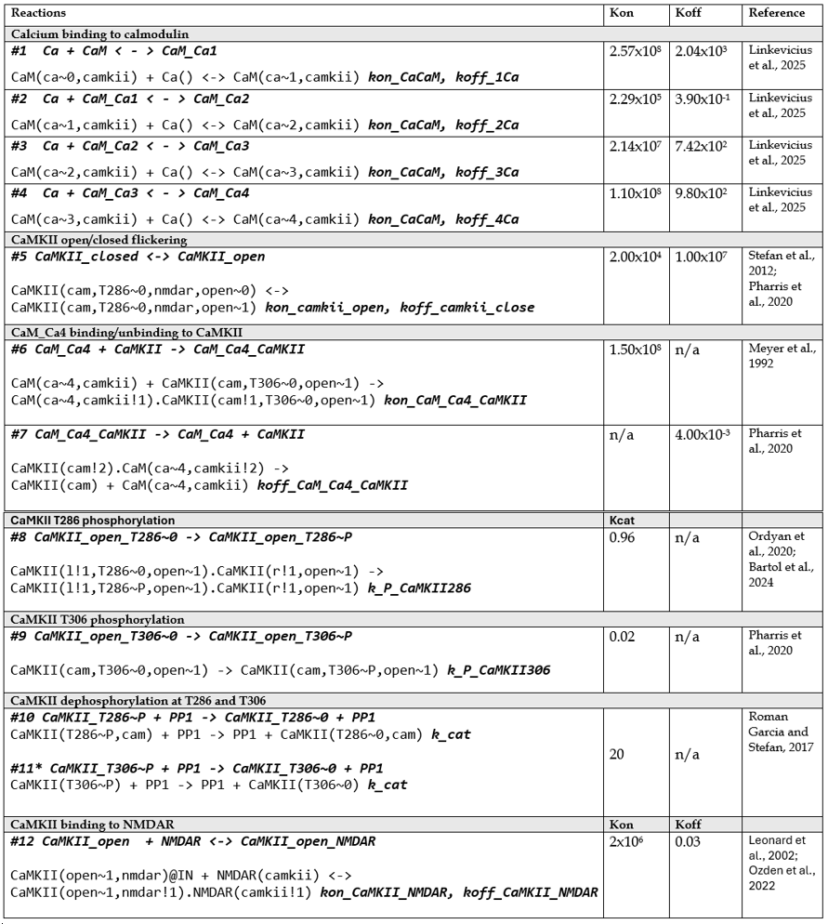
Figure 5.5: Reaction rules and rate constants used in the model. $k_{\text{on}}$ (association rates) in M$​^{−1}$s$​^{−1}$, $k_{\text{off}}$ (dissociation rates) in s$​^{−1}$, $k_{\text{cat}}$ (catalytic rates) in s$​^{−1}$.

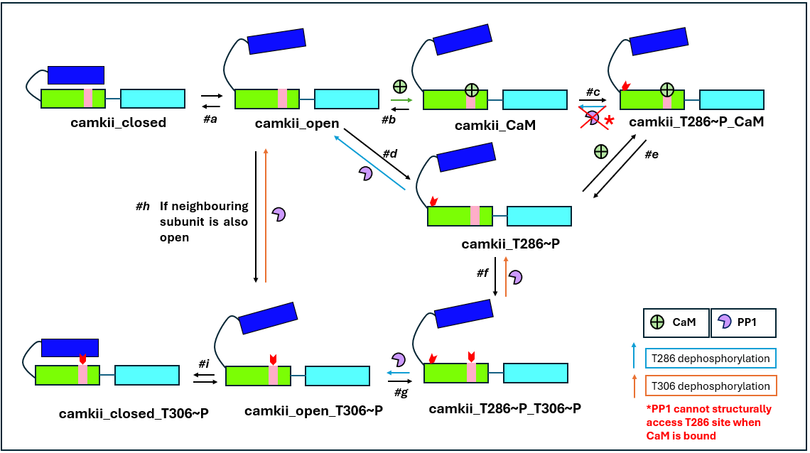
Figure 5.6: Reaction rules depicted for possible reaction pathways of CaMKII subunits. (#a) CaMKII in a closed state can flicker between open and closed states; (#b) CaMKII that is open can reversibly bind to a CaM molecule; (#c) CaMKII that is bound to CaM can phosphorylate at T286 (T286~P), and if CaM is bound, PP1 cannot structurally access the subunit to dephosphorylate it; (#d) CaMKII that is open and free from CaM can also phosphorylate at T286, and PP1 can access and dephosphorylate it in this state; (#e) CaMKII that is bound to CaM and T286~P can release CaM and remain T286P; (#f) CaMKII T286~P can also phosphorylate at T306, and PP1 can dephosphorylate the T306 site as well; (#g) When CaMKII is phosphorylated at both sites, PP1 can also dephosphorylate T286 instead of T306, and CaMKII that is T306P can also autophosphorylate at T286; (#h) CaMKII that is T306P can be dephosphorylated by PP1, and if a CaMKII subunit that is open has a neighbouring subunit that is also open, it may autophosphorylate at T306; (#i) CaMKII that is T306P can close (unlike when CaMKII is T286~P).

5.3 Validating Model Behaviour
To validate the model, I focused on several key aspects: first, I checked how closely the model matched biological reality and ensured it was biologically plausible. I also built the model step by step, allowing for gradual improvements and refinements. The kinetic parameters for the model’s reactions were either taken from existing literature or estimated from experimental data. When there was uncertainty, I ran parameter explorations to see how changes in the kinetic rates affected the model’s behaviour.

5.3.1 Incremental Construction and Stepwise Validation
In order to validate model behaviour, each reaction rule was added one at a time and tested to see if it produced biologically plausible results. Reactions or sets of reactions were introduced sequentially and tested independently. Structuring the model this way made it possible to validate individual components before integrating them into the full system. For example, the model was first tested by incorporating the calcium binding to CaM reactions. These were validated by comparing the outputs to those of a previously published and experimentally validated model (Roman Garcia and Stefan 2017). Once consistent behaviour was observed, the next layer —CaM binding to CaMKII— was added and validated in a similar manner. Finally, interactions between CaMKII and NMDARs were introduced and tested. While a detailed account of each individual rule implementation is not provided here for the sake of conciseness, a summary of the key reaction layers and their expected outputs is presented in Table 5.1. Each row links an expected biological behaviour to its underlying model rule(s), along with an indication of whether the behaviour was observed in simulation results. These outputs not only confirm that the system produces plausible results at each stage but also serve as checkpoints for model development.
The list below presents a series of expected model behaviours that arise from specific reaction rules defined in the model, as per Figure 5.5 (in Chapter 5).
Table 5.1: Summary of model predictions and expected results.
Expected Result | Associated Reaction Rules | Observed in Models
$Ca^{2+}$ binds to CaM in a stepwise manner, with higher affinity for forming CaM_Ca3 and CaM_Ca4 states. | Rules #1 - #4 (Figure 5.5) | No, see discussion.
CaMKII autophosphorylation at T286 is increased by binding to NMDARs and CaM. | Rules #5, #6, #8, #12 (Figure 5.5) | Yes, see Figure 6.6 and 6.8
CaM binds CaMKII only in its fully saturated state (CaM_Ca4), stabilizing CaMKII in its open conformation. | Rule #6 (Figure 5.5) | Yes, data not shown
Open CaMKII binds to NMDARs, anchoring the kinase at the membrane . | Rule #12 (Figure 5.5) | Yes, see Figure 6.4
CaMKII undergoes autophosphorylation at T286 regardless of CaM binding, though this phosphorylation is enhanced by CaM binding. | Rule #8 (Figure 5.5) | Yes, see Figure 6.8
CaMKII is likely to undergo autophosphorylation at T306 following T286 phosphorylation, but T286 phosphorylation is not strictly required for T306 phosphorylation to occur. | Rules #8, #9 (Figure 5.5) | Yes, see Figure 6.10 and Figure 6.16
CaMKII subunits can be found to be T306-phosphorylated and in a closed conformation. | Rules #5, #10 (Figure 5.5) | Yes, data not shown.

5.3.2 Sanity Checks
As part of the model validation process, a series of sanity checks were implemented to ensure the system behaved in accordance with known biochemical rules and structural constraints. These checks primarily aimed to verify that the model did not produce molecular species that are biologically implausible or explicitly forbidden by the reaction rules defined in the system.
Sanity checks were performed by recording observables in the BioNetGen Language (BNGL) model file. These observables are explicitly commented with justifications within the code itself and are structured to align with the logic and reaction rules outlined in Figure 5.5. The purpose of these observables is to serve as logical safeguards: if any of them yield a nonzero value during simulation, it indicates a breach of the model’s core assumptions or rule constraints.
All sanity check observables listed above were expected to yield zero values, and did so consistently in simulation results. This confirms that the implemented reaction rules correctly prohibit the formation of biologically impossible species. These results are consistent and replicable; if the model is executed under the same rules and initial conditions, these observables are expected to remain zero in any future runs.
Below is a list of observables defined for sanity checks, along with a description of the corresponding molecular species, and an explanation of why their expected output should be zero under biologically valid conditions.

CaMKII_CaM_Ca4_PP
- Description: CaMKII bound to CaM (saturated with four Ca²⁺ ions), phosphorylated at both T286 and T306.
- Expected Output: 0
- Rationale: CaM binding and T306 phosphorylation are mutually exclusive. T306 lies within the CaM-binding domain of CaMKII, and its phosphorylation prevents CaM association. Thus, the coexistence of CaM and T306 phosphorylation is structurally impossible.

CaMKII_CaM_Ca4_T306P1
- Description: CaMKII bound to Ca⁴⁺-CaM, phosphorylated at T306 only.
- Expected Output: 0
- Rationale: Similar to the case above, T306 phosphorylation sterically blocks CaM binding. Therefore, this species cannot exist under correct model logic.

CaMKII_CaM_closed
- Description: CaMKII bound to CaM_Ca4 while in a closed conformation.
- Expected Output: 0
- Rationale: CaM binding induces a conformational opening of CaMKII. Thus, the closed state is incompatible with CaM-bound configurations.

CaMKII_CaM_unbound_closed_T286P1
- Description: CaMKII phosphorylated at T286, unbound to CaM, and in a closed state.
- Expected Output: 0
- Rationale: Phosphorylation at T286 stabilizes the open conformation of CaMKII. Once phosphorylated at T286, the subunit is expected to remain open and cannot revert to the closed conformation.

CaMKII_closed_complex
- Description: CaMKII subunit is closed and bound to NMDAR forming NMDAR/CaMKII complex.
- Expected Output: 0
- Rationale: CaMKII can only bind to NMDARs if open and will remain open once bound, so none can be closed when bound in the NMDAR/CaMKII complex.
Beyond molecular states which were expected to yield a value of zero, other sanity checks focused on conservation rules and population consistency. For example, if a simulation starts with 100 CaMKII subunits and 50% are phosphorylated at T286, the remaining 50% should be in unphosphorylated. Any deviation from this expected balance may indicate erroneous reaction pathways or state duplications. These sanity checks were observed during simulation results and cross-validated with the total molecule counts to ensure system integrity, as we will explore in Chapter 6.

5.3.3 Exploration of Uncertain Parameters
As discussed in Chapter 2, computational models can serve as predictive tools to deepen our understanding of the mechanisms underlying observed biochemical processes. However, parameters such as rate constants, activation energies, diffusion coefficients, etcetera, are rarely known with precision (Sumathi and Green Jr. 2002; Turányi et al. 2012; McDonald and Tipton 2022). Consequently, predictions are typically subject to uncertainty. Thus understanding how parameter variations influence outcomes is a crucial part of model development and validation.
While other models have explored the dynamics of calcium, calmodulin, and CaMKII (Holmes 2000; John E. Lisman and Zhabotinsky 2001; J. Lisman, Schulman, and Cline 2002; Zhabotinsky 2000; Lučić, Greif, and Kennedy 2008; M. I. Stefan, Edelstein, and Le Novère 2008; M. Stefan et al. 2011; T. Johnson et al. 2015; Pharris et al. 2019; Ordyan et al. 2020b; Bartol et al. 2024), to the best of our knowledge none have specifically focused on the direct interactions between CaMKII and NMDARs, as is done in the present study. Consequently, determining parameters for calcium binding to CaM and CaM binding to CaMKII was relatively straightforward, as there are studies that have provided analyses and reviews of parameters that best fit biological phenomena (Linkevicius et al. 2025). However, there were four reaction parameters that were more uncertain and key for this study: $k_{\text{on}}$/$k_{\text{off}}$ for CaMKII flicker of opening and closing (reaction rule #5 in Figure 5.5), and $k_{\text{on}}$/$k_{\text{off}}$ for CaMKII binding to NMDARs (reaction rule #12 in Figure 5.5).
First, we examine the opening and closing kinetics of CaMKII subunits, specifically focusing on the association $k_{\text{on}}$ and dissociation $k_{\text{off}}$ rates of these two states. While most models assume that CaM binding directly induces CaMKII activation, this assumption is not applied in the current model, as discussed throughout this thesis. Instead, we use the parameters proposed by (Pharris et al. 2019), as they modelled the flickering (transient opening and closing) of CaMKII holoenzyme subunits. However, since the current model integrates parameters from multiple sources, parameter exploration was performed to ensure robust and consistent dynamics aligned with the existing literature. Specifically, we varied the opening and closing rates by factors of 0.01, 0.1, and 1 relative to the values proposed by Pharris et al. (Pharris et al. 2019), where $k_{\text{off}}$ = $1.00×{10}^{7}$ $s^{−1}$ and $k_{\text{off}}$ = $2.00×{10}^{4}$ $M^{−1}s^{−1}$.
To ensure that the behaviour of CaMKII was well-understood and stable before introducing additional complexity, I first modelled the changes in the binding kinetics of CaMKII without the inclusion of NMDARs. This approach allowed me to isolate and focus on the fundamental properties of CaMKII itself. NMDARs introduce their own kinetic properties and interactions with CaMKII, which could influence the system’s behaviour. By first confirming that CaMKII operates predictably in isolation, I ensured that any subsequent changes observed after introducing NMDARs could be confidently attributed to interactions between the two systems, rather than unaccounted-for variations in CaMKII dynamics. By initially focusing on CaMKII alone, I could verify that its kinetic behaviour was stable and robust before layering on the complexities of NMDAR interactions.
Figure 5.7 and Figure 5.8 show the accumulation of CaMKII bound to CaM_Ca4 and CaMKII T286 phosphorylation over time, under different kinetic conditions for the opening and closing rates $k_{\text{on}}$ and $k_{\text{off}}$ of CaMKII subunits. Each curve represents a simulation where $k_{\text{on}}$ and $k_{\text{off}}$ were changed by factors of 0.01, 0.1, and 1 relative to baseline parameters, while keeping the equilibrium dissociation constant $k_{\text{D}}$ fixed at 500~M. Even though $k_{\text{on}}$ and $k_{\text{off}}$ differ across conditions (spanning orders of magnitude), the general trajectory of molecule accumulation over time remains broadly similar. Small differences are visible: simulations with faster kinetics (higher $k_{\text{on}}$ and $k_{\text{off}}$) tend to show slightly faster initial accumulation, but by the end (around 100 seconds), the molecule counts converge relatively closely across all conditions.
Across both datasets, although $k_{\text{on}}$ and $k_{\text{off}}$ span orders of magnitude, the general trajectory of molecule accumulation remains broadly similar. Simulations with faster kinetics (higher $k_{\text{on}}$ and $k_{\text{off}}$) show a steeper initial accumulation, reflecting more rapid binding and activation due to quicker subunit opening and closing. However, by approximately 100 seconds, the total number of bound or phosphorylated molecules converges across conditions.
Maintaining the same $k_{\text{D}}$ isolates the effects of flickering rates on early dynamics without confounding the overall binding strength. Faster flickering enhances the speed at which steady-state is approached, but does not alter the final outcome because the underlying affinity remains the same. If $k_{\text{D}}$ were instead varied, it would affect not just the kinetics but also the steady-state occupancy, leading to fundamentally different final amounts of CaMKII-CaM complexes or T286-phosphorylated CaMKII.
These results led to the conclusion that varying $k_{\text{on}}$ and $k_{\text{off}}$ by factors of 0.01, 0.1, and 1 did not significantly affect the system’s final outcomes. The system was robust enough that these changes in flickering rates did not alter the overall behaviour, making it reasonable to retain the original parameters proposed by (Pharris et al. 2019). Since altering the rates did not drastically change the system’s dynamics or steady-state outcomes, the original parameter values were kept unchanged for the final model simulations.
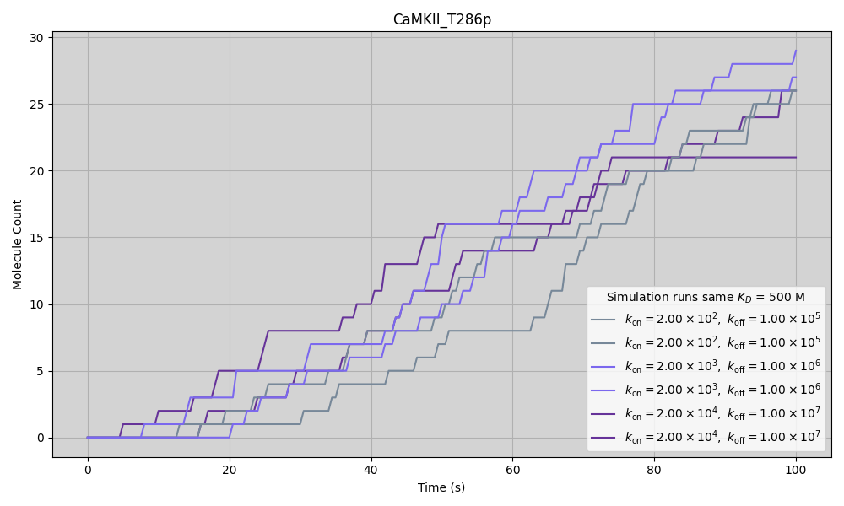
Figure 5.7: CaMKII T286 phosphorylation was unaffected by changes in $k_{\text{on}}$ and $k_{\text{off}}$ by factors of 0.1 and 0.01. The baseline values for $k_{\text{on}}$ and $k_{\text{off}}$ were taken from (Pharris et al. 2019): $k_{\text{off}}$ = $1.00×{10}^{7}$ $s^{−1}$ and $k_{\text{off}}$ = $2.00×{10}^{4}$ $M^{−1}s^{−1}$. Simulations were performed by varying these parameters by factors of 0.1 and 0.01, with the equilibrium dissociation constant ($k_{\text{D}}$) held constant at 500 M.

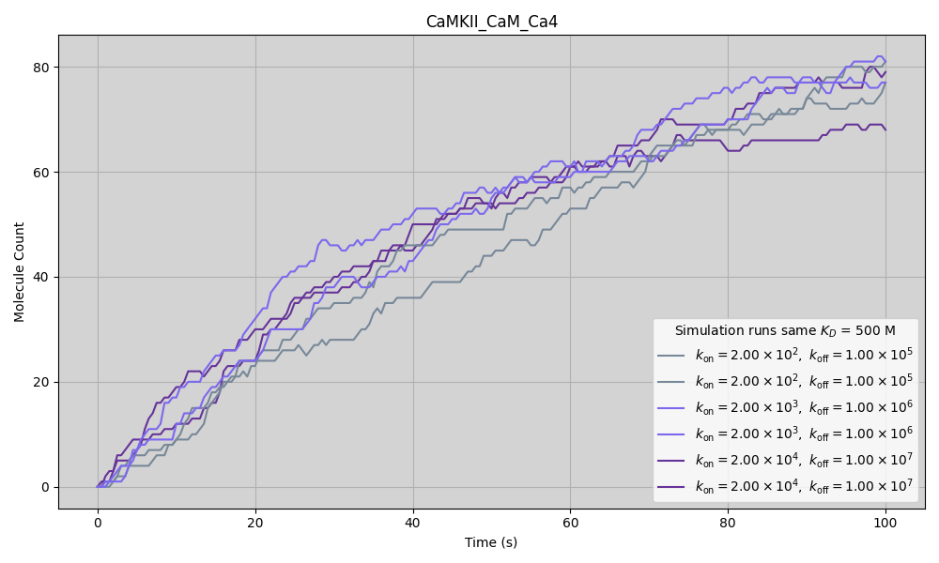
Figure 5.8: CaMKII binding to CaM was unaffected by changes in $k_{\text{on}}$ and $k_{\text{off}}$ by factors of 0.1 and 0.01. The baseline values for $k_{\text{on}}$ and $k_{\text{off}}$ were taken from (Pharris et al. 2019): $k_{\text{off}}$ = $1.00×{10}^{7}$ $s^{−1}$ and $k_{\text{off}}$ = $2.00×{10}^{4}$ $M^{−1}s^{−1}$. Simulations were performed by varying these parameters by factors of 0.1 and 0.01, with the equilibrium dissociation constant ($k_{\text{D}}$) held constant at 500 M.
Similarly, parameter variations for CaMKII and NMDAR binding rates were explored to assess their impact on the model. Specifically, a $k_{\text{off}}$ for the unbinding of CaMKII from the NR1 subunit of NMDARs was estimated by (Leonard et al. 2002), though to the best of our knowledge, we could not find estimated values for the GluN2B subunit, to which CaMKII binds more readily (Strack and Colbran 1998; Leonard et al. 2002; Barria and Malinow 2005). We therefore proceeded to use the parameters that were used for a previously validated model (Roman Garcia and Stefan 2017), with a $k_{\text{D}}$ value of $1.5×{10}^{−7}\text{M}$. We run the simulation by varying this $k_{\text{D}}$ by factor of 0.1 and 0.01.
The objective was to determine how changes in these parameters affected the molecules in the model. Specifically, we focused on CaMKII T286 phosphorylation and CaM binding, as they had been used in previous parameter sweeps and were indirectly influenced by these changes. While direct changes such as CaMKII binding or unbinding would obviously be affected by the change in parameters that directly affect their dynamics, T286 phosphorylation and CaM binding are not directly impacted in the same way, making them suitable for testing the effects of parameter variation on the system.
After varying $k_{\text{D}}$ as described (Figure 5.9 and Figure 5.10), we found a recent paper proposing a $k_{\text{D}}$ value of $1.07×{10}^{−7}\text{M}$. Observing that the results did not vary significantly with this new $k_{\text{D}}$ value, which was in close agreement with our original one, we proceeded with the choice of $k_{\text{D}}=1.5×{10}^{−7}\text{M}$.
Similarly, parameter variations for CaMKII and NMDAR binding rates were explored to assess their impact on the model. Specifically, a $k_{\text{off}}$ for the unbinding of CaMKII from the NR1 subunit of NMDARs was estimated by (Leonard et al. 2002). However, to the best of our knowledge, we could not find estimated values for the GluN2B subunit, to which CaMKII binds more readily (Strack and Colbran 1998; Leonard et al. 2002; Barria and Malinow 2005). We therefore proceeded to use the parameters from a previously validated model (Roman Garcia and Stefan 2017), with a $k_{\text{D}}$ value of $1.5×{10}^{−7}\text{M}$. We ran the simulation by varying this $k_{\text{D}}$ by factors of 0.1 and 0.01.
The objective was to determine how changes in these parameters affected the molecules in the model. Specifically, we focused on CaMKII T286 phosphorylation and CaM binding, as they had been used in previous parameter sweeps and were indirectly influenced by these changes. While direct changes such as CaMKII binding or unbinding would obviously be affected by the change in parameters that directly affect their dynamics, T286 phosphorylation and CaM binding are not directly impacted in the same way, making them suitable for testing the effects of parameter variation on the system.
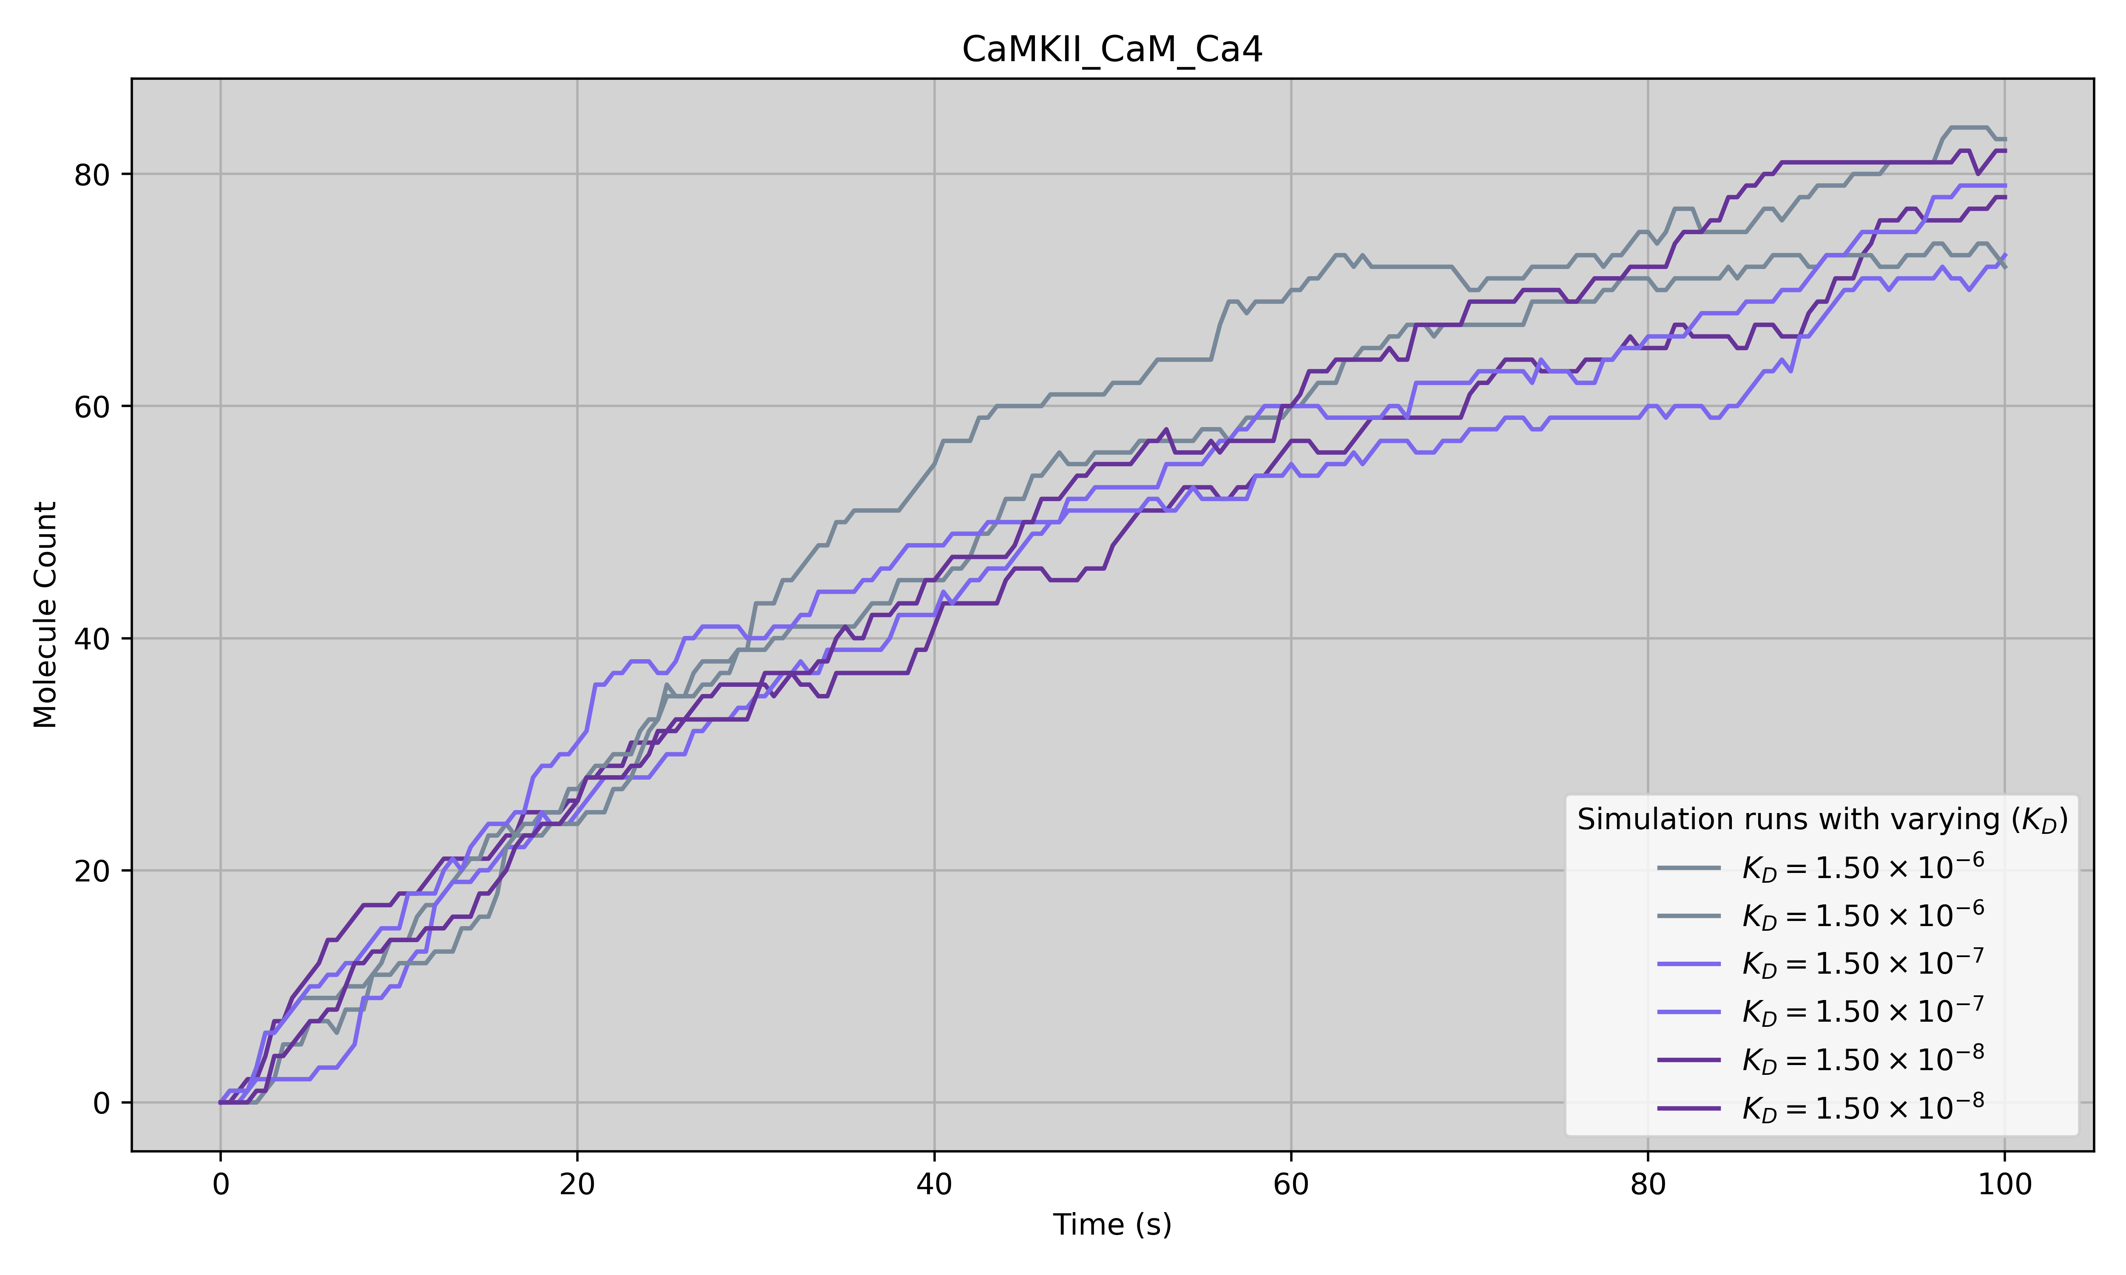
Figure 5.9: CaMKII binding to CaM was unaffected by changes in $k_{\text{D}}$ by factors of 0.1 and 0.01, from a previously used $k_{\text{D}}$ value of $1.5×{10}^{−7}\text{M}$

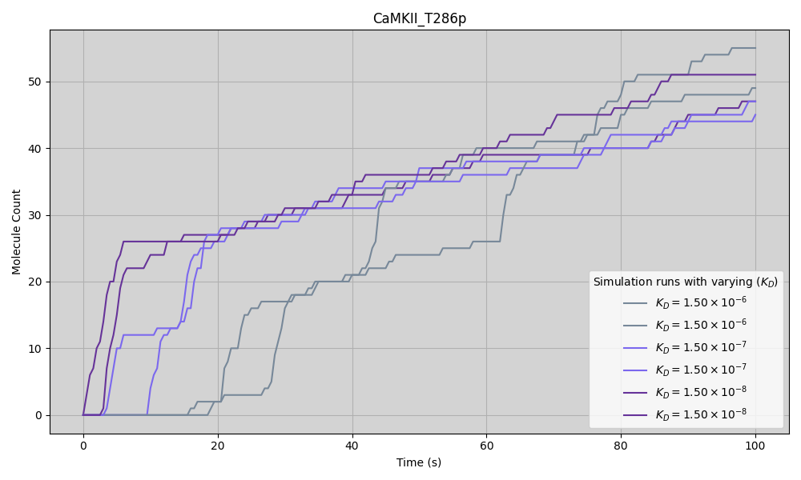
Figure 5.10: CaMKII T286 phosphorylation CaMKII binding to CaM was unaffected by changes in $k_{\text{D}}$ by factors of 0.1 and 0.01, from a previously used $k_{\text{D}}$ value of $1.5×{10}^{−7}\text{M}$
Taken together, these parameter sweeps demonstrate that the model’s core behaviours, particularly CaMKII T286 phosphorylation and CaM binding, are robust to substantial variations in both flickering kinetics and CaMKII–NMDAR binding affinities. Despite exploring parameter changes across multiple orders of magnitude, the system consistently converged on similar outcomes. Based on this robustness, and the agreement with literature-based estimates, the final parameters selected were the original literature-based parameters were retained in the final model.

5.4 Expected Model Outcomes
In addition to direct rule-by-rule validation and sanity checks, I defined a set of expected outcomes to assess whether the model could produce emergent behaviours consistent with known biological expectations—despite these behaviours not being explicitly hardcoded. These behaviours arise not from isolated reactions, but from the interaction and timing of multiple rules within the network, offering important insight into whether the system captures the complex, context-dependent behaviour observed in vivo.
For instance, phenomena such as the sustained opening of CaMKII following transient calcium signalling are not encoded as fixed outcomes. Instead, they should emerge from the model structure if the underlying mechanisms of encoded rules are implemented correctly. Similarly, the transition from CaM-dependent to CaM-independent anchoring at NMDARs, are emergent outcomes expected to arise from the model’s rule interactions. The following emergent behaviours were not coded into the rules in Figure 5.5, but were expected behaviours to follow what is known in the literature.
- CaMKII phosphorylation at T286 occurs regardless of CaM binding, although phosphorylation is more likely when CaM is present. This behaviour is not explicitly hardcoded into the model, but is expected as an emergent property of the system. Both CaM binding and T286 phosphorylation stabilise the CaMKII subunit in its open conformation (rules #6 and #8), which increases the likelihood of both events co-occurring. Therefore, while the model does not directly specify this co-occurrence, the chances of T286 phosphorylation are indirectly increased when CaMKII is either already phosphorylated at T286 or bound to CaM, as both conditions promote an open state conducive to phosphorylation.
- When phosphorylated at T286, CaMKII binds more readily to NMDARs, independent of the presence of CaM. This behaviour arises from the fact that T286 phosphorylation stabilises CaMKII in its open conformation, and only open CaMKII can bind to NMDARs. While the model does not explicitly encode a direct link between T286 phosphorylation and NMDAR binding, it encodes the conditions that promote each event separately. As a result, we expect that T286-phosphorylated CaMKII subunits will indirectly bind NMDARs more readily due to their maintained open state.
- When CaMKII is maintained in the open state by CaM binding, the kinase binds more readily to NMDARs and is likely to remain associated with the NMDAR/CaMKII complex even after CaM dissociates. Both CaM binding and NMDAR binding stabilise CaMKII in its open conformation. The model allows multiple routes to maintaining this open state, one of them being CaM binding, hence CaM-bound CaMKII may be more likely to interact with NMDARs, and once that interaction occurs, the open conformation can be preserved by NMDAR binding alone.
These expected behaviours serve as key indicators of the model’s capacity to recapitulate biologically realistic dynamics through rule interactions alone. How these behaviours emerge in simulation is examined in detail in Section 6.3, where the model’s outputs are evaluated against known experimental observations.

6. Results of In Silico Wild-Type and Mutant Models
Three principal model versions of the CaMKII/NMDAR model have been developed. The first is a wild-type (WT) model, as described in Chapter 5. In addition, two mutant (MT) models were constructed: one in which CaMKII is unable to phosphorylate at T286, and another in which CaMKII cannot bind to NMDARs. These mutations were implemented by setting the reaction rates corresponding to CaMKII autophosphorylation and CaMKII–NMDAR binding, respectively, to zero.
The simulations were designed to observe whether known emergent behaviours of CaMKII could be reproduced by the model without being explicitly encoded. In particular, following the expected outputs stated in Section 5.4, I looked for: (1) phosphorylation at T286 occurring with or without CaM binding; (2) increased NMDAR binding by T286-phosphorylated CaMKII; and (3) enhanced NMDAR binding in the CaM-bound open state, with continued association after CaM dissociation.
The results show that two out of the three expected behaviours emerge from the model dynamics. T286 phosphorylation was more likely when CaM was bound, though not strictly dependent on it. Similarly, T286-phosphorylated CaMKII was increased through NMDAR binding due to its stabilised open state. Finally, CaMKII bound to CaM binding and NMDAR association were shown to be independent. These observations will be discussed in more detail in the sections that follow.

6.1 Analysis of the Wild-type model
This section presents a summary of the results obtained from the WT model. In the WT simulation, the final total number of CaMKII_open molecules reaches a mean of approximately 108 molecules at 100 seconds. The shaded area surrounding the mean trajectory in the graph represents the standard deviation (SD), indicating the degree of variability across different simulation runs.

6.1.1 CaM binding and NMDAR binding independently stabilise CaMKII activity in the early stages of the simulation
Figure 6.1 provides an overview of the key molecular interactions and states observed in the WT CaMKII/NMDAR model during the simulation. Each subpanel (a–d) captures specific aspects of the molecular dynamics, focusing particularly on the interplay between CaMKII opening, T286 phosphorylation, CaM binding, and NMDAR binding.
Panel (a) in Figure 6.1 shows the evolution of the open conformation of CaMKII over time. The brown line represents the total number of CaMKII_open subunits, which steadily increases as the simulation progresses. Two main factors contribute to the stabilisation of CaMKII in the open state: (1) CaM binding (light blue line, camkii_cam_unbound_open) and (2) NMDAR binding (dark blue line, nmdar_camkii_complex). Notably, NMDAR binding can maintain CaMKII in the open conformation even in the absence of CaM binding (Fig 7.2c). Figure 7.2b focuses on T286 phosphorylation dynamics of CaMKII. The orange line (camkii_t286p) shows the total number of CaMKII subunits phosphorylated at T286, while the pink line (camkii_t286p1_bound_nmdar) represents the subset of T286-phosphorylated subunits that are also bound to NMDARs. A large fraction of phosphorylated subunits are found associated with NMDARs, indicating that NMDAR binding promotes or sustains T286 phosphorylation. Importantly, this phosphorylation happens largely independently of CaM, as further illustrated in panels (c) and (d).
Panel (c) in Figure 6.1 dissects the T286-phosphorylated CaMKII subunits that are bound to NMDARs into CaM-bound and CaM-unbound populations. Here, the pink line represents all T286-phosphorylated CaMKII subunits bound to NMDARs, while the orange line shows the subset that are CaM-free (camkii_cam_unbound_t286p1_bound_nmdar). It is clear that the majority of the T286-phosphorylated CaMKII subunits bound to NMDARs are unbound from CaM, emphasizing that CaMKII can maintain phosphorylation at T286 even after CaM dissociates. This further supports the idea that NMDAR binding alone is sufficient to stabilize the active, open, phosphorylated state in this model. Figure 7.2d provides a more detailed look at T286 phosphorylation in relation to CaM binding across the whole CaMKII population. The data shows that roughly equal numbers of CaMKII subunits are phosphorylated at T286 whether they are CaM-bound or CaM-unbound. This demonstrates that although CaM binding facilitates CaMKII opening and activation, T286 phosphorylation does not require continuous CaM binding once CaMKII is locked in its open, phosphorylated conformation.
To further dissect the molecular events underlying these dynamics, the following sections will explore a representative simulation run in detail, focusing on the specific behaviours of CaMKII subunits in relation to NMDAR and CaM binding, and T286 phosphorylation. For reproducibility, the simulation run used for the single-run figures was “run_2025-04-03_08-45-21_seed_2”. The model simulation files is available in the model’s GitHub repository page: https://github.com/Susana465/CaMKII_hexa_bgnl_to_mcell. In order to facilitate comprehensive understanding of the molecule names used, a summary is provided in Figure 6.2.

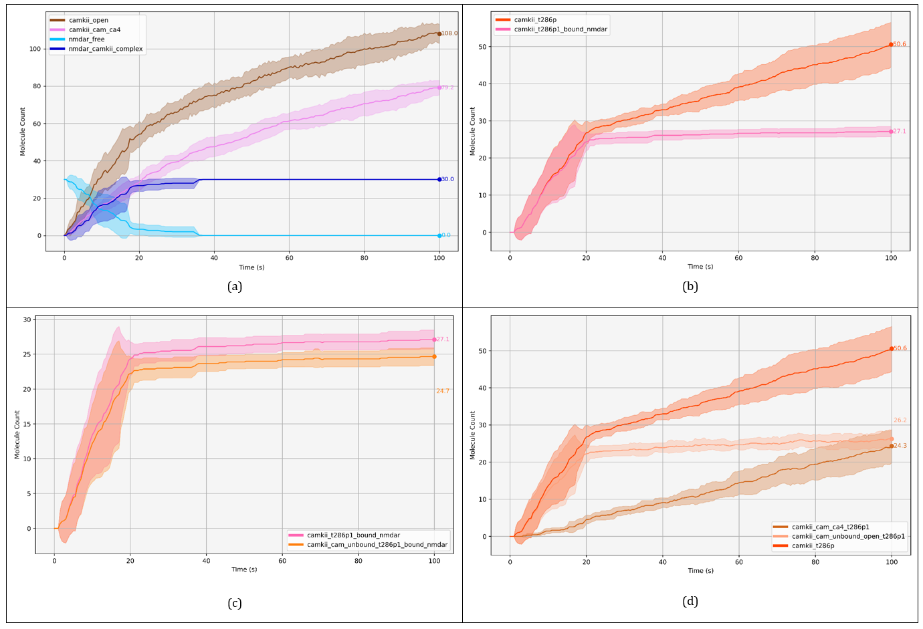
Figure 6.1: CaM binding and NMDAR binding independently stabilise CaMKII activity in the early stages of the simulation. Final value means of total molecule counts (mean ± SD): camkii_open (108.00 ± 5.12); camkii_cam_ca4 (79.22 ± 3.85); nmdar_free (0.00 ± 0.00); nmdar_camkii_complex (30.00 ± 0.00); camkii_t286p (50.56 ± 5.96); camkii_t286p1_bound_nmdar (27.11 ± 1.37); camkii_cam_unbound_t286p1_bound_nmdar (24.67 ± 1.25); camkii_cam_ca4_t286p1 (24.33 ± 4.45); camkii_cam_unbound_open_t286p1 (26.22 ± 2.35)

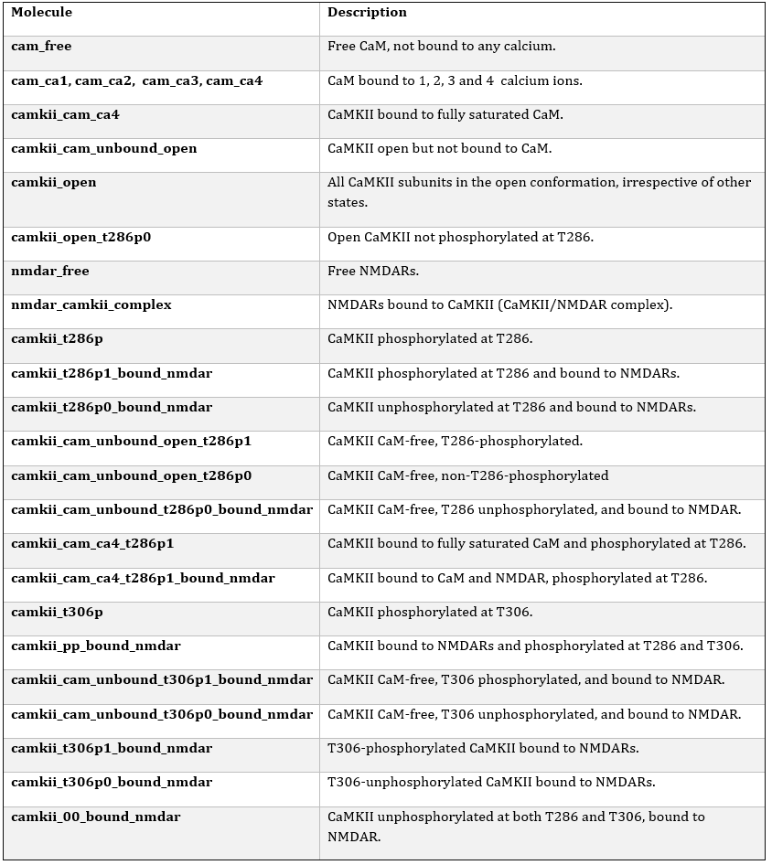
Figure 6.2: Summary of observable names and their meaning.

6.1.2 Approximately half of CaM binds to calcium within the first 5s
In the WT model (described in detail in Chapter 5), a release of 1000 calcium ions occurs within a dendritic spine volume of 0.50588 $μ{\text{m}}^{3}$. This calcium subsequently binds to CaM, which can bind up to four calcium ions. Full saturation of CaM is required for subsequent binding to CaMKII, resulting in the formation of the CaMKII–CaM complex (CaMKII_CaM_Ca4).
This progression is illustrated in (Figure 6.3), where the gradual formation of partially and fully calcium-bound CaM species is shown. Although calcium itself is not displayed (due to its relatively high concentration distorting the plot scale), the stepwise increase in CaM species bound to one, two, three, and four calcium ions is clearly visible. The appearance of CaMKII bound to fully saturated CaM (camkii_cam_ca4) further confirms the expected dynamics. as per the set reaction rates and established literature, CaM fully bound to four calcium ions is immediately available for binding to CaMKII, whereas CaM bound to fewer calcium ions is less readily available for this interaction.
The simulation reveals a rapid decrease in the concentration of free CaM, which stabilises at approximately half of its initial value, suggesting that roughly half of the CaM molecules remain unbound to calcium. Upon further investigation, this suggests that calcium is acting as a saturating factor. Given that each CaM molecule can bind up to four calcium ions, the 290 CaM molecules would require at least 1200 calcium ions (290 × 4 $≈$ 1200) for full saturation. However, the model uses 1000 calcium ions, which is slightly below this threshold. It is also worth noting that calcium ions are continuously binding to and dissociating from CaM as part of the ongoing reactions, so as some calcium may dissociate from one species, it might then associate to another, allowing for dynamic and emergent molecule behaviours. Even if the calcium concentration were increased (the difference between 1000 and 1200 calcium ions would be relatively small, from 3.282 $μ\text{M}$ to 3.938 $μ\text{M}$, respectively), we would expect an increase in the number of CaM molecules bound to four calcium ions, but the change might not be substantial.
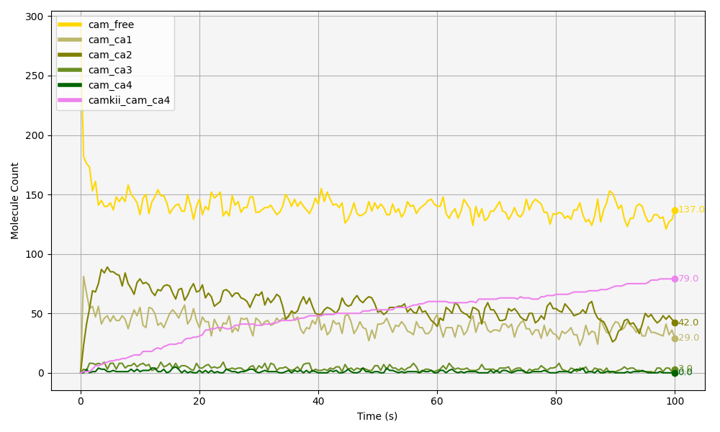
Figure 6.3: CaM binding to 1,2,3 and 4 calcium ions (calcium not shown) and formation of CaMKII-CaM complex (CaMKII_CaM_Ca4).

6.1.3 CaM stabilises CaMKII in the open conformation, but is not required for CaMKII/NMDAR binding
Next, we examine CaM–CaMKII binding (Figure 6.4 (a)), focusing on how CaMKII’s open conformation of subunits stabilises over time. Out of the 720 CaMKII subunits released (not shown), a total of 104 molecules remain in the open conformation (camkii_open), at 100 seconds. Camkii_open represent the total population of CaMKII subunits that are structurally in their open state. To determine how many of these open subunits are simultaneously bound to CaM, we refer to the pink trace in Figure 6.4 (a), which indicates that 79 subunits are CaM-bound by the end of the simulation. This shows that approximately 75% of the open CaMKII subunits are being stabilised in this state through CaM binding up until the end of the simulation.
In contrast, the population of open CaMKII subunits that are not bound to CaM reaches equilibrium just before the 20-second mark, maintaining a steady count of just above 20 molecules until the end of the simulation. This accounts for the remaining 25% of the open CaMKII pool. These observations indicate that the majority of open CaMKII subunits are stabilised in their active conformation via CaM binding, while a smaller proportion is maintained in the open state by alternative mechanisms.
In the model at hand, CaMKII is defined as dynamically transitioning between open and closed conformations, and unless stabilised in the open state —either through CaM binding, T286 phosphorylation, or NMDAR association— it will revert to the closed state (see Figure 5.5). So we can see in Figure 6.4 (a) that the majority of CaMKII open is stabilised by CaM, however, there is another mechanism that is keeping CaMKII open. This other mechanism is in direct relation with NMDAR interaction as we will explore next.
By examining Figure 6.4 (b), we observe that the levels of CaMKII binding to NMDARs (dark blue line: nmdar_camkii_complex) closely follow the same pattern as CaM unbinding from CaMKII (medium blue: camkii_cam_unbound_open). In other words, as CaMKII associates with NMDARs, this interaction maintains CaMKII in an open state, without the need for CaM binding to CaMKII.
Interestingly, the proportion of CaMKII free from CaM that are still in their open conformation (medium blue: camkii_cam_unbound_open, Figure 6.4 (b)) fluctuates up and down frequently, which comes from CaMKII opening and closing (as CaM is not bound yet).
Initially, the level of CaMKII free from CaM that are still in their open conformation (camkii_cam_unbound_open) fluctuates and exceeds the amount of CaMKII bound to NMDARs (nmdar_camkii_complex). This indicates that while a pool of open CaMKII is available, not all of it is bound to NMDARs at once. Over time, as CaMKII binding to NMDARs progresses and the system approaches a steady state, newly opened CaMKII subunits are quickly captured by available NMDAR binding sites. Consequently, the amount of free, open CaMKII stabilizes at a level consistently lower than the amount of NMDAR-bound CaMKII, indicating that binding to NMDARs efficiently sequesters and stabilizes open CaMKII in the later phase.
Moreover, in Figure 6.4 (b), we observe a three-step, ladder-like progression of CaMKII binding to NMDARs. Each step corresponds to an increase in the number of CaMKII subunits bound: first reaching approximately 12 subunits, then 24, and finally 30. This pattern suggests that entire CaMKII holoenzymes (each containing 12 subunits) sequentially bind to NMDARs. Here, looking at a single run reveals a clear pattern that was obscured when averaging across multiple simulations
Initially, one holoenzyme binds rapidly, with its subunits quickly associating with available NMDARs. The process of a second holoenzyme binding is slower, likely because after the first 12 subunits are bound, there are fewer free NMDARs left. Now, the second holoenzyme has fewer choices, and it may need to “search” or “diffuse” around more to find free receptors. Finally, after the second holoenzyme binds (up to 24 subunits), a third holoenzyme binds partially, occupying the remaining 6 NMDARs. By the time the third holoenzyme tries to bind, only 6 NMDARs are free — not enough for all 12 subunits. The progressive slowing reflects decreasing availability of free NMDARs for binding. The implications of these findings are discussed in Section 6.3. However, this particular mode of CaMKII binding to NMDARs may be an artifact of the model. Although not necessarily invalid, this aspect warrants further scrutiny and should be revisited in future research, as explored further in the discussion section below.
In summary, the majority (75%) of CaMKII subunits in the open conformation are stabilized by binding to CaM. However, while CaM helps stabilize CaMKII in the open state, the binding of CaMKII to NMDARs is not dependent on CaM. As CaMKII binds to NMDARs, it maintains its open conformation even without CaM binding, indicating that the interaction between CaMKII and NMDARs can stabilize the open state of CaMKII independently of CaM.
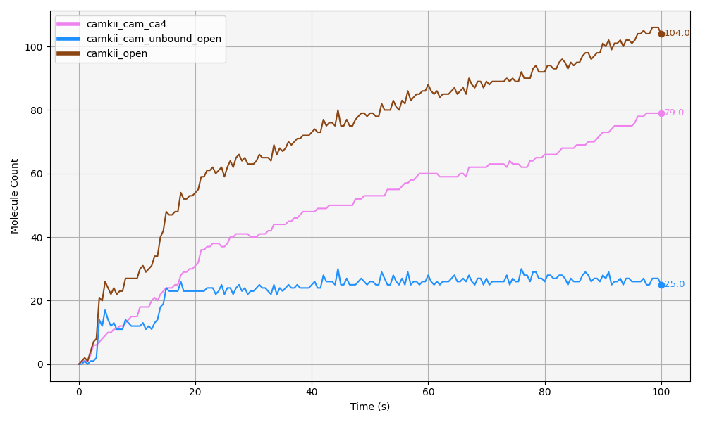
(a)

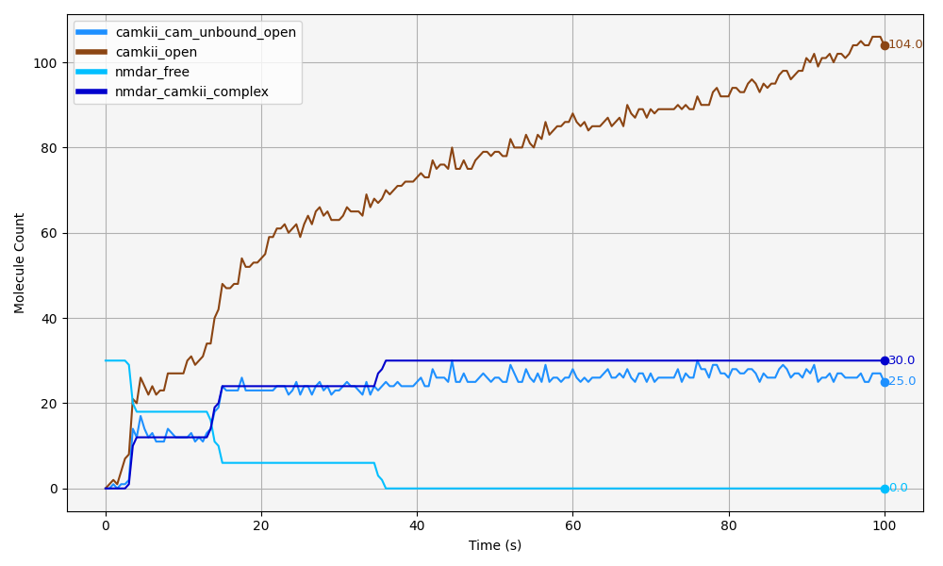
(b)

Figure 6.4: Stabilisation of CaMKII in the Open Conformation.

6.1.4 CaMKII subunits remain open and autophosphorylate at T286 upon NMDAR binding, regardless of CaM binding
Next we look at total number of CaMKII subunits phosphorylated at T286. Camkii_t286p reflects the full amount of T286-phosphorylated CaMKII, irrespective of any other concurrent molecular states. All CaMKII subunits categorised as camkii_t286p are necessarily in the open conformation. Therefore, camkii_t286p represents a subset of the camkii_open population (Figure 6.5). This is consistent with both the model’s coding and biological evidence, as phosphorylation at T286 locks CaMKII in an autonomously active, open conformation by preventing the regulatory segment from re-binding to the catalytic domain, which physically prevents closing of the subunit.
Out of the 104 CaMKII subunits that are open at the end of the simulation, 45 are found to be phosphorylated at T286 (Figure 6.5), and the rest (104 - 45 = 59) are therefore not phosphorylated at this site. This indicates that approximately half of the open CaMKII subunits are in a T286-phosphorylated state.
Of the 45 T286-phosphorylated CaMKII subunits, a subset of 25 are found to be bound to NMDARs (pink line: camkii_t286p1_bound_nmdar as shown in Figure 6.6). The difference between these two molecules, corresponds to the number of CaMKII molecules that are T286-phosphorylated but not associated with NMDARs. This is, out of all the CaMKII subunits that are phosphorylated at T286, about half can be found bound to NMDARs, and the other half is not. Figure 6.7 further demonstrates that the majority of CaMKII subunits bound to NMDARs and phosphorylated at T286 are free from CaM. This complements observations in Figure 6.6, where 25 CaMKII subunits are both T286-phosphorylated and bound to NMDARs, of which 23 are CaM-free and only 2 remain CaM-bound by the end of the simulation.
Further, within the population of T286-phosphorylated CaMKII that is also bound to NMDARs (pink line: camkii_t286p1_bound_nmdar), only a very small number of subunits remain bound to CaM (Figure 6.7). Thus, the majority of CaMKII subunits that are bound in a NMDAR/CaMKII complex are both phosphorylated at T286 and free from CaM (which is consistent with literature, as further discussed in Section 6.3). This is, once CaMKII is bound to the NMDARs, the holoenzyme subunits can remain open, and autophosphorylate even in the absence of CaM.
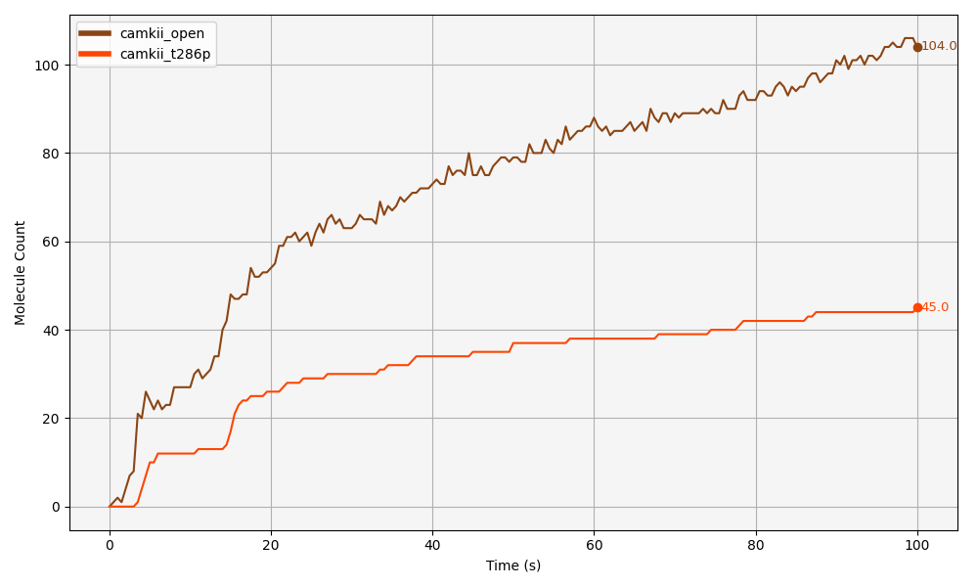
Figure 6.5: Approximately half of CaMKII that is open (camkii_open) is also phosphorylated at T286 (camkii_t286p). The difference between 104 and 45 is the amount of CaMKII that is open and unphosphorylated at T286.

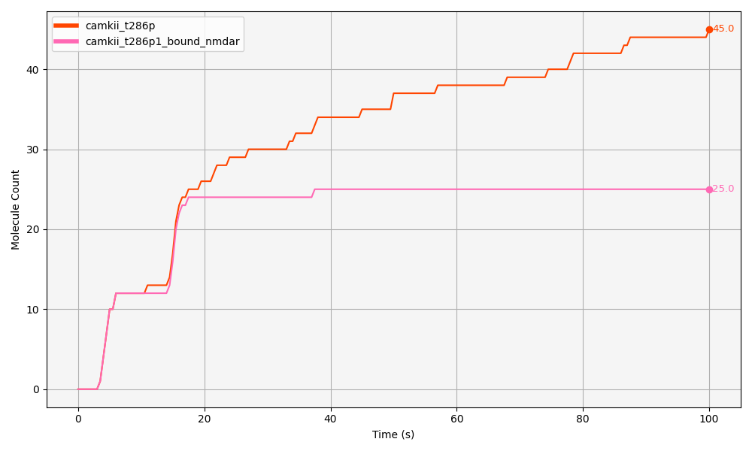
Figure 6.6: Approximately half of all T286-phosphorylated CaMKII subunits (camkii_t286p) are also bound to NMDARs (camkii_t286p_bound_nmdar) by the end of the simulation.

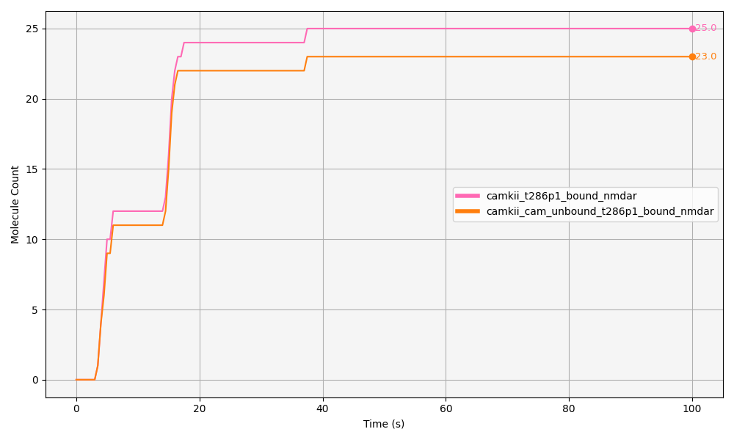
Figure 6.7: Most CaMKII phosphorylated at T286 and bound to NMDARs (camkii_t286p1_bound_nmdar) is free from CaM (camkii_cam_unbound_t286p1_nmdar).

6.1.5 NMDAR binding is the primary driver of T286 phosphorylation
As explained in Section 1.4.1, we use a ‘conformational selection’ approach to modelling CaMKII activation, where CaMKII can exist in both open and closed states independently, and CaM selectively binds to and stabilizes the open conformation, without inducing a conformational change. In order to understand how CaM is interacting with CaMKII T286 phosphorylation, we look at Figure 6.8. Here we can see that among all CaMKII subunits phosphorylated at T286, approximately half (23 molecules) are also bound to CaM, represented by the peach-coloured trace “camkii_cam_ca4_t286p1”, while the remaining half (22 molecules) are unbound from CaM (brown-coloured trace: “camkii_cam_unbound_open_t286p1”).
This indicates that, although CaM binding co-occurs with T286 phosphorylation, T286 is not necessarily more likely when subunits are bound to CaM. In fact, subunits that are both CaM-bound and T286-phosphorylated emerge more slowly during the simulation (Figure 6.8), suggesting that CaM binding is not the main event leading to the increase of initial CaMKII T286 phosphorylation, but as we will see next, NMDAR binding is (by keeping CaMKII subunits in their open conformation and allowing subsequent T286 autophosphorylation).
T286-phosphorylated CaMKII which is free from CaM (peach-coloured line in Figure 6.9) corresponds in timing with the formation of the CaMKII/NMDAR complex (Figure 6.7). This suggests that, once CaMKII binds to NMDARs and its subunits are held in the open conformation, autophosphorylation at T286 is further facilitated in the CaMKII subunits that are part of the CaMKII/NMDAR complex.
Interestingly, a slight increase in the population of CaMKII free from CaM and T286 phosphorylated is observed around 80 seconds. This rise suggests that subunits of holoenzymes locked into the CaMKII/NMDAR complex undergo further autophosphorylation of neighbouring subunits, resulting in a momentary increase in CaMKII subunits that are free from CaM and phosphorylated at T286.
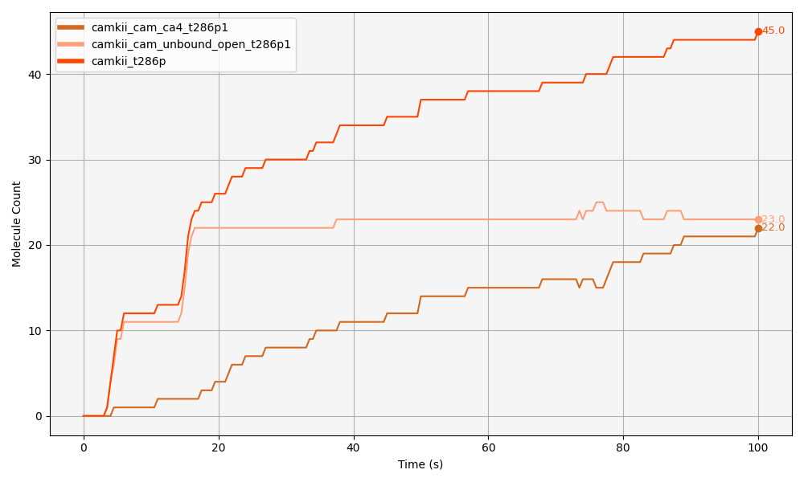
Figure 6.8: CaM binding is not the main event leading to the increase of initial CaMKII T286 phosphorylation, as out of all the CaMKII that is T286 phosphorylated (camki_t286p), most of it first increases in a state that is free from CaM (camkii_cam_unbound_open_t286p1), whereas CaMKII that is bound to CaM and T286 phosphorylated (camkii_cam_ca4_t286p1) increases more slowly and later.

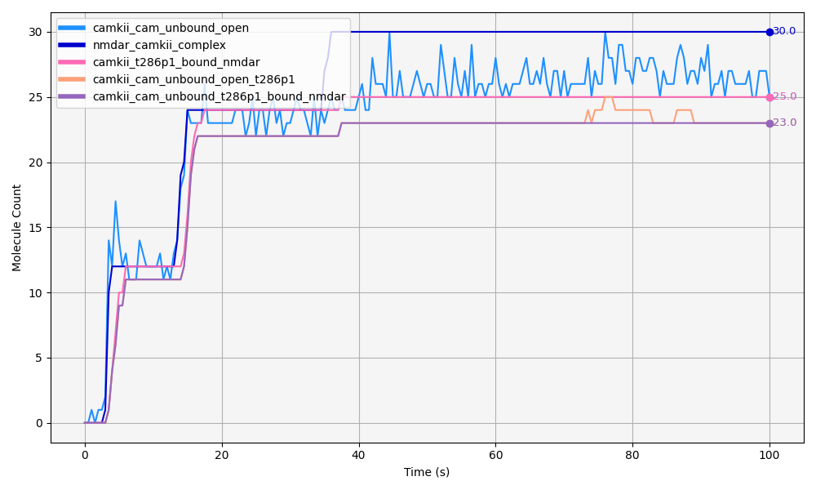
Figure 6.9: Binding of CaMKII to NMDARs promotes and stabilizes the open conformation of its subunits, facilitating T286 autophosphorylation within the CaMKII/NMDAR complex.

6.1.6 NMDAR binding also promotes CaMKII autophosphorylation at T306 site
Phosphorylation at the T306 site is known to occur at a slower rate than phosphorylation at T286 (Otmakhov, Regmi, and Lisman 2015; Chang et al. 2017), and this is reflected in the model outputs. A total of 25 CaMKII subunits become phosphorylated at T306 over the course of the simulation (burgundy trace: camkii_t306p in Figure 6.10), of which 21 are bound to the NMDAR (golden trace:camkii_cam_unbound_t306p1_bound_nmdar in Figure 6.10) —indicating that approximately 84% of T306-phosphorylated subunits are part of NMDAR complexes.
Moreover, the accumulation of doubly phosphorylated subunits (T286P and T306P; here referred to as CaMKII_PP, hot pink trace in Figure 6.10) appears to track closely with the rate of T306 phosphorylation. This indicates that T306 phosphorylation typically follows T286 phosphorylation, particularly during the earlier stages of the simulation. This behaviour is consistent with both the modelled mechanisms and findings reported in the literature (Pi et al. 2010).
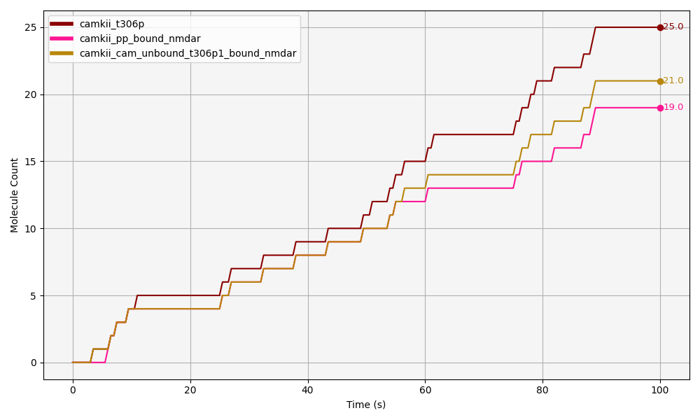
Figure 6.10: At later stages, T306 phosphorylation can occur and persist independently of T286 in CaMKII that is bound to NMDARs.Initially, most of the CaMKII phosphorylated at T306 (camkii_t306p) is also phosphorylated at T286—i.e., it is in the doubly phosphorylated state (camkii_pp_bound_nmdar). This indicates that early T306 phosphorylation often coincides with T286 phosphorylation. After 60 seconds, the amount of CaMKII that is bound to NMDARs and phosphorylated only at T306 (camkii_cam_unbound_t306p1_bound_nmdar) surpasses the doubly phosphorylated form. Saying cam_unbound (CaM free) in this molecule name is redundant as camkii that is t306p is necessarily free from CaM.
Interestingly, after around 60 seconds, subunits that are solely phosphorylated at T306 continue to increase above CaMKII_PP (Figure 6.10). This suggests that, at later stages in the simulation, T306 phosphorylation can occur and persist independently of T286 phosphorylation. Extending the simulation time may offer further insights into this dynamic, as it could support the biological hypothesis that initial T286 phosphorylation enables subsequent T306 phosphorylation, but that T306P can then be maintained even in the absence of T286 phosphorylation (Hanson and Schulman 1992; Pi et al. 2010; Bhattacharyya et al. 2020).
Furthermore, T306 phosphorylation follows NMDAR binding dynamics closely. As shown in Figure 6.11, CaMKII subunits initially bind to NMDARs in an unphosphorylated T306 state (slate-green: camkii_t306p0_bound_nmdar in Figure 6.11). Once the CaMKII–NMDAR complex reaches equilibrium, levels of T306 phosphorylation increase correspondingly, as unphosphorylated T306 decreases.
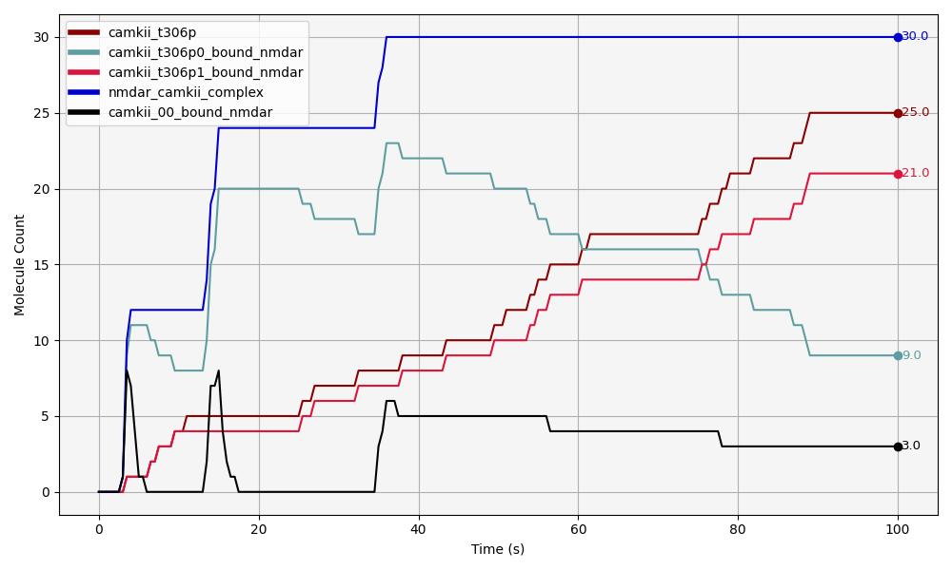
Figure 6.11: CaMKII binds unphosphorylated to NMDARs (camkii_00_bound_nmdar). T286 phosphorylation ensues, followed by an increase in T306 phosphorylation (camkii_t306p1_bound_nmdar) -and a T306 unphosphorylated state decrease (camkii_t306p0_bound_nmdar). All these molecules are a subset of CaMKII bound to NMDARs (nmdar_camkii_complex).
In the final phase of CaMKII binding to NMDARs, after approximately 40 seconds —when all NMDARs are saturated, T306 phosphorylation continues to rise. This is likely supported by the concurrent increase in T286 phosphorylation, and by a decrease in CaM binding to CaMKII subunits already bound to NMDARs. This aligns with expectations, as CaM binding and T306 phosphorylation are mutually exclusive processes —CaM must be unbound for T306 phosphorylation to occur. Therefore, as the model shows a decrease in CaM binding to CaMKII subunits that are already part of the CaMKII–NMDAR complex, the opportunity for T306 phosphorylation increases. In other words, the less CaM is bound to CaMKII subunits, the more likely it is that T306 can become phosphorylated, and the less likely CaM is to bind.
Figure 6.11 shows three distinct peaks, each representing CaMKII subunits that are in the “p00” state — meaning they are not phosphorylated at either T286 or T306. This pattern highlights three important insights. First, CaMKII binds to NMDARs before any phosphorylation has occurred. Second, although phosphorylation is not required for binding, once CaMKII is incorporated into an NMDAR complex, autophosphorylation becomes more likely. Third, phosphorylation at T306 follows phosphorylation at T286, following a sequential phosphorylation mechanism as expected.
These findings show that the formation of CaMKII-NMDAR complexes does not depend on prior phosphorylation at T286. However, once T286 phosphorylation occurs, it can initiate a cascade of further autophosphorylation events, including at T306, within the same NMDAR/CaMKII complex. Previous studies have shown that CaMKII does not need to be phosphorylated at T286 in order to bind to NMDARs or to perform its catalytic functions. That said, phosphorylation at T286 can modulate or enhance both the binding affinity and the enzymatic activity of CaMKII, making it an important regulatory step rather than an absolute requirement.

6.2 Analysis of the T286 and CaMKII/NMDAR binding mutant models
The T286 MT model is similar biologically to the CaMKII T286A MT, in which the critical autophosphorylation site T286 is substituted with alanine, preventing phosphorylation at this site. This mutation has been extensively characterised in both in vitro biochemical assays and in vivo using mice that were genetically modified. T286A mutation has been shown to impair LTP and spatial learning in rodents. This computational implementation allows investigation into how the loss of T286 phosphorylation alters CaMKII dynamics and downstream NMDAR interactions under different stimulation conditions. In the T286 MT model, this mutation is represented by setting reaction rule #8 to zero (Figure 5.5), so phosphorylation can not happen.
The NMDAR/CaMKII binding MT model simulates a mutation that disrupts the interaction between CaMKII and the GluN2B subunit of NMDARs. This disruption can be achieved through mutations in either CaMKII or GluN2B, preventing their binding without necessarily altering other functions such as kinase activity (Sanhueza and Lisman 2013). A well-characterized example is the CaMKII I205K mutation, where isoleucine is replaced by lysine. This substitution significantly impairs binding to GluN2B while leaving kinase activity intact (K.-Ulrich Bayer et al. 2001a). Experimental evidence shows that this mutation also reduces CaMKII accumulation at synapses following LTP induction (K.-Ulrich Bayer et al. 2001a). In the CaMKII/NMDAR MT model, this binding disruption is represented by setting reaction rule #12 to zero (Figure 5.5), so NMDAR and CaMKII binding can not proceed.
The following analysis compares WT simulations with those of the two MT models. The total number of simulation runs for each group is as follows: WT (N = 9), T286 MT (N = 9), and CaMKII/NMDAR MT (N = 4). T-tests and one-way ANOVAs were performed after testing for normality of the datasets using the Shapiro-Wilk test.
Simulations were conducted under identical parameters across all conditions (see Figure 5.1 for initial molecule release and Figure 5.5 for reaction rates), except for two CaMKII/NMDAR MT runs, as I explain below, which were part of preliminary tests involving a different CaMKII release state. Aside from this, the only intended differences between groups were the modifications to the relevant reaction rules described above.
The reduced number of simulations for the CaMKII/NMDAR MT model resulted from a human error during file execution, which will be explored in greater detail in the discussion section below. Due to this error, only four usable simulation runs were available for this model. It is important to note that, while all other simulation groups released CaMKII in its open state, the CaMKII/NMDAR MT group includes two runs with CaMKII released in the closed state and two with CaMKII released in the open state. These files, originally generated during preliminary testing (data not shown), were the only available usable runs for this condition due to the aforementioned error. As no substantial differences in simulation outcomes were observed between the two release states, all four runs were retained in the analysis. This detail is provided here for transparency.

6.2.1 NMDAR binding stabilizes CaMKII open conformation more readily than T286 phosphorylation
Having established the simulation conditions for each model, we now present quantitative comparisons between WT and MT simulations across key molecular outputs. A primary focus of this analysis is the extent of CaMKII opening, as this conformational state is influenced by both T286 phosphorylation and binding to NMDARs. Given that both of these interactions promote and stabilise the open conformation of CaMKII, it was expected that disrupting either mechanism, through mutation at T286 or impairment of NMDAR binding, would lead to a reduction in CaMKII opening.
Figure 6.12 displays the results of an ANOVA, with an F-statistic of 36.327, indicating a substantial difference between the group means relative to the variation within each group. Further, the associated p-value of $3.219×{10}^{−7}$ indicates a very low probability that the observed differences between the groups are due to random chance.
Both mutations significantly decreased CaMKII opening relative to the WT control. The reduction observed in the T286_MT group was modest, with a mean of 100 compared to 109 in the WT group, but statistically significant (p < 0.05), supporting the role of T286 phosphorylation in stabilising the open conformation of CaMKII. These results were expected, as abolishing T286 phosphorylation means decreasing the chances of CaMKII subunits being kept in their open conformation via this mechanism.
The NMDAR_CaMKII_MT group exhibited a much more pronounced and highly significant reduction in CaMKII opening compared to the WT group (p < 0.0001). As expected, reduced binding to NMDARs corresponds to a decreased likelihood of CaMKII remaining in its open conformation. Interestingly, CaMKII opening in the NMDAR_CaMKII_MT group was not only significantly lower than in the WT group, but also lower than in the T286_MT group (p < 0.0001). These findings reinforce the idea that NMDAR binding plays a central role in maintaining CaMKII in its open state in our simulations. While T286 phosphorylation is also important, it is the disruption of CaMKII/NMDAR binding that most strongly impacts CaMKII opening levels.
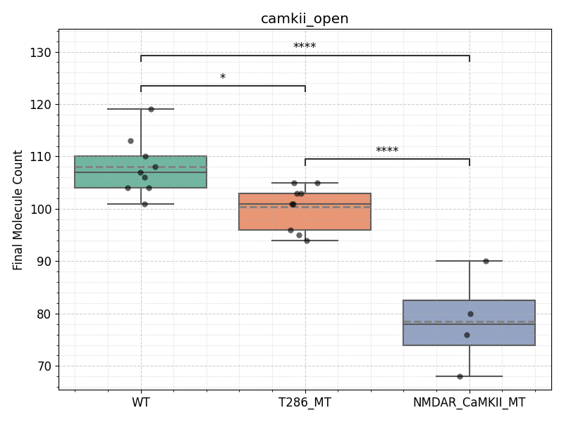
Figure 6.12: Both the T286 MT (T286_MT) and the NMDAR/CaMKII binding MT (NMDAR_CaMKII_MT) exhibit significantly lower levels of CaMKII opening compared to WT, with the largest reduction observed in the NMDAR_CaMKII_MT condition. Final molecule counts for camkii_open are shown for each simulation run (dots), with group-level distributions represented as boxplots. Solid lines represent medians, and dashed lines represent means. Statistical comparisons were performed using one-way ANOVA followed by Tukey’s HSD post hoc test. Asterisks indicate levels of statistical significance from Tukey’s HSD post hoc test: p < 0.05 (*), p < 0.001 (), and p < 0.0001 (**). ANOVA F-statistic between groups = 36.327, and $p=3.219×{10}^{−7}$.

6.2.2 Autophosphorylation at T286 promotes CaM binding but NMDAR binding does not
Next, I aimed to examine whether CaM binding to CaMKII was affected across the three models. Given the expected reduction in CaMKII opening, I expected that this decrease might also result in reduced CaM binding in both MT models. Specifically, I wanted to explore how CaM binding is related to both T286 phosphorylation and NMDAR/CaMKII binding.
As shown in Figure 6.13, total CaMKII bound to CaM (camkii_cam_ca4) was significantly reduced only in the T286 MT. The F-value of 4.668 indicates that the variance between groups (i.e., how much the CaM binding values differ between the WT, T286_MT, and NMDAR/CaMKII_MT) is considerably larger than the variance within groups (i.e., how much individual data points vary within each group). In other words, the groups are not just randomly different; the differences between the groups are meaningful and consistent. The significant reduction in CaM binding in the T286 MT (p < 0.05), and the lack of difference in the NMDAR/CaMKII MT compared to WT, suggests that T286 phosphorylation influences CaM binding to CaMKII by keeping it in the open state. On the other hand, NMDAR binding does not appear to have a similar effect.
These findings were initially unexpected, as I had anticipated that reduced CaMKII opening in both MTs might affect CaM binding in both models. However, the results are actually consistent with the underlying mechanisms that we had previously observed. In the WT model, CaM binding and NMDAR binding to CaMKII subunits appeared to be independent processes. Notably, the majority of CaMKII bound to NMDARs did not interact with CaM. This independence between NMDAR binding and CaM binding to CaMKII helps explain why the NMDAR/CaMKII MT, which disrupts NMDAR binding, does not significantly affect CaM binding. Since NMDAR binding and CaM binding to CaMKII are independent events, disrupting NMDAR binding does not impact the ability of CaMKII to bind to or release CaM. In contrast, the T286 mutation does lead to a reduction in CaM binding, highlighting the specific role of T286 phosphorylation in regulating CaM binding.
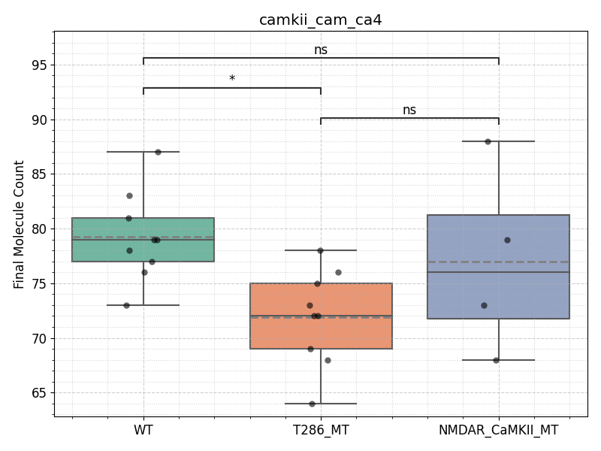
Figure 6.13: CaM binding to CaMKII is significantly reduced only with the loss of T286 phosphorylation. Final molecule counts for camkii_cam_ca4 are shown for each simulation run (dots), with group-level distributions represented as boxplots. Solid lines represent medians, and dashed lines represent means. The T286 MT (T286_MT) shows a significant reduction in CaM-bound CaMKII compared to WT (p < 0.05), whereas no significant difference (‘ns’) is observed between WT and the NMDAR/CaMKII MT (NMDAR_CaMKII_MT), or between the two MT groups. Statistical analysis was performed using one-way ANOVA (F = 4.668, p = 0.022), followed by Tukey’s HSD post hoc test.

NMDAR binding is the main stabiliser of CaMKII’s open state
To further explore how NMDARs and T286 phosphorylation affect CaMKII opening, I looked at the amount of CaMKII subunits that remain free from CaM and are kept in their open state (denoted as CaMKII–CaM_unbound_open, Figure 6.14). I observed a significant decrease in this molecule count in the NMDAR/CaMKII binding MT. As discussed previously, in the WT model, NMDARs play an active role in stabilizing CaMKII in its open state, even in the absence of CaM. This means that, in this model, NMDARs are crucial for maintaining CaMKII in its open form, free from calmodulin. When this stabilizing mechanism is disrupted in the NMDAR/CaMKII mutant, less CaMKII remains in the open state without CaM, because the NMDAR binding, which normally helps keep the CaMKII subunits open and CaM-free, is no longer functioning. As a result, there is a reduction in the amount of CaMKII remaining in its open state. Conversely, in the T286 mutant model, the ability of NMDARs to keep CaMKII in its open, CaM-free state is still intact, which explains why this aspect remains unaffected in this model.
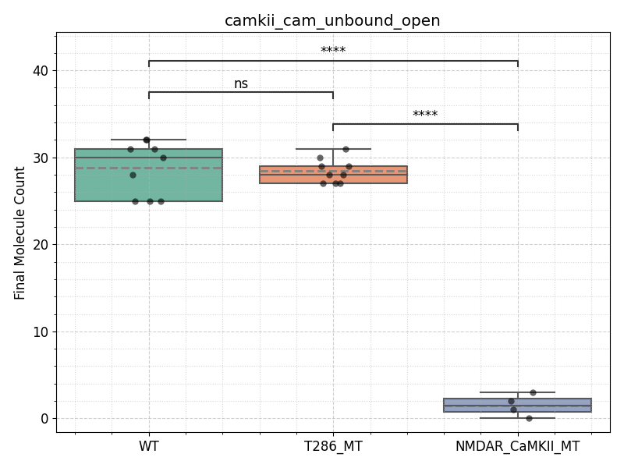
Figure 6.14: NMDAR binding is crucial for maintaining CaMKII in its open, CaM-free state (camkii_cam_unbound_open). Boxplot shows final molecule counts for camkii_cam_unbound_open across WT, T286 phosphorylation mutant (T286_MT), and NMDAR/CaMKII binding mutant (NMDAR_CaMKII_MT) models. Individual simulation runs are represented as dots. Boxes represent the interquartile range, solid lines show medians, and dashed lines show group means. A one-way ANOVA revealed a significant group effect (F = 236.180, $p=3.80×{10}^{−14}$), with post hoc Tukey’s HSD tests indicating significantly fewer CaMKII molecules in this state in the NMDAR/CaMKII mutant compared to both WT and T286_MT (**p < 0.001). No significant difference was observed between WT and T286_MT.

NMDAR binding stabilizes CaMKII open conformation and drives T286 and T306 phosphorylation
Since NMDARs play an essential role in keeping CaMKII subunits open and free from CaM (as shown by the CaMKII_cam_unbound_open data), this opens up the question of whether T286 phosphorylation, which is a key event for CaMKII activation, is also influenced by NMDAR signalling. In the WT model, we observed that CaMKII subunits bind to NMDARs in an unphosphorylated state, and T286 phosphorylation is subsequently stabilized once these subunits associate with NMDARs, even in the absence of CaM. What is more, NMDAR binding was identified as the key event leading to T286 phosphorylation, as it helps maintain CaMKII in its open conformation, thus enabling T286 autophosphorylation. Consequently, in the NMDAR/CaMKII binding mutant, where NMDAR-CaMKII interaction is disrupted, we expect T286 phosphorylation to be significantly reduced due to the loss of this stabilisation mechanism. As expected, in the NMDAR/CaMKII binding MT, we observed a significant reduction in T286 phosphorylation, confirming the importance of NMDAR-CaMKII binding in T286 autophosphorylation (Figure 6.15).
Further, as previously observed in the WT model, phosphorylation at T306 was promoted following T286 phosphorylation in CaMKII subunits already bound to NMDARs, suggesting that NMDAR association is a key upstream event driving T306 phosphorylation. Looking at Figure 6.16, we can see that T306 phosphorylation is significantly reduced in the NMDAR/CaMKII mutant model compared to both the WT and the T286 mutant, indicating that indeed NMDAR binding is important for T306 phosphorylation. Interestingly, the T286 mutant does not show a significant reduction in T306 phosphorylation relative to WT. Given that in the WT model T306 phosphorylation typically follows T286 phosphorylation, one might expect the T286 mutant to also exhibit reduced T306 levels. However, these results suggest that T306 phosphorylation can still occur independently of prior T286 phosphorylation, highlighting the dominant role of NMDAR binding in promoting the T306 phosphorylation event. The biological significance of these results is further explored in the discussion section below.
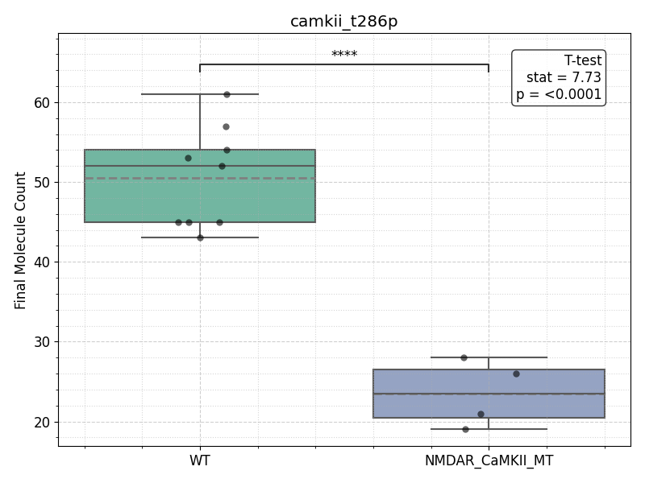
Figure 6.15: NMDAR binding is critical for promoting T286 phosphorylation of CaMKII. Individual simulation runs are shown as dots; boxes indicate the interquartile range, with solid lines denoting the median and dashed lines the mean. A two-tailed t-test revealed a highly significant reduction in T286-phosphorylated CaMKII in the NMDAR mutant (t = 7.73, p < 0.0001, ***), consistent with the proposed mechanism where NMDAR binding stabilizes CaMKII in an open conformation that favours autophosphorylation at T286.

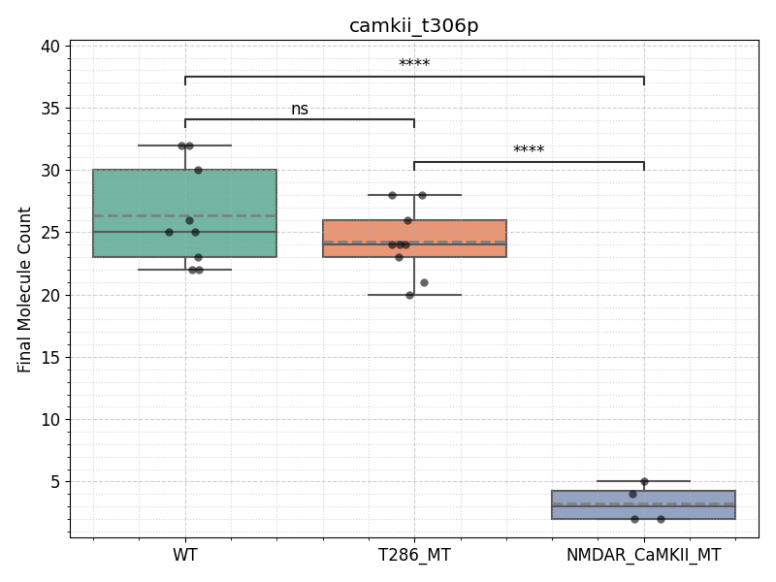
Figure 6.16: NMDAR binding is critical for T306 phosphorylation of CaMKII, while T286 phosphorylation has no significant effect. Boxplot showing final camkii_t306p molecule counts for WT, T286 mutant (T286_MT), and NMDAR/CaMKII binding mutant (NMDAR_CaMKII_MT) models. Individual simulation runs are shown as dots; boxes indicate the interquartile range, with solid lines denoting the median and dashed lines the mean. A one-way ANOVA revealed a significant overall effect (F = 77.035, p = 7.674e–10), with Tukey’s HSD post hoc test confirming significantly reduced T306 phosphorylation in the NMDAR_CaMKII_MT compared to both WT and T286_MT (***), while the difference between WT and T286_MT was not statistically significant (ns). This suggests that NMDAR-CaMKII interactions, but not T286 phosphorylation status, are critical for enabling T306 phosphorylation.

T286 phosphorylation does not influence the binding of CaMKII to NMDARs
As shown in Figure 6.17, both the T286 mutant model and the wild-type (WT) eventually plateau at 30 bound CaMKII/NMDAR complexes. This indicates that, despite the absence of T286 phosphorylation in the mutant model, the number of CaMKII subunits bound to NMDARs reaches the same final value as in the WT. This observation further strengthens the idea that NMDAR binding plays a critical role in promoting T286 phosphorylation of CaMKII, while the phosphorylation state of T286 does not influence the ability of CaMKII to bind to NMDARs. Furthermore, as observed in the WT runs above (refer back to Figure 6.11), CaMKII can bind to NMDARs in an unphosphorylated state, providing additional support for the conclusion that, in the model used here, NMDAR binding is a key driver of T286 phosphorylation but not the other way around.
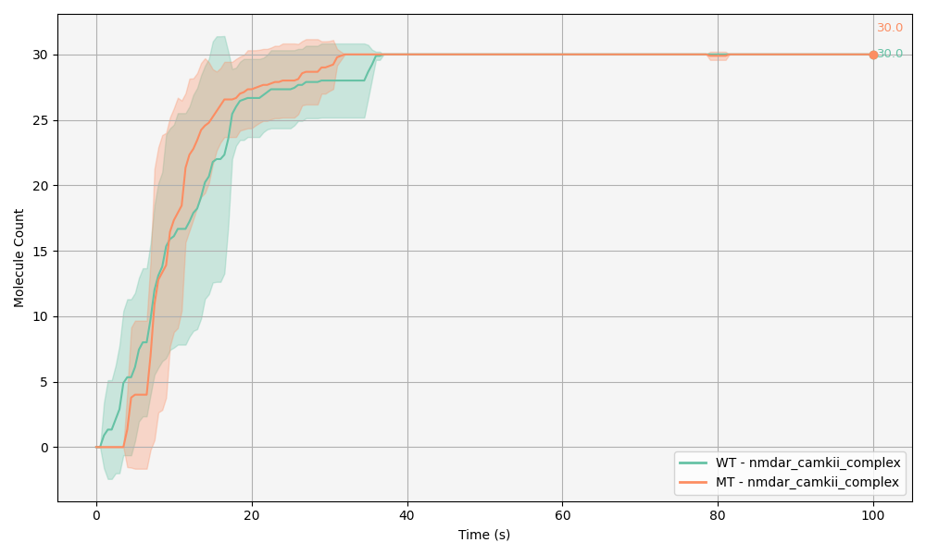
Figure 6.17: NMDAR binding reaches full saturation in both WT and NMDAR/CaMKII mutant models. Shaded areas indicate the standard deviation. Both models ultimately reach a plateau of 30 bound CaMKII/NMDAR complexes. Due to the lack of variability in the final molecule count (both reach 30 with no variance), statistical comparisons of the end-point data are not shown.

6.3 Discussion, limitations and future directions
An overarching aim of this study was to investigate how the functional states of CaMKII—particularly through its phosphorylation and binding to NMDARs—affect the stability of the CaMKII/NMDAR complex and its role in synaptic signalling. To address this, I examined how the interaction between CaMKII and NMDARs influences CaMKII activity and function, using an in silico mutation model where CaMKII–NMDAR binding is disrupted. Likewise, I explored how CaMKII phosphorylation impacts its binding to NMDARs by investigating a model in which CaMKII cannot be phosphorylated at the T286 site. The following discussion will interpret the results from these in silico mutation models, assess their relevance to the original research questions, and highlight how these findings contribute to a deeper understanding of the molecular processes underlying synaptic plasticity.
Previous studies have shown that transient CaMKII activity induces a reversible, CaM-dependent binding of GluN2B to the substrate-binding site within CaMKII’s catalytic domain. Additionally, prolonged CaMKII activation leads to a persistent interaction between GluN2B and the T286 phospho-site on CaMKII, which locks CaMKII in an active conformation. Moreover, studies have shown that even if CaM dissociates, CaMKII can remain active and have autonomous activity without CaM (Braun and Schulman 1995; S. G. Miller and Kennedy 1986; Coultrap et al. 2010; Buard et al. 2010; Chang et al. 2017). The results observed in this model are in line with these findings reported in the literature. The results show that CaMKII can maintain its open, active conformation through interactions with NMDARs, even in the absence of CaM. Notably, in the NMDAR/CaMKII MT model, there is a significant reduction in the proportion of CaMKII that remains in the open, active state when compared with both the WT and T286A MT models. This finding aligns with the literature proposal that NMDAR binding plays a critical role in stabilising CaMKII in its active conformation (K.-Ulrich Bayer et al. 2001b; K. Ulrich Bayer et al. 2006; Nicoll and Schulman 2023b).
Moreover, the NMDAR/CaMKII mutant model shows a substantial decrease in the amount of CaMKII in its open, active form when compared to both the WT and T286 mutant models. This suggests that NMDAR binding is integral to maintaining CaMKII in its open conformation. While the T286 mutation also leads to a reduction in CaMKII openness, consistent with the established role of autophosphorylation at T286 in promoting autonomous activity, the effect is notably less severe than that observed in the NMDAR-binding mutant. This aligns with prior findings indicating that CaMKII binding to GluN2B induces a conformational change that sustains kinase activity even in the absence of T286 phosphorylation.
CaMKII opening is also reduced when T286 phosphorylation is abolished, but this effect is less pronounced than in the NMDAR/CaMKII binding-deficient mutant. Previous studies have shown that CaMKII binding to GluN2B triggers a conformational change that enables the enzyme to remain autonomously active (K.-Ulrich Bayer et al. 2001b; Barcomb et al. 2016), even in the absence of T286 phosphorylation. This is consistent with the significant decrease in CaMKII open state observed in Figure 6.16 for the NMDAR/CaMKII mutant, compared to the relatively smaller effect seen in the T286A mutant. Even without T286 phosphorylation, CaMKII opening is less disrupted than when NMDAR/CaMKII binding is completely abolished. Thus, the data support a model in which NMDAR binding serves as the primary mechanism for maintaining CaMKII in its open state, while T286 phosphorylation provides a secondary stabilising influence. The more substantial loss of open CaMKII in the NMDAR/CaMKII mutant, compared to the T286 mutant, reinforces the idea that membrane anchoring to NMDARs is functionally dominant in regulating CaMKII conformational dynamics under these conditions.
In the model at hand, it appears that an entire CaMKII holoenzyme initially binds to a single NMDAR, with subsequent subunits from the same holoenzyme engaging with adjacent NMDARs. This effectively results in one holoenzyme binding to and “trapping” up to 12 NMDARs simultaneously, where we observed a stepwise increase in CaMKII binding across three phases, indicating that individual holoenzymes sequentially bind to available NMDARs (Figure 6.4 (b)). Given the structure and known conformations of the CaMKII holoenzyme, such multivalent binding across multiple receptors seems unlikely. It is more plausible that only one or possibly two subunits from a single holoenzyme engage with NMDARs, due to spatial limitations imposed by the protein’s quaternary structure (K.-Ulrich Bayer et al. 2001b; Özden et al. 2022a).
This mode of binding arises from the way reaction rules are encoded in the model, as it does not prevent multiple CaMKII subunits within a holoenzyme from binding to NMDARs simultaneously. A potential improvement for future work would be to introduce a rule where only one CaMKII subunit per holoenzyme can bind to an NMDAR, which would increase the likelihood of different CaMKII holoenzymes interacting with NMDARs. By limiting the binding to one subunit per holoenzyme, there would be more CaMKII holoenzymes available in the vicinity of NMDARs, rather than a single holoenzyme trying to bind to multiple receptors at once. This would allow for a more distributed interaction where multiple holoenzymes could engage with a set of receptors, rather than a single holoenzyme “trapping” all the receptors.
An intriguing observation in the results of this model is the emergent behaviour of CaM trapping. CaM trapping refers to the phenomenon whereby phosphorylation of CaMKII at T286 increases its affinity for CaM, preventing the dissociation of the complex (S. G. Cook et al. 2021; Goodell et al. 2017, 2017). This effect has not been explicitly encoded into the current model, as we have not specified an increased affinity for CaM upon T286 phosphorylation. Despite this, we observe that autophosphorylation at T286 does indeed promote CaM binding. Interestingly, when T286 phosphorylation is abolished, the binding of CaM is reduced. In contrast, the NMDAR/CaMKII mutant model does not show a decrease in CaM binding, likely because this mutant still retains T286 phosphorylation, which is what seems to be important for CaM binding. In summary, although the model does not explicitly incorporate the usual increase in affinity for CaM upon T286 phosphorylation, the phosphorylation event itself plays a significant role in promoting CaM binding, likely by maintaining CaMKII in its open state.
Although both T286 phosphorylation and NMDAR binding contribute to maintaining CaMKII in its open state, T286 phosphorylation appears to play a more critical role in facilitating CaM binding. This is likely due to the fact that T286 phosphorylation is leading to this emergent CaM trapping behaviour, whereas NMDAR binding keeps CaMKII in an open conformation independently of CaM. Furthermore, NMDAR binding not only stabilises the open conformation of CaMKII but also promotes further phosphorylation at T286 and T306, with the latter competing for the CaM binding site. Therefore, when T286 phosphorylation is abolished, CaM binding decreases, as the phosphorylation event at T286 is the primary mechanism that facilitates CaM binding by keeping CaMKII in its open state. In contrast, when NMDAR binding is disrupted, the main mechanism for CaM binding —T286 phosphorylation— remains intact, and as a result, CaM binding is preserved (refer back to Figure 6.13).
There is ongoing debate on the role of T306 phosphorylation in synaptic plasticity (Hanson and Schulman 1992; R. J. Colbran 1993; S. G. Cook et al. 2021). As discussed in Chapter 1, the experimental literature remains divided on whether T305/306 phosphorylation alone inhibits LTP and facilitates long-term depression LTD, or if its effects are mediated in concert with the activation of competing kinases, such as DAPK1, which play a role in regulating these bidirectional processes. In the model presented here, the majority of T306 phosphorylation is driven by NMDAR binding. This is an intriguing finding, as it may suggest that NMDAR signalling plays a critical role not only in maintaining CaMKII in an open, CaM-free conformation, but also in enabling downstream T306 phosphorylation. However, these results should be interpreted cautiously, as they could be an artefact of the model, given the way CaMKII is binding to NMDARs (one holoenzyme can bind multiple NMDARs). Future studies should consider testing the proposal that only one CaMKII subunit binds per NMDAR, as well as incorporating CaMKII’s competing kinase, DAPK1, to further regulate CaMKII binding and T306 phosphorylation. DAPK1 has been shown to directly phosphorylate CaMKII at T306 and displace it from NMDARs, suggesting it plays a critical antagonistic role in regulating CaMKII-NMDAR interactions and synaptic plasticity outcomes. Including DAPK1 would allow the model to test how kinase competition dynamically regulates CaMKII activity and subunit phosphorylation, especially under conditions favouring LTD induction.
Previous studies have shown that CaMKII binding to NMDARs can induce a conformational change that preserves CaMKII’s autonomous activity, even in the absence of T286 phosphorylation (K.-Ulrich Bayer et al. 2001b). Suggesting that CaMKII could remain active and NMDAR-bound even after dephosphorylation at T286, highlighting the critical role of NMDAR-induced CaMKII opening. However, in the current model, this scenario is not observed: CaMKII subunits bound to NMDARs consistently remain phosphorylated at T286. This discrepancy may, in part, stem from the relatively low PP1 concentration used in the model. Empirical studies report neuronal PP1 concentrations ranging from 1–10 $μ\text{M}$ (Cohen 2002), with CaMKII concentrations around 5 $μ\text{M}$, yielding a physiologically relevant ratio of approximately 5:1. In contrast, the current model uses a PP1 concentration of 0.039 $μ\text{M}$ and a CaMKII concentration of 2.36 $μ\text{M}$, resulting in a CaMKII:PP1 ratio of roughly 60:1. This may bias the system towards sustained phosphorylation and kinase dominance. Future versions of the model should consider incorporating higher PP1 concentrations to better reflect the CaMKII to PP1 ratio. Moreover, it has been suggested that PP1 binding is sterically hindered when CaM is bound to CaMKII (Pharris et al. 2019), implying that CaMKII-NMDAR complexes with unbound CaM may be more accessible to PP1. Thus, future refinements to the model could include this regulatory mechanism to account for a more detailed spatial and allosteric regulation of PP1 access, particularly in the context of CaM dissociation and subunit-specific interactions within CaMKII-NMDAR complexes.
Likewise, although the current model uses biologically plausible molecular concentrations (as discussed in Chapter 1), future adaptations of this model should consider optimising them further, especially calcium and CaMKII concentrations as they reflect lower end of reported concentrations (Brette and Destexhe 2012; Zheng, Jensen, and Rusakov 2018; Otmakhov and Lisman 2012, 2012; Lee et al. 2009; Feng, Raghavachari, and Lisman 2011). Increasing these concentrations would not only elevate total molecular outputs but also enhance the likelihood of key interactions, such as CaMKII binding to NMDARs or CaM. For example, increasing calcium concentrations could facilitate full CaM saturation and promote more extensive CaMKII phosphorylation, potentially aligning better with experimentally observed dynamics. Conversely, if increasing molecular concentrations yields no significant change in outputs, this would serve as evidence for the model’s robustness to variations in input conditions.
Furthermore, future implementations could introduce calcium pulses to enable the model to more accurately investigate how the timing, frequency, and amplitude of calcium signals influence downstream molecular interactions, such as CaM binding and CaMKII phosphorylation. In the present study, the model simulates a single calcium stimulus to initiate signalling events. Future model developments could incorporate repetitive calcium bursts—akin to the approach used by (Chang et al. 2019b)—designed to emulate theta burst stimulation, a well-established protocol for inducing LTP. Incorporating such bursts would allow for the investigation of threshold effects (e.g., how many pulses are required for full CaMKII activation and sustained LTP). It would also enable exploration of further temporal integration, a key feature of CaMKII, which responds not just to the presence of calcium signals but also to their frequency and duration, thereby shaping downstream signalling outcomes (Chang et al. 2017). As a potential direction for this future implementation, calcium pulses could be incorporated directly into the BNGL file using time-dependent functions.
In addition to the proposed biochemical refinements, future adaptations of the model could benefit from incorporating spatial visualisation using MCell’s viz_output feature in CellBlender (Gupta et al. 2018). This would allow the model to move beyond abstract molecule counts and provide an intuitive, dynamic representation of molecular interactions within a defined spatial environment. Such visualisations can help identify spatial effects—such as molecular crowding, diffusion limitations, or compartmental segregation—that may influence the behaviour of key species like CaMKII, CaM, or PP1. For example, experimental evidence has shown that mutations disrupting CaMKII binding to NMDARs reduces CaMKII accumulation at synapses following LTP induction (K.-Ulrich Bayer et al. 2001a), which could be effectively visualised and explored in future models. For example, experimental evidence has shown that mutations disrupting CaMKII binding to NMDARs reduces CaMKII accumulation at synapses following LTP induction (K.-Ulrich Bayer et al. 2001a), which could be effectively visualised and explored in future models. Although preliminary simulation runs with visual output were conducted, time constraints precluded their full integration and analysis in the present study. Nevertheless, spatial visualisation remains a valuable avenue for expanding the interpretability and realism of future CaMKII-NMDAR models.
Furthermore, future implementations could introduce calcium pulses would allow the model to more accurately explore how the timing, frequency, and amplitude of calcium signals influence downstream molecular interactions, such as CaM binding and CaMKII phosphorylation. In the current study, the model simulates the release of a single calcium stimulus to initiate signalling events. Future implementations could incorporate repetitive calcium bursts, perhaps similarly to what (Chang et al. 2019b) did, designed to emulate theta burst stimulation, which is a well established protocol for inducing LTP. Implementing calcium bursts in this form would allow the exploration of threshold effects (e.g., how many pulses are required for full CaMKII activation and sustained LTP) and would enable probing of temporal integration, a hallmark feature of CaMKII, which can decode the frequency and duration of calcium transients to determine downstream signalling outcomes.
Recent research suggests that the CaMKII/NMDAR complex may facilitate activity-dependent CaMKII incorporation into postsynaptic sites, acting as a structural seed to recruit PSD proteins and promote synapse remodelling and plasticity (K. Kim et al. 2016; Özden et al. 2022a). Ultimately, any structural CaMKII mechanism will also involve CaMKII’s interactions with filamentous (F)-actin cytoskeleton in dendritic spines. A promising future direction could be to explore the dynamic reshaping of the cytoskeleton in dendritic neurons, potentially using BioDynaMo (Biology Dynamics Modeller) (Breitwieser et al. 2021) to model these processes.
Similar to MCell, BioDynaMo is an agent-based modelling tool that enables the simulation of 3D biophysical molecular interactions (Breitwieser et al. 2021). However, unlike MCell, BioDynaMo supports dynamic geometry modelling, allowing the simulation of geometries that change in size or shape during the simulation. In contrast, MCell uses static and predefined geometries that remain fixed throughout the simulation process. For dynamic changes such as geometry growth, shrinkage, or reshaping, BioDynaMo offers significant advantages. While MCell and BioNetGen allow for the modelling of multimeric protein dynamics using a rule-based approach (which BioDynaMo lacks), BioDynaMo’s capability to model dynamic geometry is a key strength. Notably, BioNetGen can export models written in BNGL to the SBML format, enabling interoperability with BioDynaMo. This allows for the integration of BioNetGen’s rule-based modelling strengths with BioDynaMo’s advanced capabilities for dynamic geometry simulations, creating an ideal platform for modelling both molecular interactions and structural changes in the cytoskeleton.
To demonstrate the possibility of using BioDynaMo as a tool to simulate neuronal growth through formation of an actin cytoskeleton inside dendritic spines, I helped with supervision of a project that carried out by Adrian Trajlinek (Trajlinek 2022). The model works with actin filaments represented as molecular agents with cylindrical shapes. These can then be modelled to support tree-like structures that can branch out, sever, polymerize and depolymerize in similar manners to the biological equivalent. Overall, this project provided proof of concept that actin dynamics can be modelled in BioDynaMo, and further research can be developed from here onwards. Tools like MCell+CellBlender, BioDynaMo and RuleBender provide an exciting prospect of modelling how the morphology of dendritic spines changes during synaptic plasticity. Together, they provide tools to build a general-purpose platform for large-scale biological simulations.

7. Conclusion
The in silico models presented in this research suggest that NMDAR binding constitutes an early and important mechanism for maintaining CaMKII in its open, active conformation. The mode of CaMKII binding, whereby the holoenzyme anchors itself to NMDARs, underscores the potential role of its dodecameric structure as a molecular scaffold, locally organising and stabilising signalling complexes. This structural arrangement may contribute to the spatial coordination of signalling molecules during LTP, offering a potential mechanism by which CaMKII supports activity-dependent synaptic strengthening.
As outlined in the discussion, further investigations are warranted to elucidate the precise dynamics and constraints governing CaMKII–NMDAR interactions, particularly in the context of subunit accessibility and spatial organisation. Additionally, the simulations revealed distinct contributions of NMDAR binding and T286 autophosphorylation to CaM binding dynamics: while NMDAR-mediated activation appears largely independent of CaM, T286 phosphorylation facilitates and stabilises CaM association with CaMKII. Finally, the findings indicate that NMDAR binding not only maintains CaMKII in an open conformation but also promotes phosphorylation at T286 and T306 sites. These results collectively support a model in which NMDARs serve as pivotal regulators of CaMKII activation, both structurally and biochemically.
In addition to the biological findings, this PhD has placed considerable emphasis on the principles of reproducibility, research integrity, and ethical responsibility. These values were integrated throughout the research process, from model development and data analysis to documentation and dissemination. In particular, this work serves as a case study in how computational neuroscience can be conducted with a strong commitment to transparency and responsible research practices.
Issues such as data hazard classification, future societal implications, and ethical foresight were actively considered and discussed in detail. These reflections highlight that, while computational modelling may seem distant from direct experimental risks, it too carries responsibilities. Addressing these challenges is not without complexity or time costs, but as with all rigorous science, I believe the investment in doing so with integrity is worthwhile.It is my hope that this thesis contributes not only to the scientific understanding of CaMKII–NMDAR signalling in memory-related processes; but also offers a useful example for how to embed reproducibility and ethics into research. Reproducible and ethically grounded research should not be viewed as an idealistic add-on, but as an integral part of good science, something achievable, impactful, and worth striving for. This has been the guiding principle throughout this PhD, and it is what I have consistently aimed to uphold.

8. List of publications and presentations resulting from this PhD
The following publications have emerged as a direct outcome of the research conducted during this PhD. They reflect the various strands of work undertaken, ranging from the development and application of computational models to contributions in open science and data ethics. Together, they demonstrate the interdisciplinary impact of the project and the collaborative efforts that supported its progress.
- Román García, S., Welsh, C., Di Cara, N. H., Sterratt, D., Romano, N., & Stefan, M. I. (2025). Data Hazards as an ethical toolkit for neuroscience.
Neuroethics, 18, 15.
DOI: 10.1007/s12152-024-09580-3
- Zelenka, N., Di Cara, N. H., Bennet, E., Clatworthy, P., Day, H., Kherroubi Garcia, I., Román García, S., Hanschke, V. A., & Kuwertz, E. S. (2025). Data Hazards: An open-source vocabulary of ethical hazards for data-intensive projects.
Journal of Responsible Technology, 21, 100110.
DOI: 10.1016/j.jrt.2025.100110
- Fong, P., Román García, S., Stefan, M. I., & Sterratt, D. C. (2024). In silico identification and modelling of FDA-approved drugs targeting T-type calcium channels [Preprint]. bioRxiv. DOI: 10.1101/2024.09.27.615366
- Welsh, C., Román García, S., Barnett, G. C., & Jena, R. (2024). Democratising artificial intelligence in healthcare: community-driven approaches for ethical solutions.
Future Healthcare Journal
DOI: 10.1016/j.fhj.2024.100165
- Welsh, C., Román García, S., Zelenka, N. & Turing Way Community (2023). Data Hazards Chapter. In The Turing Way: A handbook for reproducible, ethical and collaborative data science.
Co-authored and available at: https://book.the-turing-way.org/ethical-research/data-hazards
- Román García, S., & Steele. (2023). Open Science & Reproducibility: The Turing Way Workshop.
Presented at the “Data Science Perspectives” PhD conference, Newcastle University.
DOI: 10.5281/zenodo.7704563
- Román García, S., & Welsh, C. (2023). Data Hazards, Ethics and Reproducibility Hybrid Symposium. Co-organised and facilitated event, Alan Turing Institute, London (March 2023). Theme: “Aligning our values with our research: thinking about how to embed ethics and reproducibility into our work.” Materials available in GitHub
- Román García, S. (2023). What Data Hazards apply to my PhD? Poster presented at AI UK 2023, London. Volunteered and presented a summary of PhD research to prompt discussion on applicable Data Hazards. Materials available in GitHub
- Román García, S. (2023). Ethical Standards and Reproducibility of Computer Models in Neurobiology.
Presented as part of Open Life Sciences cohort 6.
Watch the recording
- Román García, S. (2023). Enrichment Scheme Reflections.
Women in High Performance Computing blog.
Read the post
- Román García, S., Stefan, M., Hanschke, V., Di Cara, N., & Zelenka, N. (2022). Data Hazard Workshops. Materials available in GitHub Presented at Data Hazards, Ethics and Reproducibility One-Day Symposium, Alan Turing Institute, London Presented at COMBINE and ICSB Conferences 2022, Berlin.
- Román García, S., Sterratt, D., & Stefan, M. I. (2022). Thinking about Ethics in (Computer) Science. Edinburgh College of Medicine and Veterinary Medicine Good Practice Showcase
DOI: 10.5281/zenodo.6973796

References
Abraham, W. C., T. V. P. Bliss, G. L. Collingridge, and R. G. M. Morris. 2024. “Long-Term Potentiation: 50 Years on: Past, Present and Future.” Philosophical Transactions of the Royal Society B: Biological Sciences 379 (1906): 20230218. https://doi.org/10.1098/rstb.2023.0218.
Abraham, Wickliffe C., Owen D. Jones, and David L. Glanzman. 2019. “Is Plasticity of Synapses the Mechanism of Long-Term Memory Storage?” Npj Sci. Learn. 4 (1): 1–10. https://doi.org/10.1038/s41539-019-0048-y.
Abraham, Wickliffe C., and Joanna M. Williams. 2003. “Properties and Mechanisms of LTP Maintenance.” Neuroscientist 9 (6): 463–74. https://doi.org/10.1177/1073858403259119.
———. 2008. “LTP Maintenance and Its Protein Synthesis-Dependence.” Neurobiology of Learning and Memory, Protein Synthesis and Memory, 89 (3): 260–68. https://doi.org/10.1016/j.nlm.2007.10.001.
Aert, Robbie C. M. van, Jelte M. Wicherts, and Marcel A. L. M. van Assen. 2019. “Publication Bias Examined in Meta-Analyses from Psychology and Medicine: A Meta-Meta-Analysis.” PLOS ONE 14 (4): e0215052. https://doi.org/10.1371/journal.pone.0215052.
Afonso, José, Rodrigo Ramirez-Campillo, Filipe Manuel Clemente, Fionn Cléirigh Büttner, and Renato Andrade. 2024. “The Perils of Misinterpreting and Misusing ‘Publication Bias’ in Meta-analyses: An Education Review on Funnel Plot-Based Methods.” Sports Med 54 (2): 257–69. https://doi.org/10.1007/s40279-023-01927-9.
Ahmed, Raheel, Xiang-ming Zha, Steven H. Green, and Michael E. Dailey. 2006. “Synaptic Activity and F-actin Coordinately Regulate CaMKIIα Localization to Dendritic Postsynaptic Sites in Developing Hippocampal Slices.” Molecular and Cellular Neuroscience 31 (1): 37–51. https://doi.org/10.1016/j.mcn.2005.08.020.
Akashi, Kaori, Toshikazu Kakizaki, Haruyuki Kamiya, Masahiro Fukaya, Miwako Yamasaki, Manabu Abe, Rie Natsume, Masahiko Watanabe, and Kenji Sakimura. 2009. “NMDA Receptor GluN2B (GluRε2/NR2B) Subunit Is Crucial for Channel Function, Postsynaptic Macromolecular Organization, and Actin Cytoskeleton at Hippocampal CA3 Synapses.” J. Neurosci. 29 (35): 10869–82. https://doi.org/10.1523/JNEUROSCI.5531-08.2009.
Aksnes, Dag W., Liv Langfeldt, and Paul Wouters. 2019. “Citations, Citation Indicators, and Research Quality: An Overview of Basic Concepts and Theories.” SAGE Open 9 (1): 2158244019829575. https://doi.org/10.1177/2158244019829575.
Alkadhi, Karim A. 2021. “NMDA Receptor-Independent LTP in Mammalian Nervous System.” Progress in Neurobiology 200 (May): 101986. https://doi.org/10.1016/j.pneurobio.2020.101986.
Allaire, J. J., Charles Teague, Carlos Scheidegger, Yihui Xie, Christophe Dervieux, and Gordon Woodhull. 2024. “Quarto.” https://doi.org/10.5281/zenodo.5960048.
Amutuhaire, Tibelius. 2022. “The Reality of the ‘Publish or Perish’ Concept, Perspectives from the Global South.” Pub Res Q 38 (2): 281–94. https://doi.org/10.1007/s12109-022-09879-0.
ANGELL, MARCIA. 1986. “Publish or Perish: A Proposal.” Ann Intern Med 104 (2): 261–62. https://doi.org/10.7326/0003-4819-104-2-261.
Aou, S., X.-L. Li, A.-J. Li, Y. Oomura, T. Shiraishi, K. Sasaki, T. Imamura, and M. J. Wayner. 2003. “Orexin-A (Hypocretin-1) Impairs Morris Water Maze Performance and CA1-Schaffer Collateral Long-Term Potentiation in Rats.” Neuroscience 119 (4): 1221–28. https://doi.org/10.1016/s0306-4522(02)00745-5.
Asciutto, Eliana K., Sergio Pantano, and Ignacio J. General. 2021a. “Physical Interactions Driving the Activation/Inhibition of Calcium/Calmodulin Dependent Protein Kinase II.” Journal of Molecular Graphics and Modelling 105 (June): 107875. https://doi.org/10.1016/j.jmgm.2021.107875.
———. 2021b. “Physical Interactions Driving the Activation/Inhibition of Calcium/Calmodulin Dependent Protein Kinase II.” Journal of Molecular Graphics and Modelling 105 (June): 107875. https://doi.org/10.1016/j.jmgm.2021.107875.
Atkins, D. L., T. Ball, T. L. Graves, and A. Mockus. 2002. “Using Version Control Data to Evaluate the Impact of Software Tools: A Case Study of the Version Editor.” IEEE Transactions on Software Engineering 28 (7): 625–37. https://doi.org/10.1109/TSE.2002.1019478.
Baker, Monya. 2016. “1,500 Scientists Lift the Lid on Reproducibility.” Nature 533 (7604, 7604): 452–54. https://doi.org/10.1038/533452a.
Balaur, Irina, David P. Nickerson, Danielle Welter, Judith A. H. Wodke, Francois Ancien, Tom Gebhardt, Valentin Grouès, et al. 2025. “FAIRification of Computational Models in Biology.” March 24, 2025. https://doi.org/10.1101/2025.03.21.644517.
Baltaci, Saltuk Bugra, Rasim Mogulkoc, and Abdulkerim Kasim Baltaci. 2019. “Molecular Mechanisms of Early and Late LTP.” Neurochem Res 44 (2): 281–96. https://doi.org/10.1007/s11064-018-2695-4.
Bannerman, D. M., M. A. Good, S. P. Butcher, M. Ramsay, and R. G. M. Morris. 1995. “Distinct Components of Spatial Learning Revealed by Prior Training and NMDA Receptor Blockade.” Nature 378 (6553): 182–86. https://doi.org/10.1038/378182a0.
Barba, Lorena A. 2018. “Terminologies for Reproducible Research.” February 9, 2018. https://doi.org/10.48550/arXiv.1802.03311.
Barcomb, Kelsey, Isabelle Buard, Steven J. Coultrap, Jacqueline R. Kulbe, Heather O’Leary, Timothy A. Benke, and K. Ulrich Bayer. 2014. “Autonomous CaMKII Requires Further Stimulation by Ca2+/Calmodulin for Enhancing Synaptic Strength.” FASEB J 28 (8): 3810–19. https://doi.org/10.1096/fj.14-250407.
Barcomb, Kelsey, Johannes W. Hell, Tim A. Benke, and K. Ulrich Bayer. 2016. “The CaMKII/GluN2B Protein Interaction Maintains Synaptic Strength *.” Journal of Biological Chemistry 291 (31): 16082–89. https://doi.org/10.1074/jbc.M116.734822.
Barria, Andres, and Roberto Malinow. 2005. “NMDA Receptor Subunit Composition Controls Synaptic Plasticity by Regulating Binding to CaMKII.” Neuron 48 (2): 289–301. https://doi.org/10.1016/j.neuron.2005.08.034.
Bar-Shira, Ossnat, Ronnie Maor, and Gal Chechik. 2015. “Gene Expression Switching of Receptor Subunits in Human Brain Development.” PLOS Computational Biology 11 (12): e1004559. https://doi.org/10.1371/journal.pcbi.1004559.
Bartocci, Ezio, and Pietro Lió. 2016. “Computational Modeling, Formal Analysis, and Tools for Systems Biology.” PLOS Computational Biology 12 (1): e1004591. https://doi.org/10.1371/journal.pcbi.1004591.
Bartol, Thomas M., Daniel X. Keller, Justin P. Kinney, Chandrajit L. Bajaj, Kristen M. Harris, Terrence J. Sejnowski, and Mary B. Kennedy. 2015. “Computational Reconstitution of Spine Calcium Transients from Individual Proteins.” Frontiers in Synaptic Neuroscience 7. https://www.frontiersin.org/articles/10.3389/fnsyn.2015.00017.
Bartol, Thomas M., Mariam Ordyan, Terrence J. Sejnowski, Padmini Rangamani, and Mary B. Kennedy. 2024. “A Spatial Model of Autophosphorylation of CaMKII in a Glutamatergic Spine Suggests a Network-Driven Kinetic Mechanism for Bistable Changes in Synaptic Strength.” February 2, 2024. https://doi.org/10.1101/2024.02.02.578696.
Bartol, Thomas M., and Joel R Stiles. 2000. Monte Carlo Methods for Simulating Realistic Synaptic Microphysiology Using MCell. Vol. chapter 4. CRC Press. https://books.google.com?id=8TLpBwAAQBAJ.
Bartolomeis, Andrea de, and Germano Fiore. 2004. “Postsynaptic Density Scaffolding Proteins at Excitatory Synapse and Disorders of Synaptic Plasticity: Implications for Human Behavior Pathologies.” In International Review of Neurobiology, 59:221–54. Disorders of Synaptic Plasticity and Schizophrenia. Academic Press. https://doi.org/10.1016/S0074-7742(04)59009-8.
Bausell, R. Barker. 2021. The Problem with Science: The Reproducibility Crisis and What to Do About It. Oxford University Press. https://books.google.com?id=oHEWEAAAQBAJ.
Bayer, K. Ulrich, Paul De Koninck, and Howard Schulman. 2002. “Alternative Splicing Modulates the Frequency‐dependent Response of CaMKII to Ca2+ Oscillations.” The EMBO Journal 21 (14): 3590–97. https://doi.org/10.1093/emboj/cdf360.
Bayer, K. Ulrich, Eric LeBel, Greg L. McDonald, Heather O’Leary, Howard Schulman, and Paul De Koninck. 2006. “Transition from Reversible to Persistent Binding of CaMKII to Postsynaptic Sites and NR2B.” J Neurosci 26 (4): 1164–74. https://doi.org/10.1523/JNEUROSCI.3116-05.2006.
Bayer, K. Ulrich, and Howard Schulman. 2019. “CaM Kinase: Still Inspiring at 40.” Neuron 103 (3): 380–94. https://doi.org/10.1016/j.neuron.2019.05.033.
Bayer, Karl Ulrich, and Karl Peter Giese. 2024. “A Revised View of the Role of CaMKII in Learning and Memory.” Nat Neurosci, November, 1–11. https://doi.org/10.1038/s41593-024-01809-x.
Bayer, K.-Ulrich, Paul De Koninck, A. Soren Leonard, Johannes W. Hell, and Howard Schulman. 2001b. “Interaction with the NMDA Receptor Locks CaMKII in an Active Conformation.” Nature 411 (6839): 801–5. https://doi.org/10.1038/35081080.
———. 2001a. “Interaction with the NMDA Receptor Locks CaMKII in an Active Conformation.” Nature 411 (6839): 801–5. https://doi.org/10.1038/35081080.
Beck, Heinz, Ivan V. Goussakov, Ailing Lie, Christoph Helmstaedter, and Christian E. Elger. 2000. “Synaptic Plasticity in the Human Dentate Gyrus.” J. Neurosci. 20 (18): 7080–86. https://doi.org/10.1523/JNEUROSCI.20-18-07080.2000.
Bekenstein, Jonathan W., and Eric W. Lothman. 1991. “An in Vivo Study of the Ontogeny of Long-Term Potentiation (LTP) in the CA1 Region and in the Dentate Gyrus of the Rat Hippocampal Formation.” Developmental Brain Research 63 (1): 245–51. https://doi.org/10.1016/0165-3806(91)90084-V.
Belmeguenai, Amor, and Christian Hansel. 2005. “A Role for Protein Phosphatases 1, 2A, and 2B in Cerebellar Long-Term Potentiation.” J. Neurosci. 25 (46): 10768–72. https://doi.org/10.1523/JNEUROSCI.2876-05.2005.
Bergmann, Frank T., Richard Adams, Stuart Moodie, Jonathan Cooper, Mihai Glont, Martin Golebiewski, Michael Hucka, et al. 2014. “COMBINE Archive and OMEX Format: One File to Share All Information to Reproduce a Modeling Project.” BMC Bioinformatics 15 (1): 369. https://doi.org/10.1186/s12859-014-0369-z.
Besozzi, Daniela. 2016. “Reaction-Based Models of Biochemical Networks.” In Pursuit of the Universal, edited by Arnold Beckmann, Laurent Bienvenu, and Nataša Jonoska, 24–34. Cham: Springer International Publishing. https://doi.org/10.1007/978-3-319-40189-8_3.
Bhandari, Mohit, Jason W. Busse, Dianne Jackowski, Victor M. Montori, Holger Schünemann, Sheila Sprague, Derek Mears, Emil H. Schemitsch, Dianne Heels-Ansdell, and P. J. Devereaux. 2004. “Association Between Industry Funding and Statistically Significant Pro-Industry Findings in Medical and Surgical Randomized Trials.” CMAJ 170 (4): 477–80. https://www.cmaj.ca/content/170/4/477.
Bhattacharyya, Moitrayee, Deepti Karandur, and John Kuriyan. 2020. “Structural Insights into the Regulation of Ca2+/Calmodulin-Dependent Protein Kinase II (CaMKII).” Cold Spring Harb Perspect Biol 12 (6): a035147. https://doi.org/10.1101/cshperspect.a035147.
Bhattacharyya, Moitrayee, Young Kwang Lee, Serena Muratcioglu, Baiyu Qiu, Priya Nyayapati, Howard Schulman, Jay T Groves, and John Kuriyan. 2020. “Flexible Linkers in CaMKII Control the Balance Between Activating and Inhibitory Autophosphorylation.” Edited by Tony Hunter, Jonathan A Cooper, John D Scott, and Stefan Knapp. eLife 9 (March): e53670. https://doi.org/10.7554/eLife.53670.
“Biochemical Principles Underlying the Stable Maintenance of LTP by the CaMKII/NMDAR Complex.” 2015. Brain Research 1621 (September): 51–61. https://doi.org/10.1016/j.brainres.2014.12.010.
Birhane, Abeba, and Olivia Guest. 2020. “Towards Decolonising Computational Sciences.” September 29, 2020. https://doi.org/10.48550/arXiv.2009.14258.
Björk, Bo-Christer, Mikael Laakso, Patrik Welling, and Patrik Paetau. 2014. “Anatomy of Green Open Access.” Journal of the Association for Information Science and Technology 65 (2): 237–50. https://doi.org/10.1002/asi.22963.
Błażewicz, Jacek, Piotr Formanowicz, and Marta Kasprzak. 2005. “Selected Combinatorial Problems of Computational Biology.” European Journal of Operational Research 161 (3): 585–97. https://doi.org/10.1016/j.ejor.2003.10.054.
Bliss, T. V. P., and G. L. Collingridge. 1993. “A Synaptic Model of Memory: Long-Term Potentiation in the Hippocampus.” Nature 361 (6407): 31–39. https://doi.org/10.1038/361031a0.
Bliss, T. V. P., G. L. Collingridge, R. G. M. Morris, and Wickliffe C. Abraham. 2003. “How Long Will Long-Term Potentiation Last?” Philosophical Transactions of the Royal Society of London. Series B: Biological Sciences 358 (1432): 735–44. https://doi.org/10.1098/rstb.2002.1222.
Bliss, T. V. P., and A. R. Gardner-Medwin. 1973. “Long-Lasting Potentiation of Synaptic Transmission in the Dentate Area of the Unanaesthetized Rabbit Following Stimulation of the Perforant Path.” The Journal of Physiology 232 (2): 357–74. https://doi.org/10.1113/jphysiol.1973.sp010274.
Bliss, T. V. P., and T. Lømo. 1973. “Long-Lasting Potentiation of Synaptic Transmission in the Dentate Area of the Anaesthetized Rabbit Following Stimulation of the Perforant Path.” The Journal of Physiology 232 (2): 331–56. https://doi.org/10.1113/jphysiol.1973.sp010273.
Bliss, Tim V. P., Graham L. Collingridge, Richard G. M. Morris, and Klaus G. Reymann. 2018. “Long-Term Potentiation in the Hippocampus: Discovery, Mechanisms and Function.” Neuroforum 24 (3): A103–20. https://doi.org/10.1515/nf-2017-A059.
Boda, Phillip Andrew, Nusbaum, and Saili S. and Kulkarni. 2022. “From ‘What Is’ Toward ‘What If’ Through Intersectionality: Problematizing Ableist Erasures and Coloniality in Racially Just Research.” International Journal of Research & Method in Education 45 (4): 356–69. https://doi.org/10.1080/1743727X.2022.2054981.
Bodenreider, Olivier, and Robert Stevens. 2006. “Bio-Ontologies: Current Trends and Future Directions.” Briefings in Bioinformatics 7 (3): 256–74. https://doi.org/10.1093/bib/bbl027.
Borovac, Jelena, Miquel Bosch, and Kenichi Okamoto. 2018. “Regulation of Actin Dynamics During Structural Plasticity of Dendritic Spines: Signaling Messengers and Actin-Binding Proteins.” Molecular and Cellular Neuroscience, Membrane Trafficking and Cytoskeletal Dynamics in Neuronal Function, 91 (September): 122–30. https://doi.org/10.1016/j.mcn.2018.07.001.
Borrego, Ángel. 2023. “Article Processing Charges for Open Access Journal Publishing: A Review.” Learned Publishing 36 (3): 359–78. https://doi.org/10.1002/leap.1558.
Bortolotto, Z. A., and G. L. Collingridge. 1993. “Characterisation of LTP Induced by the Activation of Glutamate Metabotropic Receptors in Area CA1 of the Hippocampus.” Neuropharmacology 32 (1): 1–9. https://doi.org/10.1016/0028-3908(93)90123-k.
Bortolotto, Z. A., S. M. Fitzjohn, and G. L. Collingridge. 1999. “Roles of Metabotropic Glutamate Receptors in LTP and LTD in the Hippocampus.” Curr Opin Neurobiol 9 (3): 299–304. https://doi.org/10.1016/s0959-4388(99)80044-0.
Bossuyt, Julie, and Donald M. Bers. 2013. “Visualizing CaMKII and CaM Activity: A Paradigm of Compartmentalized Signaling.” J Mol Med 91 (8): 907–16. https://doi.org/10.1007/s00109-013-1060-y.
Boutillier, Pierre, Mutaamba Maasha, Xing Li, Héctor F Medina-Abarca, Jean Krivine, Jérôme Feret, Ioana Cristescu, Angus G Forbes, and Walter Fontana. 2018. “The Kappa Platform for Rule-Based Modeling.” Bioinformatics 34 (13): i583–92. https://doi.org/10.1093/bioinformatics/bty272.
Branch, Haley A., Amanda N. Klingler, Kelsey J. R. P. Byers, Aaron Panofsky, and Danielle Peers. 2022. “Discussions of the ‘Not So Fit’: How Ableism Limits Diverse Thought and Investigative Potential in Evolutionary Biology.” The American Naturalist 200 (1): 101–13. https://doi.org/10.1086/720003.
Braun, A. P., and H. Schulman. 1995. “The Multifunctional Calcium/Calmodulin-Dependent Protein Kinase: From Form to Function.” Annu Rev Physiol 57: 417–45. https://doi.org/10.1146/annurev.ph.57.030195.002221.
Breitwieser, Lukas, Ahmad Hesam, Jean de Montigny, Vasileios Vavourakis, Alexandros Iosif, Jack Jennings, Marcus Kaiser, et al. 2021. “BioDynaMo: A Modular Platform for High-Performance Agent-Based Simulation.” Bioinformatics 38 (2): 453–60. https://doi.org/10.1093/bioinformatics/btab649.
Brette, Romain, and Alain Destexhe. 2012. Handbook of Neural Activity Measurement. Cambridge University Press. https://books.google.com?id=YLyGmfVuBsIC.
Brini, Marisa, Tito Calì, Denis Ottolini, and Ernesto Carafoli. 2013. “Intracellular Calcium Homeostasis and Signaling.” In Metallomics and the Cell, edited by Lucia Banci, 119–68. Dordrecht: Springer Netherlands. https://doi.org/10.1007/978-94-007-5561-1_5.
Brochhausen, M., A. Burgun, W. Ceusters, A. Hasman, T. Y. Leong, M. Musen, J. L. Oliveira, M. Peleg, A. Rector, and S. Schulz. 2018. “Discussion of ‘Biomedical Ontologies: Toward Scientific Debate’.” Methods of Information in Medicine 50 (January): 217–36. https://doi.org/10.1055/s-0038-1625243.
Brocke, Lihi, Lillian W. Chiang, Paul D. Wagner, and Howard Schulman. 1999. “Functional Implications of the Subunit Composition of Neuronal CaM Kinase II *.” Journal of Biological Chemistry 274 (32): 22713–22. https://doi.org/10.1074/jbc.274.32.22713.
Brodland, G. Wayne. 2015. “How Computational Models Can Help Unlock Biological Systems.” Seminars in Cell & Developmental Biology, Coding and non-coding RNAs & Mammalian development, 47–48 (December): 62–73. https://doi.org/10.1016/j.semcdb.2015.07.001.
Brown, Carolyn Nicole, and Karl Ulrich Bayer. 2024. “Studying CaMKII: Tools and Standards.” Cell Reports 43 (4). https://doi.org/10.1016/j.celrep.2024.113982.
Brown, Joshua C., Edmund S. Higgins, and Mark S. George. 2022. “Synaptic Plasticity 101: The Story of the AMPA Receptor for the Brain Stimulation Practitioner.” Neuromodulation: Technology at the Neural Interface 25 (8): 1289–98. https://doi.org/10.1016/j.neurom.2021.09.003.
Buard, Isabelle, Steven J. Coultrap, Ronald K. Freund, Yong-Seok Lee, Mark L. Dell’Acqua, Alcino J. Silva, and K. Ulrich Bayer. 2010. “CaMKII ‘Autonomy’ Is Required for Initiating But Not for Maintaining Neuronal Long-Term Information Storage.” J. Neurosci. 30 (24): 8214–20. https://doi.org/10.1523/JNEUROSCI.1469-10.2010.
Buonarati, Olivia R., Adam P. Miller, Steven J. Coultrap, K. Ulrich Bayer, and Steve L. Reichow. 2021. “Conserved and Divergent Features of Neuronal CaMKII Holoenzyme Structure, Function, and High-Order Assembly.” Cell Rep 37 (13): 110168. https://doi.org/10.1016/j.celrep.2021.110168.
Burgess, Neil, Eleanor A. Maguire, and John O’Keefe. 2002. “The Human Hippocampus and Spatial and Episodic Memory.” Neuron 35 (4): 625–41. https://doi.org/10.1016/S0896-6273(02)00830-9.
Byrne, Michael D. 2013. “How Many Times Should a Stochastic Model Be Run? An Approach Based on Confidence Intervals.” In Proceedings of the 12th International Conference on Cognitive Modeling.
Cameron, Heather A., and Lucas R. Glover. 2015. “Adult Neurogenesis: Beyond Learning and Memory*.” Annual Review of Psychology 66 (January): 53–81. https://doi.org/10.1146/annurev-psych-010814-015006.
Campbell, Corbin M., Marisol Jimenez, and Christine Arlene N. Arrozal. 2019. “Prestige or Education: College Teaching and Rigor of Courses in Prestigious and Non-Prestigious Institutions in the U.S.” High Educ 77 (4): 717–38. https://doi.org/10.1007/s10734-018-0297-3.
Carlson, Kevin D., and Andrew O. Herdman. 2012. “Understanding the Impact of Convergent Validity on Research Results.” Organizational Research Methods 15 (1): 17–32. https://doi.org/10.1177/1094428110392383.
Castro Torres, Andrés F., and Diego Alburez-Gutierrez. 2022. “North and South: Naming Practices and the Hidden Dimension of Global Disparities in Knowledge Production.” Proceedings of the National Academy of Sciences 119 (10): e2119373119. https://doi.org/10.1073/pnas.2119373119.
Cavus, I., and T. Teyler. 1996. “Two Forms of Long-Term Potentiation in Area CA1 Activate Different Signal Transduction Cascades.” Journal of Neurophysiology 76 (5): 3038–47. https://doi.org/10.1152/jn.1996.76.5.3038.
Chan, An-Wen, Fujian Song, Andrew Vickers, Tom Jefferson, Kay Dickersin, Peter C. Gøtzsche, Harlan M. Krumholz, Davina Ghersi, and H. Bart van der Worp. 2014. “Increasing Value and Reducing Waste: Addressing Inaccessible Research.” The Lancet 383 (9913): 257–66. https://doi.org/10.1016/S0140-6736(13)62296-5.
Chang, Jui-Yun, Yoshihisa Nakahata, Yuki Hayano, and Ryohei Yasuda. 2019a. “Mechanisms of Ca2+/Calmodulin-Dependent Kinase II Activation in Single Dendritic Spines.” Nat Commun 10 (1): 2784. https://doi.org/10.1038/s41467-019-10694-z.
———. 2019b. “Mechanisms of Ca2+/Calmodulin-Dependent Kinase II Activation in Single Dendritic Spines.” Nat Commun 10 (1): 2784. https://doi.org/10.1038/s41467-019-10694-z.
Chang, Jui-Yun, Paula Parra-Bueno, Tal Laviv, Erzsebet M. Szatmari, Seok-Jin R. Lee, and Ryohei Yasuda. 2017. “CaMKII Autophosphorylation Is Necessary for Optimal Integration of Ca2+ Signals During LTP Induction, but Not Maintenance.” Neuron 94 (4): 800–808.e4. https://doi.org/10.1016/j.neuron.2017.04.041.
Changeux, Jean-Pierre, and Stuart J. Edelstein. 2005. “Allosteric Mechanisms of Signal Transduction.” Science 308 (5727): 1424–28. https://doi.org/10.1126/science.1108595.
Chao, Luke H., Margaret M. Stratton, Il-Hyung Lee, Oren S. Rosenberg, Joshua Levitz, Daniel J. Mandell, Tanja Kortemme, Jay T. Groves, Howard Schulman, and John Kuriyan. 2011b. “A Mechanism for Tunable Autoinhibition in the Structure of a Human Ca2+/Calmodulin- Dependent Kinase II Holoenzyme.” Cell 146 (5): 732–45. https://doi.org/10.1016/j.cell.2011.07.038.
———. 2011a. “A Mechanism for Tunable Autoinhibition in the Structure of a Human Ca2+/Calmodulin- Dependent Kinase II Holoenzyme.” Cell 146 (5): 732–45. https://doi.org/10.1016/j.cell.2011.07.038.
Chater, Thomas E., and Yukiko Goda. 2014. “The Role of AMPA Receptors in Postsynaptic Mechanisms of Synaptic Plasticity.” Front. Cell. Neurosci. 8 (November). https://doi.org/10.3389/fncel.2014.00401.
Chen, W R, S Lee, K Kato, D D Spencer, G M Shepherd, and A Williamson. 1996. “Long-Term Modifications of Synaptic Efficacy in the Human Inferior and Middle Temporal Cortex.” Proceedings of the National Academy of Sciences 93 (15): 8011–15. https://doi.org/10.1073/pnas.93.15.8011.
Chen, Xiaobing, Lucia Vinade, Richard D. Leapman, Jennifer D. Petersen, Terunaga Nakagawa, Terry M. Phillips, Morgan Sheng, and Thomas S. Reese. 2005. “Mass of the Postsynaptic Density and Enumeration of Three Key Molecules.” Proceedings of the National Academy of Sciences 102 (32): 11551–56. https://doi.org/10.1073/pnas.0505359102.
Chen, Xiumin, Qixu Cai, Jing Zhou, Samuel J. Pleasure, Howard Schulman, Mingjie Zhang, and Roger A. Nicoll. 2024. “CaMKII Autophosphorylation Is the Only Enzymatic Event Required for Synaptic Memory.” Proceedings of the National Academy of Sciences 121 (26): e2402783121. https://doi.org/10.1073/pnas.2402783121.
Chidambaram, Saravana Babu, A. G. Rathipriya, Srinivasa Rao Bolla, Abid Bhat, Bipul Ray, Arehally Marappa Mahalakshmi, Thamilarasan Manivasagam, et al. 2019. “Dendritic Spines: Revisiting the Physiological Role.” Progress in Neuro-Psychopharmacology and Biological Psychiatry 92 (June): 161–93. https://doi.org/10.1016/j.pnpbp.2019.01.005.
Choquet, Daniel. 2010. “Fast AMPAR Trafficking for a High-Frequency Synaptic Transmission.” European Journal of Neuroscience 32 (2): 250–60. https://doi.org/10.1111/j.1460-9568.2010.07350.x.
Chylek, Lily A., Leonard A. Harris, Chang-Shung Tung, James R. Faeder, Carlos F. Lopez, and William S. Hlavacek. 2014. “Rule-Based Modeling: A Computational Approach for Studying Biomolecular Site Dynamics in Cell Signaling Systems.” WIREs Systems Biology and Medicine 6 (1): 13–36. https://doi.org/10.1002/wsbm.1245.
Chylek, Lily A, Leonard A Harris, James R Faeder, and William S Hlavacek. 2015. “Modeling for (Physical) Biologists: An Introduction to the Rule-Based Approach.” Phys. Biol. 12 (4): 045007. https://doi.org/10.1088/1478-3975/12/4/045007.
Ciabarra, A. M., J. M. Sullivan, L. G. Gahn, G. Pecht, S. Heinemann, and K. A. Sevarino. 1995. “Cloning and Characterization of Chi-1: A Developmentally Regulated Member of a Novel Class of the Ionotropic Glutamate Receptor Family.” J Neurosci 15 (10): 6498–508. https://doi.org/10.1523/JNEUROSCI.15-10-06498.1995.
Claerbout, Jon F., and Martin Karrenbach. 1992. “Electronic Documents Give Reproducible Research a New Meaning.” In SEG Technical Program Expanded Abstracts 1992, 601–4. SEG Technical Program Expanded Abstracts. Society of Exploration Geophysicists. https://doi.org/10.1190/1.1822162.
Cohen, Patricia T. W. 1997. “Novel Protein Serine/Threonine Phosphatases: Variety Is the Spice of Life.” Trends in Biochemical Sciences 22 (7): 245–51. https://doi.org/10.1016/S0968-0004(97)01060-8.
———. 2002. “Protein Phosphatase 1–Targeted in Many Directions.” J Cell Sci 115 (January): 241–56. https://doi.org/10.1242/jcs.115.2.241.
Colbran, R. J. 1993. “Inactivation of Ca2+/Calmodulin-Dependent Protein Kinase II by Basal Autophosphorylation.” J Biol Chem 268 (10): 7163–70.
Colbran, Roger J. 2004. “Protein Phosphatases and Calcium/Calmodulin-Dependent Protein Kinase II-Dependent Synaptic Plasticity.” J. Neurosci. 24 (39): 8404–9. https://doi.org/10.1523/JNEUROSCI.3602-04.2004.
Cole, Timothy W., Myung-Ja K. Han, Maria Janina Sarol, Monika Biel, and David Maus. 2017-03-20Z. “Using Linked Open Data to Enhance the Discoverability, Functionality and Impact of Emblematica Online.” Library Hi Tech 35 (1): 159–78. https://doi.org/10.1108/LHT-11-2016-0126.
Collingridge, G L, S J Kehl, and H McLennan. 1983. “Excitatory Amino Acids in Synaptic Transmission in the Schaffer Collateral-Commissural Pathway of the Rat Hippocampus.” The Journal of Physiology 334 (1): 33–46. https://doi.org/10.1113/jphysiol.1983.sp014478.
Collyer, Fran M. 2018. “Global Patterns in the Publishing of Academic Knowledge: Global North, Global South.” Current Sociology 66 (1): 56–73. https://doi.org/10.1177/0011392116680020.
Cook, Matthew, David Soloveichik, Erik Winfree, and Jehoshua Bruck. 2009. “Programmability of Chemical Reaction Networks.” In Algorithmic Bioprocesses, edited by Anne Condon, David Harel, Joost N. Kok, Arto Salomaa, and Erik Winfree, 543–84. Berlin, Heidelberg: Springer. https://doi.org/10.1007/978-3-540-88869-7_27.
Cook, S. G., O. R. Buonarati, S. J. Coultrap, and K. U. Bayer. 2021. “CaMKII Holoenzyme Mechanisms That Govern the LTP Versus LTD Decision.” Science Advances 7 (16). https://doi.org/10.1126/sciadv.abe2300.
Cook, Sarah G., Olivia R. Buonarati, Steven J. Coultrap, and K. Ulrich Bayer. 2021. “CaMKII Holoenzyme Mechanisms That Govern the LTP Versus LTD Decision.” Science Advances 7 (16): eabe2300. https://doi.org/10.1126/sciadv.abe2300.
Cook, Sarah G., Nicole L. Rumian, and K. Ulrich Bayer. 2022. “CaMKII T286 Phosphorylation Has Distinct Essential Functions in Three Forms of Long-Term Plasticity.” Journal of Biological Chemistry 298 (9). https://doi.org/10.1016/j.jbc.2022.102299.
Coultrap, Steven J., and K. Ulrich Bayer. 2012. “CaMKII Regulation in Information Processing and Storage.” Trends in Neurosciences 35 (10): 607–18. https://doi.org/10.1016/j.tins.2012.05.003.
Coultrap, Steven J., Isabelle Buard, Jaqueline R. Kulbe, Mark L. Dell’Acqua, and K. Ulrich Bayer. 2010. “CaMKII Autonomy Is Substrate-dependent and Further Stimulated by Ca2+/Calmodulin*.” Journal of Biological Chemistry 285 (23): 17930–37. https://doi.org/10.1074/jbc.M109.069351.
Coultrap, Steven J., Ronald K. Freund, Heather O’Leary, Jennifer L. Sanderson, Katherine W. Roche, Mark L. Dell’Acqua, and K. Ulrich Bayer. 2014. “Autonomous CaMKII Mediates Both LTP and LTD Using a Mechanism for Differential Substrate Site Selection.” Cell Reports 6 (3): 431–37. https://doi.org/10.1016/j.celrep.2014.01.005.
Curtis, Ashton. 2024. “Building Stronger Synapses: Investigating the Structural Role of CaMKII in Long-Term Potentiation.” PhD thesis, University College London.
Cutsuridis, Vassilis, Stuart Cobb, and Bruce P. Graham. 2010. “Encoding and retrieval in a model of the hippocampal CA1 microcircuit.” Hippocampus 20 (3): 423–46. https://doi.org/10.1002/hipo.20661.
Davies, Kurtis D., Rachel M. Alvestad, Steven J. Coultrap, and Michael D. Browning. 2007. “αCaMKII Autophosphorylation Levels Differ Depending on Subcellular Localization.” Brain Research 1158 (July): 39–49. https://doi.org/10.1016/j.brainres.2007.05.008.
De Koninck, Paul, and Howard Schulman. 1998. “Sensitivity of CaM Kinase II to the Frequency of Ca2+ Oscillations.” Science 279 (5348): 227–30. https://doi.org/10.1126/science.279.5348.227.
Demopoulos, Nikos. 2025. “From Chaos to Order: A Stochastic Approach to Self Organizing Systems.” February 21, 2025. https://doi.org/10.20944/preprints202502.1719.v1.
Dhont, Kristof, Gordon Hodson, Ana C. Leite, and Alina Salmen. 2019. “The Psychology of Speciesism.” In Why We Love and Exploit Animals. Routledge.
Díaz-Alonso, Javier, Wade Morishita, Salvatore Incontro, Jeffrey Simms, Julia Holtzman, Michael Gill, Lennart Mucke, Robert C Malenka, and Roger A Nicoll. n.d. “Long-Term Potentiation Is Independent of the C-tail of the GluA1 AMPA Receptor Subunit.” eLife 9: e58042. Accessed October 15, 2024. https://doi.org/10.7554/eLife.58042.
Domínguez-Oliva, Adriana, Ismael Hernández-Ávalos, Julio Martínez-Burnes, Adriana Olmos-Hernández, Antonio Verduzco-Mendoza, and Daniel Mota-Rojas. 2023. “The Importance of Animal Models in Biomedical Research: Current Insights and Applications.” Animals 13 (7, 7): 1223. https://doi.org/10.3390/ani13071223.
Dringenberg, Hans C. 2020. “The History of Long-Term Potentiation as a Memory Mechanism: Controversies, Confirmation, and Some Lessons to Remember.” Hippocampus 30 (9): 987–1012. https://doi.org/10.1002/hipo.23213.
Earnest, Tyler M, John A Cole, and Zaida Luthey-Schulten. 2018. “Simulating Biological Processes: Stochastic Physics from Whole Cells to Colonies.” Rep. Prog. Phys. 81 (5): 052601. https://doi.org/10.1088/1361-6633/aaae2c.
Eastwood, Brian J., Mark W. Farmen, Philip W. Iversen, Trelia J. Craft, Jeffrey K. Smallwood, Kim E. Garbison, Neil W. Delapp, and Gerald F. Smith. 2006. “The Minimum Significant Ratio: A Statistical Parameter to Characterize the Reproducibility of Potency Estimates from Concentration-Response Assays and Estimation by Replicate-Experiment Studies.” SLAS Discovery 11 (3): 253–61. https://doi.org/10.1177/1087057105285611.
Ebadi, Ashkan, and Andrea Schiffauerova. 2016. “How to Boost Scientific Production? A Statistical Analysis of Research Funding and Other Influencing Factors.” Scientometrics 106 (3): 1093–1116. https://doi.org/10.1007/s11192-015-1825-x.
Edel, Abraham, ed. 2018. Science and the Structure of Ethics. New York: Routledge. https://doi.org/10.4324/9781351291002.
Elbanna, Said, and John Child. 2023. “From ‘Publish or Perish’ to ‘Publish for Purpose’.” European Management Review 20 (4): 614–18. https://doi.org/10.1111/emre.12618.
Elgersma, Ype, Nikolai B. Fedorov, Sami Ikonen, Esther S. Choi, Minetta Elgersma, Ofelia M. Carvalho, Karl Peter Giese, and Alcino J. Silva. 2002. “Inhibitory Autophosphorylation of CaMKII Controls PSD Association, Plasticity, and Learning.” Neuron 36 (3): 493–505. https://doi.org/10.1016/S0896-6273(02)01007-3.
Emery, Jill. n.d. “LibGuides: Discovery of Scholarly Open Access Content: What Is Open Scholarship?” Accessed February 10, 2025. https://guides.library.pdx.edu/c.php?g=931273&p=6711316.
Engelhardt, Jakob von, Beril Doganci, Vidar Jensen, Øivind Hvalby, Christina Göngrich, Amy Taylor, Chris Barkus, et al. 2008. “Contribution of Hippocampal and Extra-Hippocampal NR2B-Containing NMDA Receptors to Performance on Spatial Learning Tasks.” Neuron 60 (5): 846–60. https://doi.org/10.1016/j.neuron.2008.09.039.
Erickson, Jeffrey R., Mei-ling A. Joiner, Xiaoqun Guan, William Kutschke, Jinying Yang, Carmine V. Oddis, Ryan K. Bartlett, et al. 2008. “A Dynamic Pathway for Calcium-Independent Activation of CaMKII by Methionine Oxidation.” Cell 133 (3): 462–74. https://doi.org/10.1016/j.cell.2008.02.048.
Erondu, N. E., and M. B. Kennedy. 1985. “Regional Distribution of Type II Ca2+/Calmodulin-Dependent Protein Kinase in Rat Brain.” J Neurosci 5 (12): 3270–77. https://doi.org/10.1523/JNEUROSCI.05-12-03270.1985.
Esarey, Justin, and Ahra Wu. 2016. “Measuring the Effects of Publication Bias in Political Science.” Research & Politics 3 (3): 2053168016665856. https://doi.org/10.1177/2053168016665856.
Evans, T. Idil Apak, and Madeline A. Shea. 2009. “Energetics of Calmodulin Domain Interactions with the Calmodulin Binding Domain of CaMKII.” Proteins: Structure, Function, and Bioinformatics 76 (1): 47–61. https://doi.org/10.1002/prot.22317.
Faeder, James R., Michael L. Blinov, and William S. Hlavacek. 2009. “Rule-Based Modeling of Biochemical Systems with BioNetGen.” Methods Mol Biol 500: 113–67. https://doi.org/10.1007/978-1-59745-525-1_5.
Farrow, Rob. 2016. “A Framework for the Ethics of Open Education.” Open Praxis 8 (2): 93–109. https://dialnet.unirioja.es/servlet/articulo?codigo=5474032.
Feng, Bihua, Sridhar Raghavachari, and John Lisman. 2011. “Quantitative Estimates of the Cytoplasmic, PSD, and NMDAR-bound Pools of CaMKII in Dendritic Spines.” Brain Research 1419 (October): 46–52. https://doi.org/10.1016/j.brainres.2011.08.051.
Figurov, Alexander, Lucas D. Pozzo-Miller, Petur Olafsson, Ti Wang, and Bai Lu. 1996. “Regulation of Synaptic Responses to High-Frequency Stimulation and LTP by Neurotrophins in the Hippocampus.” Nature 381 (6584): 706–9. https://doi.org/10.1038/381706a0.
Fink, Charles C., Karl-Ulrich Bayer, Jason W. Myers, James E. Ferrell, Howard Schulman, and Tobias Meyer. 2003. “Selective Regulation of Neurite Extension and Synapse Formation by the Beta but Not the Alpha Isoform of CaMKII.” Neuron 39 (2): 283–97. https://doi.org/10.1016/s0896-6273(03)00428-8.
Fink, Charles C., and Tobias Meyer. 2002. “Molecular Mechanisms of CaMKII Activation in Neuronal Plasticity.” Curr Opin Neurobiol 12 (3): 293–99. https://doi.org/10.1016/s0959-4388(02)00327-6.
Fitzpatrick, Richard, and Melanie I. Stefan. 2022. “Validation Through Collaboration: Encouraging Team Efforts to Ensure Internal and External Validity of Computational Models of Biochemical Pathways.” Neuroinform 20 (1): 277–84. https://doi.org/10.1007/s12021-022-09584-5.
Flier, Jeffrey S. 2017. “Irreproducibility of Published Bioscience Research: Diagnosis, Pathogenesis and Therapy.” Molecular Metabolism 6 (1): 2–9. https://doi.org/10.1016/j.molmet.2016.11.006.
Foster, Kelly A., Nathan McLaughlin, Dieter Edbauer, Marnie Phillips, Andrew Bolton, Martha Constantine-Paton, and Morgan Sheng. 2010. “Distinct Roles of NR2A and NR2B Cytoplasmic Tails in Long-Term Potentiation.” J. Neurosci. 30 (7): 2676–85. https://doi.org/10.1523/JNEUROSCI.4022-09.2010.
Foy, Michael R., Mark E. Stanton, Seymour Levine, and Richard F. Thompson. 1987. “Behavioral Stress Impairs Long-Term Potentiation in Rodent Hippocampus.” Behavioral and Neural Biology 48 (1): 138–49. https://doi.org/10.1016/S0163-1047(87)90664-9.
Frey, Uwe, and Richard G. M. Morris. 1997. “Synaptic Tagging and Long-Term Potentiation.” Nature 385 (6616): 533–36. https://doi.org/10.1038/385533a0.
Friese, Malte, and Julius Frankenbach. 2020. “P-Hacking and Publication Bias Interact to Distort Meta-Analytic Effect Size Estimates.” Psychological Methods 25 (4): 456–71. https://doi.org/10.1037/met0000246.
Fuenzalida, Marco, David Fernández de Sevilla, Alejandro Couve, and Washington Buño. 2010. “Role of AMPA and NMDA Receptors and Back-Propagating Action Potentials in Spike Timing–Dependent Plasticity.” Journal of Neurophysiology 103 (1): 47–54. https://doi.org/10.1152/jn.00416.2009.
Gaertner, Tara R., Steven J. Kolodziej, Dan Wang, Ryuji Kobayashi, John M. Koomen, James K. Stoops, and M. Neal Waxham. 2004. “Comparative Analyses of the Three-dimensional Structures and Enzymatic Properties of α, β, γ, and δ Isoforms of Ca2+-Calmodulin-dependent Protein Kinase II *.” Journal of Biological Chemistry 279 (13): 12484–94. https://doi.org/10.1074/jbc.M313597200.
Gangopadhyay, Samudra S., Cynthia Gallant, Eric J. Sundberg, William S. Lane, and Kathleen G. Morgan. 2008. “Regulation of Ca2+/Calmodulin Kinase II by a Small C-terminal Domain Phosphatase.” Biochemical Journal 412 (3): 507–16. https://doi.org/10.1042/BJ20071582.
Garcia, Susana Roman, David Sterratt, and Melanie Stefan. 2022. “Thinking about Ethics in (Computer) Science.” https://doi.org/10.5281/zenodo.6973796.
Garcia, Susana Roman, Ceilidh Welsh, Nina Di Cara, David Sterratt, Nicola Romano, and Melanie Stefan. 2024. “Data Hazards as an Ethical Toolkit for Neuroscience.” March 11, 2024. https://doi.org/10.31219/osf.io/yn2j9.
García, Susana Román, Ceilidh Welsh, Nina H. Di Cara, David C. Sterratt, Nicola Romanò, and Melanie I. Stefan. 2025. “Data Hazards as An Ethical Toolkit for Neuroscience.” Neuroethics 18 (1, 1): 1–21. https://doi.org/10.1007/s12152-024-09580-3.
Gensler, Harry J. 2017. Ethics: A Contemporary Introduction. 3rd ed. New York: Routledge. https://doi.org/10.4324/9781351231831.
Ghosh, Anshua, and Karl Peter Giese. 2015. “Calcium/Calmodulin-Dependent Kinase II and Alzheimer’s Disease.” Mol Brain 8 (1): 78. https://doi.org/10.1186/s13041-015-0166-2.
Ghosh, Samik, Yukiko Matsuoka, Yoshiyuki Asai, Kun-Yi Hsin, and Hiroaki Kitano. 2011. “Software for Systems Biology: From Tools to Integrated Platforms.” Nat Rev Genet 12 (12): 821–32. https://doi.org/10.1038/nrg3096.
Giese, Karl Peter, Nikolai B. Fedorov, Robert K. Filipkowski, and Alcino J. Silva. 1998. “Autophosphorylation at Thr286 of the α Calcium-Calmodulin Kinase II in LTP and Learning.” Science 279 (5352): 870–73. https://doi.org/10.1126/science.279.5352.870.
Gillespie, Daniel T. 2007. “Stochastic Simulation of Chemical Kinetics.” Annual Review of Physical Chemistry 58 (May): 35–55. https://doi.org/10.1146/annurev.physchem.58.032806.104637.
GitHub, Wiki. n.d. “About READMEs.” GitHub Docs. Accessed April 13, 2025. https://docs-internal.github.com/en/repositories/managing-your-repositorys-settings-and-features/customizing-your-repository/about-readmes.
Gladding, Clare M., and Lynn A. Raymond. 2011. “Mechanisms Underlying NMDA Receptor Synaptic/Extrasynaptic Distribution and Function.” Molecular and Cellular Neuroscience, Membrane Trafficking and Cytoskeletal Dynamics in Neuronal Function, 48 (4): 308–20. https://doi.org/10.1016/j.mcn.2011.05.001.
Gnegy, Margaret E. 2000. “Ca2+/Calmodulin Signaling in NMDA-lnduced Synaptic Plasticity.” CRN 14 (2). https://doi.org/10.1615/CritRevNeurobiol.v14.i2.10.
Gomperts, B. D., Peter E. R. Tatham, and Ijsbrand M. Kramer. 2009. Signal Transduction. Elsevier/Academic Press. https://books.google.com?id=5ZvNngEACAAJ.
González-Andrade, Martin, Rodríguez-Sotres, Madariaga-Mazón, Rivera-Chávez, Mata, Sosa-Peinado, Pozo-Yauner, and Imilla I. and Arias-Olguín. 2016. “Insights into Molecular Interactions Between CaM and Its Inhibitors from Molecular Dynamics Simulations and Experimental Data.” Journal of Biomolecular Structure and Dynamics 34 (1): 78–91. https://doi.org/10.1080/07391102.2015.1022225.
Goodell, Dayton J., Tatiana A. Eliseeva, Steven J. Coultrap, and K. Ulrich Bayer. 2014. “CaMKII Binding to GluN2B Is Differentially Affected by Macromolecular Crowding Reagents.” PLOS ONE 9 (5): e96522. https://doi.org/10.1371/journal.pone.0096522.
Goodell, Dayton J., Vincent Zaegel, Steven J. Coultrap, Johannes W. Hell, and K. Ulrich Bayer. 2017. “DAPK1 Mediates LTD by Making CaMKII/GluN2B Binding LTP Specific.” Cell Reports 19 (11): 2231–43. https://doi.org/10.1016/j.celrep.2017.05.068.
Grover, L. M. 1998. “Evidence for Postsynaptic Induction and Expression of NMDA Receptor Independent LTP.” J Neurophysiol 79 (3): 1167–82. https://doi.org/10.1152/jn.1998.79.3.1167.
Grover, L. M., and T. J. Teyler. 1990. “Two Components of Long-Term Potentiation Induced by Different Patterns of Afferent Activation.” Nature 347 (6292): 477–79. https://doi.org/10.1038/347477a0.
———. 1992. “N-Methyl-d-Aspartate Receptor-Independent Long-Term Potentiation in Area CA1 of Rat Hippocampus: Input-specific Induction and Preclusion in a Non-Tetanized Pathway.” Neuroscience 49 (1): 7–11. https://doi.org/10.1016/0306-4522(92)90072-A.
Grüning, Björn, John Chilton, Johannes Köster, Ryan Dale, Nicola Soranzo, Marius van den Beek, Jeremy Goecks, Rolf Backofen, Anton Nekrutenko, and James Taylor. 2018. “Practical Computational Reproducibility in the Life Sciences.” Cels 6 (6): 631–35. https://doi.org/10.1016/j.cels.2018.03.014.
Gupta, Sanjana, Jacob Czech, Robert Kuczewski, Thomas M. Bartol, Terrence J. Sejnowski, Robin E. C. Lee, and James R. Faeder. 2018. “Spatial Stochastic Modeling with MCell and CellBlender.” September 30, 2018. https://doi.org/10.48550/arXiv.1810.00499.
Gustin, Richard M., Brian C. Shonesy, Stacey L. Robinson, Tyler J. Rentz, Anthony J. Baucum, Nidhi Jalan-Sakrikar, Danny G. Winder, Gregg D. Stanwood, and Roger J. Colbran. 2011. “Loss of Thr286 Phosphorylation Disrupts Synaptic CaMKIIα Targeting, NMDAR Activity and Behavior in Pre-Adolescent Mice.” Molecular and Cellular Neuroscience 47 (4): 286–92. https://doi.org/10.1016/j.mcn.2011.05.006.
Halpain, Shelley, Kathy Spencer, and Simone Graber. 2005. “Dynamics and Pathology of Dendritic Spines.” In Progress in Brain Research, 147:29–37. Development, Dynamics and Pathiology of Neuronal Networks: From Molecules to Functional Circuits. Elsevier. https://doi.org/10.1016/S0079-6123(04)47003-4.
Halt, Amy R, Robert F Dallapiazza, Yu Zhou, Ivar S Stein, Hai Qian, Scott Juntti, Sonja Wojcik, Nils Brose, Alcino J Silva, and Johannes W Hell. 2012. “CaMKII Binding to GluN2B Is Critical During Memory Consolidation.” The EMBO Journal 31 (5): 1203–16. https://doi.org/10.1038/emboj.2011.482.
Hamra, Ghassan B., Ian D. Buller, Corinne A. Riddell, Lauren B. Wilner, Audrey Brown, and Nathaniel S. MacNell. 2025. “Advancing Reproducible Research Through Version Control Technology.” Epidemiology 36 (3): 344. https://doi.org/10.1097/EDE.0000000000001845.
Hangel, Nora, and Diana Schmidt-Pfister. 2017-09-18Z. “Why Do You Publish? On the Tensions Between Generating Scientific Knowledge and Publication Pressure.” Aslib Journal of Information Management 69 (5): 529–44. https://doi.org/10.1108/AJIM-01-2017-0019.
Hansen, Kasper B., Feng Yi, Riley E. Perszyk, Hiro Furukawa, Lonnie P. Wollmuth, Alasdair J. Gibb, and Stephen F. Traynelis. 2018. “Structure, Function, and Allosteric Modulation of NMDA Receptors.” Journal of General Physiology 150 (8): 1081–1105. https://doi.org/10.1085/jgp.201812032.
Hanson, P. I., and H. Schulman. 1992. “Inhibitory Autophosphorylation of Multifunctional Ca2+/Calmodulin-Dependent Protein Kinase Analyzed by Site-Directed Mutagenesis.” J Biol Chem 267 (24): 17216–24.
Harris, Eric W., Alan H. Ganong, and Carl W. Cotman. 1984. “Long-Term Potentiation in the Hippocampus Involves Activation of N-methyl-D-aspartate Receptors.” Brain Research 323 (1): 132–37. https://doi.org/10.1016/0006-8993(84)90275-0.
Harris, K M, and T J Teyler. 1984. “Developmental Onset of Long-Term Potentiation in Area CA1 of the Rat Hippocampus.” The Journal of Physiology 346 (1): 27–48. https://doi.org/10.1113/jphysiol.1984.sp015005.
Harris, Leonard A., Justin S. Hogg, and James R. Faeder. 2009. “Compartmental Rule-Based Modeling of Biochemical Systems.” In Proceedings of the 2009 Winter Simulation Conference (WSC), 908–19. https://doi.org/10.1109/WSC.2009.5429719.
Harris, Leonard A., Justin S. Hogg, José-Juan Tapia, John A. P. Sekar, Sanjana Gupta, Ilya Korsunsky, Arshi Arora, Dipak Barua, Robert P. Sheehan, and James R. Faeder. 2016. “BioNetGen 2.2: Advances in Rule-Based Modeling.” Bioinformatics 32 (21): 3366–68. https://doi.org/10.1093/bioinformatics/btw469.
Hartgerink, C. H. J., J. M. Wicherts, and M. A. L. M. van Assen. 2017. “Too Good to Be False: Nonsignificant Results Revisited.” Collabra: Psychology 3 (1): 9. https://doi.org/10.1525/collabra.71.
Hassan, Sa’adah, Novia Indriaty Admodisastro, Hazura Zulzalil, and Mohd Hafeez Osman. 2023. “The Perspectives on Developing a Conceptual Model for Exploring Emergent Behaviors in Complex Systems.” In Proceedings of the 9th International Conference on Computational Science and Technology, edited by Dae-Ki Kang, Rayner Alfred, Zamhar Iswandono Bin Awang Ismail, Aslina Baharum, and Vinesh Thiruchelvam, 501–15. Singapore: Springer Nature. https://doi.org/10.1007/978-981-19-8406-8_40.
Hasselbring, Wilhelm, Leslie Carr, Simon Hettrick, Heather Packer, and Thanassis Tiropanis. 2019. “FAIR and Open Computer Science Research Software.” August 16, 2019. https://doi.org/10.48550/arXiv.1908.05986.
Hayashi, Yasunori, Song-Hai Shi, José A. Esteban, Antonella Piccini, Jean-Christophe Poncer, and Roberto Malinow. 2000. “Driving AMPA Receptors into Synapses by LTP and CaMKII: Requirement for GluR1 and PDZ Domain Interaction.” Science 287 (5461): 2262–67. https://doi.org/10.1126/science.287.5461.2262.
Hebb, D. O. 1949. The Organization of Behavior; a Neuropsychological Theory. The Organization of Behavior; a Neuropsychological Theory. Oxford, England: Wiley.
Hell, Johannes W. 2014. “CaMKII: Claiming Center Stage in Postsynaptic Function and Organization.” Neuron 81 (2): 249–65. https://doi.org/10.1016/j.neuron.2013.12.024.
Henneberger, Christian, Lucie Bard, Claire King, Alistair Jennings, and Dmitri A. Rusakov. 2013. “NMDA Receptor Activation: Two Targets for Two Co-Agonists.” Neurochem Res 38 (6): 1156–62. https://doi.org/10.1007/s11064-013-0987-2.
Herring, Bruce E., and Roger A. Nicoll. 2016. “Long-Term Potentiation: From CaMKII to AMPA Receptor Trafficking.” Annual Review of Physiology 78 (February): 351–65. https://doi.org/10.1146/annurev-physiol-021014-071753.
Hethey, Jonathan M. 2013. GitLab Repository Management. Packt Publishing.
Hoffman, Laurel R. 2011. “Investigation of CaMKII Activation: A Model of Self-Regulation,” December. https://etd.library.vanderbilt.edu/etd-11302011-144712.
Hoffman, Laurel, Richard A. Stein, Roger J. Colbran, and Hassane S. Mchaourab. 2011. “Conformational Changes Underlying Calcium/Calmodulin-Dependent Protein Kinase II Activation.” EMBO J 30 (7): 1251–62. https://doi.org/10.1038/emboj.2011.40.
Holmes, William R. 2000. “Models of Calmodulin Trapping and CaM Kinase II Activation in a Dendritic Spine.” J Comput Neurosci 8 (1): 65–86. https://doi.org/10.1023/A:1008969032563.
Hoops, Stefan, Raquel Hontecillas, Vida Abedi, Andrew Leber, Casandra Philipson, Adria Carbo, and Josep Bassaganya-Riera. 2016. “Chapter 5 - Ordinary Differential Equations (ODEs) Based Modeling.” In Computational Immunology, edited by Josep Bassaganya-Riera, 63–78. Academic Press. https://doi.org/10.1016/B978-0-12-803697-6.00005-9.
Hopkins, Allison L., James W. Jawitz, Christopher McCarty, Alex Goldman, and Nandita B. Basu. 2013. “Disparities in Publication Patterns by Gender, Race and Ethnicity Based on a Survey of a Random Sample of Authors.” Scientometrics 96 (2): 515–34. https://doi.org/10.1007/s11192-012-0893-4.
Huang, Emily P. 1998. “Synaptic Plasticity: Going Through Phases with LTP.” Current Biology 8 (10): R350–52. https://doi.org/10.1016/S0960-9822(98)70219-2.
Hucka, M., A. Finney, H. M. Sauro, H. Bolouri, J. C. Doyle, H. Kitano, A. P. Arkin, et al. 2003. “The Systems Biology Markup Language (SBML): A Medium for Representation and Exchange of Biochemical Network Models.” Bioinformatics 19 (4): 524–31. https://doi.org/10.1093/bioinformatics/btg015.
Hunsaker, Michael R., Bart Lee, and Raymond P. Kesner. 2008. “Evaluating the Temporal Context of Episodic Memory: The Role of CA3 and CA1.” Behavioural Brain Research 188 (2): 310–15. https://doi.org/10.1016/j.bbr.2007.11.015.
Hunt, David L, and Pablo E Castillo. 2012. “Synaptic Plasticity of NMDA Receptors: Mechanisms and Functional Implications.” Current Opinion in Neurobiology, Synaptic structure and function, 22 (3): 496–508. https://doi.org/10.1016/j.conb.2012.01.007.
Hunter, Tony. 2000. “Signaling—2000 and Beyond.” Cell 100 (February): 113–27. https://doi.org/10.1016/S0092-8674(00)81688-8.
Husar, Adam, Mariam Ordyan, Guadalupe C. Garcia, Joel G. Yancey, Ali S. Saglam, James R. Faeder, Thomas M. Bartol, and Terrence J. Sejnowski. 2022. “MCell4 with BioNetGen: A Monte Carlo Simulator of Rule-Based Reaction-Diffusion Systems with Python Interface.” May 19, 2022. https://doi.org/10.1101/2022.05.17.492333.
Incontro, Salvatore, Javier Díaz-Alonso, Jillian Iafrati, Marta Vieira, Cedric S. Asensio, Vikaas S. Sohal, Katherine W. Roche, Kevin J. Bender, and Roger A. Nicoll. 2018. “The CaMKII/NMDA Receptor Complex Controls Hippocampal Synaptic Transmission by Kinase-Dependent and Independent Mechanisms.” Nat Commun 9 (1): 2069. https://doi.org/10.1038/s41467-018-04439-7.
Ioannidis, John P. A. 2005. “Why Most Published Research Findings Are False.” PLOS Medicine 2 (8): e124. https://doi.org/10.1371/journal.pmed.0020124.
Ivie, Peter, and Douglas Thain. 2018. “Reproducibility in Scientific Computing.” ACM Comput. Surv. 51 (3): 63:1–36. https://doi.org/10.1145/3186266.
Jackson, John P., Nadine M. Weidman, and Gretchen Rubin. 2005–2006. “The Origins of Scientific Racism.” The Journal of Blacks in Higher Education, no. 50 (Winter): 66–79. https://www.proquest.com/docview/195541933/abstract/7D2B19E7A5E4D1DPQ/1.
Jackson, P. S., T. Suppes, and K. M. Harris. 1993. “Stereotypical Changes in the Pattern and Duration of Long-Term Potentiation Expressed at Postnatal Days 11 and 15 in the Rat Hippocampus.” Journal of Neurophysiology 70 (4): 1412–19. https://doi.org/10.1152/jn.1993.70.4.1412.
Jacobsen, Annika, Ricardo de Miranda Azevedo, Nick Juty, Dominique Batista, Simon Coles, Ronald Cornet, Mélanie Courtot, et al. 2020. “FAIR Principles: Interpretations and Implementation Considerations.” Data Intelligence 2 (1-2): 10–29. https://doi.org/10.1162/dint_r_00024.
Jaquet, François. 2021. “A Debunking Argument Against Speciesism.” Synthese 198 (2): 1011–27. https://doi.org/10.1007/s11229-019-02080-5.
Jazeel, Tariq, and Colin McFarlane. 2010. “The Limits of Responsibility: A Postcolonial Politics of Academic Knowledge Production.” Transactions of the Institute of British Geographers 35 (1): 109–24. https://doi.org/10.1111/j.1475-5661.2009.00367.x.
John, Leslie K., George Loewenstein, and Drazen Prelec. 2012. “Measuring the Prevalence of Questionable Research Practices With Incentives for Truth Telling.” Psychol Sci 23 (5): 524–32. https://doi.org/10.1177/0956797611430953.
Johnson, M. E., A. Chen, J. R. Faeder, P. Henning, I. I. Moraru, M. Meier-Schellersheim, R. F. Murphy, T. Prüstel, J. A. Theriot, and A. M. Uhrmacher. 2021. “Quantifying the Roles of Space and Stochasticity in Computer Simulations for Cell Biology and Cellular Biochemistry.” MBoC 32 (2): 186–210. https://doi.org/10.1091/mbc.E20-08-0530.
Johnson, Todd, Tom Bartol, Terrence Sejnowski, and Eric Mjolsness. 2015. “Model Reduction for Stochastic CaMKII Reaction Kinetics in Synapses by Graph-Constrained Correlation Dynamics.” Phys. Biol. 12 (4): 045005. https://doi.org/10.1088/1478-3975/12/4/045005.
Jonas, Peter. 2000. “The Time Course of Signaling at Central Glutamatergic Synapses.” News Physiol Sci 15 (April): 83–89. https://doi.org/10.1152/physiologyonline.2000.15.2.83.
Joyner, Brenda E., and Dinah Payne. 2002. “Evolution and Implementation: A Study of Values, Business Ethics and Corporate Social Responsibility.” Journal of Business Ethics 41 (4): 297–311. https://doi.org/10.1023/A:1021237420663.
Jyothis, James. 2016. “Neuro-Oppression: Does Neuroscience Perpetuate Social Marginalization?” Thesis for Bachelor of Arts, Lake Forest College.
Kampa, Björn M., John Clements, Peter Jonas, and Greg J. Stuart. 2004. “Kinetics of Mg2+ Unblock of NMDA Receptors: Implications for Spike-Timing Dependent Synaptic Plasticity.” The Journal of Physiology 556 (2): 337–45. https://doi.org/10.1113/jphysiol.2003.058842.
Kandel, E. R. 2001. “The Molecular Biology of Memory Storage: A Dialogue Between Genes and Synapses.” Science 294 (5544): 1030–38. https://doi.org/10.1126/science.1067020.
Karp, R. M. 1975. “On the Computational Complexity of Combinatorial Problems.” Networks 5 (1): 45–68. https://doi.org/10.1002/net.1975.5.1.45.
Karp, Richard M. 1972. “Reducibility Among Combinatorial Problems.” In Complexity of Computer Computations: Proceedings of a Symposium on the Complexity of Computer Computations, Held March 20–22, 1972, at the IBM Thomas J. Watson Research Center, Yorktown Heights, New York, and Sponsored by the Office of Naval Research, Mathematics Program, IBM World Trade Corporation, and the IBM Research Mathematical Sciences Department, edited by Raymond E. Miller, James W. Thatcher, and Jean D. Bohlinger, 85–103. Boston, MA: Springer US. https://doi.org/10.1007/978-1-4684-2001-2_9.
Kaur, Parampreet, and Gurjot Singh Gaba. 2021. “Computational Neuroscience Models and Tools: A Review.” In Bio-Inspired Neurocomputing, edited by Akash Kumar Bhoi, Pradeep Kumar Mallick, Chuan-Ming Liu, and Valentina E. Balas, 403–17. Singapore: Springer. https://doi.org/10.1007/978-981-15-5495-7_22.
Kawasaki, Hiroshi, and Robert H. Kretsinger. 2017. “Conformational Landscape Mapping the Difference Between N-lobes and C-lobes of Calmodulin.” Journal of Inorganic Biochemistry 177 (December): 55–62. https://doi.org/10.1016/j.jinorgbio.2017.08.025.
Keating, Sarah M, Dagmar Waltemath, Matthias König, Fengkai Zhang, Andreas Dräger, Claudine Chaouiya, Frank T Bergmann, et al. 2020. “SBML Level 3: An Extensible Format for the Exchange and Reuse of Biological Models.” Molecular Systems Biology 16 (8): e9110. https://doi.org/10.15252/msb.20199110.
Kennedy, M. B., M. K. Bennett, and N. E. Erondu. 1983. “Biochemical and Immunochemical Evidence That the "Major Postsynaptic Density Protein" Is a Subunit of a Calmodulin-Dependent Protein Kinase.” Proc Natl Acad Sci U S A 80 (23): 7357–61. https://doi.org/10.1073/pnas.80.23.7357.
Kerr, Rex A., Thomas M. Bartol, Boris Kaminsky, Markus Dittrich, Jen-Chien Jack Chang, Scott B. Baden, Terrence J. Sejnowski, and Joel R. Stiles. 2008. “FAST MONTE CARLO SIMULATION METHODS FOR BIOLOGICAL REACTION-DIFFUSION SYSTEMS IN SOLUTION AND ON SURFACES.” SIAM J Sci Comput 30 (6): 3126. https://doi.org/10.1137/070692017.
Khan, Shahid, Justin E. Molloy, Henry Puhl, Howard Schulman, and Steven S. Vogel. 2024. “Real-Time Single-Molecule Imaging of CaMKII-calmodulin Interactions.” Biophysical Journal 123 (7): 824–38. https://doi.org/10.1016/j.bpj.2024.02.021.
Kicinski, Michal. 2013. “Publication Bias in Recent Meta-Analyses.” PLOS ONE 8 (11): e81823. https://doi.org/10.1371/journal.pone.0081823.
———. 2014. “How Does Under-Reporting of Negative and Inconclusive Results Affect the False-Positive Rate in Meta-Analysis? A Simulation Study.” BMJ Open 4 (8): e004831. https://doi.org/10.1136/bmjopen-2014-004831.
Kim, Inji. 2024. “Findability and Discoverability of Qualitative Research Data in Social Sciences. An Explorative Study Using Re3data API and Systematic Evidence Searching,” October. https://irf.fhnw.ch/handle/11654/49487.
Kim, Jeansok J., and David M. Diamond. 2002. “The Stressed Hippocampus, Synaptic Plasticity and Lost Memories.” Nat Rev Neurosci 3 (6): 453–62. https://doi.org/10.1038/nrn849.
Kim, Karam, Takeo Saneyoshi, Tomohisa Hosokawa, Kenichi Okamoto, and Yasunori Hayashi. 2016. “Interplay of Enzymatic and Structural Functions of CaMKII in Long-Term Potentiation.” Journal of Neurochemistry 139 (6): 959–72. https://doi.org/10.1111/jnc.13672.
Kim, Seonil, and Edward B. Ziff. 2014. “Calcineurin Mediates Synaptic Scaling Via Synaptic Trafficking of Ca2+-Permeable AMPA Receptors.” PLoS Biol 12 (7): e1001900. https://doi.org/10.1371/journal.pbio.1001900.
Kim, Yungwook, and Youjin Choi. 2003. “Ethical Standards Appear to Change with Age and Ideology: A Survey of Practitioners.” Public Relations Review 29 (1): 79–89. https://doi.org/10.1016/S0363-8111(02)00197-2.
Klamt, Steffen, and Jörg Stelling. 2002. “Combinatorial Complexity of Pathway Analysis in Metabolic Networks.” Mol Biol Rep 29 (1): 233–36. https://doi.org/10.1023/A:1020390132244.
Knierim, James J. 2015. “The Hippocampus.” Current Biology 25 (23): R1116–21. https://doi.org/10.1016/j.cub.2015.10.049.
Kohl, Michael. 2011. “Standards, Databases, and Modeling Tools in Systems Biology.” In Data Mining in Proteomics: From Standards to Applications, edited by Michael Hamacher, Martin Eisenacher, and Christian Stephan, 413–27. Totowa, NJ: Humana Press. https://doi.org/10.1007/978-1-60761-987-1_26.
Kremen, Petr, and Martin Necasky. 2018. “Improving Discoverability of Open Government Data with Rich Metadata Descriptions Using Semantic Government Vocabulary.” SSRN Scholarly Paper. Rochester, NY. December 18, 2018. https://doi.org/10.2139/ssrn.3303148.
Kumar, Ashok. 2011. “Long-Term Potentiation at CA3–CA1 Hippocampal Synapses with Special Emphasis on Aging, Disease, and Stress.” Front Aging Neurosci 3 (May): 7. https://doi.org/10.3389/fnagi.2011.00007.
Kushwaha, Ravindra Kumar, Kamlesh Yadav, Pradeep Kumar Yadav, and Mukesh Kumar Yadav. 2024. Ethical Frameworks in Special Education: A Guide for Researchers. Blue Rose Publishers. https://books.google.com?id=xSAaEQAAQBAJ.
Kvist, Trine, Jeremy R. Greenwood, Kasper B. Hansen, Stephen F. Traynelis, and Hans Bräuner-Osborne. 2013. “Structure-Based Discovery of Antagonists for GluN3-containing N-methyl-D-aspartate Receptors.” Neuropharmacology 75 (December): 324–36. https://doi.org/10.1016/j.neuropharm.2013.08.003.
LaFOLLETTE, Hugh, and Niall Shanks. 1995. “Util-Izing Animals.” Journal of Applied Philosophy 12 (1): 13–25. https://doi.org/10.1111/j.1468-5930.1995.tb00116.x.
Lai, Kwok-On, and Nancy Y. Ip. 2013. “Structural Plasticity of Dendritic Spines: The Underlying Mechanisms and Its Dysregulation in Brain Disorders.” Biochimica Et Biophysica Acta (BBA) - Molecular Basis of Disease 1832 (12): 2257–63. https://doi.org/10.1016/j.bbadis.2013.08.012.
Lamprecht, Raphael, and Joseph LeDoux. 2004a. “Structural Plasticity and Memory.” Nat Rev Neurosci 5 (1): 45–54. https://doi.org/10.1038/nrn1301.
———. 2004b. “Structural Plasticity and Memory.” Nat Rev Neurosci 5 (1): 45–54. https://doi.org/10.1038/nrn1301.
Lannelongue, Loïc, Hans-Erik G. Aronson, Alex Bateman, Ewan Birney, Talia Caplan, Martin Juckes, Johanna McEntyre, Andrew D. Morris, Gerry Reilly, and Michael Inouye. 2023. “GREENER Principles for Environmentally Sustainable Computational Science.” Nat Comput Sci 3 (6): 514–21. https://doi.org/10.1038/s43588-023-00461-y.
Le Novère, Nicolas, Benjamin Bornstein, Alexander Broicher, Mélanie Courtot, Marco Donizelli, Harish Dharuri, Lu Li, et al. 2006. “BioModels Database: A Free, Centralized Database of Curated, Published, Quantitative Kinetic Models of Biochemical and Cellular Systems.” Nucleic Acids Research 34 (January): D689–91. https://doi.org/10.1093/nar/gkj092.
Le Novère, Nicolas, and Thomas Simon Shimizu. 2001. “StochSim: Modelling of Stochastic Biomolecular Processes.” Bioinformatics 17 (6): 575–76. https://doi.org/10.1093/bioinformatics/17.6.575.
Lee, Seok-Jin R., Yasmin Escobedo-Lozoya, Erzsebet M. Szatmari, and Ryohei Yasuda. 2009. “Activation of CaMKII in Single Dendritic Spines During Long-Term Potentiation.” Nature 458 (7236): 299–304. https://doi.org/10.1038/nature07842.
Leite, Luciana, and Luisa Maria Diele-Viegas. 2021. “Juggling Slow and Fast Science.” Nat Hum Behav 5 (4): 409–9. https://doi.org/10.1038/s41562-021-01080-1.
Leonard, A. Soren, K.-Ulrich Bayer, Michelle A. Merrill, Indra A. Lim, Madeline A. Shea, Howard Schulman, and Johannes W. Hell. 2002. “Regulation of Calcium/Calmodulin-dependent Protein Kinase II Docking toN-Methyl-d-aspartate Receptors by Calcium/Calmodulin and α-Actinin *.” Journal of Biological Chemistry 277 (50): 48441–48. https://doi.org/10.1074/jbc.M205164200.
Levenstein, Daniel, Veronica A. Alvarez, Asohan Amarasingham, Habiba Azab, Zhe S. Chen, Richard C. Gerkin, Andrea Hasenstaub, et al. 2023. “On the Role of Theory and Modeling in Neuroscience.” J. Neurosci. 43 (7): 1074–88. https://doi.org/10.1523/JNEUROSCI.1179-22.2022.
Lew, Michael J. 2020. “A Reckless Guide to P-values.” In Good Research Practice in Non-Clinical Pharmacology and Biomedicine, edited by Anton Bespalov, Martin C. Michel, and Thomas Steckler, 223–56. Cham: Springer International Publishing. https://doi.org/10.1007/164_2019_286.
Liang, Jingyi, Don Kulasiri, and Sandhya Samarasinghe. 2017. “Computational Investigation of Amyloid-β-induced Location- and Subunit-Specific Disturbances of NMDAR at Hippocampal Dendritic Spine in Alzheimer’s Disease.” PLOS ONE 12 (8): e0182743. https://doi.org/10.1371/journal.pone.0182743.
Linkevicius, Domas, Angus Chadwick, Guido C. Faas, Melanie I. Stefan, and David C. Sterratt. 2025. “Fitting and Comparison of Calcium-Calmodulin Kinetic Schemes to a Common Data Set Using Non-Linear Mixed Effects Modelling.” PLoS One 20 (2): e0318646. https://doi.org/10.1371/journal.pone.0318646.
Lisman, J. E., S. Raghavachari, N. Otmakhov, and N. A. Otmakhova. 2005. “The Phases of LTP: The New Complexities.” In Synaptic Plasticity and Transsynaptic Signaling, edited by Patrick K. Stanton, Clive Bramham, and Helen E. Scharfman, 343–57. Boston, MA: Springer US. https://doi.org/10.1007/0-387-25443-9_20.
Lisman, John. 2017. “Glutamatergic Synapses Are Structurally and Biochemically Complex Because of Multiple Plasticity Processes: Long-Term Potentiation, Long-Term Depression, Short-Term Potentiation and Scaling.” Philosophical Transactions of the Royal Society B: Biological Sciences 372 (1715): 20160260. https://doi.org/10.1098/rstb.2016.0260.
Lisman, John E. 1999. “Relating Hippocampal Circuitry to Function: Recall of Memory Sequences by Reciprocal Dentate–CA3 Interactions.” Neuron 22 (2): 233–42. https://doi.org/10.1016/S0896-6273(00)81085-5.
Lisman, John E., and Anatol M. Zhabotinsky. 2001. “A Model of Synaptic Memory: A CaMKII/PP1 Switch That Potentiates Transmission by Organizing an AMPA Receptor Anchoring Assembly.” Neuron 31 (2): 191–201. https://doi.org/10.1016/S0896-6273(01)00364-6.
Lisman, John, Ryohei Yasuda, and Sridhar Raghavachari. 2012a. “Mechanisms of CaMKII Action in Long-Term Potentiation.” Nat Rev Neurosci 13 (3): 169–82. https://doi.org/10.1038/nrn3192.
———. 2012b. “Mechanisms of CaMKII Action in Long-Term Potentiation.” Nat Rev Neurosci 13 (3, 3): 169–82. https://doi.org/10.1038/nrn3192.
Lisman, J., H. Schulman, and H. Cline. 2002. “The Molecular Basis of CaMKII Function in Synaptic and Behavioural Memory.” Nat Rev Neurosci 3 (3): 175–90. https://doi.org/10.1038/nrn753.
Liu, Xiao-Bo, Karl D. Murray, and Edward G. Jones. 2004. “Switching of NMDA Receptor 2A and 2B Subunits at Thalamic and Cortical Synapses During Early Postnatal Development.” J Neurosci 24 (40): 8885–95. https://doi.org/10.1523/JNEUROSCI.2476-04.2004.
Loeliger, Jon, and Matthew McCullough. 2012. Version Control with Git: Powerful Tools and Techniques for Collaborative Software Development. "O’Reilly Media, Inc.".
Lomo, T. 1971. “Patterns of Activation in a Monosynaptic Cortical Pathway: The Perforant Path Input to the Dentate Area of the Hippocampal Formation.” Exp Brain Res 12 (1): 18–45.
Lopez, Carlos F, Jeremy L Muhlich, John A Bachman, and Peter K Sorger. 2013. “Programming Biological Models in Python Using PySB.” Molecular Systems Biology 9 (1): 646. https://doi.org/10.1038/msb.2013.1.
Lou, L L, S J Lloyd, and H Schulman. 1986. “Activation of the Multifunctional Ca2+/Calmodulin-Dependent Protein Kinase by Autophosphorylation: ATP Modulates Production of an Autonomous Enzyme.” Proceedings of the National Academy of Sciences 83 (24): 9497–9501. https://doi.org/10.1073/pnas.83.24.9497.
Lučić, Vladan, Gabriela J. Greif, and Mary B. Kennedy. 2008. “Detailed State Model of CaMKII Activation and Autophosphorylation.” Eur Biophys J 38 (1): 83–98. https://doi.org/10.1007/s00249-008-0362-4.
Luis, Clara Ortega-de San, and Tomás J. Ryan. 2022. “Understanding the Physical Basis of Memory: Molecular Mechanisms of the Engram.” Journal of Biological Chemistry 298 (5). https://doi.org/10.1016/j.jbc.2022.101866.
Lüscher, Christian, and Robert C. Malenka. 2012a. “NMDA Receptor-Dependent Long-Term Potentiation and Long-Term Depression (LTP/LTD).” Cold Spring Harb Perspect Biol 4 (6): a005710. https://doi.org/10.1101/cshperspect.a005710.
———. 2012b. “NMDA Receptor-Dependent Long-Term Potentiation and Long-Term Depression (LTP/LTD).” Cold Spring Harb Perspect Biol 4 (6): a005710. https://doi.org/10.1101/cshperspect.a005710.
Lynch, Joseph R., Mary R. A. Cunningham, Winston J. Warme, Douglas C. Schaad, Fredric M. Wolf, and Seth S. Leopold. 2007. “Commercially Funded and United States-Based Research Is More Likely to Be Published; Good-Quality Studies with Negative Outcomes Are Not.” JBJS 89 (5): 1010. https://doi.org/10.2106/JBJS.F.01152.
Lynch, M. A. 2004. “Long-Term Potentiation and Memory.” Physiological Reviews 84 (1): 87–136. https://doi.org/10.1152/physrev.00014.2003.
Macklin, Ruth. 2008. “Standard of Care: An Evolution in Ethical Thinking.” The Lancet 372 (9635): 284–85. https://doi.org/10.1016/S0140-6736(08)61098-3.
Madden, Judith C., Steven J. Enoch, Alicia Paini, and Mark T. D. Cronin. 2020. “A Review of In Silico Tools as Alternatives to Animal Testing: Principles, Resources and Applications.” Altern Lab Anim 48 (4): 146–72. https://doi.org/10.1177/0261192920965977.
Maji, Amiya K., Lev Gorenstein, and Geoffrey Lentner. 2020. “Demystifying Python Package Installation with Conda-Env-Mod.” In 2020 IEEE/ACM International Workshop on HPC User Support Tools (HUST) and Workshop on Programming and Performance Visualization Tools (ProTools), 27–37. https://doi.org/10.1109/HUSTProtools51951.2020.00011.
Malenka, Robert C., and Mark F. Bear. 2004. “LTP and LTD: An Embarrassment of Riches.” Neuron 44 (1): 5–21. https://doi.org/10.1016/j.neuron.2004.09.012.
Malenka, Robert C., Barrie Lancaster, and Robert S. Zucker. 1992. “Temporal Limits on the Rise in Postsynaptic Calcium Required for the Induction of Long-Term Potentiation.” Neuron 9 (1): 121–28. https://doi.org/10.1016/0896-6273(92)90227-5.
Malik-Sheriff, Rahuman S, Mihai Glont, Tung V N Nguyen, Krishna Tiwari, Matthew G Roberts, Ashley Xavier, Manh T Vu, et al. 2020. “BioModels—15 Years of Sharing Computational Models in Life Science.” Nucleic Acids Research 48 (D1): D407–15. https://doi.org/10.1093/nar/gkz1055.
Maly, Ivan V. 2009. “Introduction: A Practical Guide to the Systems Approach in Biology.” Methods Mol Biol 500: 3–13. https://doi.org/10.1007/978-1-59745-525-1_1.
Marchetti, Luca, Corrado Priami, and Vo Hong Thanh. 2017. Simulation Algorithms for Computational Systems Biology. 1st ed. Springer Publishing Company, Incorporated.
Marin, Guy B., Gregory S. Yablonsky, and Denis Constales. 2019. Kinetics of Chemical Reactions: Decoding Complexity. John Wiley & Sons. https://books.google.com?id=v357DwAAQBAJ.
Martínez-Gallego, Irene, Antonio Rodríguez-Moreno, and Yuniesky Andrade-Talavera. 2022. “Role of Group I Metabotropic Glutamate Receptors in Spike Timing-Dependent Plasticity.” International Journal of Molecular Sciences 23 (14, 14): 7807. https://doi.org/10.3390/ijms23147807.
Matta, Jose A., Michael C. Ashby, Antonio Sanz-Clemente, Katherine W. Roche, and John T. R. Isaac. 2011. “mGluR5 and NMDA Receptors Drive the Experience- and Activity-Dependent NMDA Receptor NR2B to NR2A Subunit Switch.” Neuron 70 (2): 339–51. https://doi.org/10.1016/j.neuron.2011.02.045.
Mayford, Mark. 2007. “Protein Kinase Signaling in Synaptic Plasticity and Memory.” Current Opinion in Neurobiology, Signalling mechanisms, 17 (3): 313–17. https://doi.org/10.1016/j.conb.2007.05.001.
Mayson, Sandra G. 2018–2019. “Bias in, Bias Out.” Yale L. J. 128 (8): 2218–2301. https://heinonline.org/HOL/P?h=hein.journals/ylr128&i=2309.
Mazo, Robert M. 2008. “PROBABILITY THEORY.” In Brownian Motion: Fluctuations, Dynamics, and Applications, edited by Robert M. Mazo, 0. Oxford University Press. https://doi.org/10.1093/acprof:oso/9780199556441.003.0002.
McCauley, Renée, Fitzgerald, Lewandowski, Murphy, Simon, Thomas, and Carol and Zander. 2008. “Debugging: A Review of the Literature from an Educational Perspective.” Computer Science Education 18 (2): 67–92. https://doi.org/10.1080/08993400802114581.
McDonald, Andrew G., and Keith F. Tipton. 2022. “Parameter Reliability and Understanding Enzyme Function.” Molecules 27 (1): 263. https://doi.org/10.3390/molecules27010263.
McKay, Sean, Tomás J. Ryan, Jamie McQueen, Tim Indersmitten, Katie F. M. Marwick, Philip Hasel, Maksym V. Kopanitsa, et al. 2018. “The Developmental Shift of NMDA Receptor Composition Proceeds Independently of GluN2 Subunit-Specific GluN2 C-Terminal Sequences.” Cell Reports 25 (4): 841–851.e4. https://doi.org/10.1016/j.celrep.2018.09.089.
Medicine, and, Engineering, Policy and Global Affairs, Medicine Policy Engineering, and Committee on Responsible Science. 2017. Fostering Integrity in Research. National Academies Press. https://books.google.com?id=f8dEDwAAQBAJ.
Meldolesi, Jacopo. 2022. “Post-Synapses in the Brain: Role of Dendritic and Spine Structures.” Biomedicines 10 (8, 8): 1859. https://doi.org/10.3390/biomedicines10081859.
Menapace, Marcello. 2019. “Scientific Ethics: A New Approach.” Sci Eng Ethics 25 (4): 1193–1216. https://doi.org/10.1007/s11948-018-0050-4.
Meyer, Tobias, Phyllis I. Hanson, Lubert Stryer, and Howard Schulman. 1992. “Calmodulin Trapping by Calcium-Calmodulin-Dependent Protein Kinase.” Science 256 (5060): 1199–1202. https://doi.org/10.1126/science.256.5060.1199.
Migues, Paola V., Ingo T. Lehmann, Lisa Fluechter, Martin Cammarota, James W. Gurd, Alistair T. R. Sim, Phillip W. Dickson, and John A. P. Rostas. 2006. “Phosphorylation of CaMKII at Thr253 Occurs in Vivo and Enhances Binding to Isolated Postsynaptic Densities.” Journal of Neurochemistry 98 (1): 289–99. https://doi.org/10.1111/j.1471-4159.2006.03876.x.
Milentijevic, Ivan, Vladimir Ciric, and Oliver Vojinovic. 2008. “Version Control in Project-Based Learning.” Computers & Education 50 (4): 1331–38. https://doi.org/10.1016/j.compedu.2006.12.010.
Miller, Alan N., Shannon G. Taylor, and Arthur G. Bedeian. 2011. “Publish or Perish: Academic Life as Management Faculty Live It.” Career Development International 16 (5): 422–45. https://doi.org/10.1108/13620431111167751.
Miller, S. G., and M. B. Kennedy. 1986. “Regulation of Brain Type II Ca2+/Calmodulin-Dependent Protein Kinase by Autophosphorylation: A Ca2+-Triggered Molecular Switch.” Cell 44 (6): 861–70. https://doi.org/10.1016/0092-8674(86)90008-5.
Mohanan, Archana G., Sowmya Gunasekaran, Reena Sarah Jacob, and R. V. Omkumar. 2022. “Role of Ca2+/Calmodulin-Dependent Protein Kinase Type II in Mediating Function and Dysfunction at Glutamatergic Synapses.” Front. Mol. Neurosci. 15 (June). https://doi.org/10.3389/fnmol.2022.855752.
Mohns, Ethan J., and Mark S. Blumberg. 2008. “Synchronous Bursts of Neuronal Activity in the Developing Hippocampus: Modulation by Active Sleep and Association with Emerging Gamma and Theta Rhythms.” J. Neurosci. 28 (40): 10134–44. https://doi.org/10.1523/JNEUROSCI.1967-08.2008.
“Monte Carlo Methods for Simulating Realistic Synaptic Microphysiology Using MCell.” 2000. In Computational Neuroscience. CRC Press.
Morley, Louise, and Sarah Aynsley. 2007. “Employers, Quality and Standards in Higher Education: Shared Values and Vocabularies or Elitism and Inequalities?” Higher Education Quarterly 61 (3): 229–49. https://doi.org/10.1111/j.1468-2273.2007.00353.x.
Morris, R. G. M. 2006. “Elements of a Neurobiological Theory of Hippocampal Function: The Role of Synaptic Plasticity, Synaptic Tagging and Schemas.” European Journal of Neuroscience 23 (11): 2829–46. https://doi.org/10.1111/j.1460-9568.2006.04888.x.
Morris, R. G. M., E. Anderson, G. S. Lynch, and M. Baudry. 1986. “Selective Impairment of Learning and Blockade of Long-Term Potentiation by an N-methyl-D-aspartate Receptor Antagonist, AP5.” Nature 319 (6056): 774–76. https://doi.org/10.1038/319774a0.
Morrison, Abigail, Markus Diesmann, and Wulfram Gerstner. 2008. “Phenomenological Models of Synaptic Plasticity Based on Spike Timing.” Biol Cybern 98 (6): 459–78. https://doi.org/10.1007/s00422-008-0233-1.
Moscovitch, Morris, Roberto Cabeza, Gordon Winocur, and Lynn Nadel. 2016. “Episodic Memory and Beyond: The Hippocampus and Neocortex in Transformation.” Annual Review of Psychology 67 (January): 105–34. https://doi.org/10.1146/annurev-psych-113011-143733.
Moser, May-Britt, and Edvard I. Moser. 2000. “Pretraining and the Function of Hippocampal Long-Term Potentiation.” Neuron 26 (3): 559–61. https://doi.org/10.1016/S0896-6273(00)81192-7.
Mukherjee, P., S. Roy, D. Ghosh, and S. K. Nandi. 2022. “Role of Animal Models in Biomedical Research: A Review.” Laboratory Animal Research 38 (1): 18. https://doi.org/10.1186/s42826-022-00128-1.
Muller, Dominique, Michael Oliver, and Gary Lynch. 1989. “Developmental Changes in Synaptic Properties in Hippocampus of Neonatal Rats.” Developmental Brain Research 49 (1): 105–14. https://doi.org/10.1016/0165-3806(89)90063-1.
Munton, Richard P., Sándor Vizi, and Isabelle M. Mansuy. 2004. “The Role of Protein Phosphatase-1 in the Modulation of Synaptic and Structural Plasticity.” FEBS Letters, Warsaw Special Issue, 567 (1): 121–28. https://doi.org/10.1016/j.febslet.2004.03.121.
Myers, Janette B., Vincent Zaegel, Steven J. Coultrap, Adam P. Miller, K. Ulrich Bayer, and Steve L. Reichow. 2017. “The CaMKII Holoenzyme Structure in Activation-Competent Conformations.” Nat Commun 8 (June): 15742. https://doi.org/10.1038/ncomms15742.
Nabavi, Sadegh, Rocky Fox, Christophe D. Proulx, John Y. Lin, Roger Y. Tsien, and Roberto Malinow. 2014. “Engineering a Memory with LTD and LTP.” Nature 511 (7509): 348–52. https://doi.org/10.1038/nature13294.
Najenson, Jonathan. 2024. “LTP Revisited: Reconsidering the Explanatory Power of Synaptic Efficacy.” Rev.Phil.Psych. 15 (4): 1281–1306. https://doi.org/10.1007/s13164-023-00694-w.
Nature, Special Issue. 2018. “Challenges in Irreproducible Research.” Nature. October 18, 2018. https://www.nature.com/collections/prbfkwmwvz.
Nguyen, Tuan A., Pabak Sarkar, Jithesh V. Veetil, Kaitlin A. Davis, Henry L. Puhl, and Steven S. Vogel. 2015. “Covert Changes in CaMKII Holoenzyme Structure Identified for Activation and Subsequent Interactions.” Biophysical Journal 108 (9): 2158–70. https://doi.org/10.1016/j.bpj.2015.03.028.
Nicoll, Roger A. 2003. “Expression Mechanisms Underlying Long-Term Potentiation: A Postsynaptic View.” Philosophical Transactions of the Royal Society B: Biological Sciences 358 (1432): 721. https://doi.org/10.1098/rstb.2002.1228.
———. 2017. “A Brief History of Long-Term Potentiation.” Neuron 93 (2): 281–90. https://doi.org/10.1016/j.neuron.2016.12.015.
Nicoll, Roger A., and Dietmar Schmitz. 2005b. “Synaptic Plasticity at Hippocampal Mossy Fibre Synapses.” Nat Rev Neurosci 6 (11): 863–76. https://doi.org/10.1038/nrn1786.
———. 2005a. “Synaptic Plasticity at Hippocampal Mossy Fibre Synapses.” Nat Rev Neurosci 6 (11): 863–76. https://doi.org/10.1038/nrn1786.
Nicoll, Roger A., and Howard Schulman. 2023a. “Synaptic Memory and CaMKII.” Physiological Reviews 103 (4): 2897–2945. https://doi.org/10.1152/physrev.00034.2022.
———. 2023b. “Synaptic Memory and CaMKII.” Physiol Rev 103 (4): 2897–2945. https://doi.org/10.1152/physrev.00034.2022.
Nielsen, Thomas A., David A. DiGregorio, and R. Angus Silver. 2004. “Modulation of Glutamate Mobility Reveals the Mechanism Underlying Slow-Rising AMPAR EPSCs and the Diffusion Coefficient in the Synaptic Cleft.” Neuron 42 (5): 757–71. https://doi.org/10.1016/j.neuron.2004.04.003.
Noble, Denis. 2002. “The Rise of Computational Biology.” Nat Rev Mol Cell Biol 3 (6): 459–63. https://doi.org/10.1038/nrm810.
Nuzzo, Rigina. 2014. “Statistical Errors: P Values, the ’Gold Standard’ of Statistical Validity, Are Not as Reliable as Many Scientists Assume.” Nature 506 (7487): 150–53. https://go.gale.com/ps/i.do?p=HRCA&sw=w&issn=00280836&v=2.1&it=r&id=GALE%7CA362064378&sid=googleScholar&linkaccess=abs.
O’Leary, Heather, Erika Lasda, and K. Ulrich Bayer. 2006. “CaMKIIβ Association with the Actin Cytoskeleton Is Regulated by Alternative Splicing.” MBoC 17 (11): 4656–65. https://doi.org/10.1091/mbc.e06-03-0252.
Ohno, Masuo, Paul W. Frankland, and Alcino J. Silva. 2002. “A Pharmacogenetic Inducible Approach to the Study of NMDA/αCaMKII Signaling in Synaptic Plasticity.” Current Biology 12 (8): 654–56. https://doi.org/10.1016/S0960-9822(02)00767-4.
Okamoto, Kenichi, Miquel Bosch, and Yasunori Hayashi. 2009. “The Roles of CaMKII and F-Actin in the Structural Plasticity of Dendritic Spines: A Potential Molecular Identity of a Synaptic Tag?” Physiology 24 (6): 357–66. https://doi.org/10.1152/physiol.00029.2009.
Okamoto, Ken-Ichi, Takeharu Nagai, Atsushi Miyawaki, and Yasunori Hayashi. 2004. “Rapid and Persistent Modulation of Actin Dynamics Regulates Postsynaptic Reorganization Underlying Bidirectional Plasticity.” Nat Neurosci 7 (10): 1104–12. https://doi.org/10.1038/nn1311.
Okamoto, Ken-Ichi, Radhakrishnan Narayanan, Sang H. Lee, Kazuyoshi Murata, and Yasunori Hayashi. 2007. “The Role of CaMKII as an F-actin-bundling Protein Crucial for Maintenance of Dendritic Spine Structure.” Proc Natl Acad Sci U S A 104 (15): 6418–23. https://doi.org/10.1073/pnas.0701656104.
Olivier, Brett G., Maciej J. Swat, and Martijn J. Moné. 2016. “Modeling and Simulation Tools: From Systems Biology to Systems Medicine.” In Systems Medicine, edited by Ulf Schmitz and Olaf Wolkenhauer, 441–63. New York, NY: Springer. https://doi.org/10.1007/978-1-4939-3283-2_19.
Opazo, Patricio, Simon Labrecque, Cezar M. Tigaret, Arnaud Frouin, Paul W. Wiseman, Paul De Koninck, and Daniel Choquet. 2010. “CaMKII Triggers the Diffusional Trapping of Surface AMPARs Through Phosphorylation of Stargazin.” Neuron 67 (2): 239–52. https://doi.org/10.1016/j.neuron.2010.06.007.
Open Content - a Practical Guide to Using Creative Commons Licences. 2014. Bonn, Köln, Berlin: German Commission for UNESCO North Rhine-Westphalian Library Service Centre (hbz) Wikimedia Deutschland - Gesellschaft fur Förderung Freien Wissens e.V. https://d-nb.info/1063386357/04.
opendatasoft. n.d.a. “What Is Open Data? - Practical Guide.” Opendatasoft. Accessed March 13, 2025. https://www.opendatasoft.com/en/what-is-open-data-practical-guide/.
OpenDefinition. n.d.b. “Guide to Open Licensing - Open Definition - Defining Open in Open Data, Open Content and Open Knowledge.” Accessed March 13, 2025. https://opendefinition.org/guide/.
Ordyan, Mariam, Tom Bartol, Mary Kennedy, Padmini Rangamani, and Terrence Sejnowski. 2020b. “Interactions Between Calmodulin and Neurogranin Govern the Dynamics of CaMKII as a Leaky Integrator.” PLOS Computational Biology 16 (7): e1008015. https://doi.org/10.1371/journal.pcbi.1008015.
———. 2020a. “Interactions Between Calmodulin and Neurogranin Govern the Dynamics of CaMKII as a Leaky Integrator.” PLOS Computational Biology 16 (7): e1008015. https://doi.org/10.1371/journal.pcbi.1008015.
Otmakhov, Nikolai, and John Lisman. 2012. “Measuring CaMKII Concentration in Dendritic Spines.” Journal of Neuroscience Methods 203 (1): 106–14. https://doi.org/10.1016/j.jneumeth.2011.09.022.
Otmakhov, Nikolai, Shaurav Regmi, and John E. Lisman. 2015. “Fast Decay of CaMKII FRET Sensor Signal in Spines After LTP Induction Is Not Due to Its Dephosphorylation.” PLOS ONE 10 (6): e0130457. https://doi.org/10.1371/journal.pone.0130457.
Otmakhova, Nonna A., Nikolai Otmakhov, and John E. Lisman. 2002. “Pathway-Specific Properties of AMPA and NMDA-Mediated Transmission in CA1 Hippocampal Pyramidal Cells.” J Neurosci 22 (4): 1199–1207. https://doi.org/10.1523/JNEUROSCI.22-04-01199.2002.
Özden, Can, Roman Sloutsky, Tomohiro Mitsugi, Nicholas Santos, Emily Agnello, Christl Gaubitz, Joshua Foster, et al. 2022a. “CaMKII Binds Both Substrates and Activators at the Active Site.” Cell Reports 40 (2). https://doi.org/10.1016/j.celrep.2022.111064.
———, et al. 2022b. “CaMKII Binds Both Substrates and Activators at the Active Site.” Cell Reports 40 (2). https://doi.org/10.1016/j.celrep.2022.111064.
Page, Matthew J, Julian PT Higgins, and Jonathan AC Sterne. 2019. “Assessing Risk of Bias Due to Missing Results in a Synthesis.” In Cochrane Handbook for Systematic Reviews of Interventions, 349–74. John Wiley & Sons, Ltd. https://doi.org/10.1002/9781119536604.ch13.
Page, Matthew J., Jonathan A. C. Sterne, Julian P. T. Higgins, and Matthias Egger. 2021. “Investigating and Dealing with Publication Bias and Other Reporting Biases in Meta-Analyses of Health Research: A Review.” Research Synthesis Methods 12 (2): 248–59. https://doi.org/10.1002/jrsm.1468.
Pandini, Alessandro, Howard Schulman, and Shahid Khan. 2019. “Conformational Coupling by Trans-Phosphorylation in Calcium Calmodulin Dependent Kinase II.” PLoS Comput Biol 15 (5): e1006796. https://doi.org/10.1371/journal.pcbi.1006796.
Paradeise, Catherine, and Jean-Claude Thoenig. 2013. “Academic Institutions in Search of Quality: Local Orders and Global Standards.” Organization Studies 34 (2): 189–218. https://doi.org/10.1177/0170840612473550.
Park, Kwanghoon, Hoyong Park, and ChiHye Chung. 2024. “Fear Conditioning and Extinction Distinctively Alter Bidirectional Synaptic Plasticity Within the Amygdala of an Animal Model of Post-Traumatic Stress Disorder.” Neurobiology of Stress 29 (January): 100606. https://doi.org/10.1016/j.ynstr.2024.100606.
Park, Pojeong, Heather Kang, Thomas M. Sanderson, Zuner A. Bortolotto, John Georgiou, Min Zhuo, Bong-Kiun Kaang, and Graham L. Collingridge. 2018. “The Role of Calcium-Permeable AMPARs in Long-Term Potentiation at Principal Neurons in the Rodent Hippocampus.” Front. Synaptic Neurosci. 10 (November). https://doi.org/10.3389/fnsyn.2018.00042.
Parsons, Sam, Flávio Azevedo, Mahmoud M. Elsherif, Samuel Guay, Owen N. Shahim, Gisela H. Govaart, Emma Norris, et al. 2022. “A Community-Sourced Glossary of Open Scholarship Terms.” Nat Hum Behav 6 (3): 312–18. https://doi.org/10.1038/s41562-021-01269-4.
Patriarchi, Tommaso, Olivia R Buonarati, and Johannes W Hell. 2018. “Postsynaptic Localization and Regulation of AMPA Receptors and Cav1.2 by Β2 Adrenergic Receptor/PKA and Ca2+/CaMKII Signaling.” The EMBO Journal 37 (20): e99771. https://doi.org/10.15252/embj.201899771.
Peikert, Aaron, Caspar J. van Lissa, and Andreas M. Brandmaier. 2021. “Reproducible Research in R: A Tutorial on How to Do the Same Thing More Than Once.” Psych 3 (4, 4): 836–67. https://doi.org/10.3390/psych3040053.
Pellicena, Patricia, and Howard Schulman. 2014. “CaMKII Inhibitors: From Research Tools to Therapeutic Agents.” Front. Pharmacol. 5 (February). https://doi.org/10.3389/fphar.2014.00021.
Pepke, Shirley, Tamara Kinzer-Ursem, Stefan Mihalas, and Mary B. Kennedy. 2010. “A Dynamic Model of Interactions of Ca2+, Calmodulin, and Catalytic Subunits of Ca2+/Calmodulin-Dependent Protein Kinase II.” PLOS Computational Biology 6 (2): e1000675. https://doi.org/10.1371/journal.pcbi.1000675.
Perouansky, M, and Y Yaari. 1993. “Kinetic Properties of NMDA Receptor-Mediated Synaptic Currents in Rat Hippocampal Pyramidal Cells Versus Interneurones.” The Journal of Physiology 465 (1): 223–44. https://doi.org/10.1113/jphysiol.1993.sp019674.
Petralia, Ronald S. 2012. “Distribution of Extrasynaptic NMDA Receptors on Neurons.” The Scientific World Journal 2012 (1): 267120. https://doi.org/10.1100/2012/267120.
Pfeiffer, Brad E., and Kimberly M. Huber. 2006. “Current Advances in Local Protein Synthesis and Synaptic Plasticity.” The Journal of Neuroscience 26 (27): 7147. https://doi.org/10.1523/JNEUROSCI.1797-06.2006.
Pharris, Matthew C., Neal M. Patel, Tyler G. VanDyk, Thomas M. Bartol, Terrence J. Sejnowski, Mary B. Kennedy, Melanie I. Stefan, and Tamara L. Kinzer-Ursem. 2019. “A Multi-State Model of the CaMKII Dodecamer Suggests a Role for Calmodulin in Maintenance of Autophosphorylation.” PLOS Computational Biology 15 (12): e1006941. https://doi.org/10.1371/journal.pcbi.1006941.
Pi, Hyun Jae, Nikolai Otmakhov, David Lemelin, Paul De Koninck, and John Lisman. 2010. “Autonomous CaMKII Can Promote Either Long-Term Potentiation or Long-Term Depression, Depending on the State of T305/T306 Phosphorylation.” J. Neurosci. 30 (26): 8704–9. https://doi.org/10.1523/JNEUROSCI.0133-10.2010.
Piggott, Margaret A., Elaine K. Perry, Robert H. Perry, and Jennifer A. Court. 1992. “[3H]MK-801 Binding to the NMDA Receptor Complex, and Its Modulation in Human Frontal Cortex During Development and Aging.” Brain Research 588 (2): 277–86. https://doi.org/10.1016/0006-8993(92)91586-4.
Pilato, C. Michael, Ben Collins-Sussman, and Brian W. Fitzpatrick. 2008. Version Control with Subversion: Next Generation Open Source Version Control. "O’Reilly Media, Inc.". https://books.google.com?id=b3TsOSvU5TUC.
Plesser, Hans E. 2018. “Reproducibility Vs. Replicability: A Brief History of a Confused Terminology.” Frontiers in Neuroinformatics 11. https://www.frontiersin.org/articles/10.3389/fninf.2017.00076.
Postawa, Karol, Jerzy Szczygieł, and Marek Kułażyński. 2020. “A Comprehensive Comparison of ODE Solvers for Biochemical Problems.” Renewable Energy 156 (August): 624–33. https://doi.org/10.1016/j.renene.2020.04.089.
Postle, Bradley R. 2016. “Chapter 21 - The Hippocampus, Memory, and Consciousness.” In The Neurology of Conciousness (Second Edition), edited by Steven Laureys, Olivia Gosseries, and Giulio Tononi, 349–63. San Diego: Academic Press. https://doi.org/10.1016/B978-0-12-800948-2.00021-2.
Pound, Pandora, Shah Ebrahim, Peter Sandercock, Michael B. Bracken, and Ian Roberts. 2004. “Where Is the Evidence That Animal Research Benefits Humans?” BMJ 328 (7438): 514–17. https://doi.org/10.1136/bmj.328.7438.514.
Pullara, Filippo, Eliana K. Asciutto, and Ignacio J. General. 2017. “Mechanisms of Activation and Subunit Release in Ca2+/Calmodulin-Dependent Protein Kinase II.” J. Phys. Chem. B 121 (45): 10344–52. https://doi.org/10.1021/acs.jpcb.7b09214.
Purkey, Alicia M., and Mark L. Dell’Acqua. 2020. “Phosphorylation-Dependent Regulation of Ca2+-Permeable AMPA Receptors During Hippocampal Synaptic Plasticity.” Front. Synaptic Neurosci. 12 (March). https://doi.org/10.3389/fnsyn.2020.00008.
Putkey, John A., and M. Neal Waxham. 1996. “A Peptide Model for Calmodulin Trapping by Calcium/Calmodulin-dependent Protein Kinase II *.” Journal of Biological Chemistry 271 (47): 29619–23. https://doi.org/10.1074/jbc.271.47.29619.
Ramón y Cajal, Santiago. 1909. Histologie du système nerveux de l’homme & des vertébrés. Paris : Maloine. http://archive.org/details/histologiedusyst01ram.
Rawat, Seema, and Sanjay Meena. 2014. “Publish or Perish: Where Are We Heading?” J Res Med Sci 19 (2): 87–89. https://www.ncbi.nlm.nih.gov/pmc/articles/PMC3999612/.
Rebola, Nelson, Mario Carta, and Christophe Mulle. 2017. “Operation and Plasticity of Hippocampal CA3 Circuits: Implications for Memory Encoding.” Nat Rev Neurosci 18 (4): 208–20. https://doi.org/10.1038/nrn.2017.10.
Rebola, Nelson, Rafael Lujan, Rodrigo A. Cunha, and Christophe Mulle. 2008. “Adenosine A2A Receptors Are Essential for Long-Term Potentiation of NMDA-EPSCs at Hippocampal Mossy Fiber Synapses.” Neuron 57 (1): 121–34. https://doi.org/10.1016/j.neuron.2007.11.023.
Regulation. 2016. “Regulation (EU) 2016/679 of the European Parliament and of the Council of 27 April 2016 on the Protection of Natural Persons with Regard to the Processing of Personal Data and on the Free Movement of Such Data (United Kingdom General Data Protection Regulation) (Text with EEA Relevance).” Text. https://webarchive.nationalarchives.gov.uk/eu-exit/https://eur-lex.europa.eu/legal-content/EN/TXT/?uri=CELEX:02016R0679-20160504; King’s Printer of Acts of Parliament. 2016. https://www.legislation.gov.uk/eur/2016/679/contents.
Rellos, Peter, Ashley C. W. Pike, Frank H. Niesen, Eidarus Salah, Wen Hwa Lee, Frank von Delft, and Stefan Knapp. 2010. “Structure of the CaMKIIδ/Calmodulin Complex Reveals the Molecular Mechanism of CaMKII Kinase Activation.” PLoS Biol 8 (7): e1000426. https://doi.org/10.1371/journal.pbio.1000426.
Rellos, Peter, Ashley C. W. Pike, Frank H. Niesen, Eidarus Salah, Wen Hwa Lee, Frank von Delft, and Stefan Knapp. 2010. “Structure of the CaMKIIδ/Calmodulin Complex Reveals the Molecular Mechanism of CaMKII Kinase Activation.” PLOS Biology 8 (7): e1000426. https://doi.org/10.1371/journal.pbio.1000426.
Resat, Haluk, Linda Petzold, and Michel F. Pettigrew. 2009. “Kinetic Modeling of Biological Systems.” In Computational Systems Biology, edited by Reneé Ireton, Kristina Montgomery, Roger Bumgarner, Ram Samudrala, and Jason McDermott, 311–35. Totowa, NJ: Humana Press. https://doi.org/10.1007/978-1-59745-243-4_14.
Reymann, Klaus G., and Julietta U. Frey. 2007. “The Late Maintenance of Hippocampal LTP: Requirements, Phases, ‘Synaptic Tagging,’ ‘Late-Associativity’ and Implications.” Neuropharmacology, LTP: Forty Unforgettable Years. A Festschrift in Honour of Professor Tim Bliss FRS, 52 (1): 24–40. https://doi.org/10.1016/j.neuropharm.2006.07.026.
Ritter, Frank E., Michael J. Schoelles, Karen S. Quigley, and Laura Cousino Klein. 2011. “Determining the Number of Simulation Runs: Treating Simulations as Theories by Not Sampling Their Behavior.” In Human-in-the-Loop Simulations: Methods and Practice, edited by Ling Rothrock and S. Narayanan, 97–116. London: Springer. https://doi.org/10.1007/978-0-85729-883-6_5.
Roberson, E. D., J. D. English, and J. D. Sweatt. 1996. “A Biochemist’s View of Long-Term Potentiation.” Learn. Mem. 3 (1): 1–24. https://doi.org/10.1101/lm.3.1.1.
Robinson, Stewart, Richard E. Nance, Ray J. Paul, Michael Pidd, and Simon J. E. Taylor. 2004. “Simulation Model Reuse: Definitions, Benefits and Obstacles.” Simulation Modelling Practice and Theory, Simulation in Operational Research, 12 (7): 479–94. https://doi.org/10.1016/j.simpat.2003.11.006.
Rollin, Bernard E. 2006. Science and Ethics. Cambridge University Press. https://books.google.com?id=a_if1WSQQHcC.
Roman Garcia, Susana. (2023) 2023. “Data Hazards Project Case Study.” https://github.com/Susana465/DH_Project_CaseStudy.
Roman Garcia, Susana, and Melanie Stefan. 2017. “Computational Modelling and Simulation of the Interaction Between NMDA Receptors and CaMKII in the Postsynaptic Neuron.” With Thanks to Colleagues from MCell.org for Assistance with Technical Matters. University of Edinburgh. School of Biological Sciences. https://doi.org/10.7488/ds/2226.
Roman Garcia, Susana, Melanie Stefan, David Sterratt, Nicola Romano, Malvika Sharan, and Claudia Fischer. (2022) 2022. “Bias and Reproducibility in a Computational Neurobiology PhD’s Journey.” https://github.com/Susana465/Bias-and-Reproducibility-Poster.
Roman-Garcia, Susana, Melanie Stefan, Vanessa Hanschke, Nina Di Cara, and Natalie Zelenka. (2022) 2022. “Data Hazard Workshops.” https://github.com/Susana465/Data_Hazards_workshops.
Rosenberg, Oren S., Sebastian Deindl, Rou-Jia Sung, Angus C. Nairn, and John Kuriyan. 2005. “Structure of the Autoinhibited Kinase Domain of CaMKII and SAXS Analysis of the Holoenzyme.” Cell 123 (5): 849–60. https://doi.org/10.1016/j.cell.2005.10.029.
Ross, Howard J. 2020. Everyday Bias: Identifying and Navigating Unconscious Judgments in Our Daily Lives. Rowman & Littlefield. https://books.google.com?id=ivbkDwAAQBAJ.
Rothschild, Lynn. 2006. “The Role of Emergence in Biology.” In The Re-Emergence of Emergence: The Emergentist Hypothesis from Science to Religion, edited by Philip Clayton and Paul Davies, 151–65. Oxford University Press.
Rumian, Nicole L., C. Madison Barker, Matthew E. Larsen, Jonathan E. Tullis, Ronald K. Freund, Amir Taslimi, Steven J. Coultrap, Chandra L. Tucker, Mark L. Dell’Acqua, and K. Ulrich Bayer. 2024. “LTP Expression Mediated by Autonomous Activity of GluN2B-bound CaMKII.” Cell Reports 43 (10). https://doi.org/10.1016/j.celrep.2024.114866.
Ruppersberg, J. Peter, Eberhard v. Kitzing, and Ralf Schoepfer. 1994. “The Mechanism of Magnesium Block of NMDA Receptors.” Seminars in Neuroscience 6 (2): 87–96. https://doi.org/10.1006/smns.1994.1012.
Sacktor, Todd Charlton. 2008. “Chapter 2 PKMζ, LTP Maintenance, and the Dynamic Molecular Biology of Memory Storage.” In Progress in Brain Research, edited by Wayne S. Sossin, Jean-Claude Lacaille, Vincent F. Castellucci, and Sylvie Belleville, 169:27–40. Essence of Memory. Elsevier. https://doi.org/10.1016/S0079-6123(07)00002-7.
Sala, Carlo, and Menahem Segal. 2014. “Dendritic Spines: The Locus of Structural and Functional Plasticity.” Physiological Reviews 94 (1): 141–88. https://doi.org/10.1152/physrev.00012.2013.
Sanabria, Hugo, Michelle A. Digman, Enrico Gratton, and M. Neal Waxham. 2008. “Spatial Diffusivity and Availability of Intracellular Calmodulin.” Biophys J 95 (12): 6002–15. https://doi.org/10.1529/biophysj.108.138974.
Sandve, Geir Kjetil, Anton Nekrutenko, James Taylor, and Eivind Hovig. 2013. “Ten Simple Rules for Reproducible Computational Research.” PLOS Computational Biology 9 (10): e1003285. https://doi.org/10.1371/journal.pcbi.1003285.
Sanhueza, Magdalena, German Fernandez-Villalobos, Ivar S. Stein, Gyulnara Kasumova, Peng Zhang, K. Ulrich Bayer, Nikolai Otmakhov, Johannes W. Hell, and John Lisman. 2011. “Role of the CaMKII/NMDA Receptor Complex in the Maintenance of Synaptic Strength.” The Journal of Neuroscience 31 (25): 9170. https://doi.org/10.1523/JNEUROSCI.1250-11.2011.
Sanhueza, Magdalena, and John Lisman. 2013. “The CaMKII/NMDAR Complex as a Molecular Memory.” Molecular Brain 6 (1): 10. https://doi.org/10.1186/1756-6606-6-10.
Saucier, Deborah, and Donald P. Cain. 1995. “Spatial Learning Without NMDA Receptor-Dependent Long-Term Potentiation.” Nature 378 (6553): 186–89. https://doi.org/10.1038/378186a0.
Scanlon, Eileen. 2014. “Scholarship in the Digital Age: Open Educational Resources, Publication and Public Engagement.” British Journal of Educational Technology 45 (1, 1): 12–23. https://oro.open.ac.uk/35646/.
Schaff, James C., Dan Vasilescu, Ion I. Moraru, Leslie M. Loew, and Michael L. Blinov. 2016. “Rule-Based Modeling with Virtual Cell.” Bioinformatics 32 (18): 2880–82. https://doi.org/10.1093/bioinformatics/btw353.
Scheefhals, Nicky, and Harold D. MacGillavry. 2018. “Functional Organization of Postsynaptic Glutamate Receptors.” Molecular and Cellular Neuroscience, Membrane Trafficking and Cytoskeletal Dynamics in Neuronal Function, 91 (September): 82–94. https://doi.org/10.1016/j.mcn.2018.05.002.
Schmidt, Mandi E., Nicholas S. Caron, Amirah E. Aly, Fanny L. Lemarié, Louisa Dal Cengio, Yun Ko, Nikola Lazic, et al. 2020. “DAPK1 Promotes Extrasynaptic GluN2B Phosphorylation and Striatal Spine Instability in the YAC128 Mouse Model of Huntington Disease.” Front. Cell. Neurosci. 14 (November). https://doi.org/10.3389/fncel.2020.590569.
Schneck, Andreas. 2023. “Are Most Published Research Findings False? Trends in Statistical Power, Publication Selection Bias, and the False Discovery Rate in Psychology (1975–2017).” PLOS ONE 18 (10): e0292717. https://doi.org/10.1371/journal.pone.0292717.
Science, Innovation and Technology Committee. 2023. “Reproducibility and Research Integrity – Report Summary.” UK Parliament. https://publications.parliament.uk/pa/cm5803/cmselect/cmsctech/101/summary.html.
Seeburg, PETER H., NAIL Burnashev, GEORG Köhr, THOMAS Kuner, ROLF Sprengel, and HANNAH Monyer. 1995. “The NMDA Receptor Channel: Molecular Design of a Coincidence Detector.” In Proceedings of the 1993 Laurentian Hormone Conference, edited by C. WAYNE Bardin, 50:19–34. Recent Progress in Hormone Research. Boston: Academic Press. https://doi.org/10.1016/B978-0-12-571150-0.50006-8.
Seth, Suman. 2009. “Putting Knowledge in Its Place: Science, Colonialism, and the Postcolonial.” Postcolonial Studies 12 (4): 373–88. https://doi.org/10.1080/13688790903350633.
Shapiro, Matthew L., and Howard Eichenbaum. 1999. “Hippocampus as a Memory Map: Synaptic Plasticity and Memory Encoding by Hippocampal Neurons.” Hippocampus 9 (4): 365–84. https://doi.org/10.1002/(SICI)1098-1063(1999)9:4<365::AID-HIPO4>3.0.CO;2-T.
Shen, Kang, Mary N. Teruel, Kala Subramanian, and Tobias Meyer. 1998. “CaMKIIβ Functions As an F-Actin Targeting Module That Localizes CaMKIIα/β Heterooligomers to Dendritic Spines.” Neuron 21 (3): 593–606. https://doi.org/10.1016/S0896-6273(00)80569-3.
Shibasaki, Futoshi, Ulrika Hallin, and Hiroyuki Uchino. 2002. “Calcineurin as a Multifunctional Regulator.” The Journal of Biochemistry 131 (1): 1–15. https://doi.org/10.1093/oxfordjournals.jbchem.a003063.
Shioda, Norifumi, and Kohji Fukunaga. 2017. “Physiological and Pathological Roles of CaMKII-PP1 Signaling in the Brain.” Int J Mol Sci 19 (1): 20. https://doi.org/10.3390/ijms19010020.
Singla, S. I., A. Hudmon, J. M. Goldberg, J. L. Smith, and H. Schulman. 2001. “Molecular Characterization of Calmodulin Trapping by Calcium/Calmodulin-Dependent Protein Kinase II.” J Biol Chem 276 (31): 29353–60. https://doi.org/10.1074/jbc.M101744200.
Singla, Sheela I., Andy Hudmon, Jonathan M. Goldberg, Janet L. Smith, and Howard Schulman. 2001. “Molecular Characterization of Calmodulin Trapping by Calcium/Calmodulin-dependent Protein Kinase II *.” Journal of Biological Chemistry 276 (31): 29353–60. https://doi.org/10.1074/jbc.M101744200.
Sinha, Mukesh K, and Victor M and Montori. 2006. “Reporting Bias and Other Biases Affecting Systematic Reviews and Meta-Analyses: A Methodological Commentary.” Expert Review of Pharmacoeconomics & Outcomes Research 6 (5): 603–11. https://doi.org/10.1586/14737167.6.5.603.
Smith, Stephen, and Ramon Grima. 2019. “Spatial Stochastic Intracellular Kinetics: A Review of Modelling Approaches.” Bull Math Biol 81 (8): 2960–3009. https://doi.org/10.1007/s11538-018-0443-1.
Spinellis, Diomidis. 2003. Code Reading: The Open Source Perspective. Addison-Wesley Professional. https://books.google.com?id=8lYbNfsAVT4C.
Spriggs, Meg J., Chris S. Thompson, David Moreau, Nicolas A. McNair, C. Carolyn Wu, Yvette N. Lamb, Nicole S. McKay, et al. 2019. “Human Sensory LTP Predicts Memory Performance and Is Modulated by the BDNF Val66Met Polymorphism.” Frontiers in Human Neuroscience 13 (February): 22. https://doi.org/10.3389/fnhum.2019.00022.
Stahl, D., and A. Pickles. 2018. “Fact or Fiction: Reducing the Proportion and Impact of False Positives.” Psychological Medicine 48 (7): 1084–91. https://doi.org/10.1017/S003329171700294X.
Stefan, Angelika M., and Felix D. Schönbrodt. 2023. “Big Little Lies: A Compendium and Simulation of p-Hacking Strategies.” Royal Society Open Science 10 (2): 220346. https://doi.org/10.1098/rsos.220346.
Stefan, Melanie I., Thomas M. Bartol, Terrence J. Sejnowski, and Mary B. Kennedy. 2014. “Multi-State Modeling of Biomolecules.” PLoS Comput Biol 10 (9): e1003844. https://doi.org/10.1371/journal.pcbi.1003844.
Stefan, Melanie I., Stuart J. Edelstein, and Nicolas Le Novère. 2008. “An Allosteric Model of Calmodulin Explains Differential Activation of PP2B and CaMKII.” Proceedings of the National Academy of Sciences 105 (31): 10768–73. https://doi.org/10.1073/pnas.0804672105.
Stefan, Melanie I., David P. Marshall, and Nicolas Le Novère. 2012. “Structural Analysis and Stochastic Modelling Suggest a Mechanism for Calmodulin Trapping by CaMKII.” PLOS ONE 7 (1): e29406. https://doi.org/10.1371/journal.pone.0029406.
Stefan, Melanie, Shirley Pepke, Stefan Mihalas, Thomas M. Bartol, Terrence J. Sejnowski, and Mary B. Kennedy. 2011. “Multi-Stage Modeling of the Kinetics of Activation of CaMKII.” In Multi-Stage Modeling of the Kinetics of Activation of CaMKII. https://doi.org/10.3389/conf.fninf.2011.08.00033.
Stefanescu, Roxana A., and Susan Shore. 2015. “NMDA Receptors Mediate Stimulus-Timing-Dependent Plasticity and Neural Synchrony in the Dorsal Cochlear Nucleus.” Front. Neural Circuits 9 (November). https://doi.org/10.3389/fncir.2015.00075.
Stengers, Isabelle. 2016. “‘Another Science Is Possible!’” In. Brill. https://doi.org/10.1163/9789462096448_004.
Stevens, Charles F., Susumu Tonegawa, and Yanyan Wang. 1994. “The Role of Calcium–Calmodulin Kinase II in Three Forms of Synaptic Plasticity.” Current Biology 4 (8): 687–93. https://doi.org/10.1016/S0960-9822(00)00153-6.
Stiles, J R, D Van Helden, T M Bartol, E E Salpeter, and M M Salpeter. 1996. “Miniature Endplate Current Rise Times Less Than 100 Microseconds from Improved Dual Recordings Can Be Modeled with Passive Acetylcholine Diffusion from a Synaptic Vesicle.” Proceedings of the National Academy of Sciences 93 (12): 5747–52. https://doi.org/10.1073/pnas.93.12.5747.
Stodden, Victoria, Friedrich Leisch, and Roger D. Peng. 2014. Implementing reproducible research. CRC Press. https://doi.org/10.1201/b16868.
Strack, Stefan, and Roger J. Colbran. 1998. “Autophosphorylation-Dependent Targeting of Calcium/ Calmodulin-dependent Protein Kinase II by the NR2B Subunit of theN-Methyl-d-aspartate Receptor *.” Journal of Biological Chemistry 273 (33): 20689–92. https://doi.org/10.1074/jbc.273.33.20689.
Strack, Stefan, R. Blair McNeill, and Roger J. Colbran. 2000. “Mechanism and Regulation of Calcium/Calmodulin-dependent Protein Kinase II Targeting to the NR2B Subunit of the N-Methyl-d-aspartate Receptor *.” Journal of Biological Chemistry 275 (31): 23798–806. https://doi.org/10.1074/jbc.M001471200.
Suárez, María, and Alfonso Jaramillo. 2009. “Challenges in the Computational Design of Proteins.” Journal of the Royal Society Interface 6 (March): S477. https://doi.org/10.1098/rsif.2008.0508.focus.
Suber, Peter. 2012. Open Access. The MIT Press. https://library.oapen.org/handle/20.500.12657/26065.
Suki, Béla, Jason H. T. Bates, and Urs Frey. 2011. “Complexity and Emergent Phenomena.” Comprehensive Physiology 1 (2): 995–1029. https://doi.org/10.1002/j.2040-4603.2011.tb00341.x.
Sullivan, Ian, Alexander DeHaven, and David Mellor. 2019. “Open and Reproducible Research on Open Science Framework.” Current Protocols Essential Laboratory Techniques 18 (1): e32. https://doi.org/10.1002/cpet.32.
Sumathi, R., and William H. Green Jr. 2002. “A Priori Rate Constants for Kinetic Modeling.” Theor Chem Acc 108 (4): 187–213. https://doi.org/10.1007/s00214-002-0368-4.
Sweatt, J. David. 2010. “Chapter 7 - Long-Term Potentiation—A Candidate Cellular Mechanism for Information Storage in the Central Nervous System.” In Mechanisms of Memory (Second Edition), edited by J. David Sweatt, 150–89. London: Academic Press. https://doi.org/10.1016/B978-0-12-374951-2.00007-X.
Székely, Tamás, and Kevin Burrage. 2014. “Stochastic Simulation in Systems Biology.” Computational and Structural Biotechnology Journal 12 (20): 14–25. https://doi.org/10.1016/j.csbj.2014.10.003.
Takeuchi, Tomonori, Adrian J. Duszkiewicz, and Richard G. M. Morris. 2014. “The Synaptic Plasticity and Memory Hypothesis: Encoding, Storage and Persistence.” Philosophical Transactions of the Royal Society B: Biological Sciences 369 (1633): 20130288. https://doi.org/10.1098/rstb.2013.0288.
Tennant, John, Jennifer E. Beamer, Jeroen Bosman, Björn Brembs, Neo Christopher Chung, Gail Clement, Tom Crick, et al. 2019. “Foundations for Open Scholarship Strategy Development,” January. https://doi.org/10.31222/osf.io/b4v8p.
Teschendorff, Andrew E., and Andrew P. Feinberg. 2021. “Statistical Mechanics Meets Single-Cell Biology.” Nat Rev Genet 22 (7): 459–76. https://doi.org/10.1038/s41576-021-00341-z.
“The Open Definition - Open Definition - Defining Open in Open Data, Open Content and Open Knowledge.” n.d. Accessed June 16, 2023. https://opendefinition.org/.
Thornton, Alison, and Peter Lee. 2000. “Publication Bias in Meta-Analysis: Its Causes and Consequences.” Journal of Clinical Epidemiology 53 (2): 207–16. https://doi.org/10.1016/S0895-4356(99)00161-4.
Tiwari, Krishna, Sarubini Kananathan, Matthew G. Roberts, Johannes P. Meyer, Mohammad Umer Sharif Shohan, Ashley Xavier, Matthieu Maire, et al. 2021a. “Reproducibility in Systems Biology Modelling.” Mol Syst Biol 17 (2): e9982. https://doi.org/10.15252/msb.20209982.
Tiwari, Krishna, Sarubini Kananathan, Matthew G Roberts, Johannes P Meyer, Mohammad Umer Sharif Shohan, Ashley Xavier, Matthieu Maire, et al. 2021b. “Reproducibility in Systems Biology Modelling.” Molecular Systems Biology 17 (2): e9982. https://doi.org/10.15252/msb.20209982.
Tjeltveit, Alan C. 2015. “Appropriately Addressing Psychological Scientists’ Inescapable Cognitive and Moral Values.” Journal of Theoretical and Philosophical Psychology 35 (1): 35–52. https://doi.org/10.1037/a0037909.
Tønnesen, Jan, V. V. G. Krishna Inavalli, and U. Valentin Nägerl. 2018. “Super-Resolution Imaging of the Extracellular Space in Living Brain Tissue.” Cell 172 (5): 1108–1121.e15. https://doi.org/10.1016/j.cell.2018.02.007.
Tovar, Kenneth R., and Gary L. Westbrook. 2017. “Modulating Synaptic NMDA Receptors.” Neuropharmacology, Ionotropic Glutamate Receptors, 112 (January): 29–33. https://doi.org/10.1016/j.neuropharm.2016.08.023.
Trajlinek, Adrian. 2022. “How Do Connections Between Brain Cells Grow? Implementation of 3D Model in BioDynaMo (Not Published).” University of Edinburgh.
Traynelis, Stephen F., Lonnie P. Wollmuth, Chris J. McBain, Frank S. Menniti, Katie M. Vance, Kevin K. Ogden, Kasper B. Hansen, Hongjie Yuan, Scott J. Myers, and Ray Dingledine. 2010. “Glutamate Receptor Ion Channels: Structure, Regulation, and Function.” Pharmacological Reviews 62 (3): 405–96. https://doi.org/10.1124/pr.109.002451.
Tullis, Jonathan E., and K. Ulrich Bayer. 2023. “Distinct Synaptic Pools of DAPK1 Differentially Regulate Activity-Dependent Synaptic CaMKII Accumulation.” iScience 26 (5): 106723. https://doi.org/10.1016/j.isci.2023.106723.
Tullis, Jonathan E., Olivia R. Buonarati, Steven J. Coultrap, Ashley M. Bourke, Erika L. Tiemeier, Matthew J. Kennedy, Paco S. Herson, and K. Ulrich Bayer. 2021. “GluN2B S1303 Phosphorylation by CaMKII or DAPK1: No Indication for Involvement in Ischemia or LTP.” iScience 24 (10). https://doi.org/10.1016/j.isci.2021.103214.
Tullis, Jonathan E., Matthew E. Larsen, Nicole L. Rumian, Ronald K. Freund, Emma E. Boxer, Carolyn Nicole Brown, Steven J. Coultrap, et al. 2023. “LTP Induction by Structural Rather Than Enzymatic Functions of CaMKII.” Nature 621 (7977): 146–53. https://doi.org/10.1038/s41586-023-06465-y.
Turányi, T., T. Nagy, I. Gy. Zsély, M. Cserháti, T. Varga, B. T. Szabó, I. Sedyó, P. T. Kiss, A. Zempléni, and H. J. Curran. 2012. “Determination of Rate Parameters Based on Both Direct and Indirect Measurements.” International Journal of Chemical Kinetics 44 (5): 284–302. https://doi.org/10.1002/kin.20717.
Turing Way Community, The, Louise Bowler, Sarah Gibson, Patricia Herterich, Rosie Higman, Anna Krystalli, Alexander Morley, Martin O’Reilly, and Kirstie Whitaker. 2019. “The Turing Way: A Handbook for Reproducible Data Science.” Zenodo. https://doi.org/10.5281/zenodo.3233986.
Turrigiano, Gina G, and Sacha B Nelson. 2000. “Hebb and Homeostasis in Neuronal Plasticity.” Current Opinion in Neurobiology 10 (3): 358–64. https://doi.org/10.1016/S0959-4388(00)00091-X.
Umbach, Gaby. 2024. “Open Science and the Impact of Open Access, Open Data, and FAIR Publishing Principles on Data-Driven Academic Research: Towards Ever More Transparent, Accessible, and Reproducible Academic Output?” Statistical Journal of the IAOS 40 (1): 59–70. https://doi.org/10.3233/SJI-240021.
UNESCO. n.d.c. “Open Science Glossary - Open Science.” Accessed March 13, 2025. https://www.unesco.org/en/open-science/open-science-glossary.
Valdivielso, José M., Àuria Eritja, Maite Caus, and Milica Bozic. 2020. “Glutamate-Gated NMDA Receptors: Insights into the Function and Signaling in the Kidney.” Biomolecules 10 (7, 7): 1051. https://doi.org/10.3390/biom10071051.
Vicente-Saez, Ruben, and Clara Martinez-Fuentes. 2018. “Open Science Now: A Systematic Literature Review for an Integrated Definition.” Journal of Business Research 88 (July): 428–36. https://doi.org/10.1016/j.jbusres.2017.12.043.
Vigil, Fabio A. B., and Karl Peter Giese. 2016. “CaMKII Autophosphorylation-Dependent Learning and Memory.” In Novel Mechanisms of Memory, edited by Karl Peter Giese and Kasia Radwanska, 67–87. Cham: Springer International Publishing. https://doi.org/10.1007/978-3-319-24364-1_4.
Volianskis, Arturas, Grace France, Morten S. Jensen, Zuner A. Bortolotto, David E. Jane, and Graham L. Collingridge. 2015. “Long-Term Potentiation and the Role of N-methyl-D-aspartate Receptors.” Brain Res 1621 (September): 5–16. https://doi.org/10.1016/j.brainres.2015.01.016.
Vorhees, Charles V., and Michael T. Williams. 2024. “Tests for Learning and Memory in Rodent Regulatory Studies.” Current Research in Toxicology 6 (January): 100151. https://doi.org/10.1016/j.crtox.2024.100151.
Wagenmakers, Eric-Jan. 2007. “A Practical Solution to the Pervasive Problems Ofp Values.” Psychonomic Bulletin & Review 14 (5): 779–804. https://doi.org/10.3758/BF03194105.
Wang, Qian, Mingchen Chen, Nicholas P. Schafer, Carlos Bueno, Sarah S. Song, Andy Hudmon, Peter G. Wolynes, M. Neal Waxham, and Margaret S. Cheung. 2019. “Assemblies of Calcium/Calmodulin-Dependent Kinase II with Actin and Their Dynamic Regulation by Calmodulin in Dendritic Spines.” Proc Natl Acad Sci U S A 116 (38): 18937–42. https://doi.org/10.1073/pnas.1911452116.
Wilkinson, Mark D., Michel Dumontier, IJsbrand Jan Aalbersberg, Gabrielle Appleton, Myles Axton, Arie Baak, Niklas Blomberg, et al. 2016. “The FAIR Guiding Principles for Scientific Data Management and Stewardship.” Sci Data 3 (1): 160018. https://doi.org/10.1038/sdata.2016.18.
Willis, Malachi, Ana J. Bridges, and Kristen N. Jozkowski. 2021. “Gender and Racial/Ethnic Disparities in Rates of Publishing and Inclusion in Scientific-Review Processes.” Translational Issues in Psychological Science 7 (4): 451–61. https://doi.org/10.1037/tps0000253.
Winder, D. G., I. M. Mansuy, M. Osman, T. M. Moallem, and E. R. Kandel. 1998. “Genetic and Pharmacological Evidence for a Novel, Intermediate Phase of Long-Term Potentiation Suppressed by Calcineurin.” Cell 92 (1): 25–37. https://doi.org/10.1016/s0092-8674(00)80896-x.
Xia, Zhengui, and Daniel R. Storm. 2005. “The Role of Calmodulin as a Signal Integrator for Synaptic Plasticity.” Nat Rev Neurosci 6 (4): 267–76. https://doi.org/10.1038/nrn1647.
Xiao, Renbin, Yaofeng Zhang, and Zhendong Huang. 2015. “Emergent Computation of Complex Systems: A Comprehensive Review.” IJBIC 7 (2): 75. https://doi.org/10.1504/IJBIC.2015.069292.
Yang, Liuqing, Wenxue Liu, Linyuan Shi, Jing Wu, Wenchi Zhang, Yang-An Chuang, Javier Redding-Ochoa, Alfredo Kirkwood, Alena V. Savonenko, and Paul F. Worley. 2023. “NMDA Receptor–Arc Signaling Is Required for Memory Updating and Is Disrupted in Alzheimer’s Disease.” Biological Psychiatry, Neurodegeneration in Aging and Dementia, 94 (9): 706–20. https://doi.org/10.1016/j.biopsych.2023.02.008.
Yasuda, Ryohei. 2017. “Biophysics of Biochemical Signaling in Dendritic Spines: Implications in Synaptic Plasticity.” Biophysical Journal 113 (10): 2152–59. https://doi.org/10.1016/j.bpj.2017.07.029.
Yasuda, Ryohei, Yasunori Hayashi, and Johannes W. Hell. 2022b. “CaMKII: A Central Molecular Organizer of Synaptic Plasticity, Learning and Memory.” Nat Rev Neurosci 23 (11, 11): 666–82. https://doi.org/10.1038/s41583-022-00624-2.
———. 2022c. “CaMKII: A Central Molecular Organizer of Synaptic Plasticity, Learning and Memory.” Nat Rev Neurosci 23 (11): 666–82. https://doi.org/10.1038/s41583-022-00624-2.
———. 2022a. “CaMKII: A Central Molecular Organizer of Synaptic Plasticity, Learning and Memory.” Nat Rev Neurosci 23 (11): 666–82. https://doi.org/10.1038/s41583-022-00624-2.
York, Travis T., Charles Gibson, and Susan Rankin. 2015. “Defining and Measuring Academic Success.” Practical Assessment, Research & Evaluation 20 (5). https://eric.ed.gov/?id=EJ1059739.
Zalcman, Gisela, Noel Federman, and Arturo Romano. 2018. “CaMKII Isoforms in Learning and Memory: Localization and Function.” Front. Mol. Neurosci. 11 (December). https://doi.org/10.3389/fnmol.2018.00445.
Zelenka, Natalie, Nina Di Cara, Euan Bennet, Vanessa Aisyahsari Hanschke, Emma Kuwertz, and Susana Roman Garcia. 2023. “Data Hazards V1.0: An Open-Source Vocabulary of Ethical Hazards for Data-Intensive Projects.” March 27, 2023. https://doi.org/10.31219/osf.io/hzmyp.
Zemla, Roland, and Jayeeta Basu. 2017. “Hippocampal Function in Rodents.” Current Opinion in Neurobiology, Neurobiology of Learning and Plasticity, 43 (April): 187–97. https://doi.org/10.1016/j.conb.2017.04.005.
Zhabotinsky, Anatol M. 2000. “Bistability in the Ca2+/Calmodulin-Dependent Protein Kinase-Phosphatase System.” Biophysical Journal 79 (5): 2211–21. https://doi.org/10.1016/S0006-3495(00)76469-1.
Zhaksylyk, Alikhan, Olena Zimba, Marlen Yessirkepov, and Burhan Fatih Kocyigit. 2023. “Research Integrity: Where We Are and Where We Are Heading.” J Korean Med Sci 38 (47). https://doi.org/10.3346/jkms.2023.38.e405.
Zhang, Pengzhi, Swarnendu Tripathi, Hoa Trinh, and Margaret S. Cheung. 2017. “Opposing Intermolecular Tuning of Ca2+ Affinity for Calmodulin by Neurogranin and CaMKII Peptides.” Biophysical Journal 112 (6): 1105–19. https://doi.org/10.1016/j.bpj.2017.01.020.
Zheng, Kaiyu, Thomas P. Jensen, and Dmitri A. Rusakov. 2018. “Monitoring Intracellular Nanomolar Calcium Using Fluorescence Lifetime Imaging.” Nat Protoc 13 (3): 581–97. https://doi.org/10.1038/nprot.2017.154.
Zhou, Jing-Jing, Jian-Ying Shao, Shao-Rui Chen, Hong Chen, and Hui-Lin Pan. 2024. “Calcineurin Regulates Synaptic Ca2+-Permeable AMPA Receptors in Hypothalamic Presympathetic Neurons via Α2δ-1-Mediated GluA1/GluA2 Assembly.” The Journal of Physiology 602 (10): 2179–97. https://doi.org/10.1113/JP286081.
Zi, Bashir, Bortolotto Za, Davies Ch, Berretta N, Irving Aj, Seal Aj, Henley Jm, Jane De, Watkins Jc, and Collingridge Gl. 1993. “Induction of LTP in the Hippocampus Needs Synaptic Activation of Glutamate Metabotropic Receptors.” Nature 363 (6427). https://doi.org/10.1038/363347a0.

