# Timema_cryptic_geneflow
project about cryptic genetic exchange
General Info
Species analysed:

Tge
pop1 – HW 20 – karyotype 1
pop2 – Antonio – karyotype 2

Tms
pop1 – Sycamore
pop2 – ForSale – sometimes males found

Tsi
pop1 – Elk Mountain
pop2 – Spring Rd

Tdi
pop1 – Manchester
pop2 – Black Bart Road

T. genevievae
Tge
T. monikensis
Tms
T. di
T. si
Pop1
HW20
Sycamore

Pop2
Antonio
For sale

“age”
Oldest asexual Timema
2nd youngest asexual Timema

Notes about the sequencing:
Tge – DNA extraction and sequencing performed by Zoe
Tms – DNA extraction performed by Chloe, sequencing by Marjorie

Heterozygosity

Overall analysis of the data

Tge

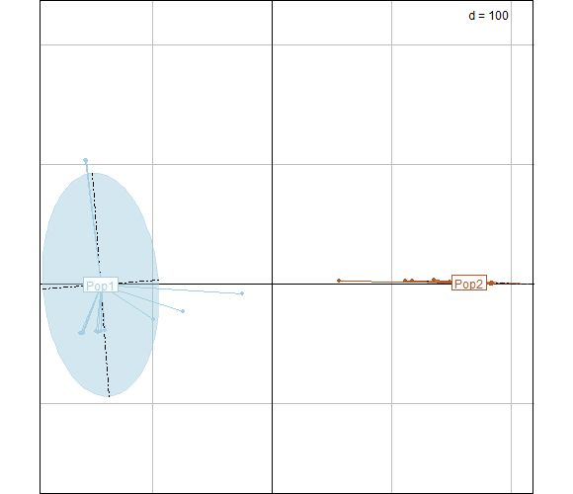

Tms

