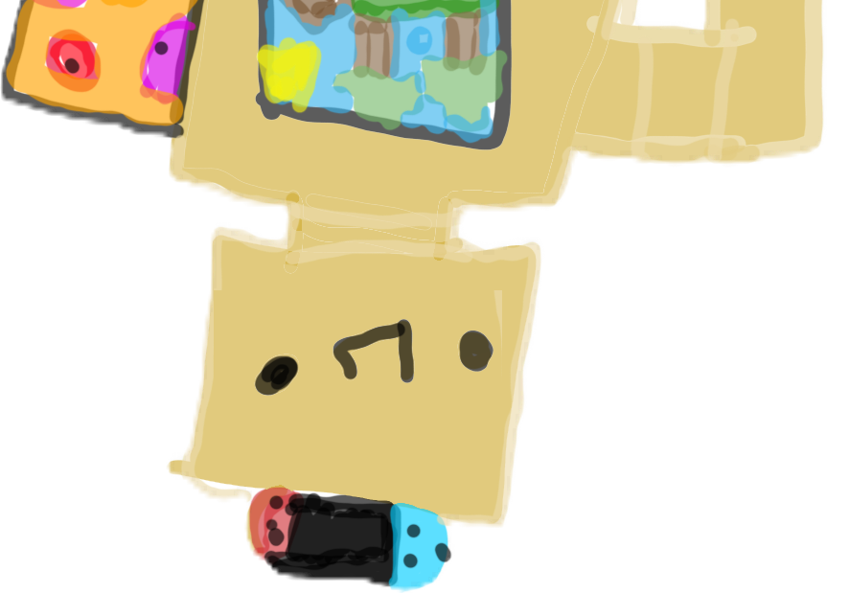

A complete guide to setting up your new robot butler and raising the standard for game nights everywhere. Sir Games is designed for home use, though he’d love to impress your friends at the office.

For the associated app instructions, see the companion Game Night Setup Manual.

Table of Contents

Important Safety Warnings 3

Visual Overview of Sir Games 5

Sir Games Assembly Instructions 6

1. Unboxing Sir Games 6

2. Setting Up Sir Games 8

Game Night App Setup 11

1. Install the Game Night App 11

2. Get Started with Game Night 12

Important Safety Warnings

Do not immerse Sir Games in deep water. While his electronics are waterproof with no risk of electrical shock, he is too heavy to swim and will sink to the bottom. He will be disappointed if he has to walk underwater.

Figure Depth Hazard Symbol

Sir Games’ Aurabesh language setting might be banned in your country. Please follow all local rules concerning his language settings.

Figure Copyright Symbol

Use caution when having Sir Games set up board games with small pieces. Children under the age of 3 can put pieces in their mouth and choke.

Visual Overview of Sir Games

Figure Sir Games Features Overview

Figure Sir Games Physical Features

Sir Games Assembly Instructions

Congratulations on your purchase of Sir Games. Please read through this manual thoroughly for instructions on setting up Sir Games and getting started hosting your own game nights.

For Sir Games’ assembly, you will need the following:

* A Philips head screwdriver (not included)

1. Unboxing Sir Games

Please note: Sir Games is not shy at all about social media and would be thrilled to star in a YouTube unboxing video. For best practice, set up a microphone in advance to record his puns during unboxing.

* 1. 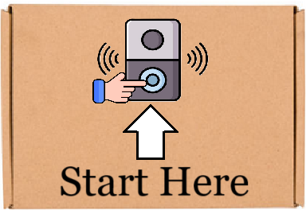Locate the “Start Here” sticker on the box as seen in Figure 5.

Figure Locate the Start Here Doorbell on the box

* 1. Push the doorbell on the box and listen for a chime. You will hear Sir Games’s voice answer, “Hello?”
  2. Say “Knock, knock!” with as much enthusiasm as possible.
  3. You will hear Sir Games answer, “Who’s there?”
  4. Respond with your favorite knock-knock joke subject and listen for Sir Games’ reply.

Please note: Triggering the *Banana, Banana Who* cycle will delay box opening as Sir Games will insist on looping through the sequence no fewer than 11 times.

* 1. After the knock-knock sequence has been completed, open the box. Sir Games will stand up and face you.

Unboxing is now complete! You are ready to set up Sir Games.

1. Setting Up Sir Games
   1. Locate the panel on the Kinetic Energy Stabilizer as seen in Figure 6. The Kinetic Energy Stabilizer is located on Sir Games’ upper right shoulder.

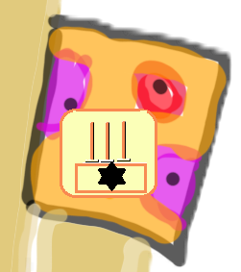

Figure Kinetic Energy Stabilizer Access Panel

* 1. A cartoon of a screwdriver and a sign

     Description automatically generatedUse a screwdriver to open the panel and access the Kinetic Energy Stabilizer switch.

Note: The movement of Sir Games’ arms during routine functioning recharges his Nano-Tech Supercell batteries. No other external power is needed for use.

* 1. Move the switch to the Primary position as seen in Figure 7 to allow Sir Games to power his own energy reserves using the motion generated by his movement.

Figure Flip the switch to Primary position.

Please note: If the switch is already in the Primary position, the movement generated during shipping must be expended by allowing Sir Games to spin in circles. Direct Sir Games to an area at least 4 (four) feet by 4 (four) feet and say, “Enter spin mode.”

Sir Games will acknowledge the command and start to spin quickly. His Quantum Dot LED display screen will turn from green to red as his energy is expended. He will return to standing position when his energy reserves are sufficiently depleted, and setup can continue.

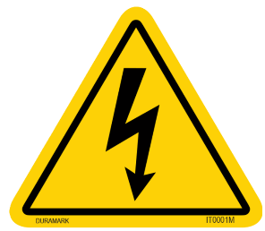

Failure to expend energy in this manner will result in Sir Games’ attempting to repeatedly clean the same area for hours, possibly causing damage to surfaces.

Figure Energy Depletion Required

* 1. Sir Games will acknowledge the Primary position by displaying a green check mark on his Quantum Dot LED display.

Setup is now complete! You are ready to configure Sir Games’s network settings and connect him to Game Night Setup app.

Game Night App Setup

To set up the Game Night App, you will need the following:

* A smartphone with Wi-Fi and Bluetooth connectivity
* An unboxed Sir Games unit

1. Install the Game Night App
   1. Download and install the Game Night App from your preferred application vendor. The Game Night App is designed to work with all smartphones and tablets.
   2. Once installed, open the app. The app will begin searching for nearby Sir Games units.

Please note: Make sure your phone has Bluetooth enabled. You may have to permit the app to allow access to Bluetooth and/or your Wi-Fi.

Sir Games will confirm connection to Bluetooth by telling a joke or making a pun about Bluetooth.

The app will then prompt you to connect Sir Games to your home Wi-Fi. Enter your credentials to proceed.

1. Get Started with Game Night

You are now ready to use Sir Games to help you host the most amazing game nights your friends have ever attended. Host game nights with no stress and allow Sir Games to set up your space for hosting.

Use the Game Night App to tell Sir Games to clean and set up your kitchen, set out board or tabletop games and accessories, and move furniture. Through the app, you can customize Sir Games and even change his language!

As your friends arrive, they are treated to the enjoyable Sir Games experience as he guides them to snacks, pulls them up a chair, and even recommends board games to play. He can roll a new character for Dungeons and Dragons or produce a previously-saved one to continue a campaign.

Enjoy your new personal gaming robot butler!

For the app experience, see the following link: <https://marvelapp.com/prototype/1b242e04>

All icons used in this manual are available at Freepik.com and have been edited and/or adapted in MS Paint. Sir Games design and art provided by Evie Moreno. Marvelapp.com is a prototyping service to design applications. Sir Games featured in a previous project for SWE 4324, summer semester 2024. All rights reserved.