**Stack Implementation using array:**

It is based on LIFO mechanism (Last In First Out)

POP- delete the element from Stack and print it. Size will reduce by 1.

PUSH – Enter a new the element into the stack.

ISEmpty – will check if the stack is empty or not.

IsFull - will check if the stack is full or not

PEEK - it will not delete the element from top like pop but helps to retrieve the element.

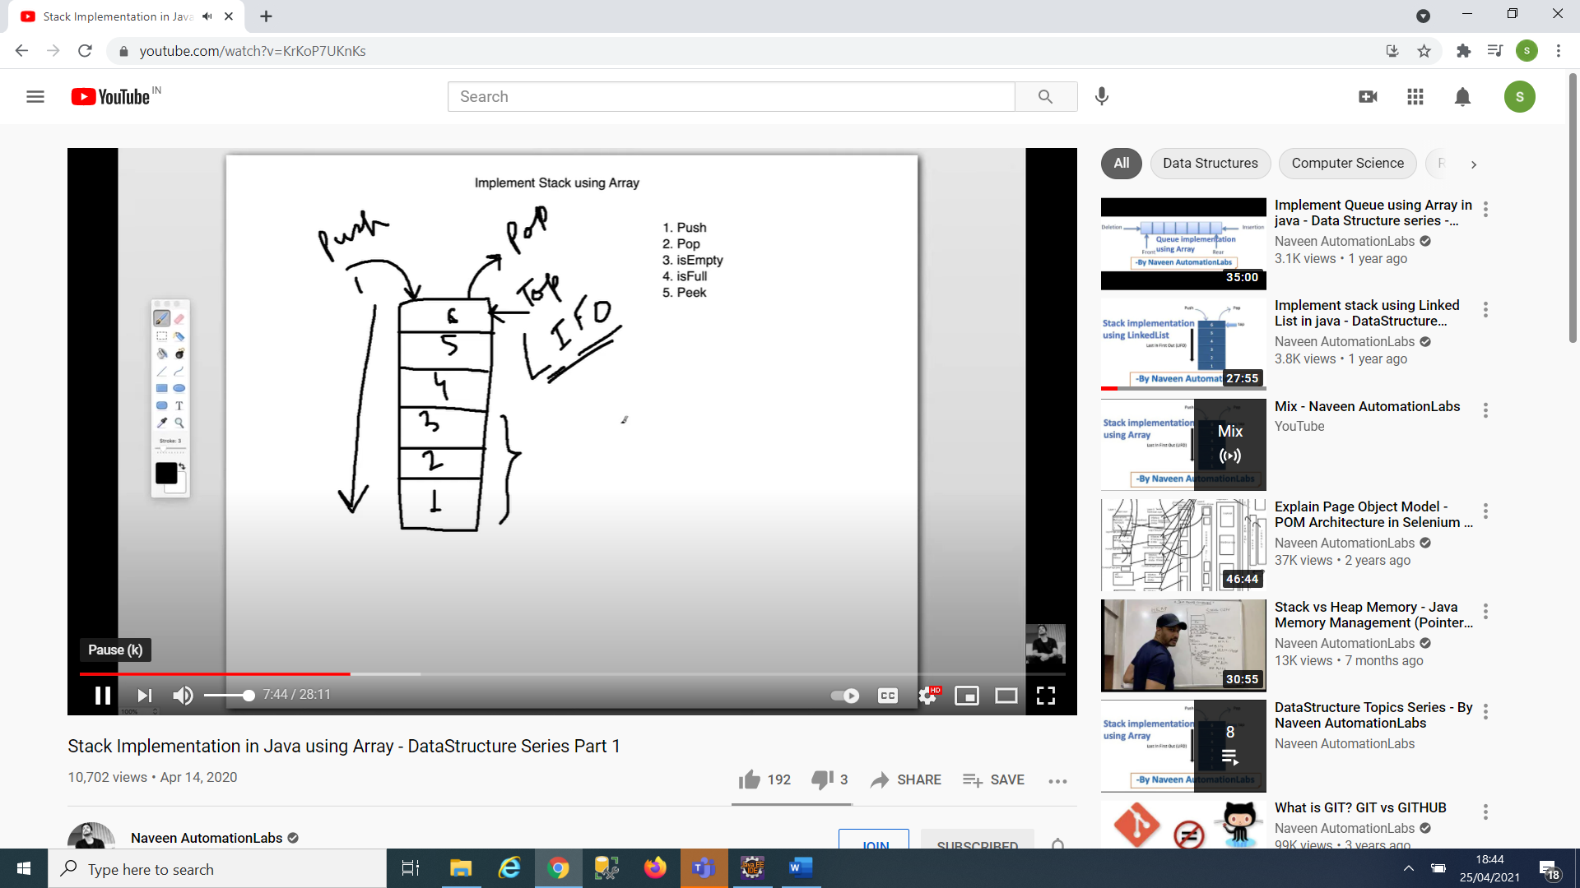

**Stack Implementation using LinkedList:**