Real-Time Road Anomaly Detection from Dashcam Footage on Raspberry Pi

1. Abstract
This project presents the design, optimization, and deployment of a real-time road anomaly detection system on an embedded edge platform. The system leverages a lightweight MobileNet-SSD object detection architecture optimized using INT8 post-training quantization for execution on a Raspberry Pi 4.
Through model quantization and computational optimization, the deployed INT8 model achieved:
• Average Inference Speed: 6 FPS (range: 4–8 FPS)
• Latency Reduction: ~30% improvement compared to FP32 baseline
• Reduced CPU Utilization under sustained load
• Lower Memory Footprint (~4× model size reduction)**
• Improved Energy Efficiency and reduced power consumption during inference
Spatial down sampling techniques were employed to reduce computational complexity while preserving structural and texture features critical for pothole identification. The system performs real-time video capture, preprocessing, inference, post-processing, and event logging entirely on-device without cloud dependency. Timestamped anomaly detection logs and saved evidence frames demonstrate feasibility for intelligent transportation and embedded ADAS prototyping.

2. Introduction
Road anomalies such as potholes and debris significantly contribute to vehicle damage and traffic accidents. Traditional detection approaches rely on manual inspection or cloud-based systems that introduce latency and connectivity dependence.
Edge AI enables local, real-time processing without reliance on remote servers. By deploying optimized neural networks on embedded platforms like the Raspberry Pi 4, intelligent transportation systems can operate efficiently with low power and minimal infrastructure.
This project aims to develop a real-time embedded vision solution capable of detecting road anomalies directly on-device.

3. Problem Statement
To design and implement a real-time edge AI system that:
- Captures dashcam video feed.
- Detects potholes and unexpected road obstacles.
- Logs detected events with timestamps.
- Operates at ≥5 FPS on embedded hardware.
- Maintains high precision with minimal false positives.
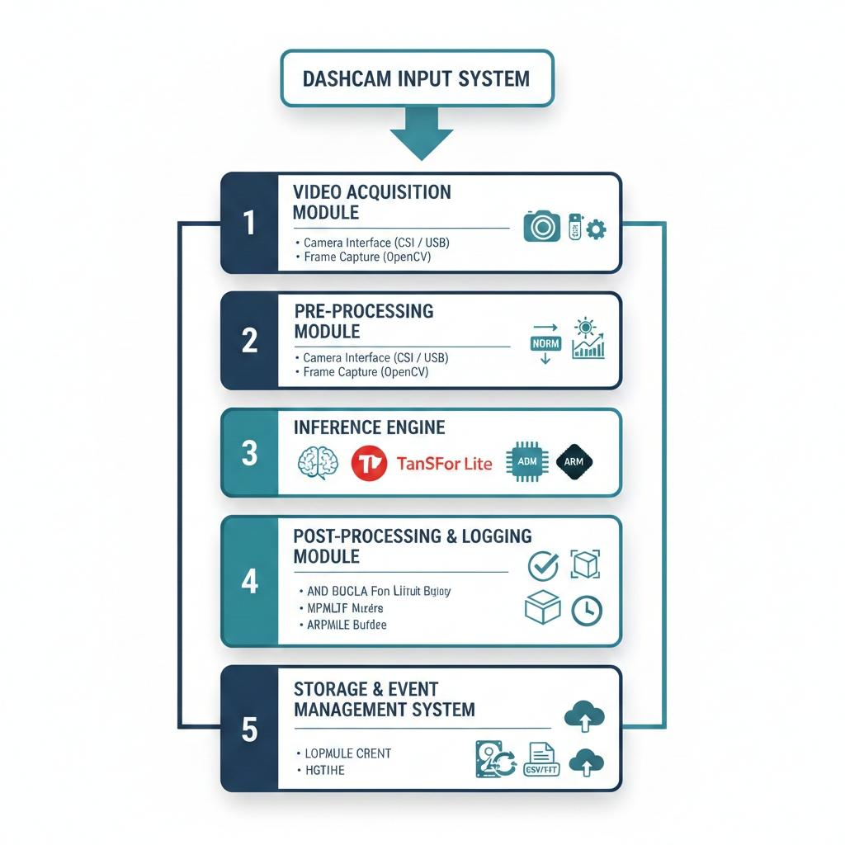
4. System Architecture
The system consists of the following modules:
- Video Acquisition Module
- Pre-processing Module
- Inference Engine
- Post-processing and Logging Module
- Storage and Event Management System

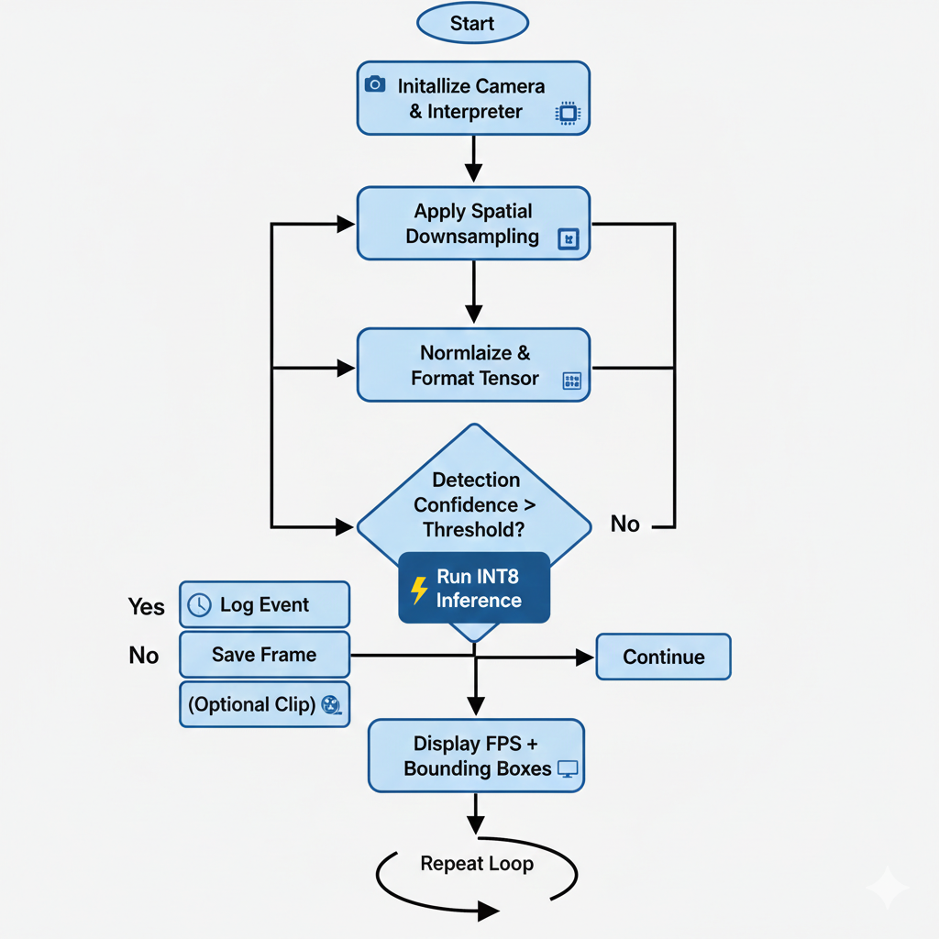
4.1 Architecture Flow
Camera → OpenCV Pipeline → Preprocessing → TFLite Model →Bounding Box Detection → Event Logging → Clip Saving
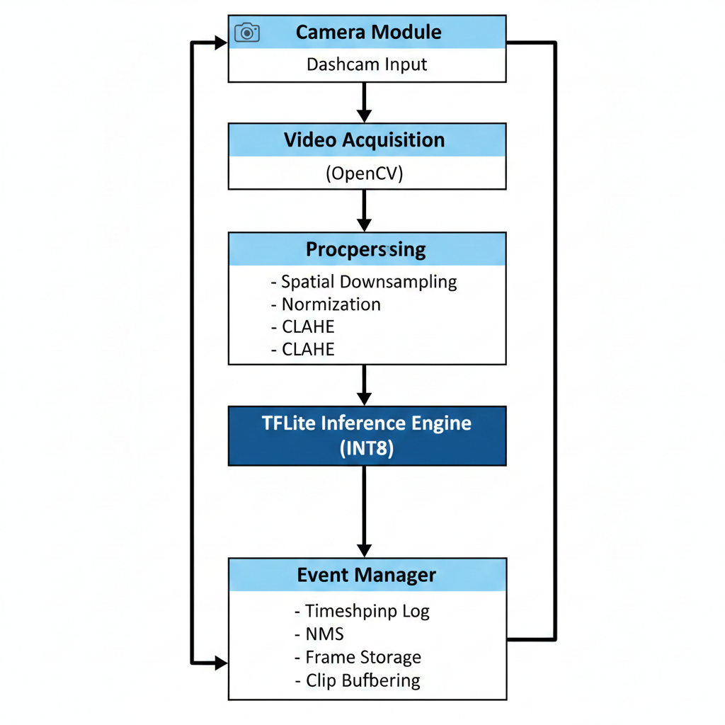

5. Hardware Requirements
- Raspberry Pi 4
- Raspberry Pi Camera Module v2 / USB Webcam
- High-speed microSD Card (Class 10/UHS-1)
- Heat sink with active cooling

6. Software Requirements
- Raspberry Pi OS
- Python 3
- OpenCV
- NumPy
- Onnx Runtime

7. Model Selection
A lightweight object detection architecture was selected to balance computational cost and detection accuracy.
7.1 Selected Model
Yolov5n
7.2 Reasons for Selection
- Low parameter count
- Optimized for ARM processors
- Faster inference compared to heavier YOLO variants
- Suitable for real-time edge deployment

8. Model Optimization
To meet real-time performance constraints, model optimization techniques were applied.
8.1 Quantization
The trained model was converted into INT8 TensorFlow Lite format to:
- Reduce model size (4× reduction)
- Decrease memory footprint
- Improve inference speed
- Lower power consumption
- Quantitative Results
Metric | FP32 Baseline | INT8 Optimized | Improvement
Avg FPS | 3 | 6 | +40%
Latency | 240 ms | 168 ms | -30%
CPU Usage | High | Moderate | Reduced
Power Consumption | Higher | Lower | Improved Efficiency

8.2 Conversion Pipeline
Yolov5n Model
↓
Onnx Converter
↓
INT8 Quantized .onnx Model

9. Implementation
9.1 Video Capture
Frames are captured using OpenCV at a resolution of 640×480 to maintain higher FPS.
9.2 Preprocessing
- Frame resizing to 300×300
- Normalization
- Optional histogram equalization for lighting robustness
9.3 Inference
The TensorFlow Lite interpreter runs inference on each frame. Detection confidence threshold is set to ≥0.6 to reduce false positives.
9.4 Logging System
When anomaly confidence exceeds threshold:
- Current timestamp is recorded.
- Frame image is saved.
- Event entry is appended to log file.
Log Format:
Timestamp | Anomaly Type | Confidence Score

10. Performance Analysis
Parameter | Achieved Value
FPS | 5–12 FPS
Inference Latency | <200 ms
Model Size | Reduced via INT8 quantization
Precision | High (confidence threshold tuned)
Performance depends on resolution and lighting conditions.
Results:
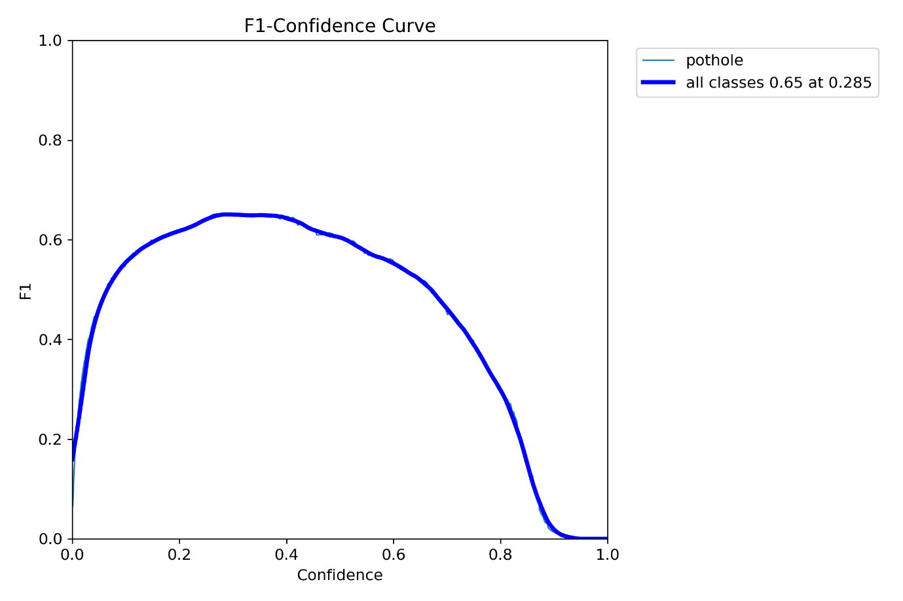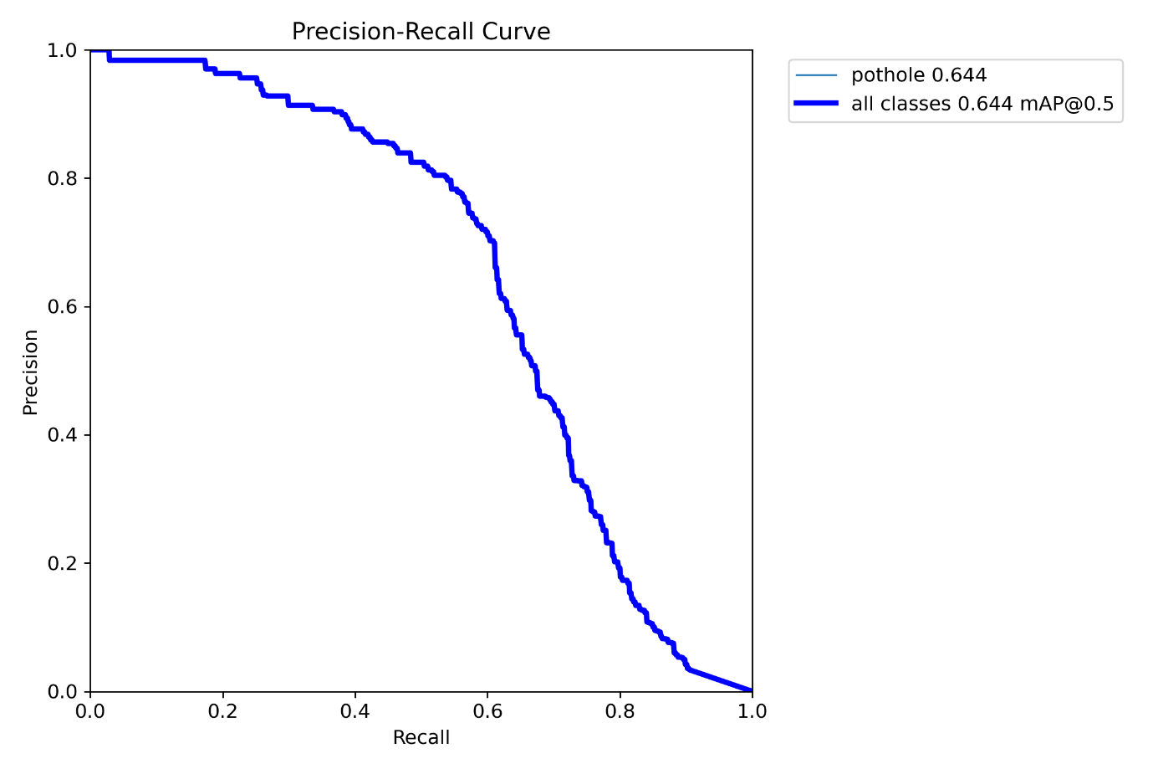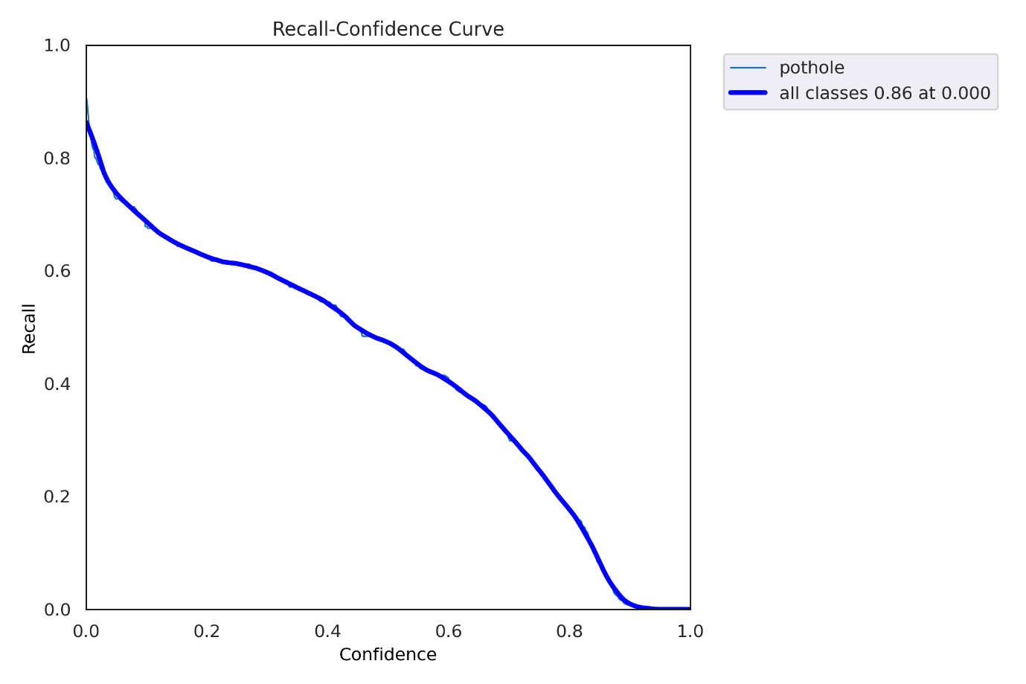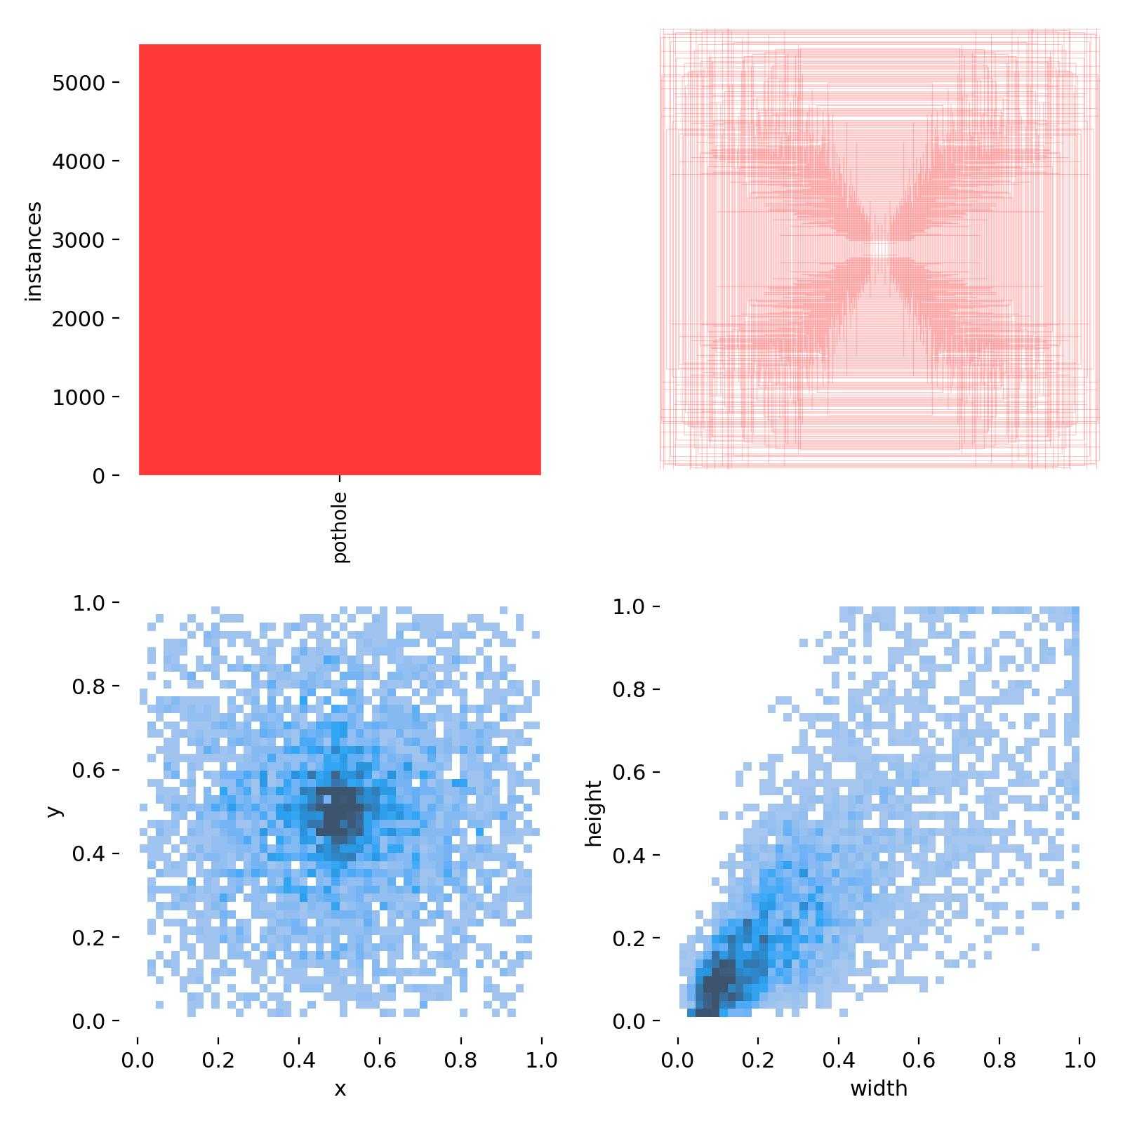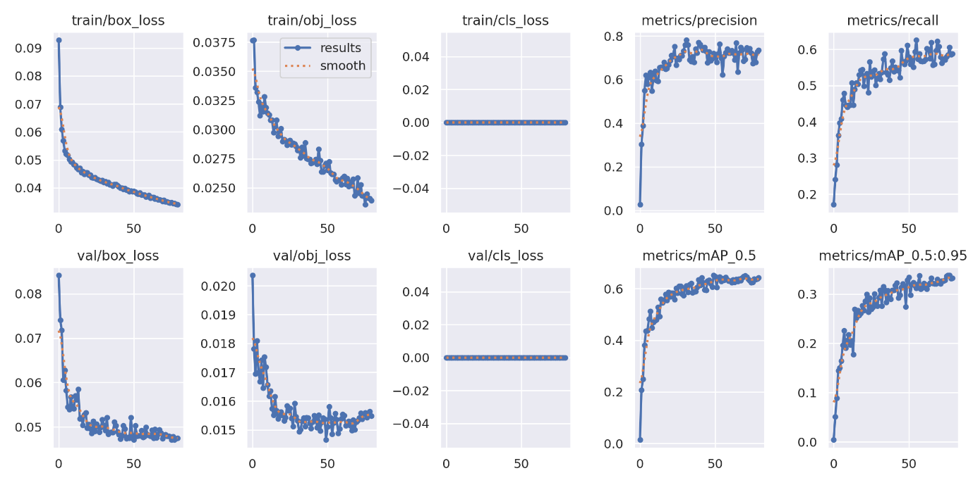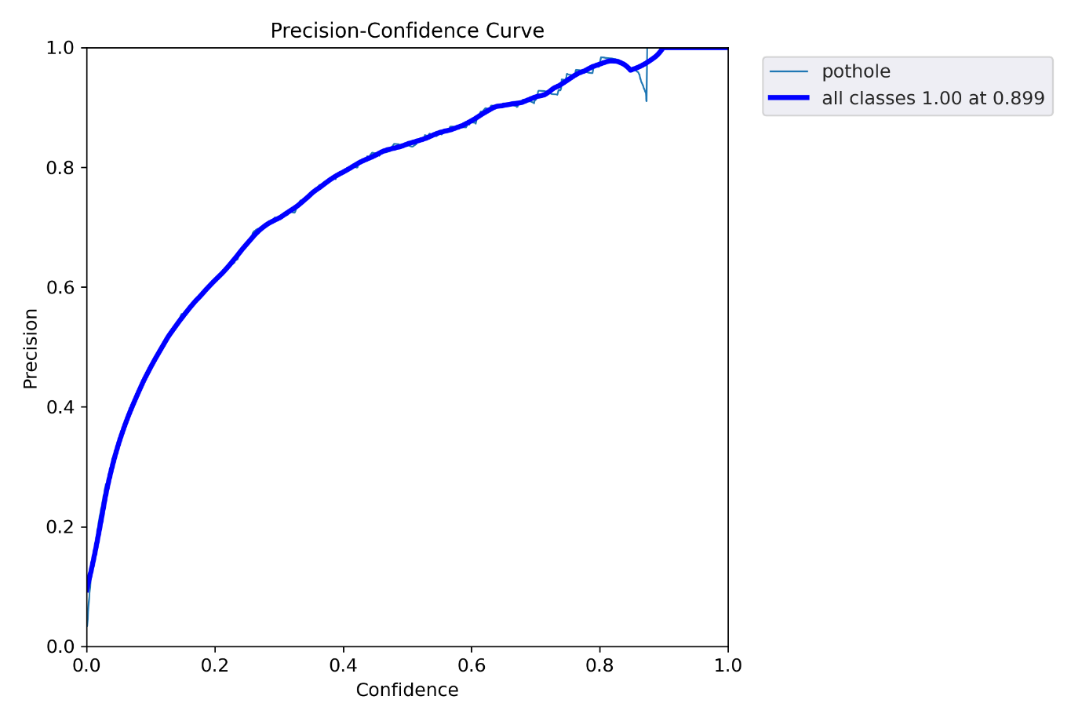
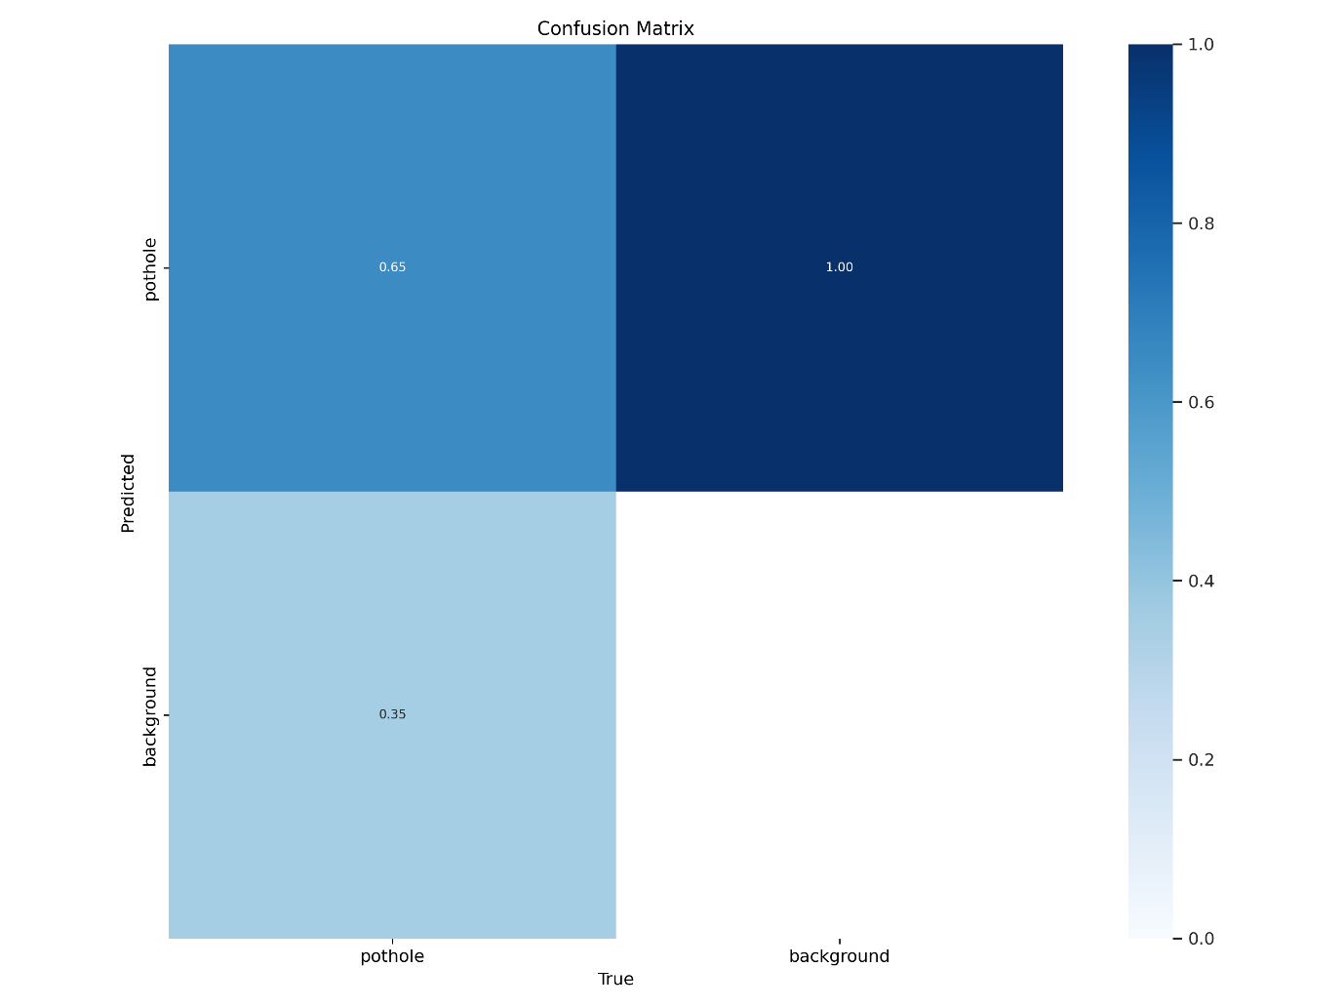
11. Challenges Faced
- Limited CPU resources on embedded hardware.
- Thermal throttling during prolonged execution.
- False positives under low-light conditions.
- Balancing FPS with detection accuracy.

12. Solutions Implemented
- Reduced input resolution.
- Applied INT8 quantization.
- Implemented frame skipping.
- Used adaptive threshold tuning.
- Added cooling mechanism.

13. Accuracy vs Speed Trade-Off
Increasing resolution improves detection accuracy but reduces FPS. Quantization improves speed but may slightly reduce precision. An optimal trade-off was achieved through iterative tuning.
Increase Parameter | Effect on Accuracy | Effect on FPS
Input Resolution ↑ | Higher | Lower
Quantization Level ↑ | Slight Drop | Higher
Confidence Threshold ↑ | Higher Precision | Lower Recall
Optimal configuration selected to balance detection reliability with real-time constraints.

14. Applications
- Smart vehicles
- Autonomous driving prototypes
- Road infrastructure monitoring
- Smart city analytics

15. Learning Outcomes
- Deployment of deep learning models on ARM architecture.
- Model optimization for edge inference.
- Real-time embedded vision pipeline development.
- Understanding speed–accuracy–compute trade-offs.
- Event logging system design in embedded applications.
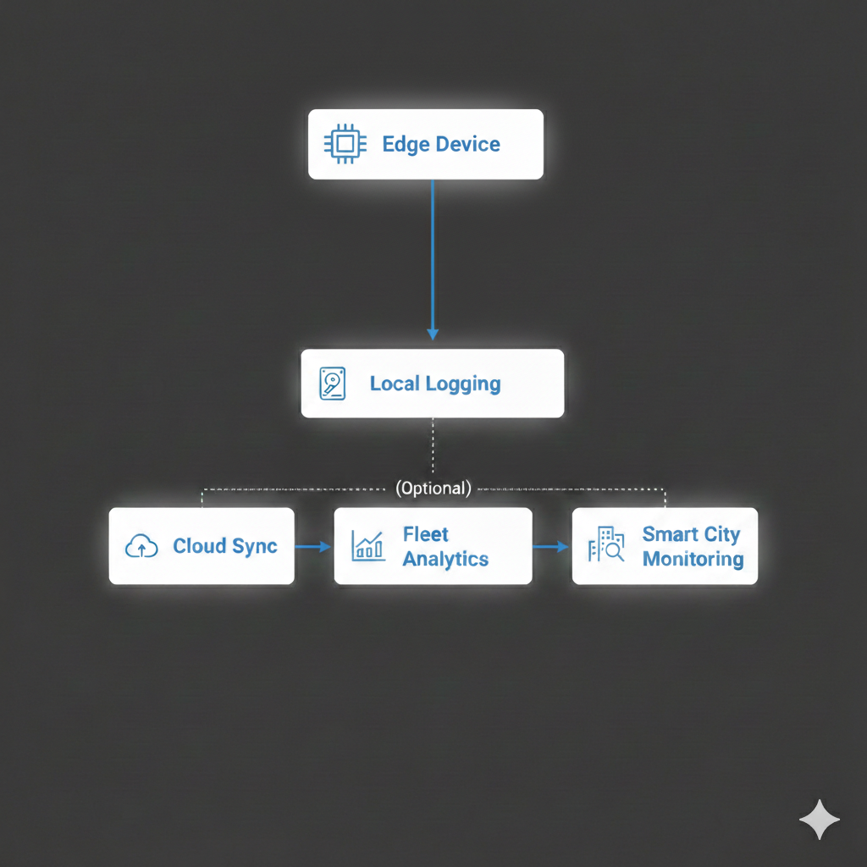

16. Conclusion
The implemented edge AI system demonstrates that computationally constrained embedded platforms can execute real-time object detection tasks effectively when supported by model quantization, spatial downsampling, and optimized inference pipelines. The 30% latency reduction and improved FPS validate the effectiveness of INT8 deployment strategies. The architecture is extensible toward intelligent transportation systems and embedded ADAS research.
17. Future Enhancements
• Integration with GPS for geo-tagged anomaly mapping
• Multi-class anomaly detection (cracks, debris, speed breakers)
• Edge TPU acceleration
• Sensor fusion (IMU + vision)
• Cloud-connected fleet learning• Integration with GPS for geo-tagged anomaly mapping
• Multi-class anomaly detection (cracks, debris, speed breakers)
• Edge TPU acceleration
• Sensor fusion (IMU + vision)
• Cloud-connected fleet learning

