CT104H – Operating System
CAN THO UNIVERSITY
COLLEGE OF INFORMATION AND COMMUNICATION TECHNOLOGY
OPERATING SYSTEMS (CT104H)
LAB #4
Student name: ID:
- Submission: Students submit 1 file named StudentName_ID_CT104H_Lab04.pdf to the Google classroom (where StudentName is the student’s name, and ID is the student’s ID).
- Instructions on how to present in the report file
⮚ For each question, students MUST provide the commands/scripts AND screenshots of the commands used and/or the content of files/scripts, CLEARLY. Note: the screenshot needs to include the name of the Ubuntu Virtual machine.
⮚ Student creates an Ubuntu Virtual machine named UbuntuID (ID is the student’s ID). For example, we have a virtual machine named Ubuntu20043, such that the student ID is 20043.
Question 0: Navigate to your home directory
Answer: $cd
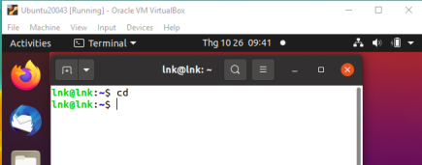
Study from the file Linux Shell Scripting Tutorial, the file Shell Script (Chapter 2), the book Linux Bible of Christopher Negus (Chapter 6: Managing Running Processes )
Questions from 1 to 10: Solve all the questions from 1 to 10 in the Section Exercises of Chapter 6 (Linux Bible of Christopher Negus)
- List all processes running on your system, showing a full set of columns. Pipe that
output to the less command so you can page through the list of processes.
Answer:
Ps aux | less
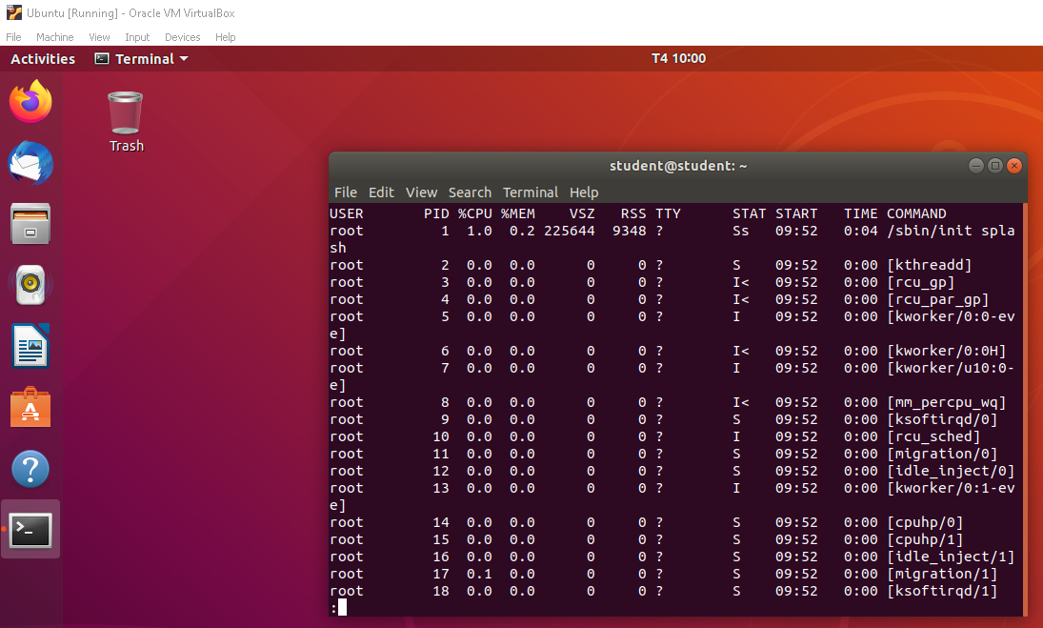
2. List all processes running on the system, and sort those processes by the name of
the user running each process.
Answer:
ps –sort=user | less
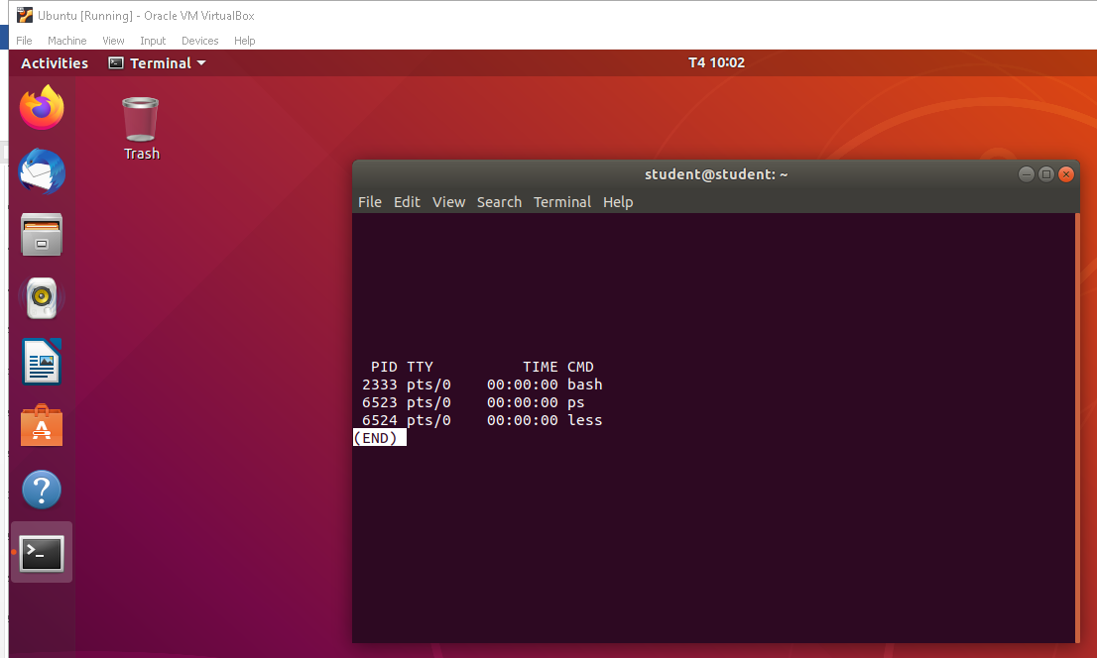

3. List all processes running on the system, and display the following columns of
information: process ID, user name, group name, virtual memory size, resident
memory size, and the command.
ps –eo pid,user,group,vsz,rss,comm | less
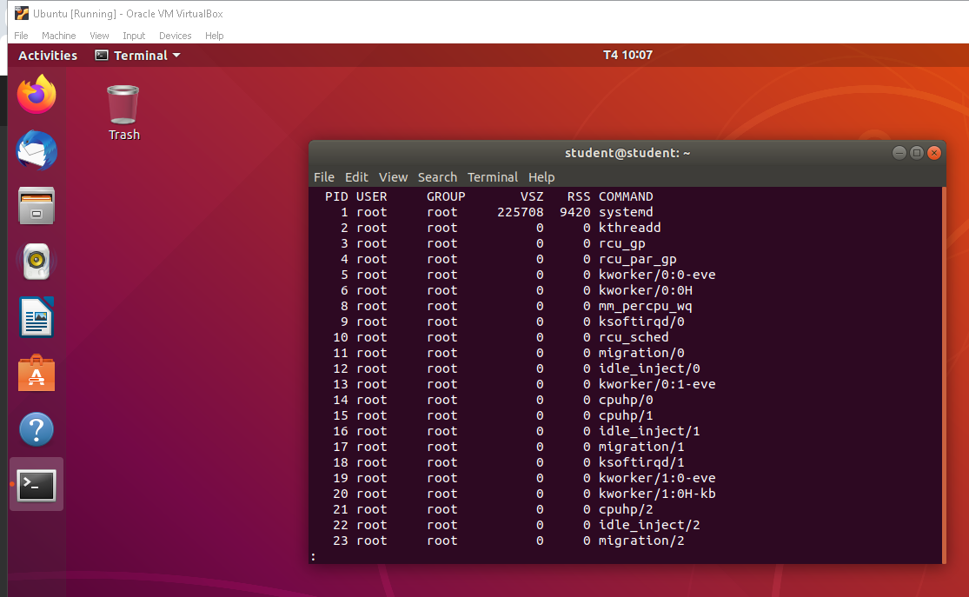
4. Run the top command to view processes running on your system. Go back and
forth between sorting by CPU usage and memory consumption.
Answer:
Cpu sort
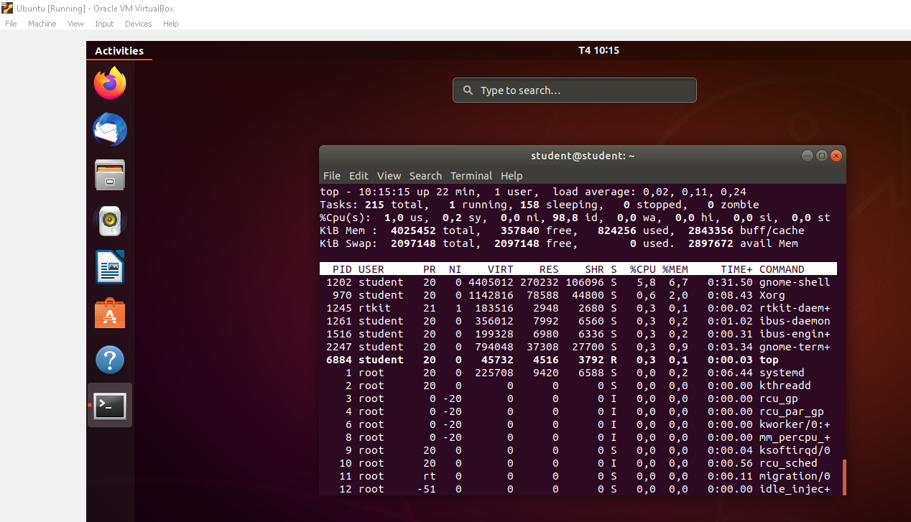
Memory sort
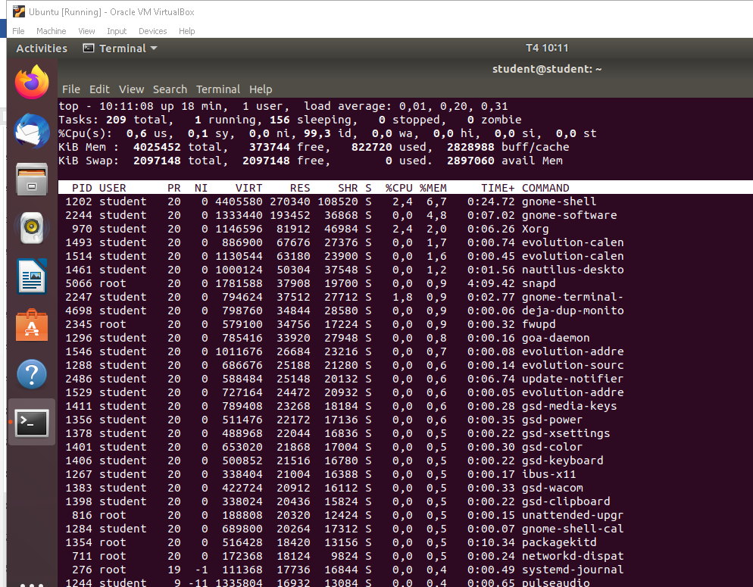
5. Start the gedit process from your desktop. Make sure you run it as the user you
are logged in as. Use the System Monitor window to kill that process.
Answer:
gedit
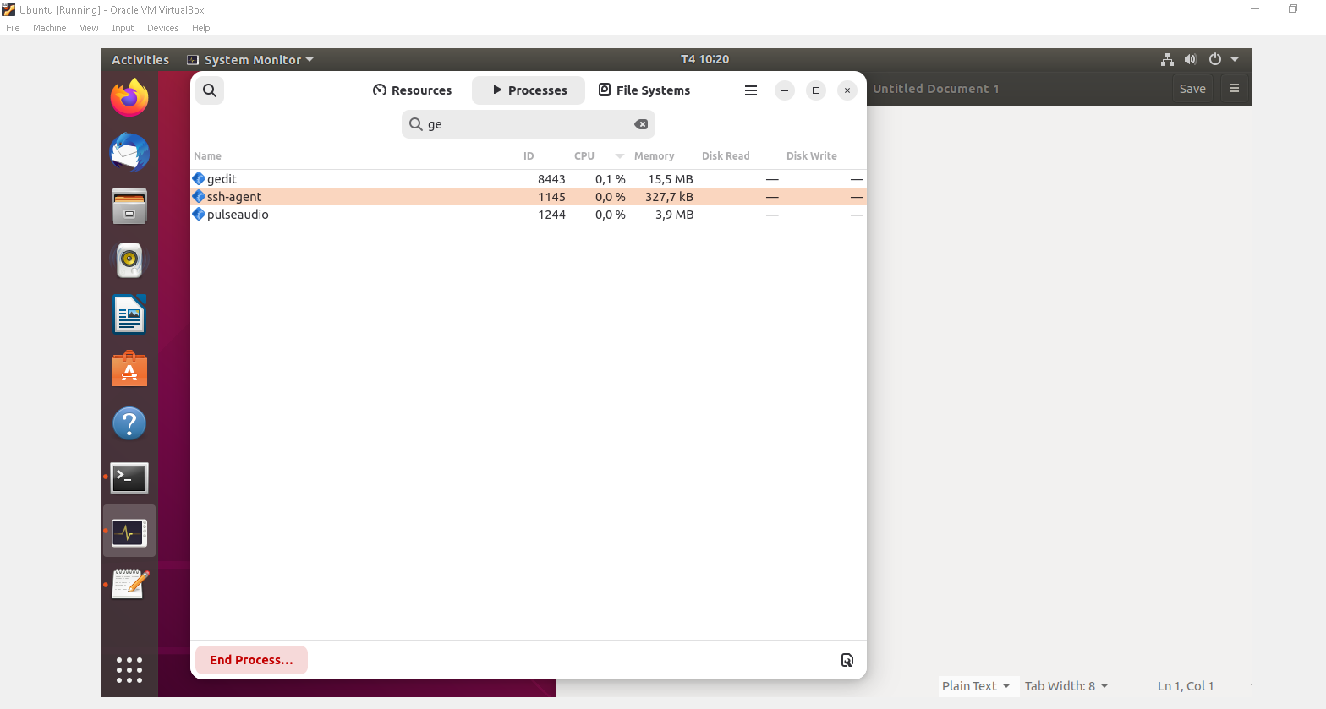
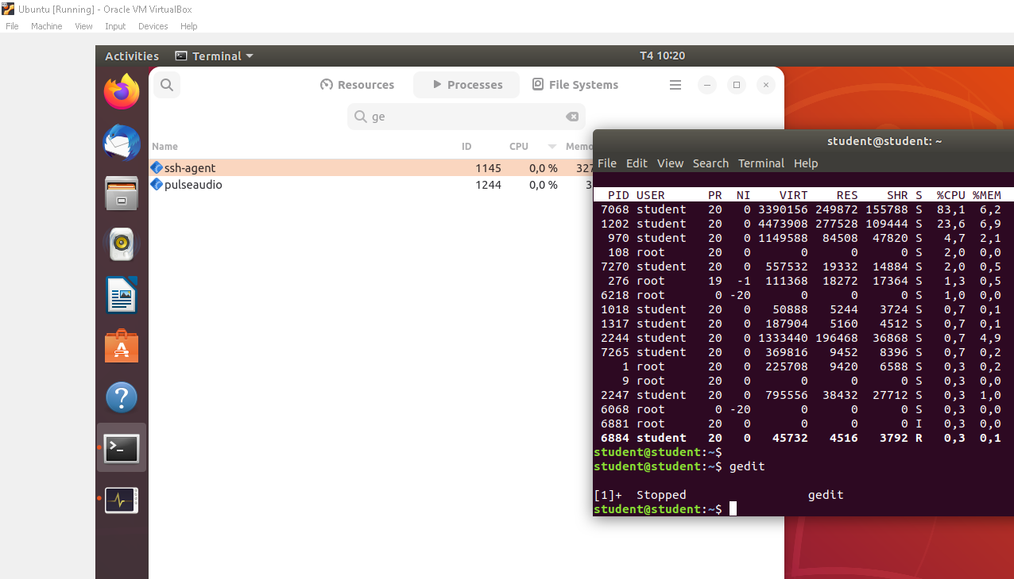
6. Run the gedit process again. This time, using the kill command, send a signal
to the gedit process that causes it to pause (stop). Try typing some text into the
gedit window and make sure that no text appears yet.
Answer
gedit
kill –STOP 10133
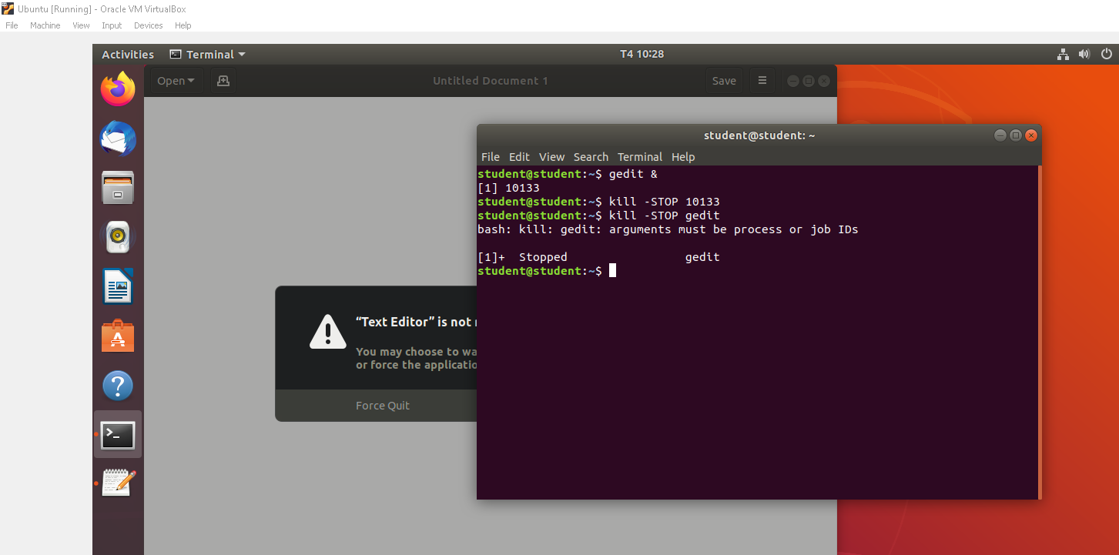
7. Use the killall command to tell the gedit command you paused in the previous
exercise to continue working. Make sure the text you type in after gedit was
paused now appears on the window.
Answer:
killall –STOP gedit
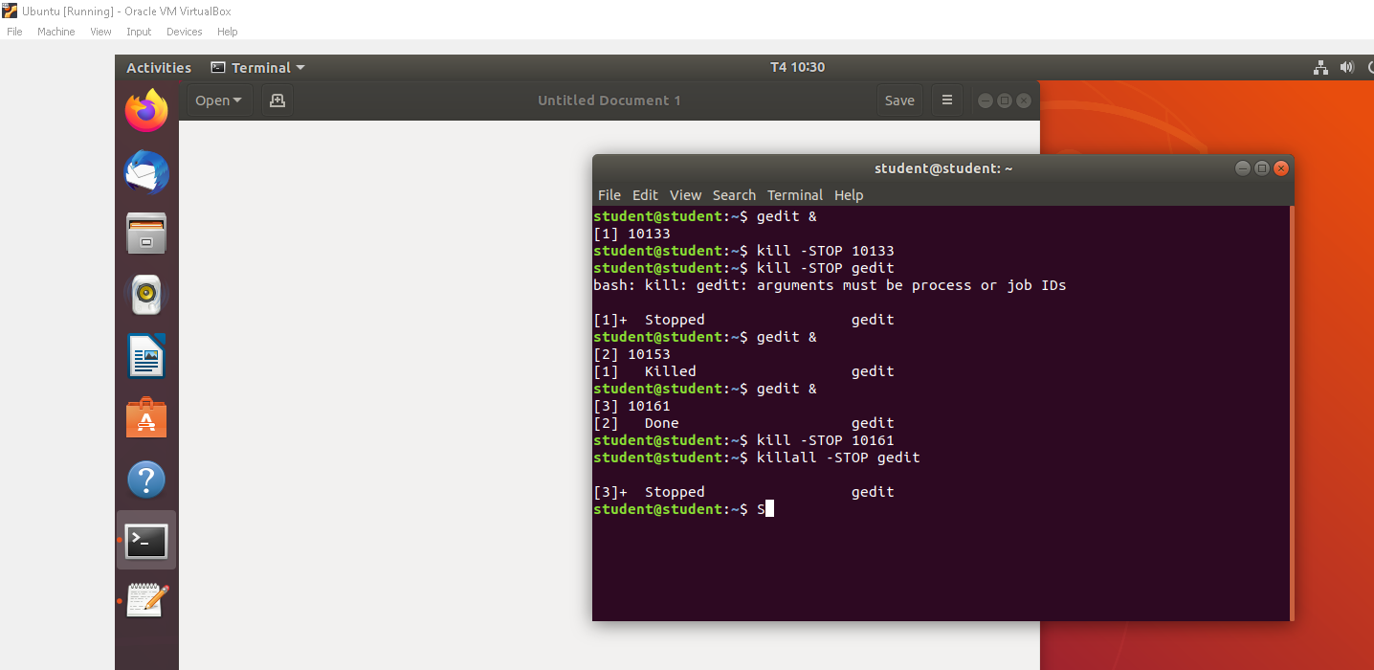
8.Install the xeyes command (in Red Hat Enterprise Linux, it is in the xorg-x11-
apps package). Run the xeyes command about 20 times in the background so
that 20 xeyes windows appear on the screen. Move the mouse around and watch
the eyes watch your mouse pointer. When you have had enough fun, kill all xeyes
processes in one command using killall.
Answer
sudo apt install x11-apps

Question 11: Write a shell script to receive a number from the user and print all numbers from 1 to that input
number such that each next number will be printed after every 5 seconds, or the next number will be printed immediately if the user presses Ctrl_C.

