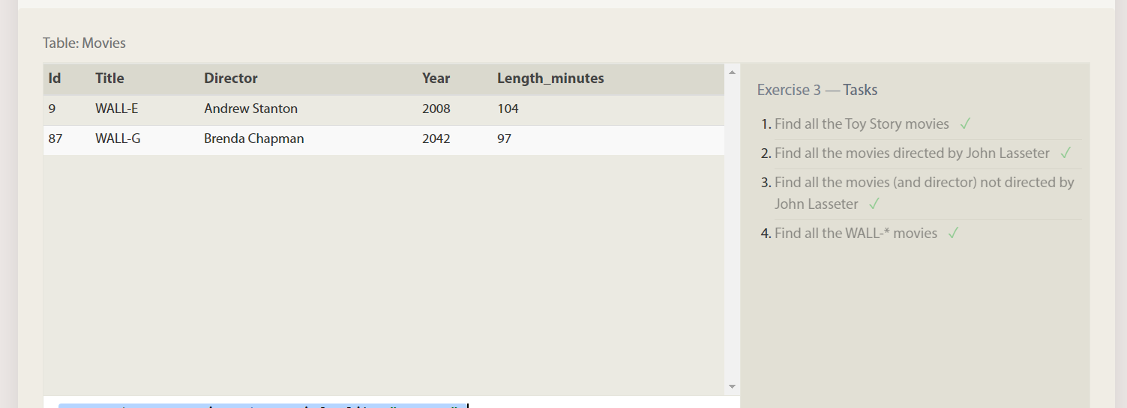

SELECT * FROM movies where Title like "%Toy story%";

SELECT * FROM movies where Director!="John Lasseter";

SELECT * FROM movies where Director="John Lasseter";

SELECT * FROM movies where Title like "WALL-_";

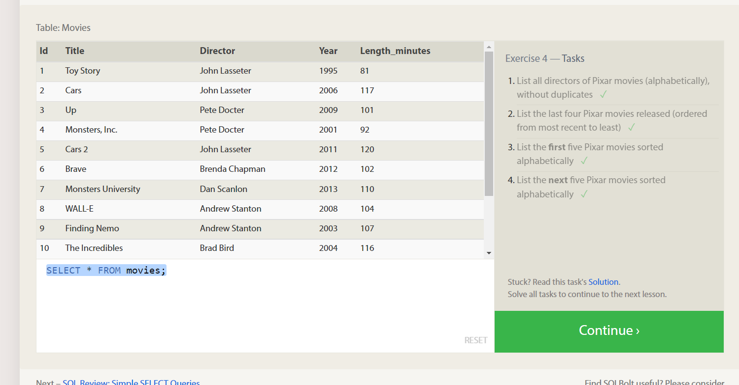

SELECT DISTINCT Director FROM movies order by Director asc;

SELECT Title,year FROM movies order by year desc limit 4;

SELECT Title FROM movies order by title asc limit 5;

SELECT Title FROM movies order by title asc limit 5 offset 5;

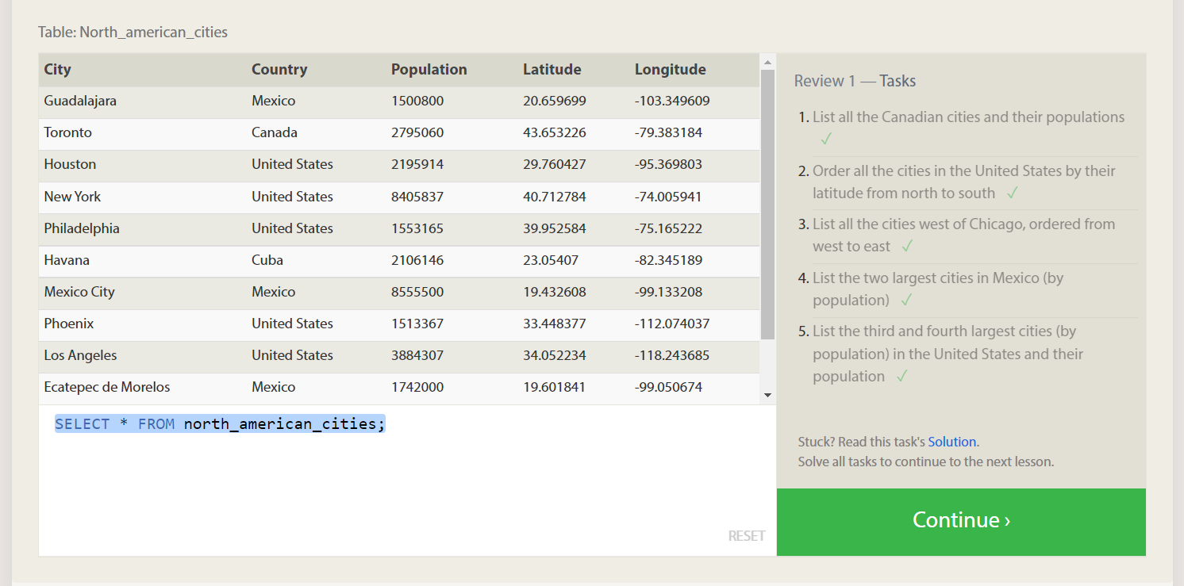

SELECT City,population FROM north_american_cities where country="Canada";

SELECT city FROM north_american_cities where country="United States" order by Latitude desc;

SELECT * FROM north_american_cities where Longitude<-87.629798 order by longitude

SELECT * FROM north_american_cities where Country="Mexico" order by population desc limit 2

SELECT * FROM north_american_cities where Country="United States" order by population desc limit 2 offset 2

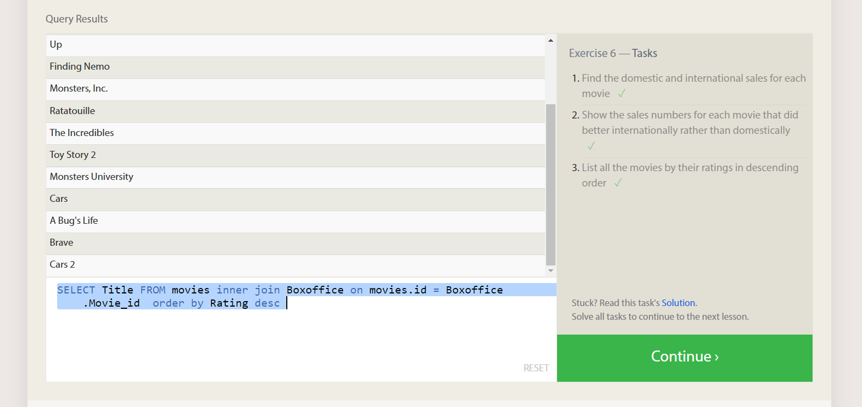

SELECT Title,Domestic_sales,International_sales FROM movies inner join Boxoffice on movies.id = Boxoffice.Movie_id ;

SELECT Title,Domestic_sales,International_sales FROM movies inner join Boxoffice on movies.id = Boxoffice.Movie_id where International_sales>Domestic_sales;

SELECT Title FROM movies inner join Boxoffice on movies.id = Boxoffice.Movie_id order by Rating desc

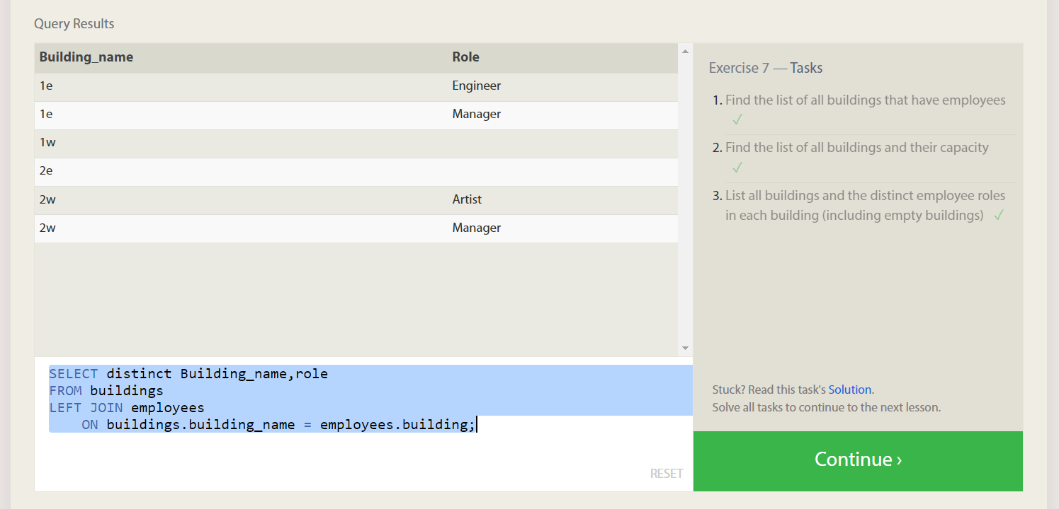

SELECT distinct Building FROM Employees join Buildings on Buildings.Building_name=Employees.Building;

SELECT * FROM Buildings

SELECT distinct Building_name,role

FROM buildings

LEFT JOIN employees

ON buildings.building_name = employees.building;