**Postman documentation.**

1. Create file request.

Endpoint - <http://localhost:3000/create-file>  
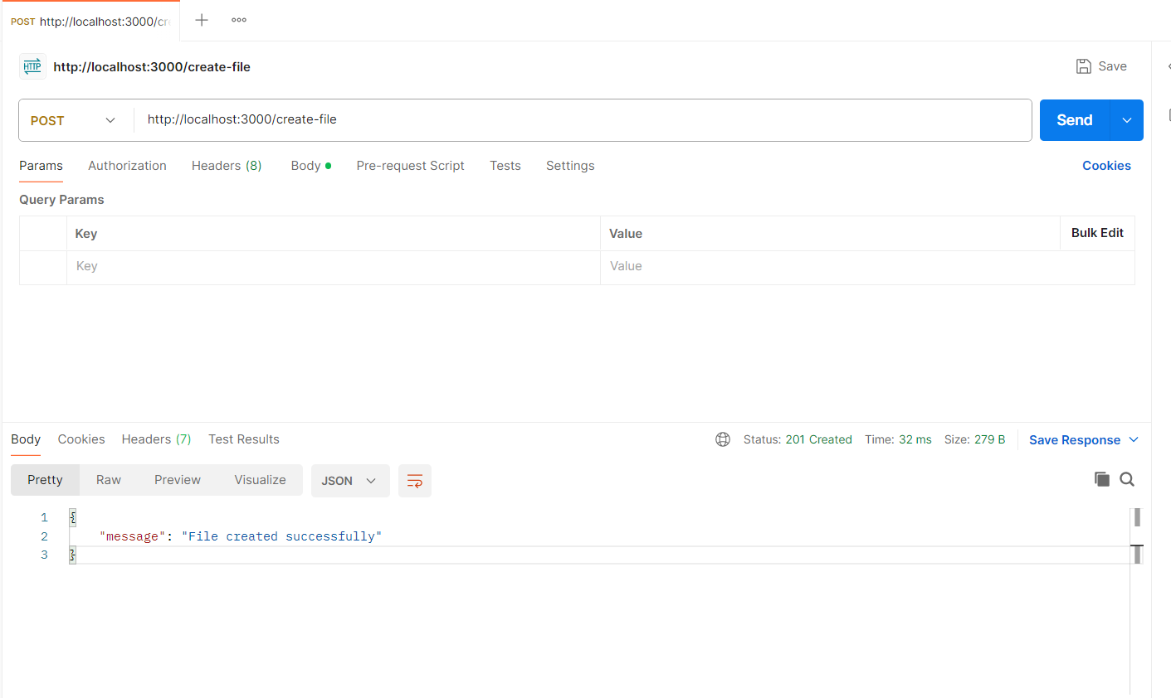

1. Get all file contents

Endpoint – http://localhost:3000/read-files

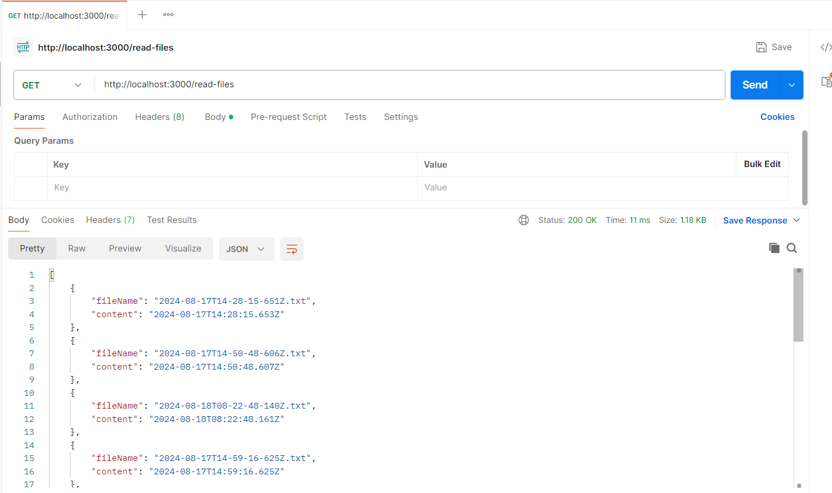

1. Get current date time.

Endpoint - <http://localhost:3000/current-datetime>

