Understanding Redux
A quick-reference guide with real-world examples

1. What is Redux?
Redux is a way to manage your app's shared data in one single, predictable place instead of scattering it across components. Think of it as one shared notebook for the whole app, with strict rules about who can write in it and how.
The core idea: nobody changes the data directly. Instead, you describe what happened (an action), and a dedicated function (a reducer) decides how the data should change in response.

The Three Core Pieces
- Store - the single notebook holding all the app's shared state.
- Action - a plain object describing what happened, e.g. { type: "ADD_TO_CART", item: "shoes" }.
- Reducer - a function that takes the current state and an action, and returns the new state.

2. Real-World Example
Imagine an e-commerce site. The "Add to Cart" button lives on the Product page, but the cart icon is in the Navbar, and the cart summary is on the Checkout page. Without Redux, you would need to manually pass data between these unrelated components.
With Redux, the Product page simply dispatches an ADD_TO_CART action. The store updates once, and every component reading from the store - Navbar, Cart page, Checkout page - automatically reflects the new cart count, with no direct communication needed between them.

3. Redux Flow Diagram
The diagram below shows how data flows through a Redux application, from a user action all the way to the UI re-rendering with updated data.
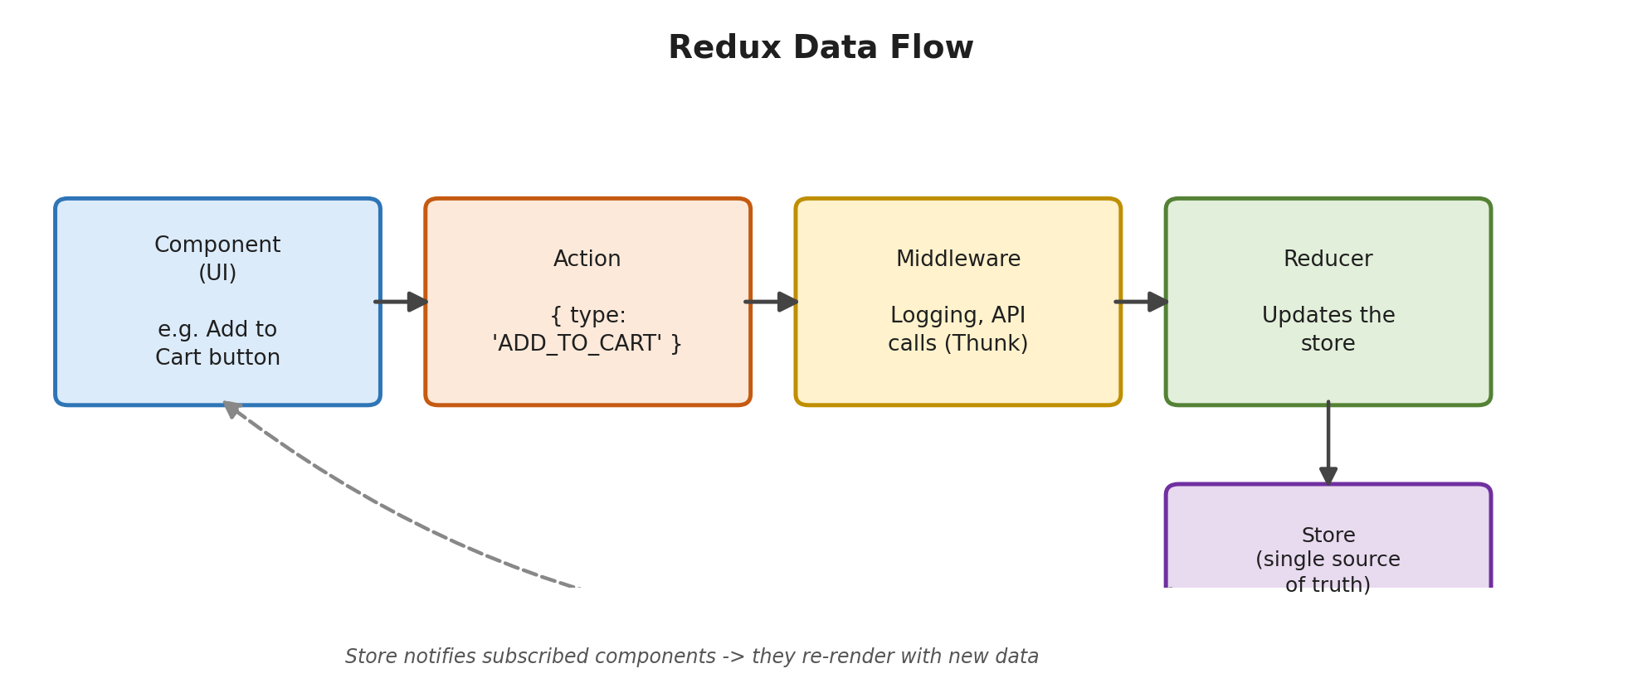
Figure 1: Component -> Action -> Middleware -> Reducer -> Store -> back to Component

4. Redux Toolkit (RTK)
Plain Redux required a lot of repetitive boilerplate code: separate files for action types, action creators, and switch-case reducers. Redux Toolkit (RTK) is the modern, official way to use Redux, and it removes most of that repetition automatically.
With RTK, you write a single "slice" - a chunk of state plus its own reducers - and RTK auto-generates the corresponding actions for you.
const cartSlice = createSlice({
name: "cart",
initialState: [],
reducers: {
addItem: (state, action) => {
state.push(action.payload); // RTK allows safe mutation
}
}
});
This one block replaces what would otherwise take three or four separate files in plain Redux.

5. Middleware
Middleware sits between "an action being dispatched" and "the reducer updating the store." It acts like a checkpoint that every action passes through first. Common uses include logging actions for debugging, blocking certain actions, or - most commonly - handling asynchronous logic such as API calls, since reducers themselves must stay simple and synchronous.

Real-World Example of Middleware
Consider clicking "Place Order." This requires calling a server to actually save the order, which a reducer cannot do directly. Instead, the action passes through middleware (commonly Redux Thunk, included by default in RTK), which calls the API first, and only dispatches the final action once the API call succeeds.
const placeOrder = (orderData) => async (dispatch) => {
dispatch({ type: "ORDER_LOADING" });
const response = await api.post("/orders", orderData);
dispatch({ type: "ORDER_PLACED", payload: response.data });
};

6. Putting It All Together
- User clicks "Place Order" -> dispatches placeOrder(orderData).
- Thunk middleware intercepts it and calls the backend API.
- Once the API responds, a plain action like ORDER_PLACED is dispatched.
- The reducer (inside the RTK slice) updates the store with the new order status.
- Every component subscribed to that part of the store - order history, confirmation page, cart icon - automatically re-renders with the latest data.

