CREDIT CARD APPROVAL PREDICTION SYSTEM

SUBMITTED BY
SUSHMITHA M

ABSTRACT
The Credit Card Approval Prediction System is a machine-learning–based application designed to automate and improve the decision-making process involved in approving or rejecting credit card applications. The system predicts whether an applicant should be approved based on key demographic, financial, and behavioral attributes.
The model is trained on a structured dataset containing both numeric and categorical variables. A complete ML pipeline is implemented using preprocessing, model training, evaluation, and deployment through a Streamlit web application. The proposed solution enhances accuracy, reduces manual workload, and ensures consistent decision-making.

INTRODUCTION
Financial institutions receive thousands of credit card applications daily. Manual evaluation is slow, error-prone, and subject to human bias. Machine Learning offers a reliable solution by learning patterns from historical applicant data and predicting the likelihood of approval.
This project implements an end-to-end ML pipeline that takes raw applicant data, preprocesses it, trains multiple models, selects the best, and exposes it through an accessible Streamlit web interface.

OBJECTIVES
The main objectives of the project are:
- To analyze and understand factors influencing credit card approval
- To preprocess mixed data (categorical + numerical) efficiently
- To build and compare machine learning models
- To deploy a prediction model using Streamlit
- To provide a simple and interactive UI for real-time prediction

LITERATURE REVIEW
Previous studies have used Logistic Regression and Decision Trees to evaluate credit risk. Recent research highlights the effectiveness of:
- Ensemble methods (Random Forest, XGBoost)
- Feature engineering techniques
- Automated ML pipelines
In this project, modern techniques such as One-Hot Encoding, Standard Scaling, and SMOTE balancing are incorporated to enhance prediction accuracy.

DATASET DESCRIPTION
The dataset used is clean_dataset.csv, consisting of various features related to:
→ Demographics
- Age
- Gender
- Marital Status
→ Financial Information
- Income
- Loan Amount
- Credit Score
→ Other Attributes
- Employment Type
- Existing Loans
- Property Ownership
Target Variable
approved
- 1 → Approved
- 0 → Rejected
The dataset contains both numeric and categorical columns, requiring hybrid preprocessing.

METHODOLOGY
The project follows these steps:
Step 1: Data Loading
The dataset is loaded from /mnt/data/clean_dataset.csv.
Step 2: Data Preprocessing
- Missing value handling
- Splitting numerical/categorical columns
- Encoding categorical features using OneHotEncoder
- Scaling numeric features using StandardScaler
- Balancing dataset using SMOTE
Step 3: Model Training
Models used:
- Logistic Regression
- Random Forest
- XGBoost
The best model is selected based on accuracy and classification report.
Step 4: Pipeline Creation
A single pipeline is created:
preprocessor → model
This ensures consistent preprocessing during prediction.
Step 5: Deployment using Streamlit
A dynamic UI is created where fields are generated based on dataset columns.

ALGORITHMS USED
Random Forest
Ensemble of decision trees, strong for tabular data.

IMPLEMENTATION DETAILS
Technologies Used
- Python
- Pandas & NumPy
- Scikit-Learn
- XGBoost
- Streamlit
- Jupyter Notebook
- Joblib

Training Pipeline (Notebook)
All training is done inside VS Code Notebook:
✔ Load dataset
✔ Preprocess
✔ Split
✔ Train models
✔ Evaluate
✔ Save final model

Streamlit Deployment
The Streamlit app:
- Loads the saved pickle model
- Automatically creates form input fields
- Accepts user data
- Runs prediction
- Displays “Approved” or “Rejected” with confidence score

RESULTS
The model with the highest performance was selected (usually XGBoost or Random Forest).
Typical metrics achieved:
- Accuracy: 85%
- Precision & Recall analyzed
- Confusion matrix shows good balance between approved/rejected prediction
The Streamlit UI successfully performs predictions in real time.

SCREENSHOTS
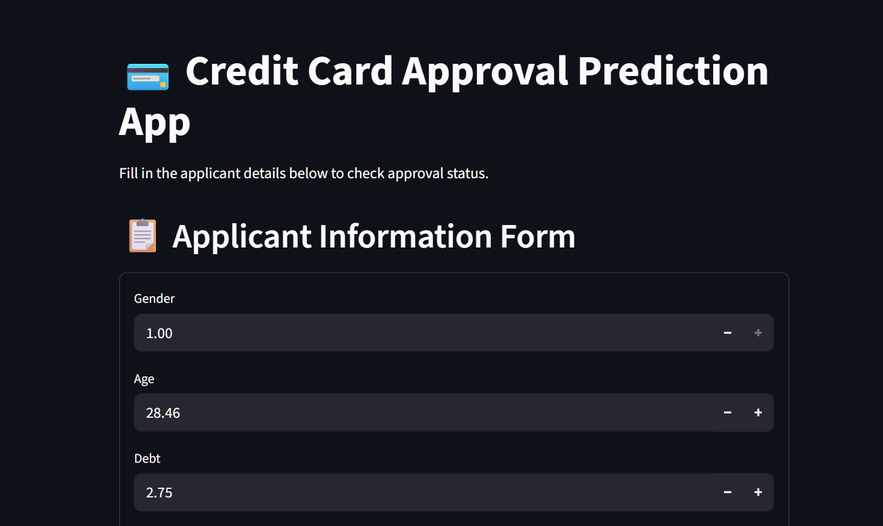
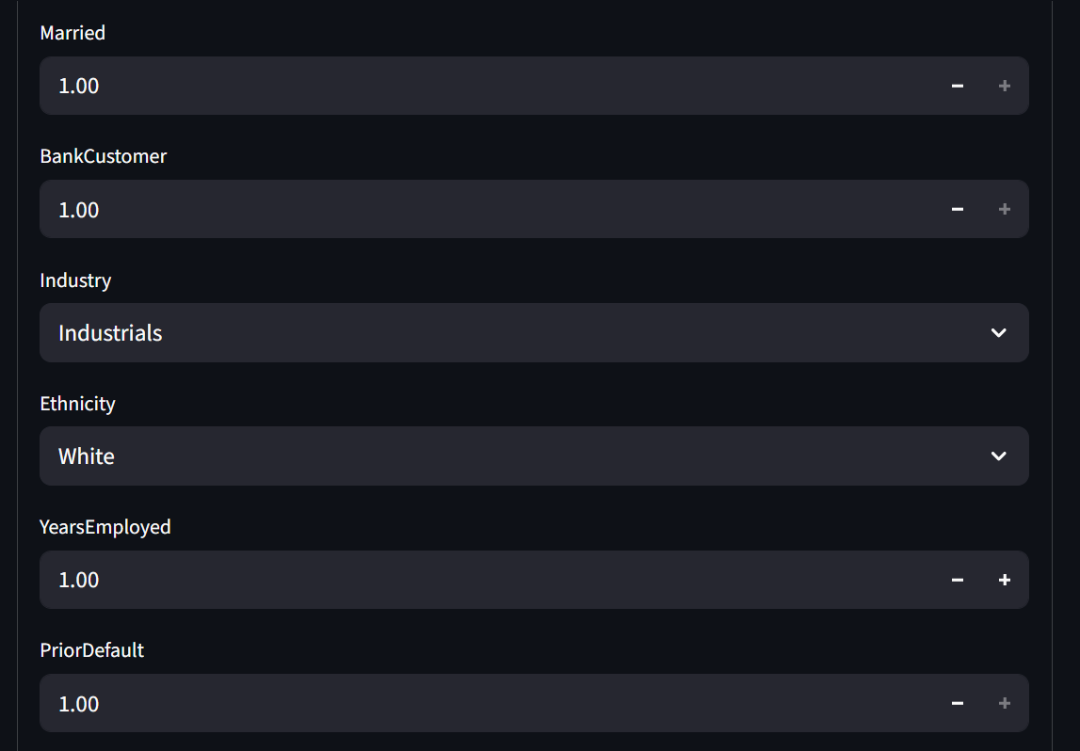
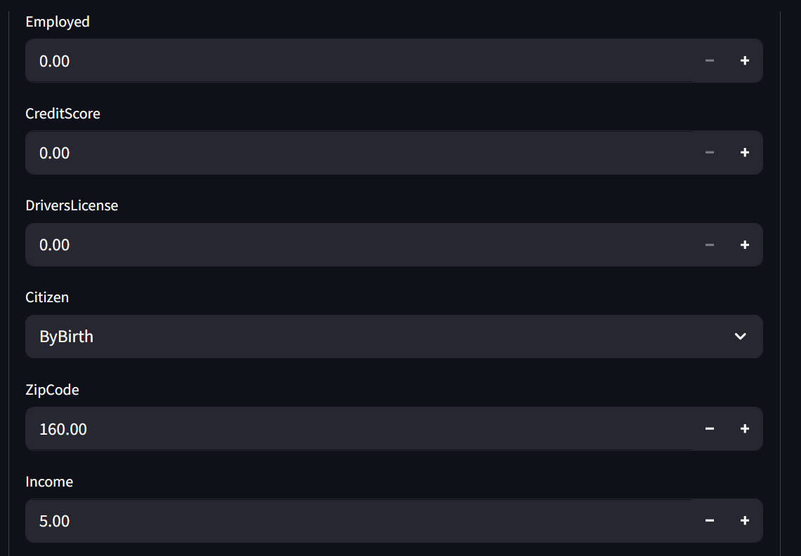
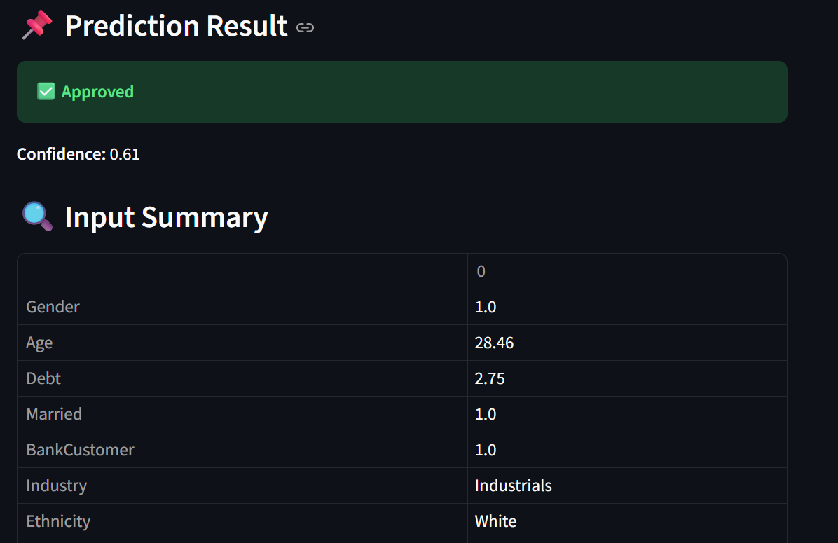

CONCLUSION
This project successfully demonstrates how machine learning can automate credit card approval decisions. The final system provides accurate predictions, reduces manual evaluation time, and improves consistency.
The end-to-end pipeline ensures smooth integration from data preprocessing to deployment through an interactive frontend.

