**Question 1: Create a Spring Web Project using Maven**

**Code:**

SpringLearnApplication.java

package com.cognizant.spring_learn;  
  
import org.springframework.boot.SpringApplication;  
import org.springframework.boot.autoconfigure.SpringBootApplication;  
  
@SpringBootApplication  
public class SpringLearnApplication {  
 public static void main(String[] args) {  
 System.*out*.println("SpringLearnApplication started...");  
 SpringApplication.*run*(SpringLearnApplication.class, args);  
 }  
}

**Spring Initialization:**

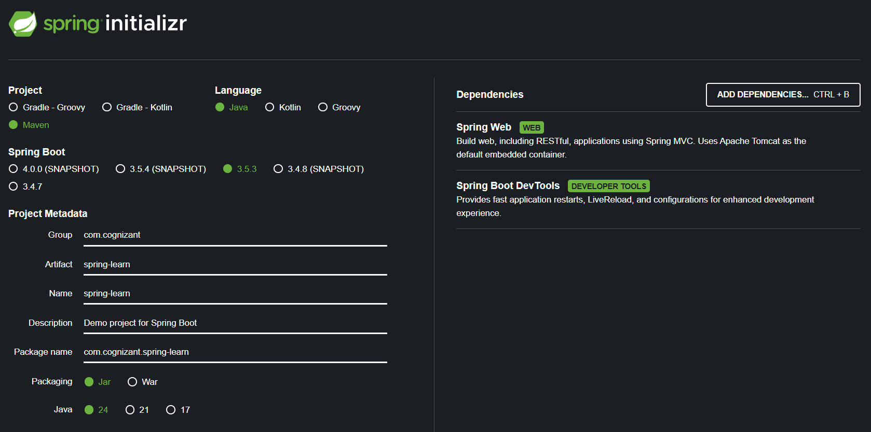

**Output:**

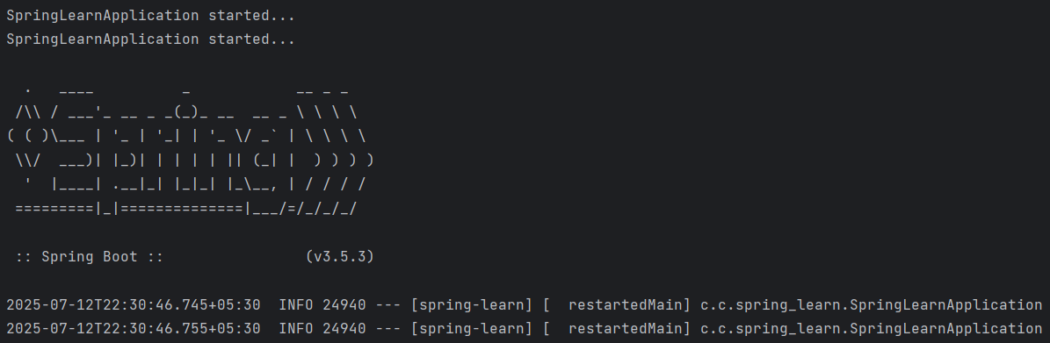

**Question 2: Spring Core – Load Country from Spring Configuration XML**

**Code:**

**Country.java**

package com.cognizant.spring_learn;  
import org.slf4j.Logger;  
import org.slf4j.LoggerFactory;  
  
public class Country {  
 private static final Logger *LOGGER* = LoggerFactory.*getLogger*(Country.class);  
 private String code;  
 private String name;  
 public Country() {  
 *LOGGER*.debug("Inside Country Constructor.");  
 }  
 public String getCode() {  
 *LOGGER*.debug("Inside getCode()");  
 return code;  
 }  
 public void setCode(String code) {  
 *LOGGER*.debug("Inside setCode()");  
 this.code = code;  
 }  
  
 public String getName() {  
 *LOGGER*.debug("Inside getName()");  
 return name;  
 }  
 public void setName(String name) {  
 *LOGGER*.debug("Inside setName()");  
 this.name = name;  
 }  
 @Override  
 public String toString() {  
 return "Country [code=" + code + ", name=" + name + "]";  
 }  
}

**country.xml:**

<?xml version="1.0" encoding="UTF-8"?>  
<beans xmlns="http://www.springframework.org/schema/beans"  
 xmlns:xsi="http://www.w3.org/2001/XMLSchema-instance"  
 xsi:schemaLocation="  
 http://www.springframework.org/schema/beans  
 http://www.springframework.org/schema/beans/spring-beans.xsd">  
  
 <bean id="country" class="com.cognizant.spring_learn.Country">  
 <property name="code" value="IN"/>  
 <property name="name" value="India"/>  
 </bean>  
</beans>

**SpringLearnApplication.java:**

package com.cognizant.spring_learn;  
import org.springframework.boot.SpringApplication;  
import org.springframework.boot.autoconfigure.SpringBootApplication;  
import org.slf4j.Logger;  
import org.slf4j.LoggerFactory;  
import org.springframework.context.ApplicationContext;  
import org.springframework.context.support.ClassPathXmlApplicationContext;  
  
@SpringBootApplication  
public class SpringLearnApplication {  
 private static final Logger *LOGGER* = LoggerFactory.*getLogger*(SpringLearnApplication.class);  
  
 public static void displayCountry() {  
 ClassPathXmlApplicationContext context = new ClassPathXmlApplicationContext("country.xml");  
 Country country = context.getBean("country", Country.class);  
 *LOGGER*.debug("Country : {}", country.toString());  
 context.close();  
 }  
 public static void main(String[] args) {  
 *LOGGER*.debug("START");  
 SpringApplication.*run*(SpringLearnApplication.class, args);  
 *displayCountry*();  
 *LOGGER*.debug("END");  
 }  
}

**Output:**

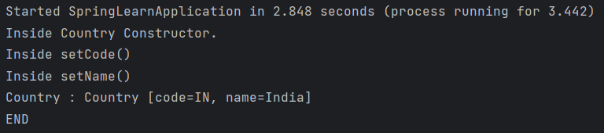

**Question 3: Hello World RESTful Web Service**

**Code:**

**HelloController.java:**

package com.cognizant.hello_controller;  
import org.slf4j.Logger;  
import org.slf4j.LoggerFactory;  
import org.springframework.web.bind.annotation.GetMapping;  
import org.springframework.web.bind.annotation.RestController;  
  
@RestController  
public class HelloController {  
 private static final Logger *LOGGER* = LoggerFactory.*getLogger*(HelloController.class);  
 @GetMapping("/hello")  
 public String sayHello() {  
 *LOGGER*.info("START: sayHello()");  
 String message = "Hello World!!";  
 *LOGGER*.info("END: sayHello()");  
 return message;  
 }  
}

**HelloControllerApplication.java:**

package com.cognizant.hello_controller;  
import org.springframework.boot.SpringApplication;  
import org.springframework.boot.autoconfigure.SpringBootApplication;  
  
@SpringBootApplication  
public class HelloControllerApplication {  
 public static void main(String[] args) {  
 SpringApplication.*run*(HelloControllerApplication.class, args);  
 }  
}

**Output:**

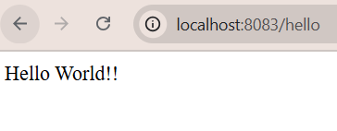

**Question 4: REST - Country Web Service**

**Code:**

**CountryController.java:**

package com.cognizant.hello_controller;  
import com.cognizant.hello_controller.Country;  
import org.slf4j.Logger;  
import org.slf4j.LoggerFactory;  
import org.springframework.context.ApplicationContext;  
import org.springframework.context.support.ClassPathXmlApplicationContext;  
import org.springframework.web.bind.annotation.RequestMapping;  
import org.springframework.web.bind.annotation.RestController;  
  
@RestController  
public class CountryController {  
 private static final Logger *LOGGER* = LoggerFactory.*getLogger*(CountryController.class);

@RequestMapping("/country")  
 public Country getCountryIndia() {  
 *LOGGER*.info("START: getCountryIndia()");  
 ApplicationContext context = new ClassPathXmlApplicationContext("country.xml");  
 Country country = (Country) context.getBean("in");  
 *LOGGER*.info("END: getCountryIndia()");  
 return country;  
 }  
}

**Country.java:**

package com.cognizant.hello_controller;  
public class Country {  
 private String code;  
 private String name;  
   
 public String getCode() {  
 return code;  
 }  
 public void setCode(String code) {  
 this.code = code;  
 }  
 public String getName() {  
 return name;  
 }  
 public void setName(String name) {  
 this.name = name; }  
}

**HelloControllerApplication.java:**

package com.cognizant.hello_controller;  
import org.springframework.boot.SpringApplication;  
import org.springframework.boot.autoconfigure.SpringBootApplication;  
  
@SpringBootApplication  
public class HelloControllerApplication {  
 public static void main(String[] args) {  
 SpringApplication.*run*(HelloControllerApplication.class, args);  
 }  
}

**Output:**

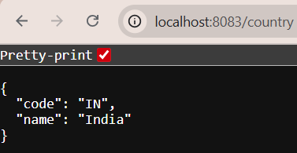

**Question 5: Get country based on country**

**Code:**

**CountryService.java:**

package com.cognizant.hello_controller.service;  
import com.cognizant.hello_controller.model.Country;  
import org.springframework.context.ApplicationContext;  
import org.springframework.context.support.ClassPathXmlApplicationContext;  
import org.springframework.stereotype.Service;  
import java.util.List;  
@Service  
public class CountryService {  
 public Country getCountry(String code) {  
 ApplicationContext context = new ClassPathXmlApplicationContext("country.xml");  
 List<Country> countryList = (List<Country>) context.getBean("countryList");  
 return countryList.stream()  
 .filter(country -> country.getCode().equalsIgnoreCase(code))  
 .findFirst()  
 .orElse(null);  
 }  
}

**CountryController.java:**

package com.cognizant.hello_controller.Controller;  
import com.cognizant.hello_controller.model.Country;  
import com.cognizant.hello_controller.service.CountryService;  
import org.slf4j.Logger;  
import org.slf4j.LoggerFactory;  
import org.springframework.beans.factory.annotation.Autowired;  
import org.springframework.web.bind.annotation.GetMapping;  
import org.springframework.web.bind.annotation.PathVariable;  
import org.springframework.web.bind.annotation.RestController;  
  
@RestController  
public class CountryController {  
 private static final Logger *LOGGER* = LoggerFactory.*getLogger*(CountryController.class);  
 @Autowired  
 private CountryService countryService;  
 @GetMapping("/countries/{code}")  
 public Country getCountry(@PathVariable String code) {  
 *LOGGER*.info("START: getCountry() with code = " + code);  
 Country country = countryService.getCountry(code);  
 *LOGGER*.info("END: getCountry()");  
 return country;  
 }  
}

**Country.java:**

package com.cognizant.hello_controller.model;  
  
public class Country {  
 private String code;  
 private String name;  
 public String getCode() {  
 return code;  
 }  
 public void setCode(String code) {  
 this.code = code;  
 }  
 public String getName() {  
 return name;  
 }  
 public void setName(String name) {  
 this.name = name;  
 }  
}

**HelloControllerApplication.java:**

package com.cognizant.hello_controller;  
import org.springframework.boot.SpringApplication;  
import org.springframework.boot.autoconfigure.SpringBootApplication;  
  
@SpringBootApplication  
public class HelloControllerApplication {  
 public static void main(String[] args) {  
 SpringApplication.*run*(HelloControllerApplication.class, args);  
 }  
}

**Output:**

