Title: Database Design

Student Name1: Sushan Bhandari
Student id:77356704

Student Name2: Sweing Nakarmi
Student id:77356776

Student Name3: Suyog Sitaula
Student id: 77356850

Page 2
Content Page
Contents
Title: Database Design 1
Introduction 3
Task 1: Conceptual Design 6
1.2 Extended Entity Relationship Diagram (EER Diagram) 7
1.3 List your attributes and identifiers here: 8
1.4 Include a list of the Validation Questions of your model 9
1.5 A definition for each entity 10
1.6 Occurrences for each entity 11
Task 2: Logical Design 16
Task 3: Physical Design 20
Task 4: Tables implementation 26
7. Bibliography 28
8. Appendixes 28

Page 3
Introduction to the Report
This is an introduction to the report for the group assessment of the Database Systems module.

The aim of this report is to create a flexible and robust database system for the LBU CARE FOUNDATION case study.

The LBU CARE FOUNDATION is a group of different care centers operated under the same umbrella whose goals are to provide quality health treatment to the elderly at a reasonable price. Currently, there are four care centers, but the company has ambitious visions to expand further.

Each care center is an independent entity overseen by a single Medical Director that is accountable for all the activities going on in the institution. Within each of these centers, a wide variety of treatments are offered to the patients, who may be either an in-patient (patients that are admitted in the hospital) or an out-patient). They are often referred to by their general practitioner.

These care centers comprise of wards that are uniquely identified by their names and can be either single bedded or twin bedded. Patients are then assigned to the beds and are given excellent treatment and hospitality by our nurses and custodians.

One of the main aspects of this database system is to organize all the distinct staff that are employed by the organization including the doctors, nurses, cleaners, porters, administrative staff and the medical directors. Each category of employee has their own unique requirement on salary, pensions, holiday rights, shifts and other important attributes. Ensuring optimal allocation of staff to different duties and shifts was one of the key goals of our project.

By simplifying roster allocation and enabling the easy assignment of workers to shifts, the proposed database infrastructure seeks to optimize these complex activities for the foundation.

Important Note
EACH screenshots must clearly show (when Apex tasks):
- Student id in Apex account
- Apex 5 – university www address
- Time and date on your machine
E.g. 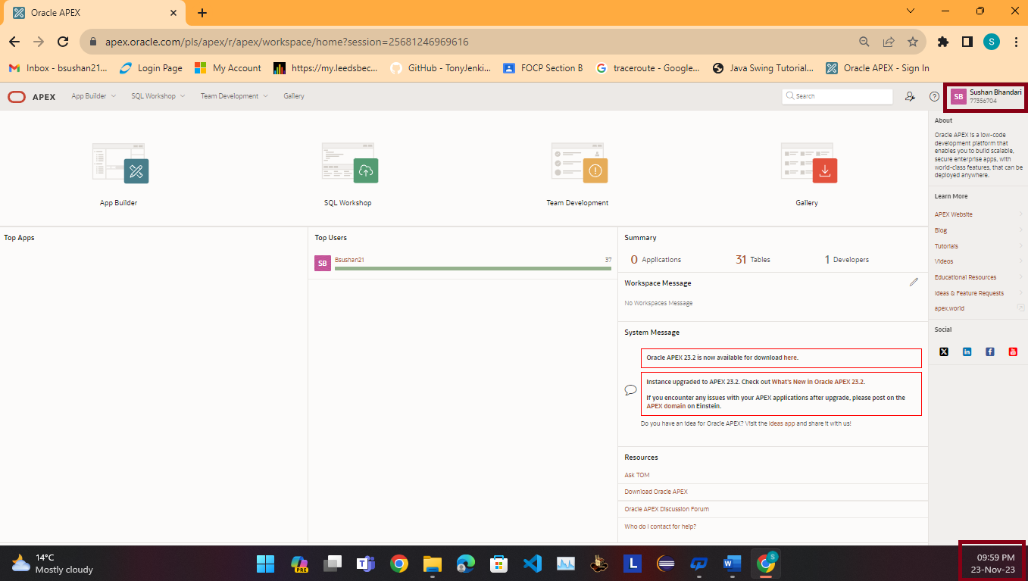

Important note: We expect to see all Recent activities in the Apex account. If these are blank or older then expected during the semester run (e.g. no activity or no

Page 4

Task 1: Conceptual Design

Assumptions about the system
- Each care center has many wards.
- A ward belongs to a single care center
- A single ward can have either one or two beds
- A bed can only be in one ward
- A bed can be occupied by multiple patients (after the previous patient discharges)
- A single patient can occupy multiple beds (if they get admitted in the care center again)
- A patient can have either one or zero General Practitioners
- A single General Practitioner can look after many patients
- A patient can make multiple appointments
- A single appointment can be made by only one patient
- One appointment can involve more than one treatment activity
- A single treatment activity requires only one appointment
- A single treatment has one payment
- A payment can be made for multiple treatments at once
- Each care center employs multiple staff members
- A staff member works in only one care center
- Non-administrative staff members may or may not be assigned to rosters every day
- A single occurrence of roster is for a single staff member
- One Medical Director manages many non-administrative staff members
- A non-administrative staff member is managed by a single Medical Director
- A doctor can conduct many appointments
- A particular appointment can be done by a single doctor
- A single nurse can be assigned to multiple wards depending on the day
- A ward can have many nurses assigned to it depending on the ward type and number of beds occupied

1.2 Extended Entity Relationship Diagram (EER Diagram)

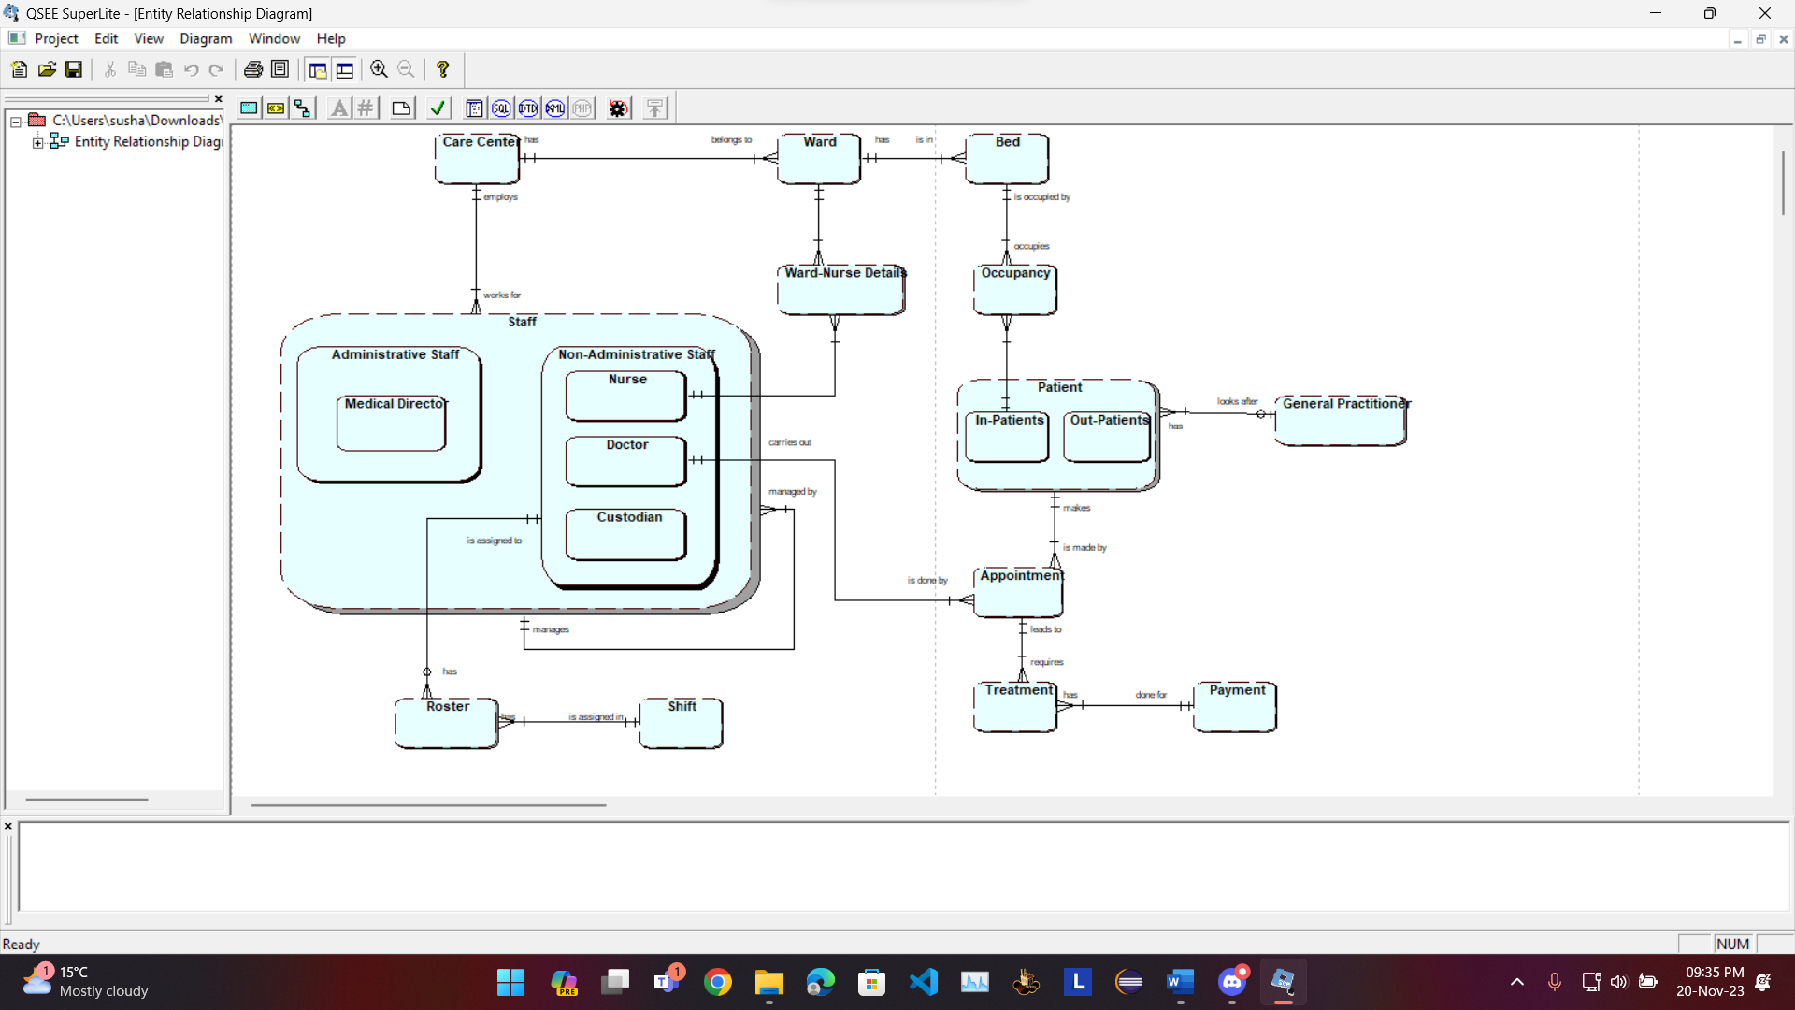
(Please make sure that we can see your diagram, easily. Use QSEE to design your EERD)

1.3 List your attributes and identifiers here:
Company (Company_id, Company_Name, Address, Phone, Country…
Cd( cd_id, … , price
- Care Centre (CareCentre_id, Name, Address, Phone_Number, Email)
- Ward ( Ward_id, Ward_Name, Ward_Type)
- Bed (Bed_id, Bed_Type)
- Patient (Patients_id, Name, Address, Phone_Number, Gender, Blood_Group, Diagnosis) • In_Patient() • Out_Patient()
- Staff (Staff_id, Staff_Name, Address, Phone_Number, Email, Job_Title, Holiday)
- Administrative Staff ()
Medical Director (Qualification, Salary, Pension)
- Non-Administrative Staff ()
Nurse (Qualification, Salary, Pension)
Custodian (hourly_salary)
Doctor (Qualification, Specialization, Salary, Pension)
- General Practitioner (Practitioner_id, Name, Address, Phone_Number, Email, Qualification)
- Appointment (Appointment_id, Appointment_Date, Appointment_Time, Duration, Details)
- Treatment (Treatment_id, Treatment_Date, Details, Treatment_Type, Treatment_Time)
- Payment (Payment_id, Amount, Depositor_Name, PhoneNumber, Date, Payment_Method)
- Roster (Roster_id, Date, Day, Hours Worked)
- Shift (Shift_id, Shift Type, StartTime, EndTIme)
- Ward-Nurse Details (Ward-NurseDetail_id, Start Date, End Date)
- Occupancy (Occupancy_id, Admission Date, Discharge Date)

1.4 Include a list of the Validation Questions of your model here:
- Ensure a unique email for each staff member:
ALTER TABLE Staff ADD CONSTRAINT unique_staff_email UNIQUE (Email);
- Ensure the date of discharge is after the date of admission in the Occupancy table:
ALTER TABLE Occupancy ADD CONSTRAINT valid_dates CHECK (Admission_Date < Discharge_Date);
- Ensure the duration of treatment is a positive value:
ALTER TABLE Treatment ADD CONSTRAINT positive_duration CHECK (Duration > 0);
- Ensure the phone numbers are of a certain length (for example, 10 digits):
ALTER TABLE Care_Center ADD CONSTRAINT phone_length_cc CHECK (LENGTH(Phone_Number) = 10); ALTER TABLE Staff ADD CONSTRAINT phone_length_staff CHECK (LENGTH(Phone_Number) = 10);
- Ensure that the appointment date is in the future:
ALTER TABLE Appointment ADD CONSTRAINT future_appointment_date CHECK (Appointment_Date > CURRENT_DATE);
- Ensure the Shift start time is before the end time:
ALTER TABLE Shift ADD CONSTRAINT valid_shift_time CHECK (Start_time < End_Time);

1.5 A definition for each entity…..
- Care Center: It holds details like address, phone number etc. about a particular care center.
- Ward: It holds all the information about a ward.
- Bed: It holds details about a particular bed in a ward.
- Staff: Parent Entity for all the employees working in a care center.
  - Administrative Staff: Sub-type for the staff entity .
    - Medical Director: Holds details about the director that manages a care center
  - Non-Administrative Staff: Sub-type for the staff entity
    - Doctor: Holds details about doctor
    - Nurse: Holds details about nurse
    - Custodian: Holds details about the custodians like cleaners, porters etc.
- Ward-Nurse Details: Contains information about the assignment of nurses to different wards
- Occupancy: Contains information about the occupation of beds by patients with the required dates
- Patient: Parent entity to hold info about patients
  - In-Patient: Sub-type that holds information about patients admitted in the care center
  - Out-Patient: Sub-type that holds information about patients not admitted in the care center
- General Practitioner: Stores data about the personal physician of a patient
- Roster: Entity to store information about the shift details about a staff for each day
- Shift: Entity to store information about the different types of shifts available (earlies, lates or nights)
- Appointment: Holds data about an appointment booked with a doctor
- Treatment: Holds data about the type of treatment that the patient undergoes
- Payment: Holds details about the payment method and amount

1.6 Occurrences for each entity...
- Care Center
Care_Center _Id | Name | Address | Phone | Email
1 | Sushan Bhandari | Chandaragiri- 13 | 9860456784 | Sushan@gmail.com
2 | Rajesh Hamal | Kathmandu_13 | 9856123434 | Rajesh@gmail.com

Ward
Ward _Id | Care_Center_Id | Ward_Name | Ward_Type
1 | 1 | General Surgery Ward | Surgical
2 | 2 | ICU | Critical Care

- Ward_Nurse_details
Ward_Nurse_Details_Id | Ward_Id | Staff_Id | Start_Date | End_date
1 | 1 | 1 | 2023-4-6 | 2023-6-7
2 | 2 | 2 | 2022-2-9 | 2022-8-7

- Bed
Bed_Id | Ward-Id | Bed_Type
1 | 1 | Single
2 | 2 | Double

- Occupancy
Occupancy_Id | Bed_Id | Patient_id | Admission_Date | Discharge_Date
1 | 1 | 1 | 2023-2-3 | 2023-2-6
2 | 2 | 2 | 2022-1-2 | 2022-1-12

- Patient
Patient_Id | Practitioner_Id | Name | Address | Phone_Number | Gender | Blood_Group | Diagnosis
1 | 1 | Hanuman Deula | Pokhara-13 | 9867903454 | Male | A+ | Type 2
2 | 2 | Lola Magar | Chitwan-13 | 98456789 | Female | B- | Pneumonia

- In_Patient
Patient_id
1
2

- Out_Patients
Patient_id

- General_Practitioner
Practitioner  _Id | Name | Address | Phone_Number | Email | Qualification
1 | Suyog Shankala | Jhapa-13 | 9860673456 | Suyog@gmail.com | null
2 | Sushan Kc | Kakarvita-1 | 9860672345 | sushan@gmail.com | null

- Appointment
Appointment  _Id | Patients_  Id | Staff  _Id | Appointment  _Date | Appointment  _Time | Duration | Details
1 | P001 | S001 | 2023-3-5 | 15:00 | 20 | Routine checkup
2 | P001 | S002 | 2023-3-5 | 12:00 | 30 | followup

- Treatment
Treatment  _ID | Appointment  _Id | Payment_id | Treatment  _Date | Details | Treatment_Type
1 | 1 | 1 | 2023-4-20 | acnes | Surgery
2 | 2 | 2 | 2023-2-28 | Mind | Medication

- Payment
Payment_ID | Amount | Depositer_Name | Phone_Number | Deposit_Date | Payment_Method
1 | 21,000 | Sam kc | 9674534541 | 2023-01-05 | Cheque
2 | 25,000 | Ram kumar | 9878674531 | 2023-01-07 | PhonePay

- Staff
Staff_Id | CareCenter_ID | Staff_  Name | Address | Phone_  Number | Email | Holiday | Job_Title
1 | 1 | Dilip | Nakhu | 9857563245 | dilip@gmiaL.COM | 23 | Nurse
2 | 2 | Deepa | Dallu | 9823457689 | deepa@gmail.com | 18 | doctor

- Administrative_Staff
Staff_Id
1
2

- Medical_Director
Staff_ID | Qualification | Pension | Salary
1 | MD | 1500 | 50000
2 | PHD | 1800 | 60000

- Non_Administrative_Staff
Staff_Id
1
2

- Nurse
Staff_Id | Pension | Qualification | Salary
1 | 800 | Null | 15000
2 | 600 | Null | 20000

- Doctor
Staff_Id | Qualification | Specialization | Pension | Salary
1 | MD | Cardology | 1000 | 50000
2 | MBBS | Radiology | 500 | 20000

- Custodian
Hourly_Salary | Staff_Id
20 | 1
28 | 2

- Rooster
Rooster_Id | Staff_Id | Shift_Id | Dates | Day | Hours_worked
1 | 1 | 1 | 2022-2-1 | Saturday | 6 hours
2 | 2 | 2 | 2022-2-3 | MOnday | 8 hours

- Shift
Shift_Id | Shift_Type | Start_Time | End_Time
1 | Day | 10:00 | 15:00
2 | Morning | 5: 00 | 9:00

Task 2: Logical Design
LIST of tables and attributes, defining all Primary Keys and any Foreign Keys(s) derived from the EERD.
Task 2: Logical Design 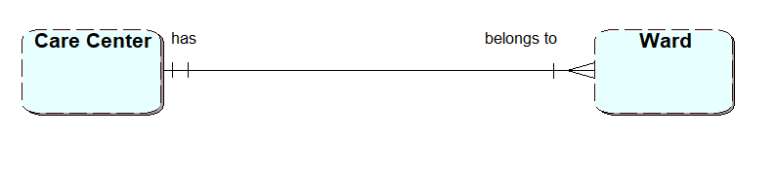

- Care Centre (CareCentre_id, Name, Address, Phone_Number, Email)
- Ward ( Ward_id, Ward_Name, Ward_Type, CareCentre_id)

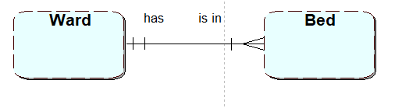
- Ward ( Ward_id, Ward_Name, Ward_Type, CareCentre_id)
- Bed (Bed_id, Bed_Type, Ward_id)

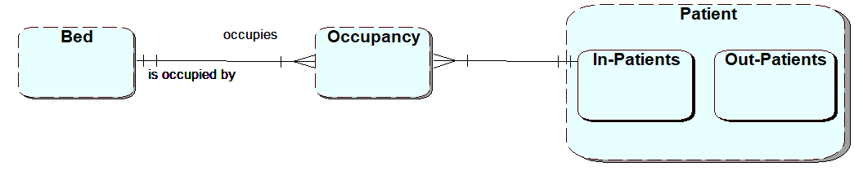

- Bed (Bed_id, Bed_Type, Ward_id)
- Occupancy (Occupancy_id, ,Start_Date, End_Date , Bed_id, Patient_id)
- Patient (Patient_id, Name, Address, Phone_Number, Blood_Group, Diagnosis)
  - In_Patient(Patient_id)
  - Out_Patient(Patient_id)

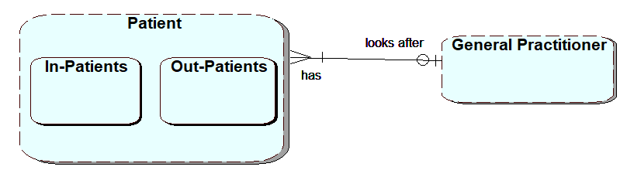

- Patient (Patient_id, Name, Address, Phone_Number, Blood_Group, Diagnosis, Practitioner_id)
- General_Practitioner(Practitioner_id, Name, Address, Phone, Email, Qualification)

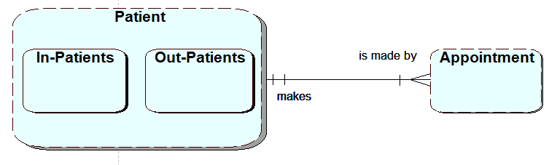
- Patient (Patient_id, Name, Address, Phone_Number, Blood_Group, Diagnosis, Practitioner_id)
- Appointment (Appointment_id, Appointment_Date, Appointment_Time, Duration, Details, Patient_id)

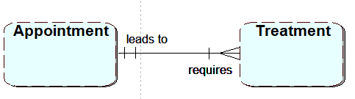
- Appointment (Appointment_id, Appointment_Date, Appointment_Time, Duration, Details, Patient_id)
- Treatment (Treatment_id, Treatment_Date, Details, Treatment_Type, Treatment_Time, Appointment_id)

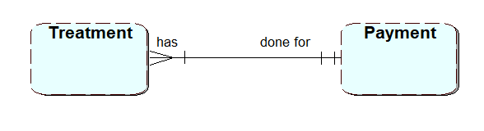
- Treatment (Treatment_id, Treatment_Date, Details, Treatment_Type, Treatment_Time, Appointment_id, Payment_id)
- Payment (Payment_id, Amount, Depositor_Name, Phone_Number, Date, Method)

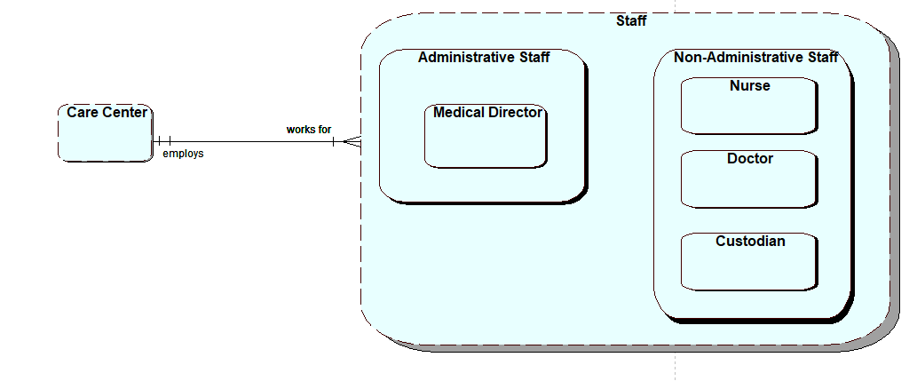
- Care Centre (CareCentre_id, Name, Address, Phone_Number, Email)
- Staff (Staff_id, Staff_Name, Address, Phone_Number, Email, Job_Title, Holiday, CareCenter_id)
  - Administrative_Staff (Staff_id)
    - Medical_Director (Staff_id, Qualification, Salary, Pension)
  - Non_Administrative_Staff (Staff_id)
    - Nurse (Staff_id, Qualification, Pension)
    - Doctor (Staff_id, Qualification, Specialization, Pension)
    - Custodian (Staff_id, hourly_wage)

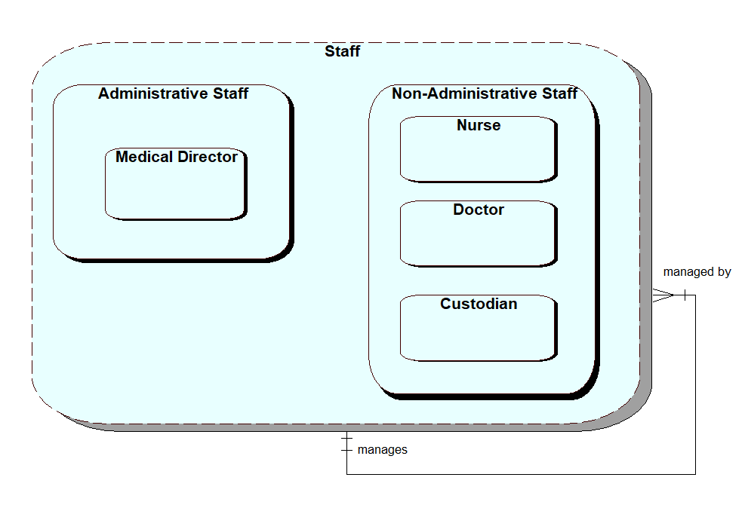
- Staff (Staff_id, Staff_Name, Address, Phone_Number, Email, Job_Title, Holiday, CareCenter_id, Staff_id)

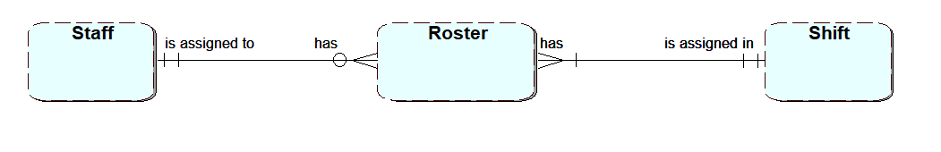
- Staff (Staff_id, Staff_Name, Address, Phone_Number, Email, Job_Title, Holiday, CareCenter_id, Staff_id)
- Roster (Roster_id, Date, Day, Hours_Worked, Staff_id, Shift_id)
- Shift (Shift_id, Shift Type, Start_Time, End_TIme)

Task 3: Physical Design

Check documents on physical design, key points that you can bring to this section and discuss as part of this task.
-- Drop tables if they exist
DROP TABLE Custodian CASCADE CONSTRAINTS;
DROP TABLE Doctor CASCADE CONSTRAINTS;
DROP TABLE Nurse CASCADE CONSTRAINTS;
DROP TABLE Non_Administrative_Staff CASCADE CONSTRAINTS;
DROP TABLE Medical_Director CASCADE CONSTRAINTS;
DROP TABLE Administrative_Staff CASCADE CONSTRAINTS;
DROP TABLE Staff CASCADE CONSTRAINTS;
DROP TABLE Payment CASCADE CONSTRAINTS;
DROP TABLE Treatment CASCADE CONSTRAINTS;
DROP TABLE Appointment CASCADE CONSTRAINTS;
DROP TABLE General_Practitioner CASCADE CONSTRAINTS;
DROP TABLE Out_Patients CASCADE CONSTRAINTS;
DROP TABLE In_Patient CASCADE CONSTRAINTS;
DROP TABLE Patient CASCADE CONSTRAINTS;
DROP TABLE Occupancy CASCADE CONSTRAINTS;
DROP TABLE Bed CASCADE CONSTRAINTS;
DROP TABLE Ward_Nurse_Details CASCADE CONSTRAINTS;
DROP TABLE Ward CASCADE CONSTRAINTS;
DROP TABLE Care_Center CASCADE CONSTRAINTS;

-- Create Care Center table
CREATE TABLE Care_Center (
Care_Center_Id NUMBER PRIMARY KEY,
Name VARCHAR2(50),
Address VARCHAR2(100),
Phone VARCHAR2(15),
Email VARCHAR2(50)
);

-- Create Ward table
CREATE TABLE Ward (
Ward_Id NUMBER PRIMARY KEY,
Care_Center_Id NUMBER REFERENCES Care_Center(Care_Center_Id),
Ward_Name VARCHAR2(50),
Ward_Type VARCHAR2(50)
);

-- Create Ward Nurse Details table
CREATE TABLE Ward_Nurse_Details (
Ward_Nurse_Details_Id NUMBER PRIMARY KEY,
Ward_Id NUMBER REFERENCES Ward(Ward_Id),
Staff_Id NUMBER,
Start_Date DATE,
End_Date DATE
);

-- Create Bed table
CREATE TABLE Bed (
Bed_Id NUMBER PRIMARY KEY,
Ward_Id NUMBER REFERENCES Ward(Ward_Id),
Bed_Type VARCHAR2(50)
);

-- Create Occupancy table
CREATE TABLE Occupancy (
Occupancy_Id NUMBER PRIMARY KEY,
Bed_Id NUMBER REFERENCES Bed(Bed_Id),
Patient_Id NUMBER,
Admission_Date DATE,
Discharge_Date DATE
);

-- Create Patient table
CREATE TABLE Patient (
Patient_Id NUMBER PRIMARY KEY,
Practitioner_Id NUMBER,
Name VARCHAR2(50),
Address VARCHAR2(100),
Phone_Number VARCHAR2(15),
Gender VARCHAR2(10),
Blood_Group VARCHAR2(5),
Diagnosis VARCHAR2(50)
);

-- Create In_Patient table
CREATE TABLE In_Patient (
Patient_Id NUMBER PRIMARY KEY REFERENCES Patient(Patient_Id)
);

-- Create Out_Patients table
CREATE TABLE Out_Patients (
Patient_Id NUMBER PRIMARY KEY REFERENCES Patient(Patient_Id)
);

-- Create General Practitioner table
CREATE TABLE General_Practitioner (
Practitioner_Id NUMBER PRIMARY KEY,
Name VARCHAR2(50),
Address VARCHAR2(100),
Phone_Number VARCHAR2(15),
Email VARCHAR2(50),
Qualification VARCHAR2(50)
);

-- Create Appointment table
CREATE TABLE Appointment (
Appointment_Id NUMBER PRIMARY KEY,
Patient_Id NUMBER REFERENCES Patient(Patient_Id),
Staff_Id NUMBER,
Appointment_Date DATE,
Appointment_Time VARCHAR2(10),
Duration NUMBER,
Details VARCHAR2(100)
);

-- Create Treatment table
CREATE TABLE Treatment (
Treatment_Id NUMBER PRIMARY KEY,
Appointment_Id NUMBER REFERENCES Appointment(Appointment_Id),
Payment_Id NUMBER,
Treatment_Date DATE,
Details VARCHAR2(100),
Treatment_Type VARCHAR2(50)
);

-- Create Payment table
CREATE TABLE Payment (
Payment_Id NUMBER PRIMARY KEY,
Amount NUMBER,
Depositer_Name VARCHAR2(50),
Phone_Number VARCHAR2(15),
Deposit_Date DATE,
Payment_Method VARCHAR2(50)
);

-- Create Staff table
CREATE TABLE Staff (
Staff_Id NUMBER PRIMARY KEY,
CareCenter_ID NUMBER REFERENCES Care_Center(Care_Center_Id),
Staff_Name VARCHAR2(50),
Address VARCHAR2(100),
Phone_Number VARCHAR2(15),
Email VARCHAR2(50),
Holiday NUMBER,
Job_Title VARCHAR2(50)
);

-- Create Administrative Staff table
CREATE TABLE Administrative_Staff (
Staff_Id NUMBER PRIMARY KEY REFERENCES Staff(Staff_Id)
);

-- Create Medical Director table
CREATE TABLE Medical_Director (
Staff_Id NUMBER PRIMARY KEY REFERENCES Staff(Staff_Id),
Qualification VARCHAR2(50),
Pension NUMBER,
Salary NUMBER
);

-- Create Non-Administrative Staff table
CREATE TABLE Non_Administrative_Staff (
Staff_Id NUMBER PRIMARY KEY REFERENCES Staff(Staff_Id)
);

-- Create Nurse table
CREATE TABLE Nurse (
Staff_Id NUMBER PRIMARY KEY REFERENCES Staff(Staff_Id),
Pension NUMBER,
Qualification VARCHAR2(50),
Salary NUMBER
);

-- Create Doctor table
CREATE TABLE Doctor (
Staff_Id NUMBER PRIMARY KEY REFERENCES Staff(Staff_Id),
Qualification VARCHAR2(50),
Specialization VARCHAR2(50),
Pension NUMBER,
Salary NUMBER
);

-- Create Custodian table
CREATE TABLE Custodian (
Hourly_Salary NUMBER,
Staff_Id NUMBER PRIMARY KEY REFERENCES Staff(Staff_Id)
);

Task 4: Tables implementation

Screenshot of code running successfully.
Each member has to include screenshot of running it in their own Oracle Apex environment, uploaded as part of the group submission.
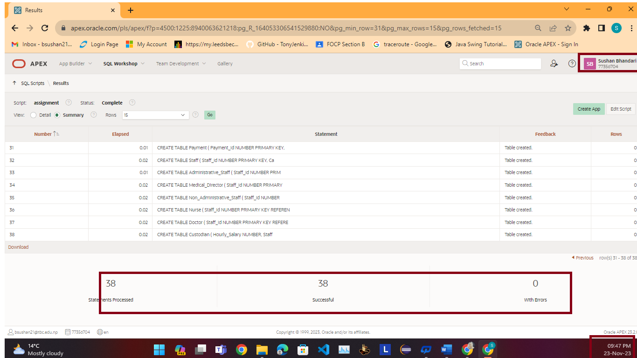

--make sure you run test...
-- evidence screenshots of code running.
-- Also, include scripts code as shown below;

-- Insert data into Care Center table
INSERT INTO Care_Center (Care_Center_Id, Name, Address, Phone, Email)
VALUES (1, 'Sushan Bhandari Care Center', 'Chandragiri-13', '9860456784', 'sushan@gmail.com');

INSERT INTO Care_Center (Care_Center_Id, Name, Address, Phone, Email)
VALUES (2, 'Rajesh Hamal Care Center', 'Kathmandu-13', '9856123434', 'rajesh@gmail.com');

-- Insert data into Ward table
INSERT INTO Ward (Ward_Id, Care_Center_Id, Ward_Name, Ward_Type)
VALUES (1, 1, 'General Surgery Ward', 'Surgical');

INSERT INTO Ward (Ward_Id, Care_Center_Id, Ward_Name, Ward_Type)
VALUES (2, 2, 'ICU', 'Critical Care');

-- Insert data into Ward_Nurse_Details table
INSERT INTO Ward_Nurse_Details (Ward_Nurse_Details_Id, Ward_Id, Staff_Id, Start_Date, End_Date)
VALUES (1, 1, 1, TO_DATE('2023-04-06', 'YYYY-MM-DD'), TO_DATE('2023-06-07', 'YYYY-MM-DD'));

INSERT INTO Ward_Nurse_Details (Ward_Nurse_Details_Id, Ward_Id, Staff_Id, Start_Date, End_Date)
VALUES (2, 2, 2, TO_DATE('2022-02-09', 'YYYY-MM-DD'), TO_DATE('2022-08-07', 'YYYY-MM-DD'));

-- Insert data into Bed table
INSERT INTO Bed (Bed_Id, Ward_Id, Bed_Type)
VALUES (1, 1, 'Single');

INSERT INTO Bed (Bed_Id, Ward_Id, Bed_Type)
VALUES (2, 2, 'Double');

-- Insert data into Occupancy table
INSERT INTO Occupancy (Occupancy_Id, Bed_Id, Patient_Id, Admission_Date, Discharge_Date)
VALUES (1, 1, 1, TO_DATE('2023-02-03', 'YYYY-MM-DD'), TO_DATE('2023-02-06', 'YYYY-MM-DD'));

INSERT INTO Occupancy (Occupancy_Id, Bed_Id, Patient_Id, Admission_Date, Discharge_Date)
VALUES (2, 2, 2, TO_DATE('2022-01-02', 'YYYY-MM-DD'), TO_DATE('2022-01-12', 'YYYY-MM-DD'));

-- Insert data into Patient table
INSERT INTO Patient (Patient_Id, Practitioner_Id, Name, Address, Phone_Number, Gender, Blood_Group, Diagnosis)
VALUES (1, 1, 'Hanuman Deula', 'Pokhara-13', '9867903454', 'Male', 'A+', 'Type 2');

INSERT INTO Patient (Patient_Id, Practitioner_Id, Name, Address, Phone_Number, Gender, Blood_Group, Diagnosis)
VALUES (2, 2, 'Lola Magar', 'Chitwan-13', '98456789', 'Female', 'B-', 'Pneumonia');

-- Insert data into In_Patient table
INSERT INTO In_Patient (Patient_Id) VALUES (1);

INSERT INTO In_Patient (Patient_Id) VALUES (2);

-- Insert data into Out_Patients table
-- (Assuming there are no outpatients for the given sample data)

-- Insert data into General_Practitioner table
INSERT INTO General_Practitioner (Practitioner_Id, Name, Address, Phone_Number, Email, Qualification)
VALUES (1, 'Suyog Shankala', 'Jhapa-13', '9860673456', 'suyog@gmail.com', 'MD');

INSERT INTO General_Practitioner (Practitioner_Id, Name, Address, Phone_Number, Email, Qualification)
VALUES (2, 'Sushan Kc', 'Kakarvita-1', '9860672345', 'sushan@gmail.com', NULL);

-- Insert data into Appointment table
INSERT INTO Appointment (Appointment_Id, Patient_Id, Staff_Id, Appointment_Date, Appointment_Time, Duration, Details)
VALUES (1, 1, 1, TO_DATE('2023-03-05', 'YYYY-MM-DD'), '15:00', 20, 'Routine checkup');

INSERT INTO Appointment (Appointment_Id, Patient_Id, Staff_Id, Appointment_Date, Appointment_Time, Duration, Details)
VALUES (2, 1, 2, TO_DATE('2023-03-05', 'YYYY-MM-DD'), '12:00', 30, 'Follow-up');

-- Insert data into Treatment table
INSERT INTO Treatment (Treatment_Id, Appointment_Id, Payment_Id, Treatment_Date, Details, Treatment_Type)
VALUES (1, 1, 1, TO_DATE('2023-04-20', 'YYYY-MM-DD'), 'Acnes', 'Surgery');

INSERT INTO Treatment (Treatment_Id, Appointment_Id, Payment_Id, Treatment_Date, Details, Treatment_Type)
VALUES (2, 2, 2, TO_DATE('2023-02-28', 'YYYY-MM-DD'), 'Mind', 'Medication');

-- Insert data into Payment table
INSERT INTO Payment (Payment_Id, Amount, Depositer_Name, Phone_Number, Deposit_Date, Payment_Method)
VALUES (1, 21000, 'Sam kc', '9674534541', TO_DATE('2023-01-05', 'YYYY-MM-DD'), 'Cheque');

INSERT INTO Payment (Payment_Id, Amount, Depositer_Name, Phone_Number, Deposit_Date, Payment_Method)
VALUES (2, 25000, 'Ram kumar', '9878674531', TO_DATE('2023-01-07', 'YYYY-MM-DD'), 'PhonePay');

-- Insert data into Staff table
INSERT INTO Staff (Staff_Id, CareCenter_ID, Staff_Name, Address, Phone_Number, Email, Holiday, Job_Title)
VALUES (1, 1, 'Dilip', 'Nakhu', '9857563245', 'dilip@gmail.com', 23, 'Nurse');

INSERT INTO Staff (Staff_Id, CareCenter_ID, Staff_Name, Address, Phone_Number, Email, Holiday, Job_Title)
VALUES (2, 2, 'Deepa', 'Dallu', '9823457689', 'deepa@gmail.com', 18, 'Doctor');

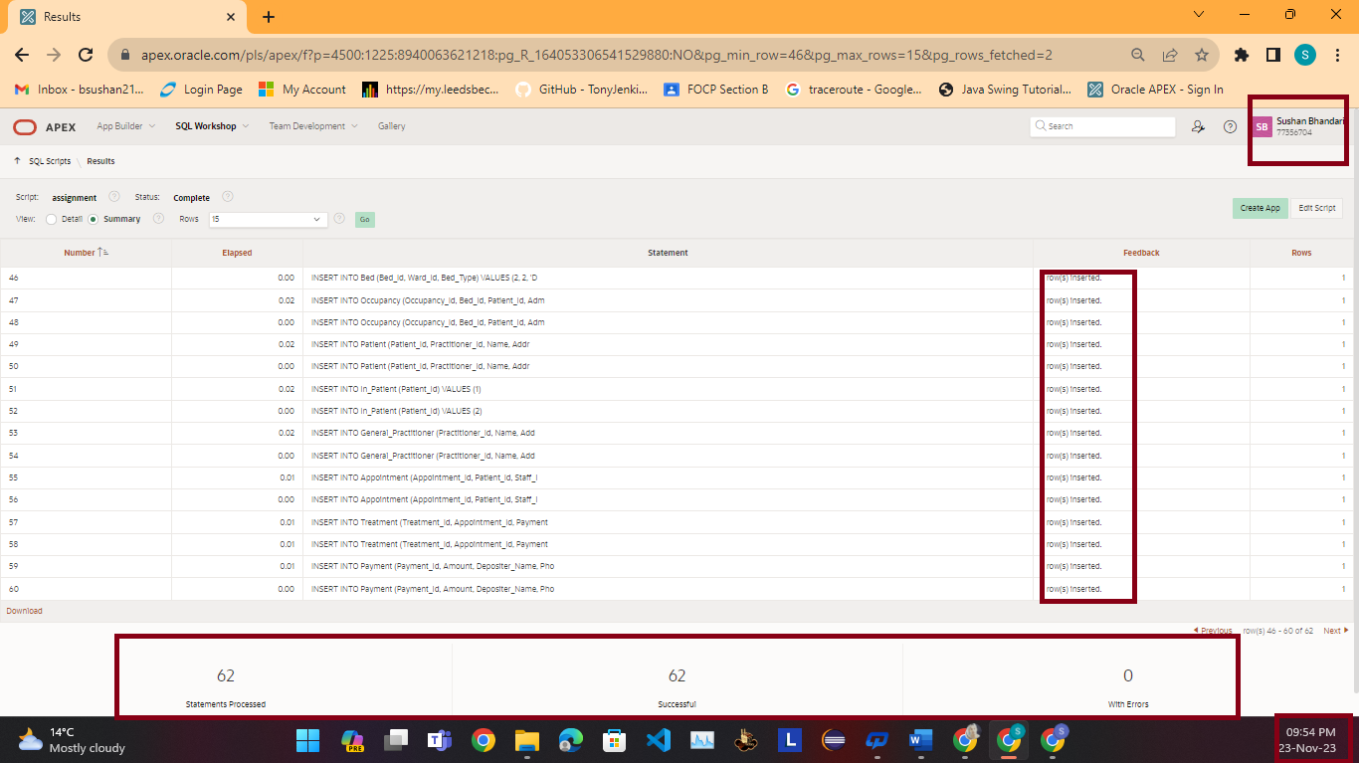

7. Bibliography

LBU Harvard style

- Molinaro, A. (2005) SQL Cookbook, 1005 Gravenstein Highway North: O’reilly Media.
- W3Schools (2023) Sql Tutorial. [Online]. Place of publication or publisher. Available from: https://www.w3schools.com/sql/ [Accessed 20th November 2023].
- Lucid Chart (2023) What is an ERD. [Online]. Place of publication or publisher. Available from: https://www.lucidchart.com/pages/er-diagrams [Accessed 21st November 2023].
- JavaTPoint (2023) DBMS Normalization. [Online]. Place of publication or publisher. Available from: https://www.javatpoint.com/dbms-normalization [Accessed 21st November 2023].
- GeeksForGeeks (2023) Normal Forms in DBMS. [Online]. Place of publication or publisher. Available from: https://www.geeksforgeeks.org/normal-forms-in-dbms/ [Accessed 22nd November 2023].
- [8:28 PM]

8. Appendixes
If any….

YOUR NAME: Sushan Bhandari
THE OTHER GROUP MEMBERS |  | SCORE (-10…10)
Sweing Nakarmi |  | 0
Suyog Situala |  | 0
 | TOTAL | 0 (ZERO)

