

**TRIBHUVAN UNIVERSITY**

**INSTITUTE OF ENGINEERING**

**PULCHOWK CAMPUS**

**A**

**Assignment On**

**File Handeling In Python**

**SUBMITTED BY:**

**SUSHANT THAKUR (081BEL092)**

**SUBMITTED TO:**

**PC sir**

**DEPARTMENT OF ELECTRONICS & COMPUTER ENGINEERING**

**1. Write the following records into file grocery.txt:  
records = [  
{'name':"rice","price":120,"category":"grocery"},  
{'name':"sugar","price":220,"category":"grocery"},  
{'name':"wheat","price":320,"category":"grocery"},  
{'name':"rcereal","price":420,"category":"grocery"},  
]  
  
with headings: ID NAME PRICE CATEGORY  
  
again, read the written records from same file and display the contents as above recods.**

**CODE:**

records = [

{'name': "rice", 'price': 120, 'category': "grocery"},

{'name': "sugar", 'price': 220, 'category': "grocery"},

{'name': "wheat", 'price': 320, 'category': "grocery"},

{'name': "rcereal", 'price': 420, 'category': "grocery"},

]

with open("grocery.txt", "w") as f:

f.write("ID\tNAME\tPRICE\tCATEGORY\n")

for i, item in enumerate(records, 1):

f.write(f"{i}\t{item['name']}\t{item['price']}\t{item['category']}\n")

new_records = []

with open("grocery.txt", "r") as f:

lines = f.readlines()[1:] # skip header

for line in lines:

parts = line.strip().split("\t")

if len(parts) == 4:

name = parts[1]

price = int(parts[2])

category = parts[3]

new_records.append(

{'name': name, 'price': price, 'category': category})

print("records = [")

for item in new_records:

print(

f"{{'name':\"{item['name']}\",\"price\":{item['price']},\"category\":\"{item['category']}\"}},")

print("]")

**OUTPUT:**

grocery.txt

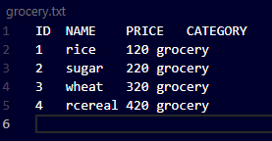

Program output:

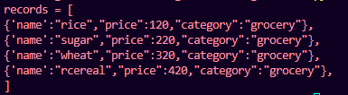

**2. Write a python code to explain the concept of seek() method in file handling.**

**CODE:**

with open("sample.txt", "w") as f:

f.write("Hello, this is a test file.\nLine 2 here.")

with open("sample.txt", "r") as f:

print("First read:")

print(f.read(5))

f.seek(0)

print("\nAfter seek(0), read again:")

print(f.read(5))

f.seek(7)

print("\nAfter seek(7), read next 9 characters:")

print(f.read(9))

**OUTPUT:**

