

**TRIBHUVAN UNIVERSITY**

**INSTITUTE OF ENGINEERING**

PULCHOWK CAMPUS

A REPORT ON

Usage of NumPy (Lab-7)

SUBMITTED BY:

SURENDRA TIRUWA (081BEL091)

SUBMITTED TO:

DEPARTMENT OF ELECTRONICS & COMPUTER ENGINEERING

**1. NumPy Built-in Functions with Examples**

## numpy.floor

Rounds down elements of an array to the nearest integer.

Example:

import numpy as np  
arr = np.array([1.7, 2.9, -3.1])  
print(np.floor(arr))

Output:



## numpy.ceil

Rounds up elements of an array to the nearest integer.

Example:

arr = np.array([1.2, 2.8, -3.5])  
print(np.ceil(arr))

Output:



## numpy.round

Rounds elements of an array to the nearest integer or specified decimals.

Example:

arr = np.array([1.234, 2.678, 3.456])  
print(np.round(arr, 2))

Output:



## numpy.clip

Limits values in an array between given minimum and maximum.

Example:

arr = np.array([1, 5, 8, 10])  
print(np.clip(arr, 3, 7))

Output:



## numpy.linspace

Creates evenly spaced numbers over a specified interval.

Example:

print(np.linspace(0, 1, 5))

Output:



## numpy.logspace

Creates numbers spaced evenly on a log scale.

Example:

print(np.logspace(1, 3, 3))

Output:



## numpy.identity

Creates an identity matrix of given size.

Example:

print(np.identity(3))

Output:



## numpy.eye

Creates a 2D array with ones on the diagonal and zeros elsewhere.

Example:

print(np.eye(3, 4))

Output:



## numpy.all

Checks if all elements of an array are True.

Example:

arr = np.array([True, True, False])  
print(np.all(arr))

Output:



## numpy.any

Checks if any element of an array is True.

Example:

arr = np.array([0, 0, 1])  
print(np.any(arr))

Output:



## numpy.argmax

Returns the index of the maximum element.

Example:

arr = np.array([1, 3, 7, 2])  
print(np.argmax(arr))

Output:



## numpy.argmin

Returns the index of the minimum element.

Example:

arr = np.array([1, 3, 7, 2])  
print(np.argmin(arr))

Output:



## numpy.where

Returns indices where condition is True.

Example:

arr = np.array([10, 20, 30, 40])  
print(np.where(arr > 20))

Output:



## numpy.sort

Sorts an array.

Example:

arr = np.array([3, 1, 2])  
print(np.sort(arr))

Output:



## numpy.unique

Finds unique elements in an array.

Example:

arr = np.array([1, 2, 2, 3, 3, 3])  
print(np.unique(arr))

Output:



## numpy.tile

Repeats an array a specified number of times.

Example:

arr = np.array([1, 2])  
print(np.tile(arr, 3))

Output:



## numpy.repeat

Repeats each element of an array a specified number of times.

Example:

arr = np.array([1, 2, 3])  
print(np.repeat(arr, 2))

Output:



## numpy.reshape

Changes the shape of an array.

Example:

arr = np.arange(6)  
print(np.reshape(arr, (2, 3)))

Output:



## numpy.ravel

Flattens an array into 1D.

Example:

arr = np.array([[1, 2], [3, 4]])  
print(np.ravel(arr))

Output:



## numpy.hstack

Stacks arrays horizontally.

Example:

a = np.array([1, 2])  
b = np.array([3, 4])  
print(np.hstack((a, b)))

Output:



## numpy.vstack

Stacks arrays vertically.

Example:

a = np.array([1, 2])  
b = np.array([3, 4])  
print(np.vstack((a, b)))

Output:



## numpy.dstack

Stacks arrays along the depth (third axis).

Example:

a = np.array([1, 2])  
b = np.array([3, 4])  
print(np.dstack((a, b)))

Output:



## numpy.split

Splits an array into multiple sub-arrays.

Example:

arr = np.array([1, 2, 3, 4, 5, 6])  
print(np.split(arr, 3))

Output:



## numpy.array_split

Splits array into unequal parts if needed.

Example:

arr = np.array([1, 2, 3, 4, 5])  
print(np.array_split(arr, 3))

Output:



## numpy.mean

Computes the mean of elements.

Example:

arr = np.array([1, 2, 3, 4])  
print(np.mean(arr))

Output:



## numpy.median

Computes the median of elements.

Example:

arr = np.array([1, 3, 2, 4])  
print(np.median(arr))

Output:



## numpy.std

Computes standard deviation of elements.

Example:

arr = np.array([1, 2, 3, 4])  
print(np.std(arr))

Output:



## numpy.var

Computes variance of elements.

Example:

arr = np.array([1, 2, 3, 4])  
print(np.var(arr))

Output:



**2.Executed examples in:**

[**https://numpy.org/doc/stable/user/quickstart.html**](https://numpy.org/doc/stable/user/quickstart.html)

**Basics:**

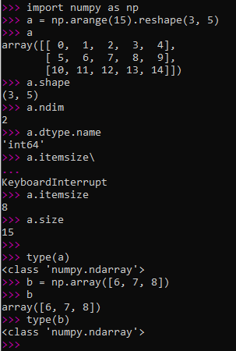

**Array Creation:**

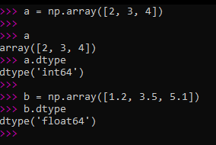

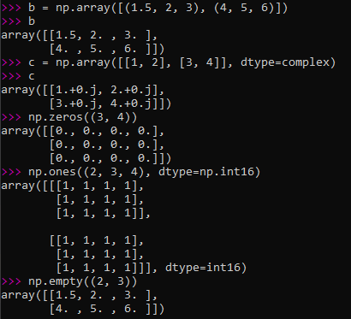

**Printing Arrays:**

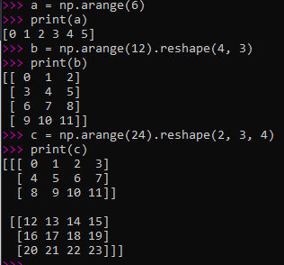

**Basic Operations:**

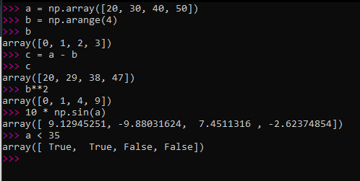

**Universal Functions:**

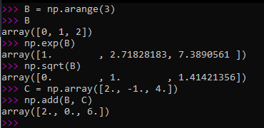

**Indexing, Slicing and Iterating:**

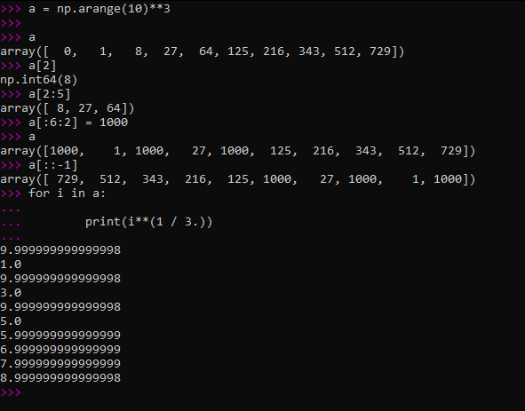

**Stacking together different arrays:**

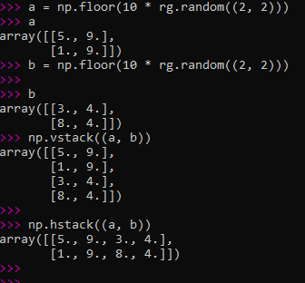

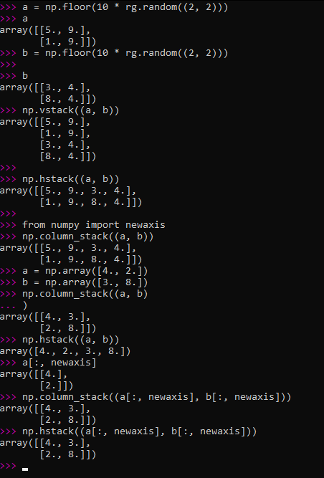

**Splitting one array into several smaller ones:**

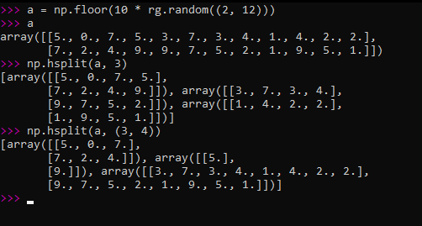

**Indexing with Boolean array:**

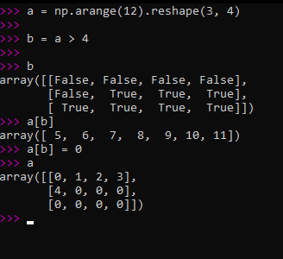

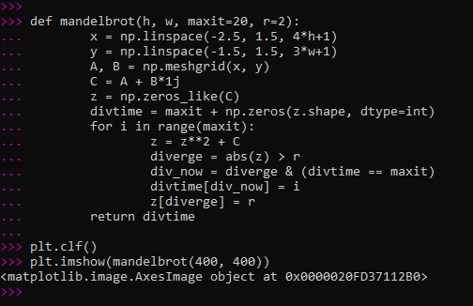

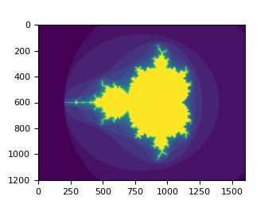

**3. Executed examples in:**

[**https://numpy.org/devdocs/user/absolute_beginners.html**](https://numpy.org/devdocs/user/absolute_beginners.html)

**Array fundamentals:**

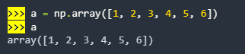



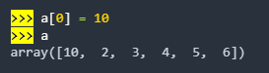



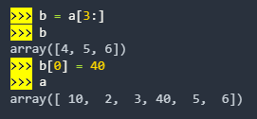

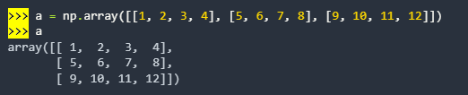



**Array Attributes:**



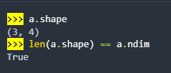

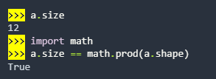



**Adding, removing, and sorting elements:**











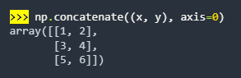

**Reshaping an array:**

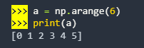

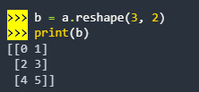 

**Converting 1D array into 2D:**

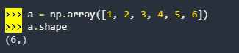

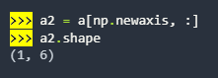

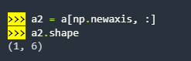

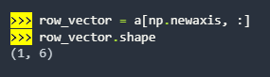

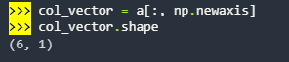



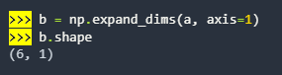

**Indexing and Slicing:**

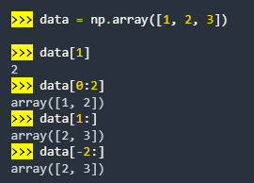





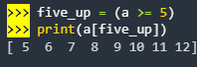

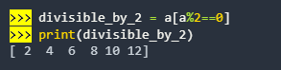

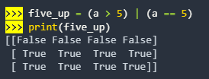

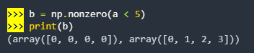

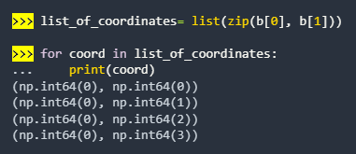

**Creating an array from an existing data:**

 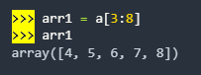

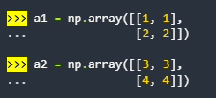

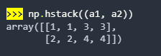

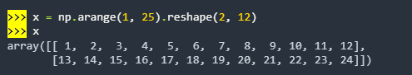

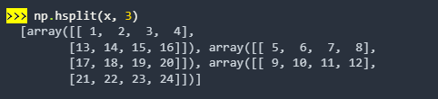

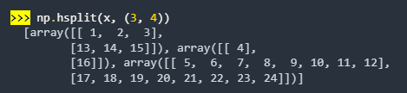

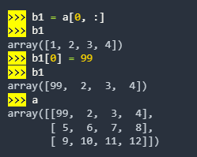

**Basic Array Operations:**

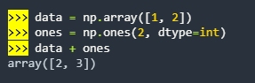

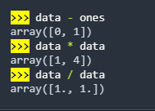

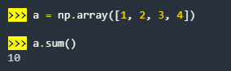







**Creating matrices:**

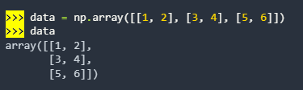

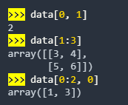

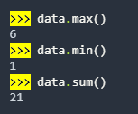

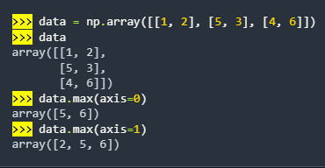

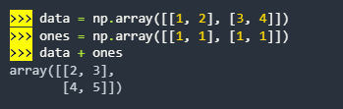

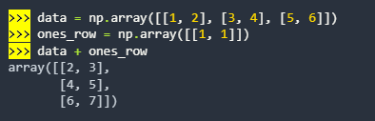

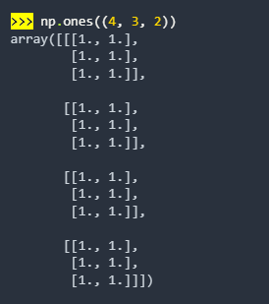

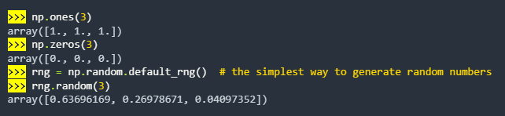

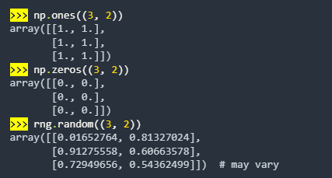

**Generating Random Numbers:**

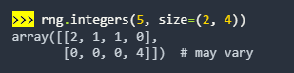



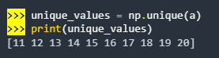

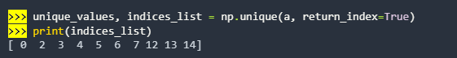

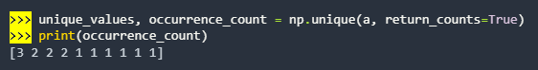



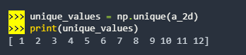

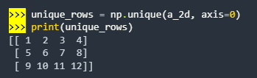

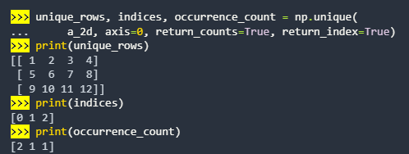

**Transposing and reshaping a matrix:**

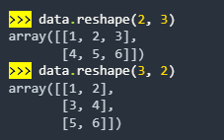

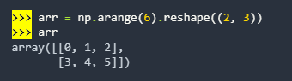

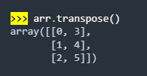

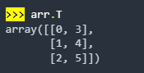

**Reverse an array:**







**Reshaping and flattening multidimensional arrays:**





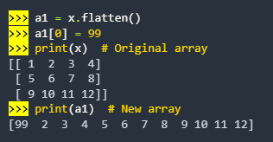

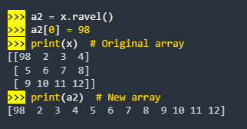

**Save and load NumPy objects:**















**Plotting arrays with Matplotlib:**









