**Armikochan:**

A 6-DOF

Articulated Mani-

pulator

Armikochan: Where Articulation Meets Innovation!

Contents:

* 3D-Model
* Code for receiver and transmitter
* Schematic diagram for electronics of receiver and transmitter
* Components used and their working mechanism
* Working of transmitter(controller-arm)
* Working of receiver (main-arm)

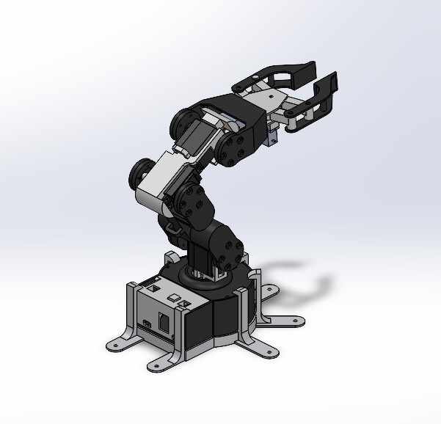

Figure 1: Main Body Adjusted View

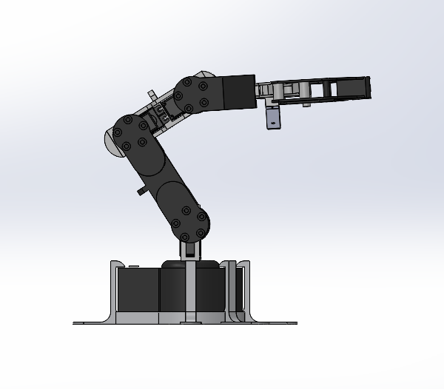

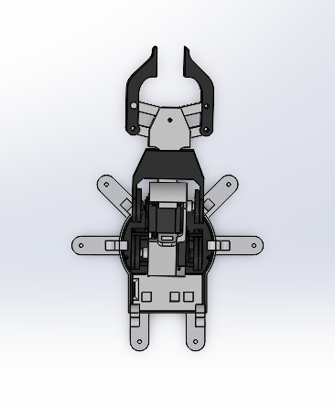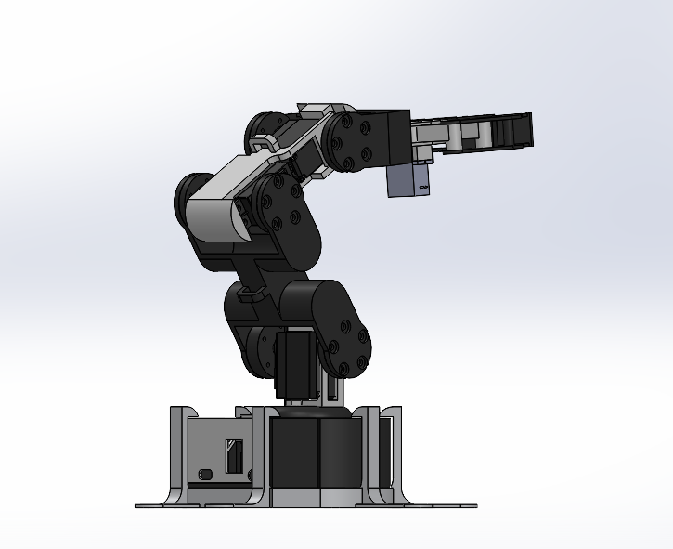

Figure 2: Lateral-view Figure 3: Side View



Figure 4: Top View

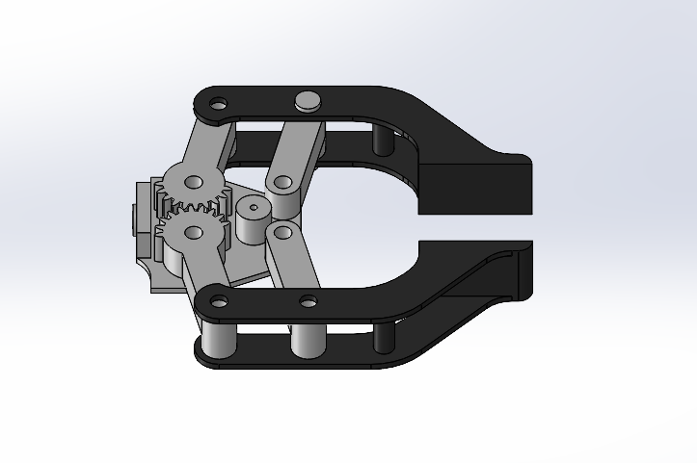

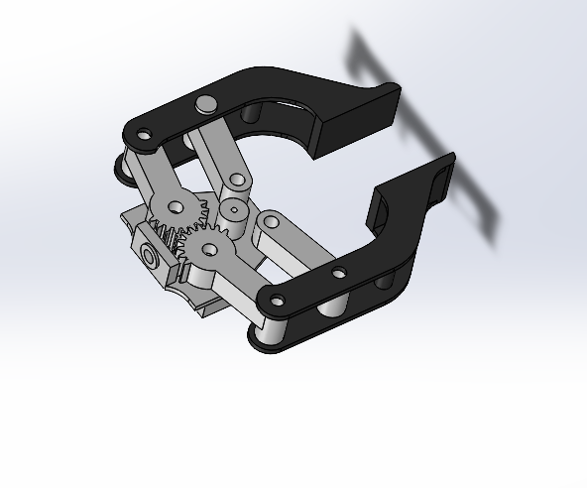

Figure 5: Gripper Mechanism

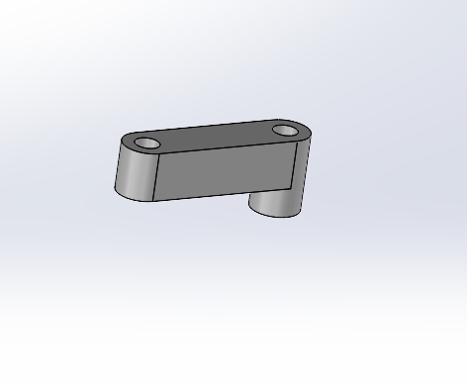

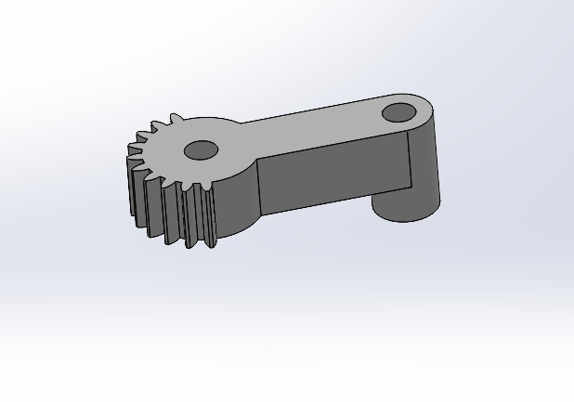

Figure 6: rot-gear Figure 7: rot-holder

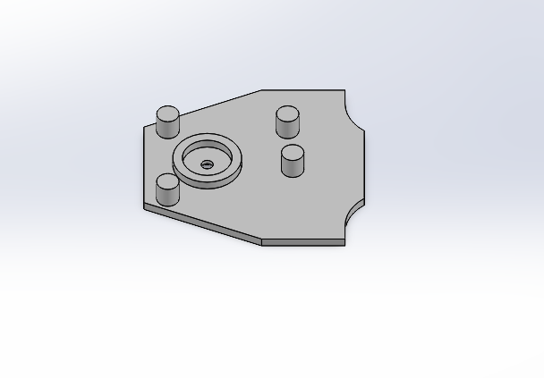

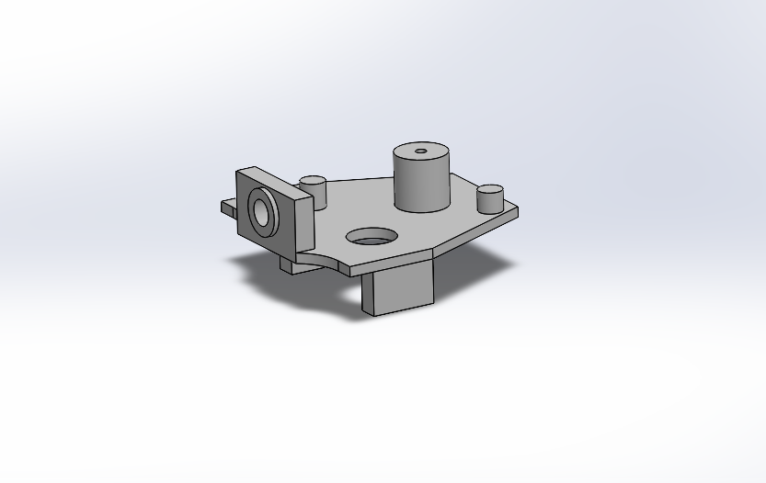

Figure 8: gripper holder Figure 9: gripper cover

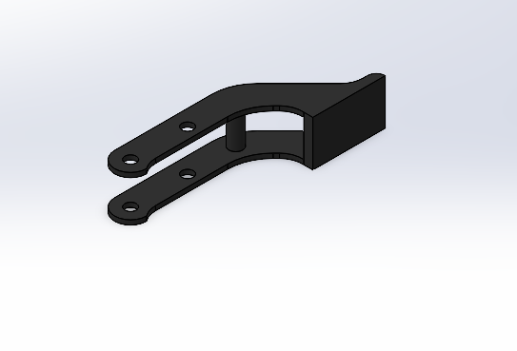

Figure 10: grip tip

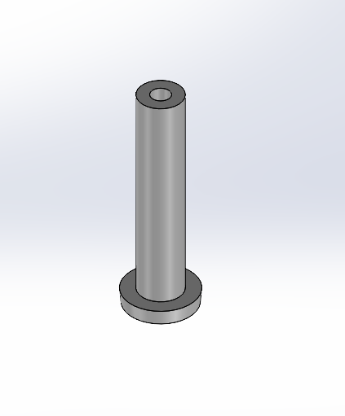

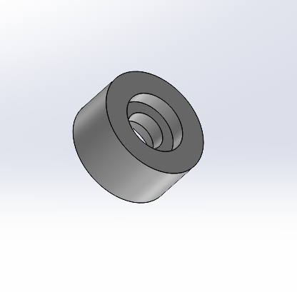

Figure 11: pin holder Figure 12: Holder pin

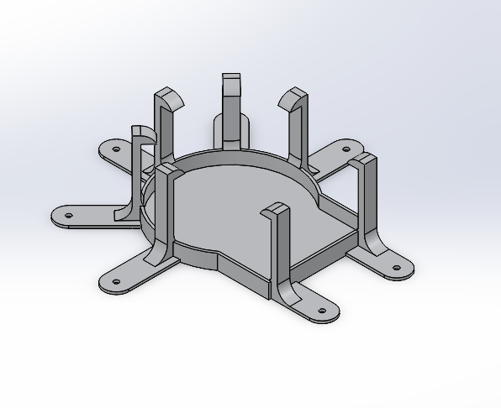

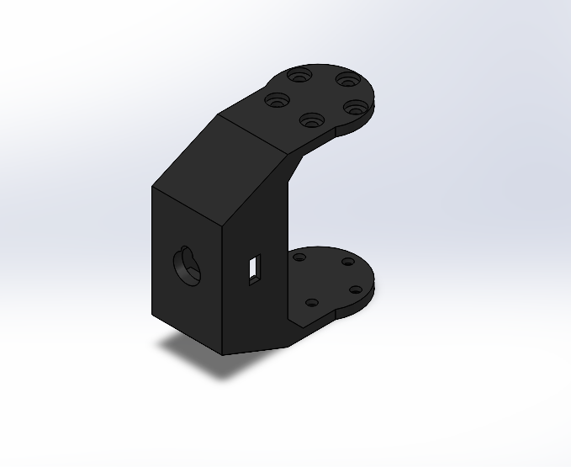

Figure 13: head Figure 14: base-body-holder

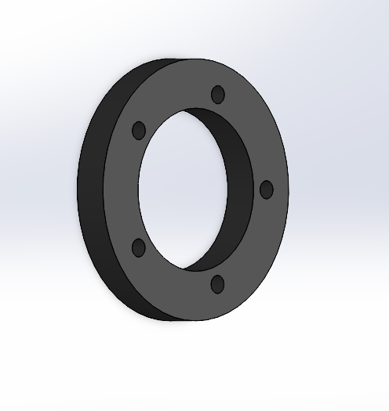

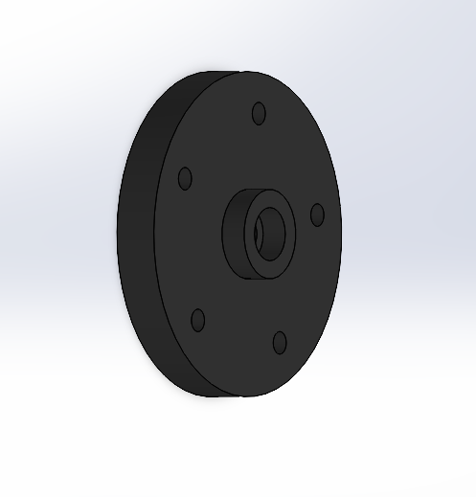

Figure 15: servo horn 1 Figure 16: bearing horn

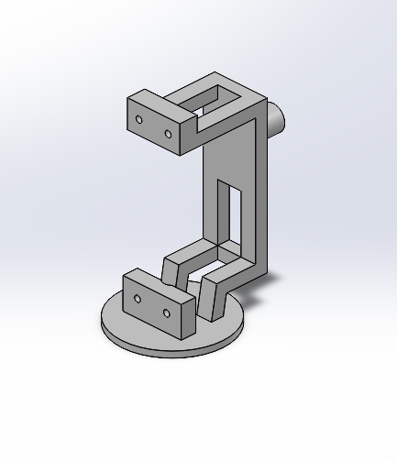

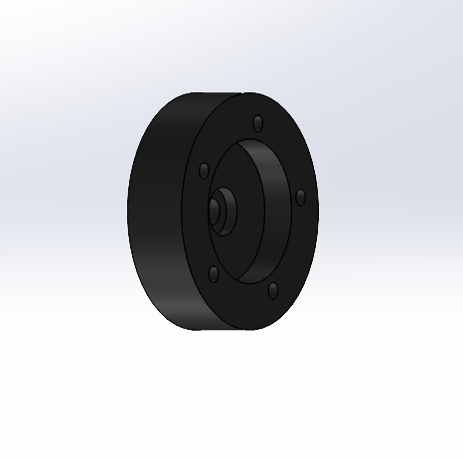

Figure 17: servo holder 1 Figure 18: servo horn 2

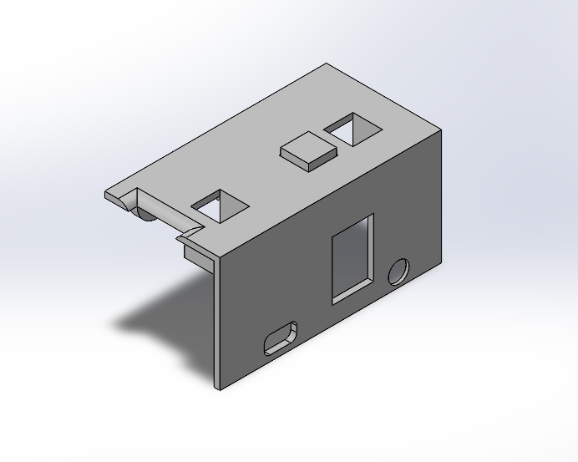

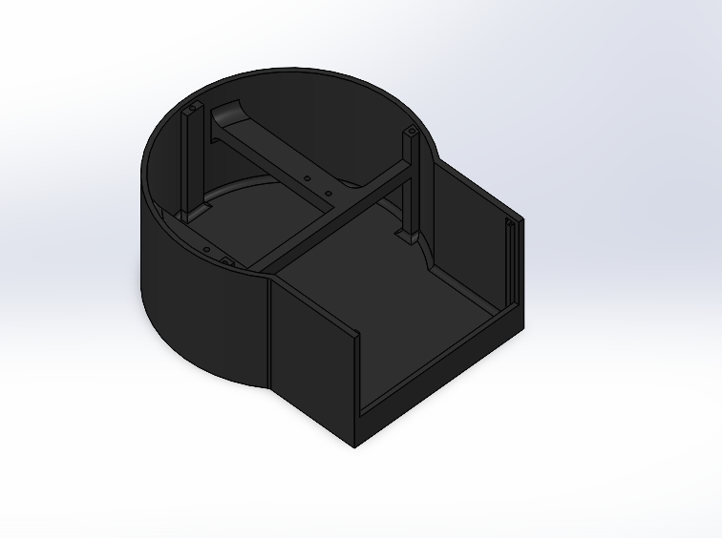

Figure 19: base Figure 20: base back cover

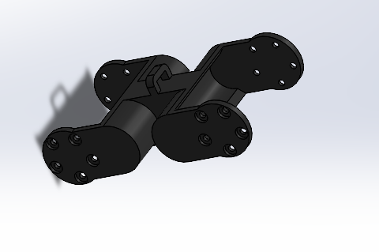

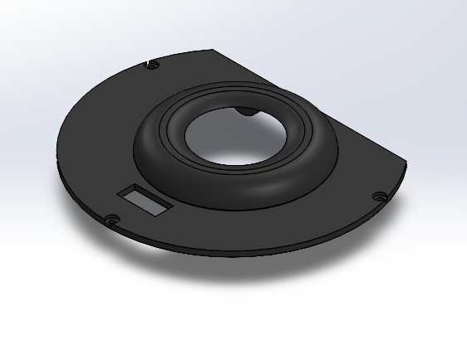

Figure 21: base top cover Figure 22: arm

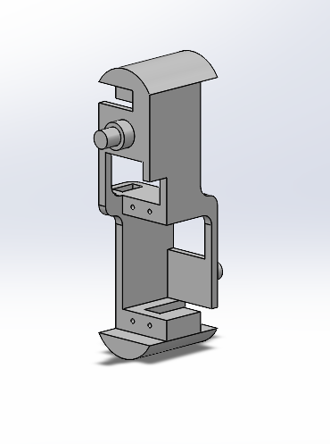

Figure 23: arm head joiner

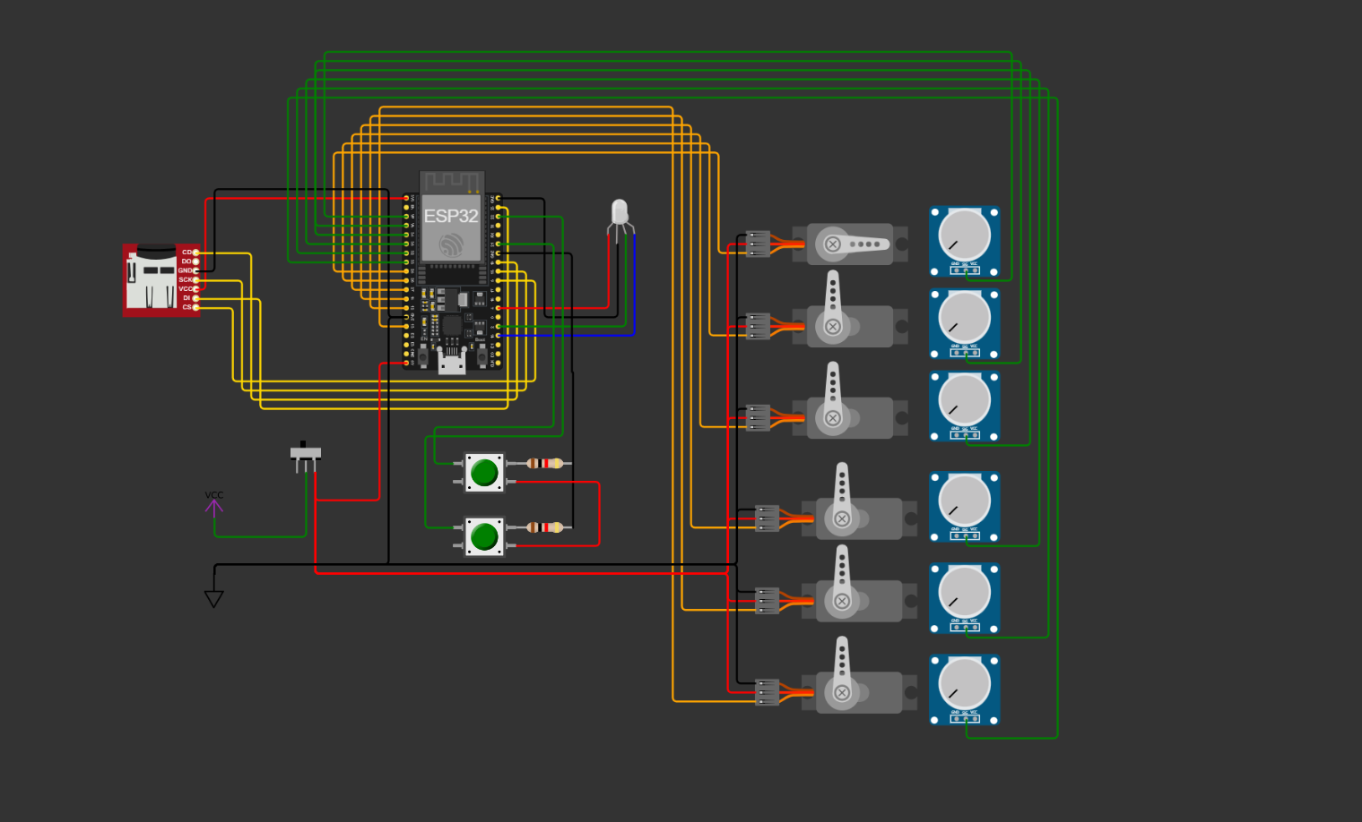

Figure 24: schematic for receiver

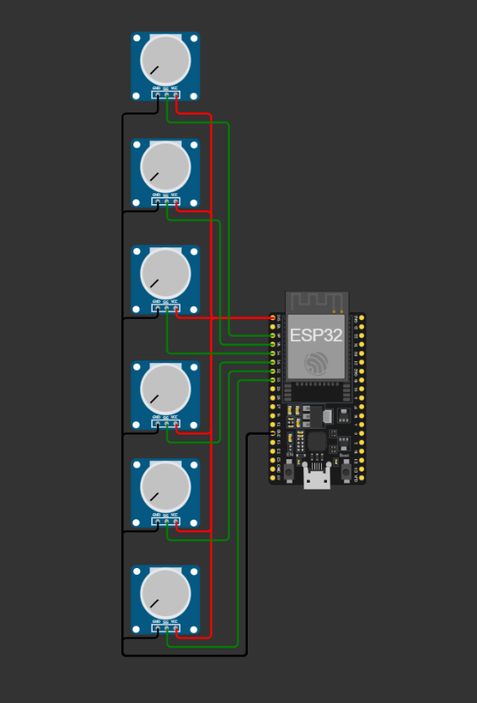

Figure 25: schematic for transmitter