A Project Synopsis on
“College Automation System”

Submitted by
Sushant Agawane – 111708004
Chaitanya Dhavan - 111708018

Software Engineering Mini Project : “College Automation System”

Abstract :

This report specifies the various processes and techniques used in gathering requirements, designing, implementing and testing for the project on college management system. The problems regarding the current system in the college were analyzed and noted. This project aims to solve some of those problems and thus, add more value to the current system. The requirements were gathered from all the stakeholders and based on that we created a requirements models and designed the software . The project was implemented in the form of a website using django(python). Using the various resources and tools we gathered along the way, we are going to implement the college Automation system using some features that solve the current problems in the system such as a provision to edit the attendance and marks before locking it at the end. Thus, the results can be integrated in the current Automation system to improve it’s working and solve some of the existing problems.

Introduction and Problem domain :

College Automation System, offers the answer to the economic and productivity troubles of manufacturing and service enterprises. It was the larger companies that have opted to use the Automation systems initially. However, the use of Automation has changed and today the term can refer to any type of company, no matter what industry it falls in. In fact, Automation systems are used in almost any type of organization - large or small. The latest Automation tools available in the market today can cover a wide range of functions and integrate them into one unified database. This made Automation to land up into higher educational institutes. In today’s competitive business world usage of Automation system is becoming a must for any educational organization to meet the challenges faced in their business process and to have a cutting edge. So in order to be different and ready for action the institutes need a central resource planning that can manage the entire information and operations of the institutions.
As we know that, a college consists of different departments, such as course departments, fees management, library, event management etc. Nowadays applications and uses of information technologies is increased as compared to before, each of these individual departments has its own computer system to do their own functionalities. By having one main system they can interact with each other from their respected system by having valid user id and password.

Aims and Objectives :

The objective of College Automation System is to allow the ad- ministrator of any organization the ability to edit and find out the personal details of a student and allows the student to keep up to date his profile. It’ll also facilitate keeping all the records of students, such as their id, name, mailing address, phone number, Date of Birth etc. So all the information about a student will be available in a few seconds. Overall, it’ll make Student Information an easier job for the administrator and the student of any organization.
The main purpose of this project is to illustrate the requirements of the project College Automation System and is intended to help any organization to maintain and manage personal data. It is a comprehensive project developed from the ground up to fulfill the needs of colleges as they guide their students. This integrated information management system connects daily operations in the college environment ranging from Attendance management to communicational means among students and teachers. This reduces data error and ensures that information is always up-to-date throughout the college. It provides a single source of data repository for streamlining your processes and for all reporting purposes. It has a simple user interface and is intuitive. This insures that the users spend less time in learning the system and hence, increase their productivity. Efficient security features provide data privacy and hence, increase their productivity.

Motivation :
As correctly said, “When you face difficulties, it’s the best time you think something new “.
Time is money for all students and student does not have to face any difficulty if the staff members cantrack all the problems related to their students. So that they can solve students problems on time and without wasting time.
So overall, the main Four stakeholders are getting benefited by this automation system namely : Administrative, Teachers, Parents, and Students . And that’s why we decided to build this software and all these stakeholders will ultimately get benefited by this process.

Proposed System and Architecture :
The automation system software requires the architectural design to represent the design of the software. Here we define a collection of hardware and software components and their interfaces to establish the framework for the development of this software. There exists number of components of the system which are integrated to form a system. The set of connectors will help in coordination, communication, and cooperation between the components. This software is built for computer-based system. The architecture comprises of various modules as given in the figure. There are 3 major categories in which the whole architecture is divided. These are administrator, staff and student. The architecture is designed such a way that it is self explanatory. The admin roles are user management, staff management, student management, staff attendance. Staff and admin perform some common functions like news management, leave management, time table management, exam management. The role of staff includes student attendance entering, student examination management, time table management, leave application management, and put on news on e-notice board. While the roles of students are few in number and includes their complete profile viewing, view their attendance, give feedback to their respective faculties, view notice and view academic time table.

Hardware and Software interfaces :

Hardware :
Since neither the mobile application nor the web portal have any designated hardware, it does not have any direct hardware interfaces. Any browser can be used to access the webapp.

Software :
Software Interfaces The following is a list of software used in making of the project.
• Operating System: We have chosen Windows operating system for its best support and user-friendliness.
• Django: We have chosen to use Django for the back-end of the website as Django is a simple python framework and is suitable for beginners.
• Database: We are using SQLite database, which comes as default with Django.

Functional Requirements :
Expected requirement:
Student and staff information Description and priority Information regarding students, teachers and courses are stored in the database. Every user can view only certain information based on their user class. For example, a teacher can view student and course information that they are handling. This feature is of high priority as the information must be viewed by only the authorized users.
Functional requirements
• Each user shall be able to view information in the database based on their user class.
• The administrator shall be able to view all the information in the database.

Normal requirement:
Attendance and marks entry Description and priority Attendance and marks entry is the main feature of the College Automation System of her class. Students can view their respective Attendance and marks of the courses they have taken.
Functional requirements
• Teachers shall be able to view, update and edit the attendance and marks of the students, part of their class.
• Teacher shall be able to take extra classes, switch classes with other teachers.

Exciting requirement:
Communication among students and teachers Description and priority Students and teacher will be able to communicate with each other directly using the College Automation System. Students may give their queries and feedback to a teacher and they may respond accordingly. The priority of this feature is low as cost of implementation could be very high. A simple version of this feature is to be implemented.
Functional requirements
• Students shall be able to communicate with their teachers by sends personal messages.
• Students shall be able to communicate with other students through a forum section.

Non-functional Requirements :

Performance Requirements :

The software will have minimum requirement of RAM and hard disc storage. Quick responses are required for user acknowledgement. Accuracy should be maintained over all types and duration of commands.
The software works fine under all sorts of condition if there is proper internet connectivity available.

Safety Requirements :

If there is extensive damage to a wide portion of the database due to catastrophic failure, such as a disk crash, the recovery method restores a past copy of the database that was backed up to archival storage (typically tape) and reconstructs a more current state by reapplying or redoing the operations of committed transactions from the backed-up log, up to the time of failure.

Security Requirements :

The database contains sensitive information of all the students and staff. Therefore, optimal security measures must be taken to ensure data is safe from unauthorized users.

Software Quality Attributes :

Availability: The users must always be able to view their information so that they can keep track regularly.

Correctness: The information about attendance and marks must be correct to not feed wrong information to the users.

Portability: The users access the ERP from various platforms such as desktops and mobile phones. The webapp must be portable to all platforms and the user experience must be optimal.

Gantt Chart :
College Automation System

Selected Process Model – Incremental Process Model .
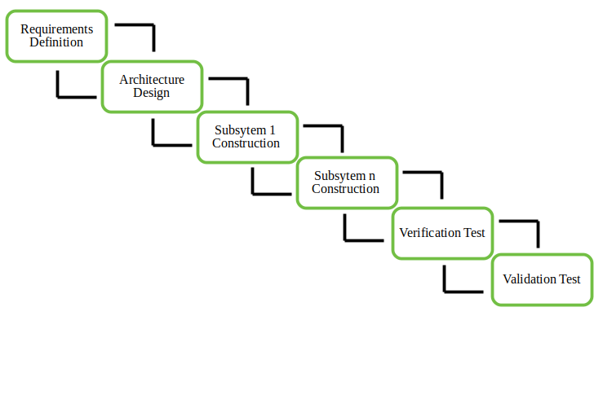

Incremental model will be suitable for this system for its flexibility and ease to modify the system later . In the incremental model software is developed in series of steps :
- Analysis phase
- Design phase
- Implementation phase
- Testing phase

Advantages :
- This model is more flexible
- less costly to change scope and requirement
- It is easier to test and debug during a smaller iteration
- Lowers initial delivery cost.

What is Incremental Process Model?
Incremental Process Model is a type of Prescriptive Analysis Model. Here the model prescribes a set of activities, actions, tasks, quality assurance and change the mechanism for every project.

Incremental Process Model’s steps are as given below:
1. Communication – Project Initiation and requirement Gathering
2. Planning – Estimating, Scheduling, tracking
3. Modeling – Analysis and design of overall project.
4. Construction – Coding/ implementation and testing the software.
5. Deployment – Delivery and Feedback

When do we use the Incremental Model?
1. When the requirements are superior.
2. A project has a lengthy development schedule.
3. When the customer demands a quick release of the product.
4. You can develop prioritized requirements first.

Why are we using the Incremental Model?
We intend to develop our Web App in small stages. Each stage will be developed according to
priority. We have an idea that initially the basic functionality of this app should be implemented.
And then to develop further we add more functionalities after proper analysis and discussion.

