OUTPUT BEFORE PL/SQL BLOCK EXECUTION

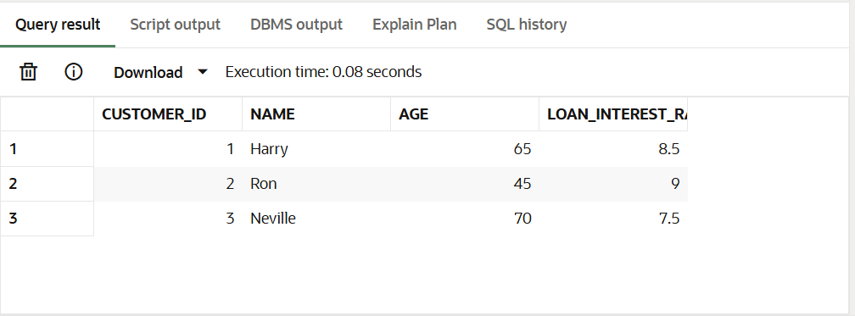

--------------------------------------------------------------------------------------------------------------------------------------

OUTPUT AFTER PL/SQL BLOCK EXECUTION

