OUTPUT BEFORE STORED PROCEDURE EXECUTION

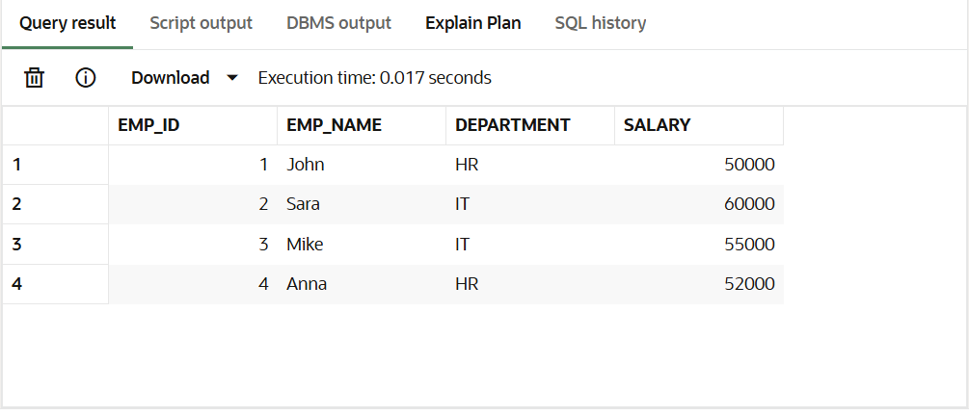

--------------------------------------------------------------------------------------------------------------------------------------

OUTPUT AFTER STORED PROCEDURE EXECUTION

