PROJECT REPORT

Brain Tumor Classification using Convolutional Neural Networks (CNN) on MRI Images

A Deep Learning Approach to 4-Class MRI Tumor Diagnosis Support

Submitted by
Sushant Tiwari

July 2026

1. Objective
The objective of this project is to build and evaluate a Convolutional Neural Network (CNN) capable of classifying brain MRI scans into four categories: Glioma, Meningioma, No Tumor, and Pituitary tumor. The target set for this project was a minimum test accuracy of 90%.

2. Dataset
The project uses the Brain Tumor MRI Dataset, sourced from Kaggle:
https://www.kaggle.com/datasets/masoudnickparvar/brain-tumor-mri-dataset
Total training images | 5,600 (1,400 per class)
Total testing images | 1,600 (400 per class)
Classes | Glioma, Meningioma, No Tumor, Pituitary
Original image size | 512 × 512 pixels, grayscale
Resized input | 64 × 64 pixels, grayscale

Figure 1 below shows one representative MRI slice from each of the four classes.
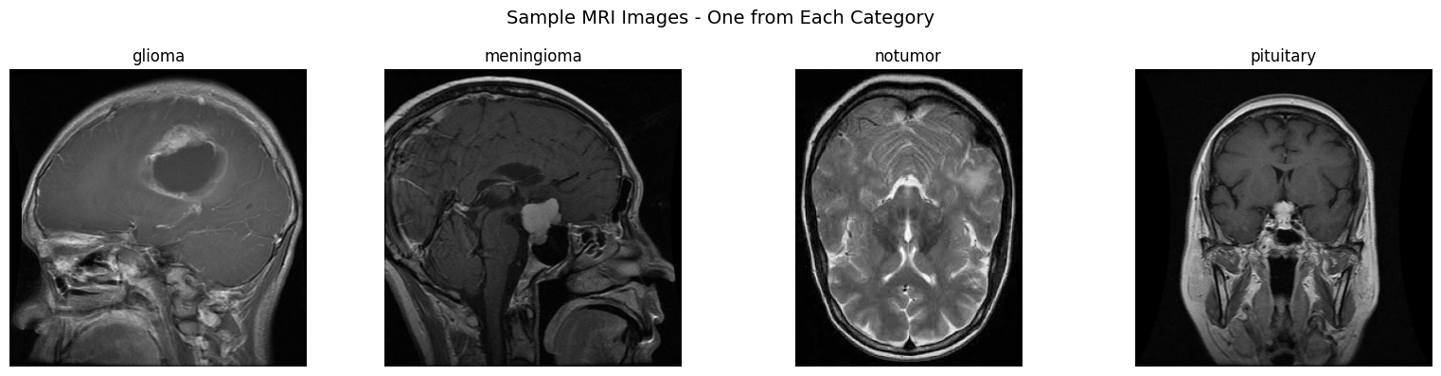
Figure 1: Sample MRI images, one from each category

3. Libraries Used
- TensorFlow / Keras — model definition, training, and inference
- NumPy — array and image tensor handling
- Pillow (PIL) — image loading and preprocessing
- scikit-learn — classification report and confusion matrix
- Matplotlib / Seaborn — training curves and confusion matrix visualization
- opendatasets — Kaggle dataset download
- Flask — web application backend serving the trained model
- pytest — automated test suite for the deployed application

4. Methodology
4.1 Data Understanding
The dataset was inspected to confirm class balance (1,400/400 images per class across Training/Testing splits) and to verify that images are single-channel grayscale MRI slices at their native 512×512 resolution.
4.2 Preprocessing
Images were resized to 64×64 pixels and pixel values rescaled to the [0, 1] range. Data was loaded using Keras' ImageDataGenerator in grayscale mode. Mild data augmentation — up to 10° rotation, 5% width/height shift, horizontal flip, and 5% zoom — was applied to the training set only, to reduce overfitting without distorting diagnostically relevant features.
4.3 Model Development
A 3-block CNN was designed using GlobalAveragePooling2D instead of a Flatten layer, keeping the total parameter count low (~305K) to reduce overfitting risk given the moderate dataset size. Full architecture details are in Section 5.
4.4 Training
The model was trained using the Adam optimizer with sparse categorical cross-entropy loss, for up to 40 epochs. ReduceLROnPlateau halved the learning rate after 4 stagnant validation-loss epochs, and EarlyStopping (patience 12, monitoring validation accuracy) restored the best-performing weights.
4.5 Evaluation
The trained model was evaluated on the held-out test set using overall accuracy/loss, a per-class classification report (precision, recall, F1-score), and a confusion matrix.

5. Model Architecture
Input: 64 × 64 × 1 grayscale image
Block | Layers
Conv Block 1 | Conv2D(32) → BatchNorm → Conv2D(32) → BatchNorm → MaxPool(2×2) → Dropout(0.25)
Conv Block 2 | Conv2D(64) → BatchNorm → Conv2D(64) → BatchNorm → MaxPool(2×2) → Dropout(0.25)
Conv Block 3 | Conv2D(128) → BatchNorm → Conv2D(128) → BatchNorm → MaxPool(2×2) → Dropout(0.25)
Classification Head | GlobalAveragePooling2D → Dense(128, ReLU) → Dropout(0.5) → Dense(4, Softmax)

Total parameters: 305,252 (304,356 trainable, 896 non-trainable). Optimizer: Adam. Loss function: sparse categorical cross-entropy.

6. Results
6.1 Overall Performance
Metric | Value
Final training accuracy | 98.36%
Best validation accuracy | 91.75%
Test accuracy | 91.75% (target: 90%)
Test loss | 0.7496
Train/validation accuracy gap | 6.61% (mild overfitting; still above target)

Figure 2 below shows training vs. validation accuracy and loss across epochs.
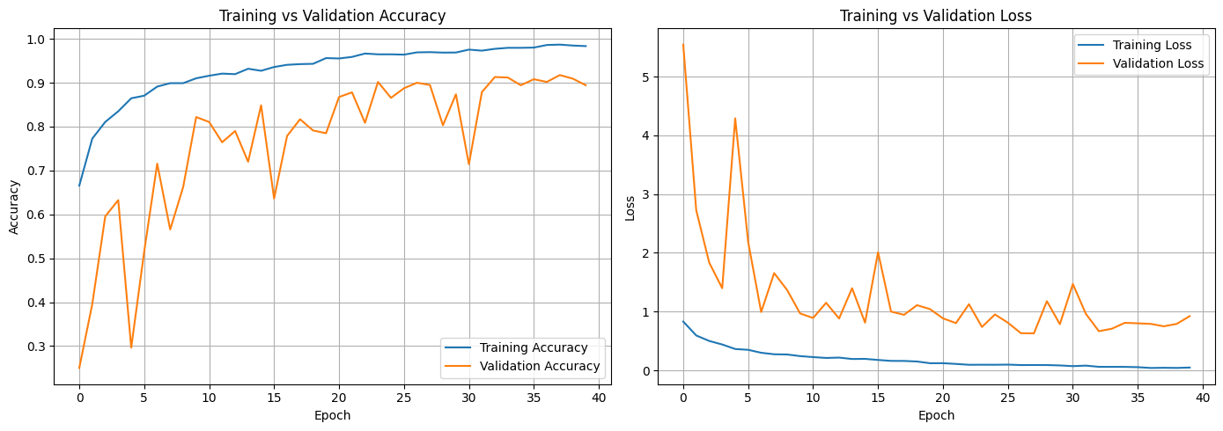
Figure 2: Training vs. validation accuracy and loss curves

6.2 Per-Class Performance
Class | Precision | Recall | F1-score
Glioma | 0.99 | 0.76 | 0.86
Meningioma | 0.93 | 0.91 | 0.92
No Tumor | 0.88 | 1.00 | 0.93
Pituitary | 0.89 | 1.00 | 0.94

6.3 Confusion Matrix
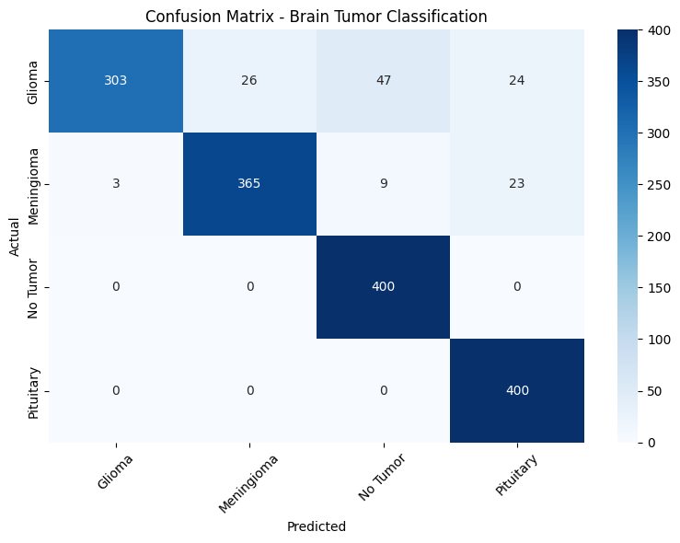
Figure 3: Confusion matrix on the test set

Glioma has the lowest recall (0.76), making it the class most frequently confused with the others — this is the clearest area for improvement identified during evaluation.

7. Conclusion
The CNN achieved 91.75% test accuracy, exceeding the 90% target, using a lightweight architecture of approximately 305K parameters that trains efficiently even on CPU due to the small 64×64 input resolution and GlobalAveragePooling2D head. Precision and recall were strong for Meningioma, No Tumor, and Pituitary classes, with Glioma recall (0.76) identified as the primary weakness. Deeper augmentation, a larger input resolution, or additional glioma-focused training data are natural next steps to close that gap.
The trained model was deployed behind a Flask web application with a dashboard for uploading an MRI slice and viewing per-class confidence scores, backed by an automated test suite covering both the preprocessing pipeline and the prediction API.
Disclaimer: This project is a research and educational prototype. It has not been validated for clinical use and is not a medical diagnostic device.

8. References
[1] Brain Tumor MRI Dataset, Kaggle — https://www.kaggle.com/datasets/masoudnickparvar/brain-tumor-mri-dataset
[2] Chollet, F. et al. — Keras: The Python Deep Learning API — https://keras.io
[3] Abadi, M. et al. — TensorFlow: Large-Scale Machine Learning on Heterogeneous Systems — https://www.tensorflow.org

