ASSIGNMENT 5

**NAME: SUSHANT BANSODE**

**ROLL:302**

**DIV:C**

**PRN:202201090025**

**CODE:**

import pandas as pd df=pd.read_csv("/content/imdb data.csv") print(df)

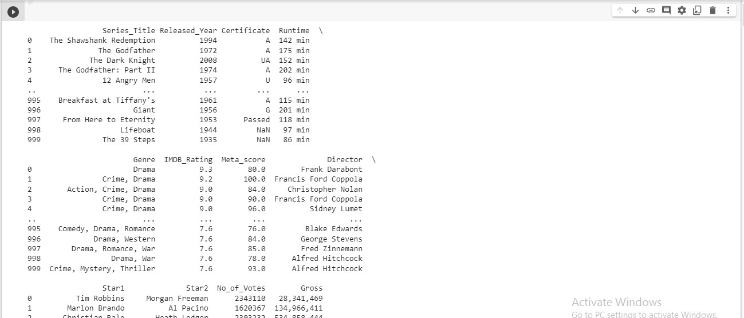

* **PIE CHART:**

import matplotlib.pyplot as plt

# Calculate the count of movies for each IMDb rating rating_counts = df['IMDB_Rating'].value_counts()

# Plotting the pie chart plt.figure(figsize=(8, 6))

plt.pie(rating_counts, labels=rating_counts.index, autopct='%1.1f%%', startangle=90)

plt.title('Movies Distribution by IMDb Ratings') plt.axis('equal')

plt.show()

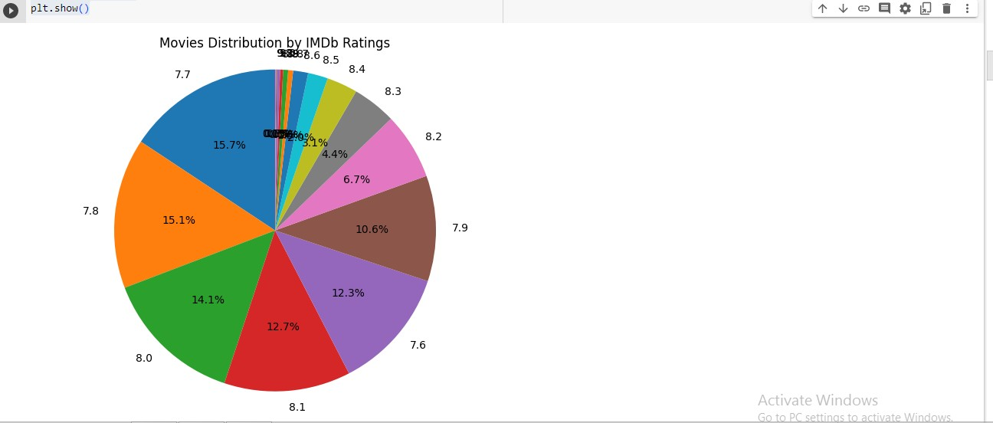

* **BAR GRAPH:**

import pandas as pd

import matplotlib.pyplot as plt

# Group the data by certificate and calculate the mean Meta Score for each certificate

certificate_scores = df.groupby('Certificate')['Meta_score'].mean()

# Create the bar graph using Matplotlib plt.figure(figsize=(10, 6)) certificate_scores.plot(kind='bar', color='blue')

# Set plot labels and title plt.xlabel('Certificate') plt.ylabel('Mean Meta Score')

plt.title('Mean Meta Score by Certificate')

# Display the plot

plt.xticks(rotation=0) # Rotate x-axis labels if needed plt.tight_layout() # Adjust plot layout

plt.show()

* 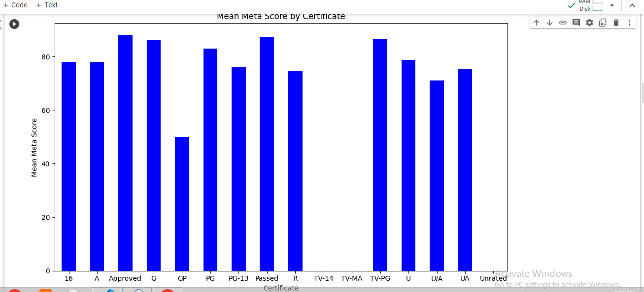**HISTOGRAM:**

import pandas as pd

import matplotlib.pyplot as plt

# Create the histogram using Matplotlib plt.figure(figsize=(10, 6))

plt.hist(df['Meta_score'], bins=20, color='blue', edgecolor='black')

# Set plot labels and title plt.xlabel('Meta Score') plt.ylabel('Frequency')

plt.title('Histogram of Meta Score based on Number of Votes')

# Display the plot

plt.tight_layout() # Adjust plot layout plt.show()

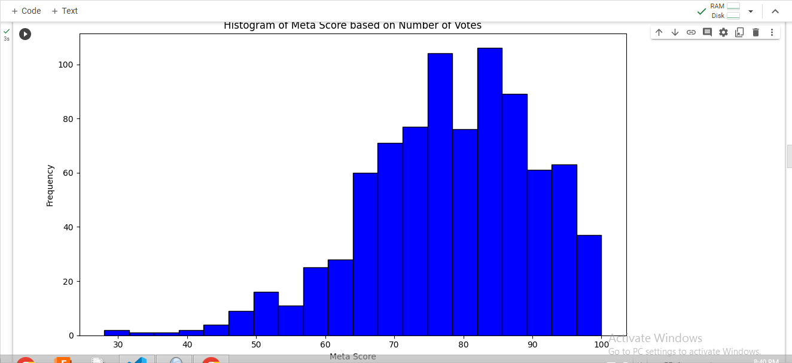

* **LINE CHART:**

import pandas as pd

import matplotlib.pyplot as plt

# Group the data by genre and calculate the mean Meta Score for each genre genre_scores = df.groupby('Genre')['Meta_score'].mean()

# Create the line chart using Matplotlib plt.figure(figsize=(10, 6)) genre_scores.plot(kind='line', marker='o')

# Set plot labels and title plt.xlabel('Genre') plt.ylabel('Mean Meta Score')

plt.title('Mean Meta Score by Genre')

# Display the plot

plt.xticks(rotation=45) # Rotate x-axis labels for better visibility plt.tight_layout() # Adjust plot layout

plt.show()

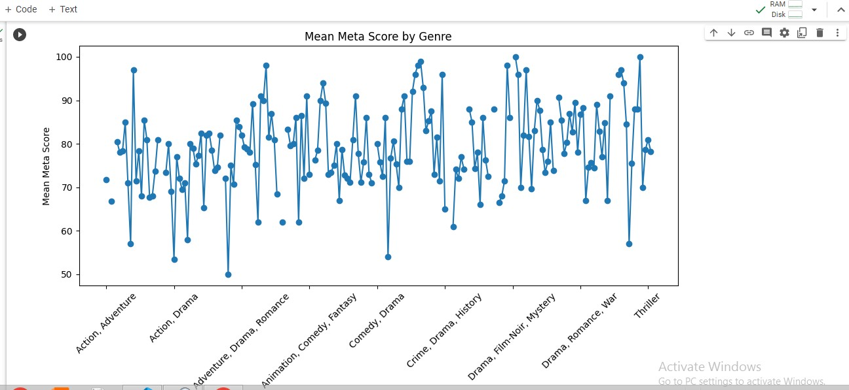

* **DENSITY PLOT:**

import pandas as pd

import matplotlib.pyplot as plt

# Create the density plot using Matplotlib plt.figure(figsize=(10, 6)) df['Meta_score'].plot(kind='density')

# Set plot labels and title plt.xlabel('Meta Score') plt.ylabel('Density') plt.title('Density Plot of Meta Score')

# Display the plot plt.show()

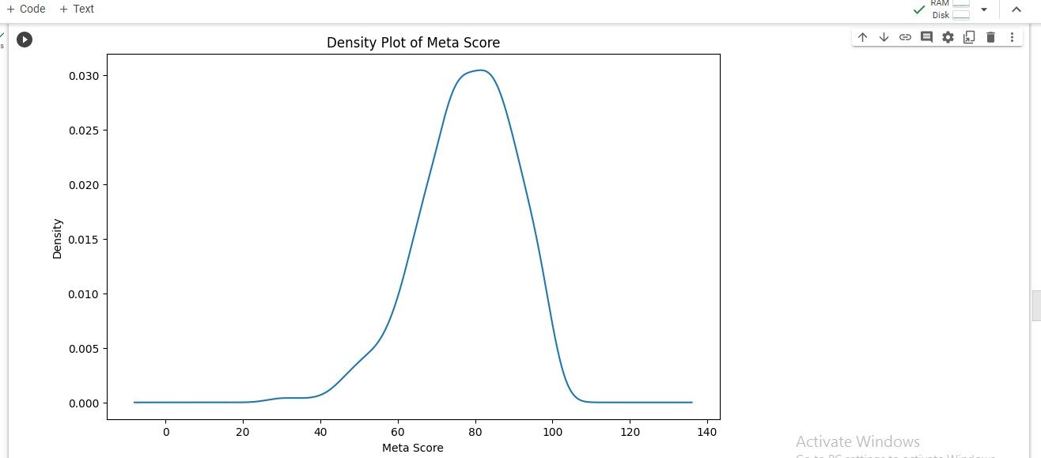

* **SCATTER PLOT:**

import pandas as pd

import matplotlib.pyplot as plt

# Create the scatter plot using Matplotlib plt.figure(figsize=(10, 6))

plt.scatter(df['Released_Year'], df['IMDB_Rating'], color='blue', alpha=0.5)

# Set plot labels and title plt.xlabel('Released Year') plt.ylabel('IMDB Rating')

plt.title('Scatter Plot of Released Year based on IMDb Ratings')

# Display the plot

plt.tight_layout() # Adjust plot layout plt.show()

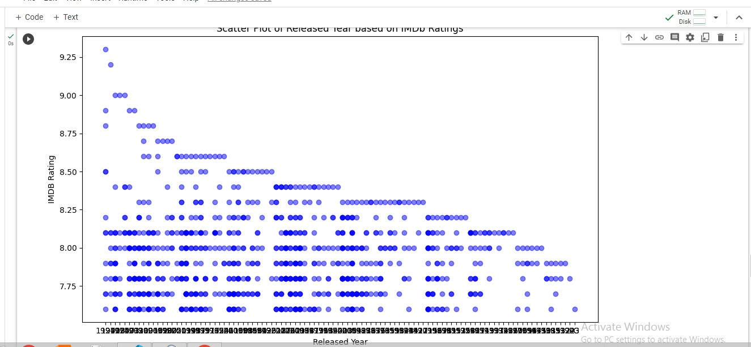

* **FACET GRID:**

import pandas as pd import seaborn as sns

import matplotlib.pyplot as plt

# Create the facet grid using Seaborn

g = sns.FacetGrid(df, col='IMDB_Rating', col_wrap=4, height=4, aspect=1.2) g.map(sns.scatterplot, 'IMDB_Rating', 'Meta_score', color='blue', alpha=0.5)

# Set plot labels and title g.set_axis_labels('IMDB Rating', 'Meta Score')

g.fig.suptitle('Facet Grid of Meta Score based on IMDb Ratings')

# Adjust plot layout plt.tight_layout() plt.subplots_adjust(top=0.9)

# Display the plot plt.show()

