**HOSPITAL MANAGEMENT SYSYTEM**

END TERM REPORT

*By*

**Sushant Kumar Singh**

**Y. Shruthi**

**Md Faiz Nawaz**

Section: K19NS

Roll Number(s): 63,64,65



**Department of Intelligent Systems**

**School of Computer Science Engineering**

**Lovely Professional University, Jalandhar**

APR-2020

**Student Declaration**

This is to declare that this report has been written by me/us. No part of the report is copied from other sources. All information included from other sources have been duly acknowledged. I/We aver that if any part of the report is found to be copied, I/we are shall take full responsibility for it.

Sushant Kumar Singh

Roll no : 63

Y. Shruthi

Roll no : 64

Md. Faiz Nawaz

Roll no : 65

Place : Phagwara

Date : 08/04/2020

**TABLE OF CONTENTS**

TITLE PAGE NO.

1. Introduction...................................................................................1
2. Problem Domain...........................................................................2
3. Solution Domain...........................................................................2
4. Requirement of proposed system..................................................2
5. System analysis.............................................................................3
6. Technologies used.........................................................................3
7. Scope of the project.......................................................................3
8. Sample of website..........................................................................4-6
9. Expected outcome..........................................................................7
10. Group contribution.........................................................................7

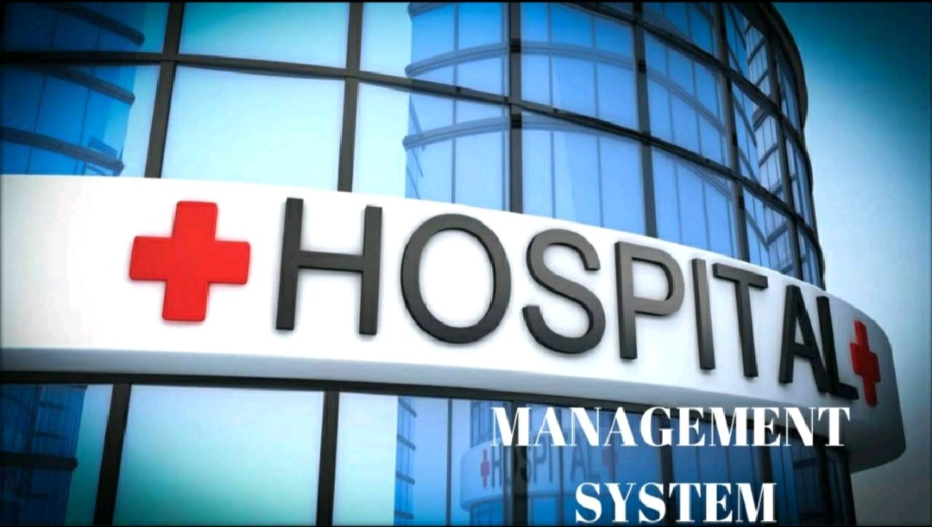

**INTRODUCTION**

The project Hospital Management system includes registration of patients, storing their details into the system, and also computerized billing in the pharmacy, and labs. The software has the facility to give a unique id for every patient and stores the details of every patient and the staff automatically. It includes a search facility to know the current status of each room. User can search availability of a doctor and the details of a patient using the id.

The Hospital Management System can be entered using a username and password. It is accessible either by an administrator or receptionist. Only they can add data into the database. The data can be retrieved easily. The interface is very user-friendly. The data are well protected for personal use and makes the data processing very fast.

The purpose of the project entitled as "HOSPITAL MANAGEMENT SYSTEM" is to computerize the Front Office Management of Hospital to develop software which is user friendly, Simple, fast, and cost- effective. It deals with the collection of patient's information, diagnosis details, etc.

Traditionally, it was done manually. The main function of the system is to register and store patient details and doctor details and retrieve these details as and when required, and also to manipulate these details meaningfully System input contains patient details, diagnosis details; while system output is to get these details on to the CRT screen

**PROBLEM DOMAIN**

This project is aimed to automate the hospital management system. This project is developed mainly too administrate doctor's appointment with the patients. The purpose of the project entitled as HOSPITAL MANAGEMENT SYSTEM is to computerize the Front Office Management of Hospital to develop software which is user friendly, simple, fast, and cost - effective. It deals with the collection of patient's information, diagnosis details, etc. Traditionally, it was done manually. The main function of the system is to register and store patient details and doctor details and retrieve these details as and when required, and also to manipulate the se details meaningfully

**SOLUTION DOMAIN**

1) REQUIREMENT OF PROPOSED SYSTEM

2) SYSEM ANALYSIS

**REQUIREMENT OF PROPOSED SYSTEM**

The first step in system development life cycle is the identification of need of change to improve or enhance an existing system. An initial investigation on Existing was carried out. The present system of hospital is completely manual. Many problems were identified during the initial study of the existing system. To develop this software detailed study is made at local hospital. Based on the information collected it is decided to maintain the basic information about doctors and patients system was carried out. The present system of hospital is completely.

**SYSTEM ANALYSIS**

System analysis is a detailed study of the various operations performed by a system and their relationships within and outside of the system. Here the key question is - What all problems exist in the present system? What must be done to solve the problem? Analysis begins when a user or manager begins a study of the program using existing system. During analysis, data collected on

the various files, decision points and transactions handled by the present system. The commonly used tools in the system are Data Flow Diagram, interviews, etc. training. experience and common sense are required for collection of relevant information needed to develop the system.

**TECHNOLOGIES USED**

* HTML
* CSS

**SCOPE OF THE PROJECT**

* Information about Patients is done by just writing the Patients name, age and gender. Whenever the Patient comes up his information is stored freshly.
* Bills are generated by recording price for each facility provided to Patient on a separate sheet and at last they all are summed up.
* Diagnosis information to patients is generally recorded on the document, which contains Patient information. It is destroyed after some time period to decrease the paper load in the office.
* Immunization records of children are maintained in pre-formatted sheets, which are kept in a file.
* Information about various diseases is not kept as any document. Doctors themselves do this job by remembering various medicines. All this work is done manually by the receptionist and other operational staff and lot of papers are needed to be handled and taken care of. Doctors have to remember various medicines available for diagnosis and sometimes miss better alternatives as they can't remember them at that time.

**SAMPLE WEBSITE**

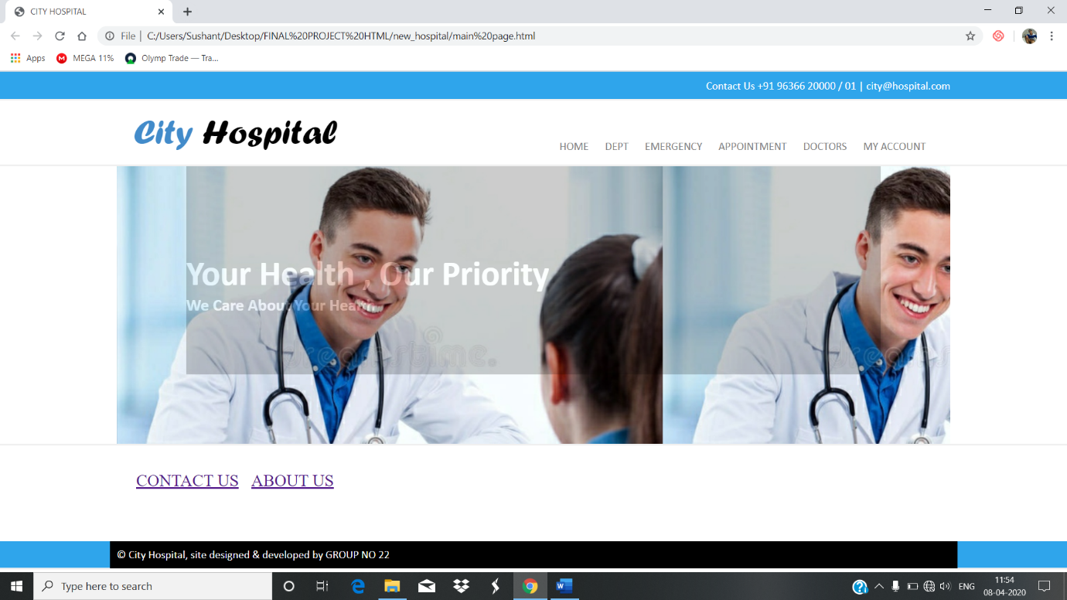

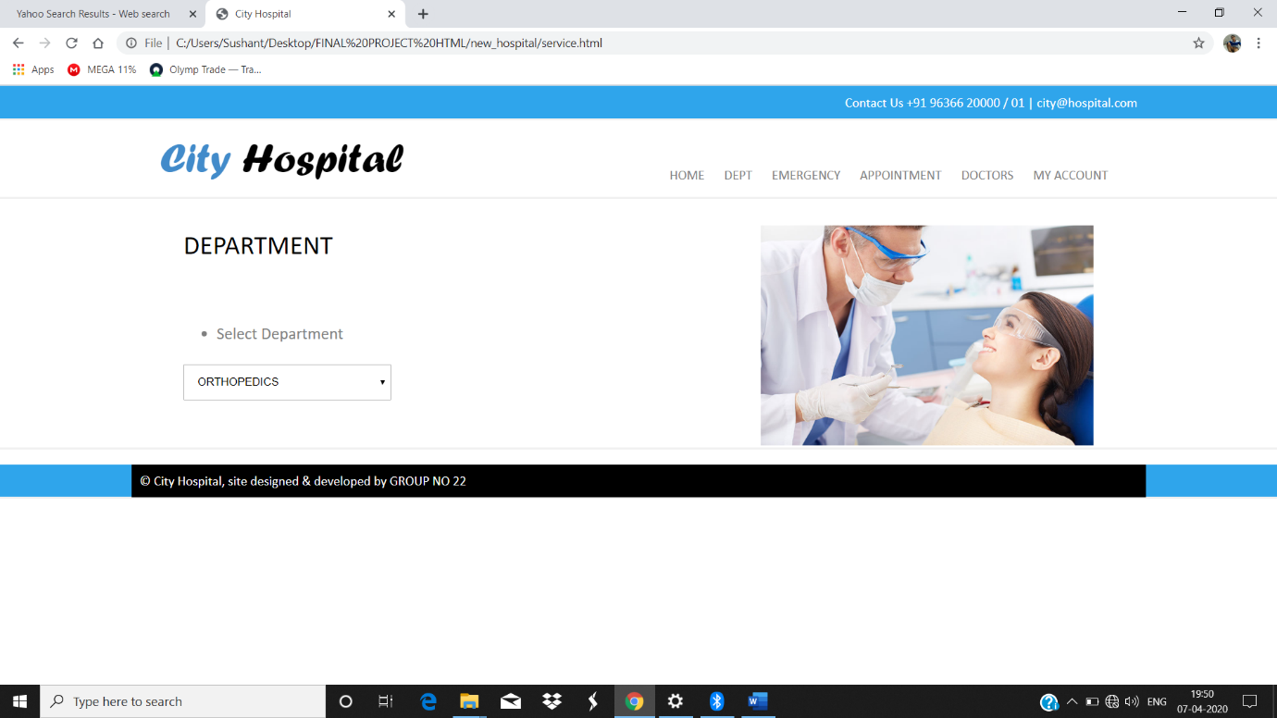

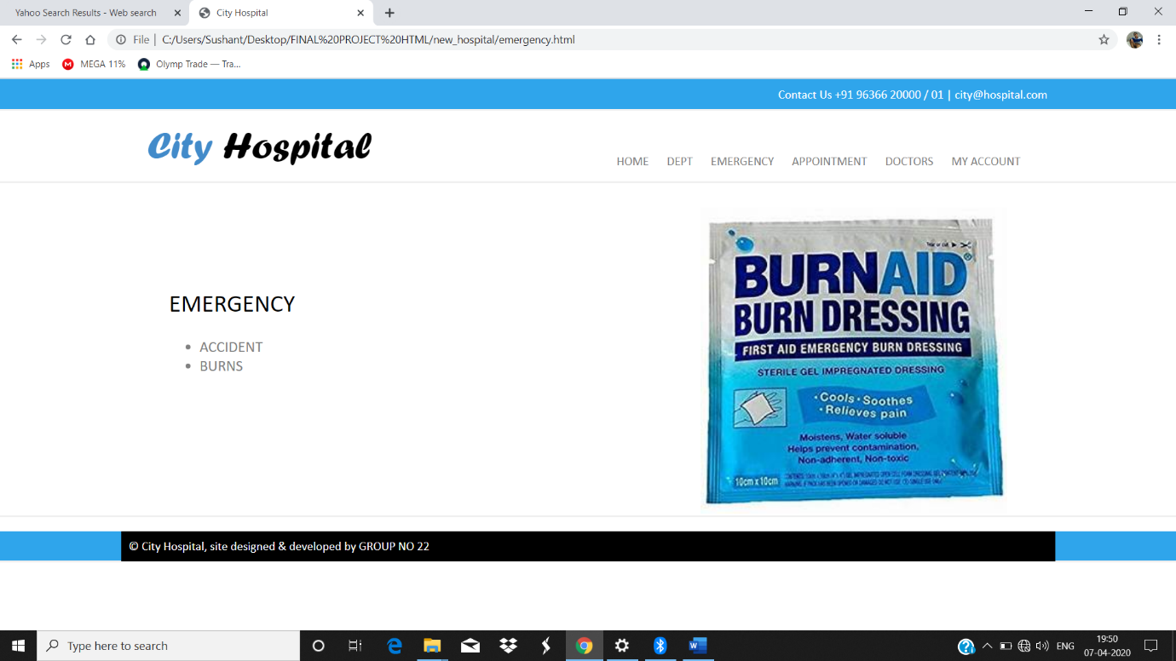

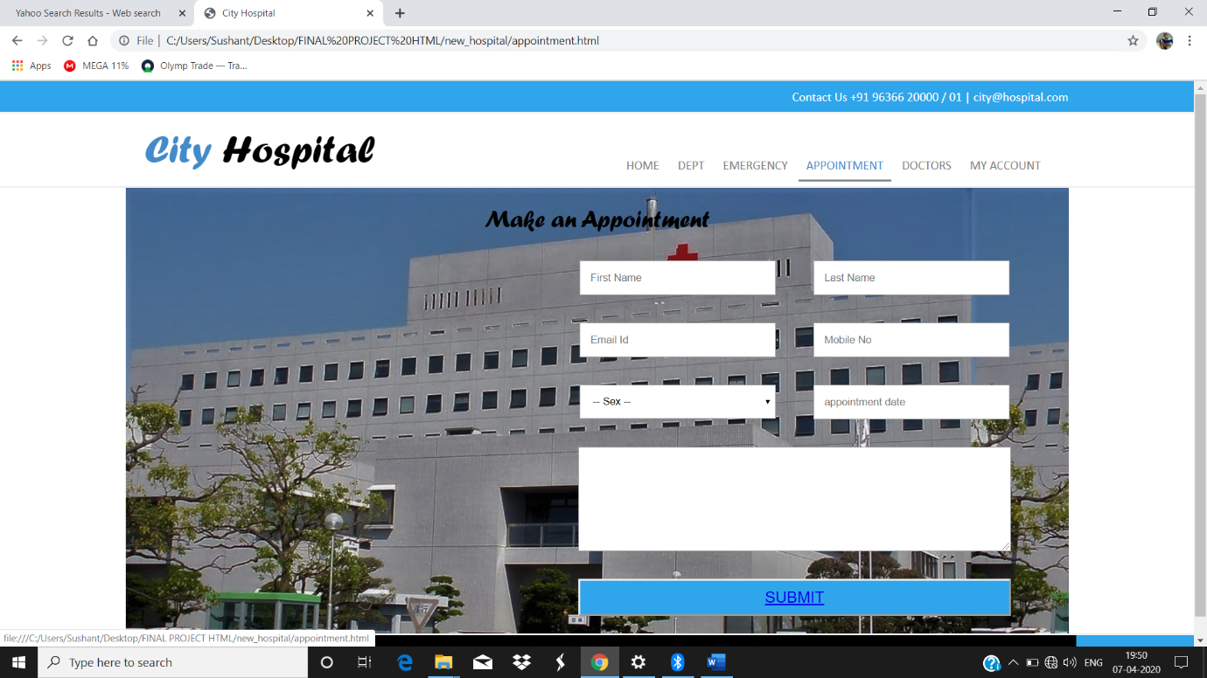

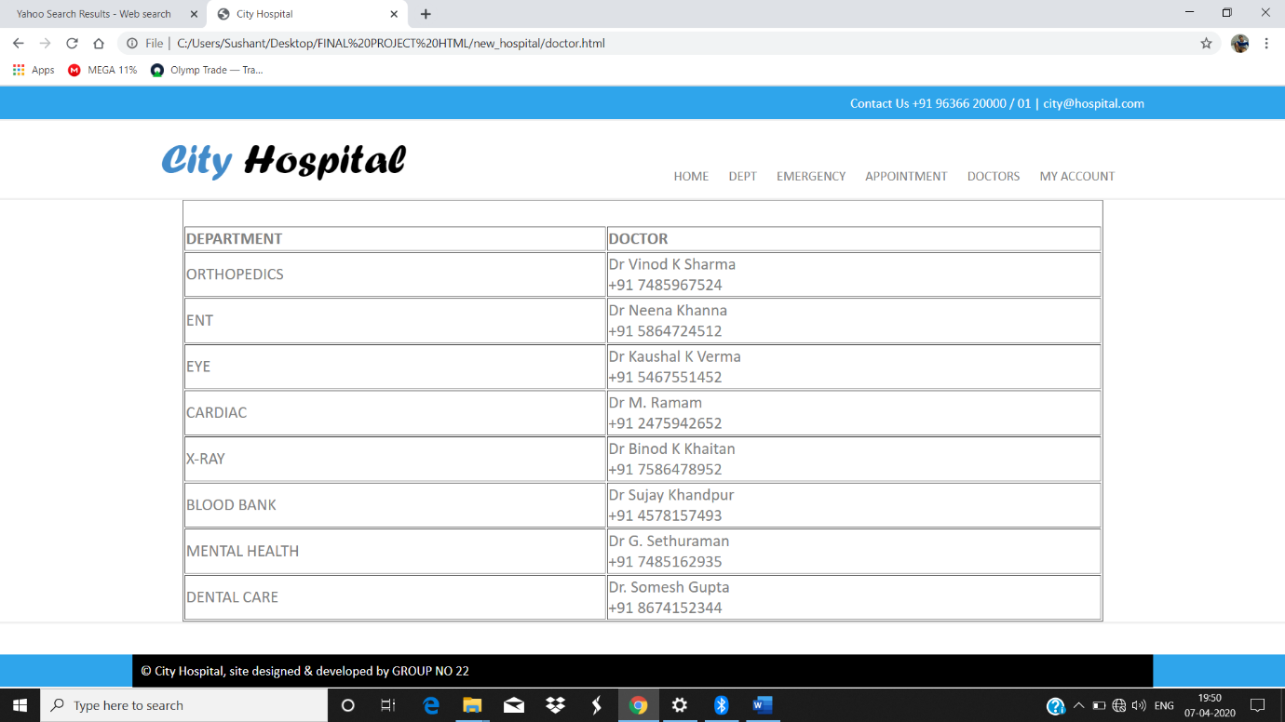

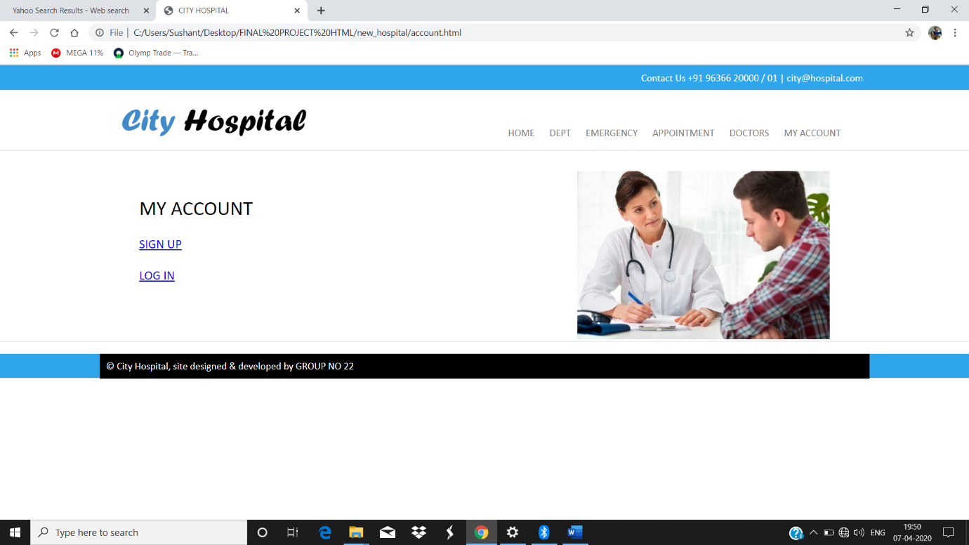

**EXPECTED OUTOME**

**CONCLUSION** : The HOSPITAL MANAGEMENT SYSTEM is a great improvement over the manual system using case fields and paper. The computerization of the system has speed up the process. In the current system, the front office managing is very slow. The hospital managing system was thoroughly checked and tested with dummy data and thus is found to be very reliable.

**ADVANTAGES**

* It is fast, efficient and reliable
* Avoids data redundancy and inconsistency
* Web-based
* Number of personnel required is conside rably less
* Provides more security and integrity to data

**GROUP CONTRIBUTION**

Everyone contributed equally in this project.

Each of the task be it :

* website designing
* writing code
* preparing the report
* research on the topic , was done by each member of the group.

On every topic we discussed and took opinion of each other , sat and completed the project topic wise.

Coding part was done by all three members , by dividing the code into three equal parts , and combining the code after completion.