Full Stack Engineering

Project Report Semester-V(Batch-2023)

RentWheels



Supervised By: Submitted By:
Rahul Sir Sushant Gupta (2310991061)
Toran (2310991070)
Shreeya (2310991132)
Vasav Sharma (2310991159)

Department of Computer Science and Engineering Chitkara University Institute of Engineering & Technology,
Chitkara University, Punjab

Table of Content

- Abstract

- Introduction to the project

  - Background

  - Features and Functionality

- Problem Definition and Requirements

  - Problem Statement

  - Software/Hardware Requirements

- Proposed Design / Methodology

- Results

- References
- ABSTRACT
RentWheels is a next-generation vehicle rental platform designed to provide a seamless, secure, and user-friendly experience for both customers and service providers. The platform enables real-time vehicle bookings, secure payments, and efficient fleet management, addressing common challenges in traditional rental systems such as manual processing.
The platform leverages advanced technologies including MongoDB for data storage, Express.js and Node.js for backend operations, and React.js for a dynamic, responsive frontend. Real-time operations and automated booking management ensure smooth coordination between users and service providers. Security features, including authentication and encrypted transactions, protect user data and financial information.
RentWheels is built using a scalable MERN stack architecture to handle high user traffic and maintain system efficiency. The integration of cloud services ensures reliable data storage and processing. This report presents the project’s background, objectives, problem definition, methodology, results, and future enhancements. It demonstrates how RentWheels leverages modern web technologies to streamline vehicle rental operations, improve customer satisfaction, and offer a robust, scalable solution for the vehicle rental industry.

Introduction

Vehicle rental and mobility services have become an essential part of modern urban life, yet traditional rental systems often face challenges such as manual processing, booking conflicts, and lack of transparency. Customers and service providers alike struggle with inefficiencies, delayed communication, and security concerns in existing rental processes.

RentWheels is a web-based platform designed to provide a seamless, secure, and efficient vehicle rental experience. By connecting users with available vehicles and service providers in real-time, the platform simplifies the booking process and ensures smooth fleet management. Leveraging modern technologies—including React.js for the frontend, Node.js and Express.js for the backend, and MongoDB as the database—RentWheels offers a dynamic, responsive, and user-friendly interface. Real-time updates and secure payment processing enhance user confidence and operational efficiency, while the scalable MERN stack architecture ensures the system can handle high traffic and large datasets effectively.

Background and Significance

Urbanization and the growing demand for flexible mobility solutions have highlighted the limitations of traditional vehicle rental systems. Customers often face challenges such as time-consuming booking processes, double reservations, inefficient fleet management, and lack of transparency. Service providers, on the other hand, struggle to manage vehicle availability, track rentals, and ensure smooth operations. These inefficiencies reduce customer satisfaction and create operational bottlenecks.
RentWheels is significant because it combines modern web technologies with user-centric design to create a seamless, efficient, and secure vehicle rental platform. By providing real-time booking, automated fleet management, and secure payment options, RentWheels addresses the key challenges faced by both customers and service providers. Its primary advantage lies in streamlining the rental process, reducing operational errors, and improving user experience. The platform ensures that users can access vehicles conveniently, while service providers can manage their fleet effectively, fostering trust, efficiency, and satisfaction in the vehicle rental ecosystem.

Objectives
The primary objectives of the RentWheels project are as follows:
- Seamless Vehicle Booking: To provide a user-friendly platform that enables customers to browse available vehicles, make real-time bookings, and manage reservations efficiently.
- Efficient Fleet Management: To assist service providers in tracking vehicle availability, managing rentals, and optimizing fleet operations through automated processes.
- Secure Transactions: To ensure safe and reliable payment processing and user authentication, protecting both customer and service provider data.
- Real-Time Updates: To provide instant notifications and updates regarding bookings, vehicle status, and fleet availability, enhancing operational transparency.
- Scalability and Performance: To design the platform using the MERN stack in a manner that can handle high user traffic and large datasets without compromising speed or efficiency.
- Enhanced User Experience: To offer a responsive, interactive, and intuitive interface that improves customer satisfaction and encourages repeated use.

2.2 Features and Functionality

- User Registration and Authentication: Secure sign-up and login system for customers and service providers, ensuring privacy and authorized access.
- Vehicle Browsing and Search: Users can view available vehicles, filter by type, location, or availability, and access detailed information about each vehicle.
- Real-Time Booking: Customers can book vehicles instantly, with the system automatically updating availability to prevent double bookings or conflicts.
- Secure Payment Integration: The platform supports reliable and encrypted payment methods, allowing users to complete transactions safely and efficiently.
- Fleet Management: Service providers can add, update, or remove vehicles from their inventory, track vehicle usage, and monitor rental history for better operational control.
- Notifications and Alerts: Users receive real-time notifications about booking confirmations, cancellations, and vehicle availability changes.
- Responsive User Interface: A dynamic and intuitive interface ensures smooth navigation, whether on desktop or mobile devices, enhancing user experience.
- Scalability and Performance Optimization: Built on the MERN stack, the platform handles high traffic and large datasets while maintaining fast response times and reliability.
- Analytics and Reporting (Optional/Advanced): Admins can access insights into user activity, vehicle usage trends, and payment summaries to make data-driven decisions.

Technology Stack

RentWheels leverages modern web technologies to provide a seamless, scalable, and efficient vehicle rental platform. The core technology stack includes:
- Frontend:
  - React.js: Used for building a dynamic, responsive, and user-friendly interface. React enables component-based development, ensuring faster rendering and efficient state management for real-time updates.
- Backend:
  - Node.js: Provides a scalable runtime environment for server-side operations, handling multiple requests efficiently.
  - Express.js: A web application framework for Node.js that simplifies routing, API creation, and server-side logic management.
- Database:
  - MongoDB: A NoSQL database that stores user data, vehicle information, bookings, and payment records in a flexible, document-oriented structure. It ensures high scalability and performance for large datasets.
- Real-Time Communication:
  - WebSockets / Socket.io (Optional): Enables instant updates on vehicle availability, booking status, and notifications.
- Security and Authentication:
  - JWT (JSON Web Tokens): Ensures secure user authentication and session management.
  - Data Encryption: Sensitive data such as passwords and payment details are encrypted to maintain user privacy.
- Deployment and Cloud Services:
  - AWS / Firebase: Provides reliable cloud hosting, database management, and storage solutions to ensure smooth operation under high traffic.
- Additional Tools:
  - NPM / Node Package Manager: Manages project dependencies and libraries.
  - Git / GitHub: Version control for collaborative development and code management.

Problem Definition and Requirements

3.1 Problem Statement:
Traditional vehicle rental systems face several challenges that limit efficiency, transparency, and user satisfaction. Customers often experience delays in booking due to manual processes, a lack of real-time updates, and double booking issues. Payment methods in many systems are either outdated or lack proper security, leading to trust concerns. Additionally, users often struggle to find a seamless platform that provides clear information on vehicle availability, pricing, and booking status.
From the service provider’s perspective, managing a fleet manually becomes complex and error-prone, especially when handling large volumes of vehicles and customer requests. Ineffective fleet tracking, poor record-keeping, and the absence of automated tools further reduce operational efficiency.
The absence of an integrated, secure, and scalable system highlights the need for a modern solution. There is a growing demand for a platform that not only simplifies the booking process for customers but also empowers service providers with efficient fleet management tools.

3.2 Software & Hardware Requirements:

Frontend: React.js (for dynamic UI, responsive design, and optimized performance)

Backend: Node.js, Express.js (handling API requests, authentication, and real-time messaging) Database: MongoDB (storing user data, chat logs, wellness resources, and system logs) Security: JWT, bcrypt.js (user authentication and encryption for privacy protection)
Cloud Services: AWS/Firebase (scalability, hosting, real-time updates, and secure cloud storage)

Hardware: Server with a minimum 8GB RAM, SSD storage, and cloud deployment capability to handle high user loads and concurrency.

Proposed Design / Methodology

System Architecture:

The RentWheels platform is built on the MERN stack, which follows a multi-tier architecture consisting of the Presentation Layer (Frontend), Application Layer (Backend), and Data Layer (Database). Each layer communicates seamlessly to provide real-time vehicle rental services, ensuring security, efficiency, and scalability.
1. Presentation Layer (Frontend)
- Developed using React.js to deliver a responsive, dynamic, and user-friendly interface.
- Handles user interactions such as browsing vehicles, booking, and making payments.
- Communicates with the backend through RESTful APIs or WebSockets for real-time updates.
2. Application Layer (Backend)
- Built using Node.js and Express.js to manage business logic and server-side operations.
- Handles requests such as booking validation, authentication, vehicle availability, and payment processing.
- Implements JWT authentication and data encryption to ensure secure access.
3. Data Layer (Database)
- Uses MongoDB, a NoSQL database, to store and manage data including:
  - User details (customers and service providers)
  - Vehicle information
  - Booking and payment records
  - Notifications and logs
- Provides fast and scalable data access for large volumes of records.
4. Real-Time Communication
- WebSockets / Socket.io ensure instant updates on vehicle availability, booking confirmations, and notifications.
5. Deployment Layer
- Hosted on cloud platforms such as AWS / Firebase / Heroku for scalability, uptime reliability, and smooth performance.
- Ensures the system can handle high traffic loads while maintaining efficiency.

File Structure:

backend/ → All server-side logic, routes, controllers, database models.

frontend/ → Client-facing React application (components, pages, services).

models/ → MongoDB schemas for User, Vehicle, Booking.

controllers/ → Business logic for each request.

routes/ → API endpoints (e.g., /api/bookings, /api/vehicles).

services/ → React API services to communicate with backend.

components/ → Reusable UI parts like Navbar, Footer, VehicleCard.

pages/ → Full-page components like Login, Register, Booking, etc.

Algorithms Used:

- User Authentication:
  - User enters login/signup details → System verifies in MongoDB → Password hashed & checked → If valid, generate JWT token → Access granted.
- Vehicle Booking:
  - User selects vehicle → System checks availability → If free, booking confirmed & vehicle status updated → Else, error shown.
- Payment Processing:
  - User chooses payment method → Gateway verifies transaction → If success, booking confirmed → If fail, booking cancelled.
- Fleet Management (Admin):
  - Admin adds/updates vehicles → Database updated → After rental ends, vehicle status reset to “Available”.
- Real-Time Notifications:
  - WebSocket connection established → Backend sends booking/availability updates → Frontend receives & displays instantly.

Results:

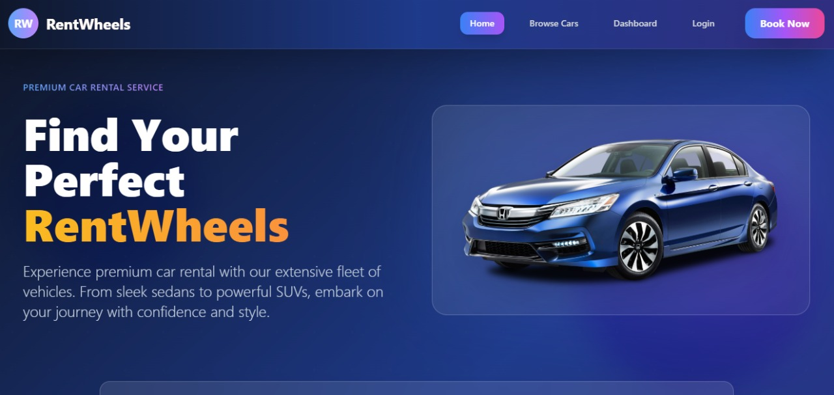

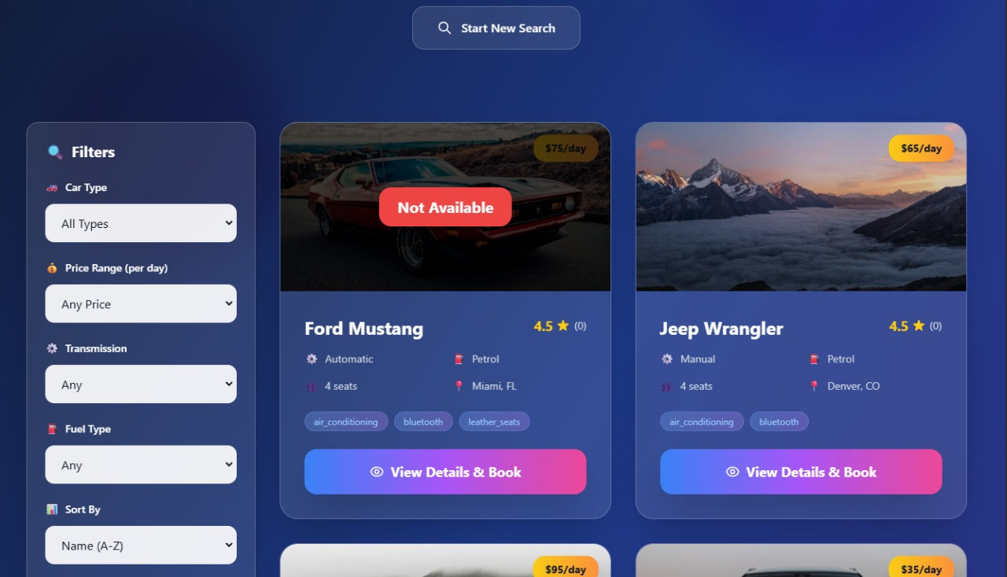
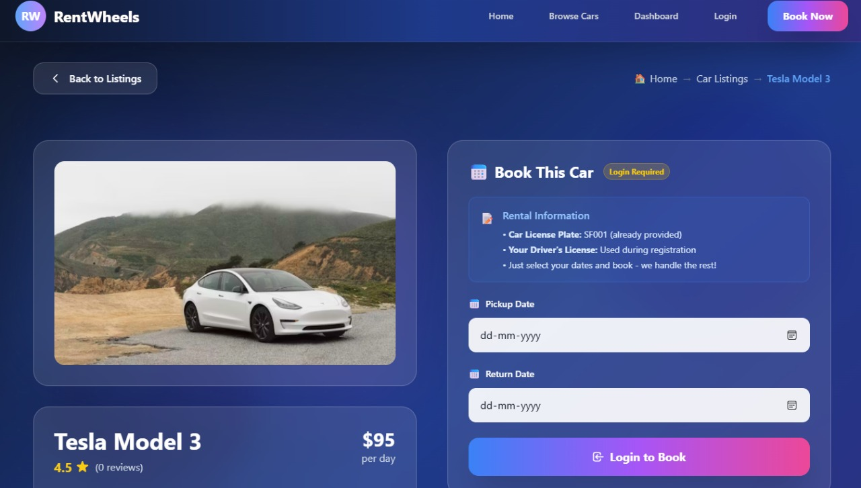

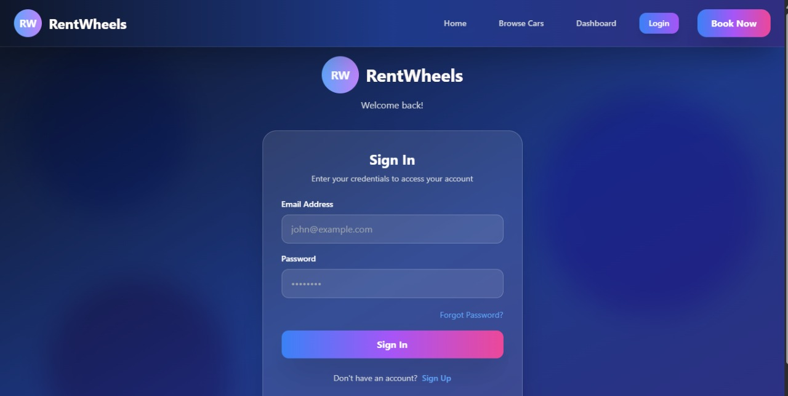

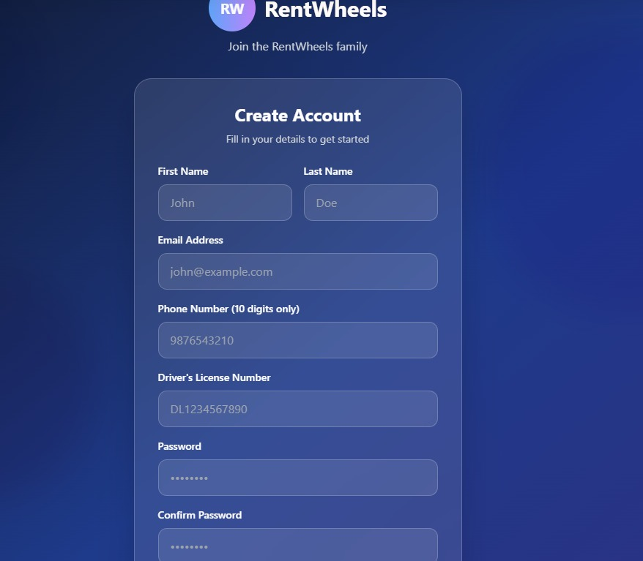

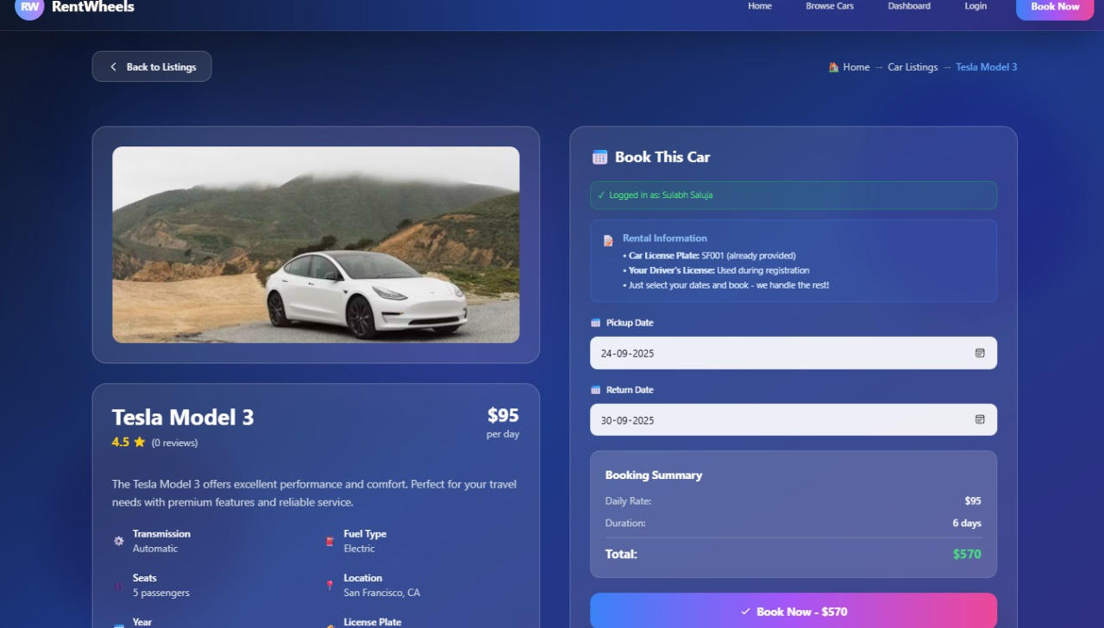
- References:

Official Documentation: Documentation for libraries, frameworks, and tools used in the project, as well as APIs or services integrated.

Tutorials and Guides: Online tutorials, guides, blog posts, and educational videos that provided assistance or insights during development.

Code Repositories: GitHub repositories or other code repositories where code snippets, examples, or inspiration were found.

Forums and Communities: Online forums, such as Stack Overflow or Reddit, and developer communities where questions were asked, advice was sought, or discussions were participated in.

Personal Communication: Mentors, peers who provided guidance, feedback, or support during development.

