**Software Requirements Specification (SRS) Document**

**Project Title:** Farm Assistant Chatbot  
**Prepared By:** Sushant Nadavade, Vedank Wakalkar, Shiromani Waghmare

**Date:** November 21, 2024

**1. Introduction**

**1.1 Purpose**

To develop an advanced AI-powered chatbot that serves as a virtual agricultural assistant, providing real-time, personalized, and expert advice to farmers. This innovative solution aims to enhance agricultural productivity, sustainability, and profitability by addressing the unique challenges faced by farmers worldwide. The chatbot will leverage advanced natural language processing, machine learning, and data analytics to deliver comprehensive support across various agricultural domains, including crop management, pest control, weather forecasting, market analysis, and farm equipment maintenance.

**1.2 Scope**

The Farm Assistant Chatbot is designed to be a comprehensive agricultural tool, providing real-time, personalized, and expert advice. It covers a wide range of areas including crop management, pest control, weather forecasting, market analysis, and farm equipment maintenance. By leveraging AI and IoT technologies, the chatbot aims to enhance agricultural productivity, sustainability, and profitability. It offers personalized crop recommendations, pest identification and control, accurate weather forecasts, market insights, and equipment maintenance tips.

**1.3 Definitions, Acronyms, and Abbreviations**

* **AI:** Artificial Intelligence
* **ML:** Machine Learning
* **NLP:** Natural Language Processing
* **JSON**: Javascript Object Notation

**2. Overall Description**

**2.1 Product Perspective**

The Farm Assistant Chatbot is a cutting-edge AI-powered solution designed to revolutionize agricultural practices. By seamlessly integrating advanced technologies like natural language processing, machine learning, and IoT, the chatbot empowers farmers with real-time insights, expert advice, and automated solutions. This innovative product aims to bridge the gap between traditional farming methods and modern agricultural techniques, enabling farmers to make informed decisions, optimize resource utilization, and enhance overall productivity. The chatbot serves as a virtual agricultural advisor, providing personalized recommendations, early warning systems, and market intelligence.

**2.2 Product Features**

**Crop Management:** Advice on planting, harvesting, and fertilization.

**Pest Control:** Identification and treatment recommendations for common pests.

**Weather Forecasting:** Real-time updates and alerts for adverse weather conditions.

**Market Analysis:** Price trends, demand forecasts, and market insights.

**Farm Equipment Maintenance:** Troubleshooting tips and maintenance schedules.

**Expert Consultation:** Direct chat with agricultural experts.

**2.3 User Classes and Characteristics**

**Small-scale Farmers:** Individuals or families who cultivate small landholdings and rely on agriculture as their primary source of income.

**Large-scale Farmers:** Commercial farmers who own and operate large agricultural enterprises.

**Agricultural Extension Workers:** Government or private sector professionals who provide technical assistance and training to farmers.

**Agribusiness Professionals:** Individuals working in sectors related to agriculture, such as seed companies, fertilizer manufacturers, and agricultural equipment suppliers.

**Researchers and Scientists:** Experts who conduct research in agricultural sciences and develop innovative solutions for farmers.

**Policymakers and Government Officials:** Individuals responsible for formulating and implementing agricultural policies and regulations.

**2.4 Operating Environment**

* Mobile Application: Android and iOS
* Web Application: Compatible with major browsers (Chrome, Firefox, Safari, Edge)
* Back-End: FastAPI with two ML Models

**2.5 Constraints**

**Data Privacy:** Secure handling of sensitive farm data.

**Accuracy:** Reliable and accurate information.

**2.6 Assumptions and Dependencies**

**Internet Connectivity:** Reliable internet access for real-time updates.

**Data Sources:** Access to accurate weather, market, and crop data.

**3. Specific Requirements**

**Natural Language Processing:** Understand and respond to user queries in natural language.

**Knowledge Base:** Comprehensive knowledge base of agricultural practices.

**Machine Learning:** Learn from user interactions and improve responses over time.

**Integration with IoT Devices:** Control farm equipment and monitor sensor data.

**4. System Features**

**Query Answering:** Provide direct answers to user questions.

**Task Completion:** Assist in tasks like scheduling, record-keeping, and decision-making.

**Proactive Alerts:** Notify users of potential issues or opportunities.

**Personalized Recommendations:** Tailor advice based on user-specific factors.

**5. External Interface Requirements**

**User Interface:** Intuitive and user-friendly interface.

**Hardware Interfaces:** Compatible with various IoT devices.

**Software Interfaces:** Integrate with weather APIs, market data providers, and other relevant services.

**Communication Interfaces:** Use APIs to communicate with external services.

**6. Non-Functional Requirements**

**Scalability:** Handle increasing user load and data volume.

**Security:** Protect user data and system integrity.

**Performance:** Respond to user queries quickly and efficiently.

**Usability:** Easy to use and understand.

**Reliability:** High availability and fault tolerance.

**7. Use Case Diagram**

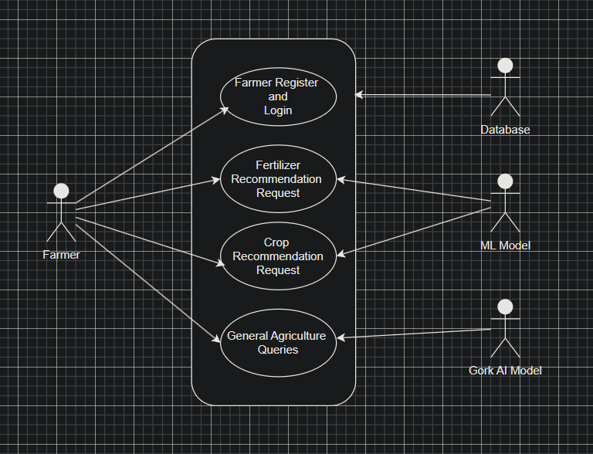

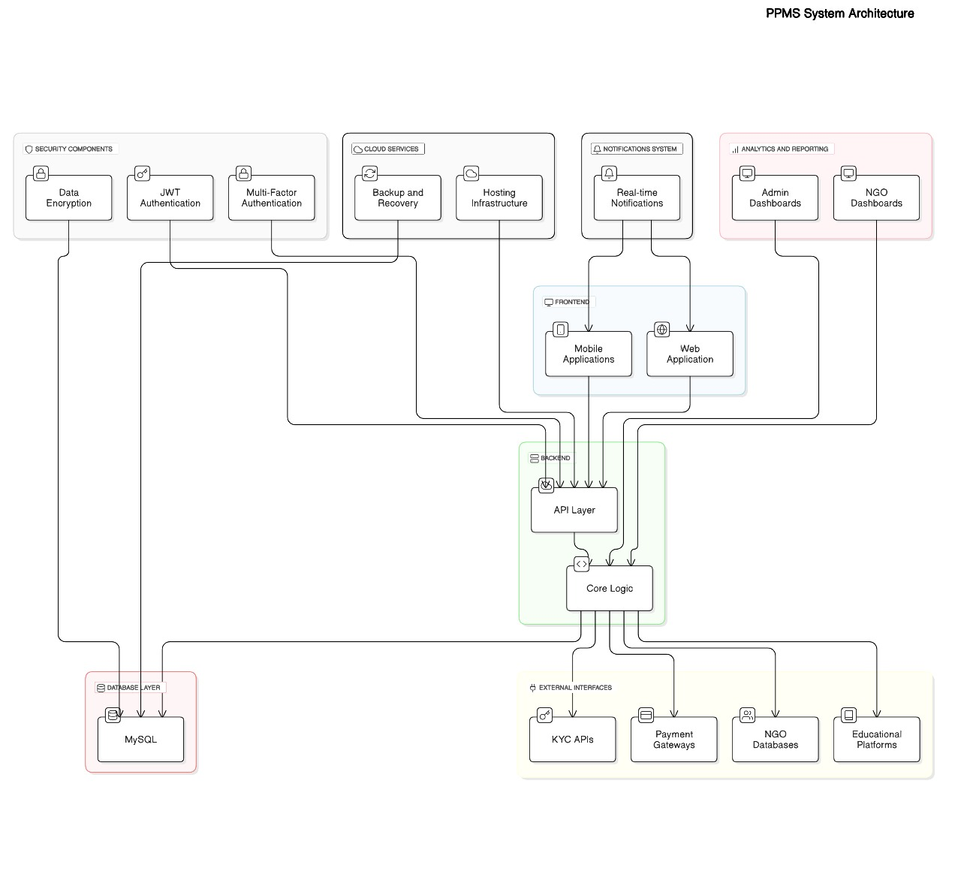

**8. Appendices**

**8.1 Glossary**

* **Admin Dashboard**: A panel for administrators to manage content, user accounts, and overall system performance.
* **NGO Support Module**: A dedicated section where NGOs can register and upload their support programs for users.
* **User Dashboard**: Personalized space for each user to track their activities, programs, and notifications.

**8.2 Acronyms**

* **API**: Application Programming Interface
* **SRS**: Software Requirements Specification
* **JSON**: JavaScript Object Notation

**8.3 References**

* Official Flutter documentation for front-end development.
* Official Spring Boot documentation for back-end development.

**9. Future Enhancements**

As the PPMS project progresses, the following enhancements are planned for future releases:

1. **AI-Powered Recommendations**: Utilize machine learning to provide personalized job and educational recommendations to users based on their profiles.
2. **Gamification Features**: Introduce badges and rewards for completing courses or successfully securing employment.
3. **Integration with Government Databases**: Streamline processes for financial aid and KYC verification by integrating with official government systems.
4. **Offline Mode**: Provide offline access to key educational resources for users with intermittent internet connectivity.
5. **Advanced Analytics**: Introduce dashboards for NGOs and administrators to track the impact and success of various programs.

**10. Conclusion**

The **PPMS** project aspires to create a unified platform that connects individuals with NGOs and opportunities, fostering personal growth, social welfare, and empowerment. By leveraging modern technologies like Flutter for a seamless user experience and Spring Boot for a robust backend (in progress), the platform is designed to be scalable, user-centric, and impactful. With features like personalized dashboards, NGO support modules, and future integrations such as AI recommendations and government database connectivity, this project aims to address India's diverse socio-economic needs. This project envisions becoming a transformative tool for knowledge-sharing and community upliftment, supporting India's path to becoming a global leader in social innovation and empowerment.