***Name :*** *Sushant Maruti Mane*

***GitHub :*** *https://github.com/Sushant2802/Electric-Vehicle.git*

**1. Executive Summary**

The Indian Electric Vehicle (EV) market is undergoing rapid growth, driven by advancements in technology, increasing environmental awareness, and government incentives. This report presents a comprehensive segmentation analysis to identify the most promising consumer groups and formulate a strategic market entry plan for an EV startup.

Key insights suggest that the highest potential lies in two distinct segments:

* **Urban Commuters:** Seeking affordable, efficient, and eco-friendly transportation solutions.
* **Fleet Operators (Ride-Sharing & Logistics):** Businesses aiming to optimize operational costs and reduce carbon footprints.
* **Premium EV Buyers:** Consumers interested in high-performance and luxury EVs.
* **Government & Institutional Buyers:** Large-scale purchasers supporting sustainability initiatives.

A dual market entry strategy focusing on affordable two-wheelers for cost-sensitive consumers and premium four-wheelers for high-end customers will maximize market penetration and long-term growth.

**2. Process and Methodology**

**Data Collection and Preprocessing**

* Acquired market data from real-world sales trends.
* Cleaned and transformed data, handling missing values and standardizing formats for analysis.
* Conducted exploratory data analysis (EDA) to identify key trends and correlations in the EV industry.

**Machine Learning Models & Segmentation Techniques**

To classify and analyze potential EV customers, we employed:

* **AdaBoost Classifier**: To enhance predictive performance by combining weak learners into a strong classifier.
* **Voting Classifier:** To improve accuracy by combining multiple models such as logistic regression, decision trees, and random forests.
* **Gradient Boosting:** To refine predictions and identify key consumer segments using iterative learning techniques.
* **Random Forest:** To predict EV adoption likelihood and assess influencing factors.
* **Logistic Regression & Decision Trees**: To analyze feature importance and target potential buyers.

**Libraries & Frameworks Utilized**

* **Pandas, NumPy:** For data manipulation and preprocessing.
* **Matplotlib, Seaborn, Plotly:** For insightful data visualization.
* **Scikit-learn:** For machine learning model implementation.

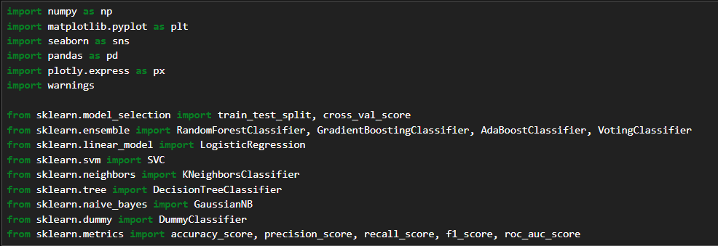

**3. Key Visualizations & Insights**

**Market Growth Trends**

* **Time-Series Analysis:** Demonstrates the upward trajectory of EV adoption *United States*, specifically from the state of *Washington*.

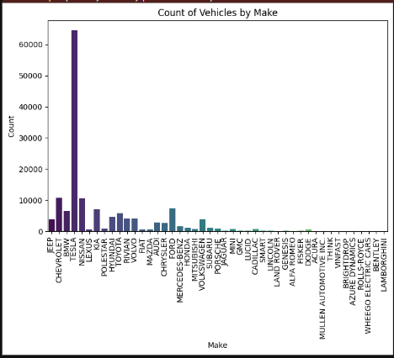

* **Pie Charts & Bar Graphs:** Illustrate the distribution of EV market segments, highlighting the dominance of BEV and PHEVs and vehicle model range by year.

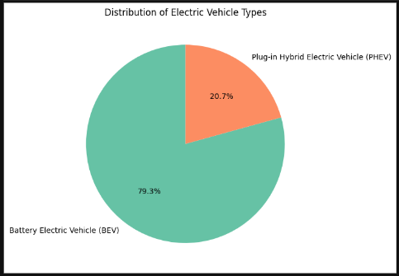

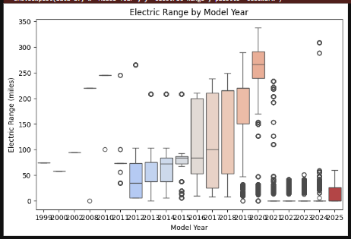

* **Geographical Analysis:** Maps EV adoption rates across different *US* states to identify high-growth areas.

**Consumer Segmentation Analysis**

* **Cluster Heatmaps:** Show distinct consumer behavior patterns and preferences.

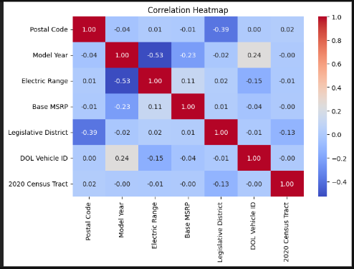

* **Line Charts:** Display trend of electric range by model year.

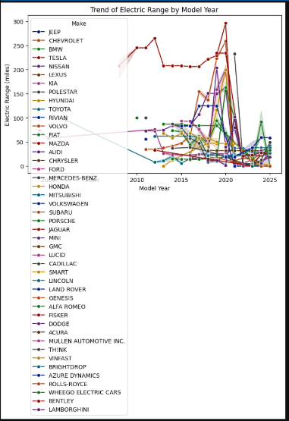

* **Survey Insights:** Analysis of consumer feedback on key factors influencing EV adoption, including charging infrastructure, range anxiety, and government incentives.

**Model Performance Metrics**

* **ROC Curves & Confusion Matrices:** Validate the accuracy and efficiency of predictive models in identifying potential EV buyers.

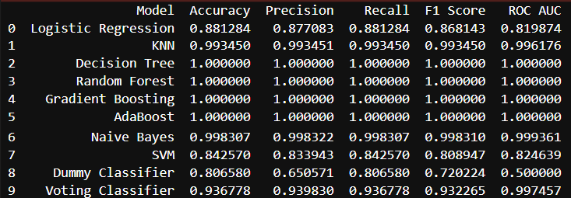

* **Feature Importance Graphs:** Highlight key factors influencing EV purchasing decisions, such as battery range, price, and brand perception.

**4. Market Entry Strategy & Business Solutions**

**Target Market Entry Strategies**

1. **Affordable EV Two-Wheelers for Urban Commuters & Fleet Operators:**
   * Address high demand for ride-sharing and last-mile delivery.
   * Introduce battery-swapping technology to improve usability.
   * Offer government-subsidized financing options.
   * Develop high-efficiency, low-maintenance battery technologies to extend vehicle lifespan.
2. **Premium Electric Cars for High-End Customers:**
   * Cater to environmentally conscious, high-income consumers.
   * Enhance brand differentiation through smart features and extended battery ranges.
   * Position as a luxury and performance-driven segment.
   * Integrate advanced driver-assistance systems (ADAS) and AI-powered enhancements to increase appeal.

**Business Model Recommendations**

* **Strategic Partnerships:** Collaborate with charging infrastructure providers to ensure accessibility.
* **Subscription & Leasing Models:** Reduce financial entry barriers for customers.
* **Government Incentive Utilization:** Capitalize on subsidies to enhance affordability.
* **Digital Marketing & Consumer Education:** Drive awareness through targeted online campaigns.
* **Expansion to Tier-2 & Tier-3 Cities:** Identify and invest in emerging markets where EV adoption is growing steadily.

**Operational and Manufacturing Strategies**

* **Local Supply Chain Development:** Reduce costs by sourcing materials and manufacturing locally.
* **Investment in Battery Technology:** Enhance battery efficiency and sustainability.
* **Production Scalability:** Design a flexible manufacturing model to scale production based on demand.