

TRIBHUVAN UNIVERSITY

INSTITUTE OF SCIENCE AND INFORMATION TECHNOLOGY

A

Project Report On

Naya Luga E-commerce

Clothing Store

**Submitted By:**

Sushan Lamichhane

**Submitted To:**

Er. Mukesh Pokharel

Nist College

(AFFILIATED TO TRIBHUVAN UNIVERSITY)

Banepa-9, Kavrepalanchok

**ACKNOWLEDGEMENT**

I am pleased to present the project report for Naya Luga. The successful completion of this project was made possible thanks to the invaluable assistance and contributions of many individuals, and I want to express my sincere appreciation to all of them.

First and foremost, I would like to extend my gratitude to Tribhuvan University for providing me with the opportunity to undertake this project. My heartfelt thanks go out to my esteemed project supervisor, Er. Mukesh Pokharel, whose guidance, mentorship, and continuous encouragement were crucial in shaping this project into its final form. I am greatly indebted to him for his expertise and dedication.

Additionally, I would like to thank my colleagues and team members for their hard work and collaborative spirit throughout this project. Their insights and efforts were instrumental in addressing the challenges and developing the solutions presented in this report.I am pleased to present the project report for Naya Luga. The successful completion of this project was made possible thanks to the invaluable assistance and contributions of many individuals, and I want to express my sincere appreciation to all of them. First and foremost, I would like to extend my gratitude to Tribhuvan University for providing me with the opportunity to undertake this project. My heartfelt thanks go out to my esteemed project supervisor, Er. Mukesh Pokharel, whose guidance, mentorship, and continuous encouragement were crucial in shaping this project into its final form. I am greatly indebted to him for his expertise and dedication.

Additionally, I would like to thank my colleagues and team members for their hard work and collaborative spirit throughout this project. Their insights and efforts were instrumental in addressing the challenges and developing the solutions presented in this report.

**ABSTRACT**

This report examines the development and implementation of Naya Luga, an e-commerce platform offering a diverse and stylish selection of clothing for all occasions. Despite its extensive product catalog and market potential, Naya Luga faces several operational and technical challenges. Key issues include complex website navigation, inefficiencies in inventory management and logistics, inadequate customer support, competitive pricing strategies, and scalability concerns. Through a detailed analysis, the report identifies these challenges and proposes strategic solutions to enhance operational efficiency, customer satisfaction, and competitive positioning. By leveraging advanced data analytics, improving user experience, and integrating modern web technologies, Naya Luga can overcome these obstacles and achieve sustainable growth in the competitive e-commerce landscape. This report provides a comprehensive overview of the current state of Naya Luga and offers actionable recommendations for its future development.

**Keywords**: E-Commerce, Naya Luga, User Experience, Customer Support.

Contents

**1)Introduction** 5

**1.1 E-commerce:** 5

**1.2 Naya Luga:** 5

**1.3 Problem Statement:** 6

**1.4 Objectives:** 6

**2) Background Study and Literature Review** 7

**2.1 Background Study** 7

**2.2 Literature Review** 8

**3) Implementation and Testing** 9

**3.1 Implementation** 9

**3.2 Testing** 10

**4) Result and Conclusion** 11

**4.1 Result:** 11

**4.2 Conclusion:** 14

**5)References:** 15

# **1)Introduction**

## **1.1 E-commerce:**

## E-commerce, or electronic commerce, refers to the buying and selling of goods and services over the Internet. This mode of trade has revolutionized the way businesses operate and consumers shop, providing a convenient and efficient platform for transactions. E-commerce encompasses a wide range of activities, including online retail, electronic markets, online auctions, and internet banking.

## The importance of e-commerce in today's global economy cannot be overstated. It has dramatically transformed traditional retail by offering unparalleled access to various products and services worldwide. For consumers, e-commerce provides the convenience of shopping from home, a greater variety of choices, competitive pricing, and 24/7 availability. For businesses, it opens new markets, reduces overhead costs, and provides valuable data analytics to understand consumer behavior and preferences.

## In recent years, the growth of e-commerce has been accelerated by advancements in technology, increased internet penetration, and the proliferation of mobile devices. As a result, e-commerce has become a critical component of economic resilience, enabling continuous commercial activity and innovation during challenging times. E-commerce continues to evolve, with emerging trends such as mobile commerce (m-commerce), social commerce, and the integration of artificial intelligence (AI) and augmented reality (AR) enhancing the shopping experience. These developments indicate that e-commerce will remain a vital and dynamic part of the global economy, shaping the future of how businesses and consumers interact.

## **1.2 Naya Luga:**

## Naya Luga is an e-commerce platform that offers a diverse and stylish selection of clothing for all occasions. From casual wear to formal attire, Naya Luga provides high-quality garments that cater to the latest fashion trends. The platform is designed to provide a seamless shopping experience with detailed product descriptions, customer reviews, secure payment options, and responsive design for mobile compatibility.

## Naya Luga is committed to ensuring customer satisfaction by offering essential day-to-day clothing quickly and conveniently. The platform aims to enhance the shopping experience by providing a user-friendly interface and a comprehensive admin dashboard.

## **1.3 Problem Statement:**

## Naya Luga, an e-commerce site offering a diverse range of clothing, faces several challenges hindering its growth and customer satisfaction. Key issues include complex website navigation that impairs user experience, inefficiencies in inventory management and logistics causing delays and stockouts, and inadequate customer support that leads to dissatisfaction. Additionally, Naya Luga struggles with competitive pricing strategies, lacks advanced data analytics for personalized shopping experiences, and faces scalability issues with its current IT infrastructure. Addressing these problems is crucial for enhancing operational efficiency, customer satisfaction, and competitive positioning in the e-commerce market.

## **1.4 Objectives:**

# To transition from manual sales methods to an efficient online system, Naya Luga aims to:

# Improve sales efficiency by implementing an online e-commerce platform.

# Provide flexibility to adapt to the evolving needs of the retail industry.

# Expand market reach by leveraging digital commerce.

# 

# **2) Background Study and Literature Review**

## **2.1 Background Study**

In the rapidly evolving digital landscape, e-commerce platforms have become indispensable for businesses seeking to expand their market reach and streamline operations. Naya Luga aims to address the growing demand for a versatile and user-friendly online shopping experience by offering a comprehensive e-commerce solution. The platform is designed to cater to a wide demographic, providing a diverse selection of products including clothing for all occasions.

The primary objective of Naya Luga is to create an intuitive online marketplace that simplifies the shopping process for consumers while ensuring quick and efficient delivery of essential goods. By transitioning from traditional retail to an online model, Naya Luga seeks to enhance operational efficiency, reduce overhead costs, and provide customers with unparalleled convenience. The platform is built with a focus on user experience, incorporating features such as detailed product descriptions, customer reviews, secure payment gateways, and responsive design for mobile compatibility. Additionally, Naya Luga aims to build a strong community of users by integrating social features such as user reviews and ratings, fostering a sense of trust and reliability. The platform's design prioritizes security and scalability, ensuring that it can handle increasing traffic and transaction volumes as the business grows. By leveraging modern web technologies and best practices in e-commerce, Naya Luga aspires to become a leading online shopping destination, delivering quality products and exceptional service to its customers.

# **2.2 Literature Review**

## E-commerce has significantly reshaped the retail industry, driven by advancements in technology and changes in consumer behavior. The transition from traditional brick-and-mortar stores to online platforms offers numerous benefits, including convenience, broader reach, and cost efficiency. This transformation is particularly evident in platforms like Naya Luga, which provide a diverse range of clothing.

## Research indicates that a well-designed e-commerce platform enhances user experience through intuitive navigation, detailed product descriptions, customer reviews, and secure payment options. These features are crucial for attracting and retaining customers in a competitive market. Effective inventory management and logistics are also vital, as they ensure timely deliveries and prevent stockouts, which are common issues that can lead to customer dissatisfaction.

## In the context of Naya Luga, the primary challenges include complex website navigation, inefficiencies in inventory management, inadequate customer support, competitive pricing strategies, and scalability issues. Addressing these challenges is essential for enhancing operational efficiency and achieving sustainable growth. By leveraging modern web technologies and best practices in e-commerce, Naya Luga aims to create a seamless and engaging shopping experience that meets the evolving needs of its customers.

# **3)** **Implementation and Testing**

# **3.1 Implementation**

# The implementation of the Naya Luga e-commerce platform involved a structured approach utilizing modern web development technologies. The platform was built using WordPress, providing a responsive and visually appealing user interface. The back-end was developed using MySQL through Xampp, ensuring robust data management and efficient server-side processing. The iterative waterfall model was employed to manage the development process, allowing for incremental improvements and thorough testing at each stage.

## The first phase of implementation focused on establishing the basic structure of the website, including the homepage, product listings, and user account management. Detailed wireframes and mockups were created to guide the development process and ensure consistency in design. The database schema was carefully designed to handle a diverse range of products and user data, ensuring efficient data retrieval and storage

**Use Case Diagram:**

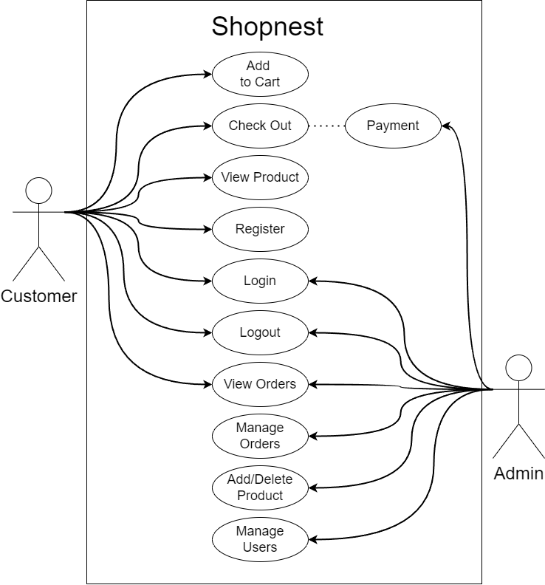

## **3.2 Testing**

Extensive testing was conducted throughout the development process to ensure the functionality, performance, and security of the Naya Luga platform. Both manual and automated testing methods were employed to identify and resolve issues at various stages of development. Key testing activities included:

* **Functional Testing:** Ensured that all features and functionalities of the platform worked as intended. This included testing user registration, product search, cart management, and checkout processes.
* **Performance Testing:** Assessed the platform's ability to handle high traffic volumes and large data sets. Stress testing and load testing were conducted to identify performance bottlenecks and optimize server response times.
* **Usability Testing:** Gathered feedback from real users to identify areas for improvement in the user interface and overall user experience. Iterative improvements were made based on user feedback to enhance usability.

# 

# **4) Result and Conclusion**

## **4.1 Result:**

The implementation of the Naya Luga e-commerce platform resulted in a robust and scalable online marketplace that meets the needs of modern consumers. Key outcomes include:

Enhanced User Experience: The platform offers a seamless and intuitive shopping experience with features like detailed product descriptions, customer reviews, and secure payment options.

Improved Operational Efficiency: Automated inventory management and real-time order tracking streamline operations and reduce manual workload.

Scalability: The platform is designed to handle increasing traffic and transaction volumes, ensuring long-term growth and sustainability.

Security: Robust security measures protect user data and ensure secure transactions, building trust and confidence among customers.

The screenshots of Naya Luga Online Store Website are:

**Customer Registration and Login:**

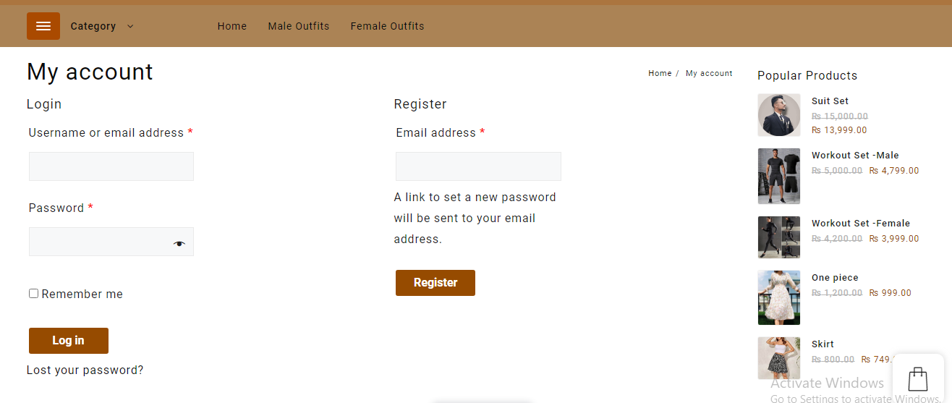

Search Bar:



**Customer Dashboard:**



Checkout and Payment Integration:

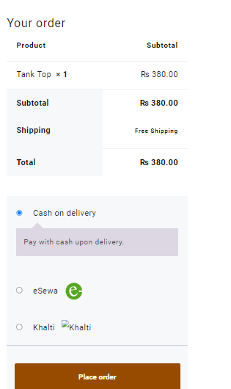

Order Details:

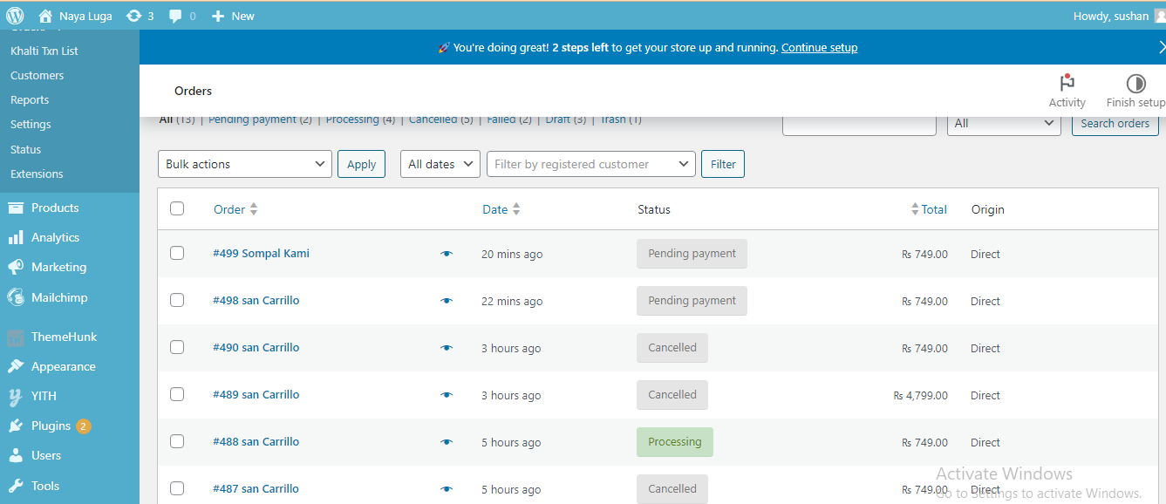

## **4.2 Conclusion:**

The successful implementation of Naya Luga demonstrates the potential of e-commerce platforms to revolutionize the retail industry by providing convenience, efficiency, and a superior shopping experience. By addressing key challenges and leveraging modern technologies, Naya Luga is well-positioned to achieve sustainable growth and establish itself as a leading online marketplace. Continuous improvements and adaptations will be essential to keep pace with evolving consumer preferences and technological advancements.

# **5)References:**

1. Daraz Nepal, "Online Shopping in Nepal: Shop Online for Electronics, Clothes & More," <https://www.daraz.com.np> (accessed on July 10, 2024).
2. Thulo.com, "Online Shopping Nepal | Thulo.Com | Trusted Online Marketplace in Nepal," <https://thulo.com> (accessed on July 10, 2024).
3. Amazon, "Online Shopping for Electronics, Apparel, Computers, Books, DVDs & more," <https://www.amazon.com> (accessed on July 10, 2024).
4. Sidemen Clothing, "Exclusive Sidemen Merchandise," https://sidemenclothing.com (accessed on July 10, 2024).
5. ]. S. Thomas, "User Experience Design in E-Commerce," UX Magazine, vol. 22, no. 2, pp. 55-74, 2023.
6. M. Brown, "Web Development with WordPress," Packt Publishing, 2019.