**Assignment – 1**

**Sushant Kumar**

**Fs_108_giet_046**

**Pin : 17551A0552**

**Github link :-** <https://github.com/Sushant385/RightStrokeFSEngGrads>

1. **What is Abstraction ?**

Abstraction is a concept in OOPs which is used to hide some unnecessory information from the user. Inother words, we can say that it is a process

of collecting data from larger pool to show only relevant data to the user.

1. **What is Encapsulation ?**

Encapsulation is a concept in OOPs which is used for binding the data with the code that manipulates it. In other words, we can say that it keeps the data and the code safe from external interference.

1. **What is JDK ?**

JDK (Java Development Kit) is a software development environment which is used to develop (execute) a java application and applet application.

1. **What is JVM ?**

JVM (Java Virtual Machine) is a run time application. It is used to call the main method which is present inside a java program. It also converts a java program into byte code ( .class) file which gives a facility to the program which is called as

“Write once execute anywhere”.

1. **Define Inheritance.**

Inheritance is a concept in JAVA where one class (Child / Derive class) acquires all the properties and behaivours of another class (Parent / Base class).

For inherit the properties of Parent class there is a keyword called as “extends”.

There are three types of Inheritance in JAVA :-

* Single Inheritance
* Multi-level Inheritance
* Hierarchical Inheritance

1. **How java achieved platform independence?**

The meaning of platform-independent in JAVA is that the byte code (.class file ) can run on all operating systems.Since all java programs run in same JVM ,so same byte code can be run in any platform .

1. **Write the syntax of main function.**

Main method of JAVA is entry point of any java program. The syntax for main method is : -

**public static void main(Strings[] args)**

**{**

**// statements;**

**}**

In the place of args we can write anything.

1. **What is conditional operator?**

Conditional operator is a ternary operator which is generally used to evaluate a boolean expression.

It is just like if-condition, the only difference is it doesn’t want block.

**Syntax :-**

(condition) ? True : False;

If condition is true it will return left side value and if it is false it will return right side value.

1. **How many data types in java?**

Actually In java data-types has catogories in two types :

1. **Primitive data type :**

* boolean
* int
* char
* short
* byte
* long
* float
* double

1. **Non – Primitive data type :**

* String
* Array

1. **What is constant? How it is declared?**

A constant is a variable whose value connot change once it has been assigned.

In Java we don’t have any built-in support for constants, but the variable modifiers static and final can be used to effectively create constant.

**Syntax :-**

* We can declare directly

datatype identifier_name = constant;

* We can declare as static

static datatype identifier_name = constant;

* We can declare as final

final datatype identifier_name = constant;

**PROGRAMS**

1. **Write a java program to find the area of rectangle.**

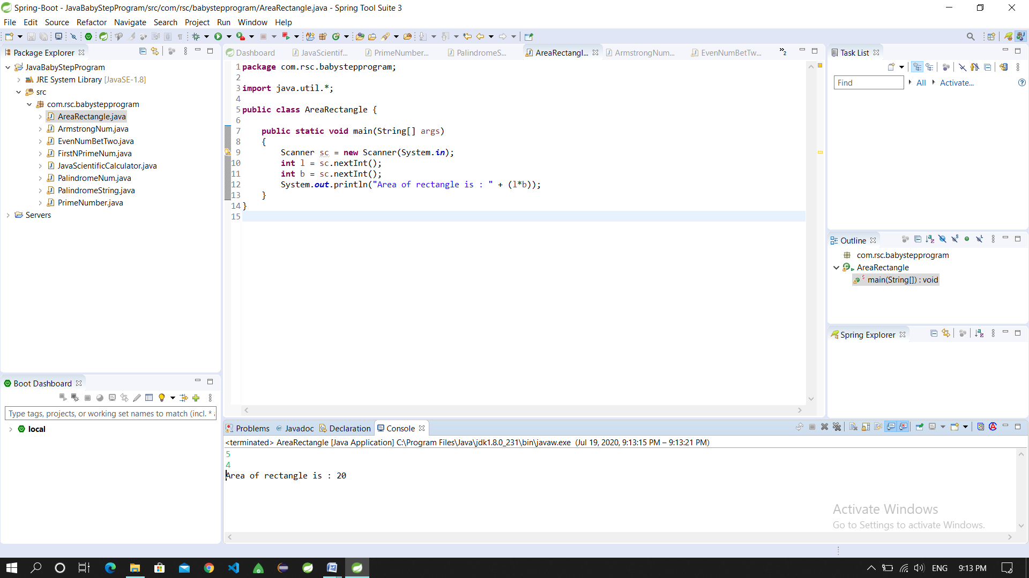

1. **Write a java program to check the given no is Armstrong or not(153 is Armstrong no 1*1*1+5*5*5+3*3*3=153).**

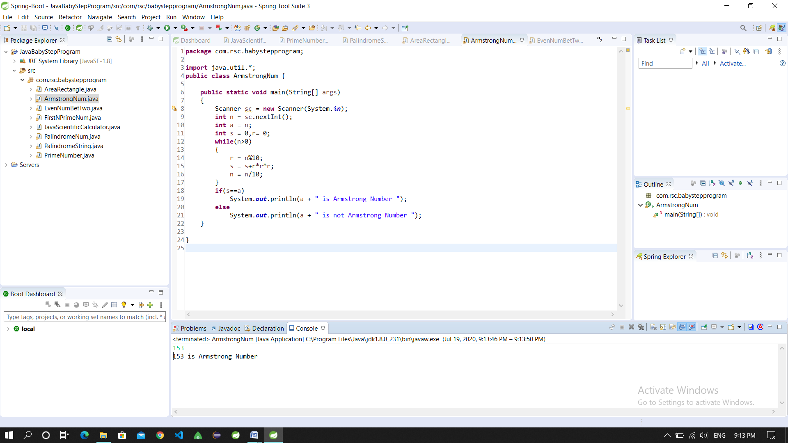

1. **Write a java program to check the given no is palindrome or not.**

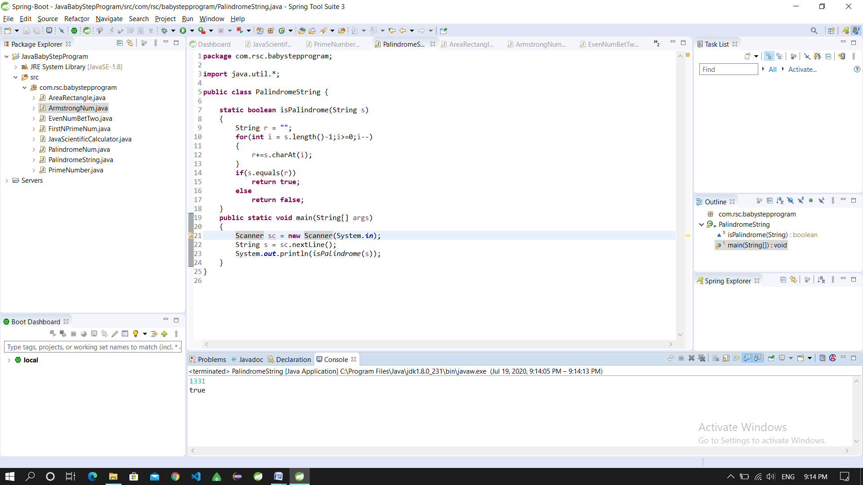

1. **Write a java program to generate first N prime numbers.**

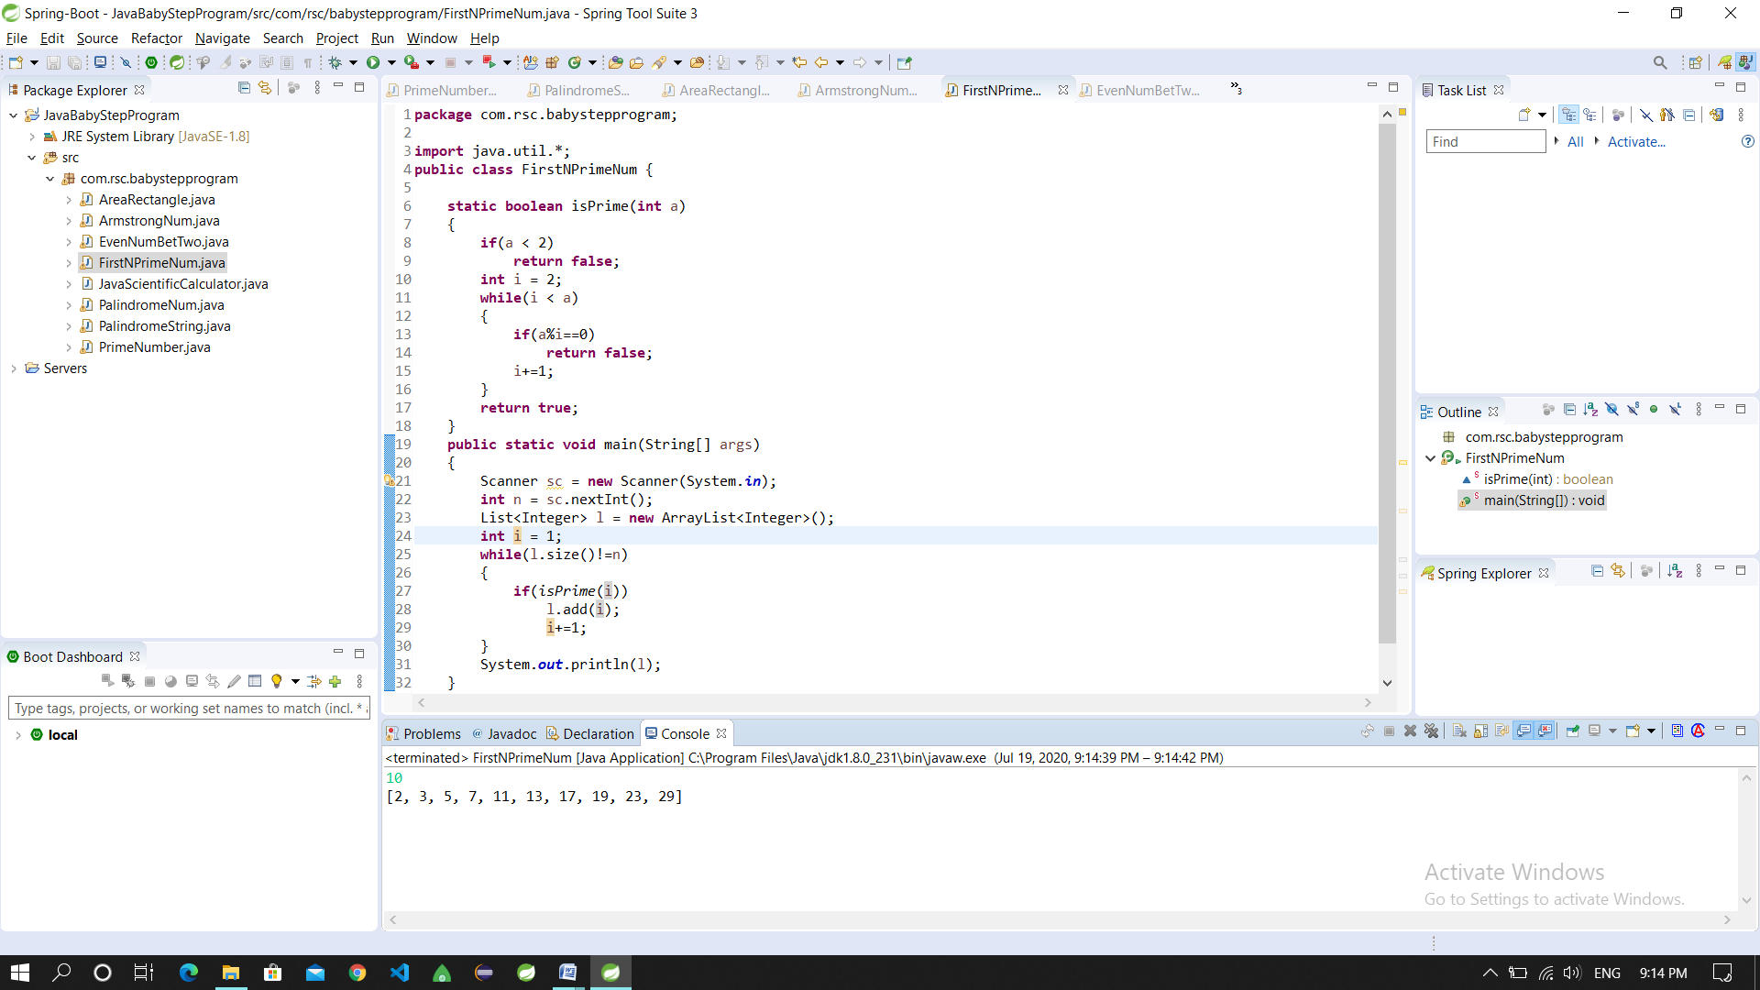

1. **Write a java program to print even numbers in between given two numbers.**

