**Assignment – 2**

**Sushant Kumar**

**fs_108_giet_046**

**Pin : 17551A0552**

**Github link :-** <https://github.com/Sushant385/RightStrokeFSEngGrads>

1. **What is conditional statement?**

**Conditional statements** help you to make a decision based on certain conditions.In other words, It is used to decide the flow of execution based on different conditions. If a condition is true, you can perform one action and if the condition is false, you can perform another action.

1. **Write the syntax of switch..case statement.**

**switch( expression )**

**{**

**case value-1:**

**// Statements ;**

**break;**

**case value-2:**

**// Statements ;**

**break;**

**case value-n:**

**// Statements ;**

**break;**

**default:**

**// Statements ;**

**break;**

**}**

1. **Write the difference between break and continue statement.**

Both the statements **break**  and **continue** works within a loop, but the difference

between then is, **break** leave the loop completly and run the rest statement which are outside from the loop while **continue**  leave the current itteration and execute next iteration in loop.

1. **What is looping statement?**

**Looping Statements** in programming languages is a feature which facilitates the execution of a set of instructions/functions repeatedly until a particular condition is satisfied.

1. **Write the difference between while and do..while statement.**

**while** loop execute the the statement present inside the loop only if the given condition is true but **do..while** loop execute the statement once then it will check the given condition.

1. **What is array? How it is created?**

An **array** is a container object that holds a fixed number of values of same type. The length of an **array** is established when the **array** is created. After creation, its length is fixed.

**To create an array in Java, you use three steps:**

* Declare a variable to hold the array.
* Create a new array object and assign it to the array variable.
* Store things in that array.

**int variable_name[ ];**

**variable_name = new int[size];**

**String[ ] s = new String[n];**

1. **What is class?**

A **class** is a **blueprint / template** that describe **behaviour / state** that the objects of its type support.Also a **class** is collection of data member and member function.

1. **What is constructor?**

**Constructor**  can be a member method, which has same name as **class name.**

It will never return anything. It is also used to allocate the memory.

1. **What is the use of copy constructor?**

A **copy constructor** in a **Java** class is a **constructor** that creates an object using another object of the same **Java** class. It is helpful when we want to **copy** a complex object that has several fields, or when we want to make a deep **copy** of an existing object.

1. **What is the use of this keyword?**

**this** keyword is a reference variable in java that refers to the current object.

* **this** can be used to refer instance variable of current class
* **this** can be used to invoke or initiate current class constructor
* **this** can be passed as an argument in the method call
* **this** can be passed as argument in the constructor call
* **this** can be used to return the current class instance

1. **What is method overloading?**

**Method overloading** is a feature in JAVA which allows a **class** to have more than one method with **same name** but having different parameters.

1. **What is static variable?**

**static variable** is just like a **global** variable which can be used in all the methods.

In other words we can say that , only a single copy of **static variable** is created and shared among all the instances of the class**.**

1. **What is access modifier?**

**access modifier** specifies which classes can access a given class and its fields, constructors and methods. **Access modifiers** are a specific part of programming language syntax used to facilitate the encapsulation of components.

1. **Write the difference between instance and static methods.**

**Instance methods** are methods in JAVA which require an object of its class to be created before it can be called.

**Static methods** are the methods in JAVA that can be called without creating an object of class.

1. **What is object? How it is created?**

**Object** is an **instance of a class**. When a class is defined, no memory is allocated but when it is instantiated (i.e. an **object** is **created**) memory is allocated.

The **new** **keyword** is used tocreate new **objects** in JAVA.

**Class_name variable_name = new Class_Name( );**

PROGRAMS

1. **Write a java program for Matrix Addition.**

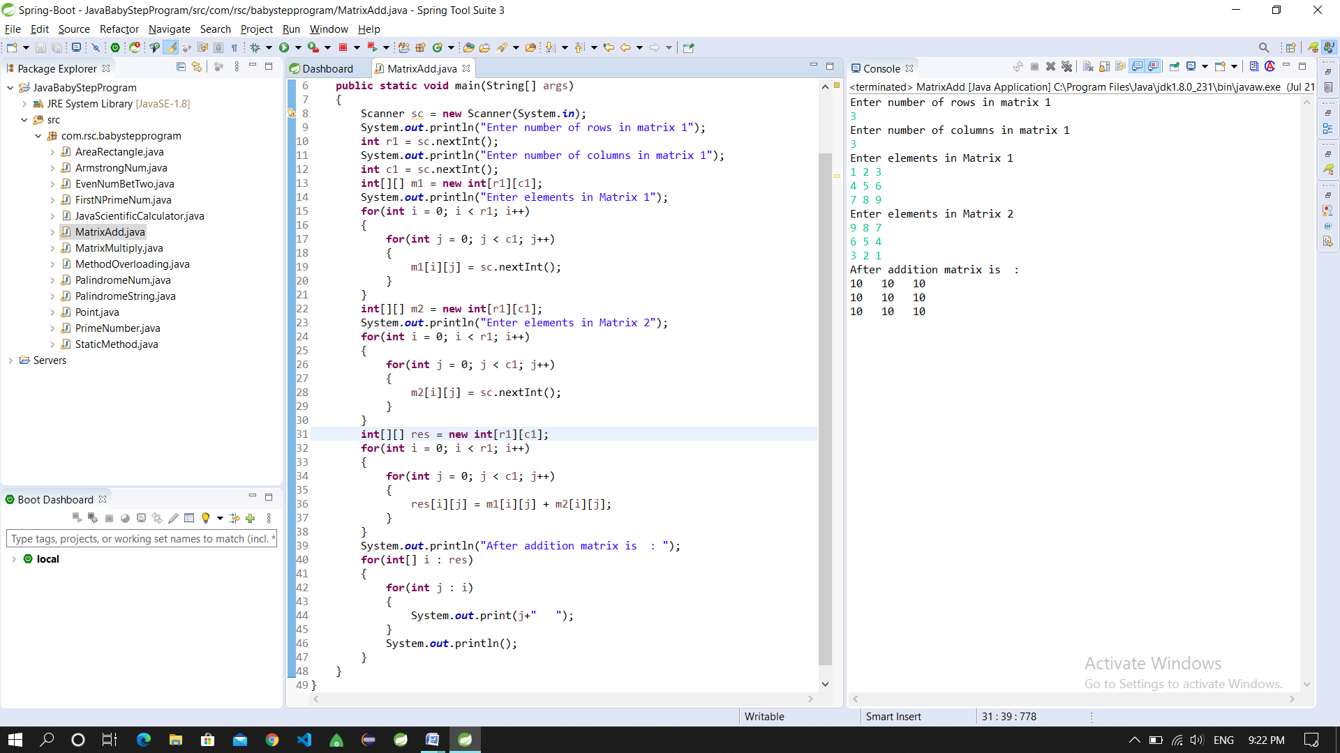

1. **Write a java program for Matrix Multiplication.**

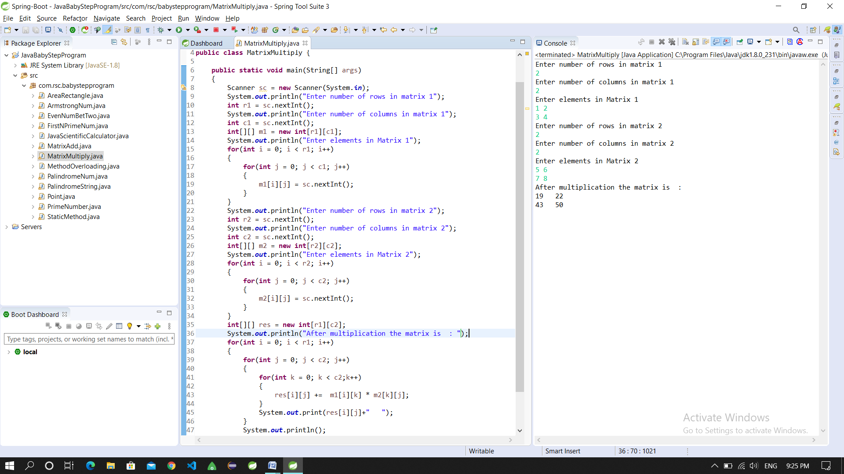

1. **Write a java program to demonstrate method overloading.**

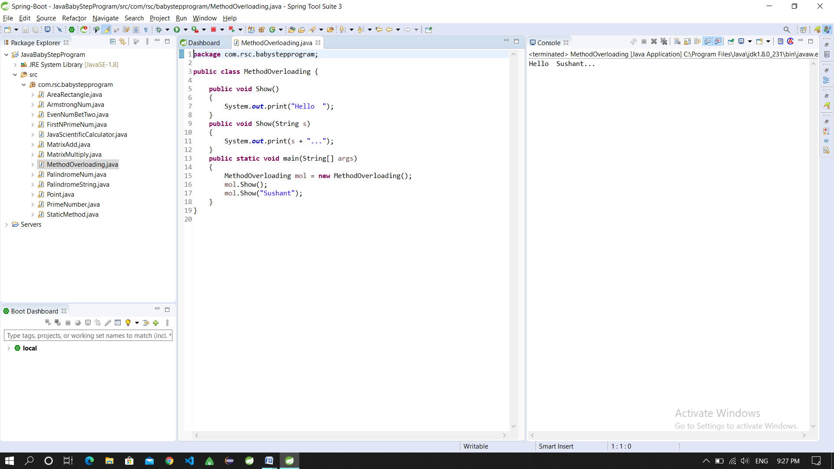

1. **Write a java program to create a class Point with two data members x & y. Include all constructors and display().**

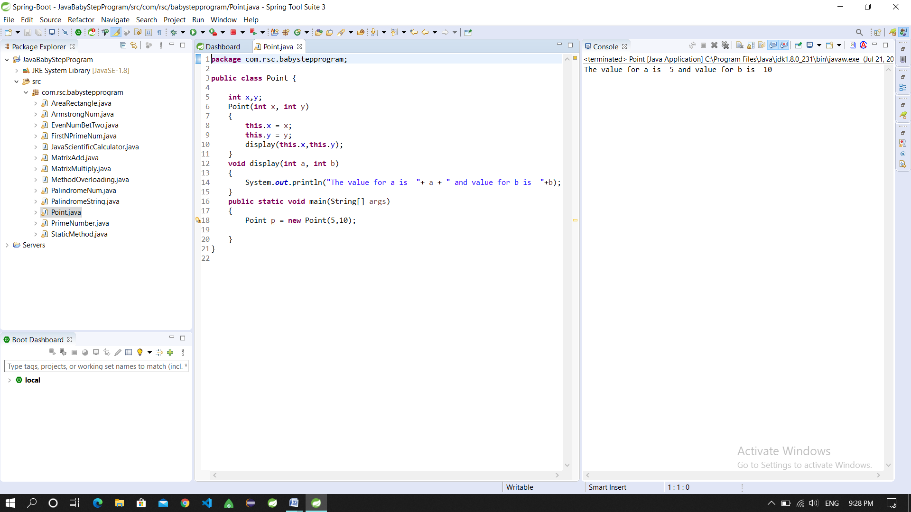

1. **Write a java program using static method.**

