7.1 Warming Up Exercise:

Task 1. Classify Study Time:
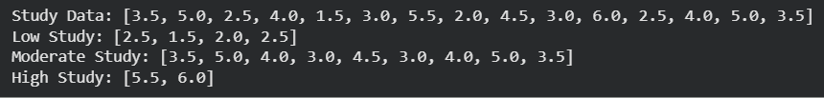

Task 2. Based on Data
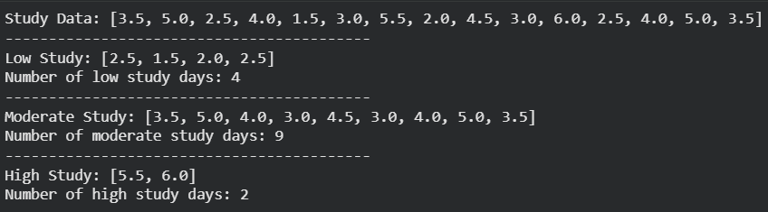

Task 3. Convert Study Hours to Minutes:

Task 4. Analyze Average Time Use:
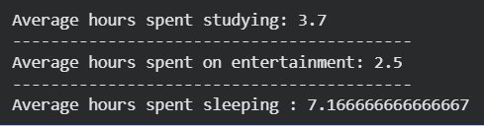

Task 5. Visualization - Study vs Sleep Pattern:
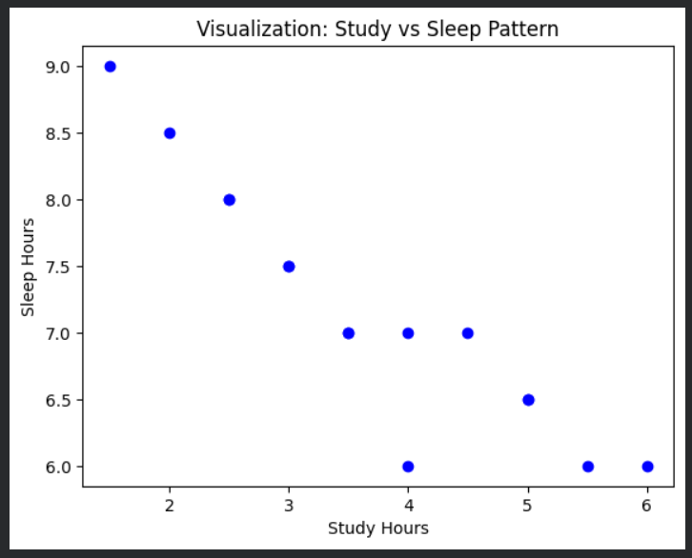

8.1.1 Exercise - Recursion:

Task 1 - Sum of Nested Lists:
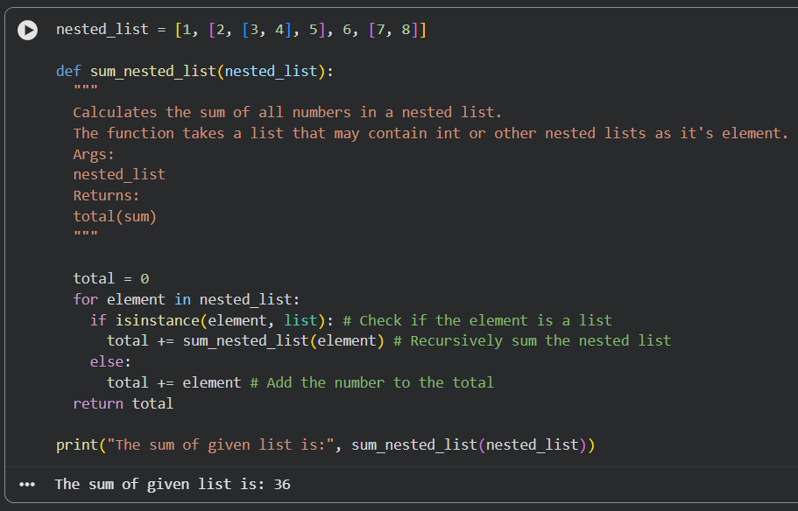

Task 2 - Generate All Permutations of a String:
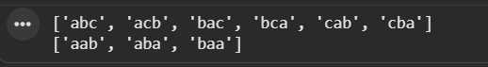

Task 3 - Directory Size Calculation:
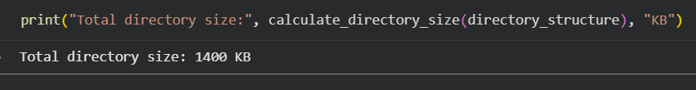

8.2.1 Exercises - Dynamic Programming:

Task 1 - Coin Change Problem:
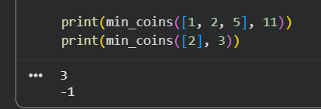

Task 2 - Longest Common Subsequence (LCS):
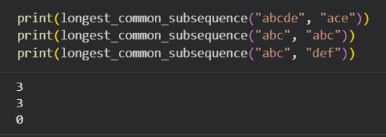

Task 3 - 0/1 Knapsack Problem:
