****Install requirements.txt****

run command pip install requirements.txt

****Configure the database****

edit database name in settings.py file

****Apply migrations****

Run py manage.py makemigrations

Run py manage.py migrate

****Run the server****

Run py manage.py runserver

**Testing endpoints**

1. ****register a user****

****endpoint**** - <http://127.0.0.1:8000/pizza/register/>

****Request**** - POST request

****request data**** - {"username":,"password":}

****Response**** - {"user":{"username":},"token":}

save the token

1. ****login****

****endpoint**** - <http://127.0.0.1:8000/pizza/login/>

****Request**** - POST request

****request data**** - {"username":,"password":}

****Response**** - {"user":{"username":},"token":}

1. ****logout****

****endpoint**** - <http://127.0.0.1:8000/pizza/logout/>

****Request**** - POST request  
 ****Response**** - {"logout": "User logged out"}

**Place the saved token in authorization headers for every request.**

**Ex -** 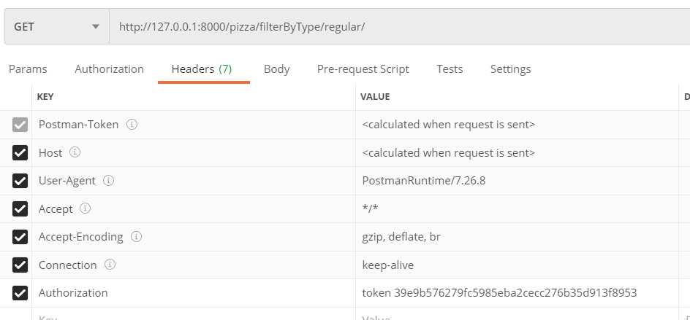

1. ****create square pizza****

****endpoint**** - <http://127.0.0.1:8000/pizza/square/>

****Request**** - POST request

****request data**** - {"size":"small","toppings":["cheese","corn"]}

****Response**** - {"id": 6,"toppings": [{"name": "cheese"},{"name": "corn"}],"created_by": {"username": "admin21"},"type": "square","size": "small"}

1. ****create regular pizza****

****endpoint**** - <http://127.0.0.1:8000/pizza/regular/>

****Request**** - POST request

****request data**** - {"size":"small","toppings":["cheese","corn"]}

****Response**** - {"id": 7,"toppings": [{"name": "cheese"},{"name": "corn"}],"created_by": {"username": "admin21"},"type": "regular","size": "small"}

1. ****list all pizzas****

****endpoint**** - <http://127.0.0.1:8000/pizza/all/>

****Request**** - GET request  
 ****Response**** - [{"id": 1,"toppings": [],"created_by": {"username": "admin1"},"type": "regular","size": "medium"},{"id": 3,"toppings": [{"name": "cheese"},{"name": "onion"},{"name": "tomato"}],"created_by": {"username": "admin1"},"type": "regular","size": "small"}]

1. ****update pizza****

****endpoint**** -  [http://127.0.0.1:8000/pizza/update/##id##/](http://127.0.0.1:8000/pizza/update/" \l "#id##/)

Ex - http://127.0.0.1:8000/pizza/update/10/

****Request**** - PUT request

****request data**** - {"type":"square","size":"small","toppings":["cheese "]}

****Response**** - {"id": 1,"toppings": [{"name": "cheese"}],"created_by": {"username": "admin21"},"type": "square","size": "small"}

1. ****delete pizza****

****endpoint**** - [http://127.0.0.1:8000/pizza/update/##id##/](http://127.0.0.1:8000/pizza/update/" \l "#id##/)

Ex - http://127.0.0.1:8000/pizza/update/10/

****Request**** - DELETE request  
 ****Response**** - {"message": "Deleted"}

1. ****filter by type****

****endpoint**** - [http://127.0.0.1:8000/pizza/filterByType/##value##/](http://127.0.0.1:8000/pizza/filterByType/" \l "#value##/)

Ex - http://127.0.0.1:8000/pizza/filterByType/square/

****Request**** - GET request  
 ****Response**** - [{"id": 3,"toppings": [{"name": "cheese"},{"name": "onion"},{"name": "tomato"}],"created_by": {"username": "admin1"},"type": "regular","size": "small"}, {"id": 9,"toppings": [{"name": "cheese"}],"created_by": {"username": "admin21"},"type": "regular","size": "small"}]

1. ****filter by size****

****endpoint**** - [http://127.0.0.1:8000/pizza/filterBySize/##value##/](http://127.0.0.1:8000/pizza/filterBySize/" \l "#value##/)

Ex - http://127.0.0.1:8000/pizza/filterBySize/small/

****Request**** - GET request  
 ****Response**** - [{"id": 3,"toppings": [{"name": "cheese"},{"name": "onion"},{"name": "tomato"}],"created_by": {"username": "admin1"},"type": "regular","size": "small"}, {"id": 8,"toppings": [{"name": "cheese"}],"created_by": {"username": "admin21"},"type": "square","size": "small"},{"id": 9,"toppings": [{"name": "cheese"}],"created_by": {"username": "admin21"},"type": "regular","size": "small"}]